**Solution Sheet**

1. Which model have you used for probability prediction? Explain your model.

The model that is used for probability prediction is a neural network model. It is implemented in Python using TensorFlow and Keras.

The architecture of the model is Sequential containing 2 Dense Layers of 64 neurons each with ‘relu’ activation function and a final output layer of a single neuron that outputs the predicted probability.

The model is compiled using mean squared error loss and adam optimizer.

Model:

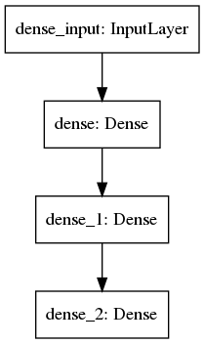

Model: "sequential"

_________________________________________________________________

Layer (type) Output Shape Param #

=================================================================

dense (Dense) (None, 64) 1472

_________________________________________________________________

dense_1 (Dense) (None, 64) 4160

_________________________________________________________________

dense_2 (Dense) (None, 1) 65

=================================================================

Total params: 5,697

Trainable params: 5,697

Non-trainable params: 0

_________________________________________________________________