**Data Analytics in Building Science**

Optimizing Indoor Environmental Quality through Occupant Feedback and Experimental Data Analysis in Building Environments

Under the Guidance of **Prof. Prashant Anand**

**Hritik Kumar Garg | 20AR10014**

**Khushi Tayal | 20AR10016**

**Mobassir Shams | 20AR10020**

**Nidam Kumar Jha | 20AR10023**

**Niraj Yadav | 20AR10025**

**Shubham | 20AR10042**

**Content**

* Introduction
  + Given Problem Statement
  + Aim
* Data Preprocessing
* Exploratory Data Analysis (EDA)
  + Perception and satisfaction of zone Air Movement
  + Perception and satisfaction of zone Temperature
  + Perception and satisfaction of zone Air Quality
* Acute Health Symptoms
* Limitations with study and future scope of improvement
  + Possible limitations of this study could include
  + Possible future scope of improvement could include
  + To improve this experiment, researchers could consider
* Conclusion

**INTRODUCTION**

**Given Problem Statement**

Analyze and correlate various sets of data related to Indoor Air Quality (IAQ), thermal comfort, and occupant feedback. Develop a Thermal and IAQ satisfaction model for the three sets of experiments, jointly and individually. Justify whether a single model will suffice or if multiple models are necessary. The decision should be based on correlation and error checks between the actual and predicted values.

**Aim:**

The aim is to develop a model that accurately predicts IAQ and thermal comfort satisfaction for different groups of people based on their age, gender, clothing, and other variables.

**IEQ with Different Ventilation and Air Movement Conditions.**

Indoor environmental quality (IEQ) is an important factor that can affect the well-being and productivity of people in indoor spaces. One crucial aspect of IEQ is thermal comfort, which can be influenced by various factors, including air temperature, air movement, and humidity. Maintain thermal comfort for occupants in elevated zones, such as mezzanine floors or tall buildings, where air stratification can be an issue. Adequate ventilation and air movement are crucial for achieving thermal comfort, and this study aims to identify the optimal conditions for maintaining occupants' well-being and productivity in such spaces. The focus is on understanding occupant perception and satisfaction with IEQ, especially thermal comfort, in elevated zones with different ventilation and air movement conditions.

**IEQ Considerations for Architects**

In the field of architecture, it is essential to create indoor environments that are comfortable and sustainable. Architects need to consider the indoor environmental quality (IEQ) to ensure that the building occupants' well-being and productivity are not compromised. Maintaining thermal comfort in elevated zones can be challenging due to air stratification. Understanding occupants' perception and satisfaction with IEQ, and the impact of ventilation and air movement, can assist architects in designing buildings that prioritize comfort. This knowledge can lead to better indoor environments in elevated spaces, informing design decisions and improving building performance. Investigating occupants' perception and satisfaction with IEQ provides valuable insights for architects.

**IEQ Perception in Classrooms under Varying Ventilation and Air Movement Conditions.**

This study was conducted based on data collected from a classroom setting to investigate the occupants' perception and satisfaction regarding indoor environmental quality (IEQ), particularly thermal comfort, under varying ventilation and air movement conditions. While the findings provide insights into designing comfortable indoor environments in classroom settings, further extensions of this research could involve collecting data from other types of indoor spaces, such as offices and bedrooms, to better understand how occupants perceive and are satisfied with IEQ in different contexts. These extensions can help broaden the study's findings and provide more comprehensive insights into designing indoor environments that prioritize occupants' comfort and well-being in various settings.

**Data Preprocessing:**



This code is merging two dataframes 'iaq_data' and 'thermal_data' based on a common column 'timestamp_pmv' and storing the merged data in a new dataframe called 'merged_df'.

Similarly, it is merging two other dataframes 'feedback_data' and 'personal_information' based on a common column 'Please select your seated position' using an inner join and storing the merged data in a new dataframe called 'merged_seat'.

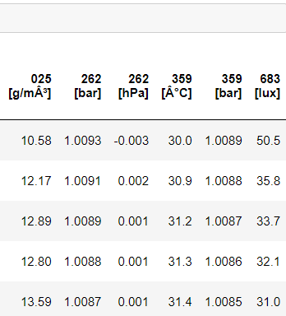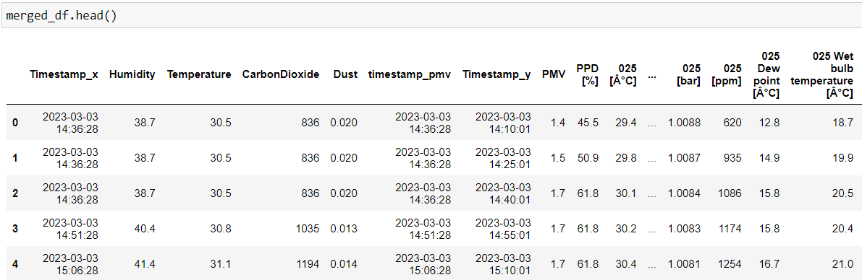

The above snapshot displays the merged result of two dataframes, 'iaq_data' and 'thermal_data', using a common column 'timestamp_pmv'.

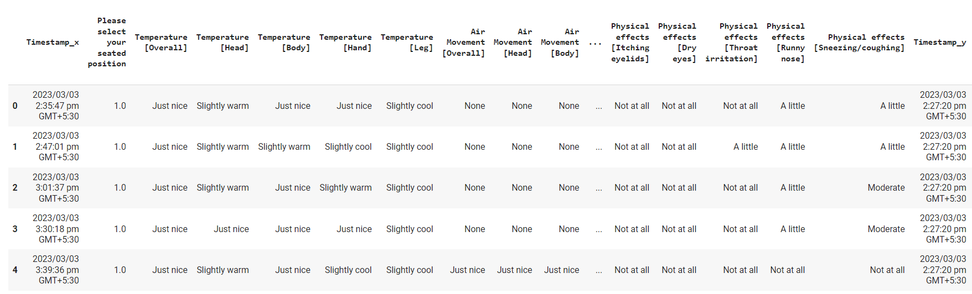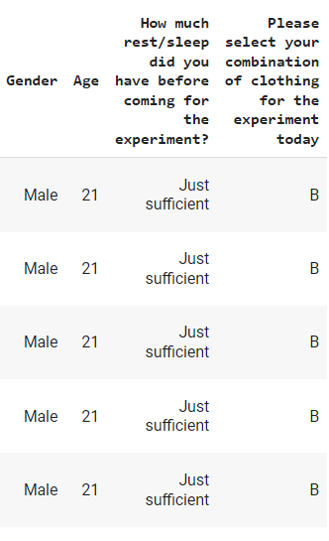

The above snapshot shows that Occupant feedback thermal Indoor air quality (IAQ), and personal information are merged to gain a better understanding of the data.

Exploratory Data Analysis (EDA)

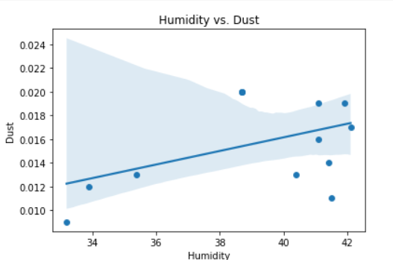

**Humidity vs. Dust:** This scatter plot shows the relationship between humidity and dust. The regression line indicates a weak positive correlation between the two variables, suggesting that higher levels of humidity may lead to slightly higher levels of dust.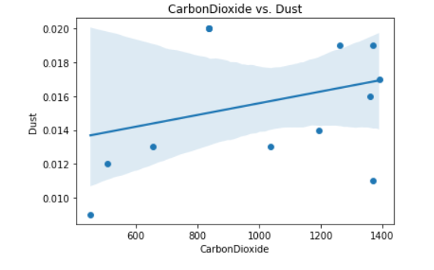

**CarbonDioxide vs. Dust:** This scatter plot shows the relationship between carbon dioxide and dust. The regression line indicates a moderate positive correlation between the two variables, suggesting that higher levels of carbon dioxide may lead to higher levels of dust.

**Temperature vs. Dust:** This scatter plot shows the relationship between temperature and dust. The regression line indicates a weak negative correlation between the two variables, suggesting that higher temperatures may lead to slightly lower levels of dust.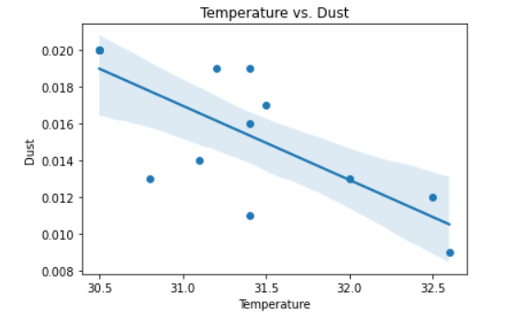

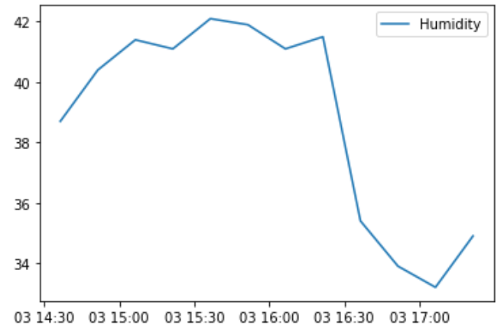

**Humidity:** The Humidity values vary between 33.2% to 42.1%. The trend seems to be somewhat constant between 33% to 41% but it increases at 41% to 42%. This could indicate that there was a change in the environment that caused an increase in humidity.

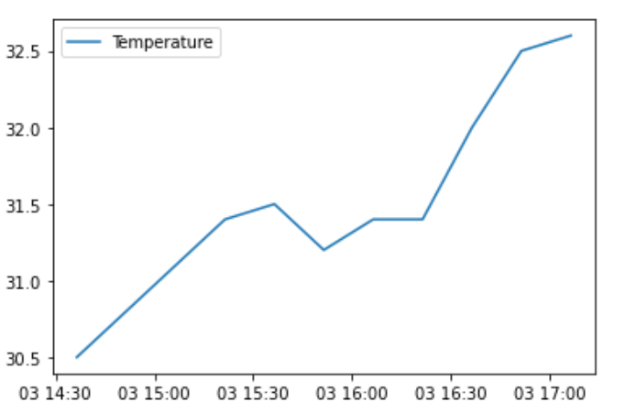

**Temperature:** The Temperature values vary between 30.5°C to 32.6°C. The trend seems to be somewhat constant between 30.5°C to 31.4°C, but it then increases to 32.6°C. This could indicate that there was a change in the environment that caused an increase in temperature.

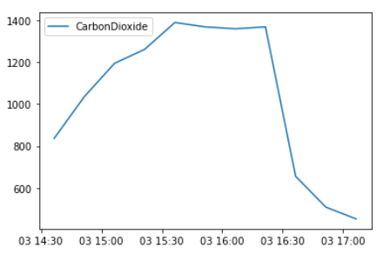

**CarbonDioxide:** The CarbonDioxide values vary between 452 ppm to 1389 ppm. There seems to be an increasing trend in the values over time. This could indicate that there was an increase in CarbonDioxide emissions over time.

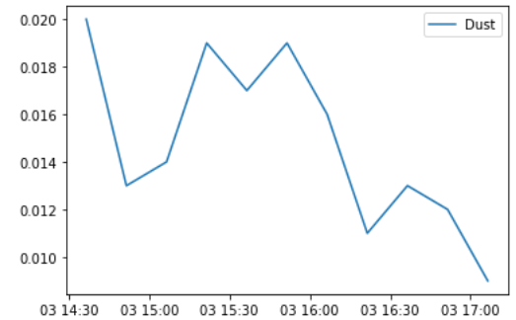

**Dust:** The Dust values vary between 0.01 mg/m³ to 0.02 mg/m³. The trend seems to be somewhat constant over time, with some slight fluctuations. This could indicate that the amount of dust in the environment remained relatively constant over time.

**Perception and satisfaction of zone Air Movement**

The x-axis of the bar graph represents the Timestamp_x column, and the y-axis represents the Air Movement [Overall] column.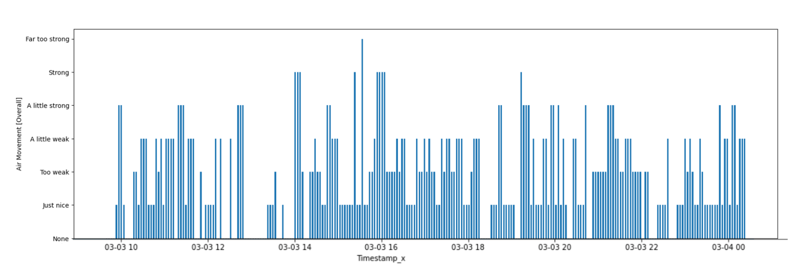

The graph shows that at the beginning of the observation period, the overall air movement was relatively low but gradually increased over time. However, in the second half of the observation period, the overall air movement started to decrease and eventually became relatively constant. This could be due to various factors such as changes in outdoor temperature, changes in HVAC settings, or changes in occupant behavior.

**Perception of and satisfaction with Temperature**

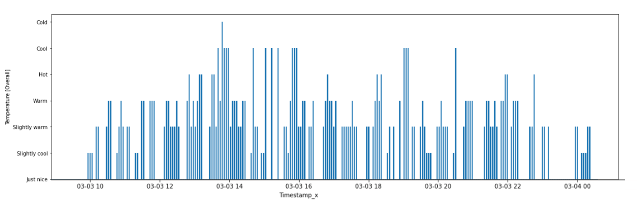

The x-axis of the bar graph represents the Timestamp_x column, and the y-axis represents the Temperature [Overall] column.

The code generates a bar graph that shows the overall response of occupants at specific time intervals. The graph indicates that the overall temperature perception generally increases with time but eventually starts decreasing, reaching a very low point at the end of the observation period.

**Perception of and satisfaction with Air Quality**

The x-axis of the bar graph represents the Timestamp_x column, and the y-axis represents the Air Quality [Overall] column.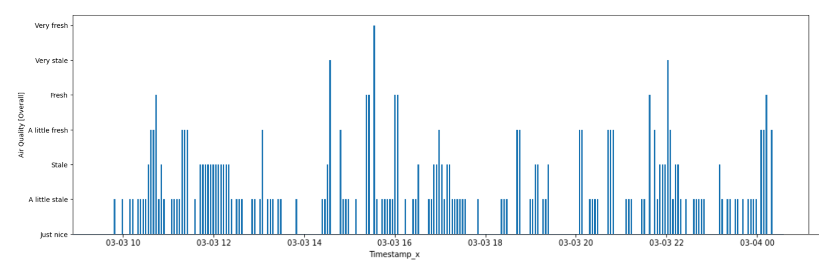

* The graph shows that the air quality starts increasing at the beginning.
* It remains constant for some time in the middle.
* After that, the air quality again starts increasing.
* It becomes constant again in the second half.
* Towards the end, the air quality increases again.

**Correlation Matrix**

This represents the correlation between the IAQ and Thermal comfort data. A correlation heatmap is a graphical representation of a correlation matrix representing the correlation between different variables. The value of correlation can take any value from -1 to 1. The heatmap visualizes this table as a color-coded grid, with warmer colors indicating positive correlations and cooler colors indicating negative correlations.

Based on the correlation coefficients, we can see that there is high collinearity between several of the data sets. Specifically, the following pairs of data sets have correlation coefficients greater than 0.9: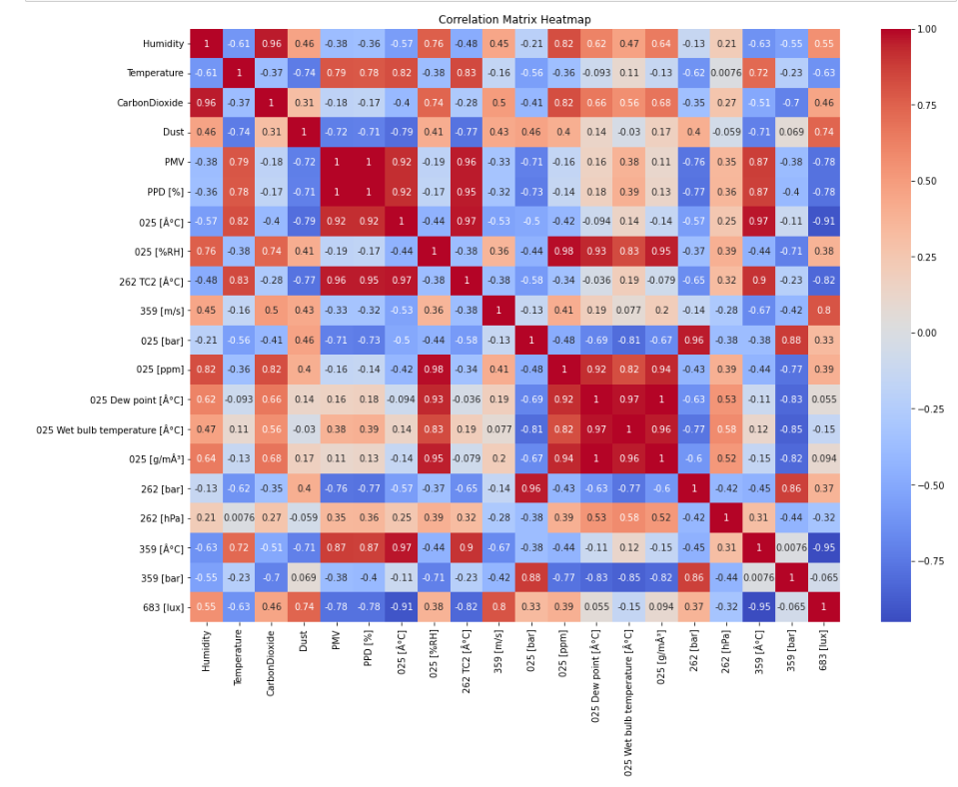

# Humidity and CarbonDioxide

# Humidity and PMV

# Temperature and CarbonDioxide

# Temperature and PMV

# CarbonDioxide and PMV

**Relationship between Occupant Feedback Data and Occupant Personal Information**

**Relationship between Thermal Comfort,Age, and Time**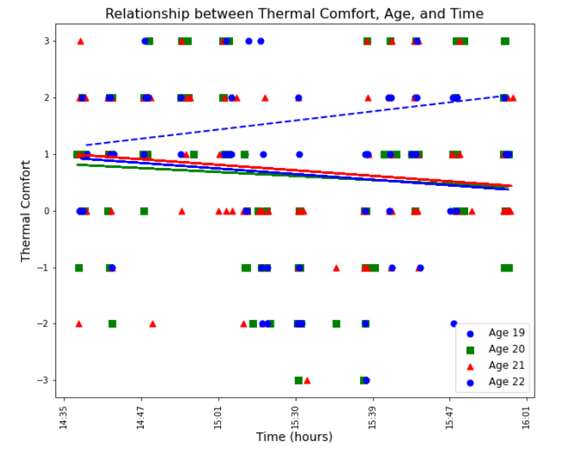

The general trend of thermal comfort with time shows a decreasing trend. However, the trend for people aged 19 is opposite, which could imply that they are more comfortable as time passes. It would be important to investigate why this is the case, as there may be factors such as activity level, clothing, or metabolism that are affecting their thermal comfort differently than other age groups. Further analysis may be required to better understand this trend.

**Relationship between Thermal Comfort, Sleep, and Time**

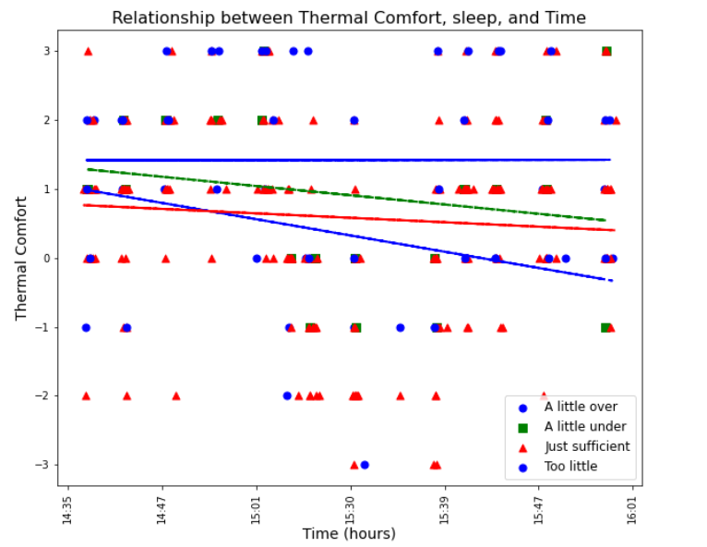

This graph shows the general trend of the amount of sleep,their thermal comfort with time spent inside the room.

**Relationship between Thermal Comfort, Clothing, and Time**

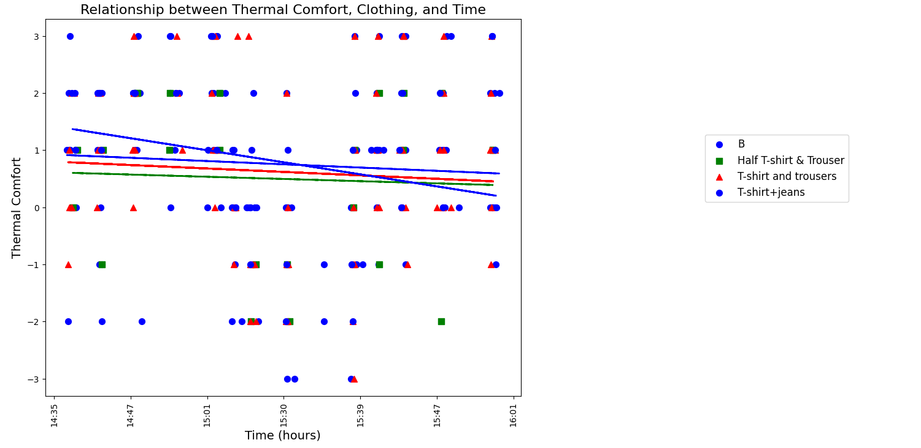

The above graph shows the relationship between time spent inside the room, types of clothing worn, and thermal comfort level.

**Relationship between Thermal Comfort, Sleepiness, and Time**

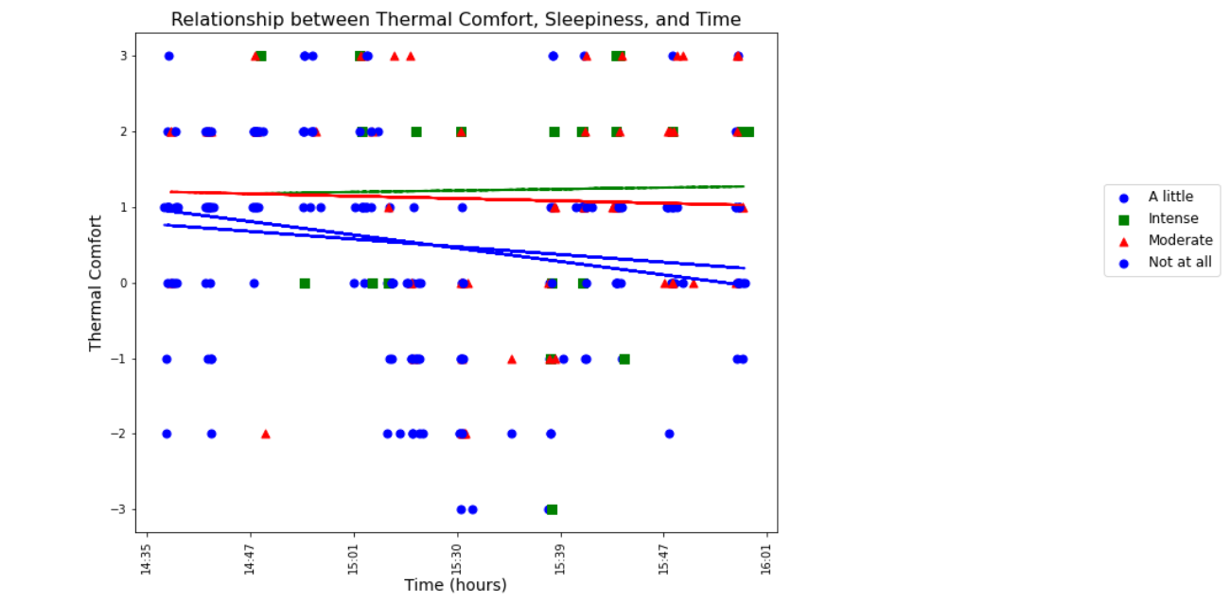

The above graph depicts the correlation between the amount of time spent inside a room, the quantity of sleep, and the level of thermal comfort. The following conclusions can be drawn from the presented data:

* Individuals with moderate sleep have a minimal effect on their thermal comfort level, as it remains relatively constant over time.
* Individuals with intense sleep, on the other hand, exhibit a significant positive impact on their thermal comfort level, as it tends to increase as time passes.
* Individuals with little or no sleep, however, have a pronounced negative impact on their thermal comfort level, as it declines steadily over time.

**Relationship between Thermal Comfort,Gender, and Time**

The above graph depicts the correlation between the amount of time spent inside a room, gender of occupant, and the level of thermal comfort. The following conclusions can be drawn from the presented data: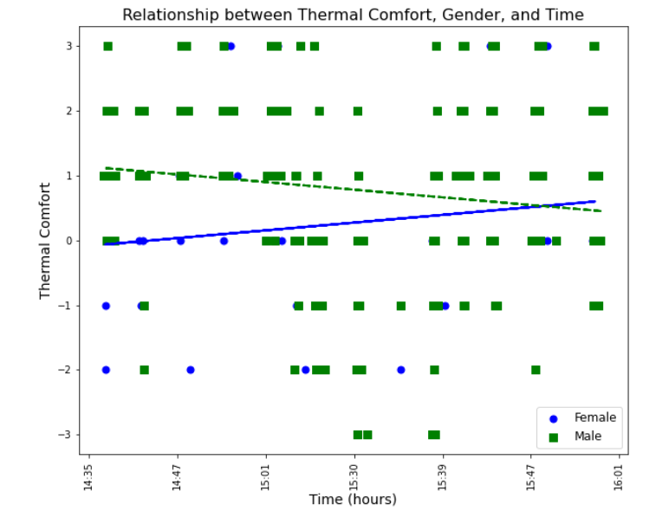

* Female thermal comfort generally increases with time .
* Male thermal comfort generally decreases with time

**Relationship between Experimental and Occupant Feedback Data**

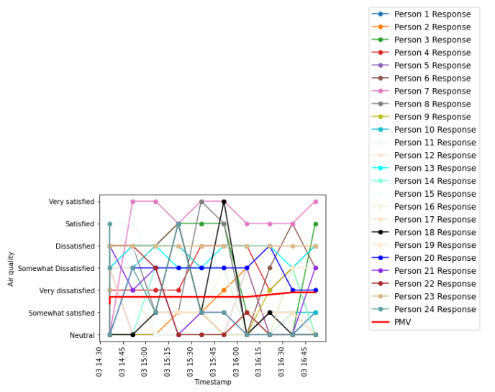

The graph shows the Air quality responses of multiple people over time, as well as the experimental predicted mean vote (PMV) data for the same time period.

The colors of the lines represent each person's Air quality responses. The code loops over each person's response, plots it as a blue line, and adds a marker to each point in the line. The experimental PMV data is plotted as a red line.

The x-axis label shows the timestamp, and the y-axis label shows the Air quality level. The legend shows the names of the lines plotted on the graph.

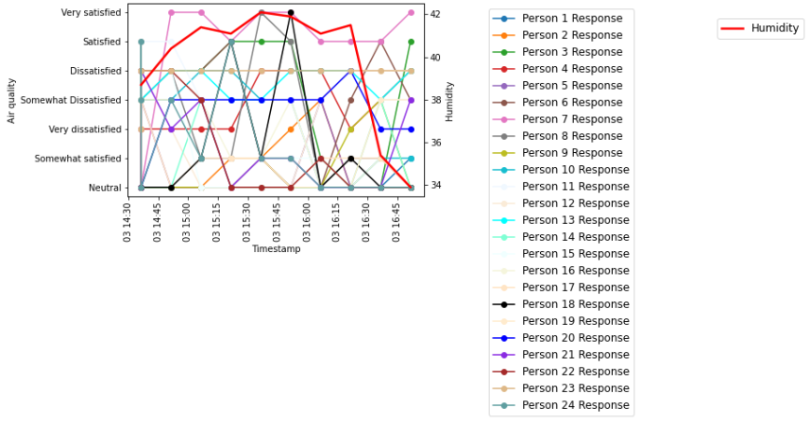

This plot has two y-axes, one for "Air quality" and the other for "Humidity". It loops over each person's response and plots it as a blue line on the "Air quality" axis. It also plots the experimental PMV data as a red line on the "Humidity" axis. The legends for each axis are set and the plot is displayed. The code also creates a list of colors to use for each person's response.

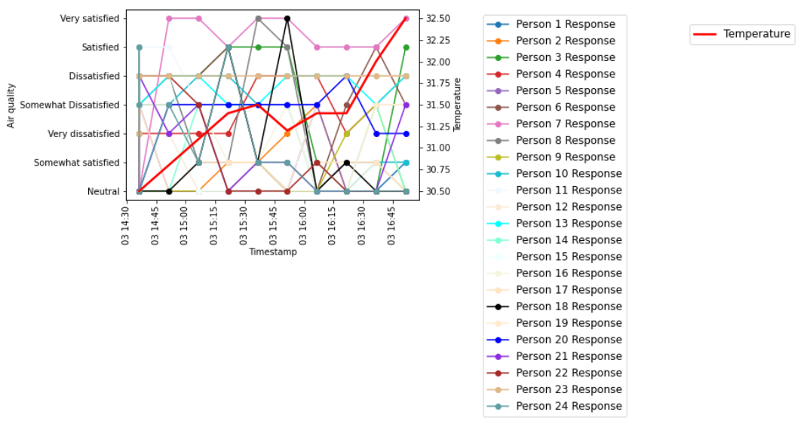

This code creates a plot with two y-axes. The first axis shows the air quality ratings of different people over time. The second axis shows the temperature data over time. The plot helps visualize how the two variables are related.

The first y-axis represents the air quality, and the second y-axis represents the temperature.

The plot is showing the responses of multiple persons to the question "How satisfied are you with the following: [Air quality]" over time.

The two y-axes display air quality and Dust levels. The first axis displays the responses of different people to air quality on a blue line, while the second axis displays the dust data as a red line. 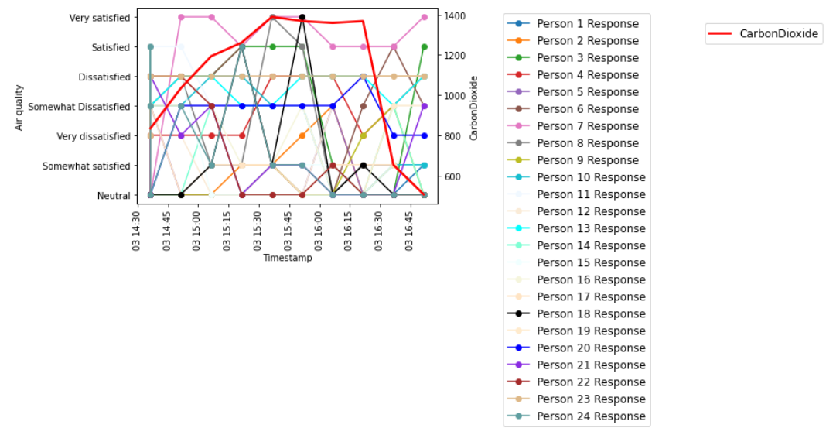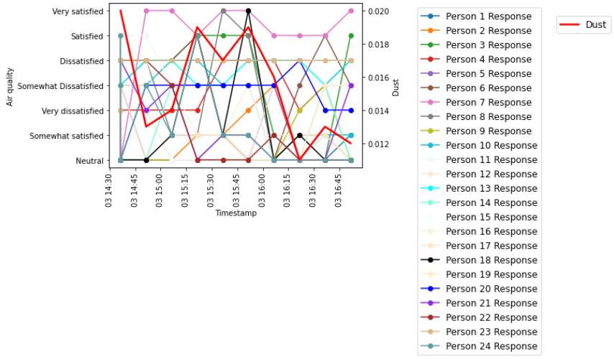

The two y-axes display air quality and carbon dioxide levels. The first axis displays the responses of different people to air quality on a blue line, while the second axis displays the carbon dioxide data as a red line.

**Acute Health Symptoms**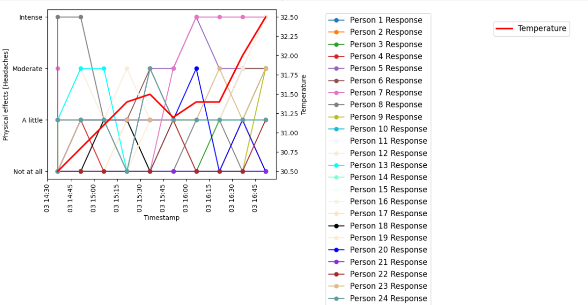

The graph displays two y-axes representing physical effects (headaches) and temperature. It illustrates how the physical health of different occupants, in terms of headaches, changes with increasing temperature over a specific time period.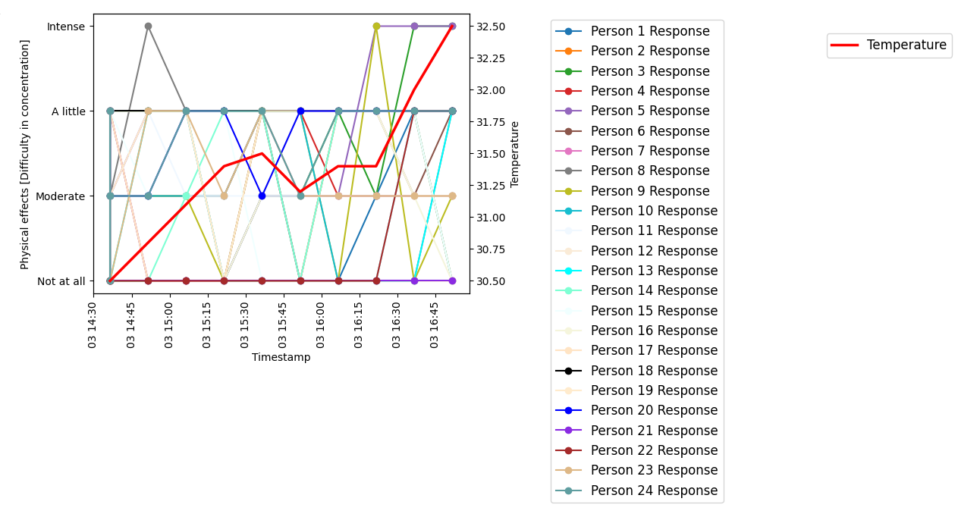

The graph displays two y-axes representing physical effects (Difficulty in concentration) and temperature. It illustrates how increasing temperature over a specific time period affects the concentration level of different occupants.

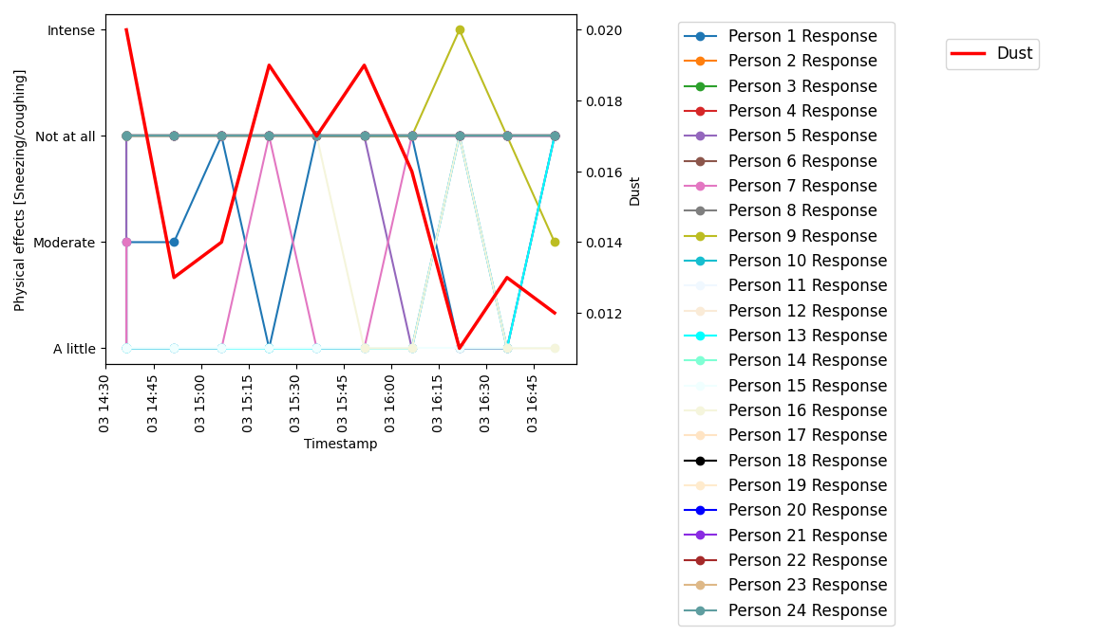

The graph displays two y-axes representing physical effects (sneezing\coughing) and Dust. It illustrates how dust level over a specific time period affects the sneezing\coughing of different occupants. 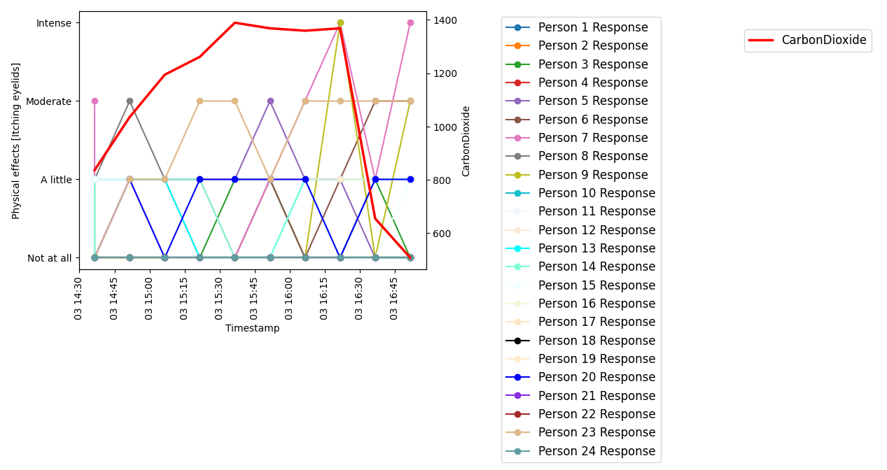

The graph displays two y-axes representing physical effects (Itching) and CarbonDioxide. It illustrates how CarbonDioxide level over a specific time period affects itchiness in the eyes of different occupants.

The graph displays two y-axes representing physical effects (Throat irritation) and CarbonDioxide. It illustrates how CarbonDioxide level over a specific time period affects throat irritation of different occupants. 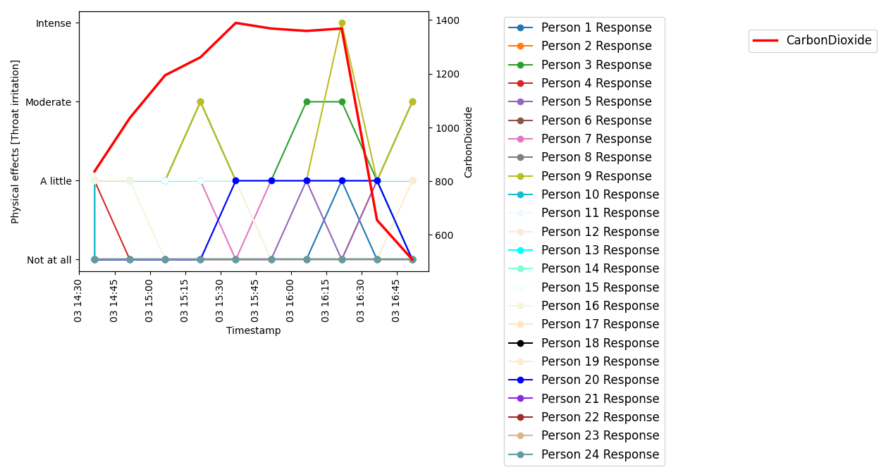

The above graph shows the occupants' satisfaction level and the levels of PMV, humidity, temperature, and dust over the time period. Also how Physical health is influenced by different factors over the time.

**Possible limitations of this study could include:**

**Sample size:** The study may have a limited sample size, which may not be representative of the general population. A larger sample size may be needed to draw more accurate conclusions.

**Lack of diversity:** The study may be limited to a specific population group, such as a certain age range, gender, or location. This may limit the generalizability of the findings to other populations.

**Data collection:** The study may rely on self-reported data from participants, which may be subject to bias or inaccuracies. Future studies could consider using more objective measures of IAQ and thermal comfort.

**Variables:** The study may not account for all possible variables that could impact IAQ and thermal comfort, such as outdoor temperature, humidity, and ventilation. Future studies could consider including more variables to improve the accuracy of the model.

**Possible future scope of improvement could include:**

**Longitudinal studies:** Future studies could be conducted over a longer period of time to gather more data and track changes in IAQ and thermal comfort over time.

**More comprehensive data collection:** Future studies could include more comprehensive data collection methods, such as sensors placed throughout the indoor environment to gather more objective data.

**Inclusion of additional variables:** Future studies could consider including more variables, such as outdoor temperature and humidity, to provide a more comprehensive understanding of IAQ and thermal comfort.

**Improved modeling techniques:** Future studies could explore different modeling techniques to improve the accuracy of the IAQ and thermal comfort satisfaction model.

**To improve this experiment, researchers could consider:**

* Using a larger and more diverse sample size to increase the generalizability of the findings.
* Collecting more objective data using sensors placed throughout the indoor environment.
* Including more variables, such as outdoor temperature and humidity, to improve the accuracy of the model.
* Using more advanced modeling techniques, such as machine learning algorithms, to develop a more accurate model of IAQ and thermal comfort satisfaction.

**Conclusion**

In conclusion, the study demonstrates the significance of indoor environmental quality (IEQ) in ensuring the well-being and productivity of occupants in indoor spaces. Specifically, the research aims to understand the occupants' perception and satisfaction with IEQ, focusing on thermal comfort in elevated zones with varying ventilation and air movement conditions. The findings provide valuable insights for architects and designers in creating indoor environments that prioritize occupants' comfort and well-being in different settings.

The data analysis reveals a weak positive correlation between humidity and dust, a moderate positive correlation between carbon dioxide and dust, and a weak negative correlation between temperature and dust. The values of humidity, temperature, carbon dioxide, and dust fluctuate over time, indicating that changes in the environment or occupant behavior can affect IEQ.

Furthermore, the correlation coefficients indicate a high degree of collinearity between several data sets, emphasizing the interdependence of these factors and the need for consideration of all factors while designing indoor environments. The trend of thermal comfort with time shows an overall decreasing trend, with some variations in specific age groups, highlighting the need for further investigation into the factors affecting occupants' comfort and well-being. Moreover, the analysis of the correlation between the amount of time spent inside a room, the quantity of sleep, and the level of thermal comfort reveals a positive correlation between the quantity of sleep and thermal comfort, highlighting the importance of adequate sleep in promoting occupants' well-being.

In summary, the findings of this study offer crucial insights for designing indoor environments that prioritize occupants' comfort and well-being. Further research could expand on these findings by collecting data from various types of indoor spaces and investigating the impact of different design factors on IEQ.