***BIRLA INSTITUTE OF TECHNOLOGY***

***PUNE***



**FOOTBALL LEAGUE SYSTEM**

**Acknowledgment**

*We would like to express our special thanks of gratitude to our professor who gave us the golden opportunity to do this wonderful project on the topic (Football League System), which also helped us in doing a lot of Research and we came to know about so many new things, we are really thankful to them.*

CONTENTS

1. INTRODUCTION

1.1 AIM AND OBJECTIVE

2. PROJECT OVERVIEW

2.1 MODULES IN PROJECT

2.2 MODULE DESCRIPTION

2.3 EXCEPTION HANDLING

2.4 DATA REQUIREMENTS

3. REQUIREMENT SPECIFICATION

3.1 HARDWARE SPECIFICATION

3.2 SOFTWARE SPECIFICATION

3.3 TECHNOLOGY SPECIFICATION

4. CONCLUSION

5. REFERENCES

INTRODUCTION

*In the Project we are implementing a way to store the football teams score which is a better approach than the conventional way of writing scores manually on a paper and refer them in future, what we’ve implemented will help the scoring panel to save scores of the team and it will also reduce the chances of manipulation of data due to human intervention and it also reduces the chances of miscalculation to zero and all the historic data will also be there to refer by the panel.*

AIM AND OBJECTIVE

*The aim is to make a reliable mechanism to store the team scores as well as to save those important data in a much secure system than the conventional scorecards whose data can be easily manipulated and also to make an authentic way to Calculate the scores for the teams.*

Project Overview

MODULES IN PROJECT

1. Start
2. AddNewRecord
3. ShowFileData
4. AddDataInFile

MODULE DESCRIPTION

Start :

The Start module is basically written to show the end

User the choices of the action that he/she can perform in the system.

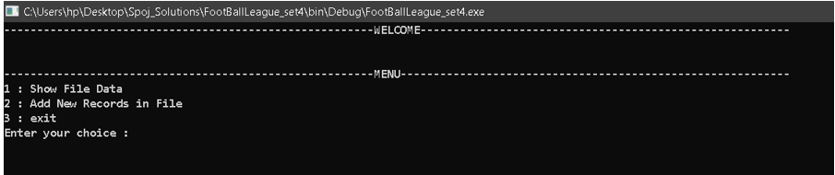

AddNewRecord:

The Start module is basically written to make the end user add the details of the team the data required fields are…

1. Name: Name of team.
2. Games Played: Games Played by the team.
3. Games Won: Games Won by team.
4. Games Lost: Games Lost by team.
5. Games Drawn: Games Drawn by team.

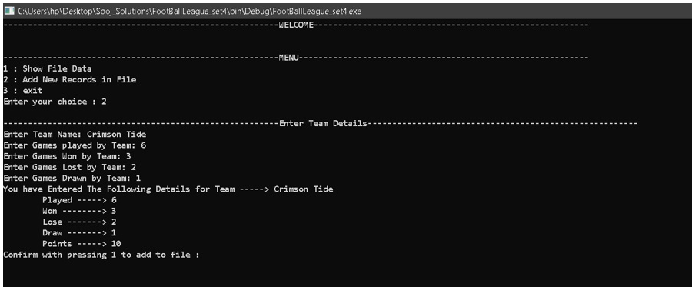

ShowFileData:

The Start module is basically written to see the data from the file which is previously there as well as the new data.

This module will also check if the file doesn’t exist in the system, it should “File not Found Error” message on the screen.

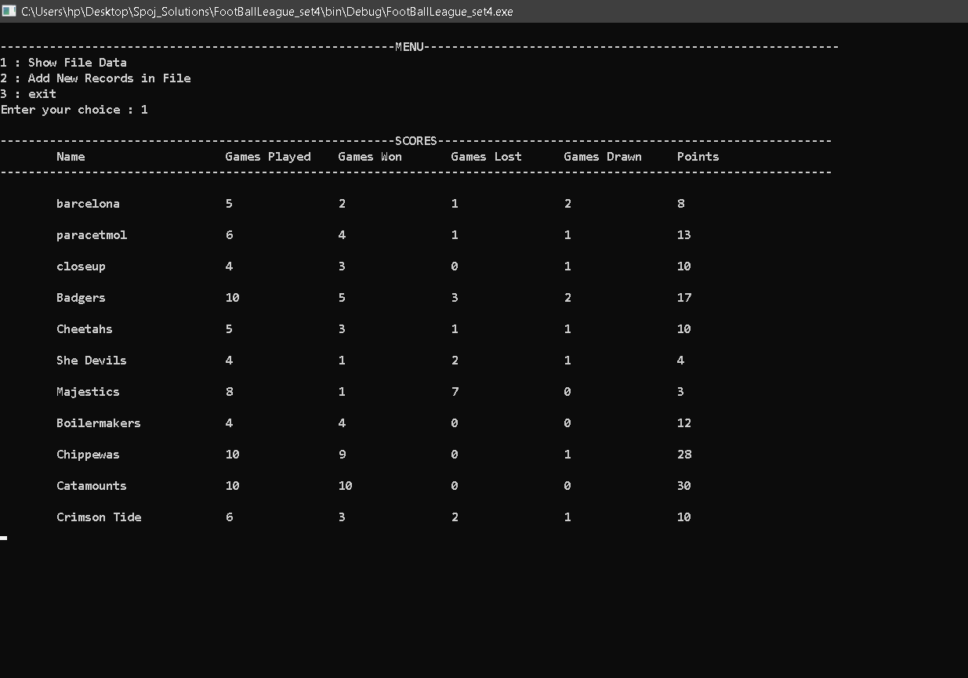

AddDataInFile:

This module is written to add the data in the text file and this data from the console then will be written in the text file which can be referred in future.

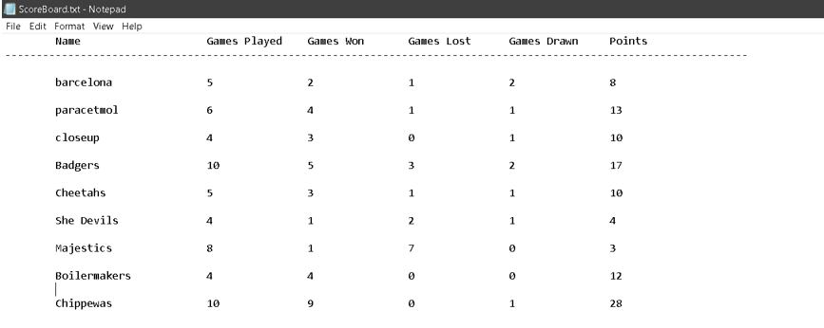

Exit:

Exit the code console.

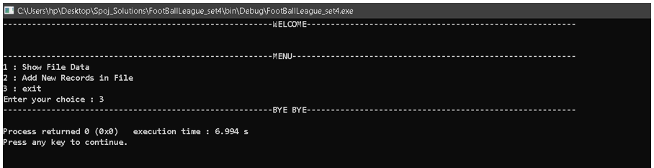

Exception Handling

We have also covered a lot of negative scenarios that can occur while working in the software and we’ve tried to handle those cases that can cause the software to produce misleading results or block with the help of explicitly handling the exceptions.

Few scenarios….

1. Invalid operations

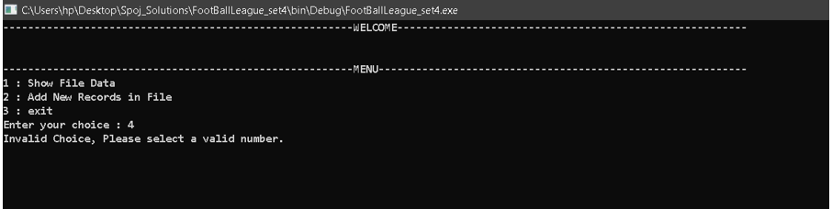

2-Invalid Data

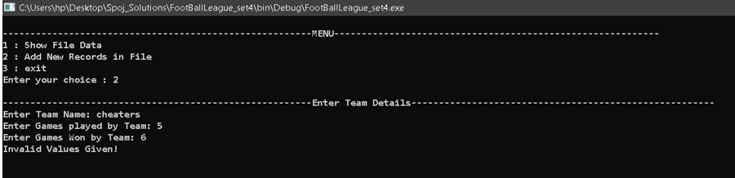

3-Manipulated Data

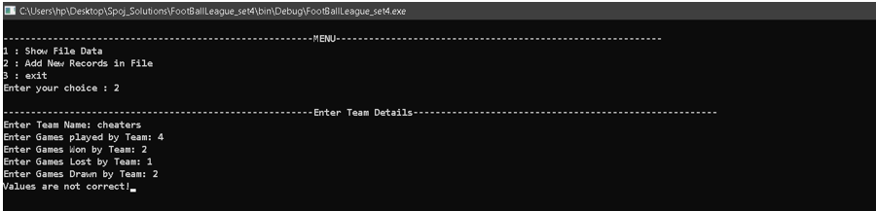

DATA REQUIREMENTS

|  |  |  |
| --- | --- | --- |
| **Name of Input** | **Type of Input** | **Value’s Source** |
| Name | char | User Input |
| GamesPlayed | int | User Input |
| GamesWon | int | User Input |
| GamesLost | int | User Input |
| GamesDrawn | int | User Input |
| Points | int | System calculates using formula |

typedef struct team

{

char Name[20];

int GamesPlayed;

int GamesWon; // structure of a single Team.

int GamesLost;

int GamesDrawn;

int Points;

}FootballTeam;

**HARDWARE REQUIREMENTS**

The System requires minimum hardware support.

The minimum preferred hardware requirements are as follows:

1. 512 Mb RAM Support
2. 1 GB Hard Disk space
3. Any low-level processor is capable of executing it

**SOFTWARE REQUIREMENTS**:

Any C-Compiler will be fine to execute it.

TEAM DETAILS

|  |  |
| --- | --- |
| Team Member | BITS ID |
| Hritik Singh | 2020wa15191 |
| Gopal Kumar | 2020wa15078 |
| Gayatri Patil | 2020wa15284 |
| Harshita Sohane | 2020wb15366 |
| Ishika Gour | 2020wa15474 |