CODE

Since Machine Learning Model size exceeds 10MB here is Google Drive Sharable link to Code

https://drive.google.com/open?id=1D04EntjDjF6tcMwbeg2m7xPsswEvuHaG

1. Extract Malicious-Urlv5 zip file.
2. Inside Malicious-Urlv5 there is a file requirements.txt
3. Open command prompt in Malicious-Urlv5 folder

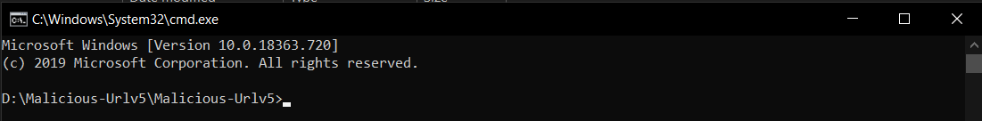

1. Type following command in cmd.

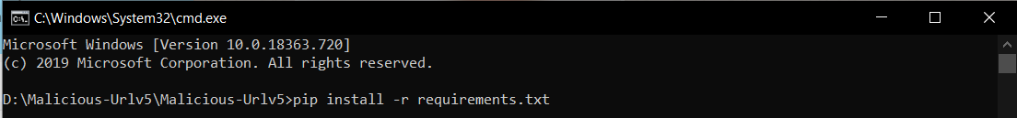

1. Dependencies will start installing.

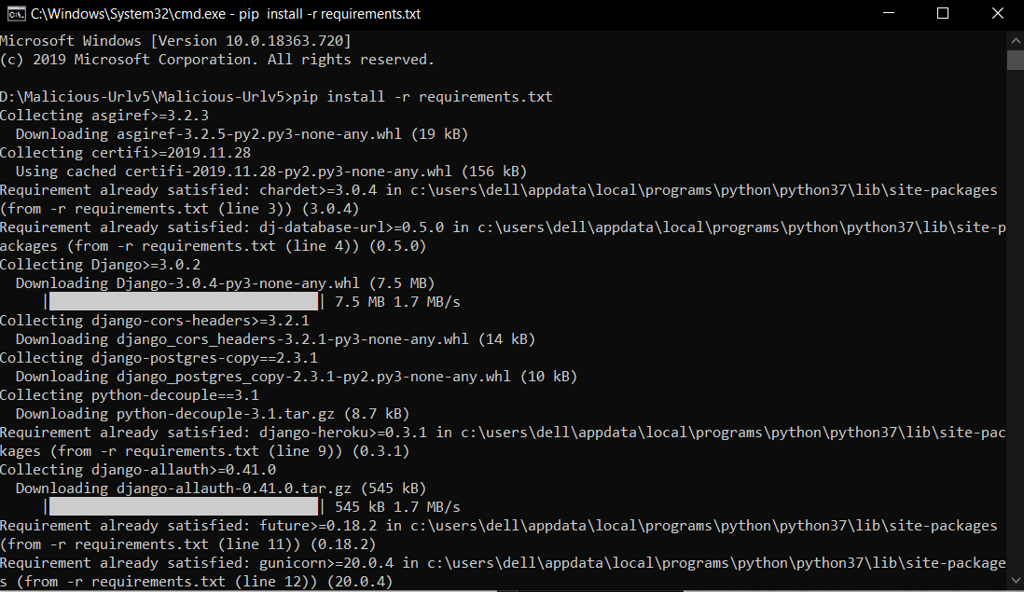

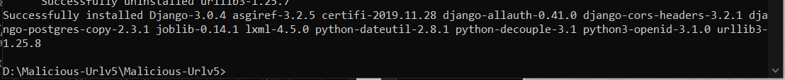

1. To run the code, write following command in terminal.

python manage.py runserver

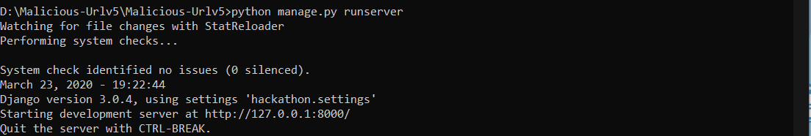

1. Type http://127.0.0.1:8000/ in URL bar of browser and press Enter. Machine Learning powered Web Application will start.

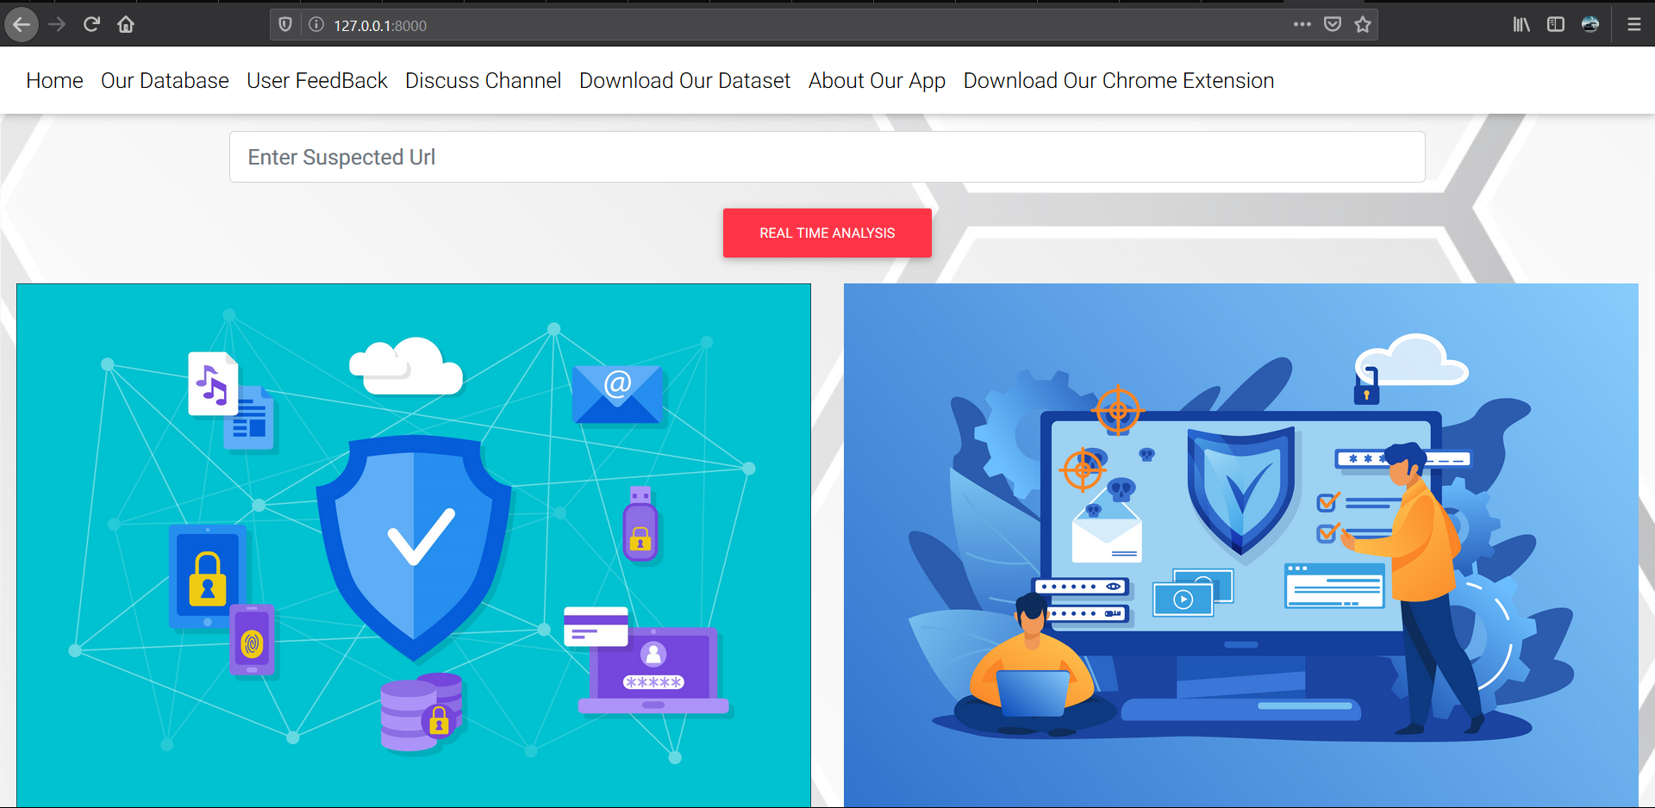

1. Type a valid URL for example to fetch analysis:

<https://www.mi.com>

This is an example of Legitimate URL.

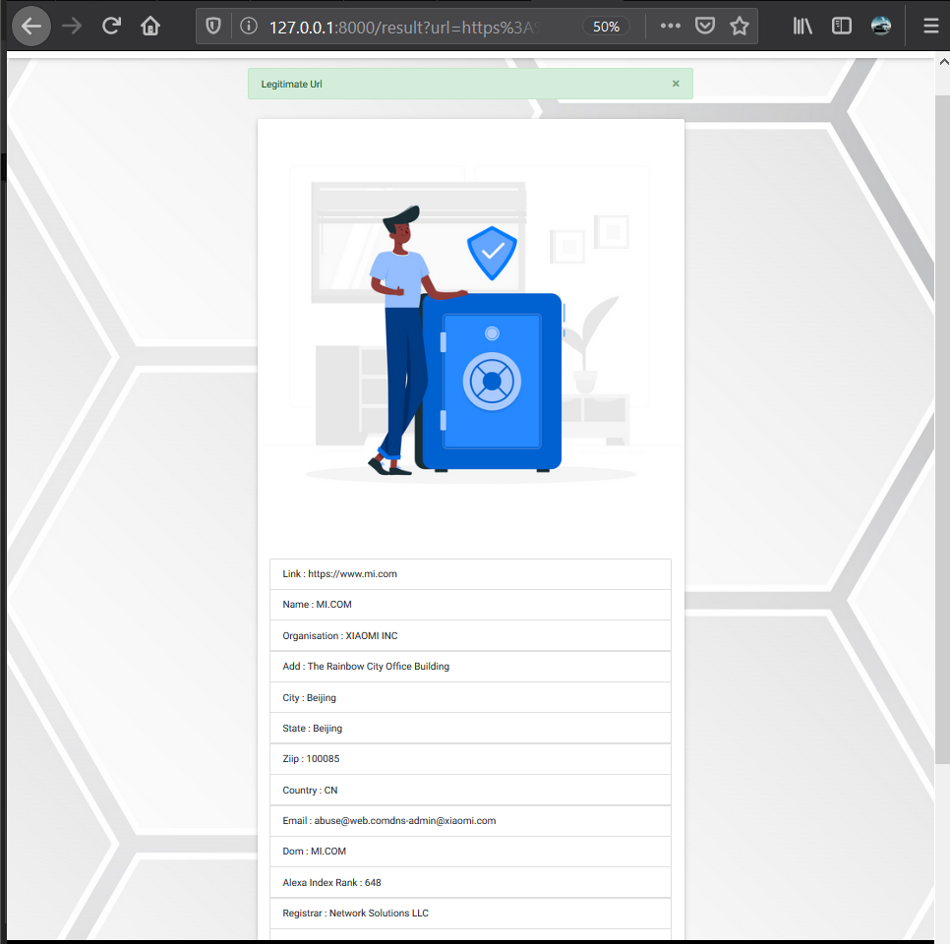

1. Another example of Legitimate URL

<https://technoutsav.techgig.com/>

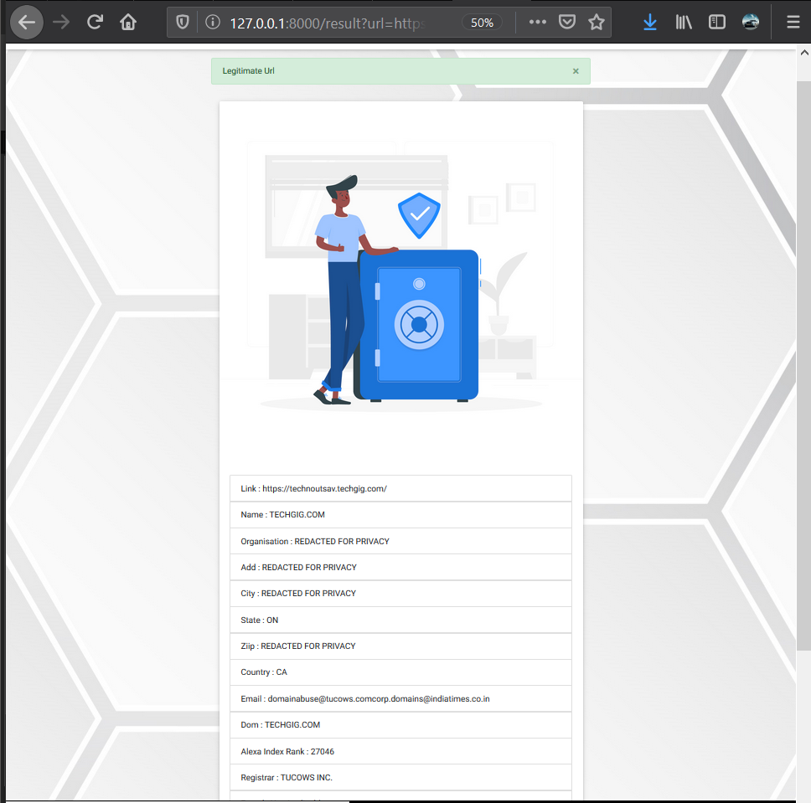

1. Another Legitimate URL

<https://www2.deloitte.com/in/en.html>

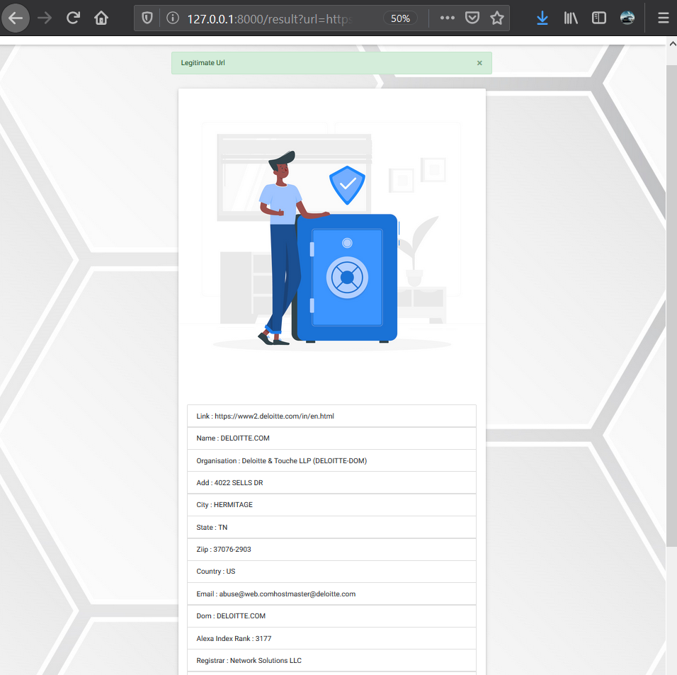

1. Example of Malicious Website

<http://www.dhilloncraneservice.com/.well-known/bankofamerica.com/>

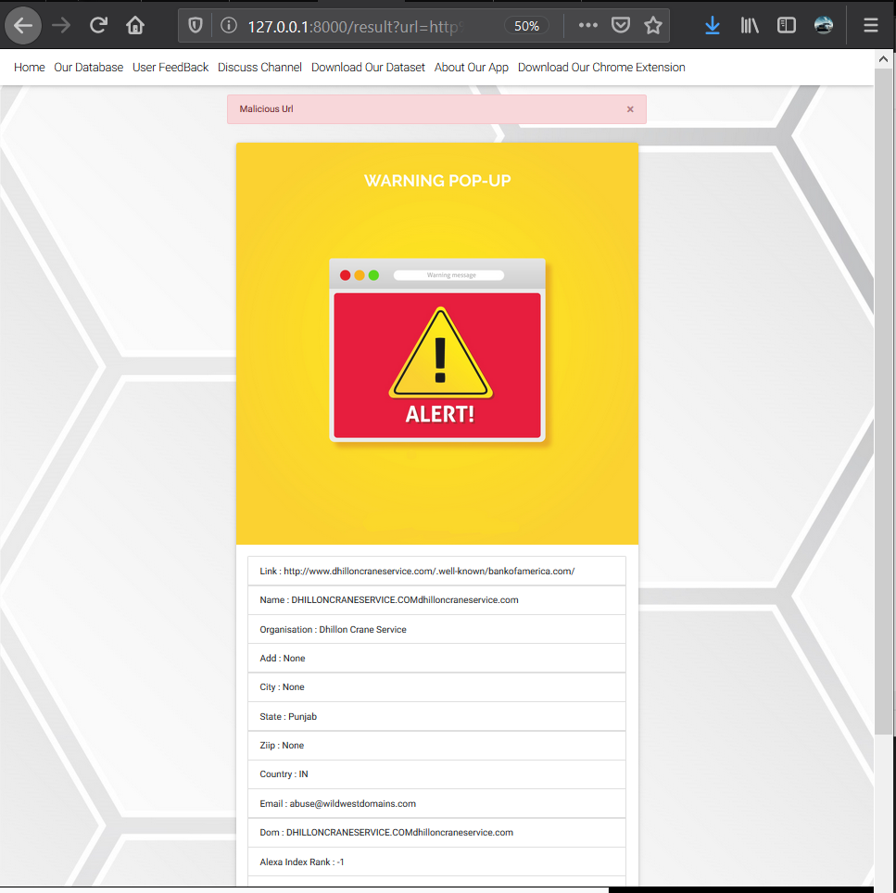

1. Another Malicious URL

<https://home-paypal-jp.moonkahonda.com/panel_JP/-/jp/xppl/>

