WEEK 1 INTERNSHIP ASSESSMENT
System Requirements Analysis and Block Diagram Design
Project Title
Smart Home Environmental Monitoring System

Student Name: Hritik Kumar Sharma
Course/Program: B.Tech-CSE(AI/ML)
University/Institution: IILM UNIVERSITY, GREATER NOIDA
Internship: SYSTEM ENGINEER INTERN
Department: SCSE
Internship Week: Week 1
Submission Date: 21-08-2026

Table of Contents
1. Introduction3
2. Project Overview3
3. Problem Statement4
4. System Objectives4
5. System Scope4
6. Parameters to be Monitored5
7. Functional Requirements5
8. Non-Functional Requirements6
9. Hardware Requirements6
10. Software Requirements7
11. Performance Requirements7
12. Communication Interfaces8
13. Power Requirements and Power Management8
14. Real-Time Constraints9
15. System Architecture9
16. System Block Diagram9
17. Component Description10
18. Data Flow / System Working11
19. Design Justification12
20. System Advantages13
21. System Limitations13
22. Future Enhancements13
23. Expected System Outcome14
24. Conclusion14
25. References14
Appendix A — Requirements Summary15
Appendix B — Proposed Component Summary15

1. Introduction
An embedded system is a combination of hardware and software designed to perform a specific, dedicated function within a larger mechanical or electronic system, as opposed to a general-purpose computer. Embedded systems are built around microcontrollers or microprocessors and typically interact with sensors and actuators to sense, process, and respond to real-world conditions.
Embedded systems are found in a wide range of everyday applications, including household appliances, automotive control units, medical devices, industrial automation equipment, and consumer electronics. Their defining characteristics are that they are purpose-built, resource-constrained, and closely tied to the physical environment they operate in.
Environmental monitoring is a particularly useful application of embedded systems in a smart home context. Being able to observe indoor conditions such as temperature, humidity, air quality, and light levels allows occupants to make informed decisions about ventilation, comfort, and general indoor well-being, without needing separate, disconnected instruments for each parameter.
The purpose of the proposed Smart Home Environmental Monitoring System is to bring together a small set of environmental sensors, a microcontroller, a local display, and a wireless communication link into a single, modular embedded design that can be understood, documented, and later implemented in stages.
This Week 1 assessment focuses specifically on requirements analysis and system architecture. It does not involve procurement, assembly, or testing of physical hardware. The objective is to define what the system should do, how its components should interact, and how the overall architecture should be structured, so that this analysis can serve as a foundation for implementation in later stages of the internship.

2. Project Overview
The proposed Smart Home Environmental Monitoring System is designed to continuously observe four basic indoor environmental parameters:
- Temperature
- Humidity
- Indoor air quality
- Light intensity
In the proposed design, dedicated sensors collect raw environmental information, which is then read and processed by an ESP32 microcontroller. The ESP32 formats the processed readings for display on a small OLED screen for immediate, local viewing, and can additionally use its built-in Wi-Fi capability to make the same data available for remote monitoring.
The overall high-level system flow proposed for this design is summarised below:
Sensors → ESP32 Microcontroller → Data Processing → OLED Display / Wi-Fi → User
This flow forms the conceptual basis for the detailed system architecture and block diagram presented later in this report.

3. Problem Statement
Occupants of a home do not typically have a simple, centralized way to keep track of basic indoor environmental conditions. Temperature and humidity are usually judged subjectively, air quality changes often go unnoticed until they become uncomfortable, and light levels are rarely monitored at all. Where standalone instruments exist for these parameters, they are usually separate devices with no shared display or communication capability.
A compact embedded monitoring system that brings temperature, humidity, air-quality, and light-intensity sensing into a single unit, with both a local display and optional wireless access, could provide a more centralized and convenient way to keep track of these conditions.
It should be clearly noted that this system is intended for general indoor environmental awareness and convenience. It is not proposed as a medical device, a safety-critical system, or a certified air-quality analyser, and no such claims are made about its capability.

4. System Objectives
The following objectives define what the proposed system is intended to achieve:
- Monitor room temperature.
- Monitor humidity.
- Monitor indoor air quality (general sensing, not laboratory-grade analysis).
- Measure light intensity.
- Process sensor data using a microcontroller.
- Display current readings locally.
- Support wireless transmission of data.
- Enable remote environmental monitoring.
- Provide continuous monitoring during normal operation.
- Design a modular and expandable system architecture.

5. System Scope

5.1 Included in This Week 1 Assessment
- Environmental sensing (temperature, humidity, air quality, light).
- Data collection from sensors.
- Microcontroller-based processing.
- Local display of readings.
- Wi-Fi communication for remote access.
- Basic system architecture and block diagram.
- Requirements analysis (functional and non-functional).
- Power and communication considerations.
- Real-time monitoring considerations.

5.2 Not Included in This Week 1 Assessment
- Physical hardware construction.
- PCB fabrication.
- Actual sensor calibration.
- Real-world performance testing.
- Cloud deployment.
- Production deployment.
- Actual mobile application development.
These excluded items may be considered as future extensions once the requirements and architecture defined in this document are carried forward into later implementation stages of the internship.

6. Parameters to be Monitored
Table 1 lists the four environmental parameters addressed by the proposed design, along with the sensor proposed for each and its purpose.
Parameter | Proposed Sensor | Purpose
Temperature | DHT22 | Measure room temperature
Humidity | DHT22 | Measure relative humidity
Air Quality | MQ-135 | Monitor general indoor air-quality changes
Light Intensity | LDR | Measure surrounding light level
Table 1: Proposed Environmental Parameters and Sensors
Temperature and humidity are measured together by a single DHT22 sensor, which simplifies wiring and reduces component count. Air quality is sensed using an MQ-135 gas sensor, which responds to a range of common airborne compounds; it is described here as a general air-quality sensing component rather than a source of laboratory-grade or fully calibrated air-quality analysis. Light intensity is measured using a simple light-dependent resistor (LDR), which is adequate for indicating relative brightness rather than precise photometric measurement.

7. Functional Requirements

7.1 Functional Requirements
The system shall:
- Measure temperature.
- Measure humidity.
- Monitor indoor air-quality-related sensor readings.
- Measure light intensity.
- Collect sensor data through the microcontroller.
- Process sensor readings.
- Display current readings on an OLED display.
- Establish Wi-Fi connectivity where available.
- Transmit sensor data wirelessly.
- Continuously update environmental information.
- Handle normal sensor-reading cycles without interrupting the monitoring process.

8. Non-Functional Requirements

8.1 Reliability
The system should operate consistently during normal operation and handle repeated sensor-reading cycles reliably, without unexpected interruptions to the monitoring loop.

8.2 Usability
Sensor readings should be presented on the OLED display in a simple, clearly labelled, and easily understandable format so that a user can interpret current conditions at a glance.

8.3 Maintainability
The modular design, with each sensor connected through a distinct interface, should make it straightforward to replace a faulty sensor or add a new one without redesigning the entire system.

8.4 Scalability
The architecture should allow additional environmental sensors to be incorporated in future versions, provided the microcontroller has sufficient available GPIO, analog, or bus capacity.

8.5 Security
Basic considerations for Wi-Fi communication include using a protected (password-secured) wireless network, avoiding transmission of sensitive information over unsecured channels, and being mindful that any network-connected device increases the exposure of a home network. This document does not claim implementation of advanced cybersecurity measures such as encryption protocols or intrusion detection, as these are beyond the scope of a Week 1 requirements analysis.

8.6 Power Efficiency
Because the system is intended for continuous monitoring, power consumption should be considered during component selection and future implementation, particularly if battery-powered operation is pursued as a future enhancement.

9. Hardware Requirements
Table 2 summarises the hardware components proposed for the system. These are proposed selections for the design; no components have been purchased, assembled, or tested as part of this Week 1 assessment.
Component | Proposed Choice | Purpose
Microcontroller | ESP32 | Central processing and Wi-Fi connectivity
Temperature/Humidity Sensor | DHT22 | Temperature and humidity measurement
Air Quality Sensor | MQ-135 | General indoor air-quality sensing
Light Sensor | LDR | Light-intensity measurement
Display | OLED | Local display of sensor readings
Power Supply | Suitable USB/DC supply | Provides system power
Table 2: Proposed Hardware Components

10. Software Requirements
The following software components are proposed for future implementation of the system:
- ESP32 firmware — the low-level program running on the microcontroller that coordinates sensor reading, processing, display updates, and Wi-Fi communication.
- Arduino IDE (or an equivalent development environment) — used to write, compile, and upload firmware to the ESP32.
- Embedded C/C++ — the programming language used to implement the firmware logic.
- Sensor libraries — vendor or community libraries that simplify reading data from the DHT22, MQ-135, and LDR.
- OLED display library — used to render text and simple layouts on the OLED screen over the I²C interface.
- Wi-Fi communication libraries — used to manage network connections and transmit sensor data to a remote interface.
These are proposed software requirements intended for a future implementation phase; no firmware has been written or deployed as part of this Week 1 assessment.

11. Performance Requirements
The proposed system is expected to exhibit the following performance characteristics once implemented:
- Periodic sensor updates at a regular, defined interval.
- Timely processing of each sensor reading before the next cycle begins.
- Minimal unnecessary delay between data collection and display.
- A responsive local display that reflects current readings without a noticeable lag.
- Reliable wireless transmission when a Wi-Fi network is available.
- Continuous monitoring during normal operation, without requiring manual restarts.
Where numerical figures are useful for future design work, they are shown below purely as proposed design targets and are not measured results, since no hardware testing has taken place:
Parameter | Proposed Design Target | Status
Sensor read/update interval | Approx. 2–5 seconds | Proposed target
Display refresh | Same as sensor update interval | Proposed target
Wi-Fi transmission interval | Every one or more update cycles | Proposed target
Table 3: Proposed Performance Design Targets (Not Measured Values)

12. Communication Interfaces
Table 4 lists the proposed communication interface between each component and the ESP32 microcontroller.
Connection | Interface | Purpose
DHT22 → ESP32 | Digital GPIO | Temperature and humidity data
MQ-135 → ESP32 | Analog input | Air-quality sensor reading
LDR → ESP32 | Analog input | Light-intensity reading
OLED → ESP32 | I²C | Display communication
ESP32 → Network | Wi-Fi | Wireless data transmission
Table 4: Proposed Communication Interfaces
The DHT22 uses a single-wire digital protocol to send temperature and humidity readings to a GPIO pin. The MQ-135 and LDR are simple analog sensors whose varying output voltage is read through the ESP32's analog-to-digital converter (ADC) input pins. The OLED display communicates over the I²C bus, which requires only two signal lines (SDA and SCL) in addition to power and ground. Finally, the ESP32's built-in Wi-Fi radio is used to connect to a local wireless network for data transmission to a remote interface.

13. Power Requirements and Power Management
The proposed system is intended to be powered from a standard USB or regulated DC power source, consistent with typical ESP32 development boards.
- The ESP32 and its connected sensors require a stable, regulated low-voltage supply (typically 3.3 V logic level, with 5 V often supplied via USB and regulated on-board).
- Voltage regulation is required so that sensitive components such as the OLED display and analog sensors receive a stable supply free of excessive noise.
- Stable, uninterrupted power delivery is important because the system is designed for continuous monitoring.
- Power-efficient operation should be considered in firmware design, for example by avoiding unnecessary processing between sensor-reading cycles.
- Battery-powered operation is a possible future improvement, but is not part of the current proposed design.
No exact power consumption figures are stated in this report, since these would depend on the specific ESP32 board and sensor modules eventually selected, and no such measurements have been taken.

14. Real-Time Constraints
- Environmental readings need to be collected periodically, at a regular and predictable interval.
- Sensor data should be processed without unnecessary delay so that displayed values remain current.
- The OLED display should be updated regularly to reflect the latest processed readings.
- Wireless data should be transmitted in a timely manner whenever a network connection is available.
- The system should continue its monitoring cycle during normal operation without requiring manual intervention.
- Temporary sensor or communication delays should not unnecessarily stop the complete monitoring process; the system should continue its next cycle as expected.
It is important to clarify that this is a general-purpose environmental monitoring application. It is not presented as a safety-critical or hard real-time system, and no guarantees of strict timing determinism are claimed.

15. System Architecture
The overall architecture of the proposed system follows a straightforward sense–process–output structure, as illustrated conceptually below:
Environmental Sensors
↓
ESP32 Microcontroller
↓
Data Processing
↓
Local OLED Display / Wi-Fi Communication
↓
Remote Mobile / Web Interface
In parallel with this data flow, a Power Supply block provides power to all components in the system, including the sensors, the ESP32, and the OLED display. Information flows from the physical environment, through the sensors, into the ESP32 for processing, and finally out to the user through either the local display or the wireless network.

16. System Block Diagram
Figure 1 presents the proposed system block diagram. It shows the three environmental sensors feeding into the ESP32 microcontroller, which processes the data and routes it to the local OLED display and, where available, to a remote interface over Wi-Fi. Arrows indicate the direction of data flow, and the shared Power Supply block is shown separately at the bottom of the diagram.
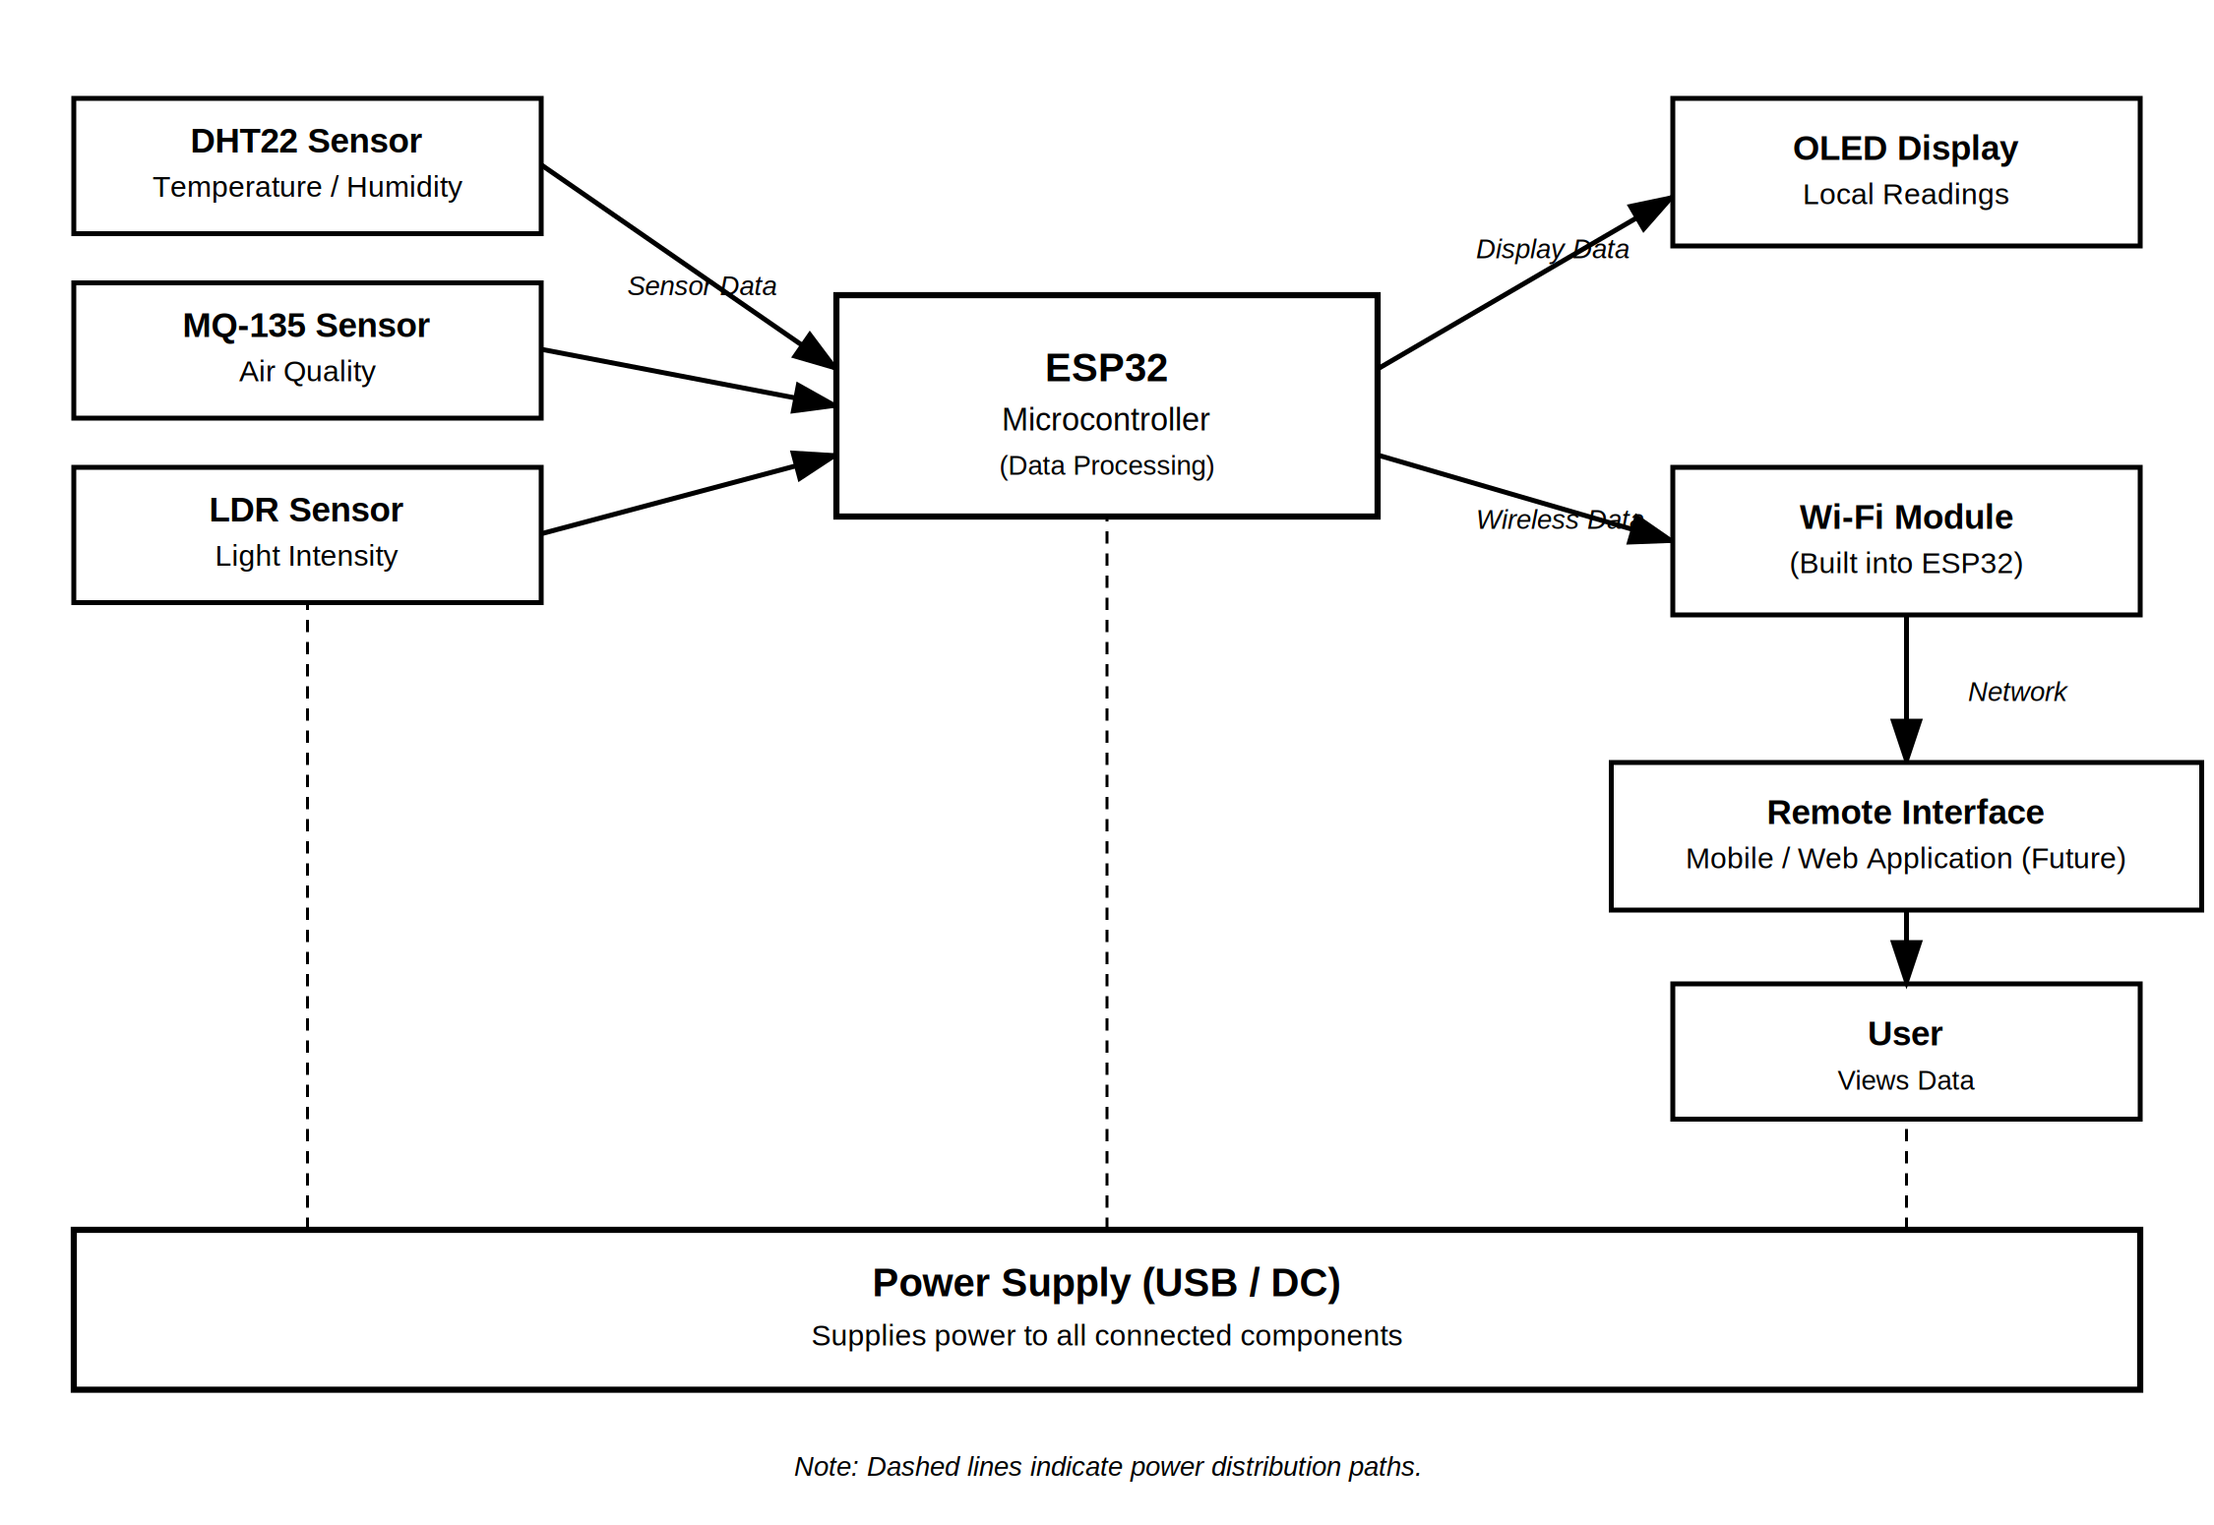
Figure 1: Proposed System Block Diagram

17. Component Description

17.1 ESP32 Microcontroller
The ESP32 acts as the central controller of the system. It interfaces with all connected sensors and the OLED display, performs the necessary data processing, and provides sufficient GPIO, analog input, and I²C pins for this design. Its built-in Wi-Fi capability makes it well suited to IoT-oriented embedded applications such as this one, without requiring a separate communication module.

17.2 DHT22
The DHT22 is a combined temperature and humidity sensor that communicates over a single-wire digital protocol. In the proposed design, it provides the readings used for the temperature and humidity monitoring objectives.

17.3 MQ-135
The MQ-135 is a gas sensor used for general indoor air-quality-related sensing. It produces an analog output that varies with the presence of certain airborne compounds. Its proposed role is to give an indicative air-quality reading; interpreting its output meaningfully requires calibration and careful handling, which is identified as a consideration for future implementation rather than something completed in this assessment.

17.4 LDR
A light-dependent resistor (LDR) is a component whose resistance changes with the amount of light falling on it. Read through an analog input, it provides a simple measurement of relative light intensity in the room.

17.5 OLED Display
The OLED display is proposed as the local output device for the system. It is compact, has low power characteristics suitable for continuous operation, and can clearly present current sensor readings to a user standing near the device.

17.6 Wi-Fi
The ESP32's built-in Wi-Fi radio is proposed for remote communication, allowing sensor information to be transmitted beyond the immediate vicinity of the device. This functionality depends on the availability of a wireless network at the deployment location.

17.7 Power Supply
The power supply block is responsible for supplying power to the ESP32 and all connected components. It is expected to provide appropriate voltage regulation so that each component receives a stable and suitable voltage for reliable operation.

18. Data Flow / System Working
The complete proposed operation of the system, as designed (not yet implemented or tested), follows the sequence below:
- The system receives power.
- The ESP32 initializes the connected sensors and display.
- The sensors collect environmental information.
- Sensor readings are sent to the ESP32.
- The ESP32 processes the readings.
- The processed values are displayed on the OLED.
- The ESP32 establishes Wi-Fi communication when available.
- Environmental data can be transmitted to a remote interface.
- The system repeats the monitoring cycle periodically.
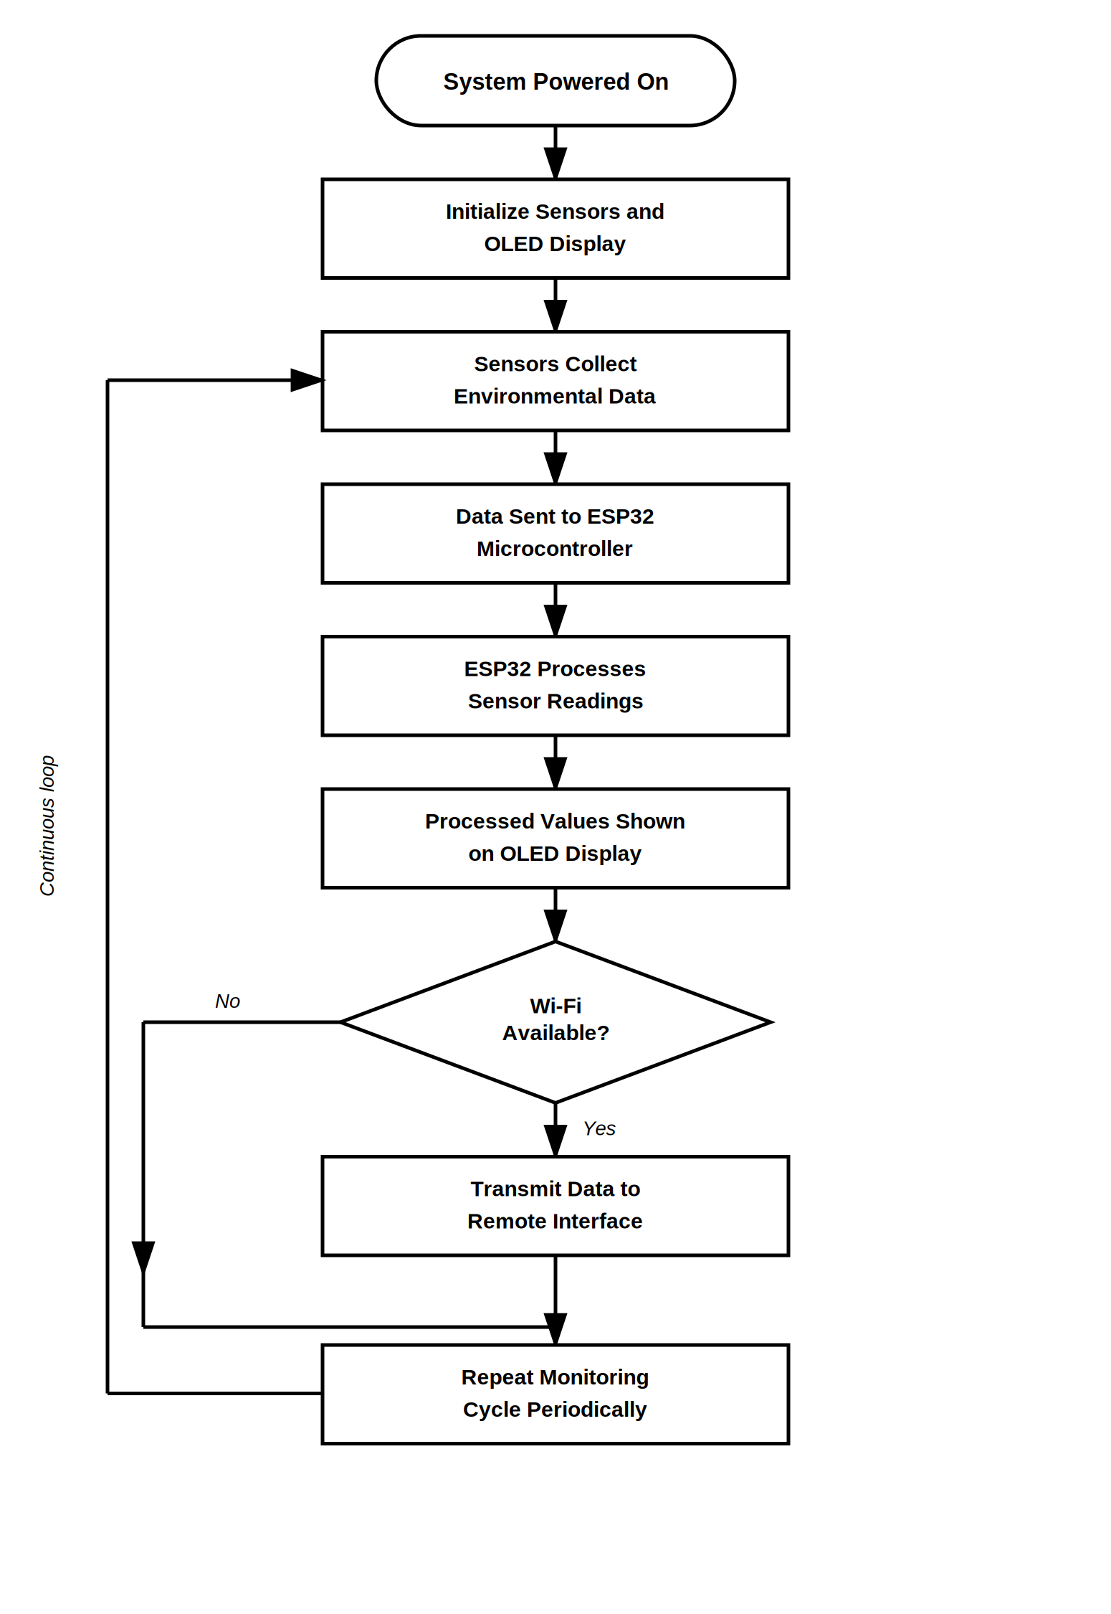
Figure 2: Proposed System Operational Flow

19. Design Justification

19.1 ESP32
The ESP32 was selected because it provides integrated Wi-Fi, a sufficient number of GPIO and analog input pins for the proposed sensors, and adequate processing capability for a design of this scale, making it a good general fit for IoT-oriented prototypes.

19.2 DHT22
The DHT22 was chosen because it provides both temperature and humidity readings from a single component through a simple digital interface, reducing wiring complexity compared with using two separate sensors.

19.3 MQ-135
The MQ-135 is a commonly available option suitable for general air-quality sensing and can provide analog readings compatible with the ESP32's ADC inputs. It is acknowledged that it requires calibration and careful interpretation to be meaningful, which is factored into the design as a future consideration.

19.4 LDR
The LDR was selected for its simplicity, low cost, and ease of analog interfacing, which is sufficient for the basic light-monitoring objective of this system.

19.5 OLED
The OLED display was chosen because it provides clear local feedback to the user in a compact form factor, without requiring a separate screen or external device.

19.6 Wi-Fi
Using the ESP32's built-in Wi-Fi avoids the need for an additional communication module, supports remote monitoring, and reduces the need for wired communication to a remote interface.

20. System Advantages
- Continuous environmental monitoring of multiple parameters from one device.
- Centralized sensor processing through a single microcontroller.
- Local display for immediate, at-a-glance readings.
- Wireless monitoring capability for remote access.
- Modular architecture that separates sensing, processing, and output.
- Expandability to accommodate additional sensors in the future.
- A relatively simple proposed architecture suitable for a beginner-level embedded systems project.

21. System Limitations
- Sensor readings may require calibration to be fully accurate.
- MQ-135 readings require careful interpretation and are not a substitute for laboratory-grade air-quality analysis.
- Wi-Fi-based remote monitoring depends on the availability and stability of a wireless network.
- Power interruption would stop the monitoring process, as no backup power source is proposed at this stage.
- The proposed design has not been physically tested as part of this Week 1 assessment.
- Environmental sensors of this type generally have accuracy limitations compared with laboratory-grade instruments.

22. Future Enhancements
The following are possible future extensions to the proposed system. They are listed here as future possibilities and are not completed or implemented features:
- A dedicated mobile application for remote viewing.
- Cloud-based data storage.
- Historical data visualization and trends.
- Environmental alerts and notifications.
- Additional sensors (for example, CO₂ or noise sensors).
- Automated fan or lighting control based on sensor readings.
- Battery-powered operation for portability.
- Improved sensor calibration procedures.
- Data analytics on collected environmental data.
- Machine-learning-based environmental prediction.

23. Expected System Outcome
Based on the proposed architecture, the system is intended to:
- Collect environmental data from the four proposed sensors.
- Process sensor readings using the ESP32 microcontroller.
- Display information locally through the OLED screen.
- Support remote monitoring through Wi-Fi connectivity.
- Provide a modular foundation that can be extended in future implementation stages.
These are the intended outcomes of the proposed design and are not presented as experimentally verified results, since no implementation or testing has taken place during this Week 1 assessment.

24. Conclusion
This report has addressed the problem of scattered, disconnected indoor environmental awareness by proposing a Smart Home Environmental Monitoring System built around an ESP32 microcontroller, a DHT22 temperature/humidity sensor, an MQ-135 air-quality sensor, an LDR light sensor, and an OLED display, with Wi-Fi used for optional remote monitoring.
The assessment carried out a structured requirements analysis covering functional and non-functional requirements, hardware and software selection, communication interfaces, power considerations, and real-time constraints. A system architecture and a corresponding block diagram were developed to represent the flow of data from sensing through to local and remote output, along with a description of the proposed operational sequence.
This Week 1 work establishes the requirements and architectural foundation for possible future implementation. Subsequent stages of the internship could build on this analysis by moving toward actual hardware assembly, firmware development, calibration, and testing.

25. References
1. Espressif Systems, "ESP32 Series Datasheet," Espressif Systems, [Online]. Available: https://www.espressif.com/en/products/socs/esp32
2. Aosong Electronics, "AM2302/DHT22 Product Manual," Aosong Electronics Co., Ltd.
3. Winsen Electronics, "MQ-135 Semiconductor Sensor for Air Quality — Technical Data," Zhengzhou Winsen Electronics Technology Co., Ltd.
4. Solomon Systech / various manufacturers, "SSD1306 OLED Display Driver Datasheet."
5. Arduino, "Arduino IDE Documentation," Arduino, [Online]. Available: https://docs.arduino.cc

Appendix A — Requirements Summary
Requirement Category | Main Requirement
Functional | Environmental monitoring
Hardware | ESP32 and sensors
Software | ESP32 firmware
Communication | GPIO, I²C and Wi-Fi
Display | OLED
Power | Stable regulated power
Performance | Timely periodic updates
Real-Time | Continuous monitoring cycle
Scalability | Additional sensors in future
Table 5: Requirements Summary

Appendix B — Proposed Component Summary
Component | Role | Interface
ESP32 | Main controller | GPIO / I²C / Wi-Fi
DHT22 | Temperature & humidity | Digital
MQ-135 | Air-quality sensing | Analog
LDR | Light sensing | Analog
OLED | Local display | I²C
Power Supply | System power | Power connection
Table 6: Proposed Component Summary

