ASSIGNMENT SUBMISSION

- TASK1:
I have chosen a A backend API(Node.js/Express). I have made this application specifically for this assignment.

- TASK2:
I have created an appropriate Dockerfile.
The three best practices that I have used are - 1. Use official base images
2. Security considerations
3. Minimize layers
- TASK3:
Issues encountered:
1. Docker Desktop was not opening even after proper installation.
→ I tried to run docker using Command line. It showed that it was running but when I tried to check the status of docker desktop it showed nothing and asked for confirmation if docker desktop was running or not. I tried to restart docker desktop through cmd but it was taking a long time. At last I uninstalled and reinstalled it and then it worked properly.
2. The application was not being exposed in the corresponding host port.
→ I used the -p flag while running the container.
- TASK4:
Verification of application:
→ Since it is a backend api with an exposed endpoint, I tested the application by hitting the endpoint from my browser and got the desired result.
- TASK5:

- Check if your container is running
→ docker ps
- View the logs of your container
→ docker logs <container_name>
- Execute a command inside your running container (e.g., list files or check environment)
→ docker exec <container_name> <conmmand>
- Stop your container
→ docker stop <container_name>
- Start it again
→ docker restart <container_name>
- Remove your container
→ docker rm <container_name>
- Run a new container with different parameters (e.g., different port mapping or environment variables)
→ docker run [...PARAMS] —name <container_name> <image_name>

- TASK6:

Documentation of optimizations made:

→ Reduced the image size: Changed the base image appropriately and reduced the image size from 1.63 GB to 242 MB.
→ Reduced the image size:Added the node_modules in .dockerignore file so that it is not added in the image created.
→ Enhanced Security: Added the port number to .env file and added it in .dockerignore file so that it is not added in the image.
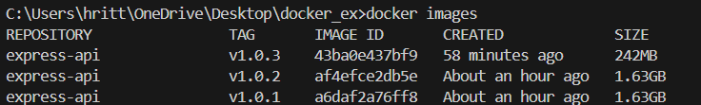

- TASK7:
Documentation is done in README.md file.
REQUIRED SCREENSHOTS:
  - Screenshots showing your application running in a container
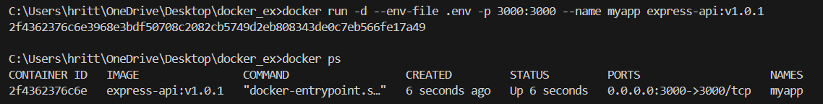

  - The Docker commands you used for each task

