A

Project Report

On

**Social Media Assistant**



## Submitted By

**Hritvik.H.Sikarwar Er.no=17082231119**

**Janavi.R.Ratel Er.no=17082231055**

**B.Sc. (Information Technology)**

**Semester-VI**

## Guided By

**Dhaval Raval**



Submitted to

**Department of Computer Science**

**Ganpat University, Ganpat Vidyanagar-384012**

**April – 2020**

|  |  |
| --- | --- |
| DCS Final Logo | **Department of Computer Science** **Ganpat University,****Ganpat Vidyanagar-384012** |

**Date: 22/04/2020**

### CERTIFICATE

TO WHOM SO EVER IT MAY CONCERN

This is to certify that the following students of Bachelor of Science in Information Technology Semester-VI have completed their full time project work titled “**Social Media Assistant**” satisfactorily.

|  |  |
| --- | --- |
| **Name** | **Exam No** |
| **Hritvik.H.Sikarwar** | **17082231119** |
| **Janavi.R.Patel** | **17082231055** |

|  |  |  |
| --- | --- | --- |
| **Internal Guide** | **Project Co-ordinator** | **Principal/HOD** |
| Prof. Dhaval Raval | Prof. Jigar Patel /  Prof. Dhara Darji | Dr. Satyen Parikh |

**Acknowledgement**

We have taken efforts in this project. However, it would not have been possible without the kind support and help of many individuals. We would like to extend my sincere thanks to all of them.

We are highly indebted to ***Mr. Dhaval Raval*** our internal guide for their guidance and constant supervision as well as for providing necessary information regarding the project & also for their support in completing the project.

We would like to express our gratitude towards our parents for their kind co-operation and encouragement which help us in completion of this project.

And also we would like to express our special gratitude and thanks to all person for giving us such attention and time.

**Presentation Title: Social Meadia Assistant**

**College:** DCS-IIC, Ganpat University

**Abstract**

This Social Media Assistant is the project which is based on android. The Purpose of this project is to make ease of Maintaining, Managing and Anneliese the social accounts .As in this hectic era social media is one of the best way to make your business grow which also requires long time to maintain the social account that it is in the wright direction .To save the time and to grow the account organically this Social Media Assistant will do it for the user.

It does not have any spam work process which will affect the account or to show the fake user items this application will show the real and accurate information with a secure way which did not affect this account.

**CONTENTS FOR PROJECT REPORT**

|  |  |  |
| --- | --- | --- |
| Sr. No | Title | Page No |
| 1 | Project Profile   * 1. Project Title   2. Objective | 01 |
| 2 | Requirement specification   * 1. About Existing System   2. Need for new system/ Features of the new system | 02 |
| 3 | Minimum Hardware & Software Requirement  3.1 Client Side Hardware / Software Requirement  3.2 Server Side Hardware / Software Requirement | 03 |
| 4 | Function Specification   * 1. User of the System   2. Modules of the System | 04 |
| 5 | System Flow Chart | 05 |
| 6 | ER Diagram | 06 |
| 7 | Data Flow Diagram [DFD] | 07 |
| 8 | Data Dictionary | 10 |
| 9 | Process Description (Module wise) | 12 |
| 10 | Input/ Output Design (Screen Layouts with title and brief description on each screen shot) | 14 |
| 11 | Testing (Design test cases of validations in tabular form) | 20 |
| 12 | Future Enhancement | 22 |
| 13 | Conclusion | 23 |
| 14 | Bibliography / References | 24 |

1. **PROJECT PROFILE**

**1.1 Project Title : Social Media Assistant**

* **Objective : To Analyse your Social Media Account**
* **Front End Tool : Android Studio[v3.6.4]**
* **Back End Tool : My SQL [xammpv2.4.41]**
* **Other Tool : 000WebHost.**
* **Developed By : Hritvik.H.Sikarwar[17082231119] Janavi.R.Patel[170882231055]**
* **Developed For : Department Of Computer Science**
* **Internal Guide : Dhaval Raval**
* **External Guide : ----------**

**1.2 Objective**

* The Tool Will Work as an Assistant by Analysis your Social Media Account
* The Capability of the Tool is from Personal to Business Accounts
* Fast work , Easy to Access , Reliable for Heavy work
* Flow Chart for Easy to Analyse
* More Secure

1. **Requirement specification**

2.1 About Existing System

* There are Some of the Tool Available in Market but all of them works Separately which is time Consuming
* There are also many Disabilities of them
* For e.g. Fake Ghost Followers , Account Blocking
* Not Reliable (as it will not working Properly)
  1. Need for New System
* Monitor The Daily Activities
* Flow Chart Availability(new)
* Average Values(new)
* Safe(new)
* User Friendly (new)
* All Functionalities in one

(Gained, Lost, New, etc.)

1. Minimum Hardware & Software Requirement
   1. Client Side Hardware / Software Requirement

*Hardware*:-

Minimum 4 GB RAM, 1.3 GHz Processor

*Software*:-

Minimum Android Lollipop 5.0

3.2 Server Side Hardware / Software Requirement

*Hardware*:-

* + 8 GB RAM (4 GB min. Free Space)
  + 1 TB ROM (500 GB min. Free Space)

***Software*:-**

* + Android Studio
  + Web browser
  + Web server
  + MySQL database
  + 000WebHost.

1. **Function Specification**
   1. User of the System

There will be two main user of this system.

* *Admin*
* *User*
  1. **Modules of the System**

**Admin**

* Login
* Manage User
* Manage System
* Change Password
* Logout

## **User**

* + Register
  + Login
  + Change Password
  + View Followers
  + View Following
  + View Posts
  + View Charts
  + View Profile
  + See About Us
  + Logout

1. **System Flow Chart**



1. **Entity Relationship Diagram**

User

Admin

Forgot Password

Login

Maintain

Login

Register new user

First name

Last name

Username

D.O.B

Mob No.

Password

Change Password

Manage

Dashboard

Total Posts

About Us

Post

Following

Followers

jOverview

Total no. of following

Total no. of followers

Total no. of posts

See Users Account

User Profile

See Quick Overview

Manage user

Charts

Posts Chart

Likes Chart

Following Chart

Followers Chart

See users Growth

1. **DATA FLOW DIAGRAM**

* **CONTEXT LEVEL DIAGRAM**

0.0

SOCIAL

MEDIA

ASSISTANT

User

Admin

Admin

Profile

Information

Admin

Login

Details

User

Login

Detail

User

Profile

Information

* **FIRST LEVEL DIAGRAM OF ADMIN**



* **FIRST LEVEL DIAGRAM OF USER**



6.0

**8. DATA DICTIONARY**

Table Name: Admin   
Table Description: Use to store data

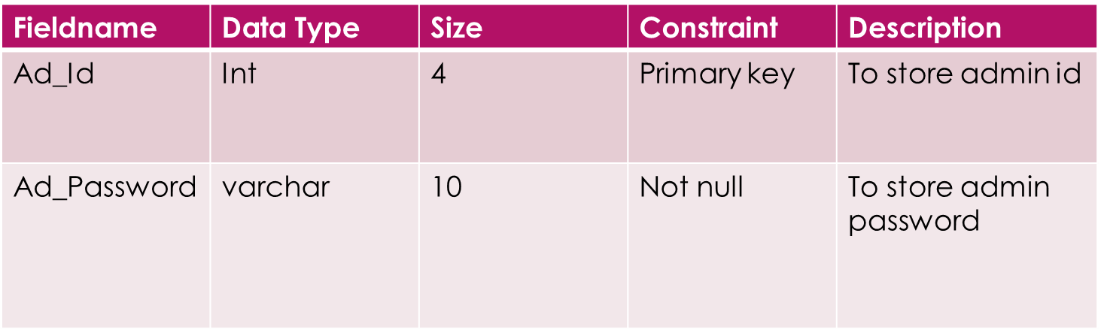

Table Name: New User   
Table Description: Use to store user data

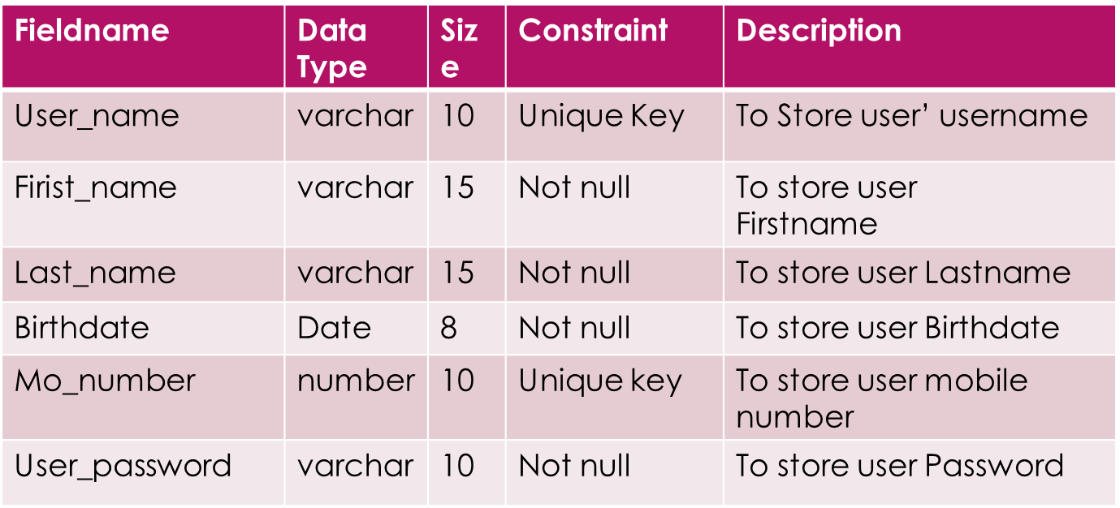

Table Name: User Information Table  
Table Description: Use to store user data

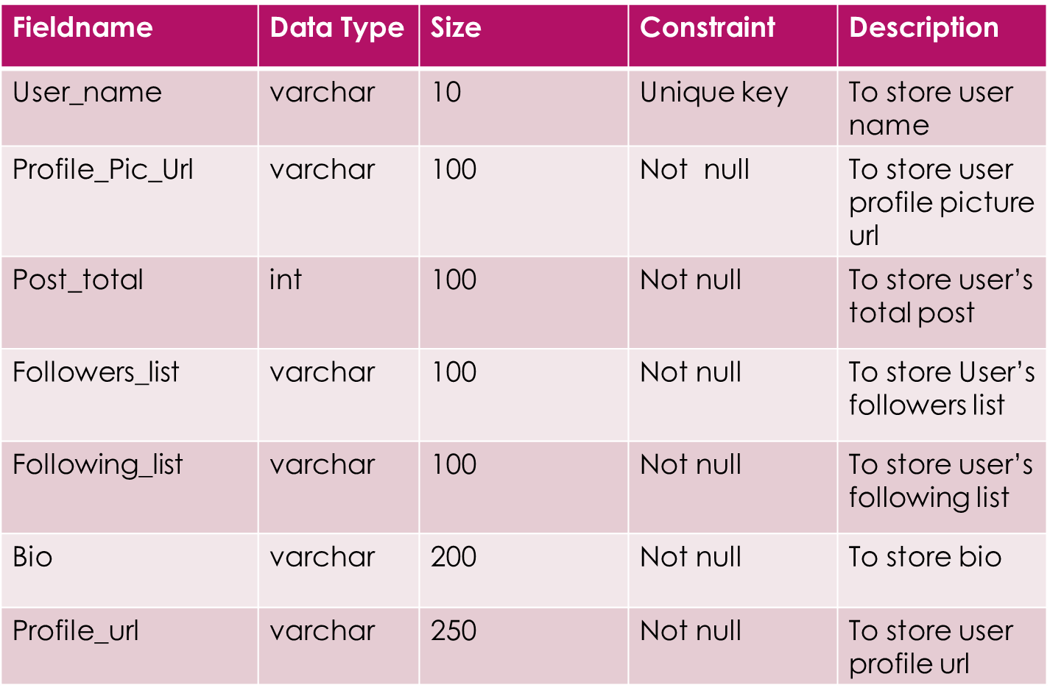

**9. Process Description**

**Brief Description Admin**

* + Login
  + Manage Users
  + Maintain System
  + Change Password
  + Login - With the use of Login Admin, Admin can check system.
  + Manage User - In this Process of Manage User Admin can Delete User from Admin panel and that particular
  + Maintain System - In this Process of Manage Service Request and Server
  + Change Password – Manage the Admin Account

**Brief Description User**

* + Register
  + Login
  + Change Password
  + View Followers
  + View Following
  + View Posts
  + View Charts
  + Overview
  + About Us
  + Logout
* Register: User can register as a new user.
* Login: User can easily login to their account.
* Change Password: User can change their password if forgot.
* View Followers: User can see his/her followers who follow the account.
* View Following: User can whom he/she follow.
* View Post: User can see the posts available in the account.
* View Chart : User can easily check their account growth by overall likes and views
* Overview: User can see the Overall details of the account.
* About Us: User can see the information about us.
* Logout: User can Logout.

**10. Input / Output Design**

**Splash Screen**

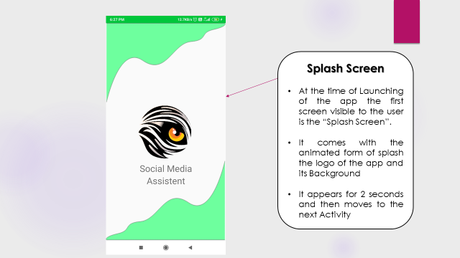

**Walk Through**

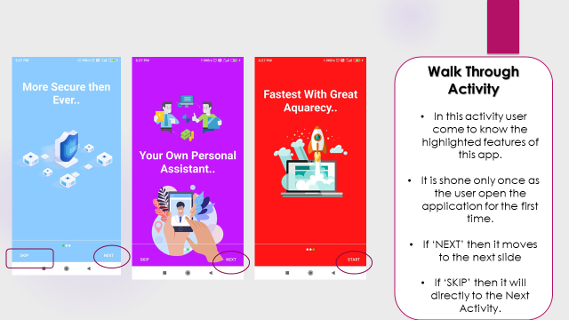

**Login Screen**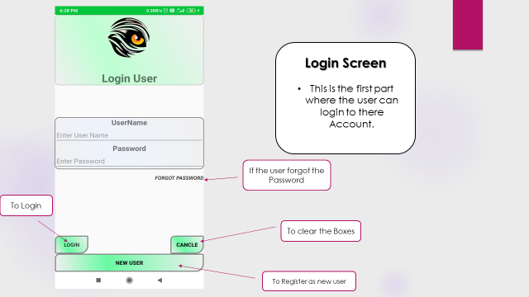

**New Registration**

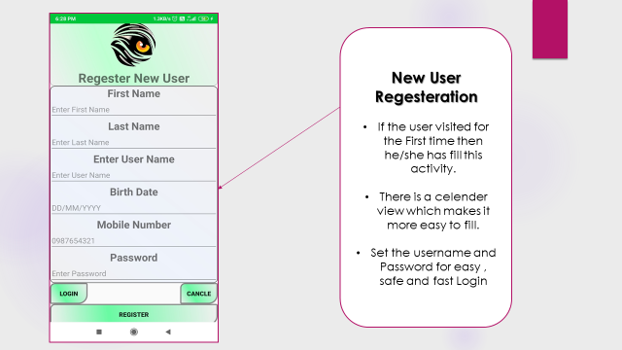

**Reset Password**

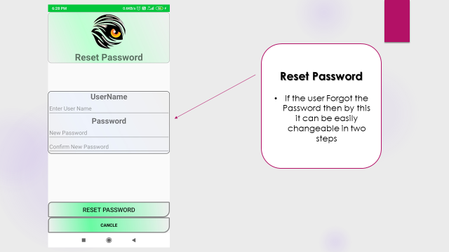

**Dashboard**

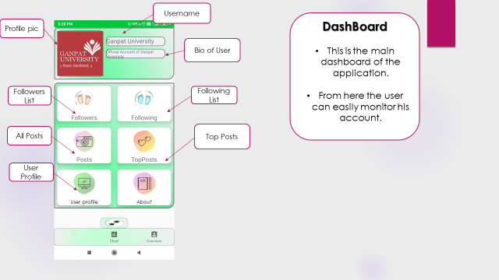

**Dashboard Functionality**

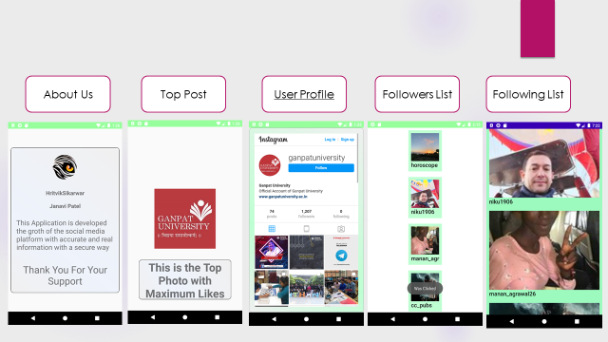

**Quick Overview**

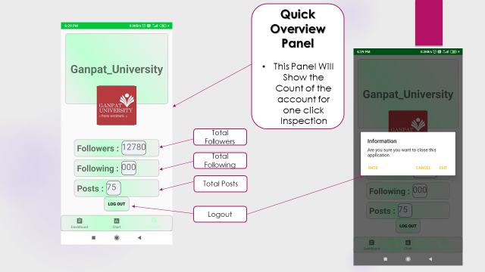

**Chart View**

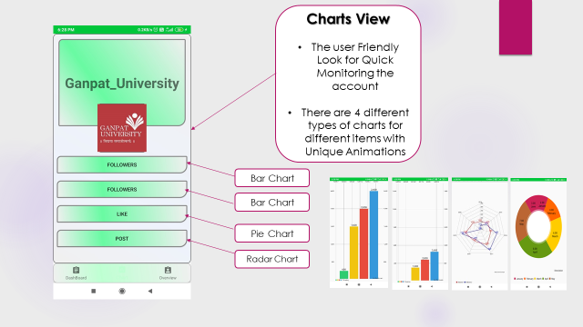

**Admin can Manage Users**

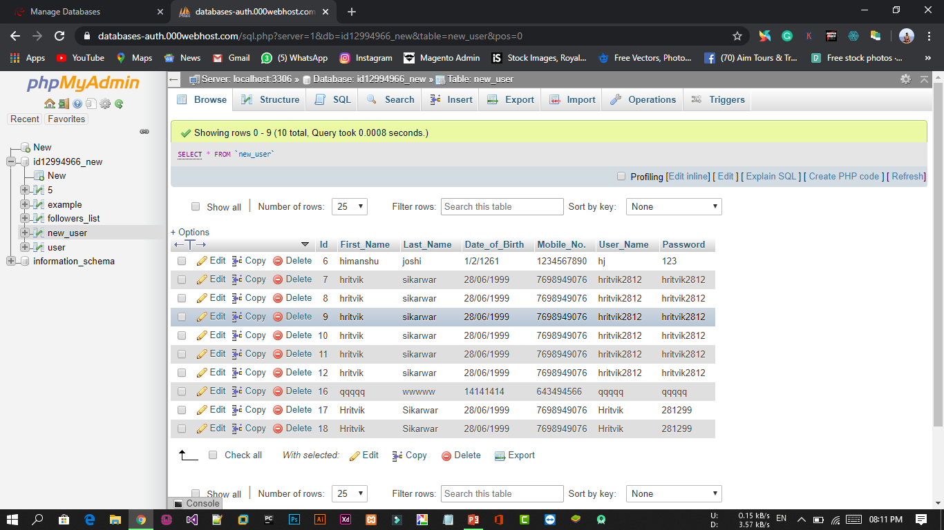

**Users Information Database Table Stores Here**

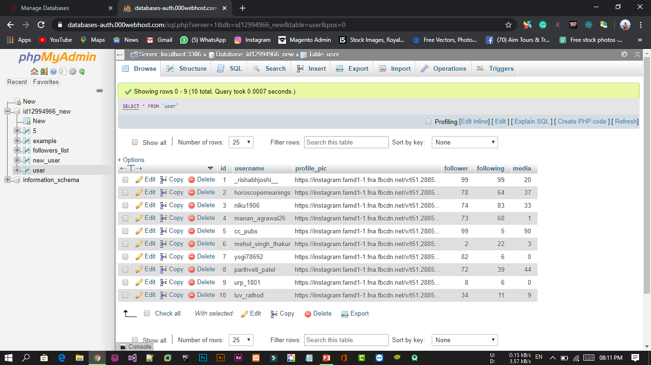

**Here is the Data for the Graphs**

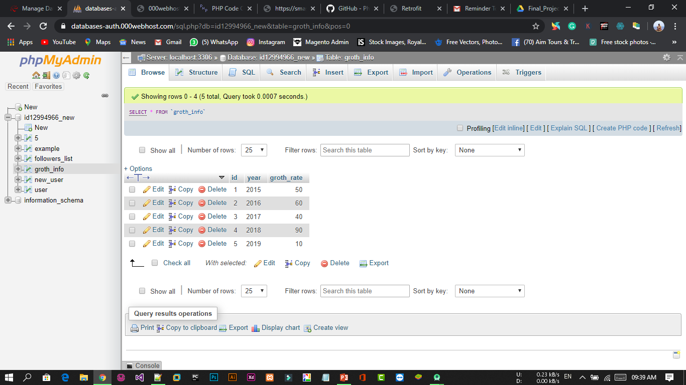

**11. Testing**

Test Cases (User Register Page)

|  |  |  |  |
| --- | --- | --- | --- |
| NO | VALIDATION | EXPRECTED | TEST RESULT |
| 1 | Input Valid Information | Registration Successfully | PASS |
| 2 | Input Empty  Fields | Fields are empty | PASS |

**New User Registration test**

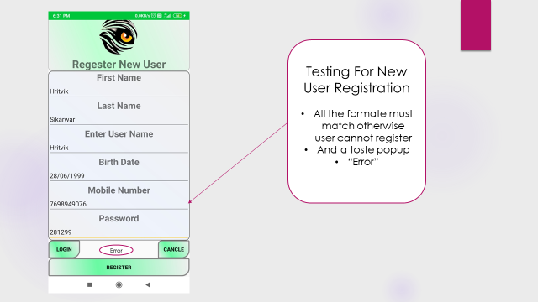

|  |  |  |  |
| --- | --- | --- | --- |
| NO | VALIDATION | EXPRECTED | TEST RESULT |
| 1 | Update Valid User Information | Update Successfully | PASS |
| 2 | Input Empty  Fields | Fields are empty | PASS |

Test Cases (Login Page)

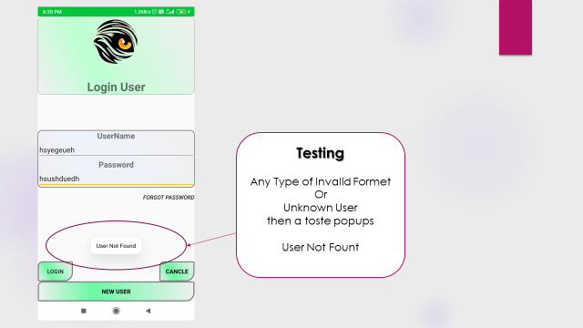

|  |  |  |  |
| --- | --- | --- | --- |
| NO | VALIDATION | EXPRECTED | TEST RESULT |
| 1 | Input Valid Username & Password | Login Successfully | PASS |
| 2 | Input  Invalid Username & Password | Invalid Username Password | PASS |
| 3 | Input  Empty Username & Password | Fields are Empty | PASS |

**12. Future Enhancement**

We think that not a Single project is ever considered as Complete forever our mind is always thinking new and our necessities also are growing day by day. We always want something more then what we have. Our Application also, if you see at the first glance that you find it to be complete but we want to make it still mature and fully automatic.

Some are the expansion which we have thought of are:

* Try to make system more user friendly
* Add in all social media application like Facebook, Tweeter, etc.
* Send notification on mobile.
* Improve searching facilities.
* Try to all type of user can use this application

**13. Conclusion**

All in all we hope that this Application will improve and help to make the work more fast and easy for everyone at any time. It will save your time and useful for every user.

14. Bibliography / References

During this development of our system, we have taken reference from various Youtube videos, Websites and Online tutors

Websites:

* [www.google.com](http://www.google.com/)
* [www.igblade.com](http://www.igblade.com)
* [www.youtube.com](http://www.youtube.com/)
* [www.codeproject.com](http://www.codeproject.com/)
* www.000webhost.com