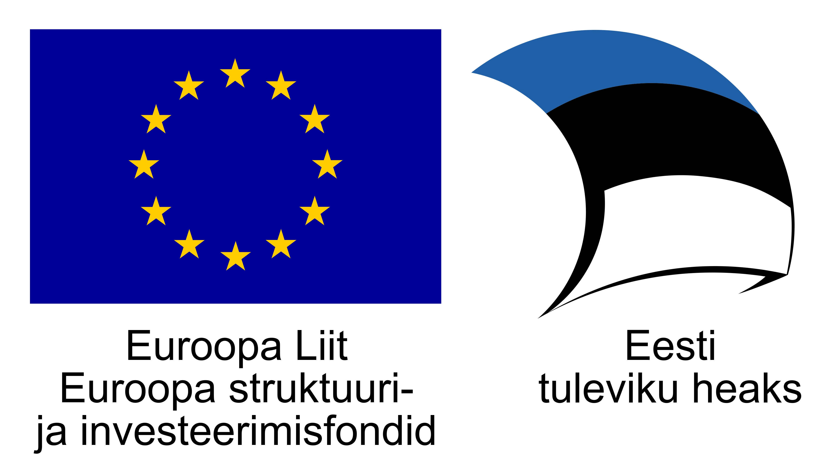

**SiVa – Signature Validation software**

SiVa is developed for validating digitally signed documents. It is a web service with REST JSON API built with [Spring Boot](http://projects.spring.io/spring-boot/) platform. Supported formats of digitally signed documents in SiVa are: BDOC, DDOC, and PDF with the signature level at least “Long Term”.

**Main features of SiVa**

* SiVa SOAP and REST ETSI compliant API to validate all supported signatures.
* SiVa supports the following file formats:
  + PDF version 1.7 and later signed with PadES-profile signatures;
  + DDOC starting from version 1.0;
  + BDOC starting from version 2.1.
* Service supports X-Road v6 security server ASiCE containers.
* SiVa uses European Commission’s TL (Trusted Service Status List) for certificate chain validation for PDF and BDOC files;
  + European Commission’s TL contains references to TLs of European Union’s member states and members of the European Economic Area. This allows the PDF Validator to validate signature that has been signed with certificates issued in any of European Union’s member states;
  + During the validation process, a certificate chain is created from signer’s certificate up to the trust anchor (national trust list referenced by the central European Commission's trust list) for all certificates included in the signature (i.e. the signer's certificate, OCSP service's certificate, time-stamping service's certificate).
* For DDOC and X-Road signature containers, SiVa will use configured list of certificates.
* Supported signature profiles and types:
  + PadES-LT and PadES-LTA;
  + BDOC-TM and BDOC-TS.
* Service enables to upload files up to 10MB by size.

At the time of creating current documentation, it is expected that SiVa will be used by the following applications:

* DigiDoc3 Client;
* Third party document management applications.

**Usage and APIs**

SiVa provides REST JSON and SOAP interfaces that enable the service users to:

* request validation of signatures in a digitally signed document (i.e. signature container like BDOC/ASiC-E or PDF);
* receive a response with the validation result regarding all the signatures in the document.

SiVa SOAP interface supports X-Road v6. However, it is optional whether to integrate SiVa using X-Road or "plain" SOAP interface. This document only describes SiVa’s part of the interface. For the X-Road specifics, visit the [web page](https://www.ria.ee/ee/x-tee.html) of Information System Authority.

**Validation request interfaces**

**REST JSON Endpoint**

POST https://<server url>/validate

**SOAP Endpoint**

POST https://<server url>/soap/validationWebService/validateDocument

**Sample JSON request**

{

"filename":"sample.ddoc",

"documentType":"DDOC",

"document":"PD94bWwgdmVyc2lvbj0iMS4....",

"signaturePolicy": "POLv1"

}

Sample app:

<https://siva-arendus.eesti.ee/>