📱 MOBILE PHONE MARKET ANALYSIS & PRICE PREDICTION
⚡ Exploratory Analytics Report • Hardware Specifications, Pricing Patterns & Linear Regression Benchmark
_________________________________________________________________________________
1. 📊 Executive Summary
This exploratory analytics report examines mobile phone pricing patterns across 1,020 product listings from Smartprix. By extracting structured hardware features and applying a Scikit-Learn Linear Regression pipeline, the study explores relationships between specifications and listed prices and establishes an interpretable baseline for price prediction.
📊 Raw / Filtered Dataset | 1,020 raw listings ➔ 846 high-quality smartphone records
💰 Pricing Baseline | Mean Retail Price: ₹38,457 | Median Retail Price: ₹26,999
🎯 Model Performance | R² Score = 0.743 (74.3% price variance explained)
📉 Prediction Error (RMSE) | RMSE = ₹12,277 across global dataset
🚀 Key Hardware Associations | Internal Storage (r = +0.69) & RAM Capacity (r = +0.61)

2. 📋 Dataset Schema & Feature Extraction
The raw dataset comprises 1,020 observations across 11 unstructured text columns. Deterministic regular expression pipelines extracted 8 continuous hardware specs and categorical processor taxonomy:
- 💵 price_inr: Target consumer retail price in Indian Rupees (₹599 to ₹449,900; Mean: ₹38,457; Median: ₹26,999) [cite: 2, 3].
- ⚡ ram_gb: System RAM capacity in GB (Range: 0–18 GB; Mean: 7.38 GB; Median: 8.00 GB).
- 💾 memory_gb: Internal flash storage in GB (Range: 0–512 GB; Mean: 182.10 GB; Median: 128.00 GB).
- 🔋 battery_mah: Battery capacity in mAh (Range: 600–10,001 mAh; Mean: 5,420.67 mAh; Median: 5,200.00 mAh).
- 📸 main_camera_mp: Lead rear camera sensor in Megapixels (Range: 0.03–200 MP; Mean: 51.69 MP).
- 🖥️ display_inches & refresh_rate_hz: Screen size (Mean: 6.35 in) and refresh rate (Mean: 121.59 Hz).
- 🧩 processor_brand & is_5g: Categorical chip brands (Snapdragon, Exynos, MediaTek, Unisoc, Other) and 5G binary flag (76% 5G coverage).
3. ⚙️ Data Preparation & Cleaning Pipeline
- 🧹 Regex Parsing: Regex patterns stripped text descriptors (e.g. `r'(\d+(?:\.\d+)?)\s*GB RAM'` and `r'(\d+)\s*mAh'`) and normalized MB storage to GB [cite: 2].
- 🩹 Imputation Strategy: Missing value imputation was encapsulated in Scikit-Learn pipelines using `SimpleImputer(strategy='median')` to eliminate data leakage.
- ⚖️ Scaling & One-Hot Encoding: Continuous features were transformed via `StandardScaler()`, while categorical chip brands were processed using `OneHotEncoder(drop='first')`.
4. 📈 Exploratory Data Analysis & Visual Insights
4.1 Price Distribution Curve & Market Tiers
The mobile phone price distribution is strongly right-skewed, with most listings concentrated below ₹35,000 and a long right tail extending into higher price ranges:
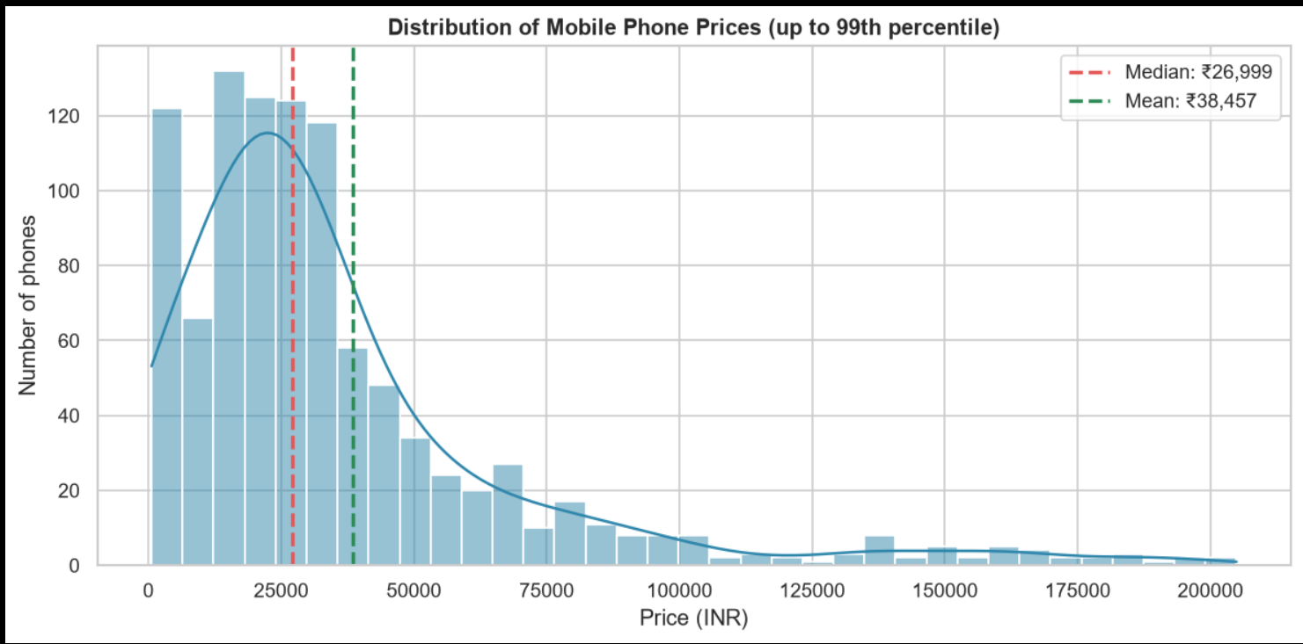
Figure 1: Mobile Phone Price Distribution (Up to 99th Percentile) showing Median (₹26,999) vs Mean (₹38,457).
- 🏷️ Budget Tier (< ₹15,500): 25th percentile threshold (₹15,499). Many listings in this range have 4–6 GB RAM and 64–128 GB storage.
- 🎯 Mid-Range Volume Range (₹15,500 – ₹27,000): Centers around the median price (₹26,999), with common configurations including 8 GB RAM, 128/256 GB storage, and 120 Hz screens.
- 👑 Upper Price Tier (> ₹43,000): Represents the upper 25% of listed prices, containing higher-priced models with premium hardware and other possible pricing factors.
4.2 Core Hardware Correlation Analysis
Pairwise Pearson correlation coefficients show how the core hardware variables are associated with listed price:
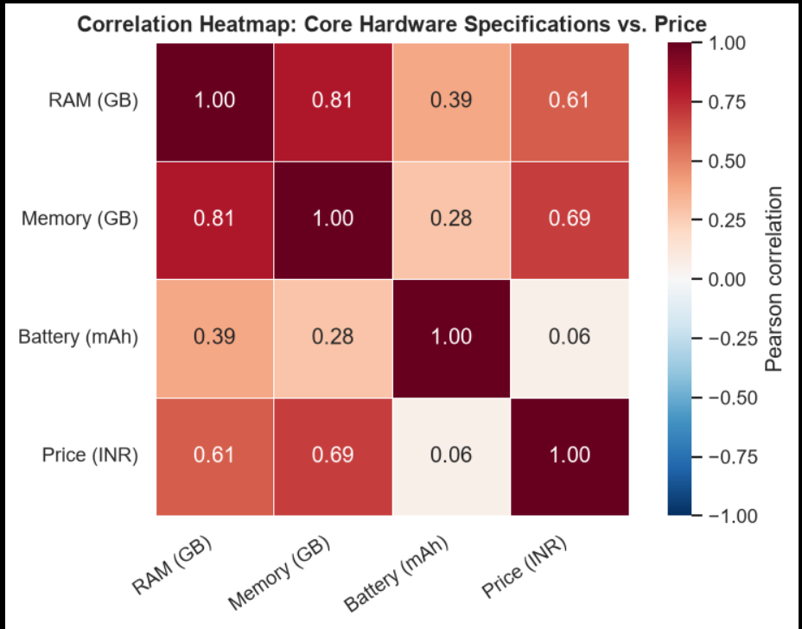
Figure 2: Correlation Heatmap — Core Hardware Specifications vs. Retail Price.
- 📈 Internal Memory (r = +0.69) & RAM (r = +0.61): Show the strongest positive linear associations with price among the core hardware variables.
- 🔄 RAM vs. Memory Inter-Correlation (r = +0.81): Shows a strong positive association between system RAM and internal storage.
- 🔋 Battery Capacity (r = +0.06): Shows a very weak linear association with price in this dataset.
4.3 Processor Brand Pricing Benchmarks
Average listed prices differ across the five most represented processor groups in the dataset:
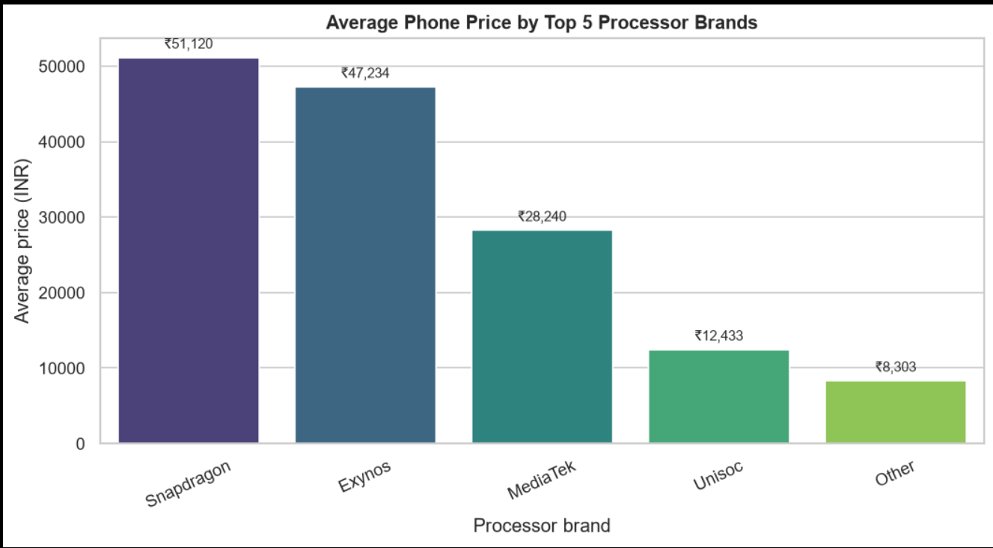
Figure 3: Average Mobile Phone Retail Price by Top 5 Processor Brands.
- 🐉 Snapdragon (₹51,120): Has the highest average listed price among the five processor groups.
- 📱 Exynos (₹47,234): Has the second-highest average listed price among the five groups.
- 💎 MediaTek (₹28,240): Falls in the middle of the observed average-price range.
- 🏷️ Unisoc (₹12,433) & Other (₹8,303): Show the lowest average listed prices among the five groups.
5. 🎯 Price Prediction Modeling & Infrastructure
An Ordinary Least Squares (OLS) Linear Regression pipeline was trained on an 80/20 train-test split (846 verified records).
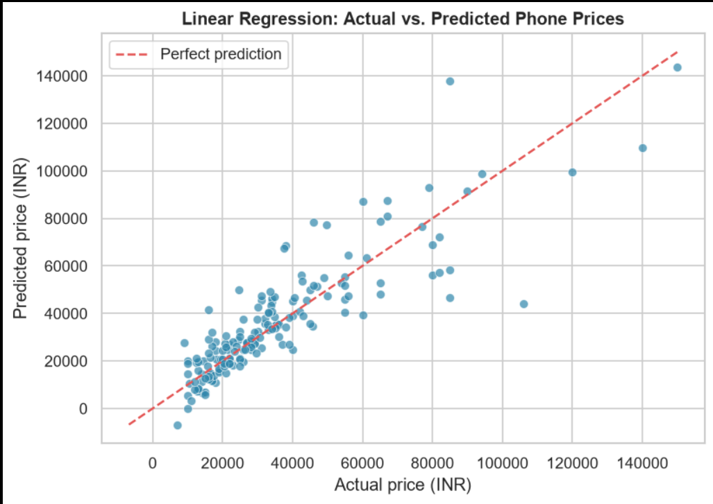
Figure 4: Linear Regression Model Performance — Actual vs. Predicted Retail Prices (INR).
- 📊 Coefficient of Determination (R² = 0.743): The model explains 74.3% of the variation in listed prices within the held-out test set.
- 📉 Root Mean Squared Error (RMSE = ₹12,277): Represents the typical scale of prediction error on the held-out test set.
- 💡 Prediction Pattern: The actual-vs-predicted plot shows larger deviations for some higher-priced phones, suggesting that the available features do not capture all price variation.
6. 💡 Analytical Insights & Future Scope
- 🔎 Price Distribution: Prices are strongly right-skewed, with a median of approximately ₹26,999 and a higher mean of about ₹38,457.
- 📈 Hardware Relationships: Storage and RAM have the strongest positive associations with price, while battery capacity has a comparatively weak relationship.
- 🎯 Processor & Model Findings: Processor groups show distinct average price levels, while the Linear Regression baseline achieved R² = 0.743 and RMSE ≈ ₹12,277.
- 🔭 Future Scope: Add features such as charging wattage, display resolution, OS version, and 5G support; test log-price modeling and tree-based ensembles; and build an interactive dashboard for pricing analysis.

