***Summative Assessment***

***(Spring Boot, MySQL, Linux, Jenkins, Docker, NodeJS)***

**Problem Statement -1:**

* This project is a demo to build a sample Employee Registration module using Java (Springboot, ORM), MySQL and Linux.

***Code is attached in Folder named Problem Statement-1***

**Tools and Technologies Used:**

* IDE - Eclipse
* JDK - 11
* Apache tomcat - 9
* JSTL - 1.2.1
* Servlet API - 2.5
* MySQL Workbench

**Project Structure**

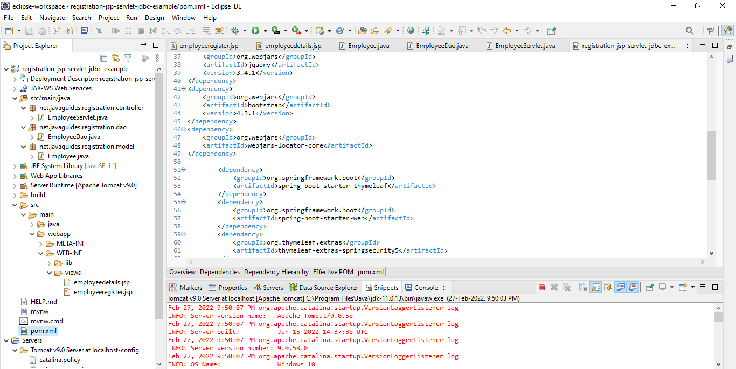

**Shows message after Successful Registration**

**Data updated in MySQL Database**

