Student 1 Name: Harsh Verma | Mobile :  8849491803 | Enroll :  202302519010095 | Div_Rollno. B24
Student 2 Name: Akash Goud | Mobile :  9328746206 | Enroll :  202302519010075 | Div_Rollno. B04
Student 3 Name: Chudasama Bhagyarajsinh | Mobile :  9375009192 | Enroll :  202302519010085 | Div_Rollno. B14
Project Title: LogiWeb - WebApplication

1. Introduction
1.1 Purpose of the Document
This Software Requirement Specification document provides a detailed description of the requirements for the Sadhi Logistic web application. The purpose of this document is to clearly define the functional and non-functional requirements of the system before its development and implementation. This document acts as a formal agreement between stakeholders, developers, and evaluators. It ensures that the system is developed according to defined objectives and expectations. The document also serves as a reference for system testing, validation, and future enhancements.

1.2 Scope of the Project
Sadhi Logistic is a web-based logistics broker application designed to connect business clients with registered transport dealers through a centralized digital platform. The system enables clients to submit shipment enquiries, allows transport dealers to submit quotations, and provides administrative control for comparing rates, assigning shipments, and managing billing operations. The platform aims to digitalize the traditional logistics brokerage process, which is usually handled manually through phone calls and emails.
The system is developed using modern web technologies. The front end is implemented using HyperText Markup Language version five, Tailwind Cascading Style Sheets framework, and JavaScript. The back end is built using Node.js runtime environment and Express.js framework. MySQL is used as the relational database management system for storing structured data. The application is deployed using the Vercel hosting platform.
- Clients to submit shipment enquiries
- Dealers to submit quotations
- Admin to compare rates and assign shipments
- Shipment tracking and status updates
- Invoice generation and payment processing
- Dealer settlement management
The system is developed using:
- Frontend: HTML5, Tailwind CSS, JavaScript
- Backend: Node.js, Express.js, three.js
- Database: MySQL, Firebase or Firestore

1.3 Definitions and Terminology
In this document, the term broker refers to the intermediary organization that connects clients with transport dealers. The term client refers to a business entity that requests logistics services. The term dealer refers to a transport partner or vehicle owner registered in the system. The term enquiry refers to a shipment request submitted by a client. Proof of Delivery refers to the official document uploaded by the dealer after successful shipment delivery.

2. Overall Description
2.1 Product Perspective
Sadhi Logistic is designed as a three-tier web application consisting of the presentation layer, the application layer, and the data layer. The presentation layer includes the user interface that interacts with clients, dealers, and administrators through a web browser. The application layer contains the business logic implemented using Node.js and Express.js, which processes requests and communicates with the database. The data layer consists of the MySQL database, which stores and manages all system data including users, enquiries, quotations, shipments, invoices, and payments.
Sadhi Logistic is a three-tier web application:
- Presentation Layer (Frontend)
- Application Layer (Backend APIs)
- Data Layer (MySQL Database)

2.2 Product Functions
The primary function of the Sadhi Logistic system is to automate logistics brokerage operations. The system enables clients to register and submit shipment enquiries. Once an enquiry is submitted, administrators review it and forward it to eligible transport dealers. Dealers then submit their quotations through the system. The administrator compares all received quotations and selects the most suitable one. The final quotation is sent to the client for approval. Upon acceptance, a shipment record is created and assigned to the selected dealer. The dealer updates shipment status throughout the transportation process and uploads proof of delivery after completion. The system also generates invoices and processes payments. Finally, the administrator processes settlement payments to the dealer after deducting the broker margin.
The system performs:
- User authentication
- Enquiry submission
- Dealer quotation collection
- Quote comparison
- Shipment creation
- Shipment tracking
- Invoice generation
- Payment processing
- Dealer settlement

2.3 User Classes and Characteristics
The system consists of three main categories of users. The first category is the client, who submits shipment enquiries and reviews quotations. Clients are expected to have basic knowledge of web-based systems. The second category is the administrator, who manages the overall brokerage process, including enquiry review, quotation comparison, shipment assignment, and financial management. Administrators are expected to have advanced system access and operational control. The third category is the dealer, who is responsible for submitting quotations, updating shipment status, and uploading proof of delivery documents.
User Classes:
Client
- Submit enquiry
- View quotations
- Accept/reject quote
- Track shipment
- Make payment

Admin
- Review enquiry
- Compare dealer quotes
- Assign shipment
- Generate invoice
- Manage users

Dealer
- View enquiry request
- Submit quotation
- Update shipment status

3. Functional Requirements
The Sadhi Logistic system shall provide secure user authentication for all user types. Clients shall be able to register by providing company details such as company name, contact person, electronic mail address, phone number, and goods and services tax identification number. After successful registration, clients shall be able to log in using valid credentials.
The system shall allow clients to submit shipment enquiries by providing pickup location, delivery location, cargo type, weight, volume, and preferred shipment date. Upon submission, the system shall generate a unique enquiry identification number and store the data in the database.
The administrator shall review each enquiry and forward it to eligible dealers. Dealers shall be able to log in to the system and view available enquiries. Dealers shall submit their quotations including price and estimated transit time. The system shall store all quotations and display them to the administrator for comparison.
The administrator shall select the most appropriate quotation and generate a final quotation by adding broker margin. The system shall send this final quotation to the client. The client shall be able to either accept or reject the quotation. If accepted, the system shall create a shipment record and assign it to the selected dealer.
The dealer shall update shipment status at different stages, such as pickup completed, in transit, and delivered. After delivery, the dealer shall upload proof of delivery documentation. The system shall notify the client regarding shipment updates.
The administrator shall generate an invoice for the completed shipment. The client shall be able to view and pay the invoice using the integrated payment system. After successful payment confirmation, the system shall update the payment status and allow the administrator to process dealer settlement.
3.1 Client Module
FR-1: User Registration
The system shall allow clients to register with company details.
FR-2: Login
The system shall authenticate clients using email and password.
FR-3: Submit Enquiry
The system shall allow clients to submit shipment enquiries including:
- Pickup location
- Delivery location
- Cargo details
- Preferred date
FR-4: View Final Quote
The system shall display final quotation after admin approval.
FR-5: Accept / Reject Quote
The system shall allow client to confirm or reject quotation.
FR-6: Track Shipment
The system shall allow client to track shipment status.
FR-7: View Invoice
The system shall generate invoice for confirmed shipments.
FR-8: Make Payment
The system shall allow payment via integrated payment gateway.

3.2 Admin Module
FR-9: Review Enquiry
Admin shall review and validate client enquiries.
FR-10: Send Enquiry to Dealers
Admin shall forward enquiry to eligible dealers.
FR-11: Compare Dealer Quotations
System shall store and display multiple dealer quotations.
FR-12: Generate Final Quote
Admin shall select dealer and generate final quotation.
FR-13: Assign Shipment
System shall create shipment record after approval.
FR-14: Generate Invoice
System shall generate GST-compliant invoice.
FR-15: Process Dealer Settlement
Admin shall process dealer payment after client payment.
FR-16: Manage Users
Admin shall manage client and dealer accounts.

3.3 Dealer Module
FR-17: Dealer Login
Dealer shall login securely.
FR-18: View Enquiry
Dealer shall view assigned enquiry requests.
FR-19: Submit Quotation
Dealer shall submit price and transit details.
FR-20: Update Shipment Status
Dealer shall update shipment tracking status.

4. Non-Functional Requirements
The system shall provide high performance and quick response time. All user requests shall be processed within three seconds under normal network conditions. The system shall support multiple concurrent users without performance degradation.
The system shall ensure security through encrypted password storage and role-based access control. Only authorized users shall access specific functionalities. The system shall implement proper input validation to prevent malicious attacks such as structured query language injection.
The system shall be reliable and maintain accurate data storage. Regular database backups shall be maintained to prevent data loss. The system shall be available twenty-four hours a day, seven days a week, subject to hosting service availability.
The user interface shall be responsive and compatible with modern web browsers. The application shall be easy to navigate and user-friendly.

4.1 Performance
- System response time shall be less than 3 seconds.
- System shall support at least 50 concurrent users.

4.2 Security
- Passwords shall be encrypted.
- Role-based access control shall be implemented.
- SQL injection prevention shall be applied.
- Session authentication shall be maintained.

4.3 Reliability
- System shall maintain data integrity.
- Database backup shall be available.

4.4 Usability
- Interface shall be responsive.
- System shall be compatible with modern browsers.
- Simple navigation shall be provided.

4.5 Availability
- System shall be available 24/7.

5. External Interface Requirements
The user interface shall be web-based and accessible through standard internet browsers. The system shall communicate between front end and back end using representational state transfer application programming interfaces. Communication shall be secured using hypertext transfer protocol secure.
The hardware requirement for users includes a device with internet connectivity and a modern browser. The server environment shall support Node.js runtime and MySQL database.

6. System Constraints
The project is developed as part of an academic curriculum and therefore uses simulated dealer quotations rather than real-time shipping line integrations. Payment integration may use test mode for demonstration purposes. The scalability of the system is limited to academic demonstration and may require additional optimization for large-scale commercial deployment.
Database Requirements
The system shall include the following tables:
- Client
- Dealer
- Admin
- Service
- Enquiry
- Dealer_Quotation
- Final_Quotation
- Shipment
- Invoice
- Payment
- Settlement
Primary and Foreign keys shall enforce relational integrity.

7. Diagrams:
FLOWCHART:

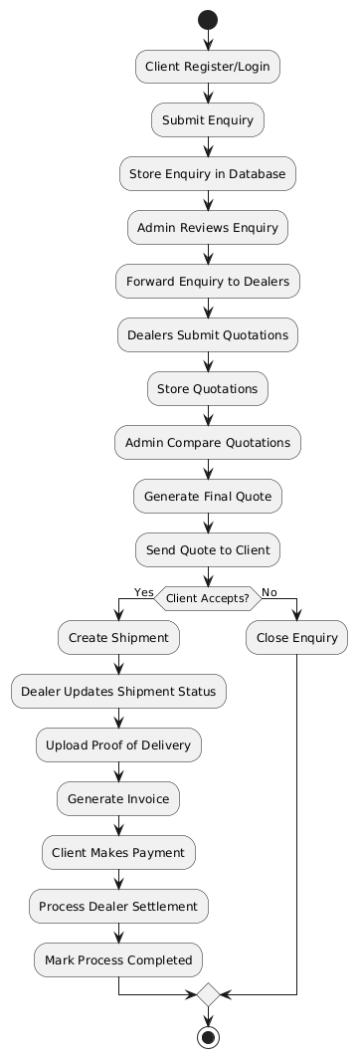

USE CASE DIAGRAM:
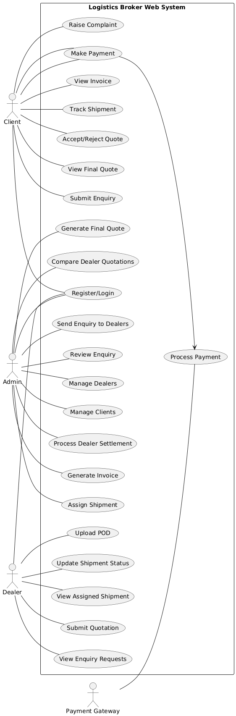
CLASS DIAGRAM:
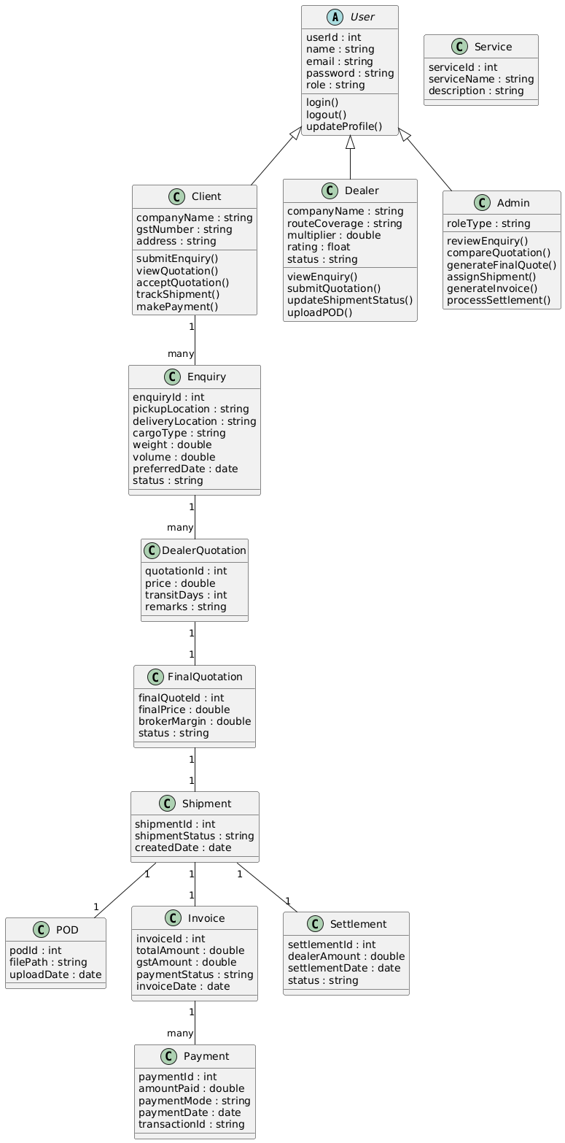
ER DIAGRAM :
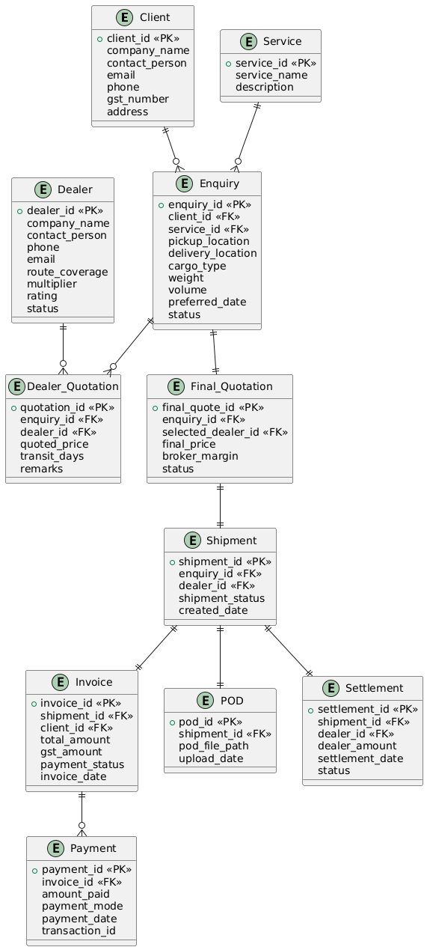

SEQUENCE DIAGRAMS :
  - Enquiry Submission Sequence Diagram –

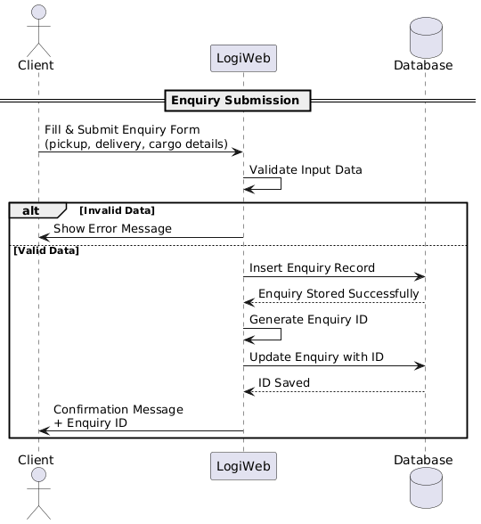

  - Dealer Rate Generation Sequence Diagram –
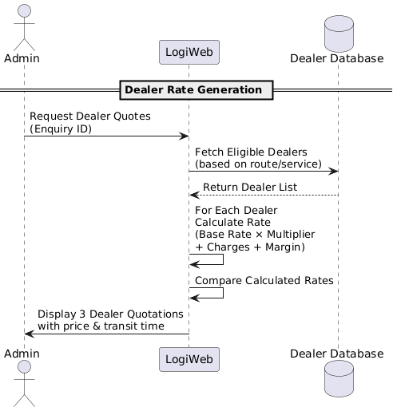
  - Quote Approval & Shipment Creation Sequence Diagram –
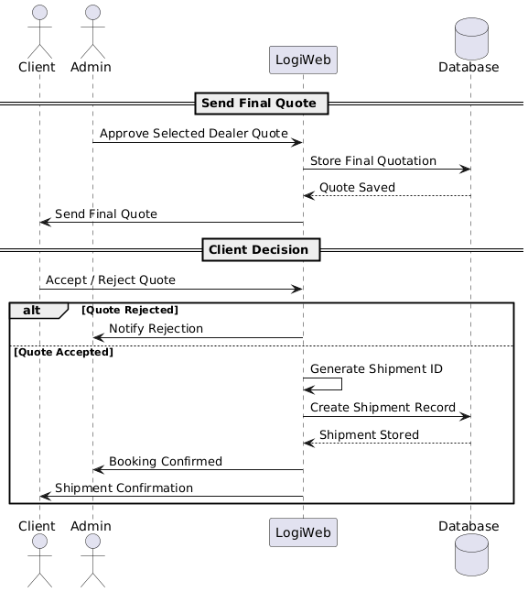

  - Shipment Tracking & POD Upload Sequence Diagram –
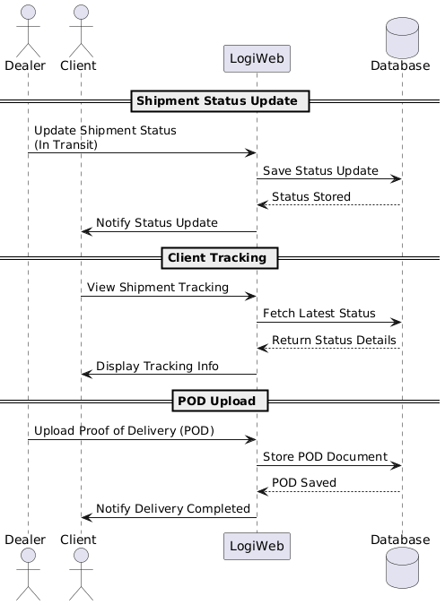

  - Billing & Payment Sequence Diagram –
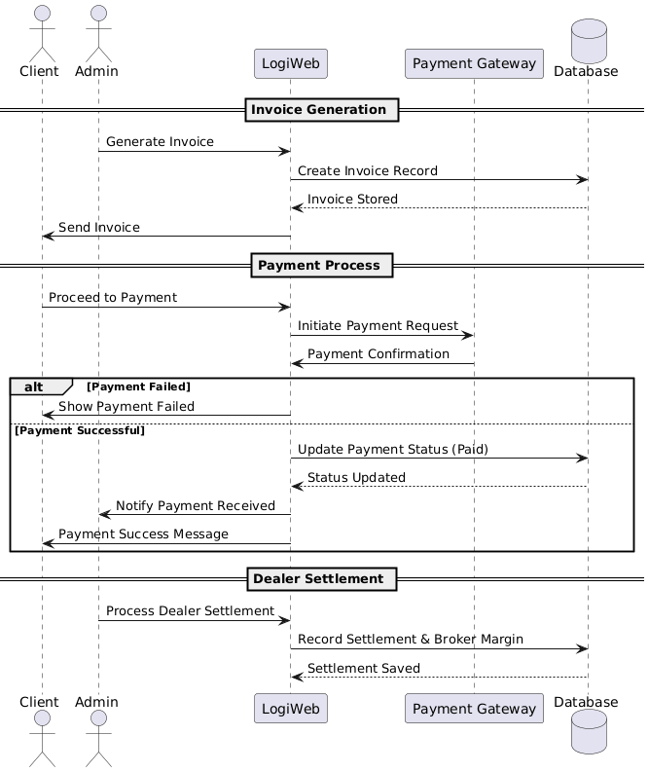

STATE DIAGRAMS:
  - Enquiry State Diagram –
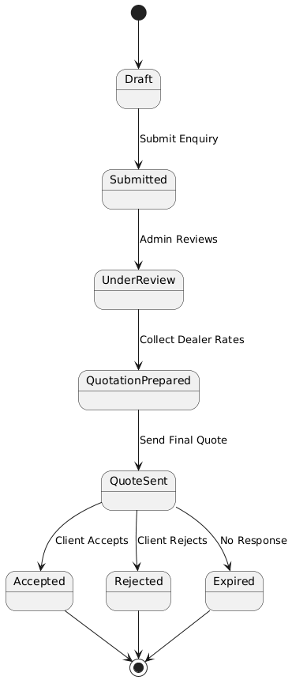

  - Shipment State Diagram –
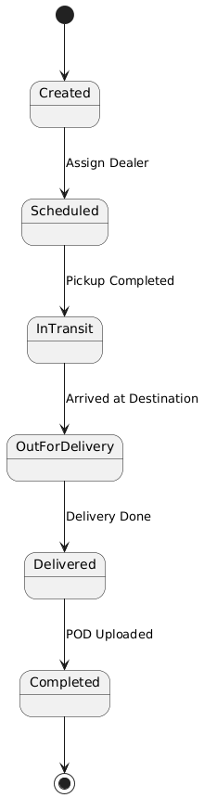
  - Payment State Diagram –
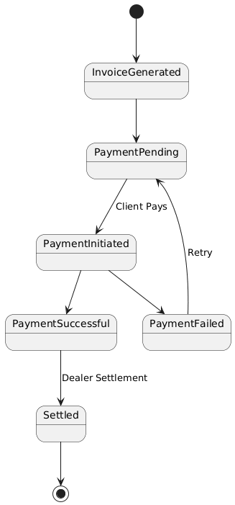

DATA DICTIONARIES : 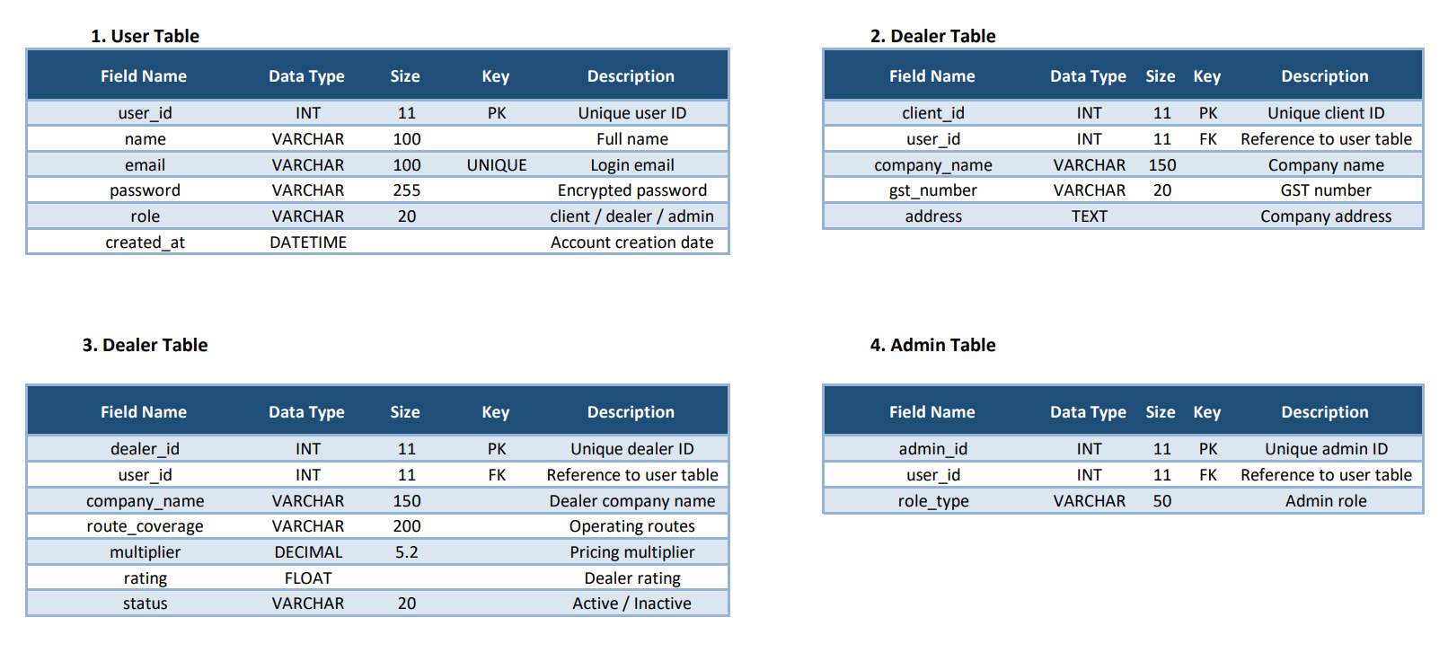
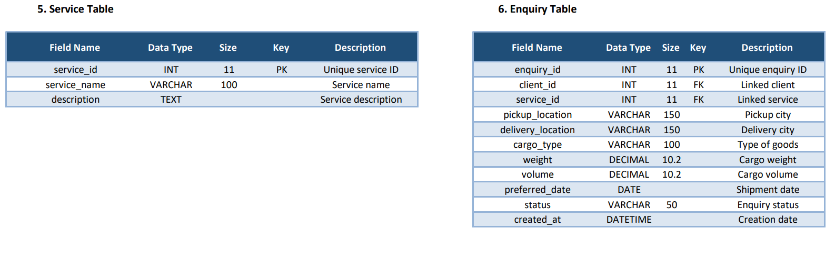
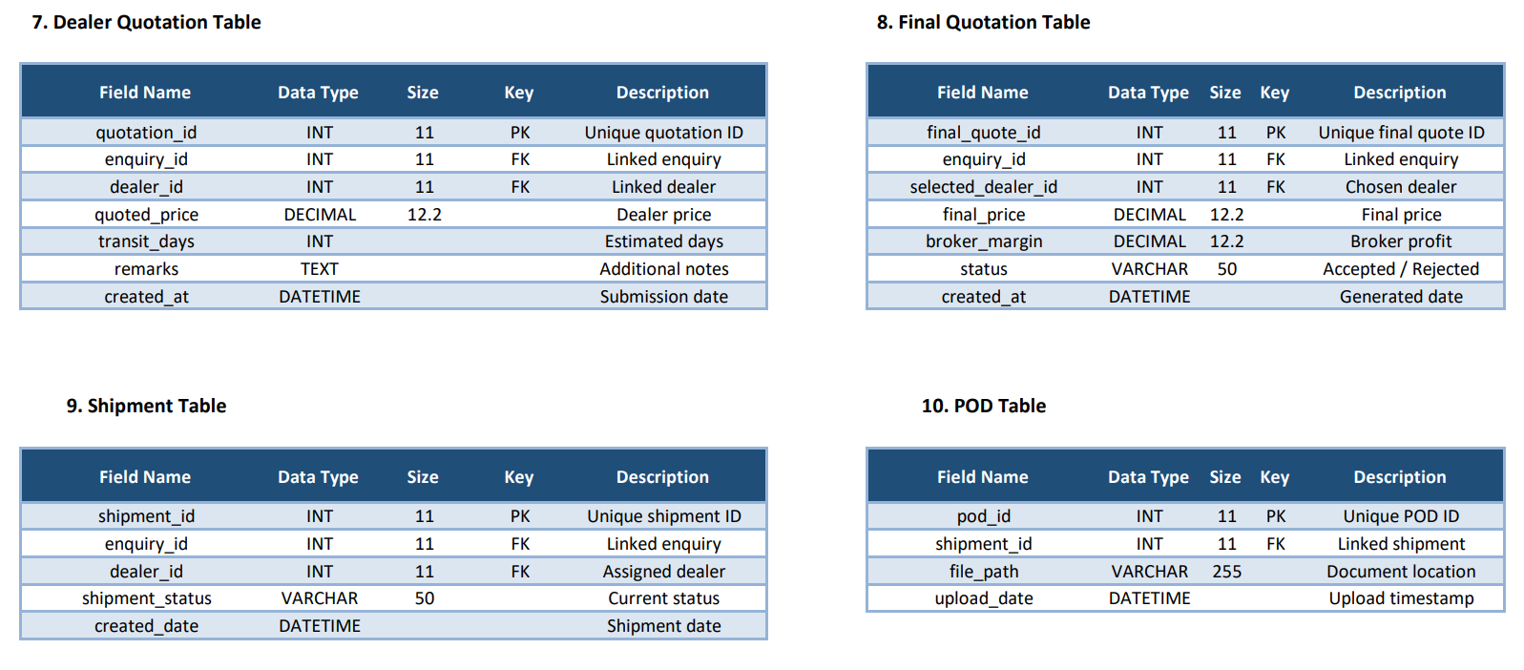
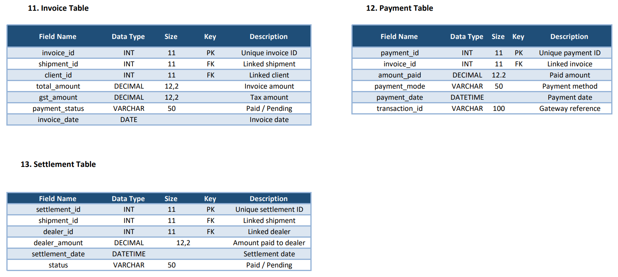
8. Future Enhancements
Future improvements may include real-time global positioning system tracking, integration with live shipping company application programming interfaces, artificial intelligence-based dealer selection algorithms, a mobile application version, and an advanced analytics dashboard for business insights.
- Real-time GPS tracking
- AI-based dealer selection
- Mobile application
- Live shipping API integration
- Analytics dashboard

9. Conclusion
Sadhi Logistic is a comprehensive web-based logistics broker platform that digitalizes and automates the traditional logistics brokerage process. The system ensures transparency, operational efficiency, and structured management of enquiries, quotations, shipments, and financial transactions. With its modern technology stack and structured architecture, the system demonstrates scalability, reliability, and practical applicability in the logistics industry.

