# Regional Sales Analytics - Comprehensive Report

### Regional Sales Analysis

Agenda:  
- Problem Statement  
- Approach  
- Data Overview  
- Project Workflow  
- Exploratory Data Analysis  
- Key Insights  
- Recommendation  
- Dashboard Preview

### Problem Statement

Inconsistent revenue and profit performance across U.S. regions.  
Lack of visibility into seasonal swings, top SKUs, and channel profitability.  
Goal: Leverage 5 years of historical data to pinpoint growth levers and optimize strategy.

### Approach

1. Exploratory Data Analysis  
 - Dive into historical sales, margins, products, channels, regions.  
2. Interactive Dashboard  
 - Build a live view for business users to self-serve insights.  
 - Enable ad-hoc slicing by time, product, region, channel.  
 - Surface trends, outliers & relationships.

### Project Workflow

Steps:  
- Import Libraries  
- Load Data  
- Initial Exploration  
- Pre-processing & Cleaning  
- Feature Engineering  
- EDA & Visualization  
- Key Insights  
- Recommendations

### Key Insights

- Pronounced Seasonality: January revenues average $124M, dipping to $95M in April.  
- SKU Concentration: Products 26 & 25 drive ~25% of sales.  
- Channel Trade-off: Wholesale captures 54% volume; Export leads with ~38% margin.  
- Geographic Dominance: California logs 7.6K orders ($230M).  
- Top customers: Aibox Company & State Ltd.

### Recommendations

- Seasonal Promotions: Launch recovery campaigns in April.  
- SKU Optimization: Focus on top products & phase out low-margin SKUs.  
- Channel Expansion: Incentivize Export partnerships.  
- Regional Investment: Replicate California's success.  
- Margin Monitoring: Flag orders below 80% margin.

### Conclusion

Completed end-to-end EDA and Power BI dashboard.  
Insights inform sales policies & operational planning.  
Stakeholders can self-serve analysis and onboard new datasets.

## Part 2: Detailed Summary for the Project Report

Summary of the End-to-End Data Analytics Project on **Regional Sales Analytics**

**1. Introduction and Project Overview**

An end-to-end data analytics project focusing on regional sales analysis. The project encompasses the full data analytics workflow, including:

1. Business understanding
2. Data collection
3. Data cleaning and preprocessing
4. Exploratory Data Analysis (EDA)
5. Insight generation
6. Dashboard creation and publishing

The goal is to provide a comprehensive demonstration of how to handle a sales dataset from raw form to a polished PowerBI dashboard. It encourages viewers to customize and extend the project rather than just copy it, highlighting the importance of creativity in portfolio projects.

**2. Dataset Description and Initial Setup**

The dataset used originates from a public source, likely Kaggle, containing sales data from 2014 to early 2018. It includes multiple Excel sheets:

* **Sales Orders:** Contains order number (primary key), customer info, order date, channel, currency, and foreign keys linking to other tables.
* **Customers:** Customer details with customer index as primary key.
* **Regions and State Regions:** Geographic data with region IDs and state codes.
* **Products:** Product details linked by product description index.
* **2017 Budget:** Budget data for products in 2017.

The relationships between these tables, emphasizing the importance of understanding foreign and primary keys for merging and analysis.

**3. Business Understanding and Problem Statement**

The core problem addressed is the lack of clear, data-driven regional sales insights for business teams. This project aims to:

1. Analyze and visualize regional sales data
2. Uncover trends and seasonality
3. Evaluate profitability across products, channels, and regions
4. Support strategic decision-making

The project highlights that while in real life, data analytics work is often fragmented (cleaning, dashboarding, extraction), portfolio projects should demonstrate the entire workflow cohesively.

**4. Data Analytics Workflow Overview**

The project follows a typical data analytics workflow:

* **Business Understanding:** Define the problem and objectives.
* **Data Understanding:** Analyze data sources, attributes, and relationships (entity-relationship diagrams).
* **Data Collection:**Acquire data from databases, flat files, or connectors.
* **Data Preparation and Cleaning:** Handle missing values, remove irrelevant columns, and merge tables as per relationships.
* **EDA:** Use Python and libraries like pandas, matplotlib, seaborn to explore data, find patterns, and create features.
* **Dashboarding:** Visualize insights in PowerBI, focusing on end-user needs and design best practices.

Project stresses the iterative nature of cleaning and EDA and the importance of domain knowledge throughout.

**5. Entity Relationship Diagram (ERD) and Data Merging**

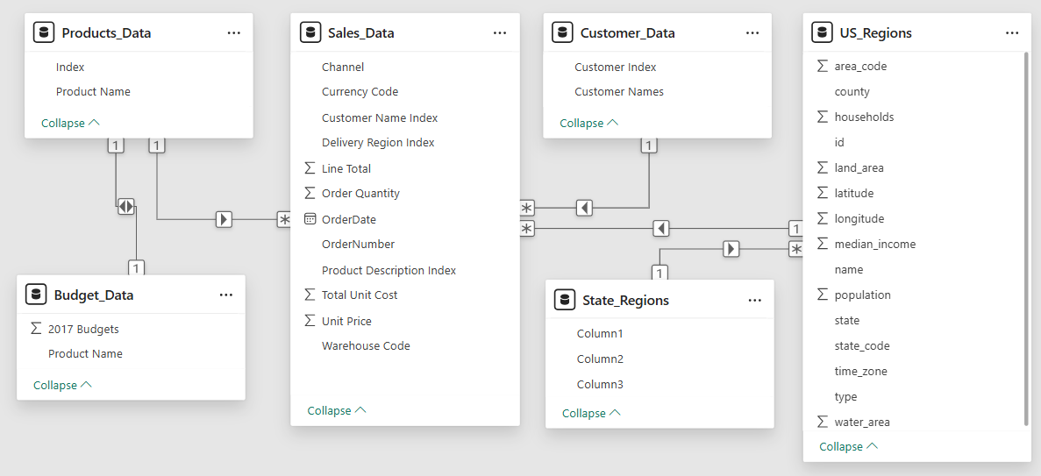

The critical step of understanding entity relationships in the dataset to perform accurate merges:

1. Primary keys: Unique identifiers (e.g., order number in sales, customer index in customers).
2. Foreign keys: References linking tables (e.g., customer name index in sales links to customer index in customers).
3. Relationships: One-to-many between customers and orders; one-to-many between regions and orders; many-to-many between products and orders.

Project shows how to merge the sales order data with customers, products, regions, state regions, and budget tables using left joins keyed on respective indices. This results in a consolidated dataframe with enriched information for analysis.

**6. Data Cleaning and Feature Selection**

Several columns were identified as redundant or irrelevant (e.g., duplicate indices, warehouse codes without references) and dropped. Domain knowledge is used to decide which columns to retain, including:

* Essential columns like order number, order date, customer name, product name, channel, order quantity, unit price, line total (revenue), total unit cost, state code, region, etc.
* Columns useful for geographic analysis like latitude and longitude, county, and state.
* Columns like population and area were excluded as they were less relevant for sales analysis.

This pruning helps focus on meaningful features and reduces noise. The final dataset structure:

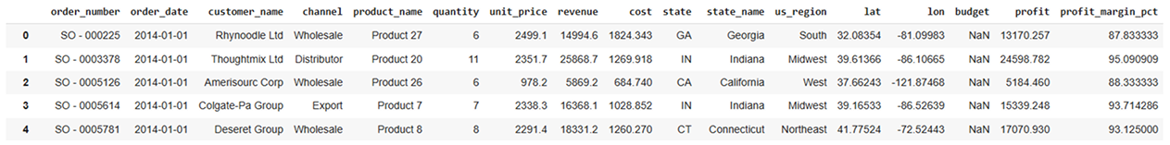

**7. Feature Engineering and Profit Calculation**

The new features critical for business insights:

* Revenue: Taken directly as line total.
* Total Cost: Calculated as order quantity multiplied by total unit cost.
* Profit: Revenue minus total cost.
* Profit Margin (%): Profit divided by revenue, multiplied by 100.

These features form the basis for profitability analysis and further visualization.

**8. Exploratory Data Analysis (EDA)**

Conducted various analyses to uncover trends and patterns:

1. **Monthly Sales Trend:**

Time series line chart showing revenue fluctuations from 2014 to 2017.

Identification of seasonality with sales spikes and dips (e.g., lower sales in January, spikes in May).

Discussion of outliers and the impact of excluding incomplete 2018 data.

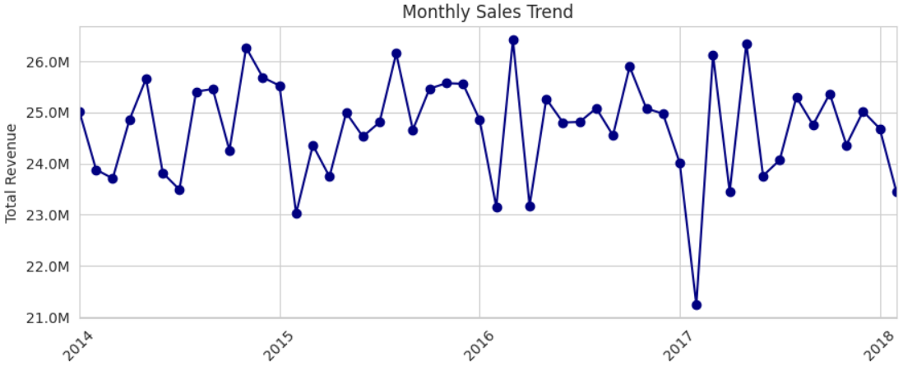

1. **Monthly Sales Aggregated Across Years:**

Aggregated sales by calendar month to identify peak months (May highest revenue).

Explanation of discrepancies between yearly and aggregate monthly views.

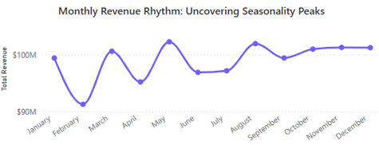

1. **Top and Bottom 10 Products by Revenue:**

Bar charts showing highest and lowest revenue-generating products.

Product 26 and 25 lead sales with significant revenue gaps to others.

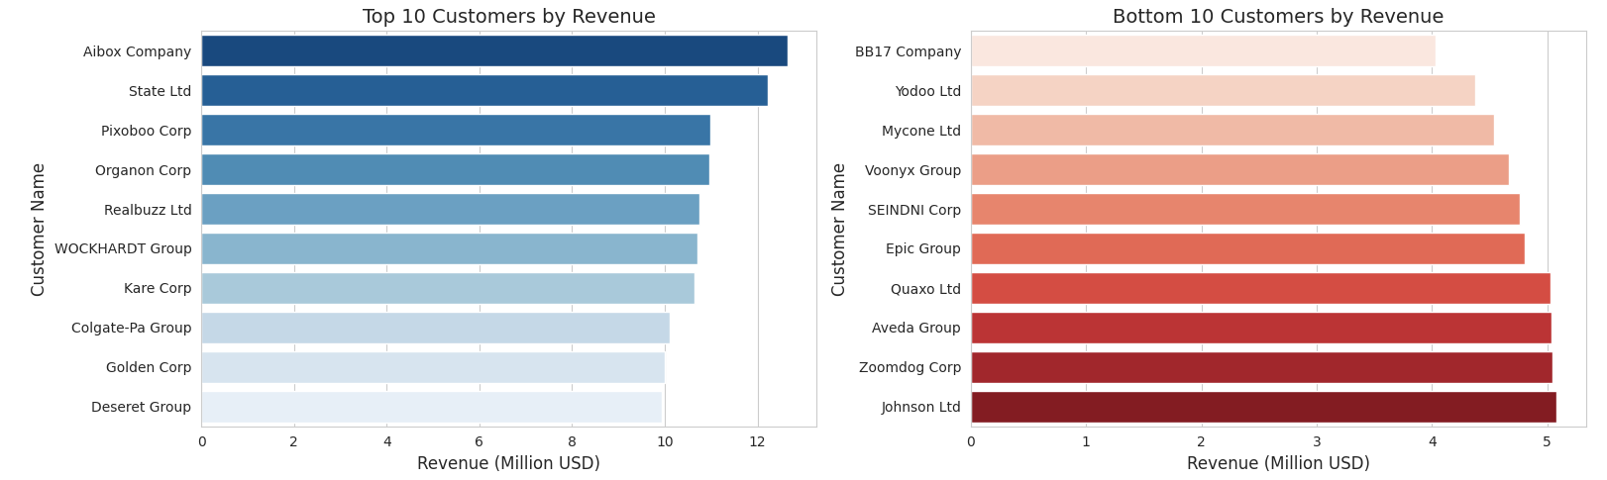

1. **Sales by Channel:**

Pie chart distribution of sales across channels: Wholesale (54%), Distributor (31%), Export (15%).

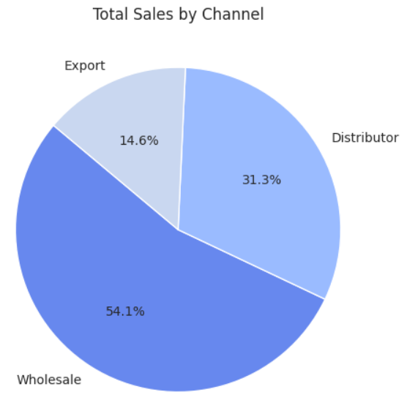

1. **Average Order Value Distribution:**

Histogram showing right-skewed distribution with most orders between $20K-$100K and a long tail of high-value orders.

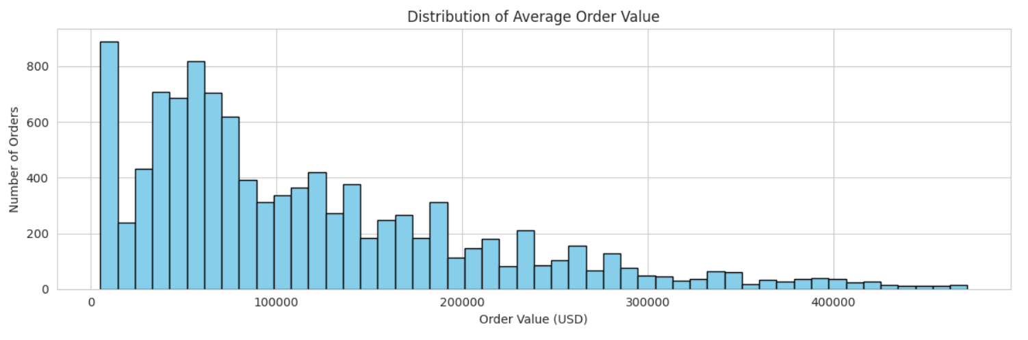

1. **Unit Price Distribution per Product:**

Visualization showing variance in unit prices across products.

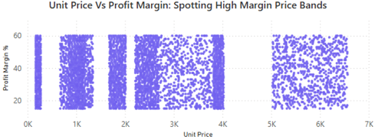

1. **Top 10 States by Revenue and Order Count:**

Geographic analysis highlighting states like California, Illinois, Florida with highest sales.

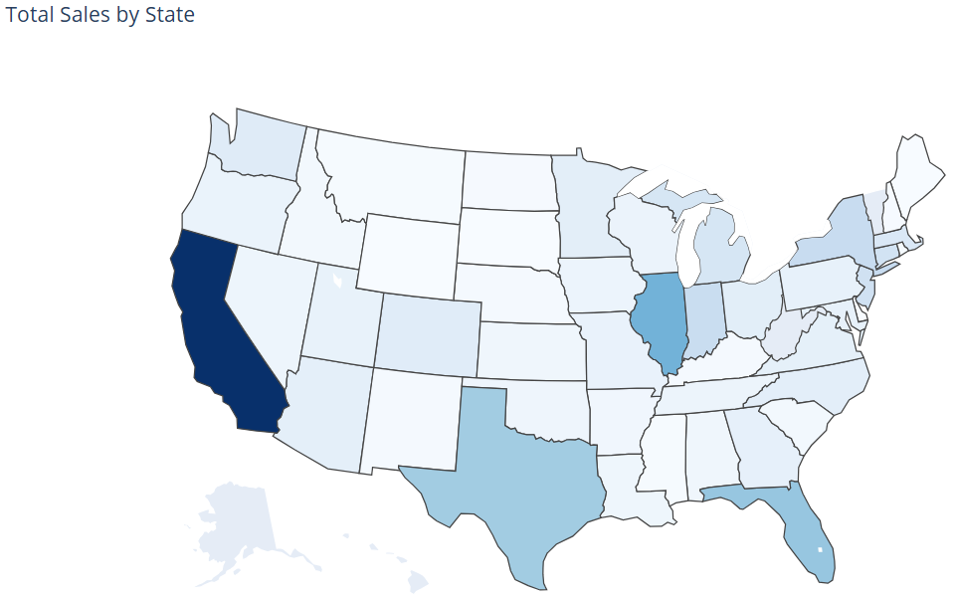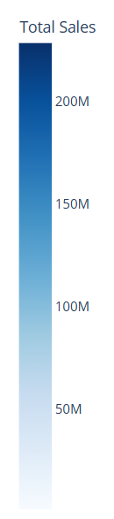

1. **Customer Segmentation:**

Clustering customers based on revenue and profit margin, identifying high-revenue/high-margin segments.

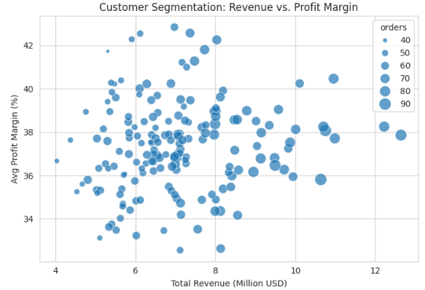

1. **Correlation Heatmap:**

Strong correlations between revenue, profit, and unit price.

Order quantity less correlated, indicating other factors drive revenue/profit.

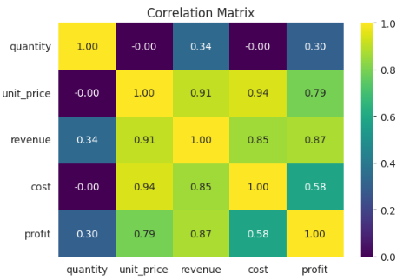

**9. Key Insights from EDA**

- Majority sales come from wholesale channels.

- May is consistently the highest revenue month across years.

- A few products dominate revenue, with a sharp drop-off for others.

- Sales distribution is highly skewed towards smaller orders with a few large transactions.

- Geographic concentration in top states like California.

- Customer segmentation reveals distinct groups by revenue and profit margin.

- These insights provide a data-driven foundation for decision-making and dashboard design.

**10. PowerBI Dashboard Creation**

The transitions to building the PowerBI dashboard, highlighting key considerations:

**Client-Centric Design:**

* Understand who will use the dashboard and their requirements.
* Conduct client interviews to align KPIs, color palettes, and UX standards.
* Use corporate design standards for consistency.

**Dashboard Structure:**

* Create a homepage with navigation buttons.
* Build multiple pages: Executive Overview & Trends, Product & Channel Performance, Geographic & Customer Insights.
* Use sketches and prototypes (tools like Canva, Figma) to design layout before implementation.

**Dashboard Elements:**

* KPIs displayed as cards (Total Revenue, Total Profit, Profit Margin %, Number of Orders, Revenue per Order).
* Time series line charts for monthly revenue and profit.
* Bar charts for product revenue and profit margin.
* Pie charts for channel sales distribution.
* Interactive slicers and filters for year, month, region, channel.
* Bookmarks for toggling top/bottom customer views.

**Technical Tips:**

* Preprocess and clean data before loading into PowerBI to reduce transformation load.
* Use DAX measures for calculated KPIs like profit margin and revenue per order.
* Sort month names by month number for correct chronological order.
* Implement page navigation buttons for seamless user experience.

**11. Publishing and Maintenance (for future scope)**

**Briefly covered deployment:**

* Publish dashboards to PowerBI service () using Pro licenses.
* Set up scheduled data refreshes based on client requirements (daily, weekly).

**Configure Role-Level Security (RLS) for data access control.**

* Troubleshoot common issues like map visualization settings, missing data labels, and refresh errors.
* Emphasizes working with data engineering teams for data pipelines and automation.

**12. Key Insights and Learnings**

End-to-end data analytics projects in sales require a blend of domain knowledge, data engineering, exploratory analysis, and visualization skills.

Understanding data relationships and cleaning are foundational steps before any meaningful analysis.

Feature engineering (e.g., calculating profit, profit margin) is critical for business insights.

Exploratory data analysis reveals trends, seasonality, outliers, and key drivers which inform dashboard KPIs.

PowerBI dashboards must be designed with user needs, corporate standards, and scalability in mind.

Leveraging AI tools can streamline coding and visualization tasks.

Real-world projects require iterative feedback loops with stakeholders and collaboration across teams.

This comprehensive project demonstration provides actionable knowledge for aspiring data analysts to build robust, client-ready sales analytics solutions from raw data to interactive dashboards.

**13. Conclusion**

Completed end‑to‑end EDA and interactive Power BI dashboard, surfacing seasonality, SKU, channel & regional insights. Insights inform sales policies and operational planning (store & warehouse prep aligned with annual trends). Stakeholders can self‑serve real‑time analysis and confidently onboard new datasets for additional use cases.