3-Bit Flash ADC Report

Definition of Flash ADC
A Flash Analog-to-Digital Converter (Flash ADC) is the fastest ADC architecture. It uses a resistor ladder to generate reference voltages and multiple comparators to compare the analog input simultaneously. The comparator outputs form a thermometer code, which is converted into binary using a thermometer encoder.

Simulation Parameters
Parameter | Value
VDD | 1.8 V
VREF | 1.8 V
VINP | Sine Wave, Frequency = 20 kHz, Amplitude = 800 mV, DC Level = 800 mV
CLK | 0 V to 1.8 V, Period = 195.61 ns, Rise = 100 ps, Fall = 100 ps, Pulse Width = 95.31 ns

Overall Flash ADC Schematic

Schematic
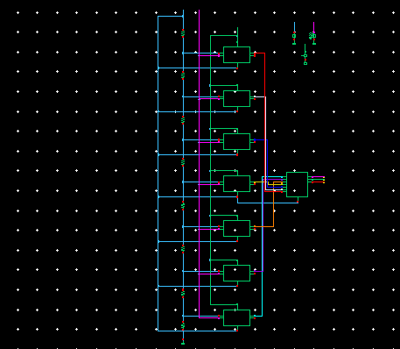
Figure 1: Overall 3-bit Flash ADC schematic (comparator array, encoder, and reference ladder)
Waveform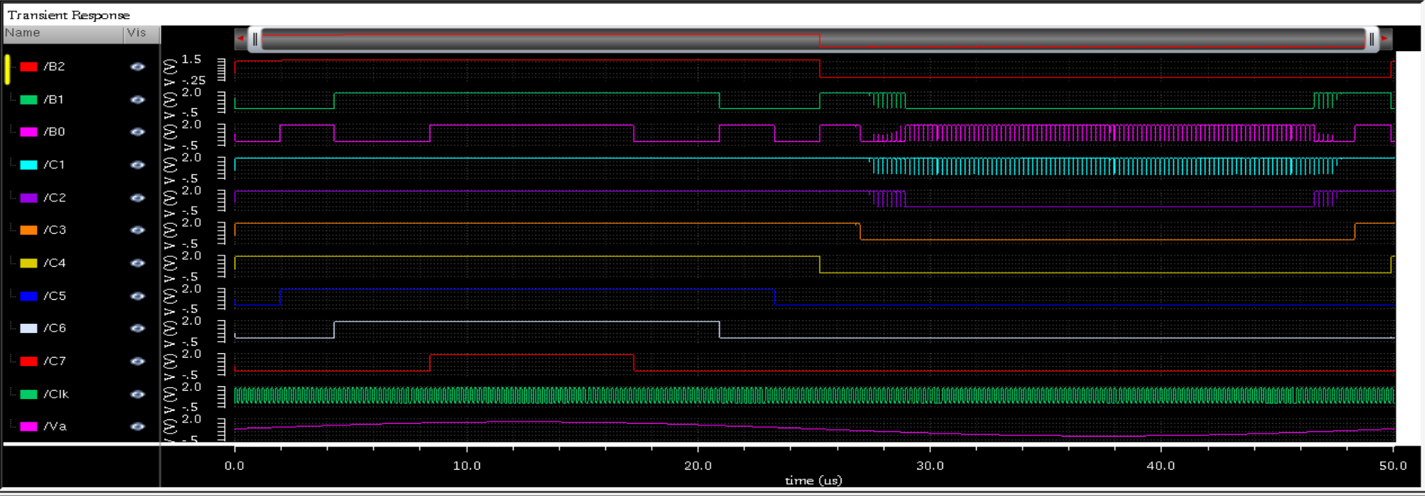
Figure 2: Transient response showing digital outputs (B2 B1 B0), comparator outputs (C1-C7), clock, and analog input

Calculations
Parameter | Value
Resolution (n bits) | 3 Bits
Number of Comparators (2^n - 1) | 7 Comparators
LSB (VREF / 2^n) | 0.225 V
Clock-to-Q Delay | 613p S
Average Power Consumption | 635.3u W

Comparator Block
Definition: The comparator compares the analog input with a reference voltage and produces a digital logic output.

Schematic
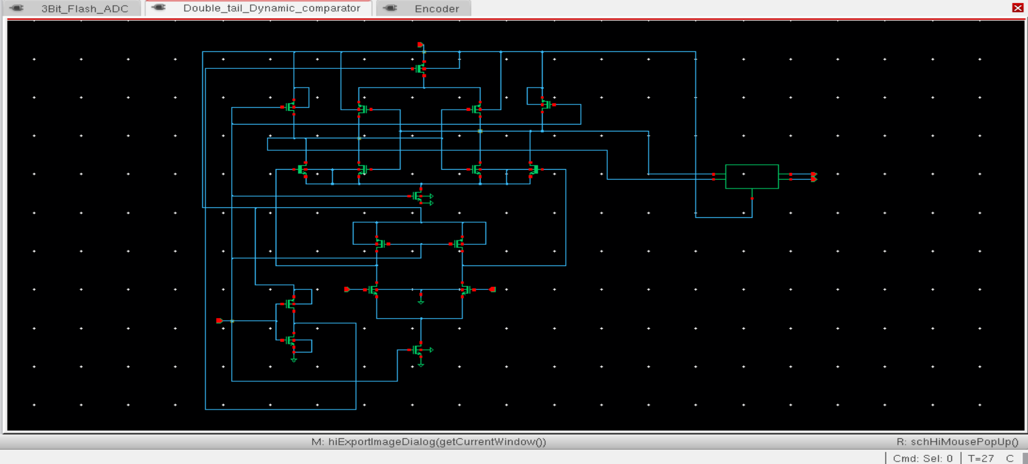
Figure 7: Double-tail dynamic comparator schematic

Waveform
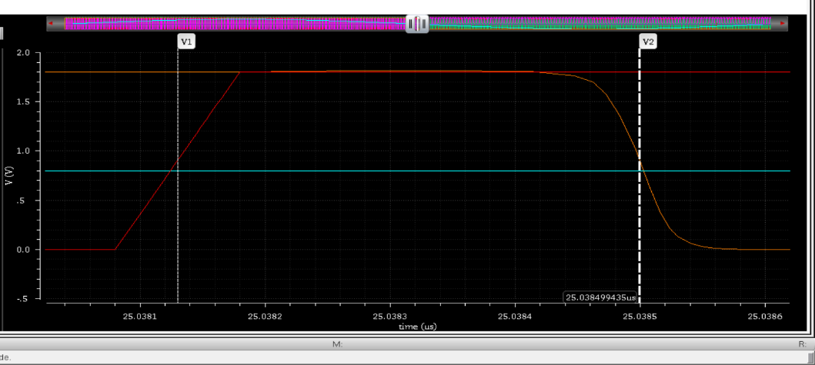
Figure 8: Clock-to-Q delay of the double-tail dynamic comparator
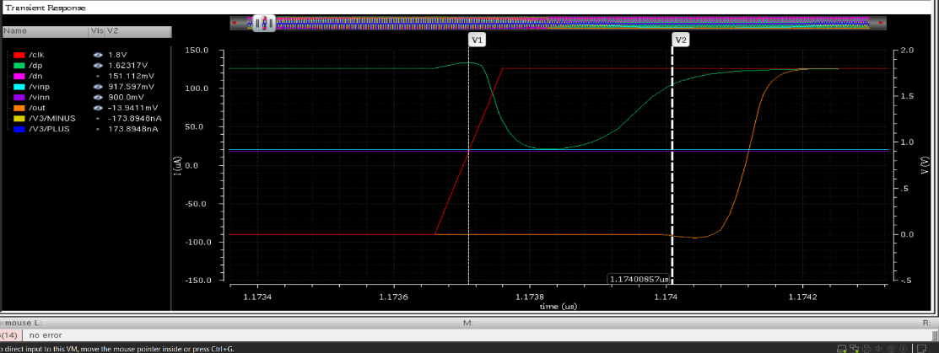
Figure 9: Regeneration time of the double-tail dynamic comparator
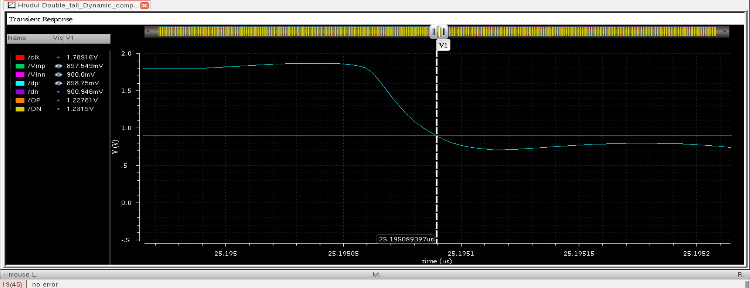
Figure 10: Input offset voltage characterization of the comparator
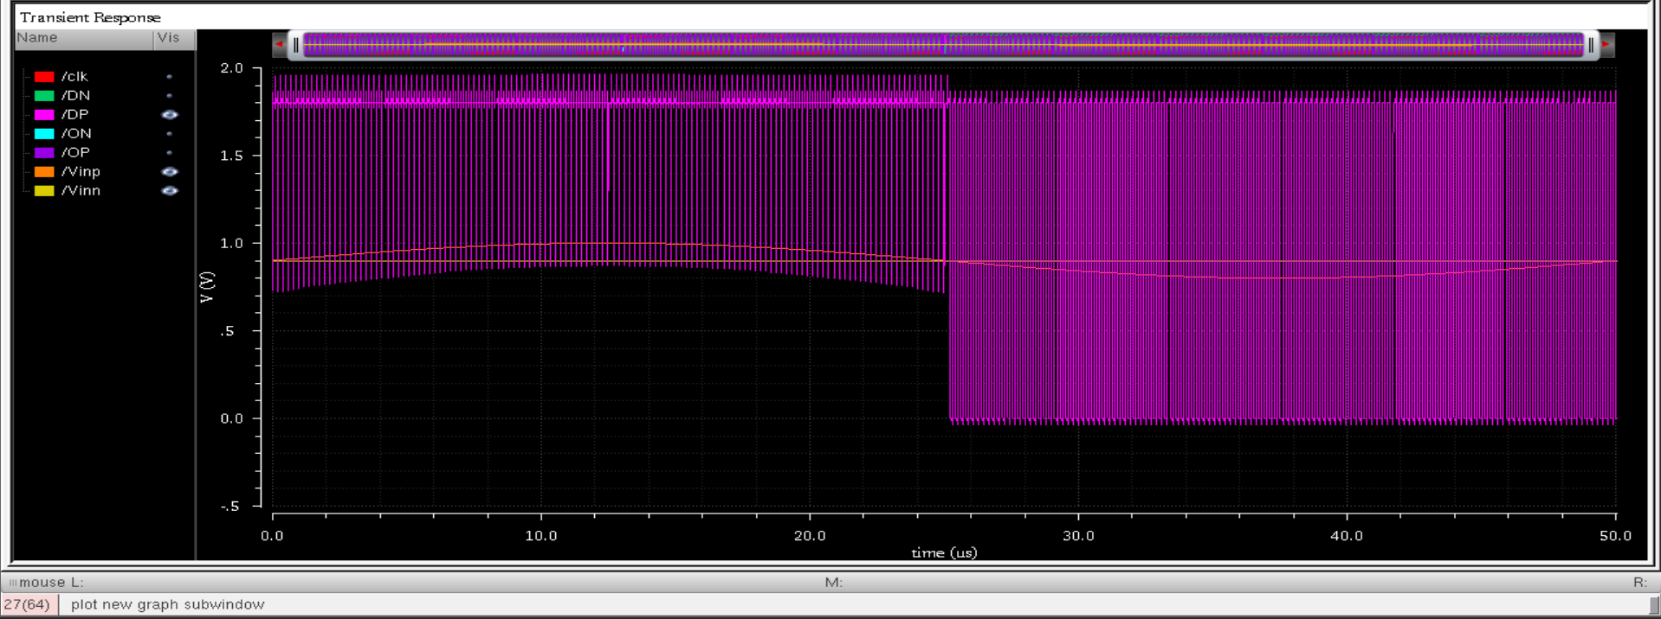
Figure 11: Internal node (DP/DN) transient response of the comparator
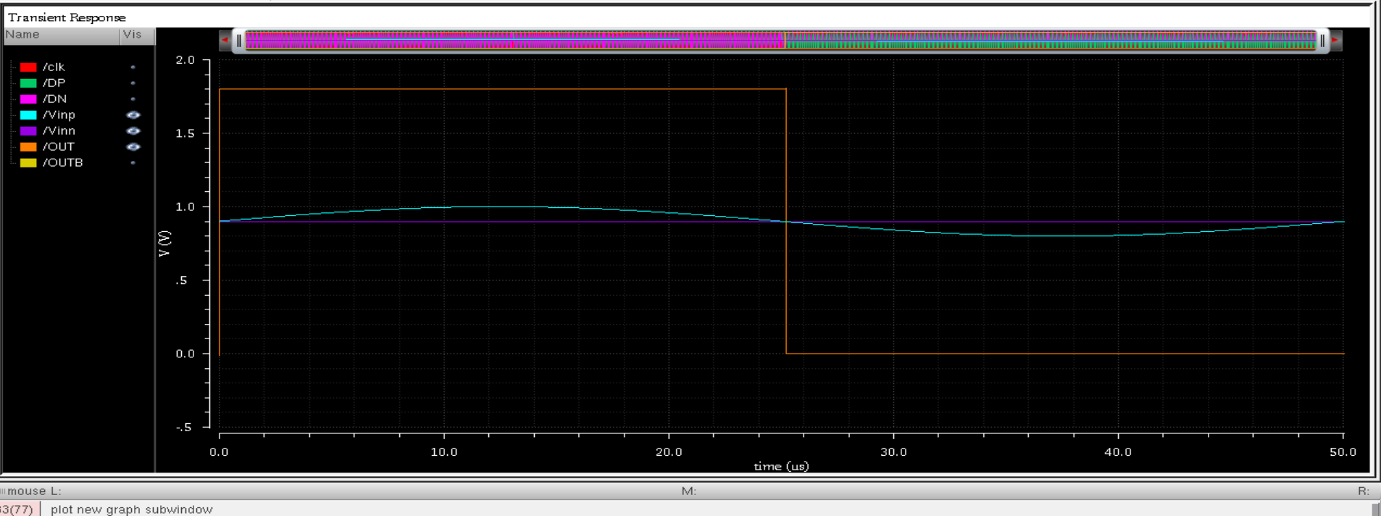
Figure 12: SR latch output (OUT/OUTB) of the comparator

Calculations
Parameter | Value
Technology | GPD090
Supply Voltage (VDD) | 1.8 V
Clock Period / Frequency | 195.31 ns / 5.12 MHz
Clock-to-Q Delay | 410p S
Regeneration Time | 298p S
Average Power Consumption | 1.345u W
Input Offset Voltage | 5.7m V

Encoder Block
Definition: The thermometer encoder converts the comparator outputs into a 3-bit binary code.

Schematic
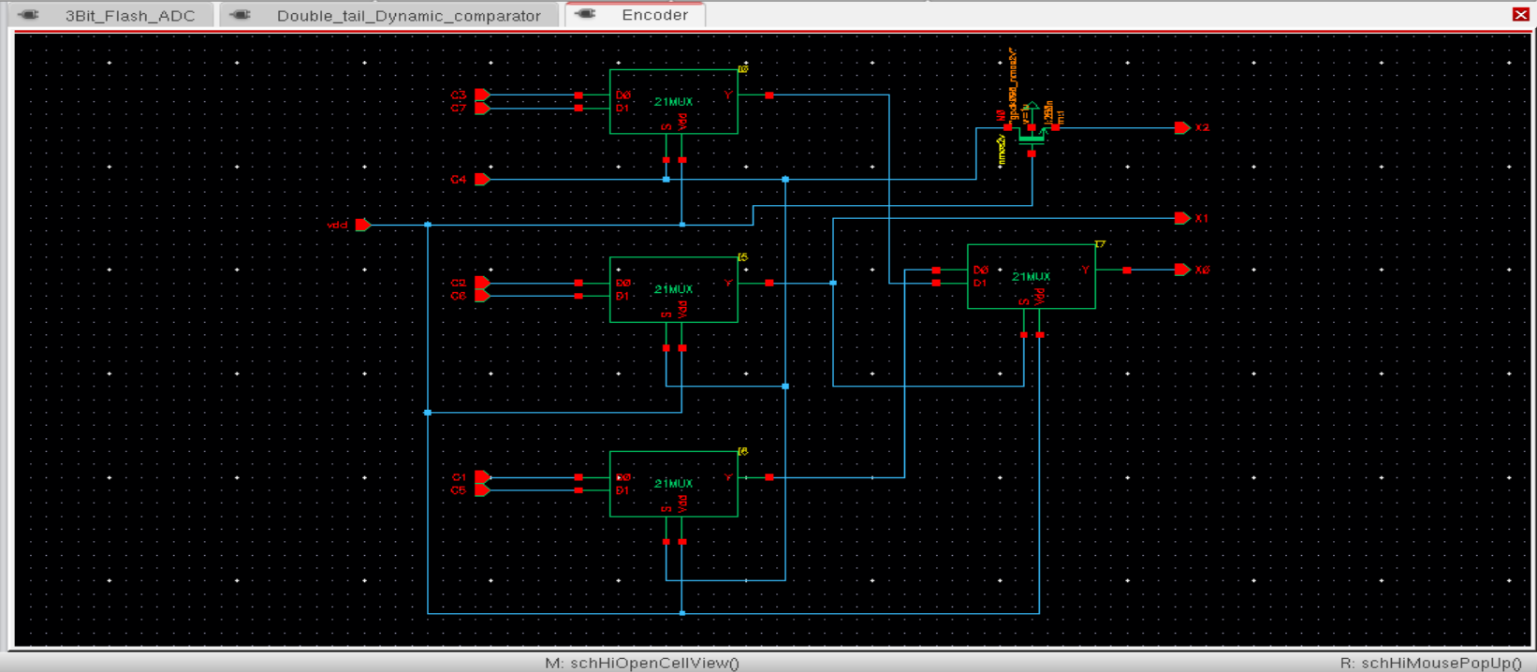
Figure 13: Thermometer-to-binary encoder schematic (2:1 MUX tree)

Calculations
Parameter | Value
Number of 2:1 MUX Stages | 4
Encoder Power Consumption | 33.46p S
Encoding Logic Verified (Y/N) | Y

Truth Table
Comparator Outputs (C7 C6 C5 C4 C3 C2 C1) | D2 D1 D0
0000000 | 000
0000001 | 001
0000011 | 010
0000111 | 011
0001111 | 100
0011111 | 101
0111111 | 110
1111111 | 111

