

Code For FormMouseClicked:

bLoginPage a=new bLoginPage();

a.setVisible(true);

this.setVisible(false);

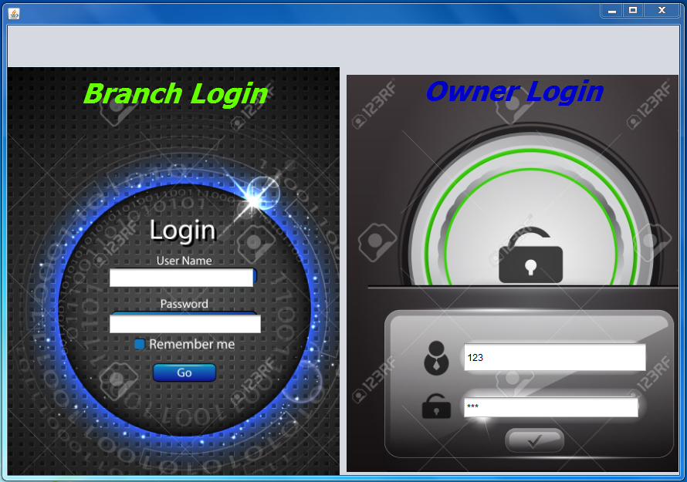

Code for OwnerLoginButton:

String admname=jTextField2.getText();

String password=new String(jPasswordField2.getPassword()),con="";

if(admname.isEmpty()||password.isEmpty())

{JOptionPane.showMessageDialog(this,"Please enter details");}

else

{

try{

Class.forName("java.sql.DriverManager");

Connection con1;

Statement st;

con1=(Connection) DriverManager.getConnection("jdbc:mysql://localhost:3306/optimist","root","admin");

st=(Statement) con1.createStatement();

String qu="select * from login where username='"+admname+"';";

ResultSet rs;

rs=st.executeQuery(qu);

while(rs.next()){

con=rs.getString(2);}

String wc=String.valueOf(password);

if (con.equals(password)){

cOwnerPage a=new cOwnerPage();

a.setVisible(true);

this.setVisible(false);

}

else JOptionPane.showMessageDialog(this,"please enter a valid username and passsword");

}

catch(Exception e){

JOptionPane.showMessageDialog(this,e.getMessage());

}

}

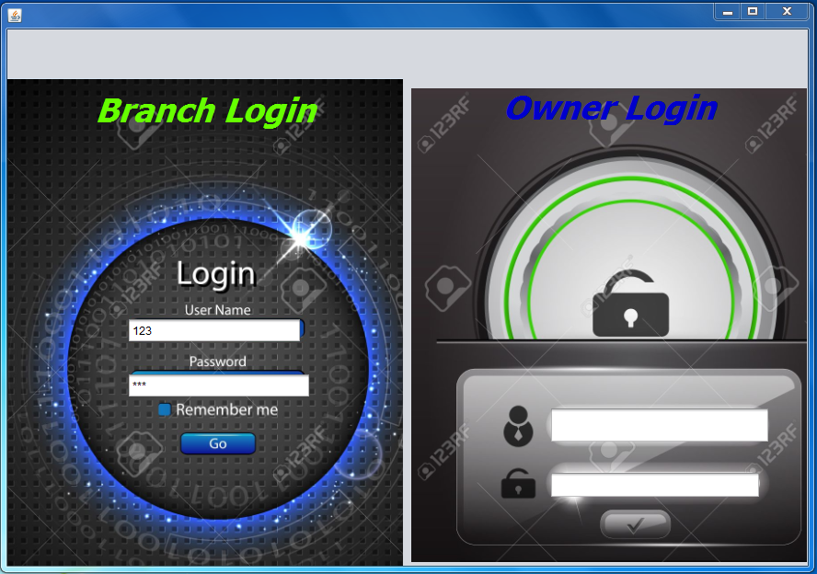

Code for BranchLoginButton:

String branchname=jTextField1.getText();

String password1=new String(jPasswordField1.getPassword()),con;

con = "";

if(branchname.isEmpty()||password1.isEmpty())

{JOptionPane.showMessageDialog(this,"Please entre details");}

else

{

try{

Class.forName("java.sql.DriverManager");

Connection con1;

Statement st;

con1=(Connection) DriverManager.getConnection("jdbc:mysql://localhost:3306/optimist","root","admin");

st=(Statement) con1.createStatement();

String qu="select * from login where username='"+branchname+"';";

ResultSet rs;

rs=st.executeQuery(qu);

while(rs.next()){

con=rs.getString(2);}

String wc=String.valueOf(password1);

if (con.equals(password1)){

d a=new d();

a.setVisible(true);

this.setVisible(false);

}

else JOptionPane.showMessageDialog(this,"please enter a valid username and passsword");

}

catch(Exception e){

JOptionPane.showMessageDialog(this,e.getMessage());

}

}

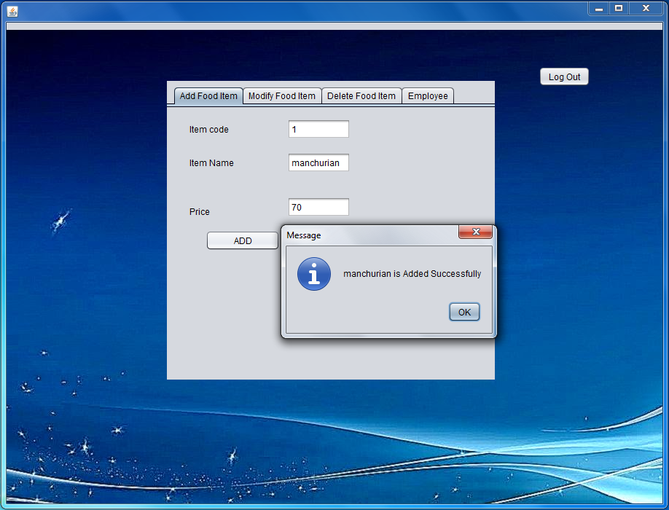

Code for Add Button:-

int ICode=Integer.parseInt(ItemCodeTF.getText());

String IName=ItemNameTF.getText();

double IPrice=Double.parseDouble(PriceTF.getText());

if(IName.isEmpty())

{

JOptionPane.showMessageDialog(this,"Please enter details");

}

else

{

try{

Class.forName("java.sql.DriverManager");

Connection con1;

Statement st;

con1=(Connection) DriverManager.getConnection("jdbc:mysql://localhost:3306/optimist","root","admin");

st=(Statement) con1.createStatement();

String qu="insert into food values ('"+ICode+"','"+IName+"','"+IPrice+"');";

st.executeUpdate(qu);

JOptionPane.showMessageDialog(this,IName +" is Added Successfully");

}

catch(Exception e){

JOptionPane.showMessageDialog(this,e.getMessage());

}

ItemCodeTF.setText("");

ItemNameTF.setText("");

PriceTF.setText("");

}

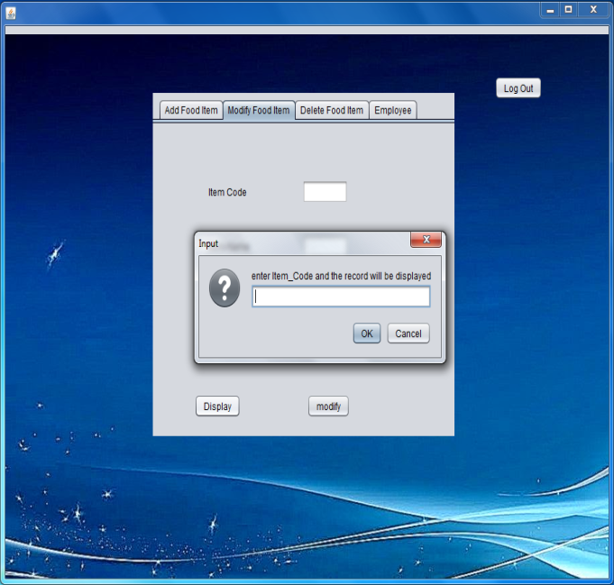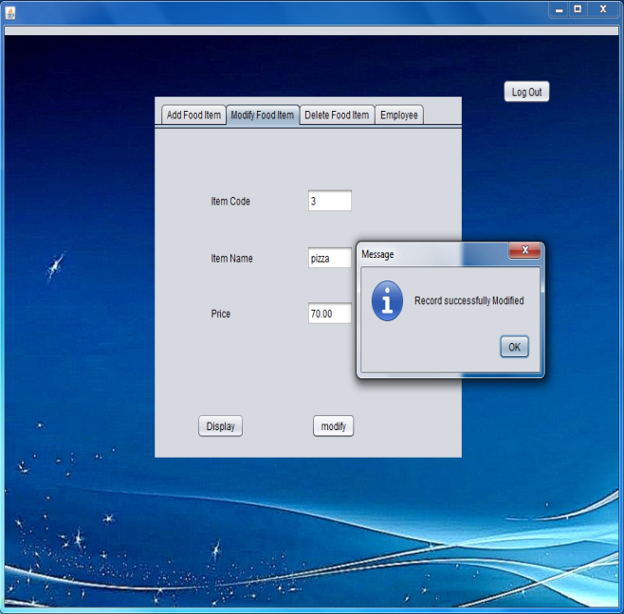

Code for Display Button:-

String Code=JOptionPane.showInputDialog("enter Item_Code and the record will be displayed");

String IName="",IPrice="",ICode="";

try{

Class.forName("java.sql.DriverManager");

Connection con1;

Statement st;

con1=DriverManager.getConnection("jdbc:mysql://localhost:3306/optimist","root","admin");

st=con1.createStatement();

String qu="Select * from FOOD where item_code='"+Code+"';";

ResultSet rs;

rs=st.executeQuery(qu);

while(rs.next()){

ICode=rs.getString("Item_code");

IName=rs.getString("item_name");

IPrice=rs.getString("price");

}

if(Code.equals(ICode)){

ModifyICodeTF.setText(""+ICode);

ModifyINameTF.setText(IName);

ModifyIPriceTF.setText(""+IPrice);

}

else

{

JOptionPane.showMessageDialog(this,"Item does not exist with code = "+Code);

}

}

catch(Exception e){

JOptionPane.showMessageDialog(this,e.getMessage());

}

Code for Modify Button:-

int c=JOptionPane.showConfirmDialog(this,"Do you want to modify?","Confirm",JOptionPane.YES_NO_CANCEL_OPTION);

if(c==0){

int ICode=Integer.parseInt(ModifyICodeTF.getText());

String IName=ModifyINameTF.getText();

double IPrice=Double.parseDouble(ModifyIPriceTF.getText());

try{

Class.forName("java.sql.DriverManager");

Connection con1;

Statement st;

con1=DriverManager.getConnection("jdbc:mysql://localhost:3306/optimist","root","admin");

st=con1.createStatement();

String qu="update food set item_name='"+IName+"',price='"+IPrice+"' where item_code='"+ICode+"';";

st.executeUpdate(qu);

JOptionPane.showMessageDialog(this,"Record successfully Modified");

}

catch(Exception e){

JOptionPane.showMessageDialog(this,e.getMessage());

}

ModifyICodeTF.setText("");

ModifyINameTF.setText("");

ModifyIPriceTF.setText("");

}

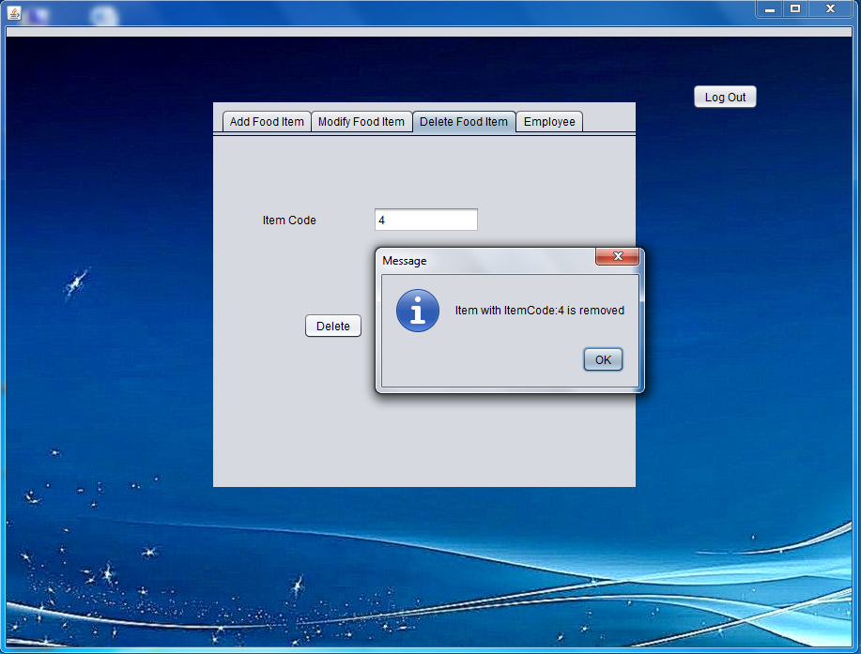

Code for Delete Button:

String Icode=DeleteICodeTF.getText();

try

{

Class.forName("java.sql.DriverManager");

Connection con1;

Statement st;

con1=DriverManager.getConnection("jdbc:mysql://localhost:3306/optimist","root","admin");

st=con1.createStatement();

String qu="delete from food where item_code='"+Icode+"';";

st.executeUpdate(qu);

JOptionPane.showMessageDialog(this,"Item with ItemCode:"+Icode + " is removed");

}

catch(Exception e)

{

JOptionPane.showMessageDialog(this,e.getMessage());

}

DeleteICodeTF.setText("");