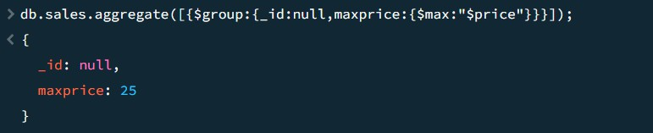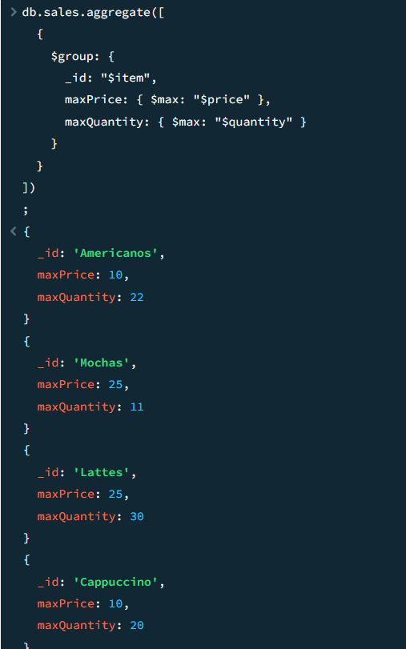

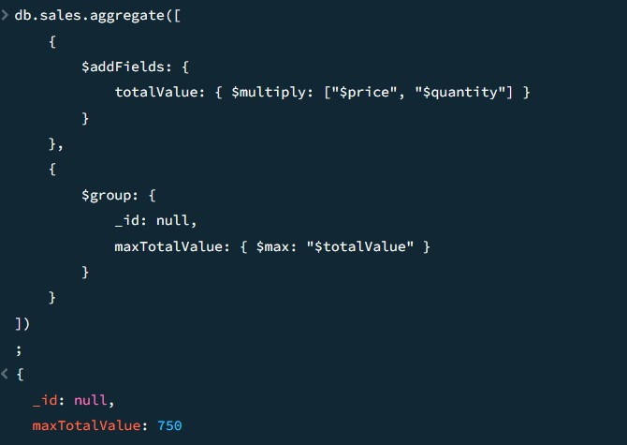

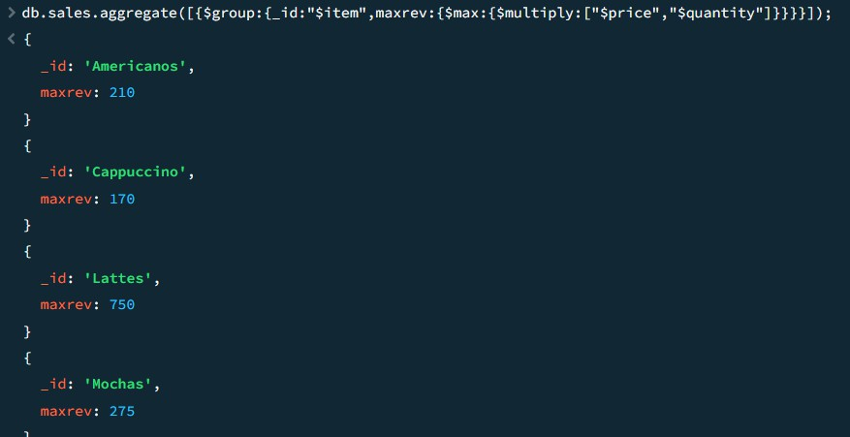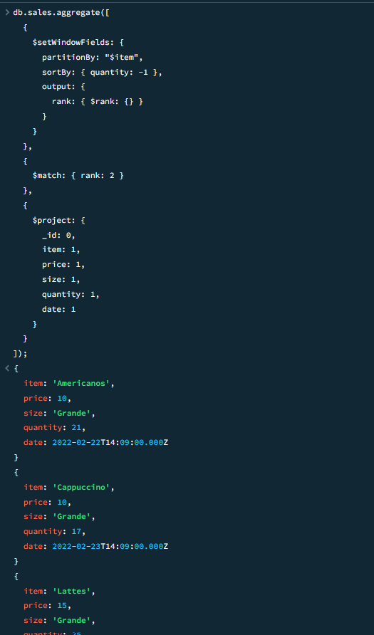

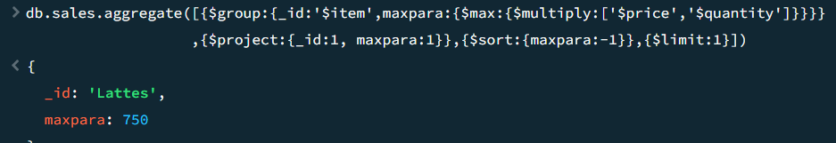

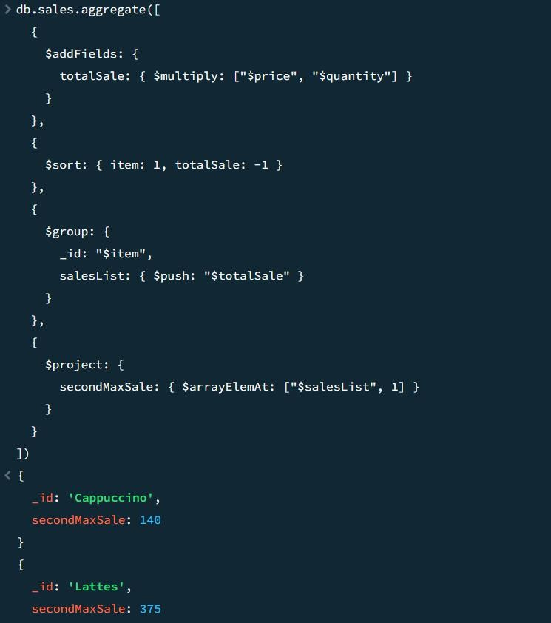

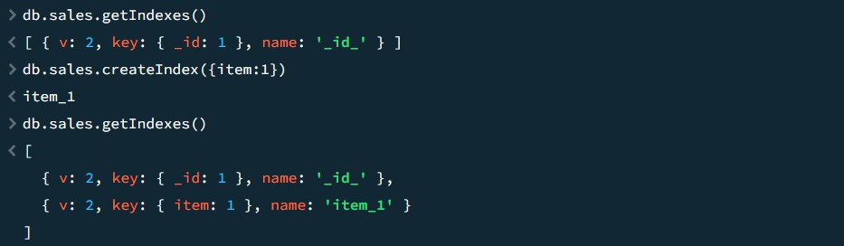

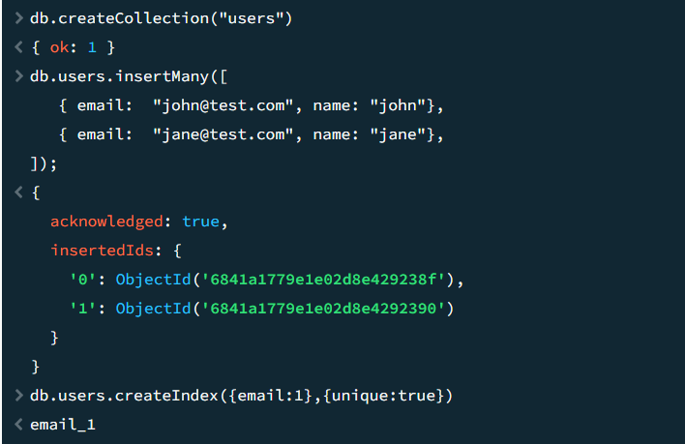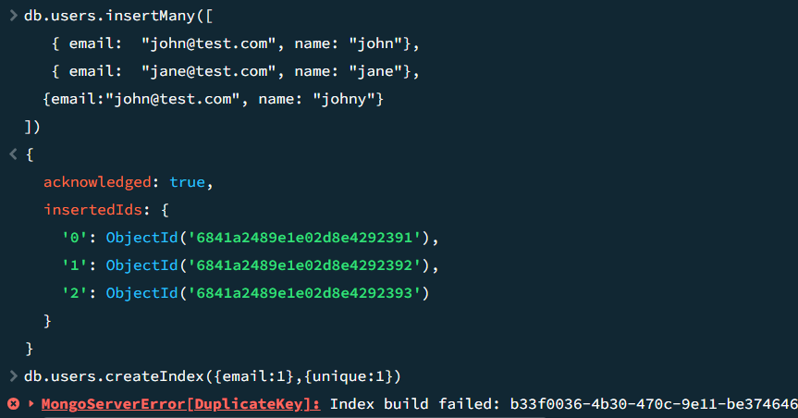

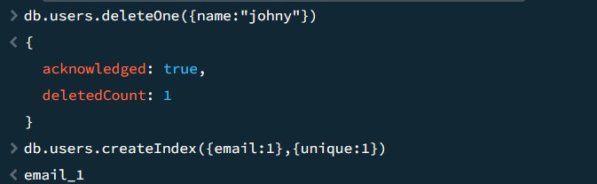

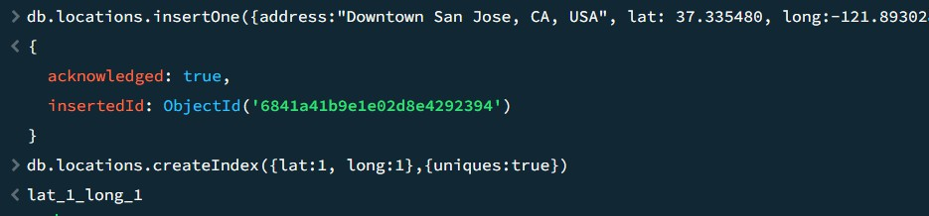

**package** connection;

**import** com.mongodb.MongoClient;

**import** com.mongodb.MongoCredential;

**import** com.mongodb.client.MongoDatabase;

**public class** mongoDB {

**public static void** main(String[] args) {

**try** { MongoClient db

= **new** MongoClient("localhost", 27017);

MongoCredential credential; credential

= MongoCredential

.*createCredential*(

"GFGUser", "mongoDb", "password".toCharArray());

System.***out***.println( "Successfully Connected"

+ " to the database");

MongoDatabase database

= db.getDatabase("mongoDb"); System.***out***.println("Credentials are: "

+ credential);

}

**catch** (Exception e) { System.***out***.println(

"Connection establishment failed"); System.***out***.println(e);

}

}

}