Name : V.L.Hrushikesh

Reg.no : 23Bce20208

Date: 27-05-2025

Basics

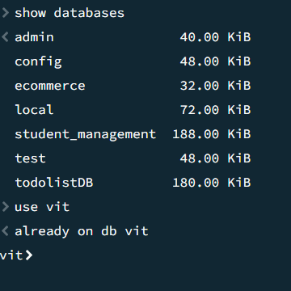

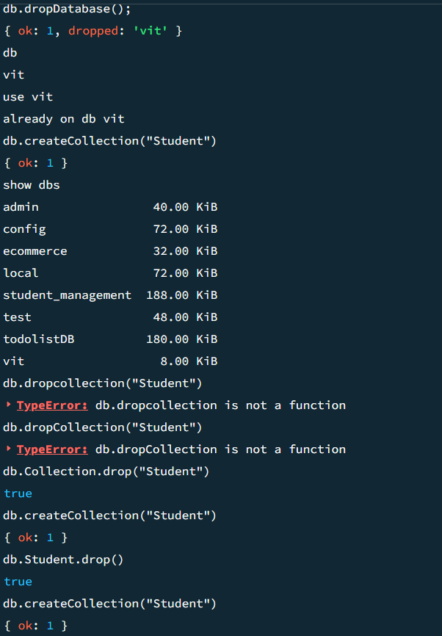

To insert only one

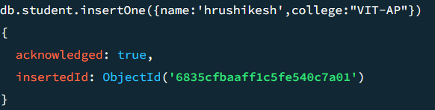

To insert Many

