

**Department of Information Technology**

**Subject – User-Centered Software Design.**

**Project Name-YourFinance.**

**Class-SY IT(B1).**

**Mentor Faculty-Mr.Mahesh Bhandari.**

**Team Members:-**

|  |  |  |  |
| --- | --- | --- | --- |
| **Sr No.** | **Roll No.** | **PRN** | **Name** |
| **1** | 232008 | 22310354 | Hrushikesh Suryawanshi |
| **2** | 232016 | 22310552 | Atharv Manatkar |
| **3** | 232018 | 22310597 | Arnav Kulkarni |

Table of Contents

1. Introduction  
 1.1 Purpose  
 1.2 Document Conventions  
 1.3 Intended Audience and Reading Suggestions  
 1.4 Project Scope  
 1.5 References  
2. Overall Description  
 2.1 Product Perspective  
 2.2 Product Features  
 2.3 User Classes and Characteristics  
 2.4 Operating Environment  
 2.5 Design and Implementation Constraints  
 2.6 User Documentation  
 2.7 Assumptions and Dependencies  
3. System Features  
 3.1 Feature Descriptions  
4. External Interface Requirements  
5. Other Nonfunctional Requirements  
6. Other Requirements  
Appendix A: Glossary  
Appendix B: Analysis Models  
Appendix C: Issues List

**1. Introduction**

1.1 Purpose

The purpose of this document is to outline the requirements for the development of a personal finance management app called 'YourFinance'. This tool is designed to simplify financial planning, provide personalized advice, and enhance user understanding of financial concepts through AI-powered functionalities.

1.2 Document Conventions

This document follows standard conventions for Software Requirements Specification (SRS), adhering to typographical guidelines to ensure clarity and readability.

1.3 Intended Audience and Reading Suggestions

This document is intended for developers, project managers, testers, and stakeholders involved in the development of the YourFinance app. It is structured to guide readers from an overview of the system to detailed requirements, ensuring a clear understanding of all aspects of the project.

1.4 Project Scope

The YourFinance app aims to simplify financial planning by providing users with tools to input financial data, generate personalized dashboards, and access AI-powered advice and goal-tracking features. The app ensures data security, cross-platform compatibility, and scalability while integrating with third-party financial systems.

1.5 References

Google Forms data for surveys, MoSCoW prioritization framework.

**2. Overall Description**

2.1 Product Perspective

YourFinance is a standalone application designed to simplify personal financial management. It leverages AI for personalized advice and is scalable to support integration with third-party financial systems.

2.2 Product Features

1. Input financial details (salary, investments, liabilities).  
2. Generate a comprehensive financial dashboard.  
3. Provide AI-powered financial advice.  
4. Include an AI chatbot for financial education.  
5. Enable financial goal tracking.  
6. Ensure data security and user privacy.

2.3 User Classes and Characteristics

1. End-users: Individuals managing personal finances.  
2. Financial experts: Professionals offering consultation.  
3. Developers: Responsible for building and maintaining the app.  
4. Regulatory bodies: Ensuring compliance.  
5. Investors: Interested in the project's success.

2.4 Operating Environment

The app(webaapp) operates on mobile (iOS, Android) and web platforms.

2.5 Design and Implementation Constraints

Constraints include adherence to data security regulations and integration with third-party APIs.

2.6 User Documentation

User manuals, online help, and video tutorials will be provided.

2.7 Assumptions and Dependencies

The app assumes users have access to mobile or web devices. Dependencies include third-party APIs and AI libraries.

**3. System Features**

3.1 Feature Descriptions

Key features include financial data input, AI-powered advice, a chatbot, goal tracking, and integration with third-party tools.

Allow users to input financial details such as salary, investments, and liabilities.

Generate a comprehensive financial dashboard based on user input.

Provide AI-powered personalized financial advice.

Ensure data security and user privacy through encryption.

Provide a user-friendly and intuitive interface.

**4. External Interface Requirements**

The app interfaces with external APIs for banking and investment platforms.

**Tax Calculation Integration**

* **Description:** Integrate with third-party tax calculation services to provide users with accurate tax estimations based on their financial data.
* **Reason:** Helps users manage tax planning and compliance more effectively.

**5. Other Nonfunctional Requirements**

1. Performance: Less than 2 seconds response time.  
2. Scalability: Support for 1,000 concurrent users.  
3. Security: Data encryption for user privacy.  
4. Usability: User-friendly and intuitive design.

**6. Other Requirements**

Future updates will include multi-language support and advanced budgeting templates.

**Appendix A: Glossary**

AI: Artificial Intelligence  
API: Application Programming Interface  
SRS: Software Requirements Specification

**Appendix B: Analysis Models**

Detailed diagrams and models will be provided in subsequent iterations.  
  
1]Class Diagram:  
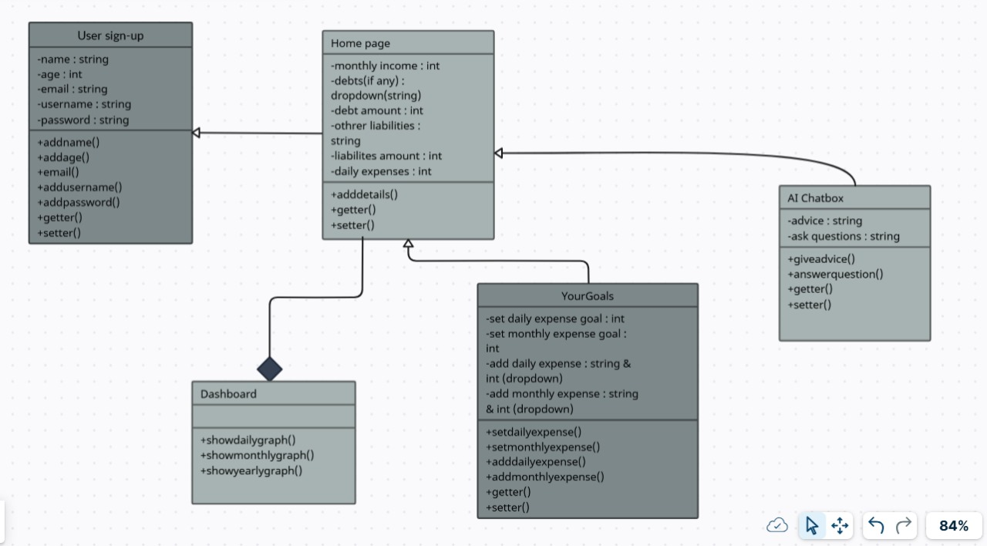

2]Kano Diagram:  
  
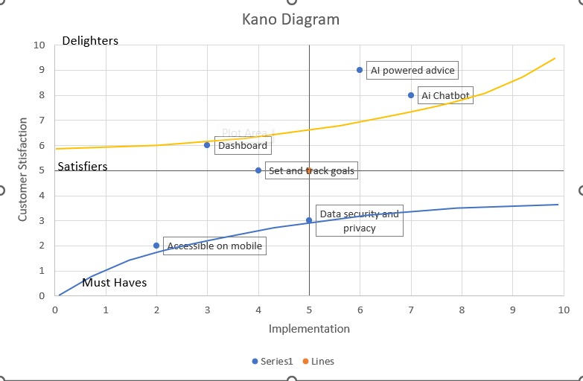

3]Entity Relationship Diagram:

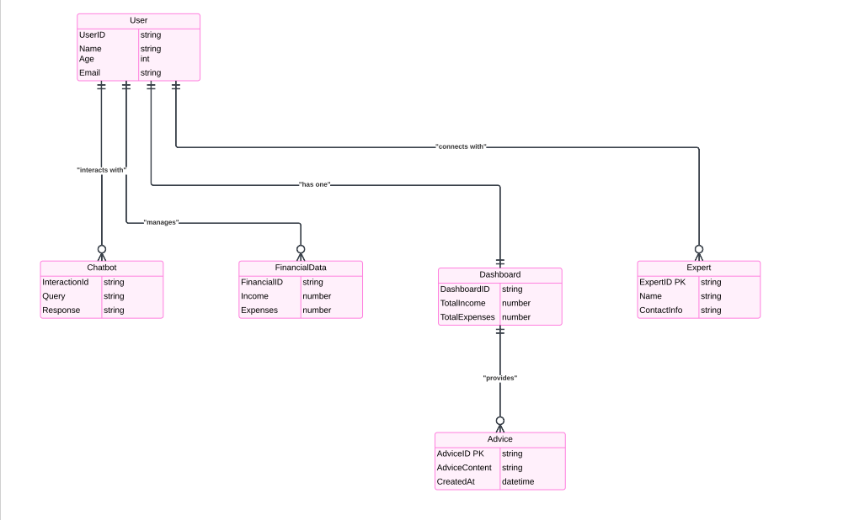

**Appendix C: Issues List**

It includes questions like finalizing third-party API integrations for payment gateways or banking services, clarifying AI chatbot functionalities, and resolving performance optimization challenges. All issues are documented and monitored using project management tools like Trello or Jira to ensure accountability. Regular updates and resolutions are provided to the development team to keep the project on track.