The Open-Source AI Ecosystem (Hugging Face)

1. Introduction

1.1 What is AI?
AI stands for Artificial Intelligence. It means teaching computers to do things that normally need human thinking — like recognising faces, understanding speech, or identifying objects in a photo.
Think of it this way:
- A normal program follows exact rules you write.
- An AI program learns from examples and improves on its own.

1.2 What is Hugging Face?
Hugging Face is like the "GitHub for AI models". It is a website where thousands of ready-made AI models are stored for free. Instead of training a model from scratch (which takes weeks and expensive computers), you can simply use a model that someone has already trained.

Website: https://huggingface.co
Free to use — just create an account and get an API key
Hosts 500,000+ models for text, image, audio, and more

1.3 Why Do We Use Hugging Face?
- No need to build or train a model from zero — saves huge time and effort.
- Free API access for students and beginners.
- Huge collection of models for many tasks.
- Easy to use — just send an HTTP request and get a result back.

2. Different Ways to Use Hugging Face

Hugging Face gives us several ways to use AI models. Each method has its own advantages. Let us look at all of them one by one.

11.1 Method 1: Inference API (No Install Needed)
The Inference API lets you call an AI model over the internet. You do NOT need to install anything on your computer — just send an HTTP request and get the result back.

When to use this method: Great for beginners, web apps, and quick prototypes.
- You need internet connection.
- Free for most models on Hugging Face.
- Just one Python file is enough to get a result.

Example 1: Image Classification
import requests
API_KEY = 'hf_your_token_here'
API_URL = 'https://api-inference.huggingface.co/models/google/vit-base-patch16-224'
headers = {'Authorization': f'Bearer {API_KEY}'}
with open('photo.jpg', 'rb') as f:
result = requests.post(API_URL, headers=headers, data=f.read())
print(result.json())

Example 2: Text Sentiment Analysis via API
import requests
API_KEY = 'hf_your_token_here'
# A different model — for text sentiment
API_URL = 'https://api-inference.huggingface.co/models/distilbert-base-uncased-finetuned-sst-2-english'
headers = {'Authorization': f'Bearer {API_KEY}'}
payload = {'inputs': 'I really love this AI workshop!'}
result = requests.post(API_URL, headers=headers, json=payload)
print(result.json())
# Output: [{'label': 'POSITIVE', 'score': 0.9998}]

11.2 Method 2: Transformers Library (Runs on Your Computer)
The Transformers Library is a Python package made by Hugging Face. Instead of calling an API over the internet, the model is downloaded to your computer and runs locally.

When to use this method:
- You want everything to run offline.
- You have a good computer (GPU helps a lot).
- You want more control over the model.

Setup:
# Install the library first (run in terminal)
# pip install transformers torch

Code Example:
from transformers import pipeline
# 'pipeline' is a simple function that loads a model for a task
classifier = pipeline('image-classification')
# Give it an image file
result = classifier('dog.jpg')
print(result)
# Output: [{'label': 'golden retriever', 'score': 0.93}, ...]

Note: The first time you run this, it downloads the model (can be 100 MB to 1 GB).
After that, it runs from your computer without internet.

2.3 Method 3: Google Colab (Free GPU in Browser )
Google Colab is a free online notebook (like a webpage where you can run Python code). The best part is that Google gives you a free GPU to run heavy AI models.
Why use Colab?
- Completely free to use.
- No installation needed — runs in your browser.
- Google provides a powerful GPU for free.
- Perfect for AI experiments and student projects.

Step-by-Step: Run AI in Google Colab
- Go to colab.research.google.com and sign in with your Google account.
- Click 'New Notebook'. A blank notebook will open.
- Click 'Runtime' menu → 'Change Runtime Type' → Select 'T4 GPU'(This makes your run time less ) → Save.
- In the first cell, install the required library:
# Install the Hugging Face library in Colab
!pip install transformers
- In the next cell, write the classifier code:
from transformers import pipeline
# Load a pre-trained sentiment analysis model
classifier = pipeline('sentiment-analysis')
# Test it with a sentence
result = classifier('I love this workshop!')
print(result)
# Output: [{'label': 'POSITIVE', 'score': 0.9998}]
- Click the Play button (▶) on each cell to run it.
- Watch the output appear below the cell!

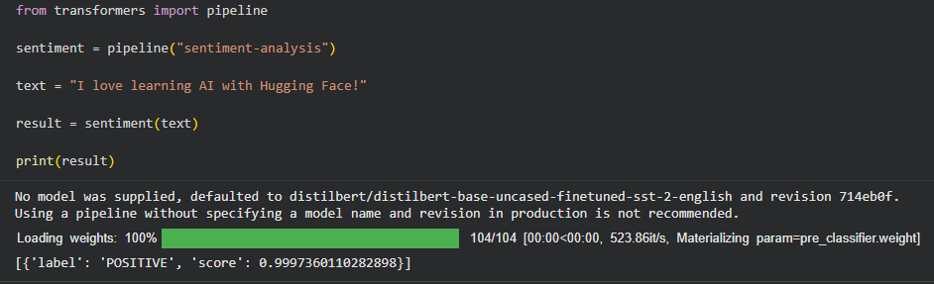

Try It Yourself — Classify an Image in Colab:
!pip install transformers torch pillow
from transformers import pipeline
from PIL import Image
import requests
from io import BytesIO
# Download a sample image from the internet
url = 'https://upload.wikimedia.org/wikipedia/commons/thumb/3/3a/Cat03.jpg/320px-Cat03.jpg'
response = requests.get(url)
img = Image.open(BytesIO(response.content))
# Load the image classifier
classifier = pipeline('image-classification', model='google/vit-base-patch16-224')
result = classifier(img)
print(result)

We have another method to use colab directly from hugging face

The steps are choose a model -> then on the top right you can see use this model -> and now click on google colab (it will redirect to colab)

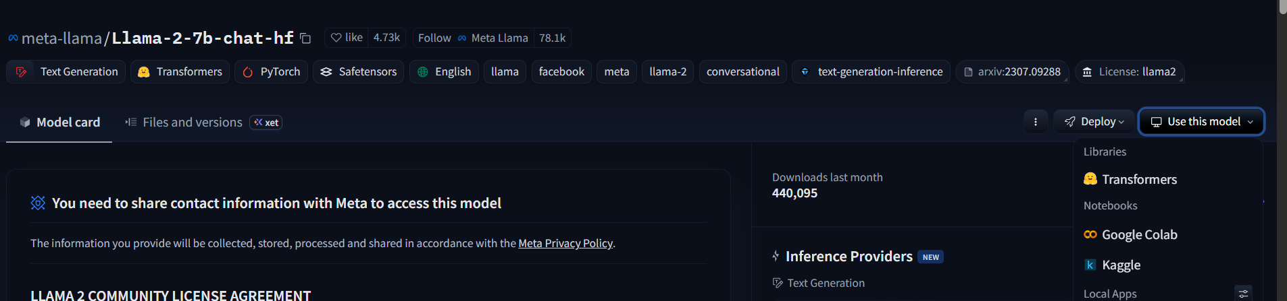

2.4 Method 4: Hugging Face Spaces (UI-Based Deployment)
Hugging Face Spaces lets you build and host a simple web app for your AI model. The most popular tool used with Spaces is called Gradio, which creates a simple web interface automatically.

Gradio Example: Build a UI in 8 Lines of Code
import gradio as gr
from transformers import pipeline
# Load the model
classifier = pipeline('sentiment-analysis')
# Define what happens when user submits text
def predict(text):
return classifier(text)
# Create the web interface and launch it
gr.Interface(fn=predict, inputs='text', outputs='text').launch()

What Gradio gives you automatically:
- A text input box on a webpage.
- A 'Submit' button.
- A result box to display the AI's answer.
- A public shareable link!

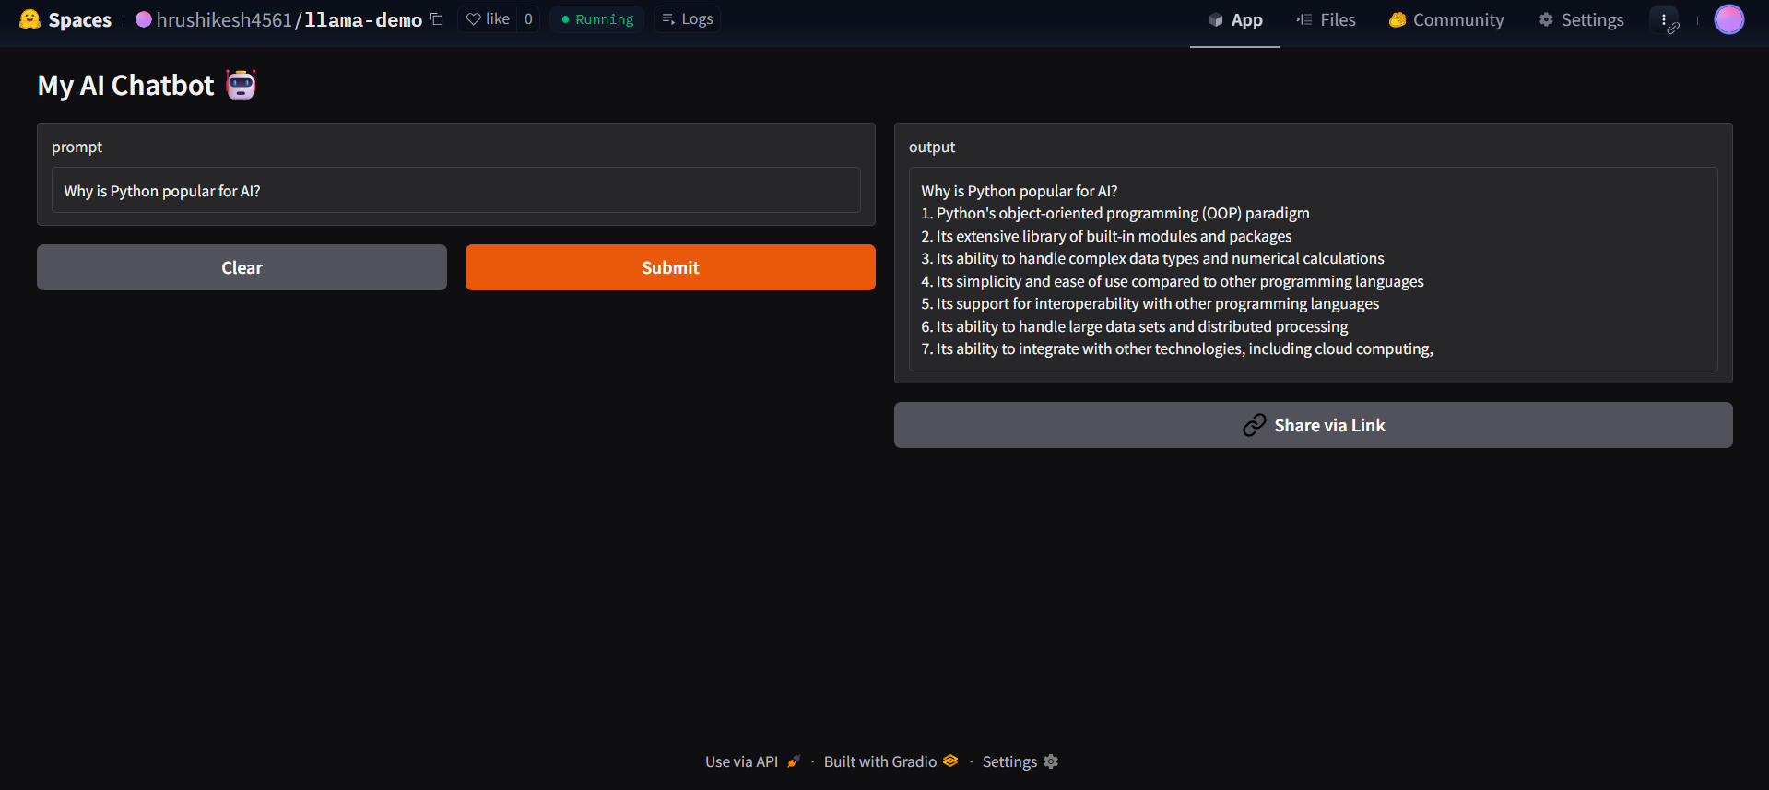

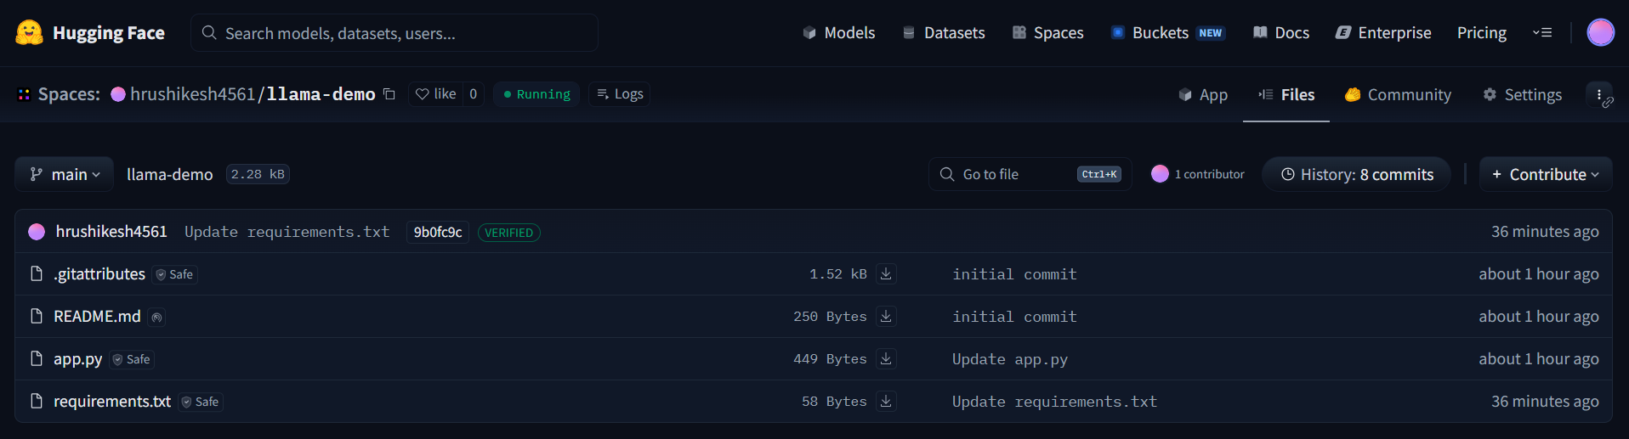

3. Types of AI Models on Hugging Face

Hugging Face has models for many different types of tasks. Here is a simple overview of each type.

16.1 Image Models 🖼️
Image models understand and analyse pictures and videos. There are three main image tasks:

Task | What It Does | Example Model
Image Classification | Looks at an image and says what is in it. | google/vit-base-patch16-224
Object Detection | Finds objects and draws boxes around them. | facebook/detr-resnet-50
Image Segmentation | Labels every pixel — finds exact shape of each object. | nvidia/segformer-b0-finetuned-ade-512-512

Try it — Object Detection in Colab:
from transformers import pipeline
# Load object detection model
detector = pipeline('object-detection', model='facebook/detr-resnet-50')
# Run on a local image
results = detector('street.jpg')
for r in results:
print(r['label'], '-', round(r['score']*100), '%')

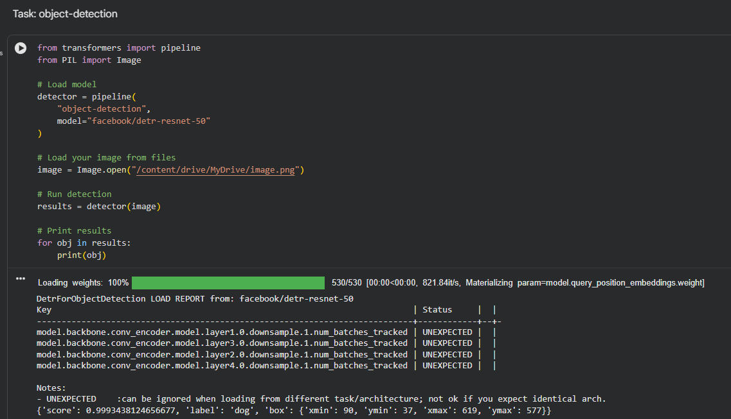

6.2 NLP Models (Text Models)
NLP stands for Natural Language Processing. These models understand and work with human language — English, Hindi, or any other language.

Task | What It Does | Example
Sentiment Analysis | Tells if text is Positive, Negative, or Neutral. | "I love this!" → POSITIVE
Text Summarization | Makes a long paragraph short. | Long article → 3 sentence summary
Question Answering | Reads a passage and answers your question. | "Who made ViT?" → "Google"
Translation | Translates text from one language to another. | "Hello" → "Bonjour" (French)

Code Example — Sentiment + Summarization:
from transformers import pipeline
# Sentiment Analysis
nlp = pipeline('sentiment-analysis')
print(nlp('This workshop is absolutely amazing!'))
# Output: [{'label': 'POSITIVE', 'score': 0.9998}]
# Text Summarization
summarizer = pipeline('summarization')
long_text = 'Hugging Face is a platform for AI models. It has over 500,000 models available. Anyone can use them for free using the API or the Transformers library. It is widely used by students, researchers, and companies around the world.'
summary = summarizer(long_text, max_length=30, min_length=10)
print(summary[0]['summary_text'])

Here is the colab link where we did all the basic models execution : colab link

Here is the sample output snippet of sentiment analysis

Here is the example output of text summarization

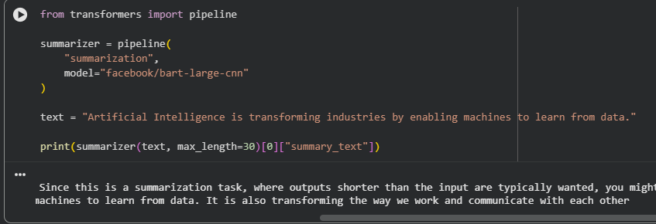

Here is the example output of question and answering

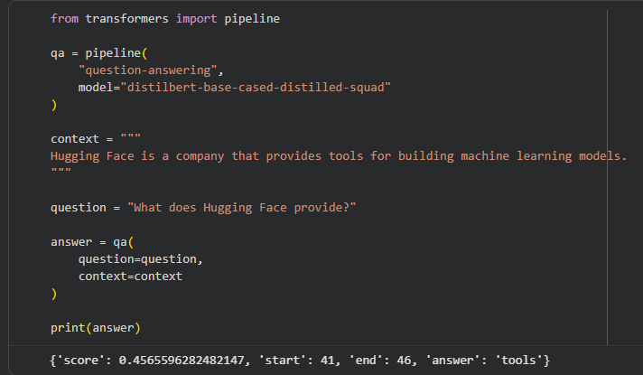

here is the example output of TRANSALTION OF TEXT

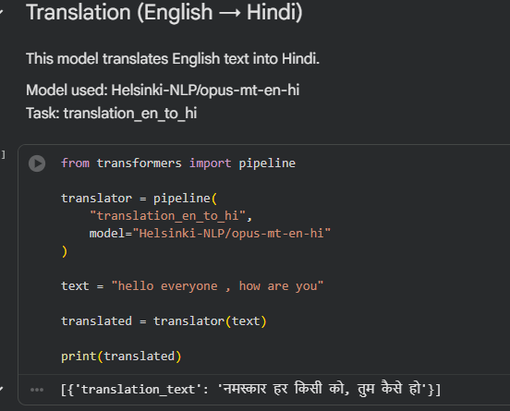

6.3 Audio Models 🔊
Audio models work with sound — they can listen and speak.

Task | What It Does | Use Case
Speech-to-Text (ASR) | Converts spoken words into written text. | Voice assistants, meeting transcripts
Text-to-Speech (TTS) | Converts written text into spoken audio. | Audiobooks, accessibility tools
Audio Classification | Identifies what kind of sound is playing. | Detecting music genre, noise alerts

Code Example — Speech to Text:
from transformers import pipeline
# Load the speech-to-text model (Whisper by OpenAI)
transcriber = pipeline('automatic-speech-recognition',
model='openai/whisper-base')
# Pass an audio file
result = transcriber('my_audio.mp3')
print(result['text'])
# Output: 'Hello, this is my voice recording.'

6.4 Generative AI Models 🎨
Generative AI models CREATE new content — they can write text, generate images, write code, and more. This is the most exciting category right now!

Task | What It Does | Famous Example
Text Generation | Writes text, stories, or code from a prompt. | GPT-2, LLaMA, Mistral
Text-to-Image | Creates a picture from a text description. | Stable Diffusion, DALL-E
Image-to-Image | Changes one image based on instructions. | Pix2Pix, ControlNet
Code Generation | Writes code from natural language description. | CodeLlama, StarCoder

Code Example — Text Generation:
from transformers import pipeline
# Load a text generation model
generator = pipeline('text-generation', model='gpt2')
# Give it a starting sentence
result = generator('Artificial Intelligence is changing the world by',
max_new_tokens=50)
print(result[0]['generated_text'])

4. How to Choose the Right Model

With over 500,000 models on Hugging Face, choosing the right one can be confusing. Here is a simple guide to help you pick the best model for your task.

7.1 Step 1: Look at the Model Card
Remember the Model Card we studied in Section 3? It is the most important source of information. Before using any model, always check its Model Card for these things:

What to Check | Why It Matters
Task type | Make sure the model does what you need (classification, detection, etc.)
Training data | Was it trained on the kind of data you have?
Accuracy / F1 score | Higher score = better performance
Inference time | How fast does it run? Important for live apps.
Model size | Bigger models are slower. Smaller models run faster.
License | Can you use it in your project or commercially?

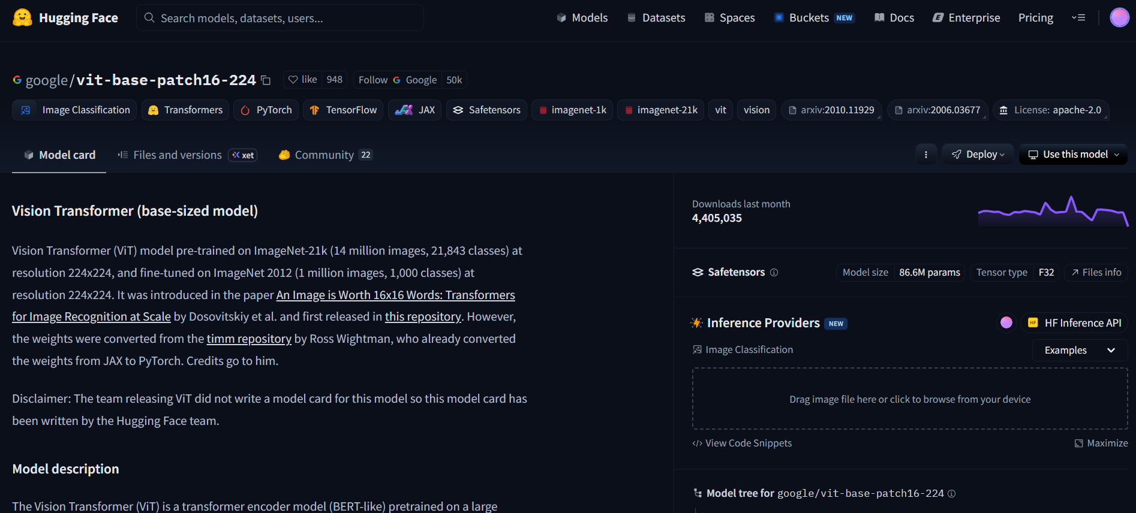

4.2 Step 2: Consider These 4 Factors

Factor | Simple Rule
Accuracy | Pick the model with the highest score on a standard test (e.g. ImageNet top-1 accuracy).
Speed | If you need real-time results, pick a smaller model (e.g. MobileNet over ViT).
Size | If running on a phone or small computer, choose a model under 50MB if possible.
License | For student projects: any license is fine. For business: avoid 'non-commercial' models.

4.3 Popular Beginner-Friendly Models

Model Name | Task | Why Good for Beginners
google/vit-base-patch16-224 | Image Classification | Free, well-documented, accurate, Apache 2.0 license
distilbert-base-uncased | Text Classification / NLP | Small and fast — only 66MB, 60% faster than BERT
openai/whisper-base | Speech-to-Text | Very accurate, works for many languages
facebook/bart-large-cnn | Text Summarization | Easy to use, great for news summarization
stabilityai/stable-diffusion-2 | Image Generation | Popular, free to use, lots of tutorials available

5. Lets Dive into Mini Project

This project builds a simple web tool where a user uploads any image and the AI tells them what is inside that image. For example, if you upload a photo of a dog, the AI will say "golden retriever" or "labrador".

Simple Idea:
User uploads an image → We send it to the Hugging Face API → The AI analyses it → We show the result back to the user.

11.1 Real Life Examples of This
- Google Photos uses image classification to find your dog photos automatically.
- Medical AI uses it to detect diseases in X-rays.
- Self-driving cars use it to identify road signs and obstacles.

11.2 Project Requirements
Item | Details
Language | Python 3.x (backend)
Frontend | HTML + JavaScript
API | Hugging Face Inference API
Model | google/vit-base-patch16-224
Cost | Free (basic tier)

6. Exploring Hugging Face

6.1 The Model Hub
The Model Hub is the main page on Hugging Face where all AI models are listed. You can search, filter, and browse models just like an app store.

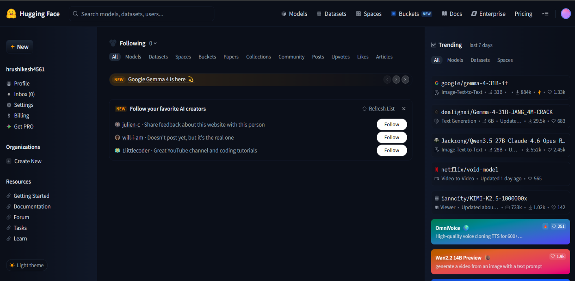

6.2 How to Search for a Model
- Go to huggingface.co in your browser.
- Click on "Models" in the top menu.
- In the search bar, type "image classification".
- You will see a list of popular models for that task.
- Click on any model name — for example, "google/vit-base-patch16-224".

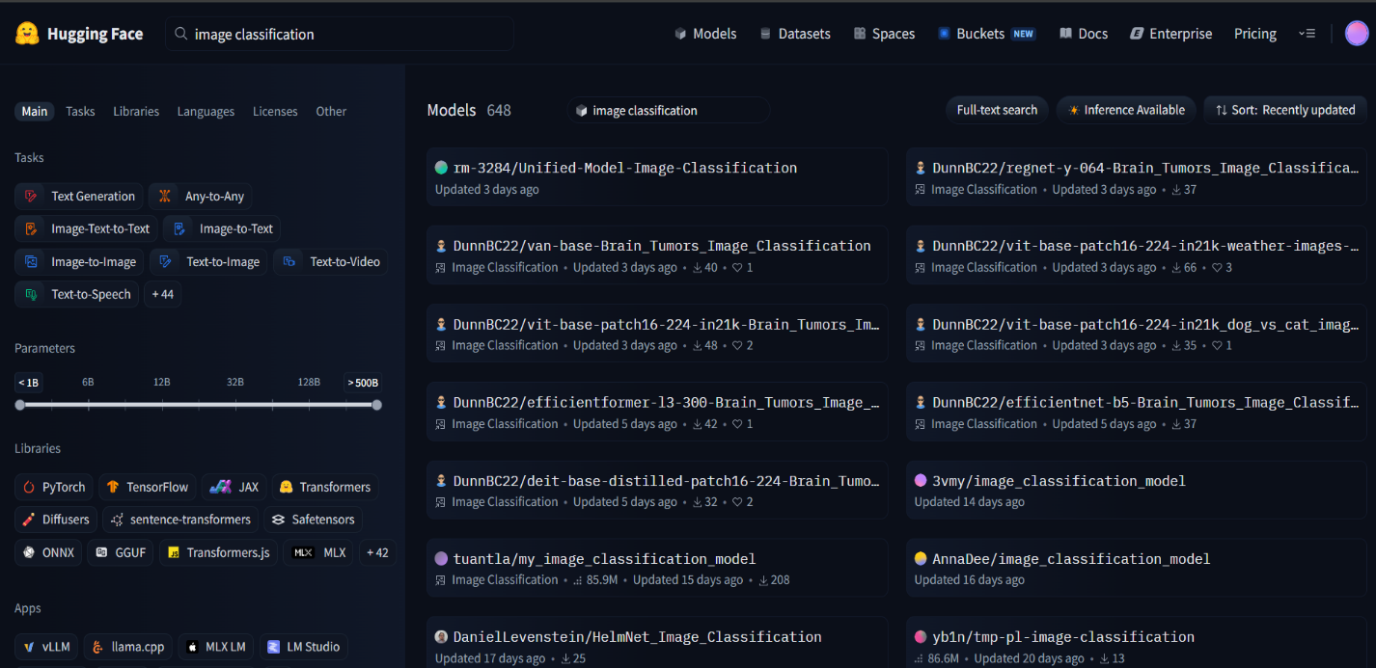

6.3 What is a Model Card?
When you open a model on Hugging Face, you see a page full of information about it. This page is called a Model Card. It is like a profile page for the AI model.

A Model Card tells you:
• What the model does (e.g. classifies images into 1000 categories)
• Who created it (e.g. Google)
• What data it was trained on (e.g. ImageNet dataset)
• How well it performs (accuracy scores)
• How to use it in your code



6.4 What is Licensing?
A license tells you the rules for using the model. Think of it like a terms-of-use agreement.
- Most models on Hugging Face use the Apache 2.0 license.
- This means: you can use it for free, even in projects.
- Some models say "non-commercial" — that means no business use.
- Always check the license before using any model in a real product.

7. Model Used

7.1 google/vit-base-patch16-224
ViT stands for Vision Transformer. It is a model made by Google that can look at an image and tell you what is inside it. It was trained on a huge collection of images called ImageNet, which has over 1 million photos across 1000 different categories.

Property | Value
Full Name | google/vit-base-patch16-224
Task | Image Classification
Categories | 1000 (animals, vehicles, food, etc.)
Input | Image (JPG / PNG)
Output | List of labels with confidence scores
License | Apache 2.0 (free to use)

🧠 How does ViT work? (Very Simple)
It breaks your image into small 16×16 pixel patches, like puzzle pieces.
Then it reads these patches using a Transformer (same idea used in GPT)

Finally it predicts: 'This is 95% a dog, 3% a cat, 2% something else.'

8. Implementation (Backend — Python)

11.1 Setup
Before writing code, you need:
- Python 3 installed on your computer.
- The "requests" library — run: pip install requests
- A free account on huggingface.co and your API key (a long token string).

11.2 Python Code — Classify an Image
This small script sends an image to the Hugging Face API and prints the result.

import requests # library to send HTTP requests

# Your Hugging Face API key — keep this secret!
API_KEY = "hf_your_token_here"
hf token differs for every one and can be accessed by using the following steps
Hugging Face → Profile Icon (top right) → Settings → Access Tokens → New Token → Enter Token Name (e.g., mini-project) → Select Role: Read ✅ → Create Token → Copy

# The URL of the model we want to use
API_URL = "https://api-inference.huggingface.co/models/google/vit-base-patch16-224"

# Tell the API who we are using the key
headers = {"Authorization": f"Bearer {API_KEY}"}

# Open the image file in binary mode (rb = read bytes)
with open("my_photo.jpg", "rb") as f:
image_data = f.read()

# Send the image to the API and store the reply
response = requests.post(API_URL, headers=headers, data=image_data)

# Print the result as readable JSON
print(response.json())

📤 Example Output:
[{"label": "golden retriever", "score": 0.94},
{"label": "Labrador retriever", "score": 0.04},
{"label": "cocker spaniel", "score": 0.01}]

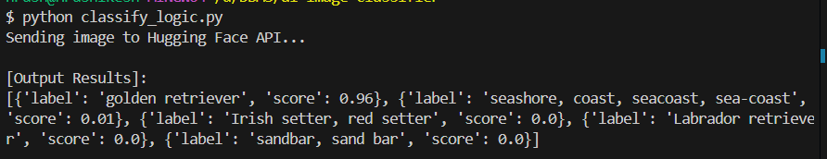

9. Frontend Example (HTML + JavaScript)

This is a very simple HTML page. The user picks an image file, clicks a button, and the result appears on the screen.

16.1 JavaScript — Sending the Image
// When the button is clicked, run this function
async function classifyImage() {
const file = document.getElementById('imgInput').files[0];

// Read the file as raw bytes (ArrayBuffer)
const buffer = await file.arrayBuffer();

// Send the image to our Python backend
const res = await fetch('/classify', {
method: 'POST',
body: buffer // send raw image bytes
});

// Get the result and show it on the page
const data = await res.json();
document.getElementById('result').innerText = data[0].label;
}

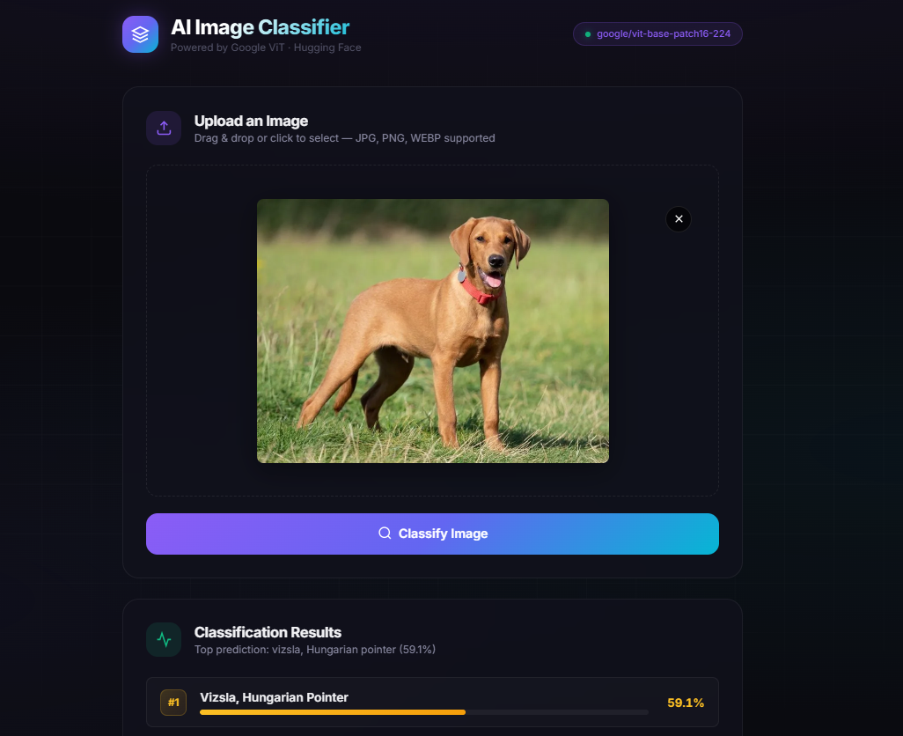

10. Project Flow

Here is the complete step-by-step flow of how the project works, from the user's action to the final result:

Step | Who / What | What Happens
1 | User | Opens the webpage and clicks 'Choose File' to upload an image.
2 | Frontend (JS) | The image is read from the user's device and sent to the backend using a fetch() request.
3 | Backend (Python) | The Python server receives the image and sends it to the Hugging Face API with the API key in the header.
4 | Hugging Face API | The ViT model analyses the image and returns a list of predictions with confidence scores (e.g. 'cat: 92%').
5 | Backend (Python) | The Python server receives the API response and sends the result back to the frontend as JSON.
6 | Frontend (JS) | The JavaScript reads the result and displays the top label on the screen for the user to see.

11. Deployment

11.1 Hugging Face Spaces
Hugging Face Spaces lets you host and run your project for free directly on the Hugging Face website. It is perfect for small student projects.

Steps to Deploy on Spaces:
- Go to huggingface.co and log in to your account.
- Click your profile icon → select "New Space".
- Give your Space a name (e.g. my-image-classifier).
- Choose SDK: select "Gradio" for a quick Python UI, or "Static" for plain HTML.
- Upload your project files (app.py or index.html, etc.).
- Hugging Face will automatically build and run your project.
- A link will be generated and that’s your project lini.

11.2 Replicate (Alternative)
Replicate is another platform where you can run AI models using an API, similar to Hugging Face. It is useful when you want to use more powerful models. The free tier gives you some credits to try it out.
- Website: replicate.com
- Works similarly — call a model via URL and get a result back.

12. Hands-On Activities

Time to practise! These three activities will help you get real experience using Hugging Face. Try each one during or after the workshop.

🎯 Activity 1: Explore and Try a Model on Hugging Face
- Open huggingface.co in your browser.
- Go to the Models section and search for 'image-classification'.
- Click on any model — read its Model Card carefully.
- Click the 'Inference API' widget on the right side of the page.
- Upload any image from your computer (a pet, food, or anything).
- See the AI predict what is in the image!
- Try at least 3 different images and note the results.

🎯 Activity 2: Run a Notebook in Google Colab
- Open colab.research.google.com and create a new notebook.
- Enable GPU: Runtime menu → Change Runtime Type → T4 GPU.
- In cell 1: type !pip install transformers and run it.
- In cell 2: copy the sentiment analysis code from Section 10.3.
- Run it and check the output.
- Challenge: Change the sentence and see if the output changes.
- Try: 'I hate Mondays' vs 'I love Fridays' — compare results!

🎯 Activity 3: Run the Image Classifier (Our Main Project)
- Make sure Python is installed on your computer.
- Open your terminal and run: pip install requests
- Copy the Python code from Section 5.2 into a file called classify.py
- Get your Hugging Face API key (Settings → Access Tokens → New Token).
- Replace hf_your_token_here with your real token in the code.
- Save any .jpg image as my_photo.jpg in the same folder.
- Run: python classify.py and read the output!
- Challenge: Try 5 different images — animals, food, cars, buildings.

13. Comparison: Which Method Should You Use?

Here is a clear side-by-side comparison of all four ways to use Hugging Face, so you can pick the best one for your situation.

Method | Pros | Cons | Best For
Inference API | Easy to use. No install. Works from anywhere. Free tier available. | Needs internet. Rate limits on free plan. Slower. | Beginners, web apps, quick demos
Transformers Library (Local) | Runs offline. Fast once loaded. Full control. | Heavy download (GB). Needs good computer/GPU. | Developers, research, offline apps
Google Colab | Free GPU. No setup. Browser-based. Easy sharing. | Session expires. Not for production. Needs Google login. | Students, experiments, learning AI
Hugging Face Spaces | Easy UI with Gradio. Free hosting. Shareable link. | Limited compute. Not for heavy models. Slow cold start. | Demos, mini-projects, portfolio

Quick Decision Guide:
Just learning? → Use Google Colab (free GPU + no setup).
Building a web app? → Use the Inference API.
Want offline use? → Use the Transformers Library locally.
Want to show your project? → Deploy on Hugging Face Spaces.

14. Real-World Applications of AI Models

The same technology we used in this project is powering products you use every single day. Here are some exciting examples:

111.1 Chatbots and Customer Support
Chatbots like the ones on banking websites or e-commerce apps use NLP models to understand your questions and reply automatically. They are trained on millions of conversations and can handle thousands of customers at the same time.
- GPT and similar models power chatbots like ChatGPT, Gemini, and Copilot.
- Companies like Zomato and Swiggy use chatbots for order tracking and complaints.
- The same Hugging Face pipeline we used can be built into a chatbot in under 20 lines of code.

111.2 Voice Assistants (Alexa, Siri, Google Assistant)
Voice assistants combine two AI models working together:
- Speech-to-Text model: converts your spoken words to text.
- NLP model: understands the text and figures out what you want.
- Text-to-Speech model: converts the reply back into voice.
This is exactly the pipeline we studied in Section 11.3!

14.3 Social Media Filters (Instagram, Snapchat)
Those fun face filters on Instagram and Snapchat use Image Segmentation models to detect your face, eyes, and nose in real time — then overlay a cartoon or effect on top.
- The AI runs 30 times per second to track your face as you move.
- This is the same type of model as segmentation in Section 11.1.

14.4 Healthcare — Disease Detection
Image Classification models are being used to save lives in hospitals:
- Detecting cancer cells in microscope images.
- Identifying COVID-19 patterns in chest X-rays.
- Counting blood cells automatically in lab tests.
The model we used (ViT) uses the same architecture as many medical AI systems.

14.5 Self-Driving Cars
Self-driving cars use AI models running hundreds of times per second to understand the road:
- Object Detection: spots cars, pedestrians, cyclists, and road signs.
- Segmentation: understands what is road, pavement, sky, or building.
- Depth Estimation: judges how far away each object is.
Companies like Tesla and Waymo have teams of engineers working on exactly these models.

Industry | AI Model Type | Real Example
Social Media | Image Classification + Segmentation | Instagram filters, content moderation
Healthcare | Image Classification + Object Detection | Cancer detection, X-ray analysis
Transport | Object Detection + Segmentation | Tesla Autopilot, Waymo robotaxi
E-Commerce | NLP Sentiment Analysis | Amazon product review summaries
Entertainment | Generative AI + Text-to-Image | Adobe Firefly, Midjourney art tools
Education | Text Summarization + Q&A | AI tutors, smart study tools

15. Bonus Concepts

116.1 What is a Transformer?
The word 'Transformer' is everywhere in AI. It is the core technology behind GPT, ChatGPT, BERT, ViT, and almost every modern AI model.

Simple Explanation:
A Transformer is a type of neural network that pays 'attention' to all parts
of the input at once — not one word or one pixel at a time.

Example: When reading 'The cat sat on the mat because it was tired',
the Transformer connects 'it' → 'cat' by paying attention to the whole sentence.

For images: ViT breaks the image into patches and pays attention to all patches.

15.2 What is Fine-Tuning?
When a model is first trained, it learns from millions of general examples (like all of ImageNet). Fine-tuning means taking that already-trained model and teaching it more — on YOUR specific data.

Analogy:
A general doctor graduates from medical school (pre-training on general data).
Then they do a specialisation in Cardiology (fine-tuning on specific data).
Now they know both general medicine AND heart diseases.

In AI: Take a model trained on all images → Fine-tune it on only dog breeds →
Now it is an expert at identifying dog breeds!

15.3 What is a Dataset?
A Dataset is a large, organised collection of data used to train an AI model. Without a dataset, an AI model cannot learn anything.

Dataset Name | What It Contains | Used For
ImageNet | 14 million labelled images in 1000 categories | Training image classification models like ViT
COCO | 330,000 images with object bounding boxes | Training object detection models
Wikipedia Text | Billions of words from Wikipedia articles | Training NLP models like BERT, GPT
LibriSpeech | 1000 hours of English speech audio | Training speech-to-text models like Whisper

16. Conclusion

16.1 What We Learned
- What AI is and how it can identify objects in images.
- How to use Hugging Face as a platform to find and use ready-made AI models.
- How to send HTTP API requests using Python to get AI predictions.
- How to build a simple frontend in HTML and JavaScript.
- How to deploy a small project online using Hugging Face Spaces.

16.2 Real-Life Uses of Image Classification
Field | Example Use
Healthcare | Detecting cancer or disease in medical scans and X-rays.
Agriculture | Identifying plant diseases from leaf photos taken by farmers.
Retail / E-commerce | Automatically tagging product photos on shopping websites.
Social Media | Filtering inappropriate or harmful images automatically.
Self-Driving Cars | Recognising road signs, pedestrians, and obstacles in real time.
Security | Face recognition systems at airports and offices.

This project shows that you do not need to be an AI expert to build a smart application. With free tools like Python and Hugging Face, anyone can get started with AI today.

Reference

- Hugging Face Official Website — https://huggingface.co
- ViT Model Card — https://huggingface.co/google/vit-base-patch16-224
- Hugging Face Inference API Docs — https://huggingface.co/docs/api-inference
- Python Requests Library — https://docs.python-requests.org
- Hugging Face Spaces — https://huggingface.co/spaces

