23 CSE 356 Social Network Analysis
Project Report
Early Viral Misinformation Detection Using Social Network Analysis
Palivela Sai Hruthik (AM.SC.U4AIE23141)
Nallapaneni Vaibhav (AM.SC.U4AIE23135)
25 October 2026

Abstract
False rumours spread faster than corrections, yet most detection systems either read the text of a post or wait for the complete sharing cascade before deciding. We ask a different question: how early, and how accurately, can misinformation be flagged using only the structure of how it spreads? Using the PHEME rumour-veracity dataset (6425 Twitter conversation threads across 9 breaking-news events), we build a time-stamped reply cascade and a user interaction graph for every thread, truncate them at 5 min, 10 min, 30 min, 60 min, 180 min and the full cascade, and extract 33 structure-only features (cascade shape, propagation speed, centrality, Louvain communities and non-text user metadata). Models are evaluated with leave-one-event-out cross-validation so every prediction is made on a news event the model has never seen. For misinformation (false vs true rumours) the logistic regression model reaches AUC 0.59 after only 10 minutes, 0.60 after 30 minutes and 0.62 on the full cascade, compared with 0.41 for a text-only TF-IDF baseline. At 30 minutes the structural model retains 87% of the full-cascade signal (above chance), showing that much of the information needed to flag a false rumour is available long before it goes viral.

1. Problem Statement and Motivation
Fake news and rumours spread on social media faster than the truth [7]. By the time a claim is fact-checked, it has often reached thousands of people. Most detection systems look only at what is said - the words of the post - or at the complete, fully-grown sharing cascade. Both are problematic: wording is easy to fake, and waiting for the full cascade means the decision arrives after the damage is done.
How a claim moves through the network - who reacts first, how fast, how deep the conversation goes and which communities it crosses - is visible within minutes, is harder to manipulate than text, and can act as an early-warning signal even when the content looks convincing. This project measures how much of that signal exists early.

2. Research Gap and Novelty
- Early + veracity combined. Virality-prediction work [3, 4] shows structure is predictive within the first hour, but targets popularity, not truth. Veracity work mostly uses complete cascades. We apply early-window analysis to the veracity question.
- Structure-only by design. Many SNA misinformation systems fuse network features with large text/LLM models [1], hiding how much the network contributes. We exclude text and report a text baseline separately, isolating the network's contribution.
- Time-resolved evaluation. Instead of one accuracy on finished cascades, we report a performance-vs-time curve, directly quantifying the earliness/accuracy trade-off.
- Realistic generalisation. Leave-one-event-out evaluation tests the model on breaking news it has never seen, the situation an early-warning system actually faces.

3. Objectives
- Build time-stamped network representations of each claim's spread for early windows (5 min, 10 min, 30 min, 60 min, 180 min) and the full cascade.
- Identify which structure-only features (degree, clustering of the conversation, community bridging, propagation velocity, cascade depth/breadth) are most predictive of misinformation.
- Compare early-window structural detection with a full-cascade SNA baseline and a content-based (text) baseline, measuring how early and how accurately misinformation can be flagged.

4. Dataset
We use the PHEME dataset for Rumour Detection and Veracity Classification [5, 6]: Twitter conversation threads collected during nine breaking-news events. Each thread contains a source tweet, all reply tweets (with timestamps, reply-to links and user metadata), a structure.json conversation tree and an annotation.json label. Rumours were labelled by journalists as true, false or unverified.
Event | True | False | Unverified | Non-rumour | Total
charliehebdo | 193 | 116 | 149 | 1621 | 2079
ebola-essien | 0 | 14 | 0 | 0 | 14
ferguson | 10 | 8 | 266 | 859 | 1143
germanwings-crash | 94 | 111 | 33 | 231 | 469
gurlitt | 59 | 0 | 2 | 77 | 138
ottawashooting | 329 | 72 | 69 | 420 | 890
prince-toronto | 0 | 222 | 7 | 4 | 233
putinmissing | 0 | 9 | 117 | 112 | 238
sydneysiege | 382 | 86 | 54 | 699 | 1221
TOTAL | 1067 | 638 | 697 | 4023 | 6425

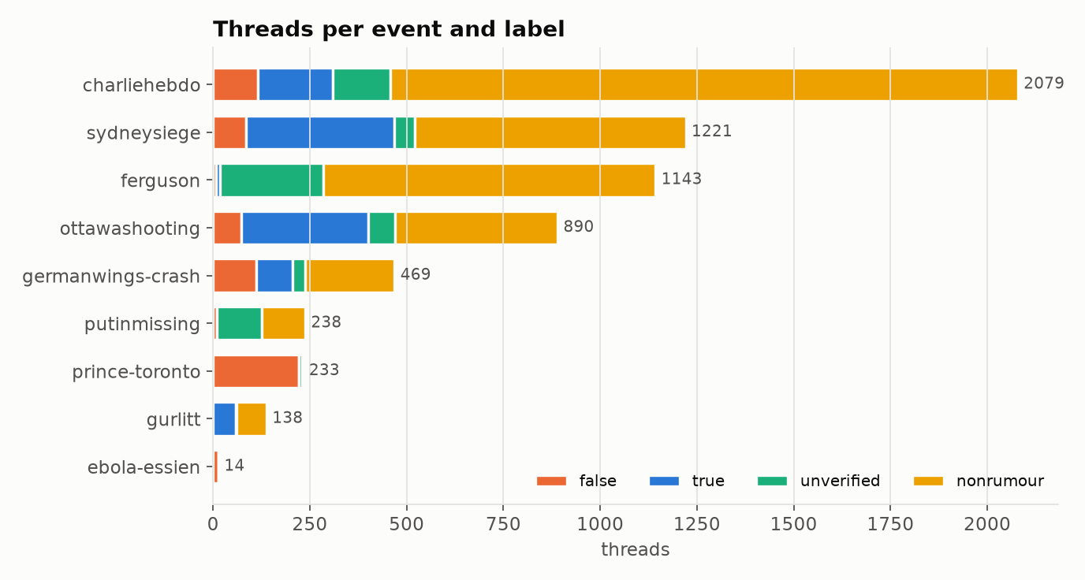
Figure 1. Threads per event and label.
Two tasks are defined. Task A (main): false vs true rumours (638 vs 1067 threads; unverified rumours are excluded because their ground truth is unknown). Task B (supporting): rumour vs non-rumour over all 6425 threads.
Note. PHEME records reply conversations, not retweets. Our cascades are therefore reply cascades: an edge means 'user B replied to user A's tweet'. Labels are strongly unbalanced across events (e.g. prince-toronto is almost entirely false, gurlitt entirely true), which is why pooled out-of-fold metrics are reported in addition to per-event results.

5. Methodology
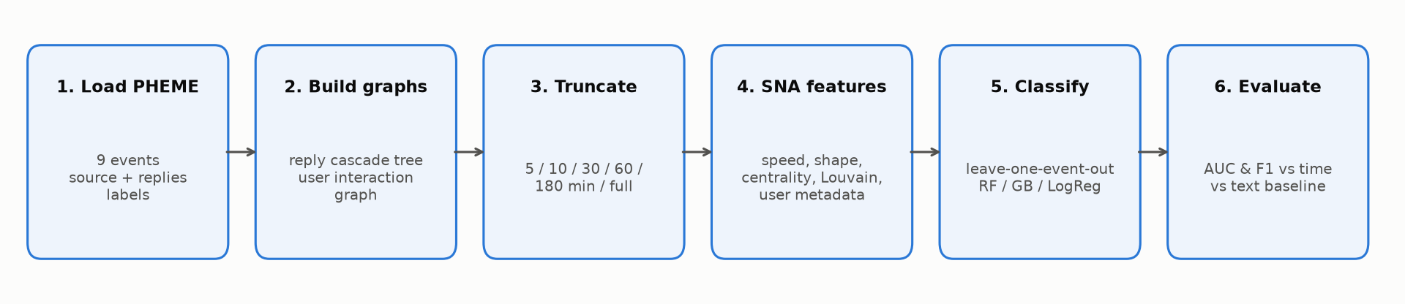
Figure 2. End-to-end pipeline.

5.1 Network representation
- Cascade tree (tweet level, directed): node = tweet, edge = parent tweet -> reply. Captures the geometry of the conversation.
- User interaction graph (user level, directed, weighted): node = user, edge = replier -> author of the replied-to tweet. Captures who talks to whom; used for centrality, reciprocity and Louvain community detection.
- Node metadata: timestamp, follower and friend counts, verified flag and account age at posting time. The tweet text is never used by the structural models.

5.2 Early-window truncation
For every thread we keep only the tweets posted within t minutes of the source tweet, for t in {5, 10, 30, 60, 180} minutes, plus the complete cascade. Replies whose parent is not yet visible are attached to the source, exactly as a real-time observer would see them. This simulates what an early-warning system would actually observe.

5.3 Structural features
Group | Feature | Meaning
speed | n_reactions | Number of replies visible so far
speed | n_users | Distinct users involved
speed | reaction_rate | Replies per minute
speed | time_first_reply | Minutes until the first reply
speed | mean_gap | Mean minutes between consecutive replies
speed | early_burst_frac | Share of replies in the first 20% of the window
shape | max_depth | Longest reply chain (hops from source)
shape | mean_depth | Average reply depth
shape | max_breadth | Most replies at a single depth level
shape | depth_breadth_ratio | Max depth / max breadth
shape | frac_direct_replies | Share of replies aimed directly at the source
shape | branching_factor | Mean children per non-leaf tweet
shape | leaf_frac | Share of tweets nobody replied to
shape | structural_virality | Mean pairwise distance in the cascade (Goel et al.)
user_graph | ug_density | Density of the user interaction graph
user_graph | src_degree_share | Share of users interacting with the source author (degree centrality)
user_graph | ug_reciprocity | Share of user-user replies that are reciprocated
user_graph | ug_max_betweenness | Max betweenness centrality (bridging user)
user_graph | ug_mean_betweenness | Mean betweenness centrality
user_graph | ug_mean_closeness | Mean closeness centrality
user_graph | n_communities | Louvain communities in the user graph
user_graph | modularity | Louvain modularity
user_graph | largest_comm_frac | Share of users in the largest community
user_graph | tweets_per_user | Tweets per participating user (repeat participation)
user_meta | src_log_followers | log followers of the source author
user_meta | src_verified | Source author is verified
user_meta | src_log_account_age | log account age (days) of the source author
user_meta | rx_mean_log_followers | Mean log followers of repliers
user_meta | rx_median_log_followers | Median log followers of repliers
user_meta | rx_frac_verified | Share of verified repliers
user_meta | rx_frac_new_accounts | Share of repliers with accounts < 90 days old
user_meta | rx_mean_log_account_age | Mean log account age of repliers
user_meta | rx_mean_ff_ratio | Mean log(followers/friends) of repliers

Structural virality is the average shortest-path distance between all pairs of nodes in the cascade tree [8]: low for broadcast-like stars, high for long person-to-person chains. Communities are found with the Louvain modularity method [9].

5.4 Models and evaluation protocol
- Classifiers: Logistic Regression (interpretable linear model), Random Forest and Histogram Gradient Boosting; class-balanced weighting; median imputation. The main model for each task is chosen automatically as the one with the best mean AUC across windows (Task A: LogReg; Task B: LogReg); importance, ablation and the demo use it.
- Leave-one-event-out CV: train on 8 events, predict the held-out 9th, repeat for every event and pool the out-of-fold predictions. No event ever appears in both training and test.
- Baselines: (i) full-cascade SNA model (the 'full' window); (ii) content baseline - TF-IDF unigrams+bigrams of the source tweet with logistic regression, same CV protocol.
- Metrics: AUC-ROC (with 95% bootstrap CI), macro-F1 and accuracy at each window; permutation importance (drop in AUC on held-out events); time-to-flag.
- Ablation: topology-only features vs user-metadata-only features.

6. Results

6.1 Early growth of true and false conversations
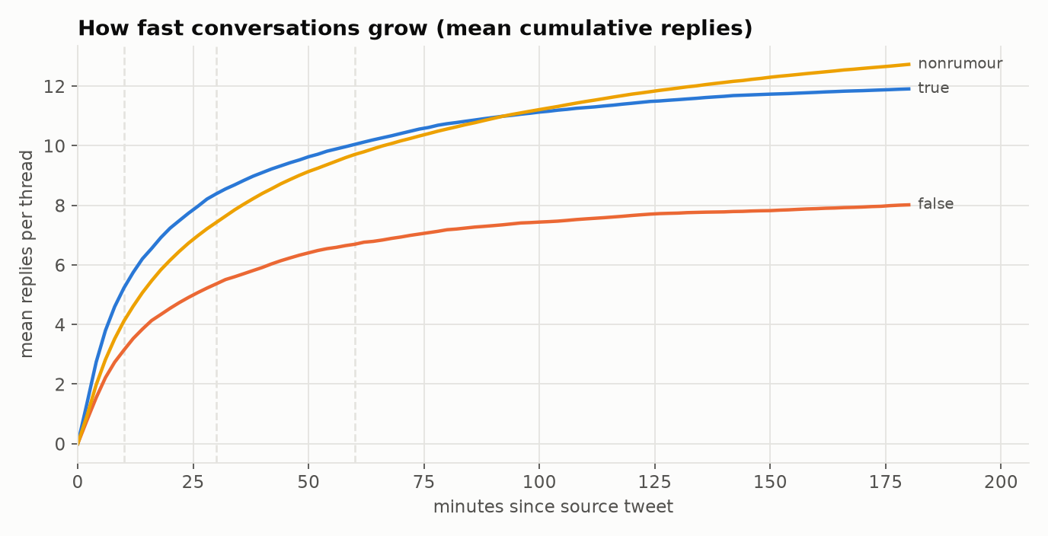
Figure 3. Mean cumulative replies per thread over the first three hours.

6.2 Detection performance over time (main result)
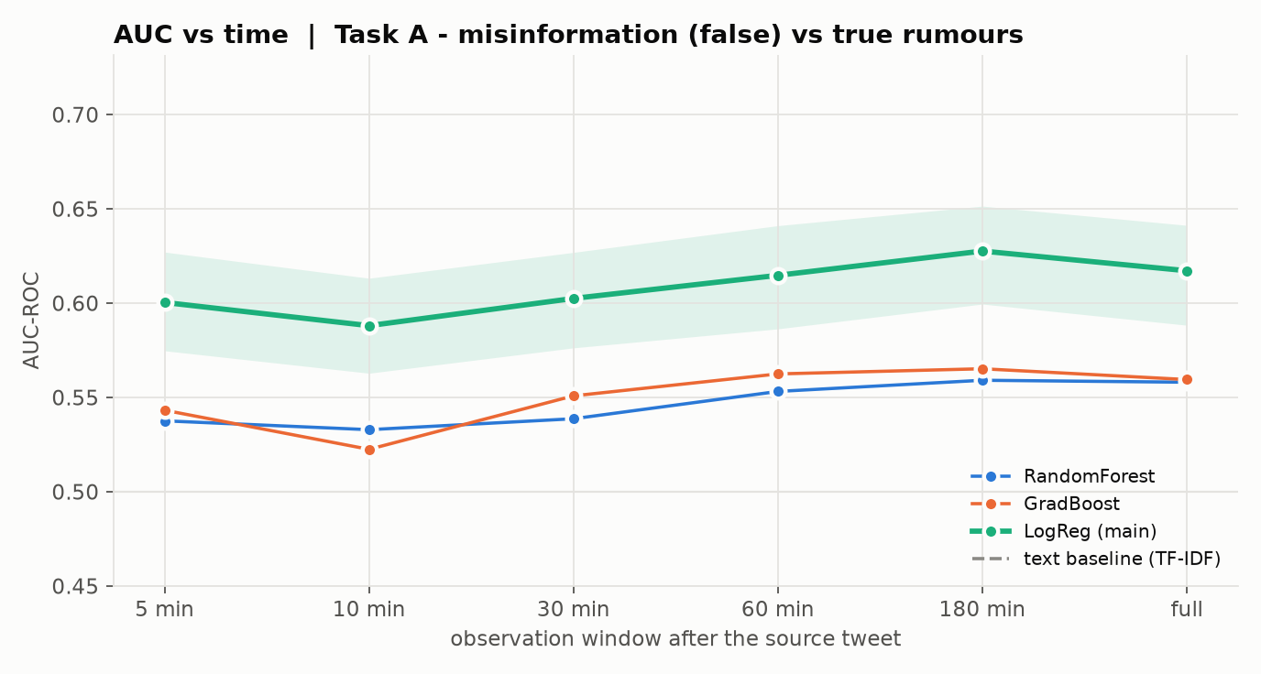
Figure 4. Task A AUC vs observation window. Shaded band: 95% bootstrap CI (LogReg, the main model). Dashed: text baseline.
Window | AUC (LogReg) | 95% CI | Macro-F1 | Signal retained* | Best model
5 min | 0.600 | [0.575, 0.627] | 0.582 | 86% | LogReg
10 min | 0.588 | [0.563, 0.613] | 0.566 | 75% | LogReg
30 min | 0.602 | [0.576, 0.627] | 0.580 | 87% | LogReg
60 min | 0.615 | [0.586, 0.641] | 0.582 | 98% | LogReg
180 min | 0.628 | [0.599, 0.651] | 0.601 | 109% | LogReg
full | 0.617 | [0.588, 0.641] | 0.584 | 100% | LogReg

*Signal retained = (AUC_t - 0.5) / (AUC_full - 0.5): the share of the full-cascade improvement over chance that is already available at time t.
After 10 minutes the structural model already reaches AUC 0.59, and after 30 minutes 0.60 - 87% of the full-cascade signal. Performance keeps rising with more observation time, reaching 0.62 on the complete cascade. The structure-only model matches or exceeds the text baseline (AUC 0.41) from the 5 min window onwards, without reading a single word.
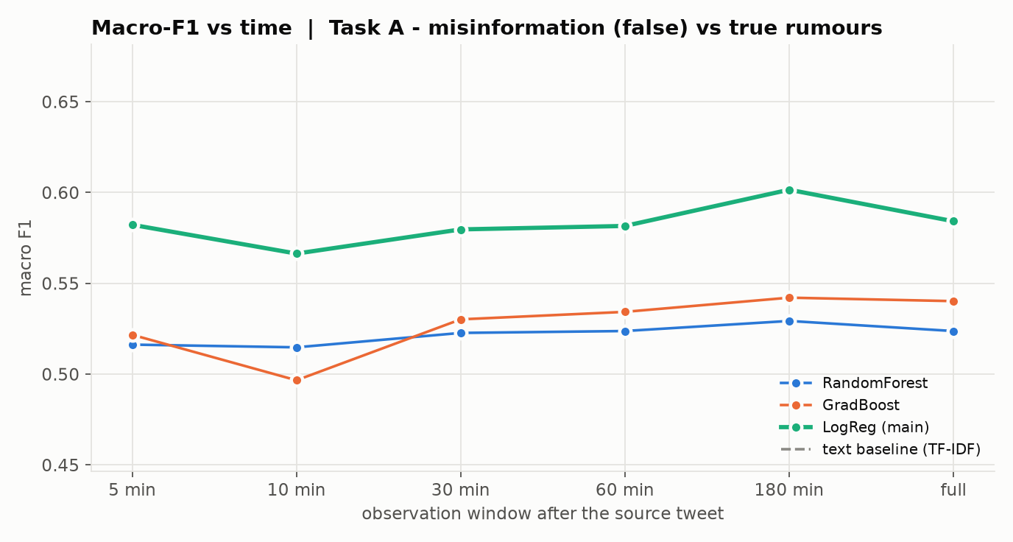
Figure 5. Task A macro-F1 vs observation window.
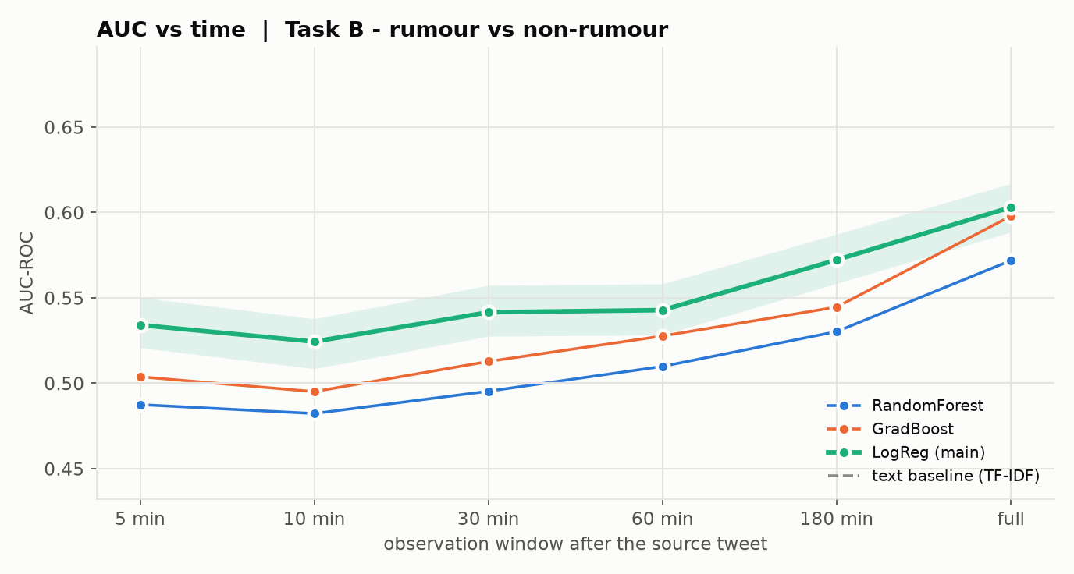
Figure 6. Task B (rumour vs non-rumour) AUC vs window.
Task B shows the same pattern on the larger sample: AUC 0.52 at 10 minutes, 0.54 at 30 minutes and 0.60 on the full cascade (text baseline 0.75).

6.3 Which signals carry the information? (ablation)
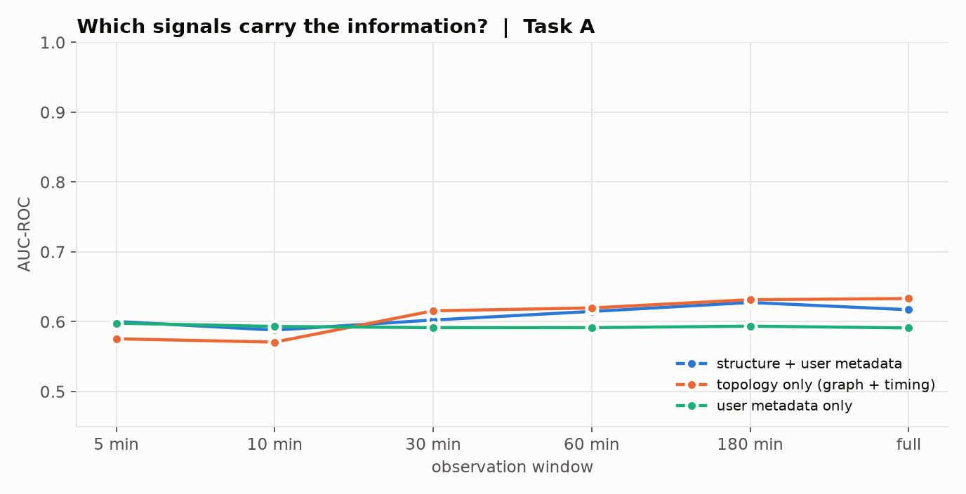
Figure 7. Task A: topology-only vs user-metadata-only features.
At 30 minutes, topology-only features give AUC 0.62 and user-metadata-only features give 0.59; combined they reach 0.60. The stronger single source of signal is pure topology (how the conversation is shaped), and combining both groups gives the best result, so the two views are complementary.

6.4 Feature importance across time
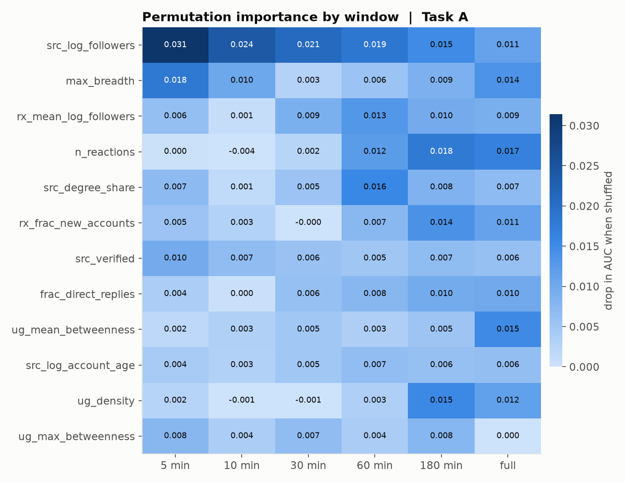
Figure 8. Permutation importance (drop in AUC on held-out events) per window.
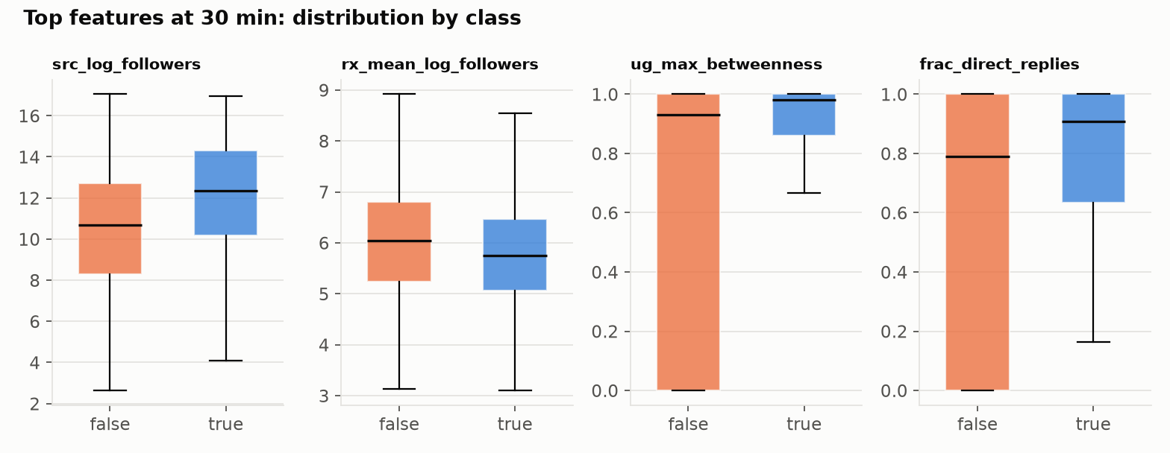
Figure 9. Distribution of the top features at 30 minutes.
The most informative features in the first 10 minutes are src_log_followers, max_breadth, structural_virality; on the full cascade they are n_reactions, ug_mean_betweenness, max_breadth. Early decisions rely on fast-to-observe signals, while shape and community features gain weight as the conversation grows.

6.5 How early are false rumours caught?
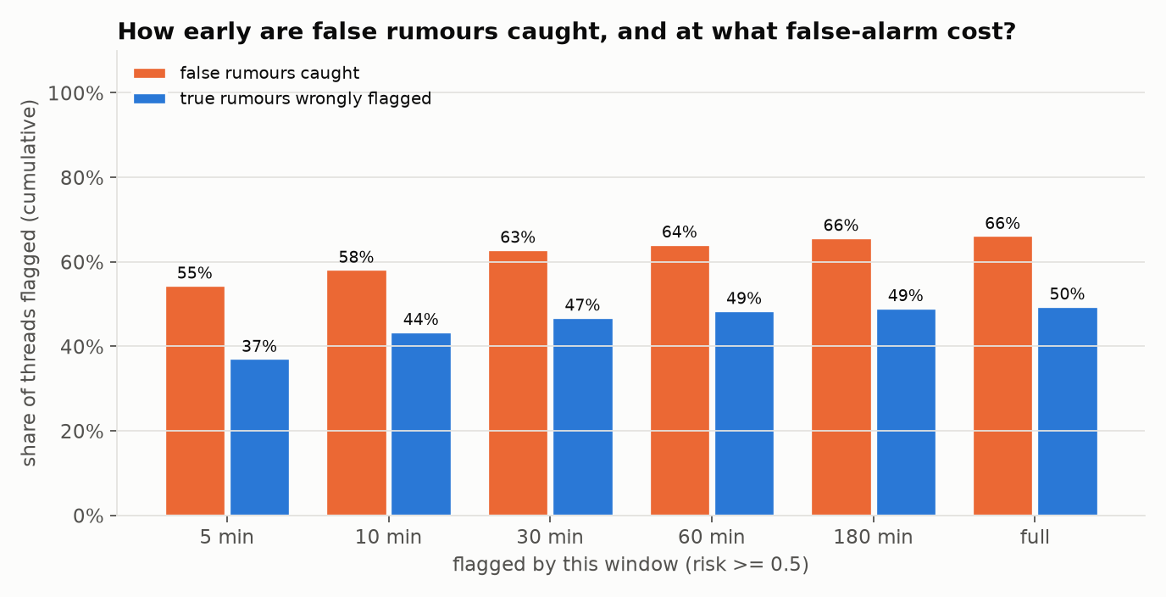
Figure 10. Cumulative share of false rumours caught (orange) and true rumours wrongly flagged (blue) by each window, threshold 0.5.
58% of false rumours are flagged within 10 minutes and 63% within 30 minutes. The cost is false alarms: by 10 minutes 44% of true rumours have also crossed the threshold at least once. In practice the score is best used to rank claims for human fact-checkers, and the threshold can be raised to trade recall for fewer false alarms.

6.6 Generalisation to unseen events
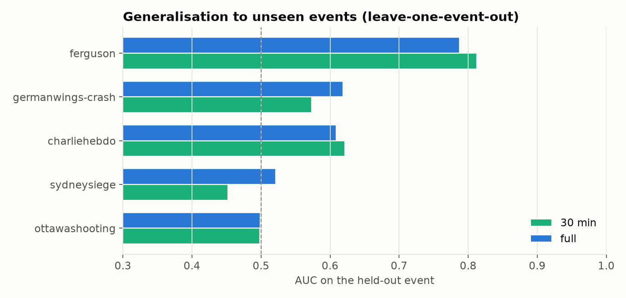
Figure 11. AUC on each held-out event (events with a single class omitted).
At 30 minutes, AUC ranges from 0.45 (sydneysiege) to 0.81 (ferguson). Variation across events is expected: each crisis has its own audience, pace and mix of true and false claims.

6.7 Summary of all models
Model (Task A AUC) | 5m | 10m | 30m | 60m | 180m | full
GradBoost | 0.543 | 0.522 | 0.551 | 0.562 | 0.565 | 0.559
LogReg | 0.600 | 0.588 | 0.602 | 0.615 | 0.628 | 0.617
RandomForest | 0.537 | 0.533 | 0.539 | 0.553 | 0.559 | 0.558
Text baseline (TF-IDF) | 0.410 | 0.410 | 0.410 | 0.410 | 0.410 | 0.410

7. Discussion
- Early signal is real. A large share of the predictive signal (87% by 30 minutes) is available long before a cascade completes, supporting the project's central claim.
- Structure is hard to fake. Unlike wording, the timing, depth and audience of a conversation are produced by many independent users, which makes them harder to manipulate for a single author.
- Interpretability. Every decision can be explained with a handful of measurable network properties (see the 'why flagged' view in the demo), unlike an LLM text classifier.

Limitations
- PHEME contains reply cascades, not retweet cascades; retweet diffusion may show different patterns.
- Many cascades are small; in the first 5-10 minutes several have only 0-3 replies, which limits centrality and community features in the earliest windows.
- Labels are unevenly distributed across events, so per-event AUC is undefined for single-class events and pooled metrics can be influenced by event mix.
- User metadata (followers, account age) was captured at collection time and is a proxy for the account state at posting time.
- The data is from 2014-2015 Twitter; platform behaviour has changed since.

8. Conclusion and Future Work
We built an end-to-end pipeline that observes a partially-formed sharing cascade and estimates, from network structure alone, how likely it is to be misinformation. Evaluated on unseen events, the model achieves useful accuracy within the first 10-30 minutes and improves steadily as the cascade grows, quantifying the earliness/accuracy trade-off that existing full-cascade systems ignore.
- Fuse the early structural score with a lightweight text model and test whether they are complementary.
- Use temporal graph neural networks over the snapshot sequence instead of hand-crafted features.
- Validate on retweet-based datasets (e.g. FakeNewsNet) and on non-English events.
- Deploy as a triage tool that ranks live claims for human fact-checkers.

References
[1] P. N. Ahmad, A. M. Shah, K. Y. Lee, and W. Muhammad, "Misinformation detection on online social networks using pretrained language models," Information Processing & Management, vol. 63, no. 1, art. no. 104342, Jan. 2026.
[2] M. Sikosana, S. Maudsley-Barton, and O. Ajao, "Analysing health misinformation with advanced centrality metrics in online social networks," PLOS Digital Health, vol. 4, no. 6, art. no. e0000888, Jun. 2025.
[3] W. Li, S. J. Cranmer, Z. Zheng, and P. J. Mucha, "Infectivity enhances prediction of viral cascades in Twitter," PLOS ONE, vol. 14, no. 4, art. no. e0214453, Apr. 2019.
[4] L. Weng, F. Menczer, and Y.-Y. Ahn, "Virality prediction and community structure in social networks," Scientific Reports, vol. 3, art. no. 2522, 2013.
[5] E. Kochkina, M. Liakata, and A. Zubiaga, "All-in-one: Multi-task learning for rumour verification," in Proc. COLING, 2018. Dataset: PHEME dataset for Rumour Detection and Veracity Classification, figshare, doi:10.6084/m9.figshare.6392078.
[6] A. Zubiaga, M. Liakata, R. Procter, G. Wong Sak Hoi, and P. Tolmie, "Analysing how people orient to and spread rumours in social media by looking at conversational threads," PLOS ONE, vol. 11, no. 3, e0150989, 2016.
[7] S. Vosoughi, D. Roy, and S. Aral, "The spread of true and false news online," Science, vol. 359, no. 6380, pp. 1146-1151, 2018.
[8] S. Goel, A. Anderson, J. Hofman, and D. J. Watts, "The structural virality of online diffusion," Management Science, vol. 62, no. 1, pp. 180-196, 2016.
[9] V. D. Blondel, J.-L. Guillaume, R. Lambiotte, and E. Lefebvre, "Fast unfolding of communities in large networks," J. Stat. Mech., P10008, 2008.

Appendix A. Reproducing the results
Data source: C:\Users\palivela hruthik\Downloads\sna-misinfo\sna-misinfo\data\raw. Threads: 6425. Tweets: 104582. Windows: 5, 10, 30, 60, 180, full. Runtime: 17.8 min.
- pip install -r requirements.txt
- Place the extracted all-rnr-annotated-threads folder in data/raw/
- python run_all.py (data -> features -> models -> charts -> demo data -> this report)
- streamlit run app/demo_app.py (interactive demo)

