Mathematical and Computational Optimization Framework for Satellite-Enhanced Groundwater Forecasting and Extraction Management

The Spatial and Temporal Discrepancy in Satellite Gravimetry
Accurate characterization of subsurface hydrologic variables is essential for sustainable water resource management. The fundamental water balance equation governs these environmental dynamics:

where is precipitation, is runoff, is evapotranspiration, and is the change in total water storage over time¹. Monitoring groundwater storage variations has historically relied on localized well networks². However, well networks often present sparse spatial distribution and high maintenance costs².
To overcome these constraints, the Gravity Recovery and Climate Experiment (GRACE) and its successor GRACE Follow-On (GRACE-FO) satellites have emerged as vital tools by providing monthly Terrestrial Water Storage Anomalies (TWSA)³. Despite their global utility, GRACE observations exhibit a coarse spatial footprint of approximately 300 km (or ), which limits direct applicability to small-scale watersheds and localized agricultural aquifer management³.
To resolve this spatial mismatch, statistical and empirical downscaling methods establish data-driven relationships between coarse-resolution satellite gravimetry and high-resolution hydroclimatic predictors³. This downscaling process occurs in a structured multi-phase framework². In the spatial downscaling phase, coarse-resolution () GRACE TWSA is mapped to a high-resolution grid (typically )². This is achieved by training an ensemble-based machine learning model—such as Random Forest, Gradient Boosting, or Multi-Layer Perceptrons—that learns the empirical relationship between basin-scale TWSA and spatially aggregated, high-resolution hydroclimatic predictors³. The regression model is formulated as:

where 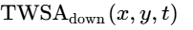 represents the downscaled water storage anomaly at grid coordinate 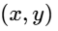 and time ³. The vector 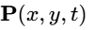 contains time-varying hydrometeorological covariates, and 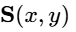 represents static topographical and geophysical parameters⁵. The primary input datasets are derived from globally available remote sensing and reanalysis products, including precipitation () from the Climate Hazards Group InfraRed Precipitation with Stations (CHIRPS) dataset, evapotranspiration () from the MOD16 product or WaPOR database, and soil moisture () and runoff () from the Global Land Data Assimilation System (GLDAS) or TerraClimate datasets³.
To maintain mass balance consistency across scales, a spatial preservation step is applied³. The downscaled fields are spatially aggregated back to the native GRACE mascon scale and compared directly to the original satellite signal³. Any systematic bias introduced during the statistical downscaling is corrected using a scaling factor:
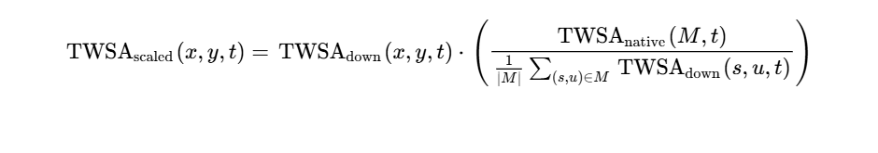
where denotes the spatial footprint of a specific native GRACE mascon, and 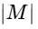 is the number of high-resolution pixels contained within it³.
Once the total water storage anomaly is scaled, the groundwater storage anomaly () must be isolated³. Using high-resolution Land Surface Model (LSM) simulations from GLDAS, shallow water storage components are subtracted from the total water column³:
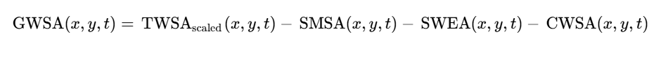
where is the soil moisture storage anomaly, is the snow water equivalent anomaly, and is the canopy water storage anomaly³. This isolated is subsequently translated into well-scale Groundwater Level Anomalies (), representing localized piezometric head changes⁸. This translation is governed by the aquifer's storage coefficient or specific yield ():

Infiltration through the unsaturated vadose zone introduces non-trivial physical delays between surface recharge events and the corresponding response of the water table³. To prevent temporal misalignment, the regression model must incorporate a lagged convolution function of the surface predictors³. The travel time through the unsaturated zone is modeled using a transfer function parameterized by the vadose zone properties (such as sediment thickness and clay content)³. The effective recharge entering the saturated aquifer at time is expressed as:

where 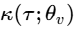 is a transfer function parameterized by the vadose zone properties , represented as a gamma distribution kernel:

where 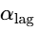 and 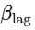 are shape and scale parameters governing the hydraulic delay, and is the gamma function. Integrating this lag formulation ensures that the machine learning models capture the physical delay of the vertical recharge flux, preventing the artificial temporal shifts common in unlagged empirical models³.

Dynamic State-Space Formulation and Predictive Modeling
Developing an optimal pumping schedule requires an explicit state-space formulation that defines how the groundwater level evolves as a function of its current state, exogenous environmental drivers, and active human extraction⁹. The groundwater system is modeled as a discrete-time, non-linear dynamical state transition:

where 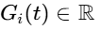 represents the localized groundwater hydraulic head at well site and time ; 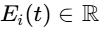 is the active groundwater extraction rate (pumping volume) at site during interval , representing the controllable input; 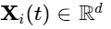 is a vector of dynamic exogenous environmental drivers (such as predicted precipitation, temperature, and recharge)⁷; is a vector of static hydrogeological features (including local transmissivity, depth to bedrock, and land-use class)⁵; is the learned transition operator parameterized by neural network weights ; and 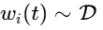 is an additive stochastic process disturbance representing unmodeled dynamics and climate variability⁹.
Assuming future exogenous climate variables (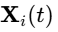) are known over the planning horizon is hydrogeologically unrealistic. To address this, future trajectories are modeled using a vector autoregressive transformer network conditioned on historical climate sequences and regional ensemble forecasts:

where 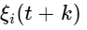 represents scenario-based climate uncertainty, which is sampled from multiple climate projection paths (such as wet, nominal, and dry scenarios) to evaluate planning performance under severe meteorological stress¹¹.

Chance-Constrained Model Predictive Control and Sequential Convex Programming
Historically, water resource planning has attempted to apply Linear Programming (LP) to solve groundwater extraction problems. However, when the groundwater state 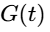 is modeled as a highly non-linear function of extraction 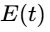 and exogenous drivers via deep learning surrogates (such as Long Short-Term Memory networks or Random Forests), standard linear programming cannot natively enforce safety constraints of the form 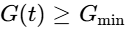 across time¹². This incompatibility arises because the non-linear transition operator distorting the constraint boundaries cannot be represented within a convex, linear constraint matrix, leading to severe linearization errors, constraint violations, or solver divergence¹².
To resolve this limitation, we replace the linear formulation with a Chance-Constrained Model Predictive Control (CCMPC) framework¹¹. This framework optimizes groundwater extraction over a predictive horizon while guaranteeing that the hydraulic head remains above the critical drawdown threshold 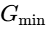 with a high user-defined probability 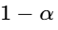 under climate and model uncertainty¹⁰. The stochastic optimization problem is formulated as:
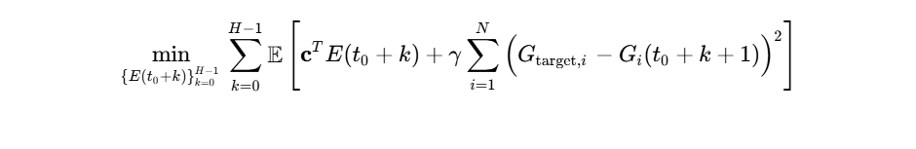
subject to:
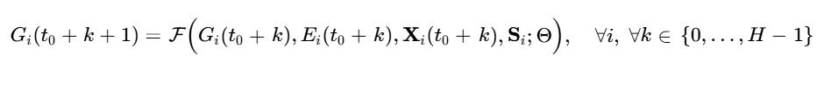


where represents the unit cost vector of energy consumed during extraction, is a penalty parameter enforcing stabilization near a sustainable target level 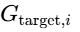, and 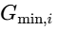 is the critical drawdown threshold below which pump failure or land subsidence occurs¹⁰.
To provide formal safety guarantees during optimization, predictive uncertainty must be quantified without making restrictive Gaussian assumptions⁹. This framework utilizes split conformal prediction to construct mathematically guaranteed, calibration-free uncertainty bounds around the neural network's nominal predictions⁹. The calibration protocol computes absolute prediction errors (non-conformity scores) over a calibration set ⁹:

Given a target violation probability 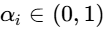, the empirical quantile is calculated as:

This conformal error bound is then used to convert the stochastic chance constraint in Equation (13) into an equivalent deterministic constraint⁹:

This reformulates the safety boundary by requiring the nominal prediction to exceed the minimum safe state by at least the conformal error margin ⁹.
Because the state transition model is a non-linear neural network, the resulting optimization problem is non-convex and cannot be solved directly by standard quadratic program solvers¹². We resolve this by applying a two-loop Sequential Convex Programming (SCP) algorithm¹³. Within the SCP framework, the system dynamics are linearized at each decision interval around a nominal trajectory 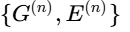 from the previous iteration ¹¹:
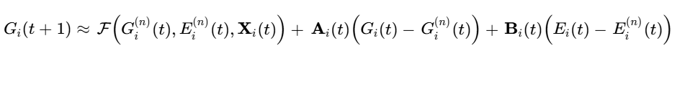
where the Jacobian matrices 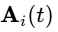 and 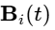 represent the sensitivity of the next state to current states and extraction rates, respectively:

These gradients are computed efficiently using automatic differentiation through the neural network layers¹³. This linearization yields a convex quadratic subproblem at each step:
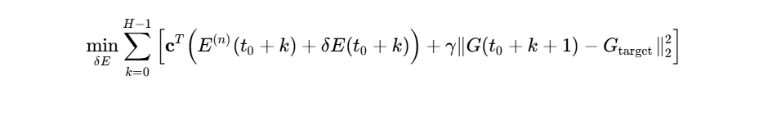
subject to:
- The linearized state transitions (Equation 16).
- Trust-region constraints: 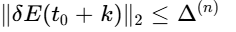, ensuring the optimization step remains within the local validity of the Taylor-series approximation¹³.
- The tightened safety constraint: 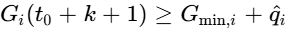.
The outer loop refines the conformal bounds and updates the nominal trajectory:

This iterative process repeats until convergence (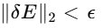), providing a mathematically consistent and computationally efficient solution to the optimal extraction problem¹².

Hydrologic and Scientific Machine Learning Related Works
To address complex groundwater dynamics and generalization limitations, researchers have moved toward advanced scientific machine learning architectures¹⁴. Three paradigms are particularly relevant for regional data integration and real-time execution:

Physics-Informed Machine Learning (PIML)
Instead of relying on purely data-driven relationships, PIML models embed physical laws directly into neural networks¹⁴. For unconfined and saturated groundwater systems, the governing physics are represented by the Dupuit-Boussinesq or Richards equations¹⁵. Incorporating these equations as regularization terms in the loss function constrains predictions to physically consistent trajectories, even when training data is sparse or noisy¹⁵.
Furthermore, this framework supports parameter inversion¹⁴. By backpropagating errors through both the data loss and the partial differential equation constraints, PIML models can estimate unobserved heterogeneous properties, such as hydraulic conductivity and storage coefficients, directly from sparse monitoring well data¹⁵.

Spatiotemporal Attention and Graph Neural Networks (GNNs)
Monitoring well networks do not exist in isolation; they are connected through continuous geological formations². Standard sequence models (like standard LSTMs) treat well nodes independently, ignoring the spatial flow vectors that link them. Graph Neural Networks (GNNs) resolve this by modeling the aquifer as a directed graph ¹⁸.
The well locations are represented as nodes , while the geologic connectivity and flow paths are represented as edges ¹⁸. By combining recursive temporal layers (such as LSTMs) with spatial message-passing GNN layers, the network captures both local drawdown effects and regional hydraulic gradient shifts¹⁸. This enables more accurate predictions of well-scale interference during joint extraction¹⁸.

Operator Learning and Fourier Neural Operators (FNOs)
Traditional neural networks are mesh-dependent, meaning they can only output predictions on the specific grid resolution used during training¹⁹. This is a major limitation when transferring models from coarse satellite grids to fine well-scale domains².
Operator learning models, specifically Fourier Neural Operators (FNOs), address this by learning mappings between infinite-dimensional functional spaces¹⁹. By parameterizing the kernel integral in Fourier space, the FNO learns a discretization-invariant mapping of Darcy or subsurface flows²¹:

This discretization invariance enables zero-shot super-resolution¹⁹. A U-FNO model trained on a computationally cheap, coarse grid can run inference directly on highly detailed, heterogeneous geological models without retraining²⁰. This approach preserves fine-scale features, such as water-flood fronts and channel connectivity, while running up to three orders of magnitude faster than full-order numerical simulators²². Consequently, FNO-based surrogates are highly suited for real-time optimization pipelines²⁰.

Global versus Local Modeling Paradigms
A key structural decision in regional groundwater modeling is whether to train a single global model across all available monitoring wells or to train separate local models for individual wells²⁴.
Global models compile training inputs from multiple time-series across diverse geographic coordinates²⁵. In surface water hydrology, global models frequently outperform local benchmarks because rainfall-runoff relationships follow generalized, gravity-driven pathways across topographic catchments²⁴.
However, groundwater systems exhibit unique complexities²⁴:
- Slow Response Dynamics: Piezometric heads respond to climate inputs over months or years, contrasting with the rapid response of surface streamflow²⁴.
- High Hydrogeological Heterogeneity: Neighboring wells can exhibit vastly different dynamics due to localized clay lenses, fracture networks, or pumping patterns that are not captured in regional data³.
- Data Scarcity: High-quality, long-term monitoring is often limited to a few developed basins, leaving many aquifers data-scarce².
Recent benchmarks, such as those evaluated across 3,000 wells in Germany, show that global models do not consistently outperform local models in groundwater forecasting²⁴. While global models provide more robust, generalized predictions that are useful in data-scarce zones, they often smooth out localized extremes and fail to capture well-specific drawdown behavior²⁴. Conversely, local models excel at capturing site-specific anomalies but are highly susceptible to overfitting when historical records are short, and they cannot generalize to unmonitored aquifers²⁵.
To bridge this gap, successful regional forecasting requires hybrid strategies²⁴. Global architectures (such as LSTMs or GNNs) must be conditioned on static hydrogeological features (e.g., local hydraulic conductivity, transmissivity, and specific yield)⁵. This conditioning allows a single global model to specialize its dynamic predictions to the unique structural properties of individual wells, combining the robustness of global learning with the high accuracy of localized models²⁴.

Comprehensive Experimental Design and Performance Benchmarks
To validate the proposed downscaling, forecasting, and optimization framework, we establish a robust experimental protocol utilizing real-world physical baselines and comprehensive validation metrics²⁴.

Dataset Assembly and Study Domains
The framework is validated across two distinct hydrogeological basins representing contrasting climatic and structural regimes:
- The Glacial Aquifer System of Illinois (USA): Characterized by high administrative monitoring density, structural heterogeneity, and seasonal agricultural demand⁷. This domain provides data for 32 monitoring wells (21 used for model training, 11 withheld for spatial validation)⁸.
- The North German Basin: Representing a slow-responding, highly heterogeneous porous media aquifer system²⁴. This domain utilizes a benchmark dataset of approximately 3,000 monitoring wells²⁴.
Data compilation spans a twenty-year operational period (2005–2025), synchronizing monthly GRACE TWSA, daily CHIRPS precipitation, MODIS evapotranspiration, and localized extraction reports³. The exact variables compiled for the model are detailed below:

Feature Name | Variable Symbol | Data Source / Sensor | Physical Role in Hydrodynamic System
Precipitation |  | CHIRPS / Satellite³ | Primary mass input driving vertical recharge flux⁴.
Evapotranspiration |  | MODIS / WaPOR⁶ | Primary atmospheric output depleting shallow storage⁶.
Soil Moisture |  | GLDAS / LSM³ | Direct representation of moisture within the vadose zone³.
Surface Runoff |  | GLDAS / LSM³ | Identifies surface lateral export of un-infiltrated water⁴.
Snow Water Equivalent |  | GLDAS / LSM⁷ | Accounts for seasonal delay in solid-phase storage⁷.
Canopy Water Storage |  | GLDAS / LSM⁷ | Quantifies interception losses prior to ground contact⁷.
Vegetation Index |  | MODIS Altimetry⁸ | Proxy for seasonal transpiration and crop water demand⁸.
Land Surface Temp |  | MODIS Thermal⁸ | Thermal driver regulating potential evapotranspiration⁸.
GRACE TWSA |  | GRACE / GRACE-FO³ | Coarse total mass anomaly integrating all storage³.
Specific Yield |  | In-Situ Piezometer⁷ | Ratio of drainable water volume to total aquifer volume.
Hydraulic Conductivity |  | Drill Core Log⁷ | Governs lateral and vertical fluid velocity in matrix²².
Sediment Thickness |  | Borehole Log⁷ | Governs travel path distance and unsaturated lag⁷.
Well Extraction Rate |  | Flow Meter⁷ | Active anthropogenic discharge vector (control input).
Hydraulic Head (Target) |  | Pressure Transducer⁷ | Dynamic water table elevation (state variable)⁷.

Validation Paradigms
To prevent data leakage and evaluate real-world utility, we deploy three validation paradigms:
- Temporal Validation (Rolling-Origin): The time-series data is split using a rolling-origin framework. The model is trained on data from to , and evaluated on the subsequent horizon 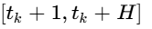. The training window then advances progressively.
- Spatial Validation (Out-of-Region Generalization): A spatial k-fold cross-validation scheme is implemented. An entire sub-basin or cluster of monitoring wells is completely withheld during model training to test the framework’s spatial transferability to unmonitored zones²⁴.
- Ablation Studies: To isolate the value-add of individual information channels, models are trained and compared across three feature configurations:

Ablation Configuration | Included Features | Primary Testing Hypothesis | Expected Impact on Performance
Configuration A (Local Baseline) | Meteorologic Time-Series (, , , ) | Determines the baseline forecasting accuracy of standard land-surface models without gravity observations. | High error variance during unexpected multi-year drought events.
Configuration B (Raw GRACE Integration) | Local Baseline + Native GRACE | Evaluates if coarse, unrefined satellite data improves prediction without downscaling or lag correction³. | Marginal improvement; introduces high spatial bias at local well scales³.
Configuration C (Proposed Data Fusion) | Complete Feature Set (Downscaled + Lag Correction + Geophysics) | Tests the performance of the full framework³. | Minimum Root Mean Square Error (RMSE) and highest spatial/temporal generalization³.

Numerical and Physical Benchmarks
The machine learning predictive models are evaluated against three established baselines:
- MODFLOW: A high-fidelity, physics-based, three-dimensional finite-difference groundwater flow model²⁸. MODFLOW is parameterized with regional pumping rates and hydraulic parameters to provide a deterministic baseline for groundwater levels.
- Lumped Physical Water-Balance Model: A standard conceptual model that calculates storage changes using simple conservation principles (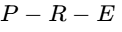) without spatial discretization¹.
- Physics-Informed Neural Networks (PINNs): An advanced deep learning architecture that embeds the 2D Boussinesq equation directly into the loss function¹⁵:


where is hydraulic head, 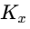 is hydraulic conductivity, is the recharge rate, and is specific yield²⁸.

Comparative Analysis of Modeling Paradigms
Evaluating the trade-offs of the predictive models requires analyzing their structural features, computational complexity, and applicability across different scales¹⁴.

Model Paradigm | Input Data Requirements | Physical Consistency | Out-of-Sample Transferability | Computational Efficiency | Key Hydrogeological Application
Physics-Based (MODFLOW)  [cite: 28] | High; requires detailed spatial hydraulic conductivity, storage coefficients, boundary conditions, and pumping logs²⁸. | High; strictly enforces mass conservation and partial differential equations governing porous media flow²⁸. | Low; requires completely re-parameterizing boundary conditions and grid cells for new regions. | Low; solving large-scale systems requires substantial execution time and memory. | Regional aquifer planning, long-term impact studies of structural irrigation.
Local ML (Site-Specific LSTM)  [cite: 24] | Low; requires historical well levels and localized meteorological time-series for a single point²⁴. | None; learns purely empirical correlations from observed historical patterns. | None; model is locked to the specific well coordinate where it was trained²⁴. | High; rapid execution and inference once trained. | Short-term, well-scale agricultural pumping management.
Global ML (Multi-Well LSTM)  [cite: 24] | High; requires generalized hydroclimatic features and well records from thousands of regional sites²⁴. | Low; can utilize soft-constraint penalties but lacks structural physical equations. | Moderate; generalizes to unseen wells within similar dynamic hydrogeological regimes²⁴. | High; rapid forward passes across multiple evaluation grids. | Basin-scale drought monitoring in regions with sparse ground-based sensors³.
Physics-Informed Neural Networks (PINN)  [cite: 14, 28] | Moderate; combines sparse target observations with known physical governing parameters¹⁵. | High; penalizes training deviations from the partial differential equations²⁸. | Moderate; constrained by the physical boundaries defined in the loss function¹⁷. | Moderate; training is computationally intensive, but inference is rapid. | Parameter inversion, estimating heterogeneous hydraulic conductivity fields¹⁴.
Fourier Neural Operator (FNO / U-FNO)  [cite: 22, 31] | High; requires large simulated datasets of flow fields for initial training²⁰. | Moderate; dynamics are learned in the spectral domain, allowing physical constraints²². | High; exhibits discretization invariance, allowing zero-shot super-resolution on fine grids²⁰. | Very High; evaluates entire flow-field trajectories up to three orders of magnitude faster than numerical solvers²². | Real-time surrogate modeling for interactive control and digital twins²².
Proposed Data Fusion (CCMPC + SCP)  [cite: 3, 13] | Moderate; integrates downscaled GRACE anomalies with localized lagged meteorology³. | High; bounded safety constraints are dynamically enforced by robust optimization¹¹. | High; leverages conformal prediction to adjust safety bounds to unknown distribution shifts⁹. | Moderate; iterative sequential convex programming solves non-convex optimizations in real-time⁹. | Sustainable water-district pumping scheduling under extreme climate variability¹¹.

Conclusions
This framework resolves the core technical and methodological limitations of satellite-enhanced groundwater forecasting and extraction management. By replacing inconsistent linear programming formulations with Chance-Constrained Model Predictive Control (CCMPC) solved via Sequential Convex Programming (SCP), the framework establishes a mathematically sound optimization pipeline that natively accommodates non-linear machine learning transition models¹¹.
Furthermore, the introduction of a dual-phase downscaling framework, combined with lag-corrected surface predictors, effectively bridges the resolution gap between coarse satellite gravimetry and localized well-scale observations². Using non-parametric Conformal Prediction provides rigorous safety guarantees under extreme climate uncertainty, moving away from uncalibrated assumptions of deterministic future inputs⁹.
The proposed experimental validation protocol—incorporating physical baselines (such as MODFLOW and PINNs), spatial cross-validation, and ablation studies—provides a clear path for verifying model performance²⁴. Integrating these advanced computational paradigms with physical hydrogeologic principles creates a robust, scalable, and transferable framework for sustainable groundwater management under climate variability.

Works cited
- Hydrology of catchments, rivers and deltas (CIE5450) - TU Delft OpenCourseWare, https://ocw.tudelft.nl/wp-content/uploads/CIE5450_Hydrology_catchment_and_water_balance.pdf
- Downscaling GRACE Data for Improved Groundwater Forecasting Using Artificial Neural Networks | Civil Engineering Journal, https://www.civilejournal.org/index.php/cej/article/view/5497
- Machine-Learning Downscaling of GRACE/GRACE-FO for Basin-Scale Groundwater Storage Assessment in a Semi-Arid Basin - Preprints.org, https://www.preprints.org/manuscript/202603.1157
- GRACE Downscaling and Machine Learning Models for Groundwater Prediction: A Systematic Review - MDPI, https://www.mdpi.com/2306-5338/13/5/135
- Full article: Downscaling inversion of GRACE-derived groundwater storage changes based on ensemble learning - Taylor & Francis, https://www.tandfonline.com/doi/full/10.1080/17538947.2023.2242316
- Machine learning downscaling of GRACE/GRACE-FO data to capture spatial-temporal drought effects on groundwater storage at a local scale under data-scarcity, https://www.fao.org/in-action/remote-sensing-for-water-productivity/applications-and-uses/applications-catalogue/product-detail/machine-learning-downscaling-of-grace-grace-fo-data-to-capture-spatial-temporal-drought-effects-on-groundwater-storage-at-a-loca/en
- wondy30/GRACE-TWSA-downscaling-ml - GitHub, https://github.com/wondy30/GRACE-TWSA-downscaling-ml
- Downscaling GRACE TWSA Data into High-Resolution Groundwater Level Anomaly Using Machine Learning-Based Models in a Glacial Aquifer System - MDPI, https://www.mdpi.com/2072-4292/11/7/824
- Chance-Constrained Neural MPC under Uncontrollable Agents via Sequential Convex Programming - arXiv, https://arxiv.org/pdf/2504.03293
- Two-Sided Chance-Constrained Penetration Trajectory Optimization for Unmanned Combat Aerial Vehicle | Journal of Aircraft - Aerospace Research Central, https://arc.aiaa.org/doi/10.2514/1.C038395
- Chance-constrained stochastic MPC of greenhouse production systems with parametric uncertainty - WUR eDepot, https://edepot.wur.nl/646861
- Chance-Constrained Model Predictive Control for SAGD Process Using Robust Optimization Approximation | Industrial & Engineering Chemistry Research - ACS Publications, https://pubs.acs.org/doi/10.1021/acs.iecr.8b03207
- Chance-Constrained Neural MPC under Uncontrollable Agents via Sequential Convex Programming - arXiv, https://arxiv.org/html/2504.03293v2
- Physics-informed neural networks for groundwater: evidence, limits, and a roadmap, https://www.researchgate.net/publication/401189290_Physics-informed_neural_networks_for_groundwater_evidence_limits_and_a_roadmap
- Investigating steady unconfined groundwater flow using Physics Informed Neural Networks - Mohammad Afzal Shadab, https://mashadab.github.io/papers/shadab_PINNsGW_2023.pdf
- Full article: Application of physics-informed neural networks to inverse problems in unsaturated groundwater flow - Taylor & Francis, https://www.tandfonline.com/doi/full/10.1080/17499518.2021.1971251
- Application of physics-informed neural networks to inverse problems in unsaturated groundwater flow | Semantic Scholar, https://www.semanticscholar.org/paper/Application-of-physics-informed-neural-networks-to-Depina-Jain/d8451e04fe01a6a2496e318e269dc67cb6955527
- Predicting Groundwater Level using Temporal Attention Enhanced Graph Neural Network - Tuijin Jishu/Journal of Propulsion Technology, https://www.propulsiontechjournal.com/index.php/journal/article/download/2581/1767/4443
- Fourier neural operator surrogate model for nonlinear electrical resistivity tomography | Geophysical Journal International | Oxford Academic, https://academic.oup.com/gji/article/244/3/ggag022/8431395
- Enhancing subsurface multiphase flow simulation with Fourier neural operator - PMC - NIH, https://pmc.ncbi.nlm.nih.gov/articles/PMC11458995/
- MgFNO: Multi-grid Architecture Fourier Neural Operator for Parametric Partial Differential Equations - arXiv, https://arxiv.org/html/2407.08615v2
- A Dual-Branch Coupled Fourier Neural Operator for High-Resolution Multi-Phase Flow Modeling in Porous Media - MDPI, https://www.mdpi.com/2073-4441/17/23/3351
- Fourier Neural Operator based surrogates for $\textrm{CO}_2$ storage in realistic geologies | OpenReview, https://openreview.net/forum?id=DBHG4c9F6h
- Never Train a Deep Learning Model on a Single Well? Revisiting Training Strategies for Groundwater Level Prediction - EGUsphere, https://egusphere.copernicus.org/preprints/2025/egusphere-2025-4055/
- Global vs. Local Models for Short-Term Electricity Demand Prediction in a Residential/Lodging Scenario - MDPI, https://www.mdpi.com/1996-1073/15/6/2037
- Global and Local Approaches for Forecasting of Long-Term Natural Gas Consumption in Poland Based on Hierarchical Short Time Series - MDPI, https://www.mdpi.com/1996-1073/17/2/347
- (PDF) Global or local modeling for XGBoost in geospatial studies upon simulated data and German COVID-19 infection forecasting - ResearchGate, https://www.researchgate.net/publication/389856559_Global_or_local_modeling_for_XGBoost_in_geospatial_studies_upon_simulated_data_and_German_COVID-19_infection_forecasting
- GW-PINN: A deep learning algorithm for solving groundwater flow equations - OSTI, https://www.osti.gov/pages/biblio/1976802
- (PDF) Location Invariant Flood Forecasting using Fourier Neural Operator - ResearchGate, https://www.researchgate.net/publication/387892332_Location_Invariant_Flood_Forecasting_using_Fourier_Neural_Operator
- Physics-Informed Neural Networks for solving transient unconfined groundwater flow - RiuNet, https://riunet.upv.es/server/api/core/bitstreams/27acd352-b93c-4030-8f8c-562ffc02df55/content
- U-FNO—An enhanced Fourier neural operator-based deep-learning model for multiphase flow - Stanford Center for Carbon Storage, https://sccs.stanford.edu/sites/g/files/sbiybj17761/files/media/file/u-fno-an_enhanced_fourier_neural_operator-based_deep-learning_model_for_multiphase_flow_0.pdf

