Swine Disease Classification Using Deep Learning

Hruthik Vinnakota, Jugal Kishore Ruvva, Rajeev Yenugula, Ramya Sudireddy
Department of Data Analytics, San Jose State University
DATA 298B: MSDA Project II
Dr. Jerry Gao
Dr. Lee Chang
February 26, 2024

Model Development

The recognition and analysis of pig cough sounds are crucial for the early detection of diseases in swine. Identifying an issue at its initial stages of certain diseases in pigs is essential for timely treatment, controlling the spread of the disease, minimizing treatment expenses, and improving overall well-being. The study aims to classify pig diseases by analyzing acoustic and visual data. This approach has the potential to decrease medical expenses and improve food safety measures. Detecting diseases at an early stage is crucial to prevent outbreaks, limit the spread of the disease, and mitigate the associated financial consequences. The dataset collection involves a wide range of audio and video recordings of swine. These recordings have been meticulously annotated by domain experts to identify specific disease features and characteristics. Data preprocessing is an essential step in improving the quality of a dataset. This process involves reducing noise and converting formats for better data accuracy and reliability. Hyperparameter tuning is employed to optimize model performance through feature extraction techniques like spectrograms and Mel-frequency cepstral coefficients (MFCCs).
This study underscores the significance of selecting deep learning models that strike a balance between complexity and interpretability. Project deliverables include an extensively annotated dataset, a standardized and efficient preprocessing pipeline, and a feature extraction pipeline that includes relevant audio features.

Model Proposals
For the project, four models were suggested. The models included Convolutional Neural Network (CNN), Residual Network (ResNet), and DenseNet Connected Convolutional Network. ResNet, known as a residual neural network, is part of the convolutional neural network family. An important objective of ResNet is to establish "identity bypass connections," which bypass several layers in the hierarchy of identity representation. DenseNet is a convolutional neural network that consists of dense connections between layers. These layers are connected through Dense Blocks, promoting direct information flow throughout the network. This section consists of the proposed models for the disease detection and classification of swine diseases using image data. Two models named MobileNet and LSTM are employed for this project.

Convolutional Neural Network (CNN)
Weizheng Shen et al. (2022) talked about the convolutional neural network (CNN), which is commonly employed for extracting in-depth features from sound signals augmenting the acoustic features obtained through pre-processing sound segments. Essential features are extracted from the input data using specialized layers, such as convolutional and pooling layers. Accurate results for various applications largely depend upon these extracted properties. The Convolutional Neural Network (CNN) network architecture is built upon the highly successful Lenet-5 model, which has consistently achieved remarkable results in various image classification tasks. Figure 1 illustrates CNN architecture.
In the evaluation of pig cough sound recognition, various CNN architectures are assessed using equations specific to Convolutional Neural Networks. The performance of these architectures is measured using multiple evaluation metrics including Accuracy, Precision, Recall, and F1-score and accuracy formulae is in (1).
Accuracy = (TP + TN) / (TP + TN + FP + FN) (1)
TP = True Positive (number of correctly identified cough sounds)
TN = True Negative (number of correctly identified non-cough sounds)
FP = False Positive (number of non-cough sounds incorrectly identified as cough sounds)
FN = False Negative (number of cough sounds incorrectly identified as non-cough sounds)
Recall = TP / (TP + FN) (2)
TP = True Positive (number of correctly identified cough sounds)
FN = False Negative (number of cough sounds incorrectly identified as non-cough sounds)
Precision = TP / (TP + FP) (3)
TP = True Positive (number of correctly identified cough sounds)
FP = False Positive (number of non-cough sounds incorrectly identified as cough sounds)
F1-score = 2 * (Precision * Recall) / (Precision + Recall) (4)
Precision = TP/(TP + FP) (number of correctly identified cough sounds)
Recall = TP/(TP + FN) (number of cough sounds incorrectly identified as non-cough sounds)
Figure 1
The CNN architecture is used for extracting deep features.
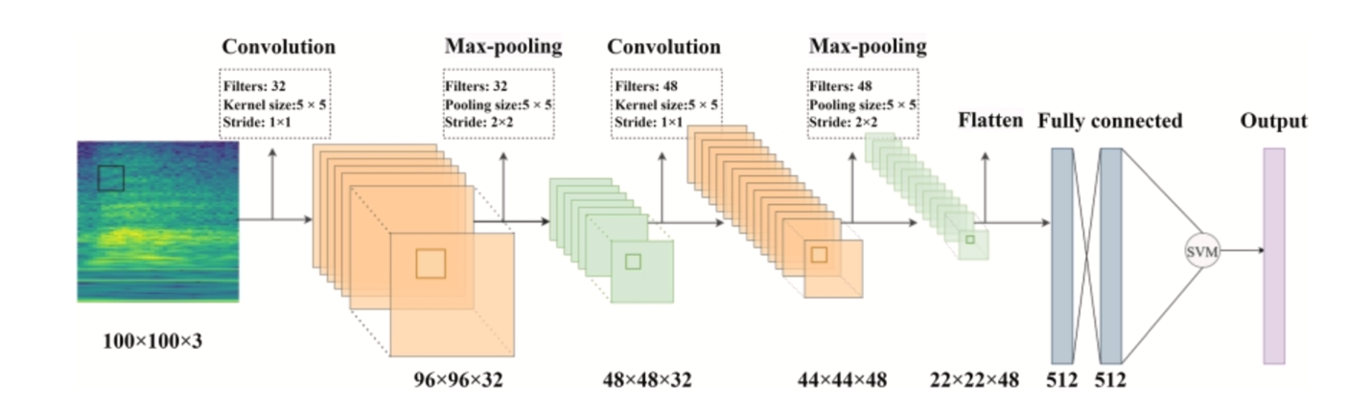Note. A 4-layer convolution block with various filter rates. The input of the previous feature maps is used by every layer that follows. From “Fusion of acoustic and deep features for pig cough sound recognition,” by Weizheng Shen et al. (2022).
Input. The Pig cough noises recorded in two dimensions are fed into the CNN model. These are the Constant-Q Transform (CQT) spectrogram and the Short-Time Fourier Transform (STFT) spectrograms. Using the LibROSA toolkit, both types of spectrograms are produced from the sound samples, offering a thorough source for the model's analysis.
The Lenet-5 Architecture. The Lenet-5 architecture is a shallow network that has yielded outstanding performance on handwritten digit recognition tasks. It utilizes multiple layers of convolutional and pooling operations, followed by fully connected layers to categorize the digits. This architecture was specifically chosen for this study because it performs well with smaller datasets, which aligns with the limited and private nature of the dataset.
Feature extraction using CNN. Where a shallow CNN network was designed and implemented to extract deep features from segments of pig cough sound. The CNN architecture utilized in this study is depicted in Figure 20. This architecture incorporates convolutional layers, max-pooling layers, and fully connected layers for feature extraction purposes.
Convolutional Layer. To extract local features from the input data, the convolutional layer applies several filters. This is accomplished by convolving the filters with the input data, which generates an output feature map.
Activation Function. The feature map is then passed through an activation function, such as the rectified linear unit, which helps introduce non-linearity into the network and enables it to learn more complex patterns. This process enhances the network's ability to capture intricate relationships within the data.
Max-Pooling layer. Max-Pooling layer is an essential part of the network architecture utilized in convolutional neural networks. It plays a crucial role in reducing the spatial dimensionality of the feature maps, thereby preserving important information while minimizing computational complexity. Among different types of pooling operations, max pooling is commonly employed. This operation involves extracting the maximum value from a specific region within the feature map and propagating it to higher layers for further processing.
Fully Connected (FC) Layer. After performing several convolutional and pooling operations, the resulting feature maps are flattened into a one-dimensional vector. This vector is then passed through one or more fully connected layers, where every neuron in these layers is interconnected with each neuron from the preceding layer. The main objective of implementing these fully connected layers is to acquire meaningful representations of the input data at a higher level.
Output Layer. The output layer of a Convolutional Neural Network is usually represented by a SoftMax layer that generates a probability distribution across multiple classes. As per this distribution, the class with the highest assigned probability is regarded as the predicted class for that input data instance. The CNN model produces deep characteristics that are taken out of the spectrograms. The CNN architecture, which consists of several layers for convolution, pooling, and interaction, is used to extract certain information from the spectrograms. The spectrograms that represent the sounds made by pigs coughing can be used to teach and extract significant properties by the CNN model.
Deep Feature Extraction. The CNN architecture is utilized to extract complex and intricate features from the pig cough sound segments. Two distinct forms of time-frequency representations, specifically continuous wavelet transform and short-time Fourier transform, were employed as inputs to the CNN. The TFRs were simultaneously inputted into two parallel networks to obtain deep features, which were subsequently combined and forwarded to a classifier for accurate classification purposes.
The acoustic elements that were taken out of the sound signals are then blended with these deep features. Early fusion, in which the features are concatenated together, is the process that combines deep and auditory data. The aggregated features are then sent into a support vector machine to identify cough sounds made by pigs. Because SVM is a robust classifier for datasets with limited training sample availability, it is selected as the classifier. Utilizing spectrograms as inputs and deep features as outputs, the CNN model can efficiently identify pig cough sounds when combined with acoustic data.

DenseNet
DenseNet is a deep learning model that addresses the vanishing-gradient problem and aims to improve the performance of convolutional neural networks by using a more complex network structure with deeper layers. In a study by Hang Song et al. (2022) talked about introducing dense connections between layers, DenseNet allows for better feature reuse throughout the network and alleviates the vanishing-gradient problem. This unique approach enhances information flow within the model, ultimately improving performance in various tasks. Figure 2 illustrates the schematic representation of the DenseNet.
Figure 2
Schematic representation of DenseNet
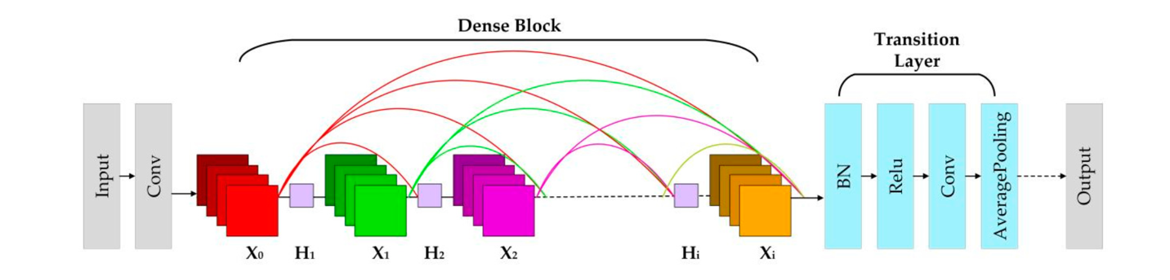Note. A class of network models known for their exceptional performance and ability to include deeper layers. They accomplish this, astonishingly, with the least amount of computational complexity and parameter requirements. From “Research on improved DenseNet pig cough sound recognition model based on Senet’s” by Hang Song et al. (2022).
The vanishing-gradient problem, which occurs when gradients backpropagate through deep networks at an exponential rate, is successfully addressed by DenseNet and improves deep network training by using dense connections to allow gradients to flow directly from the output layer to each layer before it. The SE-DenseNet architecture incorporates the SENets attention module into each dense block, improving upon the original DenseNet model. The SE-dense block is composed of convolutional layers with 1x1 and 3x3 kernel sizes. Then, the SENets attention module is added to the Conv(3x3) layer. This improves the accuracy of pig cough sound recognition and allows for more effective feature extraction from pig sound signals. The model accepts 26-dimensional MFCC + ∆MFCC parameters as input to enhance performance. Compared to existing models in this domain, this technique achieves a high recognition accuracy rate and exhibits better recall, precision, and F1 score.
Input: Pig cough sounds are sent into the DenseNet model, which then gathers and analyzes the data to extract features such as the Mel Frequency Cepstral Coefficient, delta 2 MFCC (∆2MFCC), and delta MFCC (∆MFCC). These features are merged into six parameter groups; a 26-dimensional MFCC + ∆MFCC set is the most efficient combination.
The output feature of each dense block, denoted as Xi, is obtained by applying a nonlinear transformation function to the input feature X0. This transformation function consists of Batch Normalization (BN), Rectified Linear Units (ReLU), and Convolution (Conv). The output feature Xi is mathematically calculated as follows: Xi = Hi ([X0, X1, ........, Xi−1]) where "Hi" denotes the non-linear transformation function at a specific layer, while "Xi" represents the output feature that is subsequently passed on as input to the next dense block within the network. This implementation of a dense connection allows for efficient reuse of features throughout the transmission process and facilitates enhanced feature extraction capabilities. Additionally, a transition layer is employed to minimize parameter count and computational complexity in the network. It achieves this by integrating characteristics from preceding dense blocks through convolution with a 1×1 kernel and average pooling operations, resulting in a more lightweight model overall.
Dense Blocks. The core of DenseNet lies in the dense block module, which is iterated multiple times in the network structure. Within a dense block, features are repeatedly extracted using Conv (1 × 1) and Conv (3 × 3) kernels. One major benefit of dense blocks is that they establish strong connections between layers, enabling efficient reuse and propagation of features throughout the entire network. Consequently, the output from each dense block becomes the input for the subsequent one, forming a connected chain for effective feature extraction.
Transition Layers. The transition layers play a crucial role in combining the output characteristics of the dense blocks and minimizing the number of parameters involved. To achieve this, each transition layer incorporates essential components such as Batch Normalization, Rectified Linear Units, Convolutional operation with filter size 1x1 (Conv (1 × 1)), and average pooling. Leveraging Conv (1 × 1) can effectively reduce parameter count, while the average pooling operation further enhances model efficiency by reducing spatial dimensions of features.
Output: The results obtained for pig cough sound recognition are the outputs of the DenseNet model. It was created expressly to identify pig coughs accurately and provide pigs with early detection of respiratory diseases. The outcomes cover a variety of performance metrics, such as F1 score, accuracy, recall, and precision. In this study, the accuracy of pig cough sound recognition was 93.8%, recall rate was 98.6%, precision level was 97%, and F1 score was 97.8%. These inputs and outputs show how the DenseNet model can effectively identify cough sounds made by pigs. It also emphasizes how promising it is for the early diagnosis of respiratory disorders in pigs.

Residual Networks (ResNet)
ResNet enables the use of skip connections to train incredibly deep CNNs. Taejun Kim et al. (2019) talked about ResNet and its architecture. Backpropagation is smoothed, and optimization is facilitated by skip connections, which provide gradients with clear pathways. When 'n' is the number of convolutional layers, the fundamental block with a single skip connection is referred to as a Res-n Block. ResNet were developed on top of VGGNets, which are widely recognized CNN architectures known for their effectiveness in image classification. The sample CNN architecture bears similarities to VGGNets; however, it differs by employing 1D filters and utilizing one-dimensional convolution and pooling techniques. ResNet have been widely demonstrated to perform exceptionally well in a wide range of image classification tasks.
One key advantage is that their skip connections facilitate easier optimization, fostering ensemble-like behaviors and allowing for effective training of deep networks. One kind of convolutional neural network that is utilized for picture and audio categorization is the Residual Networks model. By leveraging skip connections, it enables the training of extremely deep CNNs, improving the neural network's gradient backpropagation stability.
Input: High-dimensional sensory data, including picture or audio waveforms, are fed into the Reset model. Raw waveforms, which capture comprehensive information about the sound properties, can be used as the input for audio classification.
Res-1 block. The Res-1 block corresponds to the basic building block of a convolutional neural network. It consists of one convolutional layer and is characterized by its skip connection, represented by the dotted lines. This skip connection plays a crucial role in addressing the vanishing gradient problem commonly encountered during training deep networks. By allowing for more fluent backpropagation of gradients, the skip connection ensures an easier flow of information and facilitates the successful training of deeper networks. Figure 3 illustrates the implementation of shortcut path in ResNet.
Figure 3
A skip connection from ResNet is used in the Res-n block.
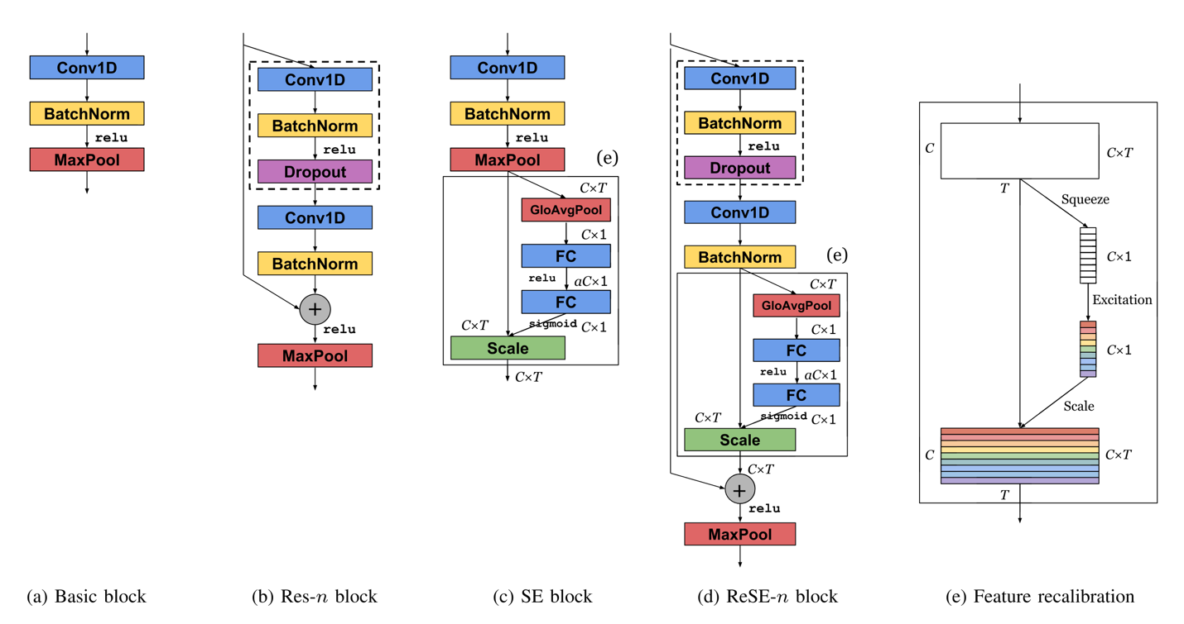
Note. Image classification tasks have made substantial use of the ResNet paradigm, with notable implementations including Alex Net, VGGNets, and ResNet. From “Comparison and analysis of SAMPLECNN architectures for Audio Classification” by Taejun Kim et al. (2019).
The Res-2. The Res-2 block is a variant of the Res-n block that consists of two convolutional layers. It incorporates two skip connections and includes a dropout layer with a drop ratio of 0.2 before the second convolutional layer to prevent overfitting, drawing inspiration from the Wide ResNet architecture. This addition helps tackle the vanishing gradient problem and facilitates training deep CNNs.
Output: As projected classes or labels for the input, the ResNet model's outputs are obtained. To anticipate whether an incoming image contains a dog or a cat, for instance, is one application of the model's image categorization capabilities.
LSTM
The emergence of Long Short-Term Memory (LSTM) networks represents a significant step forward in the evolution of recurrent neural networks (RNNs), providing a solution to one of the most persistent challenges in sequential data processing, the vanishing gradient problem. Hochreiter and Schmidhuber introduced LSTM networks in 1997 as a specialized architecture capable of learning and retaining long-term dependencies in sequential data, making them ideal for speech recognition, language modeling, and time series prediction tasks. Hochreiter and Schmidhuber (1997) pioneered LSTM networks by presenting a novel architecture designed to overcome the limitations of traditional RNNs. By incorporating explicit memory cells with gating mechanisms, LSTM networks enable the selective retention and utilization of information over long time intervals, facilitating the learning of complex temporal patterns.
Graves and Schmidhuber (2005) demonstrated the efficacy of LSTM networks in speech recognition, outperforming conventional RNN architectures. They demonstrated LSTM's ability to capture long-range dependencies in sequential data using phoneme classification tasks, improving the accuracy and robustness of speech recognition systems.
Greff et al. (2016) conducted subsequent research on the architectural space of LSTM networks to identify optimal configurations and hyperparameters. They gained valuable insights into the factors influencing LSTM performance by thoroughly analyzing various LSTM variants, paving the way for improved model design and optimization strategies.
Chung et al. (2014) contributed to empirically assessing LSTM and other gated recurrent neural network (GRNN) architectures for sequence modeling tasks. Their findings shed light on the strengths and weaknesses of various GRNN variants in capturing temporal dependencies within sequential data, informing researchers and practitioners about the models' suitability for specific applications.
LSTM networks are made up of specialized memory cells with gating mechanisms that control the flow of information, allowing them to retain and use relevant information over long periods. An LSTM cell's key components are the forget gate, input gate, cell state, and output gate, which each perform specific operations to process sequential input data.
Forget gate. The forget gate determines whether information from the previous cell state should be discarded or retained, allowing the LSTM to selectively forget or remember the last details based on their relevance to the current context.
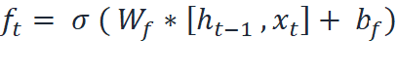 (5)
Input Gate. The input gate regulates the flow of new information into the cell state, enabling the LSTM to update its memory with relevant inputs.
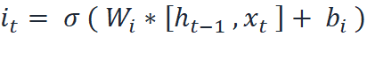 (6)
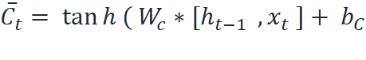 (7)
Update Cell State. The LSTM changes its cell state by selectively incorporating new information while retaining relevant information from the previous cell state, allowing it to adapt to changing input conditions and maintain long-term dependencies.
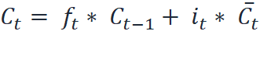 (8)
Output Gate. The output gate controls the flow of information from the updated cell state to the output, determining which parts of the cell state should be communicated to the next layer or output node.
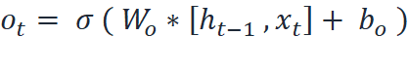 (9)
Optimizing LSTM models entails adjusting various parameters and architectural choices to improve performance and avoid problems like overfitting or vanishing gradients. Figure 4 illustrates the architecture of LSTM.
Figure 4
Architecture of LSTM
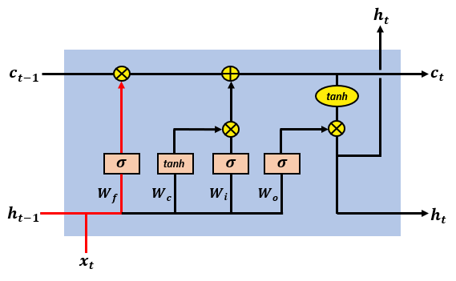
Increasing the number of hidden units in the LSTM layer can improve the model's ability to detect complex patterns in data. However, caution must be exercised to avoid overfitting, as extensive models may struggle to generalize to new data. Optimizing the Learning Rate: Fine-tuning the learning rate can significantly impact the LSTM's training dynamics. A suitable learning rate promotes efficient convergence during training while avoiding oscillations and divergence.
Regularization Techniques such as Dropout or L2 regularization can help prevent overfitting by introducing noise or imposing constraints on model parameters. These regularization methods encourage the LSTM to learn strong representations that can be generalized to new data. Gradient clipping reduces the exploding gradient problem, which can destabilize the training process, particularly in deep LSTM networks. Gradient clipping, which limits the magnitude of gradients during backpropagation, ensures more stable training dynamics and smoother convergence.
MobileNet
MobileNetV2 is a convolutional neural network tailored for mobile devices, featuring an inverted residual structure with bottleneck layers. Pravin R. Kshirsagar et.al., 2022 explained the architecture of MobileNet in image classification models. MobileNet architecture comprises an initial layer of 32 filters, succeeded by 19 residual bottleneck layers. Figure 5 explains the architecture of MobileNet. Each layer includes three sub-layers, a 1 x 1 convolutional with ReLu6, depth-wise convolutional for feature filtering and non-linear convolutional layer with ReLu6 for enhanced resilience in low-precision scenarios. The design incorporates a residual layer with a stride of 1 and a shrinking layer with a astride 2, which promotes an efficient information flow. The compatible use of ReLu6 with 3 x3 filter size maintains model stability. The synergy of these components facilitates model adaptability, making MobileNetV2 a well-suited architecture for image classification models.

Figure 5
Architecture of MobileNet.
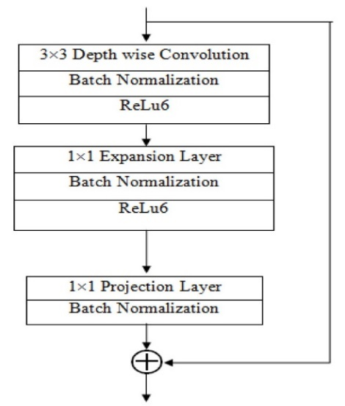
Each layer includes three sub-layers, a 1 x 1 convolutional with ReLu6, depth-wise convolutional for feature filtering and non-linear convolutional layer with ReLu6 for enhanced resilience in low-precision scenarios. The design incorporates a residual layer with a stride of 1 and a shrinking layer with a astride 2, which promotes an efficient information flow.
The compatible use of ReLu6 with 3 x3 filter size maintains model stability. The synergy of these components facilitates model adaptability, making MobileNetV2 a well-suited architecture for image classification models.

Model Supports

Environment, Platform, Tools
To ensure optimal performance in deep learning tasks and bring value to organizations, it is crucial to have access to advanced hardware capable of handling complex computations. Selecting the most suitable hardware can be challenging with a wide range of options including CPUs, GPUs, TPUs, and ASICs available. To expedite model training, executing tasks concurrently rather than sequentially is recommended. Table 1 gives details of the hardware requirements for training, testing, and evaluating the regression model in this study. Concurrent task execution enhances model training speed. Models can seamlessly run on local machines or cloud platforms like Google Cloud Platform (GCP), offering diverse services for data management, processing, training, and deployment. Replication in the production environment ensures smooth model development and deployment. Table 1 gives the details of the libraries used for model development.
Table 1
Hardware requirements.
Assistance | Fundamental specifications
Control Processing Unit | AMD Ryzen™ 7 7840HS Processor (3.80 GHz up to 5.10 GHz)
Graphical Processing Unit | NVIDIA GeForce RTX™ 3050 Laptop GPU 6GB GDDR6
Network | 1 Gbps Ethernet
RAM | 16 GB LPDDR5X-6400MHz
Storage | 1 TB SSD M.2 2280 PCIe Gen4 TLC
These requirements are necessary to ensure the continuous running of the deep learning model on a large acoustic collection. The models can be conveniently hosted and managed on both local machine and cloud-based platforms like Google Cloud Platform (GCP), which offer various services including data storage, processing, training, and deployment of models. To ensure the model's development without any difficulty, it can be replicated in the production environment. Table 2 shows the list of software requirements.
Convolutional neural network models are created by combining machine learning frameworks such as TensorFlow with deep learning networks such as DenseNet and ResNet. These models involve establishing layers like ReLU, Conv1D, Batch Normalization, and several others to enhance their performance and accuracy.
Table 2
Software requirements.
Assistance | Fundamental specifications
Operating System | Windows 11 Pro 64
Virtual Environment Tool | Anaconda 4.10
Application development environment | Jupyter Lab v3.6.0a4
Programming Language | Python 3.9
Version Control System | Git 2.32
Cloud Platform | Google Vertex AI
Containerization Tool | Docker 20.10.8
API Development | Swagger UI
Testing Framework | Pytest 7.0
Documentation | Microsoft Word
To ensure effective development and implementation of deep learning models, it is essential to utilize libraries that provide a wide range of tools and operations for data processing, analysis, and outcome visualization. The platform in which these models are created should be flexible, scalable, and conducive to productivity. Developers can use tools like Anaconda or Docker to establish a distinct and consistent environment which can create a virtual environment with the required packages and libraries by using these tools. Developers can use a variety of tools in this environment to perform operations like feature engineering, data preparation, data purification, model training, and evaluation. The development of the models suggested in this study is made simpler by using this method.
Python is widely used and popular for data analysis. Its readability and ease of use make it an excellent tool for deep learning. For this study, Jupyter Lab was utilized as a web-based Python IDE due to its interactive nature and ability to display the terminal, text editor, console, and file directory simultaneously. This enhanced user interface optimizes the workflow.
Table 3
List of libraries needed and used.
Library | Method | Purpose
os | os.listdir, os.path.join, os.makedirs | File and directory manipulation, joining path components, creating directories.
random | random.uniform, random.choice | Generation of random numbers within specified ranges, random selection.
librosa | librosa.load, librosa.feature.melspectrogram, librosa.power_to_db, librosa.effects.time_stretch, librosa.effects.pitch_shift | Audio file loading, computing spectrograms, converting power spectrograms to dB units, time-stretching, and pitch-shifting audio signals.
numpy | np.array, np.random.randn, np.max | Array creation and manipulation, generation of random numbers, finding maximum value.
soundfile | sf.write | Writing the audio data to file and save it in a specific folder.
pydub | AudioSegment.from_file, AudioSegment.silent, AudioSegment.export, AudioSegment.speedup, AudioSegment.reverse, AudioSegment.overlay | Loading audio files, creating silent segments, exporting audio, modifying playback speed, reversing, overlaying audio segments.
matplotlib | plt.figure, plt.plot, plt.imshow, plt.title, plt.show | Data visualization, creation of figures, plotting graphs, displaying images.
glob | glob.glob, glob.iglob | Filename pattern matching, retrieving file/pathnames that match specified patterns.
fnmatch | fnmatch.fnmatch, fnmatch.filter | Unix filename pattern matching, filtering filenames based on patterns.
pandas | pd.DataFrame, pd.read_csv, pd.concat | Data manipulation, creation of data frames, reading and concatenating CSV files.
seaborn | sns.pairplot, sns.heatmap, sns.countplot | Statistical data visualization, creating pair plots, heatmaps, and count plots.
IPython.display | ipd.Audio | Displaying audio objects as HTML5 audio elements.
math | math.ceil, math.floor | Mathematical operations, rounding up or down.
tensorflow | tf.keras.layers, tf.keras.models.Sequential, tf.keras.utils.to_categorical | Deep learning model creation, neural network layers, one-hot encoding.
sklearn | StandardScaler, train_test_split | Data preprocessing, scaling features, splitting datasets.
warnings  OpenCV  Torch | warnings.filterwarnings  CV2  Dataloader, imagefolder, transformer | Controlling display of warning messages.  To read and display the images.  To load image data, read images , resize the image data, normalize.
For managing dependencies and installing packages, the virtual environment tool Anaconda was selected. The Vertex AI service on the Google Cloud Platform was used in the model training procedure. Git was the version control system used for managing and collaborating on code. Conversely, the program was containerized using Docker so that it could run across several platforms without requiring any changes. Table 3 shows the list of libraries needed and used.
Swine audio and image data analysis is achieved by leveraging an extensive array of tools and platforms to establish a robust and adaptable framework for building and deploying deep learning models. Developers may focus on modeling and analysis rather than infrastructure concerns during deployment due to this integrated development environment, which streamlines the development process. Deep learning model development, testing, and deployment are efficiently supported by this platform because of its unique characteristics.
With Python 3, the OSI-approved, open-source Python programming language has been greatly improved and expanded. This version of Python was used to build tools and packages. Python and pandas libraries were used for data preprocessing activities. Furthermore, an enormous amount of work has been invested in Keras integration and Fourier transformations. TensorFlow was used to package and deploy the trained model, and Librosa, a Python module, made audio and music analysis easier. Librosa audio analysis features include the ability to load audio files in different formats, compute features like chroma and Mel-spectrograms, examine beat tempo details, discern between harmonic and percussive parts, and create visualizations of the audio data.

Model Architecture and Data Flow
The data utilization process involved the meticulous collection of diverse raw swine audio datasets from multiple sources, which were subsequently stored both locally and on the Google Cloud platform. Following this, a comprehensive data management strategy was implemented. All audio files associated with specific pig disease sounds were meticulously organized into distinct categories, facilitating a structured and organized dataset. Subsequently, data synthesis techniques were applied to enhance the dataset's diversity and richness. To work effectively with the audio data, the renowned library, Librosa, was employed for loading and processing.
The initial preprocessing steps involved removing silent intervals and eliminating unwanted disturbances, ensuring the dataset's integrity. Furthermore, data padding was implemented to maintain consistent audio lengths, and feature extraction was performed using Mel-Frequency Cepstral Coefficients (MFCC) with the addition of white noise for enhanced robustness. Figure 6 shows the system framework plotted using the Lucid Chart webpage.
Figure 6
System Framework and Data Routing
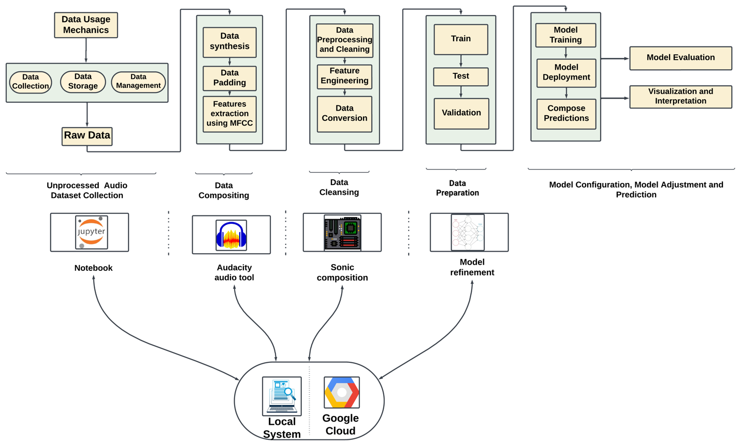
The cleaning phase commenced with thorough data preprocessing, encompassing various techniques for refining, and enhancing the dataset. Feature engineering strategies were then applied, followed by the implementation of data conversion methods to ensure compatibility with subsequent modeling steps. For the model-building phase, the dataset was divided into training (60%), testing (20%), and validation (20%) set to enable effective model training, evaluation, and validation. Three distinct deep learning models were employed to capture the intricate patterns within the audio data.
The subsequent stages involved model training and deployment techniques, paving the way for predictions. Model configurations were fine-tuned, and adjustments were made to optimize performance. The evaluation process meticulously documented the accuracy of the models, presenting results in a systematic order. The report encapsulated the model configuration, adjustments made, and detailed predictions. Finally, the findings were communicated through clear and insightful visualizations, providing a thorough interpretation of the model's performance.

Model Comparison and Justification
For object recognition in audio and images, convolutional neural networks are the method most frequently employed. CNN designs have been showing a tendency toward greater network depth over time. While more modern models like DenseNet have 19 layers, the original LeNet5 only had five. Conversely, as of last year, InceptionV3 Networks and Residual Networks have more than 100 layers. However, as CNNs get deeper, a new research challenge emerges as input or gradient information moves through numerous layers and toward the end of the network, it may begin to disappear. Using techniques like identification signals from one layer to another in ResNet and Highway Connections can help to mitigate this problem.
A Stochastic depth approach removes layers at random during training to improve gradient and information flow in ResNet. Through the integration of many parallel layer sequences, can achieve a significant nominal depth while maintaining short pathways by utilizing FractalNets. While the network structure and training process of various techniques differ, they are always characterized by the establishment of brief paths between layers. As a result, convolutional networks that have fewer connections between their input and output layers can demonstrate significant gains in precision, effectiveness, and depth. To address the drawbacks of the conventional models, the Dense Convolutional Network (DenseNet) model was developed. DenseNet is a neural network development for visual object detection. Between DenseNet and ResNet, there are a few key distinctions. DenseNet uses an additive approach (+) to merge the output of the previous layer with that of the following layer, in contrast to ResNet.
The fact that DenseNet addresses the problem of disappearing gradients, which can interfere with training, is one of its key benefits. DenseNet also has a connectivity pattern that connects all layers with matched feature-map sizes directly, which aids in feature propagation and reuse. This encourages the network's tiers to exchange information at their greatest rate. In addition, when compared to alternative topologies, DenseNet also achieves a significant reduction in parameters. Subsequent layers transfer their feature maps to all previous layers and get new inputs from them to preserve their feed-forward nature.
This dense connection design may have the paradoxical benefit of having fewer variables than conventional convolutional networks because duplicate feature maps do not need to be learned again. An algorithm with a state that is transferred from layer to layer might be thought of as a feed-forward architecture. Every layer transfers the state from the one before it to the one after it. It communicates data that needs to be kept in addition to altering the state. ResNet explicitly expresses this information representation using additive identity transformations. Recent research has demonstrated that many ResNet layers add relatively little and can be arbitrarily removed during training.
Consequently, in terms of their states, ResNet are comparable to (unfolded) recurrent neural networks. However, because each layer has a weight assigned to it, ResNet have a significantly higher number of parameters. Conversely, DenseNet architecture clearly distinguishes between new and conserved data. As a result, DenseNet layers only include a limited number of feature maps (for instance, 12 filters each layer) in the "collective knowledge" of the network, and the final classifier bases its decisions on all characteristic maps from the whole network. Furthermore, DenseNet improved gradients and information flow make the training process simpler to comprehend and follow. By giving the layers direct access to gradients formed from the beginning of the input signal as well as the loss function, they provide implicit deep supervision. This makes it possible to train more complex network topologies. In addition, for smaller training sets, the normalizing impact of extensive connections helps minimize overfitting. Table 4 compares the functional and non-functional aspects of the chosen models.
Table 4
Comparison of functional and non-functional aspects of the models.
Characteristics | ResNet | DenseNet | CNN
Architecture | Is an artificial neural network architecture that includes skip connections between layers. These skip connections allow information to bypass certain intermediate layers and propagate directly from one layer to another. | Is distinguished by the existence of straightforward connections between every layer. | Multiple essential elements, such as fully linked layers, pooling layers, and convolutional layers.
Data Type | Audio Dataset | Audio Dataset | Audio Dataset
Data Size | Suitable for big datasets | Suitable for both small and big datasets | Uses modest filter dimensions and performs well with minimal datasets.
Complexity | Better in terms of computing than Dense | Minimizes the complexity of computing | Moderate
Complications with underfitting | It’s possible that ResNet layers aren't deep enough to accurately represent the convoluted nature of the data. | Due to its highly coupled layers, DenseNet architecture might be challenging to train. | Possibly if not sufficiently deep to capture complicated patterns.
Complications with overfitting | Deep layers in ResNet may make it more likely to overfit, which can happen if regularization isn't done. | If correct regularization is not applied, DenseNet densely connected layers may cause overfitting. | Prone to overfitting, particularly in cases with limited data
Strengths | Shorten the training period while increasing precision | Diminish the issue of the vanishing gradient, enhance the distribution of features, encourage the reuse of features, and significantly lower the quantity of characteristics. | Suitable for jobs involving images; with preprocessing, applicable for audio
Limitations | Issue with vanishing gradients, increasing complexity might make computing more difficult; careful adjustment is needed. | The fact that feature maps are repeatedly replicated and combined with earlier layers is a drawback, potentially costly computationally and resource-intensive | Restricted capacity to identify distant relationships in audio sequences
Approach | Deep Learning | Deep Learning | Deep Learning
Hardware requirements | GPU ( Google Colab Pro, energy efficient T4 GPU) | GPU ( Google Colab Pro, energy efficient T4 GPU) | GPU ( Google Colab Pro, energy efficient T4 GPU)
Accuracy | Achieved good accuracy score on test data i.e. 96.4% | Achieved good accuracy score on test data i.e. 96.4% | Achieved good accuracy score on test data i.e. 96.4%
Training Speed | Fast | Moderate | Slowest
Training Time | A few hours | Several hours to a few days | Several hours
Space complexity | Low | Moderate | Largest
Known issues | Known for its speed and simplicity, but not very accurate | Slow prediction makes it hard to do real-time processing | Large model, requires large memory and computational resources
AI Features | Skip connections for improved representation | Dense connections for feature distribution and reuse | Combination of fully linked, pooling, and convolutional layers
DenseNet are renowned for their capacity to generate productive and compact models. DenseNet increase resource usage efficiency and facilitate training by reusing features inside the network. Additionally, enhance efficiency by supplementing input variance and concatenating feature maps from different layers. Since decision trees have a straightforward design and are capable of processing noises and audio data efficiently, they are a good choice for grouping swine audio recordings in order to categorize their ailments. It's crucial to remember, though, that decision tree models could need a lot of processing capacity and careful hyperparameter adjustment during the training process.
An identity function allows gradients to flow directly from later layers to previous layers in a neural network architecture called ResNet. They provide a different method for modeling input data, which has led to their widespread adoption for the development of strong deep-learning models. Furthermore, DenseNet functions as an extension of ResNet by creating what is referred to as a "dense block" by concatenating output feature maps from earlier convolutional layers rather than putting them together within each layer. The same convolutions and a stride value of one are usually used by both dense and residual blocks to guarantee consistent form maintenance. Due to this design decision, DenseNet can perform better than ResNet models with a noticeably smaller number of parameters.
When comparing MobileNet, a convolutional neural network (CNN) architecture primarily used for image classification, to LSTM, a recurrent neural network (RNN) architecture designed for sequence modeling, several distinguishing characteristics and considerations emerge.
MobileNet uses a deep CNN architecture, with multiple convolutional layers followed by global average pooling and fully connected layers. With lightweight convolutional operations, it is optimized for efficient inference on mobile and embedded devices. MobileNet is specifically designed to process image data and excels at image classification, object detection, and segmentation tasks. MobileNet is well-suited to processing large-scale image datasets but may need help with highly sparse or unstructured data.
Overfitting may occur when MobileNet is trained on small datasets, or the model capacity exceeds the complexity of the task. Before data is fed into MobileNet, it is usually necessary to perform preprocessing steps such as image resizing and normalization. Training time and computational complexity are determined by the model's size and the dataset's complexity. MobileNet provides high accuracy in image classification tasks while remaining efficient and low computational cost, making it ideal for resource-constrained environments. MobileNet's performance may need to improve on complex tasks like object detection or semantic segmentation compared to more intricate CNN architectures.
In contrast, LSTM is a type of RNN architecture that includes specialized memory cells and gating mechanisms. It is designed to handle sequential data, making it appropriate for tasks like natural language processing, time series prediction, and speech recognition. LSTM is adaptable and can take a wide range of sequential data, including text, time series, speech, and audio. It is especially effective at detecting long-term dependencies and patterns in sequential data streams. LSTM can process small and large datasets, including sparse and irregularly sampled time series data. Its ability to retain its internal state over time makes it resistant to data scarcity.
Table 5
Characteristic comparison of MobileNet and LSTM.
Characteristics | MobileNet | LSTM
Architecture | Convolutional Neural Network | Recurrent Neural Network
Data Type | Image | Text, Time Series, Speech, Audio
Data Size | Suited for large-scale images | Effective for both small and large datasets, resilient to sparsity
Overfitting/Underfitting | Prone to overfitting on small datasets | May suffer from overfitting on noisy or highly variable data
Model Complexity | Requires images preprocessing | Requires preprocessing for sequential data, computationally intensive training
Strengths | High accuracy for image classification | Captures temporal dependencies, suitable for sequential data
Limitations | Performance degradation on complex tasks | Sensitivity to hyperparameters, training data quality
Overfitting can also occur with LSTM models, especially when trained on noisy or highly variable sequential data sets. Dropout or L2 regularization are standard techniques used to reduce overfitting in LSTM models. Tokenization or feature engineering may be required before using LSTM models with text or time series data. Table 5 shows the characteristic comparison of MobileNet and LSTM.
Training LSTM models can be computationally intensive, especially for large datasets or deep architectures with many parameters. LSTM excels at capturing temporal dependencies and long-range patterns in sequential data, making it ideal for tasks like language modeling, sentiment analysis, and time series prediction. LSTM performance can be influenced by hyperparameter selection, training data quality, and noisy or irrelevant features in sequential data.

Model Evaluation Methods
The evaluation metric is an essential component of any model to guarantee performance. Finding an appropriate model requires evaluating how well different processes and techniques fit the gathered data. Several metrics like Confusion Matrix, Precision, Recall, F1-Score and Accuracy are implemented.

Confusion Matrix
Also referred to as an error matrix, a confusion matrix contrasts the outcomes of several test predictions with actual values. The structure of a confusion matrix in Table 6. This table helps with the computation of several evaluation measures, such as recall, accuracy, and precision.
Table 6
Confusion matrix
Actual-Values | Predicted-Values
Yes/No
  No | Yes
No
  True-Negative(TN) | False-Positive(FP)
Yes
  False-Negative(FN) | True-Positive(TP)
Note. True Positive Rate (Sensitivity/Recall): TPR = TP / TP+ FN,
False Positive Rate: FPR = FP / FP + TN

Area Under Receiver Operating Characteristic Curve (AU - ROC)
A popular graphical method for assessing a model's performance is the Receiver Operating Characteristic curve or ROC curve. By graphing the true positive rate and false positive rate against one another at different threshold levels, it is possible to examine the trade-off between the two. Can evaluate the effectiveness of the model in differentiating between the positive and negative classes by examining the graph.
A graphical representation of the True Positive Rate against the False Positive Rate at different classification thresholds. The area under the ROC curve, or AUC, is a numerical representation of the model's performance. It shows the degree to which it can distinguish between positive and negative scenarios with accuracy. Better discrimination ability in the model is demonstrated by higher AUC values. It is a widely used metric in machine learning, particularly for binary classification problems.
AUC =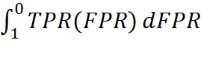 (10)

Precision
Precision is a metric that expresses "how often selected elements are appropriate." This indicates that it displays the proportion of positive observations relative to those that the method forecasted. The formula TP/(TP+FP), where TP stands for true positives and FP for false positives, can be used to determine precision.

Recall
Recall is a metric that shows how many pertinent data points were chosen. Out of all the actual positive measurements, it shows the percentage of positive observations that the algorithm anticipated. Recall is calculated using the formula TP/(TP+FN), where TP stands for true positives and FN for false negatives.

F1 Score
This metric is used to calculate algorithm performance; it accounts for both precision and recall. As a result, other names for it include f1-score and f1-measure. It can be described mathematically as F1 Score = 2*(Recall * Precision) / (Recall + Precision), which stands for the harmonic mean of precision and recall.

Accuracy
For multi-label classification issues, the accuracy measure is an essential tool, measures the ratio of correctly predicted instances to the total number of instances in a dataset. It quantifies the model's precision in predicting outcomes correctly across all classes. Represented as a percentage, accuracy gauges the overall correctness of predictions, offering a simplistic yet fundamental measure of model performance. However, in scenarios with imbalanced datasets, accuracy might not fully represent the model's effectiveness, as it doesn't consider class distribution. Despite its simplicity, accuracy remains a crucial metric for assessing the overall correctness of predictions in classification tasks. Table 7 illustrates the comparison of different evaluation metric scores.
Table 7
Comparison of evaluation metric scores
Metrics | Explanation | Model
AU - ROC | Measures the capacity of a binary classification model to differentiate between classes and ranges from 0 to 1, with higher values indicating superior performance. | CNN, DenseNet, ResNet
Precision | Evaluated as the proportion of accurate output to all generated responses. True Positives / (True Positives + False Positives) equals precision. | CNN, DenseNet, ResNet
Recall | Indicates the percentages of the audio's accurate results among all possible correct responses. True positives / (True Positives + False Negatives) equals recall. | CNN, DenseNet, ResNet
F1 Score | Balances precision and recall in one metric for classification model evaluation. Ranges from 0 to 1; higher is better. Particularly useful with imbalanced classes. | CNN, DenseNet, ResNet
Accuracy | Compiled by tallying the number of accurate audio outputs produced in relation to a predetermined list. (Total number of forecasts / Number of correct predictions) equals accuracy. | CNN, DenseNet, ResNet

Model Validation and Evaluation

DenseNet
The DenseNet confusion matrix demonstrates that the model struggled to correctly classify instances belonging to the second and third classes, as evidenced by the nonzero values outside the main diagonal. Figure 7 shows the evaluation metrics for DenseNet.
Figure 7
Evaluation metrics for DenseNet model
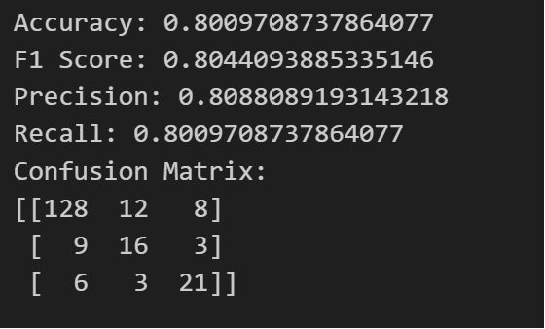
Despite achieving moderate accuracy, DenseNet's precision and F1 score indicate that it struggled to identify positive instances, resulting in lower overall performance correctly. DenseNet's architecture, which encourages feature reuse via dense connectivity patterns, provides advantages for extracting fine-grained features from images. However, the model may need help effectively leverage these features for classification, resulting in suboptimal performance.

CNN
CNN's confusion matrix performs better than DenseNet in all classes, with fewer misclassifications. CNN's superior performance is due to its ability to automatically learn hierarchical representations of features from raw data, making it ideal for image classification tasks. Figure 8 shows the evaluation metrics for CNN. CNN's success can also be attributed to its adaptable architecture, which enables easy adaptation to various data types and tasks. CNNs can effectively capture spatial hierarchies and learn discriminative features from images by stacking multiple convolutional layers followed by pooling layers and fully connected layers, respectively.
Figure 8
Evaluation metrics for CNN
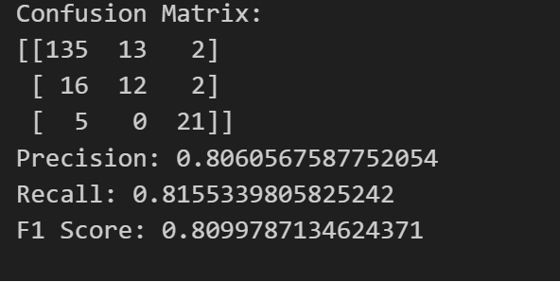

ResNet
ResNet performed similarly to CNN regarding the accuracy, precision, recall, and F1 score. However, it had a higher precision score, indicating it performed better at identifying positive instances. The confusion matrix reveals some misclassifications, particularly in the second class, where several cases were incorrectly classified as belonging to the third class. Figure 9 shows the evaluation metrics for ResNet.
Figure 9
Evaluation metrics for ResNet
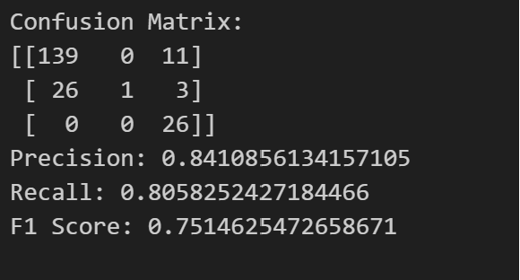
ResNet's success can be attributed to its innovative residual connections, which mitigate the vanishing gradient problem and make it easier to train deep networks. ResNet allows information to flow through the network via shortcut connections, which promotes effective feature reuse and the development of more discriminative representations.

LSTM
The evaluation results show that LSTM has an accuracy of 36.8%. The LSTM performs significantly worse than the MobileNet, indicating difficulties in effectively learning from sequential data. The model may have struggled to detect underlying patterns and dependencies in the data, resulting in poor classification performance.
The architecture of LSTMs, which is designed to maintain and update a memory state over time, makes them ideal for tasks that require temporal dependency modeling. However, in this case, the model may have needed help effectively leveraging the sequential nature of the data to make precise predictions.

MobileNet
The evaluation results show that MobileNet has an accuracy of 46.2%. When comparing LSTM and MobileNet, it is clear that LSTM exhibits significantly lower performance in terms of accuracy. MobileNet outperforms LSTM in terms of accuracy, indicating that it is better suited for the given image classification task.
The lower performance of LSTM may be attributed to the architectures not being optimized for the specific task or dataset. LSTM, designed for sequential data modeling, may not have been able to capture the patterns in the image data effectively. MobileNet, optimized for efficient image processing, may have struggled to extract relevant features from the images in the dataset. Table 8 shows the comparison of all the evaluation metrics for all the models.
Table 8
Comparison of all the evaluation metrics for all the models
Model | Accuracy | Precision | Recall | F1 Score
DenseNet | 80.01% | 53.02% | 72.82% | 61.36%
CNN | 81.55% | 80.61% | 81.55% | 80.99%
ResNet | 80.58% | 84.11% | 80.58% | 75.15%
LSTM | 36.8% | - | - | -
MobileNet | 46.2% | - | - | -
For the audio data, the comparison shows that CNN outperforms the other models regarding accuracy, precision, recall, and F1 score. ResNet performs similarly to CNN in most evaluation metrics. DenseNet performs moderately, while LSTM and MobileNet underperform compared to the other models.

Data Analytics Systems

System Requirement Analysis
System limits and Use Cases
The pork industry is an important contributor to the worldwide livestock sector, supplying a crucial source of protein-rich food to fulfill the demand for meat consumption. An ongoing challenge facing the swine sector is early illness identification which is evident prerequisite. The occurrence of illnesses within pig populations can result in significant financial impact, impair animal well-being, raise concerns about food safety, and impose higher maintenance expenses on farmers as users. To overcome this project is to give farmers a tool to monitor and control the health of their pigs by properly detecting and classifying pig ailments. The system's possible application includes various data from the pig farming industry which can lead to early detection of diseases, ultimately lowering healthcare expenses and improving food safety. It uses visual, audio, and image-based information to categorize diseases in pigs. A significant amount of audio and footage was gathered, showing swine behavior in various settings and circumstances. This appraisal is a significant issue in the pig farming sector, which is highly pertinent and influential. The swine industry is crucial for meat, but timely disease detection is challenging. Farmers play a key role as actors in caring for pigs, yet tracking all pigs in a large facility can be difficult. Late examination may lead to severe issues, rendering some pigs unsuitable for the meat industry, resulting in heavy losses. To address this, early disease detection using pig vocalizations and skin images is essential. These applications benefit both farmers and the meat and food industries, fostering a healthy relationship in various settings.

System high-level data analytics requirements
This project intends to create the best optimal disease detection from pig sector in order to effectively accommodate the different kinds of treatment according to the disease such as African swine fever, swine pox, erysipelas etc. Within the context of models, the system serves good analysis by various purposes such as predicting the early ailments detection based on the various audio data and swine skin images estimating the valid output after training the data to predict the output with high accuracy, forecasting type of illness, including the User Interface (UI) with detailed presentation with detailed image description and valid outcomes, utilizing several tools such as audacity where the audio files were carefully extracted from videos and meticulously chopped into distinct segments. Moreover, well-known Python package Librosa was used to process the audio data in which preprocessing procedures involved eliminating undesired disruptions and silence intervals to preserve the integrity of the dataset. The process of extracting features is crucial in audio analysis, using techniques such as spectrograms and Mel-frequency cepstral coefficients (MFCCs) to process data and padding sequences is used after feature extraction to ensure uniform lengths, especially in the analysis of sequence-based data such as natural language processing, time series analysis, and certain machine learning models.
To detect swine diseases early, data analytics necessitates the collection, processing, and analysis of insubstantial data volumes crucial for supporting the system's essential operations. This involves analyzing data with low volume, falling within the scope of incomplete and inaccurate system analysis. The data is collected from various sources such as professionals in swine health and acoustics, relevant organizations, and research paper authors were contacted. Additionally, pig cough sounds and images were collected from easily accessible sources such as YouTube and veterinary organizations websites. Data that is accurate are necessary for precise evaluation. The dataset is subjected to extensive data cleansing and validation processes in order to find errors, resolve them, deal with discrepancies, and fill in any missing data. Machine learning models are extensively used to analyze and interpret both audio and image data in order to make predictions with high accuracy as mentioned in Figure 10. This involves thoroughly analyzing the particular disease of swine, accurately anticipating the expected output, and strategically planning for the effective implementation of control measures for the diseases in order to minimize their impact on the swine industry. To understand, evaluate, and act upon the insightful information that the system generates, data visualization tools and statistics are created which helps users make sense of the data and make decisions based on research findings about swine diseases. In the end, maximum efficiency guarantees that the system for predicting swine disease is analyzed carefully to meet the specific need for cure. For the system connected to swine audio and image data to operate reliably in a variety of operational settings, certain advanced data analytics specifications are necessary.
Figure 10
Structural System Boundaries, Use Cases, Users
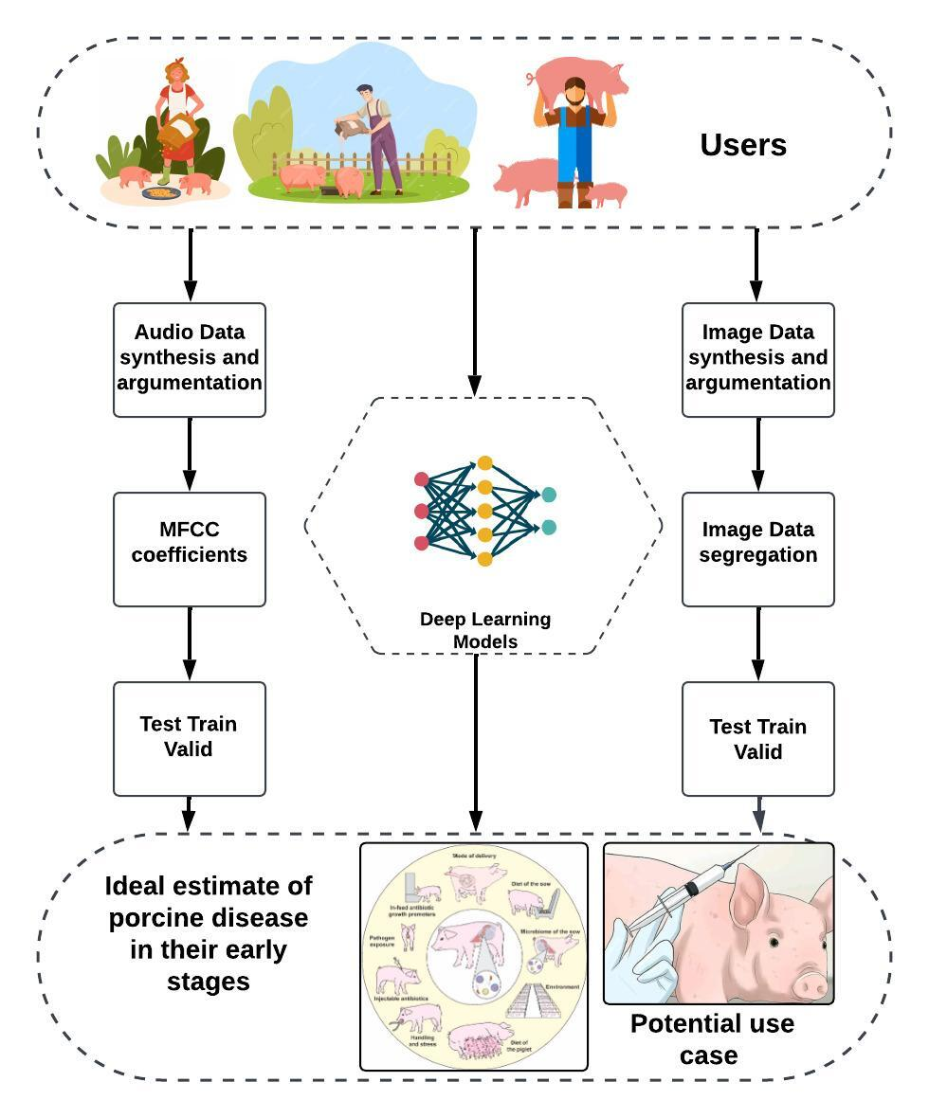

System Design

System Architecture and Infrastructure
The Pig Disease Classification System is designed to efficiently classify diseases in pigs using a combination of audio and image data. The system comprises both frontend and backend components, providing users with a seamless experience for disease prediction.
The frontend of the system is responsible for user interaction and initiating disease prediction. Users access a website where they can input relevant data and trigger the prediction process. The output of the prediction is displayed on the front-end screen for easy interpretation. The backend of the system is responsible for processing the dataset, training deep learning models, and handling the prediction process. The dataset, consisting of both audio and image data, is stored in two locations for redundancy and accessibility. It is stored on a local drive and on Amazon Web Services (AWS) for scalability and reliability. Prior to model training, the raw audio and image data undergo preprocessing. This involves cleaning, normalization, and transformation of the data to make it suitable for deep learning models.
Deep learning models are employed to classify pig diseases based on the preprocessed data. These models are trained using state-of-the-art algorithms, leveraging the power of deep neural networks. Training occurs on both audio and image datasets separately. After model training, the system undergoes rigorous testing using a separate set of test data. This ensures the robustness and accuracy of the trained models in predicting pig diseases. Once the models pass the testing phase, they are integrated into the prediction pipeline. When a user initiates a prediction from the frontend, the backend processes the input data through the trained models, predicts the disease, and sends the results to the frontend for display. Figure 11 illustrates the system architecture of the project.
The predicted disease output is presented on the front-end screen in a user-friendly format. This output includes information about the predicted disease based on the input data provided by the user. The integrated front-end and backend architecture of the Pig Disease Classification System provides a robust, efficient, and user-friendly solution for predicting pig diseases using both audio and image data. The use of deep learning models ensures accurate predictions, contributing to the early detection and management of pig diseases.
Figure 11
System Architecture
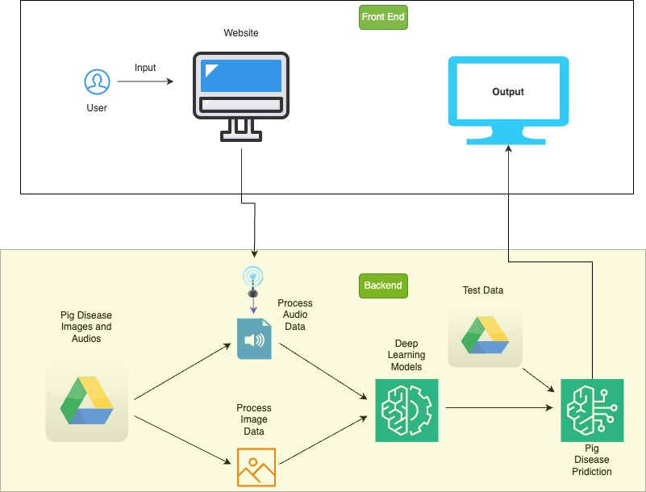

System Supporting Platforms and Cloud Environment
In the initial phase of the project, as illustrated in Figure 12, audio data was collected from YouTube using the YouTube Data API. Specific queries were employed to extract relevant audio content, Simultaneously, image data was collected from Google Images using the Google Images API. Custom queries were applied to obtain diverse and relevant images, and a web scraping tool was implemented for downloading images. The collected audio and image data were stored in Google Cloud Storage. Proper organization of storage buckets and access controls was ensured. Team members accessed the data collaboratively using Google Colab, a Python development environment. Subsequently, the data was transferred to an AWS S3 bucket for cross-platform compatibility. AWS IAM roles and permissions were configured to secure access, and AWS Lambda was employed for automating data transfer tasks.
Team members collaborated on data analysis using Google Colab notebooks. The integrated Python environment in Colab facilitated preprocessing and initial exploration of the collected data. Additionally, AWS Lambda was utilized for serverless computing to automate data processing tasks. Functions were implemented to clean and transform data before storage.
Model training took place using Amazon SageMaker, an integrated machine learning service. Both pre-built algorithms and custom scripts were employed for audio and image analysis. Flask was integrated into the system for creating a web application framework, and Keras was used for building and deploying machine learning models. Endpoints were developed for model inference and predictions. Amazon SageMaker was leveraged for generating visualizations based on model outputs. The integrated tools within SageMaker facilitated data exploration and visualization. Flask played a crucial role in developing a user-friendly web interface to interact with visualizations. Endpoints were created for fetching and displaying results. Tableau was utilized to showcase image-related insights.
The comprehensive system seamlessly integrated data collection, storage, processing, and visualization across platforms, capitalizing on the strengths of both Google Cloud and AWS. The collaborative features of Google Colab and the scalable infrastructure of AWS S3 and Lambda contributed to a robust and efficient workflow for handling audio and image data. The machine learning models, developed using Amazon SageMaker, along with Flask and Keras, provided a powerful solution for the analysis and visualization of the collected data.
Figure 12
Frameworks, Cloud Environments and Supporting Environments
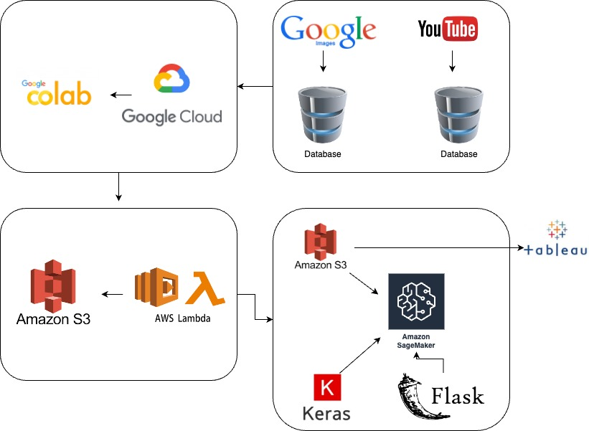

System Data Management Solution
The data flow in Figure 13 begins with the user submitting pig images and audios through the frontend. This input data is then processed in AWS, where a series of preprocessing steps take place, including cleaning, normalization, and transformation of both image and audio data. The preprocessed data is subsequently fed into the deep learning model for training, utilizing sophisticated algorithms and neural networks to discern patterns and features associated with pig diseases. Following the training phase, the system undergoes thorough testing using a separate set of data to assess the model's accuracy and effectiveness.
Upon successful testing, the deep learning model is ready for predictions. When a user triggers a prediction, the input data is processed through the trained model, and the predicted disease output is displayed on the frontend screen. This output provides comprehensive information about the detected pig disease, offering users valuable insights based on the input data they provided. The seamless flow of data from user input to output display ensures an efficient and reliable process for pig disease classification within the system.

Figure 13

Data flow chart from input to output
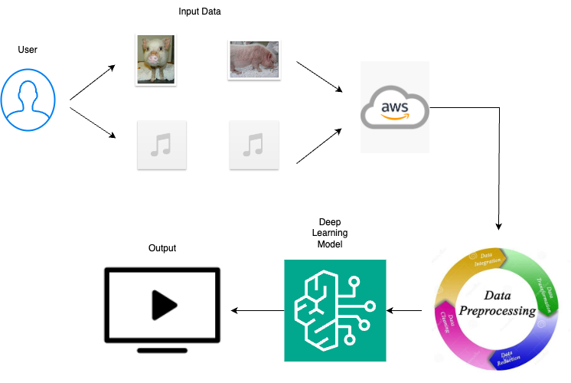

System User Interface
A graphical user interface (GUI), as depicted in Figure 14 was developed using Flask to facilitate pig disease prediction. The GUI incorporated a user-friendly design, featuring an "Upload File" field that allowed users to select images directly from their local machines. Upon selecting an image and clicking the "Upload" button, the chosen image was processed, and the predicted results were displayed below the upload section. This seamless integration of file upload and result presentation enhanced the user experience, making the prediction process intuitive and accessible. The interface not only provided a platform for users to contribute input images effortlessly but also ensured clear and immediate visibility of the model's predictions.
Figure 14
Sample graphical user interface.
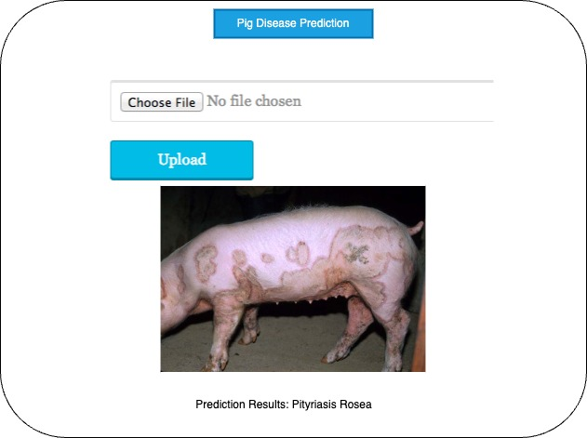

System Development and Implementation

AI and Machine Learning Models Development
The project focuses on improving swine health using advanced technology to detect and classify diseases in swine. The project includes a dual approach, utilizing both audio and image datasets to identify different types of diseases like the one that affects the internal organs where the symptoms are observed using cough sounds and skin diseases can be identified using the images of the effected pigs. The primary goal is to enhance disease detection in swine, benefiting both farmers and food industries significantly. This initiative can be further expanded to identify disease in various domestic animals which aids farmers on a large scale. The project adopts deep learning models, to work on both forms of data. Two distinctive datasets, one for audio and another for images are processed separately and dedicated models are developed for each.
The data that is required for the project is collected from various sources like extracting audio cough sounds of diseased swine from multiple videos on the internet and the image dataset is collected for 13 skin diseases using google images. The video files are converted into mp3 audio files, and the cough sounds are extracted using Audacity application. The necessary cleaning like external noise removal of the cough sounds is done during the extraction process. Whereas the image data collected from google images is clean which did not require much cleaning process.
The models employed for the project are based on the type of data that is used. To detect the disease that symptomizes the cough sounds which is audio data, deep learning models like LSTM, ResNet, DenseNet are used whereas models like MobileNet and LSTM are used to classify the skin diseases using image data. Feature extraction for audio data is done using MFCCs and CNN is used to extract features from image data. Both the models selected have their own advantages and disadvantages. LSTMs are effective in analyzing the temporal patterns in audio signals like the cough sounds of diseased swine. In the same way ResNet is also beneficial for capturing intricate patterns within complex audio data associated with swine diseases. LSTMs can also retain the trained information for longer duration, which helps them to capture the dependencies and nuances of the audio data that are important for disease detection. Residual connections are crucial for addressing the vanishing gradient problem, which ensures a smooth information flow in the network. This is particularly essential in processing audio data which is provided by ResNet model. MobileNet model is used for Image dataset in classifying swine diseases as MobileNet is specially designed for mobile and embedded devices which helps all the farmers for easy access and focuses on efficiency. It is also faster due to its lightweighted architecture which makes it appropriate for real-time applications. While LSTM excels in real-time object detection and accurate predictions and quick processing, it is also convenient for applications with low latency.

Implement Designed System
Creating a user-friendly system is the priority, to meet the needs of users while achieving the goals. The system is developed as a python application using the flask framework, which emphasizes seamless integration with an aesthetically pleasing user interface (UI). The UI is designed to be not only visually appealing but also for users to navigate and comprehend. All the data that is collected is stored on AWS and follows a meticulous process of cleaning and transforming the data to ensure its accuracy and reliability. The next step involves developing a deep learning model that classifies the disease based on the data.
To enhance the user experience, essential web pages are developed using a combination of JavaScript, HTML, and CSS. These pages are carefully designed to be intuitive, providing a seamless interaction for users. The integration of these pages with the saved deep learning models combines with python web application. The application is conducted on a dedicated server, ensuring accessibility and reliability.
The development phase involves making all the content available on the live website. Testing is conducted within the team to identify any possible issues or the areas of improvement. All the required actions are implemented to improve the performance of the system. Implementing the designed system is a crucial phase, where the plan is executed to bring the system to action. This system development life cycle requires accuracy and careful execution to ensure that the system functions as expected. The process consists of various stages including coding, proper testing, and the final development of the robust system.

Input and Output Requirements
The input requirements for the swine disease detection and classification project include audio and image data collected from various sources. For audio data input consists of cough sounds extracted from video files of diseased swine, converted into MP3 format, and processed using Audacity application to remove external noise. Image data is collected from google images focusing on 13 skin diseases of affected swine. Both datasets undergo necessary cleaning ensuring high-quality input for model training.
The output requirements depend on the type of model and data for audio-based disease detection, the output includes the classification of diseases based on the analysis of cough sounds. In the case of image-based classification, the output involves identifying specific skin diseases affecting swine. The output should be clear, interpretable, and provide valuable information for both farmers and the food industry.

System Support Environment
The project’s purpose is to build a system which can help farmers and the food industry to focus on the health of the animals to detect the state of the diseases early. Many environments were employed to assist the functioning and development during development of the project. Jira has been used as a project management application to track the strategy, pipeline, and overall project development. The project relies on cloud infrastructure, especially AWS is used to store all the image data and audio files, ensuring scalability and accessibility. Tableau is used to visualize the data to extract useful insights. Visual Studio is used to run all deep learning and machine learning models. A code repository is created on GitHub with all the project documentation. Flask API is used to create a web application and GUI for easy accessibility to users.

Supporting Systems and Solution APIs
Jira. Jira, served as the central project management tool, which aids in task assignment, project organization, and status tracking. Leveraging features like Work Breakdown Structure (WBS) and Gantt charts, Jira simplified the project planning.
AWS. Due to the diverse nature of the data which includes both audio and image data, the data is stored in Amazon Web services (AWS). By creating a S3 bucket, a cloud-based storage solution, which enables seamless storage and access to the data.
Visual Studio (VS Code). Visual Studio provides a robust environment for developing deep learning projects with its integrated tools and debugging features. VS Code streamlines code development and ensures a smooth workflow, enhancing efficiency and facilitating the creation of sophisticated deep learning models.
Tableau. Tableau is used to visualize and interpret the input data and output results in deep learning projects. It transforms complex model outputs and data into interactive, easy-to-understand visualizations. Tableau is also used to visualize the features extracted from audio data and image data.
GitHub. GitHub repositories serve as storage directories for a project, housing files like models, data processing code, and documentation. This collaborative platform enables code review, modifications, and issue tracking. With the entire project team working collectively, GitHub facilitates efficient project management and collaborative development.
Draw.io. Draw. io is a important tools in project development as an intuitive drawing tool. It assists in creating flowcharts, system architectures, and visual representations of project structures with the user-friendly interface. Draw.io streamlines communication among team members, enhancing project planning, design, and documentation processes.

References
Chung, J., Gulcehre, C., Cho, K., & Bengio, Y. (2014). Empirical evaluation of gated recurrent neural networks on sequence modeling. In NIPS 2014 Workshop on Deep Learning, December 2014
Chung, Y., Oh, S., Lee, J., Park, D., Chang, H.-H., & Kim, S. (2013). Automatic detection and recognition of pig wasting diseases using sound data in Audio Surveillance Systems. Sensors, 13(10), 12929–12942. https://doi.org/10.3390/s131012929
Colaco, S. J., Kim, J. H., Poulose, A., Neethirajan, S., & Han, D. S. (2023). DISubNet: Depthwise separable inception subnetwork for Pig Treatment Classification using thermal data. Animals, 13(7), 1184. https://doi.org/10.3390/ani13071184
DEY, K. (n.d.). (tech.)
Exadaktylos, V., Silva, M., Aerts, J.-M., Taylor, C. J., & Berckmans, D. (2008). Real-time recognition of Sick Pig Cough sounds. Computers and Electronics in Agriculture, 63(2), 207–214. https://doi.org/10.1016/j.compag.2008.02.010
Ferrari, S., Silva, M., Guarino, M., Aerts, J. M., & Berckmans, D. (2008). Cough sound analysis to identify respiratory infection in pigs. Computers and Electronics in Agriculture, 64(2), 318–325. https://doi.org/10.1016/j.compag.2008.07.003
Graves, A., & Schmidhuber, J. (2005). Framewise phoneme classification with bidirectional LSTM and other neural network architectures. Neural Networks, 18(5–6), 602–610. https://doi.org/10.1016/j.neunet.2005.06.042
Gutierrez, W. M., Kim, S., Kim, D. H., Yeon, S. C., & Chang, H. H. (2010). Classification of porcine wasting diseases using sound analysis. Asian-Australasian Journal of Animal Sciences, 23(8), 1096–1104. https://doi.org/10.5713/ajas.2010.90483
Hakansson, F., & Jensen, D. B. (2023). Automatic monitoring and detection of tail-biting behavior in groups of pigs using video-based Deep Learning Methods. Frontiers in Veterinary Science, 9. https://doi.org/10.3389/fvets.2022.1099347
Ji, N., Shen, W., Yin, Y., Bao, J., Dai, B., Hou, H., Kou, S., & Zhao, Y. (2022). Investigation of acoustic and visual features for Pig Cough Classification. Biosystems Engineering, 219, 281–293. https://doi.org/10.1016/j.biosystemseng.2022.05.010
Lee, S. et al. (2019) ‘Practical monitoring of undergrown pigs for IOT-based large-scale Smart Farm’, IEEE Access, 7, pp. 173796–173810. doi:10.1109/access.2019.2955761.
K. Greff, R. K. Srivastava, J. Koutník, B. R. Steunebrink and J. Schmidhuber, "LSTM: A Search Space Odyssey," in IEEE Transactions on Neural Networks and Learning Systems, vol. 28, no. 10, pp. 2222-2232, Oct. 2017, doi: 10.1109/TNNLS.2016.2582924. keywords: {Logic gates;Computer architecture;Training;Microprocessors;Speech recognition;Handwriting recognition;Recurrent neural networks;Functional ANalysis Of VAriance (fANOVA);long short-term memory (LSTM);random search;recurrent neural networks;sequence learning},
Kim, T., Lee, J., & Nam, J. (2019). Comparison and analysis of SAMPLECNN architectures for Audio Classification. IEEE Journal of Selected Topics in Signal Processing, 13(2), 285–297. https://doi.org/10.1109/jstsp.2019.290947
Kshirsagar, P.R. et al. (2022) ‘Deep learning approaches for prognosis of automated skin disease’, Life, 12(3), p. 426. doi:10.3390/life12030426.
Nasirahmadi, A., Sturm, B., Olsson, A.-C., Jeppsson, K.-H., Müller, S., Edwards, S., & Hensel, O. (2019). Automatic scoring of lateral and sternal lying posture in grouped pigs using image processing and support vector machine. Computers and Electronics in Agriculture, 156, 475–481. https://doi.org/10.1016/j.compag.2018.12.009
S. Hochreiter and J. Schmidhuber, "Long Short-Term Memory," in Neural Computation, vol. 9, no. 8, pp. 1735-1780, 15 Nov. 1997, doi: 10.1162/neco.1997.9.8.1735.
Shen, W., Ji, N., Yin, Y., Dai, B., Tu, D., Sun, B., Hou, H., Kou, S., & Zhao, Y. (2022). Fusion of acoustic and deep features for pig cough sound recognition. Computers and Electronics in Agriculture, 197, 106994. https://doi.org/10.1016/j.compag.2022.106994
Silva, M., Ferrari, S., Costa, A., Aerts, J.-M., Guarino, M., & Berckmans, D. (2008). Cough localization for the detection of respiratory diseases in pig houses. Computers and Electronics in Agriculture, 64(2), 286–292. https://doi.org/10.1016/j.compag.2008.05.024
Song, H., Zhao, B., Hu, J., Sun, H., & Zhou, Z. (2022a). Research on improved DenseNets pig cough sound recognition model based on SENets. Electronics, 11(21), 3562. https://doi.org/10.3390/electronics11213562
Yinggang Xie, Y. X., Yinggang Xie, Y. X., Yangpeng Xiao, X. P., & Xuewei Peng, Q. L. (2023). Animal vocal recognition-based breeding tracking and disease warning. 電腦學刊, 34(4), 127–143. https://doi.org/10.53106/199115992023083404011
Ying-Ming Shi, Y.-M. S. (2022). An improved machine learning model for Pig Abnormal Voice recognition. 電腦學刊, 33(6), 155–166. https://doi.org/10.53106/199115992022123306013
Yin, Y., Tu, D., Shen, W., & Bao, J. (2021). Recognition of sick pig cough sounds based on convolutional neural network in field situations. Information Processing in Agriculture, 8(3), 369–379. https://doi.org/10.1016/j.inpa.2020.11.001
Kshirsagar, P.R. et al. (2022) ‘Deep learning approaches for prognosis of automated skin disease’, Life, 12(3), p. 426. doi:10.3390/life12030426.

