**SPECTRUM SENSING IN COGNITIVE VEHICULAR NETWORK**

Department of Electronics and Communication Engineering

VNR VJIET Hyderabad, India

**ABSTRACT**

Spectrum sensing is an essential function of cognitive radio to prevent the harmful interference to primary users and identify the available spectrum for Secondary Users improving the spectrum efficiency. Sensing ability of a single secondary User (SU) is affected by high mobility. However, this detection performance is compromised with multipath fading and shadowing. To overcome the impact of these issues, cooperative spectrum sensing has been proposed to be an effective method to improve the detection performance .Multiple Secondary Users sense the channel simultaneously and decision is made at the fusion centre. But due to sensing overhead and synchronisation problems in CSS an Asynchronous Cooperative Spectrum Sensing scheme is proposed. Based on temporal and spatial diversities of each SU optimal weights are assigned to different Energy Information stored at CR BS using Fuzzy Logic.

Keywords—Spectrum sensing, Cooperative spectrum sensing (CSS), Asynchronous cooperative spectrum sensing (ACSS),Fuzzy Logic, Fusion Centre.

**INTRODUCTION**

The increasing number of vehicles on roads made it important for communication between the vehicles to share information about accidents, traffic jams, road works and other infotainment messages. Vehicular Ad-Hoc Network, or VANET is a technology that uses moving vehicles as nodes to create a mobile network.

The dramatic growth in the number of wireless devices alongside the static management of the radio spectrum have created a shortage of available radio spectrum. Over 50 billion wireless devices will be connected by 2020, all of which are likely going to demand access to the Internet. The static management of the radio spectrum is no longer efficient enough to grant access to all these devices. With this allocation, some portions of the radio spectrum are heavily used while some others are not or rarely used. Not sharing the radio spectrum among users can result in the creation of unwanted denial of service events. The scarcity of the radio spectrum is thus one of the major issue.

One solution to this and other challenges is to use cognitive radio technology. Here sensing of spectrum, decide about the state of the frequency channels, and reconfigure their communication parameters to meet quality of-service requirements while minimizing their energy consumption. These devices can use unlicensed bands as well as licensed bands when their licensed primary users are not active, preventing adverse interference.

In spectrum sensing the detection performance can be primarily determined on the basis of two metrics: probability of false alarm*,* which denotes the probability of a CR user declaring that a PU is present when the spectrum is actually free, and probability of detection*,* which denotes the probability of a CR user declaring that a PU is present when the spectrum is indeed occupied by the PU. Since a miss in the detection will cause the interference with the PU and a false alarm will reduce the spectral efficiency, it is usually required for optimal detection performance that the probability of detection is maximized subject to the constraint of the probability of false alarm.

There are two types of spectrum sensing

1.Non-Cooperative Spectrum Sensing

2.Cooperative Spectrum Sensing

In Non-Cooperative Spectrum Sensing, the sensing ability of a single secondary vehicular user (SVU) is affected by high mobility, dynamic topology, and unreliable wireless environment. Many factors in practice such as multipath fading, shadowing, and the receiver uncertainty problem  may significantly compromise the detection performance in spectrum sensing

Cooperative Spectrum sensing is developed to increase the sensing accuracy and efficiency. Generally, the synchronization is required in the collaborative sensing. When a cooperative SVU joins the cooperative sensing, its own data transmission has to be stopped, which results in the overhead in the secondary networks. Sensing overhead cannot be omitted in the cooperative network model.

So, these issues are overcome by Asynchronous cooperative spectrum sensing technique based on temporal and spatial diversities.

**PROPOSED WORK**

We consider the infrastructure based CVN that has a centralized CR BS. The CR BS is installed along highways at a regular interval, which can be co-located with traffic lights, gas stations, and rest areas. The BS collects the sensing results from SUs to make the final decision of the channels’ availability. The BSs are scatteringly deployed along the roadside and allocate the available spectrum in a central manner. Then, these SUs have the opportunities to access the temporarily unoccupied licensed channels. Considering the hardware limitation, we allow each SU to sense a single channel at a time and send its sensing information to BS after its sensing period.

Each cooperative SU periodically senses its channels and calculates EI(Energy Information) and sends the result to CR base station. Then, the SU in need of channel which is called Tagged SU sends the ACSS requirement and it’s measured EI to the BS, together with the current time-stamp and location information. For the BS, upon receiving the ACSS requirement from any SU for any appointed channel, it selects a subset of SU’s EI of the channel and calculates optimal weights of each EI based on the spatial and temporal information using fuzzy logic. Weight Assignment is done based on Artificial intelligence Fuzzy Logic. Fuzzy rules are made such that less distance between PU and SU and less time is assigned more weight and vice versa. The BS will then make a decision on PU’s appearance or absence and sends the decision to the SU. If the channel is available, the SU accesses the channel for its transmission. Otherwise, if the channel is unavailable, the SU starts to sense a new channel and trigger a new round sensing process.

**SYSTEM MODEL**

We consider the vehicular network in which every SVU is equipped with a single antenna by which the vehicle can communicate with other vehicles and sense the PU’s activities within its receiving range. The mobility model of the vehicles can be described as follows. The movement of each vehicle is restricted to its own lane, and the speed of vehicle i, at time t, vi(t) obeys vi(t+Δt)=vi(t)+ɛ ai(t) where ɛ is a random variable uniformly distributed within [-1, 1], and ai(t) is the acceleration of vehicle i at time t. Also, the speed of the vehicle vi(t) is assumed to follow a truncated Gaussian distribution with parameter (vbar,v) Let f(v) denote the probability density function (PDF) of vi; then, f(v)can be expressed as

$$f\left(v\right)=\frac{1}{\sqrt{2πσv}}e^{\frac{-{\left(v-vbar\right)}^{2}}{2σv^{2}}}$$

**ASYNCHRONOUS COOPERATIVE SPECTRUM SENSING**

We develop the ACSS involving multiple SVUs so as to achieve sensing performance in a multiple user scenario. In this approach we employ an energy detection for each SU. Let ts be the sensing time and fs be the sample frequency during sensing time. We denote N as the number of samples in a sensing period, that is, N=tsfs. The received signal rj(n) at the nth sample and the jth SVU is given by

rj(n)={wj (n), H0}

rj(n)={sj(n)+wj(n), H1}

H1 where H0 represents the hypothesis that PU is absent, and H1 represents the hypothesis that PU is present. Sj(n) represents the PU’s transmitted signal with mean zero. Wj(n) denotes a Gaussian process with mean zero . Then, we denote ej(r) as the jth SVU’s EI, which is defined as the measured energy of the received signal rj(n) at the jth SVU. We can obtain ej(r) as

ej(r)= $\sum_{n=1}^{N}{{\left|rj(n)\right|}^{2}}$

When the appearance of a PU is detected, the tagged SVU should sense and ask for cooperative sensing. We consider that the cooperative SVUs have sensed the appointed channel and stored the EI before tagged SVU. Without forcing SVU1 and SVU2 to sense the appointed channel, tagged SVU use the stored EI at CR BS and makes the decision of the PU’s activity on the appointed channel.

**DIVERSITY IN TIME**

Considering that PU’s activity is variable, so sensing results of channel may not match with channel’s actual state after ‘t’ secs.Variation of channel state can be estimated by past sensing results.Let PIh0(t) denotes probability that (h)th channel will be idle after t secs and PIh1(t) denotes probability that (h)th channel will be occupied after t secs.

PIh0(t)=

PIh1(t)=

Future channel availability can be predicted by these probabilities based on latest sensing result.So a connection exist between current and past sensing results.This connection also exist between cooperative SU’s if they detect same channel even at a different sensing moment. Storing duration(ti) is defined as time duration from the moment sensing results obtained by the i th SVU to the moment sensing results used by the tagged SVU. Let f(ti) denote the PDF of ti

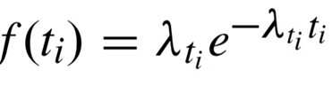

**DIVERSITY IN SPACE**

When the tagged SU requires the sensing results from different SUs, the spatial diversity exists because the SUs and the PU’s activity at different locations. We define the sensing range Dmax as the maximum distance from the PU’s transmitter at which an SVU is able to detect the PU’s signal. Considering different practical systems Dmax can have different values. In this paper, we fix the value of Dmax as 100 m. Then, we can obtain the SVU’s distributed range with Dmin and Dmax as the lower and upper bounds, respectively. Within this range, the SVUs for cooperative

sensing could detect the PU’s signal and report the sensing results without causing interference to the PU’s receiver.We assume that the cooperative SVUs are uniformly distributed with PDF

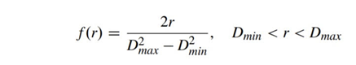

**FUZZY WEIGHT DETERMINATION**

Considering the case where K number of SUs are in the CR network, our goal is to find the optimal weights y=[y0,…yk] (for each SU to maximize the detection probability or minimize the false alarm probability.

Fuzzy Logic (FL) is a method of reasoning that resembles human reasoning. Unlike ordinary binary system, the range of values would be in between 0 to 1.The approach of FL imitates the way of decision making in humans that involves all intermediate possibilities between digital values YES and NO. Fuzzy logic is an appealing technique significantly just in case wherever target problem is difficult to model with conventional mathematical strategies however at the same time easier for people to realize. The rule based decision making, enables efficient inclusion of incomplete information. In addition, it provides saving in computational complexity. It can be implemented with systems of different capabilities and sizes also in hardware or software or in both.

It has four main parts −

• Fuzzification Module − It transforms the system inputs, which are crisp numbers, into fuzzy sets

• Knowledge Base − It stores IF-THEN rules provided by experts.

• Inference Engine − It simulates the human reasoning process by making fuzzy inference on the inputs and IF-THEN rules.

• Defuzzification Module − It transforms the fuzzy set obtained by the inference engine into a crisp value

The proposed fuzzy inference system takes two inputs i.e. difference of time sensed by tagged SU and other SU’s, distance between PU and the SU and returns the suitable weight as an output. The developed FS includes two inputs with three MBFs for each and one output with two MBFs. The fuzzy rules are made such that less distance and less time is assigned more weight and accordingly other rules are framed.

**ENERGY CALCULATION**

The receive signal of the jth SU at the nth sample is expressed as

rj(n)=Ij ϴj sj(n)+wj(n)

where Ij=0 or 1. Ij=0 represents the hypothesis H0, and Ij = 1 represents the hypothesis H1.

ϴj= is the path loss coefficient, in which rj denotes the distance between the PU’s transmitter and the receiver of SUj. In our scheme, the tagged SU collects EI from the cooperative SUs after the tagged SU’s own sensing. After weighting the cooperative SU’s EI in terms of the temporal and spatial diversities, the tagged SU can obtain E(r) as

E(r) = $\sum_{j=0}^{K}{yj ej(r)}$

where e0(r) is the EI from the tagged SU, ej(r)= $\sum_{n=1}^{N}{{\left|rj(n)\right|}^{2}}$ denotes the collected EI from jth SVU with the spatial diversity ϴj and yj is the weight of the jth SU’s EI. we can obtain the detection and false alarm probabilities as

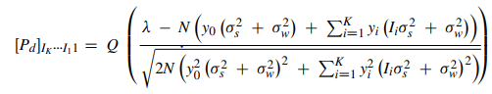

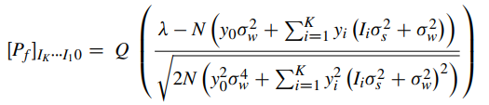

**FUSION RULES**

These are used to take a final decision by applying logic on the received data from SUs and transmit back the global decision about spectrum availability to the SUs.

**Majority Rule**

Out of the SUs, if the result from at least greater than half of the number of SUs is of one hypothesis, then that particular hypothesis is made as final decision.

**OR Rule**

If at least one of the SUs transmits that PU activity is detected, then the global detection is in favor of that SU result alone. So, if a SU detects PU activity incorrectly, then the result becomes incorrect overall.

The network is simulated for 10 iterations and so, there are 10 results from each SU throughout the simulation. Initial nodes considered are 5 and are incremented in steps of 5 up to 50. The output metrics namely probability of detection, probability of misdetection and probability of false alarm are calculated using the results obtained from the scenario for each N value.

**Probability of Detection (Pdet)**

The ability of the receiver to detect the PU status accurately.

$$P_{det}=\frac{No.of (H0/H0 or H1/H1)}{Total number of iterations}$$

**Probability of Misdetection (Pmdet)**

The inability of the receiver to detect the PU status accurately.

$$P_{mdet}=\frac{No.of (H0/H1)}{Total number of iterations}$$

**Probability of False Alarm (Pfa)**

The ambiguous PU status detected by the SU.

$$P_{fa}=\frac{No.of (H1/H0)}{Total number of iterations}$$

The global decision taken by the fusion center (FC) is transmitted to the SUs

**STEPS IN SIMULATION**

**Module-1(CR VANET Scenario Creation):**

**Step-1:** Choose background where vehicles(treated as nodes in VANET) can move and also we choose X and Y axes with some spacing on it(Axes are needed so that we can place PUs, RSUs, and SVUs on it) considered to be distance in meters.

**Step-2:** Place PU(Primary user), RSU(Roadside unit), and SVUs on the background. In the scenario, PU and RSU are fixed while SVUs position varies continuously and the number of SVUs vary from 5 to 50.

**Step-3:** Consider no. of SVUs (N) at the beginning of each loop and give movement with maximum speed up to 16m/s at the junction.

**Step-4:** We considered the signal for PU such that it is ON (represents busy for some period of time) and OFF ( represents idle in next period of time) till certain wait time (b/w 10s to 20s) and modulate this signal using AM technique.

**Step-5:** The SVUs start to move on the road with speed which increases gradually or remain constant which resemblances real time road network.

**Step-6:** As the SVUs move through the road, the Energy Information (EI) by the SVU due to signal transmitted from PU BS is affected by noise and path-loss, so EI is not same for all SVUs.

**Step-7:** The movement of SVUs is varied always throughout the program for number of vehicles from 5 to 50 in increments of 5.

**Module-2(Asynchronous Cooperative Spectrum Sensing):**

**Step-1:** Consider SVUs with different sensing times and take a random tagged SVU (if there are 5 SVUs then a random index b/w 1 to 5 is taken as tagged SVU).

**Step-2:** Create a database in excel sheet with columns: ACSS request status (0 or 1), calculated energy, distance, time and weight, to store the data of SVUs at RSU.

**Step-3:** Calculate SNR and path-loss by calculating distance and add AWGN noise to modulated PU.

**Step-4:** Filter the noise added signal, calculate EI for filtered PU signal and send the EI to RSU using FSK modulation, at respective sensing times.

**Step-5:** In the SVU iteration, if the index is equal to tagged SVU index then ACSS request =1 is also sent along with EI to RSU, else ACSS request=0 is sent.

**At RSU:**

**Step-6:** The data from SVUs is demodulated and stored in database.

**Step-7:** If ACSS request=1 in received data then the EI stored in database is assigned weight using fuzzy logic based on corresponding distance and time.

If less time and less distance, more weight(MW)is assigned

If more time and more distance, less weight(LW) is assigned

**Module-3(PU Determination Phase)**

The proposed fuzzy inference system takes two inputs i.e. difference of time sensed by Tagged SU and other cooperative SU , distance between PU and the SU and returns the optimal weight as an output. The fuzzy inference mechanism consists of three stages:

In the 1st stage, the values of the numerical inputs (distance and time stored in the database) are mapped with membership function, this operation is called fuzzification.

In the 2nd stage, the fuzzy interference system processes the rules with the firing strengths of the inputs.

In the 3rd stage, the resultant fuzzy values are converted into optimal weights between 0 and 1; this operation is called defuzzification.

**Module-4(PU Determination Phase)**

**Step-1:**The summation of the weighted EIs E(r) is compared with threshold and decision is made when final EI is greater than threshold PU present is made and vice versa.

**Step-2:** The bit values(1/0) reach FC where global decision whether PU is present or not by using Majority Rules i.e., if a particular rule is satisfied by the data at FC we increment detection else we increment the misdetection value (This step gives an idea of how many times detect/ misdirect from the given number of iterations without considering the false alarm case). False Alarm is a special case of detection where band is shown vacant even though it is busy.

**Step 3:** The extent of the presence of PUs are known by calculating the Probability of detection and misdetection along with the probability of false alarm.

Probability of detection= Final detection value from step 4.1/No. of iterations.

Probability of Misdetection=1- Probability of Detection.

Probability of false alarm = final false alarm count/ No. Of iterations

**Step 4:** The result obtained from RSU is compared with original PU status and probability of detection, misdetection, false alarm are plotted against no. of SVUs.

**10 PERFORMANCE ANALYSIS**

The network scenario created can be observed in the following figure. The blue dots represent SUs and the triangle represents Primary user base station. The movement of nodes can be interpreted from the figure below and at each instant EI is calculated and send to RSU at each instant of time.

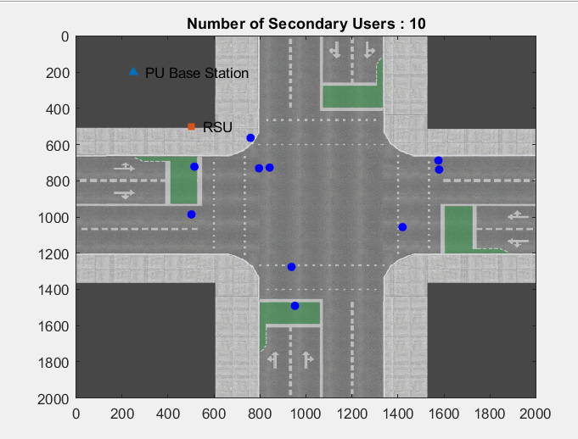

Fig-1:Network Scenario

It can be seen that the ACSS can achieve a much higher detection probability. This is because the ACSS makes accurate decision of PU’s activity by using other SU’s EI. In addition, it is observed that the detection probabilitybecomes higher if the number of the cooperative SUs becomes larger. This indicates that the number of the cooperative SUs can influence the performance of the proposed scheme. The false alarm probability achieved by the ACSS is lower than other techniques.

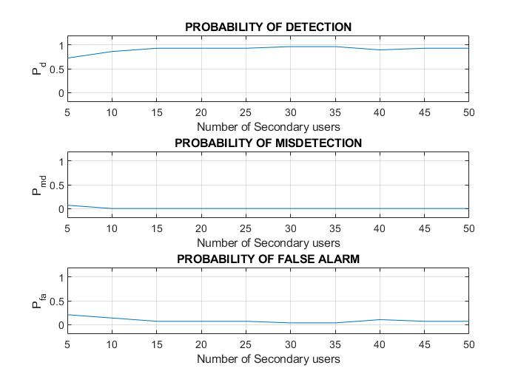

Fig-2:Plot of Pd, Pf, Pmd vs no. of SU’s

**CONCLUSION**

We proposed an ACSS for opportunistic spectrum access in CVNs. Any SU in need of channel performs ACSS where the final sensing decision is made by collecting all the local Energy Information (EI) stored at CR BS from the cooperative SUs and corresponding weights are assigned. The temporal and spatial diversities of each SU are considered for assigning weight to different EI. This is done by Fuzzy Logic where less distance and less time is assigned more weight and fuzzy rules are framed accordingly. The ACSS is able to reduce the cooperative sensing overhead. Moreover, the sensing accuracy of the proposed ACSS is higher than that of any other spectrum sensing techniques.

**REFERENCES**

[1] Yi Liu, Shengli Xie, Rong Yu, Yan Zhang, Xi Zhang and Chau Yuen, “Exploiting temporal and spatial diversities for spectrum sensing and access in cognitive vehicular networks” 2015 Wireless Communications and Mobile Computing, Vol.15 ,pp 17-27

[2] M. Mourad Mabrook1,Hussein A. Taha2,Aziza I. Hussein3, “ Cooperative spectrum sensing optimization based adaptive neuro‑fuzzy inference system (ANFIS) in cognitive radio networks” 2019 Journal of Ambient Intelligence and Humanized Computing

[3] Manish Kumar Giri, Saikat Majumder, “ Extreme Learning Machine(ELM) Based Cooperative Spectrum Sensing in Cognitive Radio Networks” 2020 7th International Conference on Signal Processing and Integrated Networks

[4] Sanjay K. Dhurandher,Isaac Woungang,“Optimal Secondary Users Selection for Cooperative Spectrum Sensing in Cognitive Radio Networks ” 2018 IEEE International Conference

[5] Chunxing Jiang, Norman C. Beaulieu, Chunxiao Jiang, “A Novel Asynchronous Cooperative Spectrum Sensing Scheme” IEEE ICC 2013

[6] Xiong Zhang , Zhengding Qiu , Dazhong Mu, “Asynchronous Cooperative Spectrum Sensing in Cognitive Radio” IEEE ICSP2008

[7] Ahmed sultan ,bilal kozal, “Multiuser cooperation spectrum sensing in wireless cognitive radio networks”, 2015

[8] Fan R, Jiang H, Sayed AH. Optimal multi-channel cooperative sensing in cognitive radio networks. IEEE Transactions on Wireless Communications 2010; 9(3): 1128–1138.

[9] Fan R, Jiang H, Guo Q, Zhang Z. Joint optimal cooperative sensing and resource allocation in multichannel cognitive radio networks. IEEE Transactions on Vehicular Technology 2011; 60(2): 722–729.

[10]. Atapattu S, Tellambura C, Jiang H. Energy detection based cooperative spectrum sensing in cognitive radio networks. IEEE Transactions on Wireless Communications 2011; 10(4): 1232–1241.

[11] Su H, Zhang X. Cross-layer based opportunistic MAC protocols for QoS provisionings over cognitive radio wireless networks. IEEE Journal on Selected Areas in Communications 2008; 26(1): 118–129.

[12] Shen J, Liu S, Zeng L, Xie G, Gao J, Liu Y. Optimisation of cooperative spectrum sensing in cognitive radio network. IET Communications 2009; 3 (7): 1170–1178.

[13] Xie S, Liu Y, Zhang Y, Yu R. A parallel cooperative spectrum sensing in cognitive radio networks. IEEE Transactions on Vehicular Technology 2010;59(8):4079–40