Primetrade.ai Assignment Report
Artificial Intelligence (AI) internship Assignment
Bitcoin Market Sentiment vs Trader Performance
Objective
The goal of this analysis was to study how market sentiment influences trader performance using the Fear & Greed Index and Hyperliquid trading data.
Data Preparation
- Converted timestamps into datetime format.
- Used Timestamp IST from the trading dataset.
- Merged Trader Data with Market Sentiment Data using trading dates.
- Successfully matched sentiment labels for over 211,000 trades.
Key Findings
1. Extreme Greed Produced the Highest Profitability
Market Sentiment | Avg Closed PnL
Extreme Greed | 67.89
Fear | 54.29
Greed | 42.74
Extreme Fear | 34.54
Neutral | 34.31

Traders achieved the highest average profit during Extreme Greed periods, suggesting that strong bullish conditions create favourable trading opportunities.

2. Win Rates Were Highest During Extreme Greed
Market Sentiment | Win Rate (%)
Extreme Greed | 46.49
Fear | 42.08
Neutral | 39.70
Greed | 38.48
Extreme Fear | 37.06

Extreme Fear showed the lowest win rate, indicating that traders generally struggle during highly negative market conditions.
3. Larger Trades Did Not Lead to Higher Profits
Average trade size was highest during Fear periods ($7,816), while the highest profitability occurred during Extreme Greed periods despite smaller average trade sizes.
This suggests that market conditions may have a stronger impact on profitability than position size alone.
Additional Observations
- The most profitable assets were @107, HYPE, SOL, ETH, and BTC.
- The top trader generated over $2.14 million in cumulative Closed PnL.
- A relatively small number of traders accounted for a large share of overall profits.
Recommendations
- Use market sentiment as an additional trading signal.
- Apply tighter risk management during Extreme Fear periods.
- Study top-performing traders to identify successful trading patterns.
- Focus on assets that consistently generate strong returns.

Charts:
1. Profit by Market Sentiment:
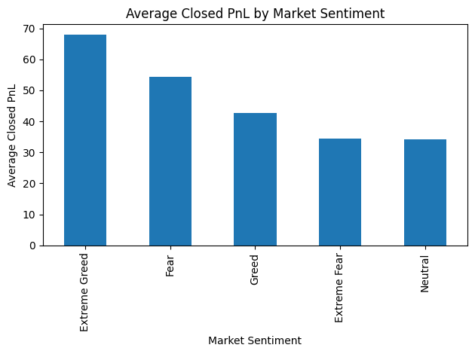
2.Win Rate by Market Sentiment:
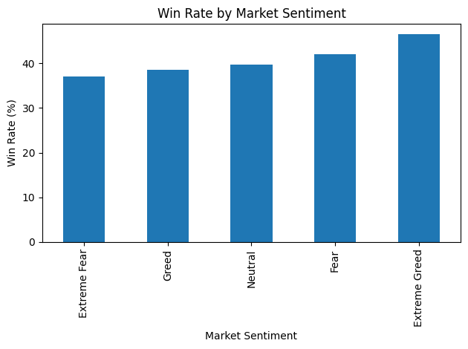

Conclusion
The analysis shows a clear relationship between market sentiment and trading performance. Extreme Greed periods consistently produced the strongest results, while Extreme Fear periods were associated with lower profitability and win rates.

