OASIS INFOBYTE

Basic Network Scanning with Nmap
Cybersecurity Internship Project • Task 1
Project | Basic Network Scanning with Nmap
Tool | Nmap 7.99
Lab environment | Kali Linux VM scanning a Windows 10 Pro VM
Target IP address | 192.168.50.20

1. Objective
The objective of this task was to use Nmap to scan a lab target, identify reachable TCP ports, review the services associated with those ports, and attempt operating-system detection.

2. Lab Setup and Scope
- Scanner: Kali Linux virtual machine.
- Target: Windows 10 Pro virtual machine.
- Target IP address: 192.168.50.20.
- Nmap version: 7.99.
- Authorization: Scan performed against the user's own lab virtual machine.

3. Methodology
- Check reachability: Used ping to confirm that the target responded on the lab network.
- Run a basic scan: Scanned the target to identify open TCP ports.
- Detect services: Used Nmap service detection to gather service/version information.
- Attempt OS detection: Ran OS detection and noted Nmap's warning that the conditions were not ideal.

4. Scan Results
The target host was reported as up. The scan reported these open TCP ports:
Port / Protocol | Service | Typical purpose
135/tcp | msrpc | Microsoft RPC
139/tcp | netbios-ssn | NetBIOS session service
445/tcp | microsoft-ds | SMB / Microsoft file and printer sharing
3389/tcp | ms-wbt-server | Remote Desktop Protocol (RDP)

5. OS Detection
Nmap estimated a Microsoft Windows 10/11/Server 2019 family operating system at approximately 97%, but warned that the result may be unreliable because it could not find at least one open and one closed port. Treat this as an estimate, not a definitive identification.

6. Security Observations
- Ports 135, 139, and 445 are commonly associated with Windows RPC, NetBIOS, and SMB networking.
- Port 3389 indicates that Remote Desktop was reachable from the scanning machine.
- An open port is not automatically a vulnerability; exposure should be reviewed against system requirements and firewall policy.
- For systems outside a lab, restrict administrative services to trusted networks, use strong authentication, and apply security updates.

7. Conclusion
The Nmap scan successfully identified the lab target as reachable and reported four open TCP ports: 135, 139, 445, and 3389. Service detection identified likely Windows networking services, and OS detection suggested a Windows-family operating system with a reliability caveat. This task demonstrates basic network discovery and service enumeration in an authorized lab environment.
8. Evidence and Screenshots
The following screenshots are from the lab session and show the basic scan, service detection, and OS detection results. Screenshot 1 — Basic Network Scan
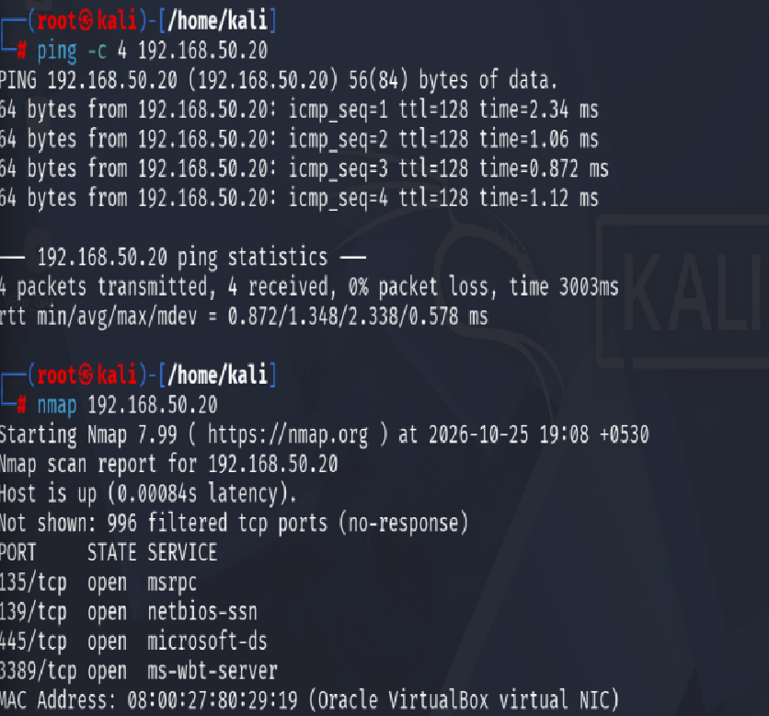Figure 1. Ping confirms target reachability; Nmap reports ports 135, 139, 445, and 3389 open.
Screenshot 2 — Service Detection
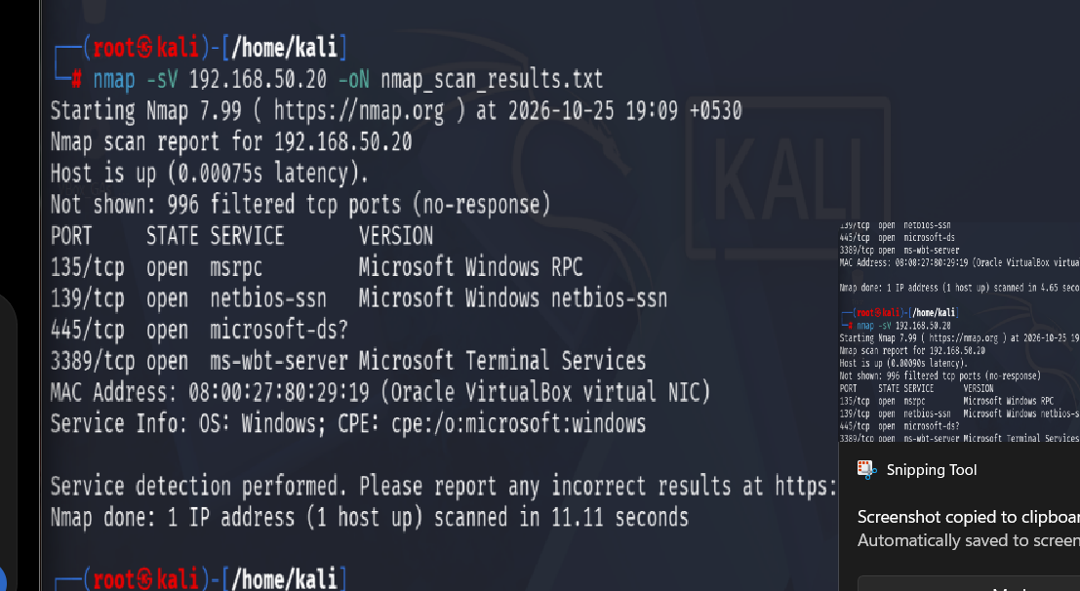
Figure 2. Nmap -sV output shows service/version details for the detected ports.
Screenshot 3 — OS Detection
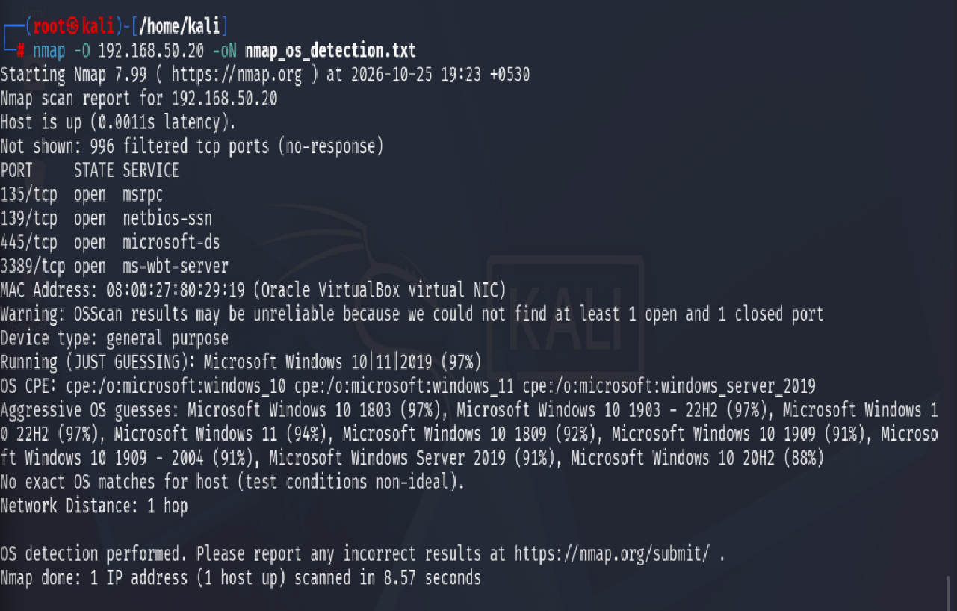
Figure 3. Nmap OS detection estimates a Windows-family OS and includes a reliability warning.

Appendix: Commands Used
ping -c 4 192.168.50.20
nmap 192.168.50.20
nmap -sV 192.168.50.20
nmap -O 192.168.50.20
Prepared for educational use. Only scan systems you own or are authorized to test.

