OASIS INFOBYTE — OIB-SIP

Task 2: Basic Firewall Configuration with UFW
Cyber Security Internship Project Report

Project | UFW Firewall Configuration
Environment | Kali Linux running in VirtualBox
Firewall | UFW (Uncomplicated Firewall)

1. Objective
Configure and verify a host-based firewall in a Kali Linux virtual machine using UFW. The exercise sets default traffic policies, creates rules for selected TCP ports, enables the firewall, and records the resulting status for documentation.

2. Tools and Environment
- Kali Linux virtual machine
- VirtualBox
- UFW (Uncomplicated Firewall)
- Terminal and GNU nano text editor

3. Firewall Configuration
The following commands were used in the lab:
sudo ufw default deny incoming
sudo ufw default allow outgoing
sudo ufw allow 22/tcp
sudo ufw deny 80/tcp
sudo ufw allow 443/tcp
sudo ufw deny 21/tcp
sudo ufw enable
sudo ufw status verbose

4. Configured Rules
Port / Protocol | Action | Service | Reason
22/TCP | Allow | SSH | Permit SSH connections for administration
80/TCP | Deny | HTTP | Block unencrypted web traffic
443/TCP | Allow | HTTPS | Permit encrypted web traffic
21/TCP | Deny | FTP | Block FTP connections
The saved status output shows UFW is active, incoming traffic is denied by default, outgoing traffic is allowed, and the configured rules appear for both IPv4 and IPv6.

5. Results and Verification
- UFW was enabled successfully and reported that it is active.
- The verbose status output confirmed the default policies and configured port rules.
- The numbered status output displayed the rules as a numbered list.
- The setup script and status output were saved in the CyberSecurity-Task2-UFW project folder.

6. Project Files
- README.md — short project overview and summary.
- firewall_setup.sh — shell script containing the UFW configuration commands.
- firewall_status.txt — saved output from the UFW status command.

7. Security Notes
Firewall rules should be limited to the services that are genuinely required. Allowing SSH (port 22) from Anywhere can expose remote administration; in a real deployment, restrict SSH to trusted IP addresses or a management network when possible. Only apply firewall changes on systems you own or are authorized to administer.

8. Screenshots / Evidence
The following evidence images are taken from the supplied project document and show the actual Kali Linux terminal output.
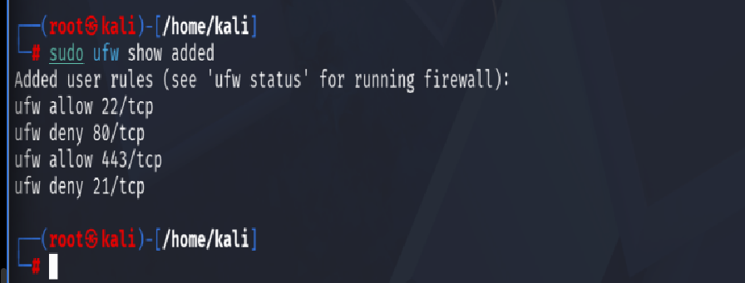
Figure 1. Added UFW rules and firewall enabled; verbose status reports the firewall as active.
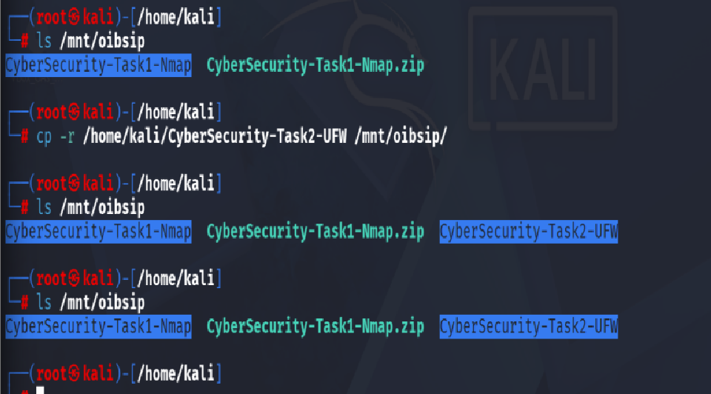
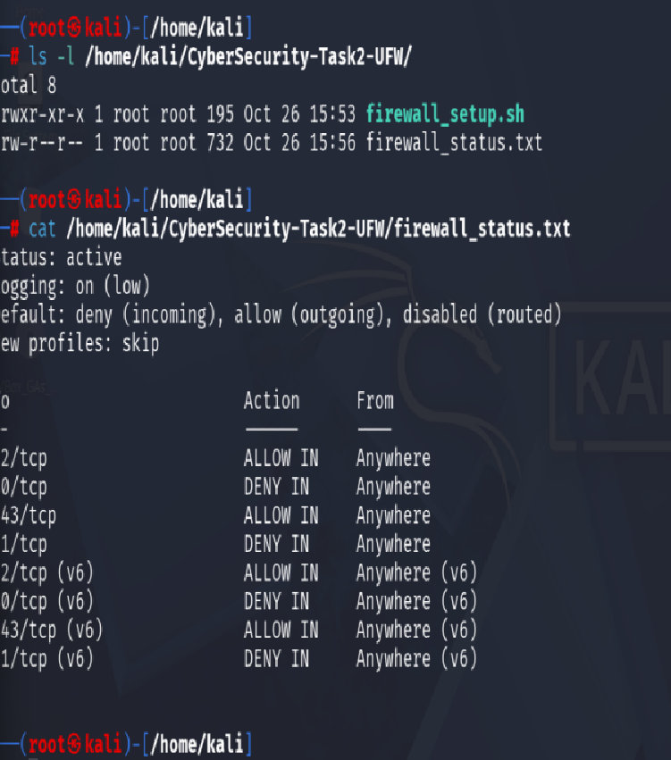
Figure 2. Numbered UFW rules and the firewall_setup.sh commands in the nano editor.

Figure 3. Creation and executable permission check for firewall_setup.sh, followed by script contents.

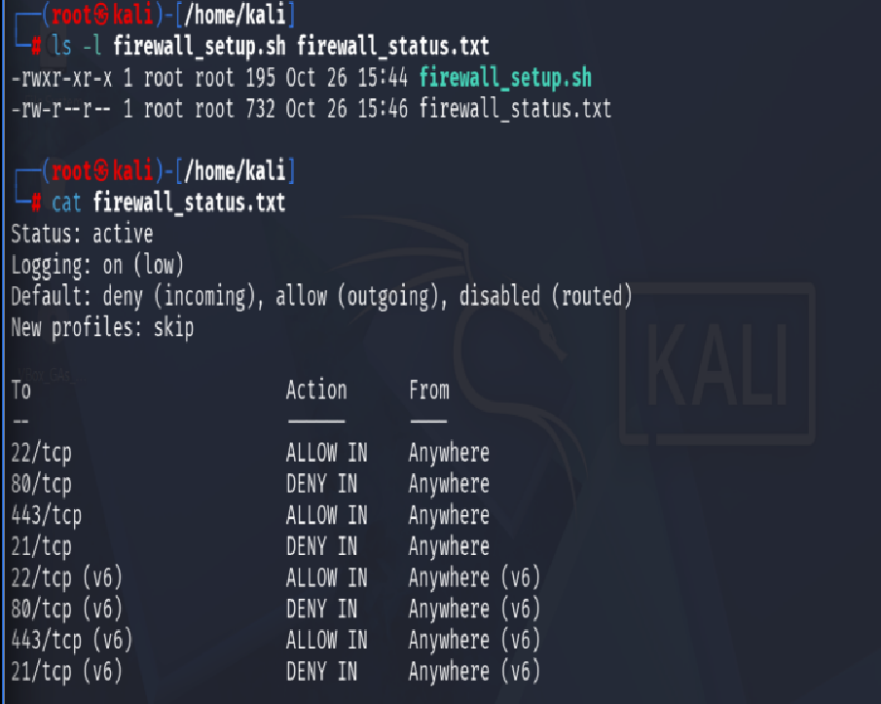
Figure 4. Saved firewall_status.txt output showing active status and configured rules.
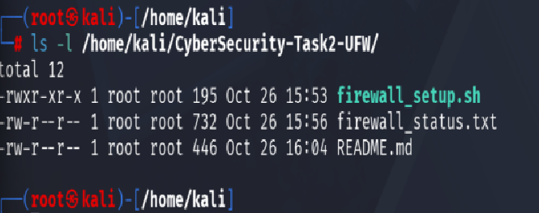
Figure 5. Verification of the project folder contents and saved firewall status.

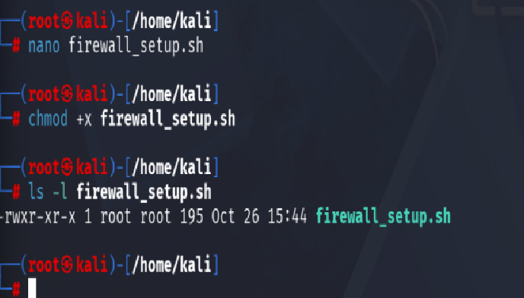
Figure 6. Copying the Task 2 project folder to the shared OIBSIP folder.

9. Conclusion
This lab demonstrated a basic firewall configuration using UFW on Kali Linux. Default policies and selected TCP port rules were applied, the firewall was enabled, and the results were captured in a text file and screenshots for project documentation.

