Software Requirements

Specification

for

<Project>

Version 1.0 approved

Prepared by <author>

<organization>

<date created>

Software Requirements

Specification

for

<Project>

Version 1.0 approved

Prepared by <author>

<organization>

<date created>

Software Requirements

Specification

for

<Project>

Version 1.0 approved

Prepared by <author>

<organization>

<date created>

Software Requirements

Specification

for

<Project>

Version 1.0 approved

Prepared by <author>

<organization>

<date created>

Software Requirements

Specification

for

<Project>

Version 1.0 approved

Prepared by <author>

<organization>

<date created>

**Software Requirements Specifications**

**Company Directory**

Harry Inwood

Tuesday 9th March 2021

1. **INTRODUCTION**

This document outlines the proposed response to the brief submitted by Paddy Evans. It represents the general overview of the main system functionality, along with the proposed User Interface layout to offer a better understanding of the proposed solution. Upon agreeing with this document, it is requested that the sponsor will sign off and in doing so, initiate the development process in which the proposed solution with be designed and develop according to the prevailing company standards.

1. **PRODUCT DECRIPTION** 
   1. **SCOPE**

Intended to be an easy-to-use single page application, designed as mobile first but has the same functionality on desktop. The application will allow the user to search for, edit, add, and delete employees from the provided database. To achieve this the front-end interface will call server-side endpoints to display relevant information. A typical flow of the program is as follows:

HTML renders Results in Alphabetic Order, displaying id’s, Names, location job roles and departments.

Document ready function to call PHP backend with SQL query.

User may Edit / remove search results as well as add new ones via CRUD

Event listener displays results with on change on the user input.

User may search for specific employees. Filtered by department / location

* 1. **Product Flow**
* On load Function call to PHP back end
* jQuery DOM manipulation to display results in alphabetical order
* User may search for employees via search function of results
* jQuery DOM manipulation to display new results
* User may Add, edit and delete employees with ease via CRUD
  1. **Product Features**

The application will be developed using the following:

* HTML/CSS/JavaScript (Bootstrap framework)
  + Bootstrap Carousel
  + Bootstrap Listgroup
  + Bootstrap Accordian
  + jQuery Library
* PHP (JSON data interchange)
* MariaDB (Create, Read, Edit and Delete).
  1. **Wireframe Model**

The wireframe model below demonstrates the proposed layout and functionality, the colours are not final and will most likely be changed before the app goes live:

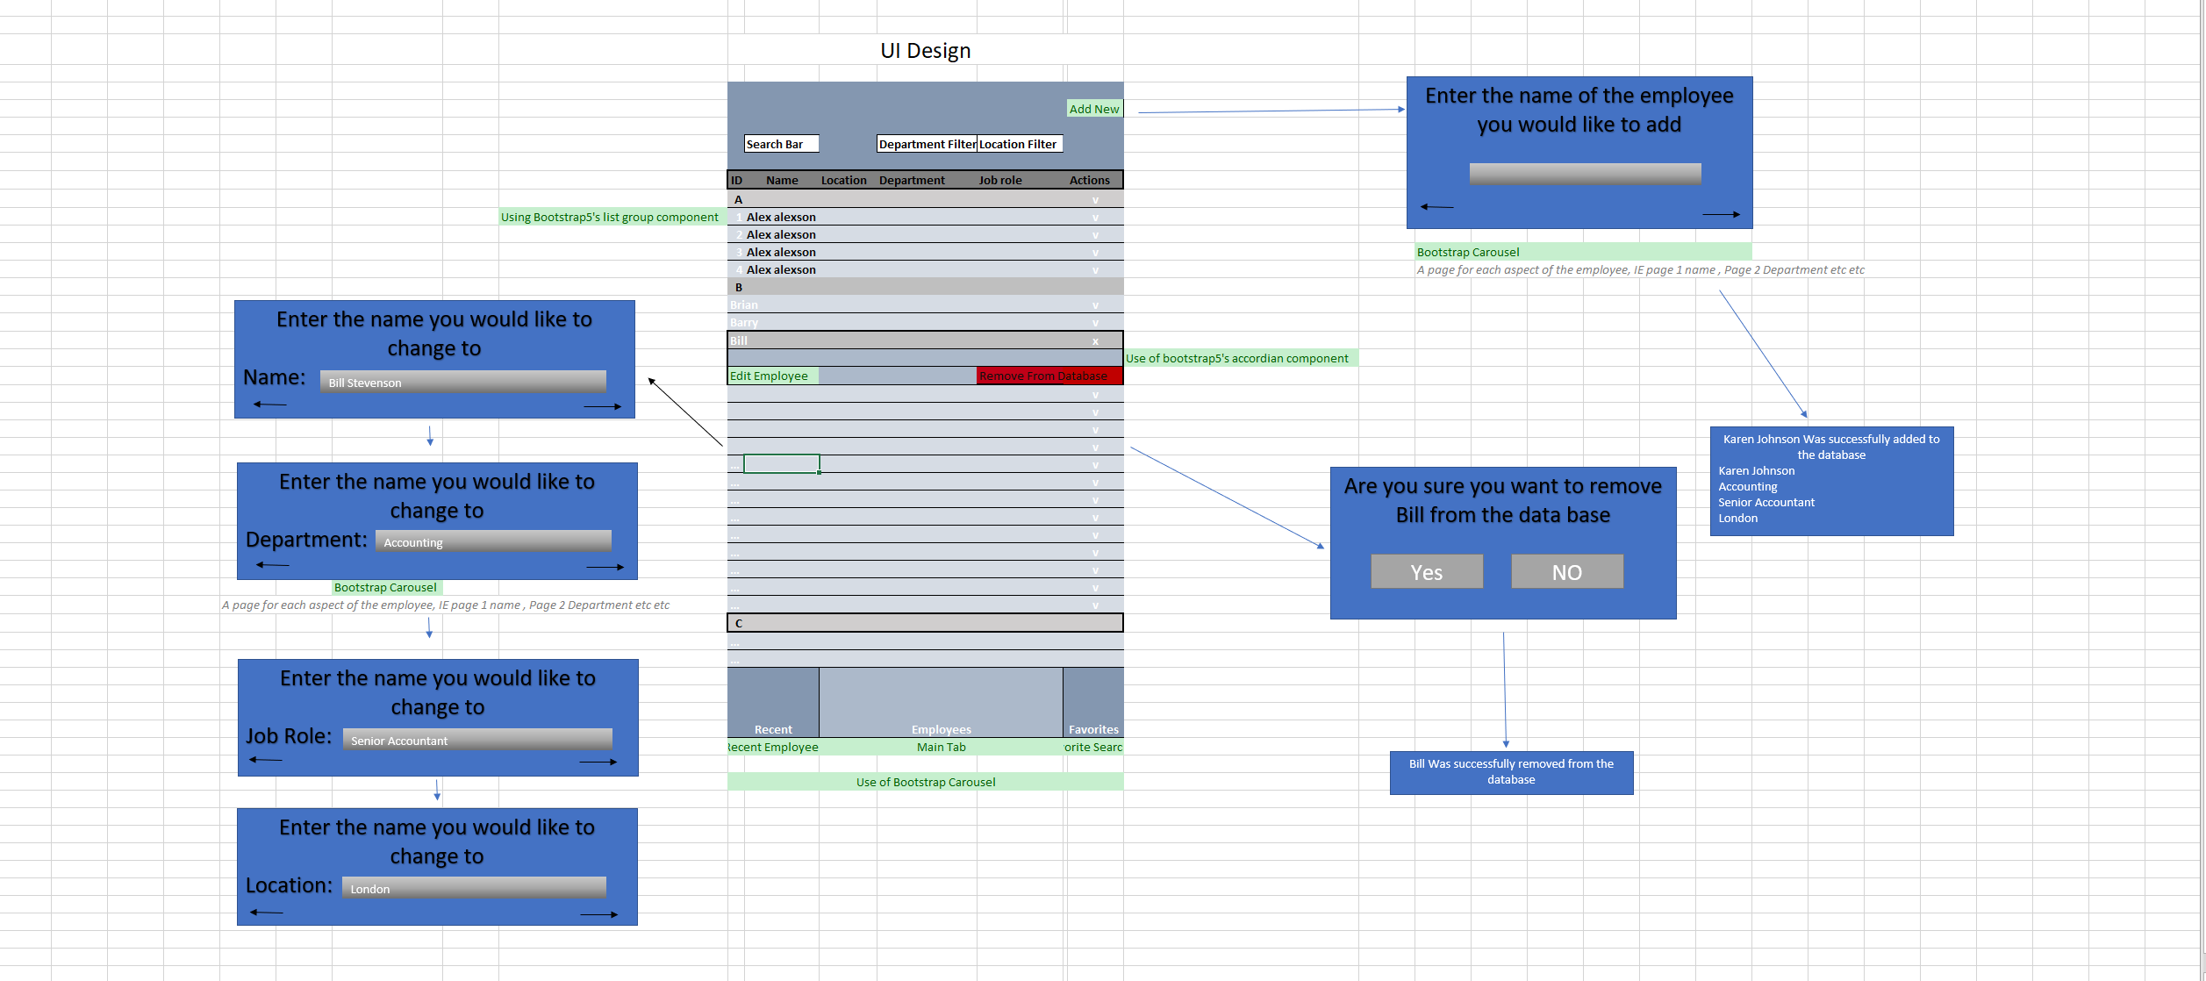 Mobile

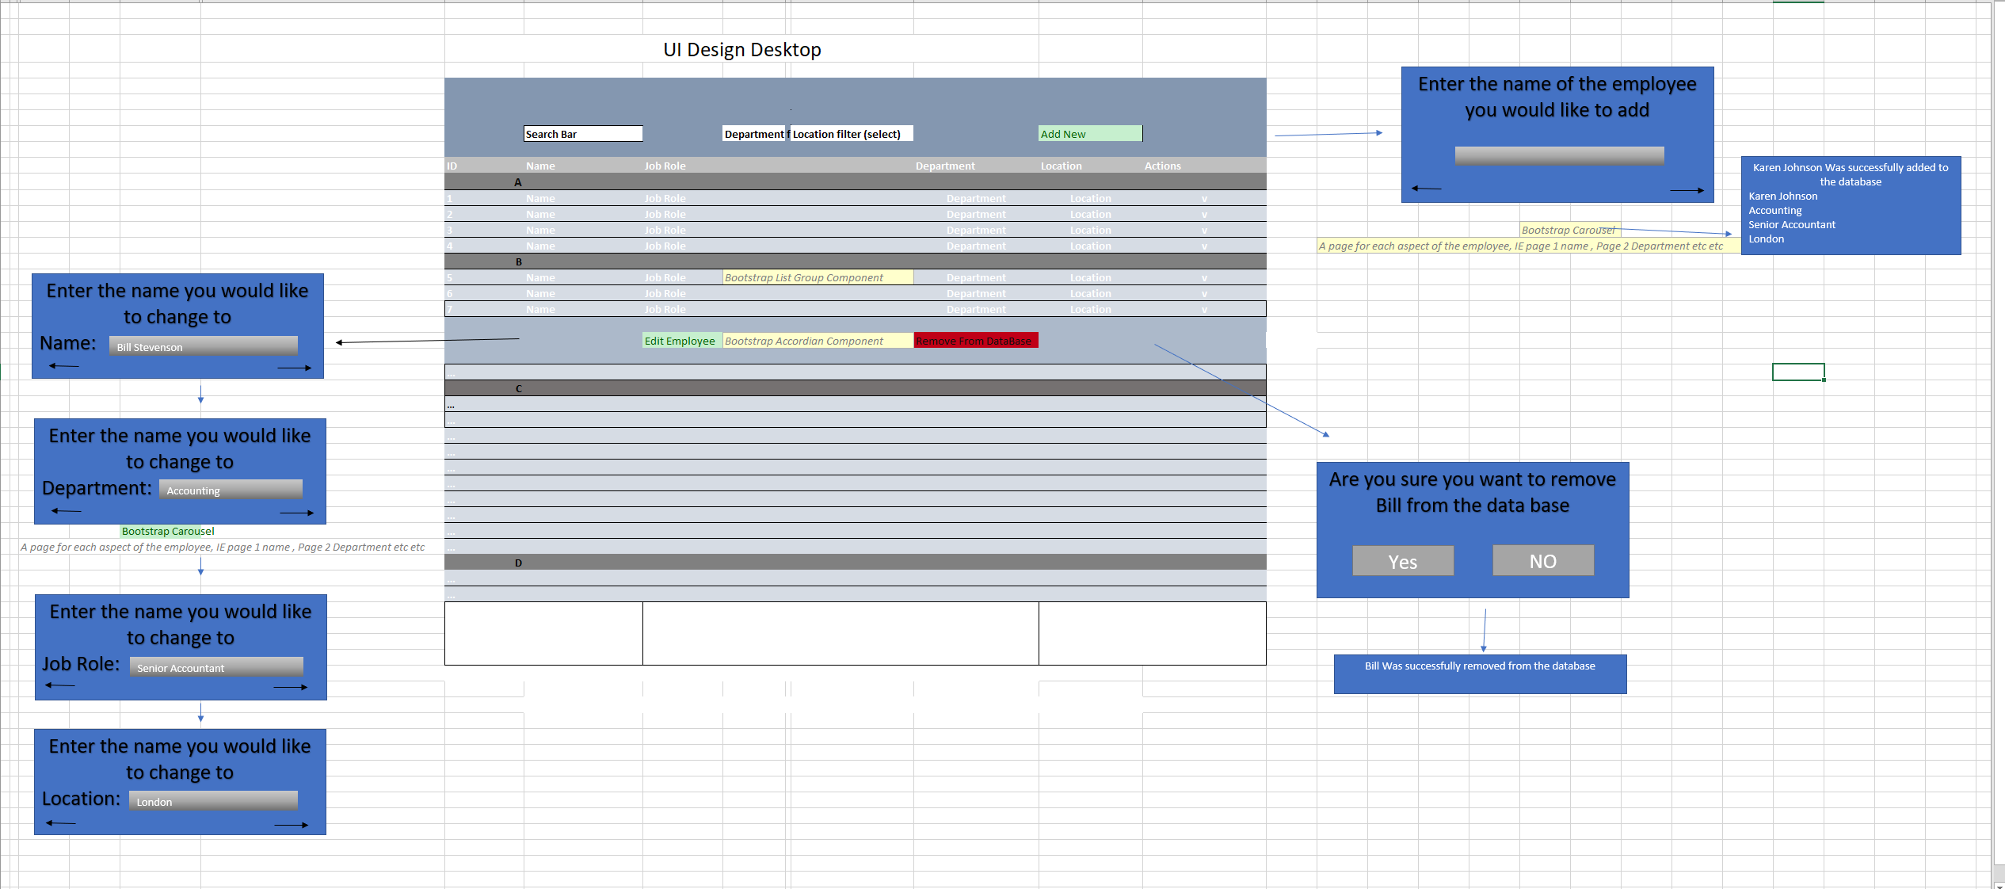Desktop

Acceptance of this document will initiate the development of the system.

Sign off: Paddy Evans

............................................................................... Date