实现模块分析
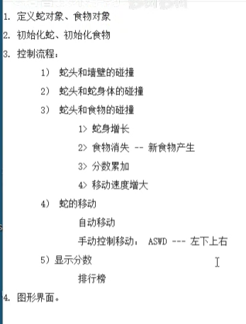
贪吃蛇蛇身定义
代码实现：
#include<stdio.h>
#include<string.h>
#include<stdlib.h>
#include<math.h>
#include<time.h>

#define WIDE 60
#define HIGH 20

struct BODY {
int X;
int Y;
};
struct snake {
struct BODY body[WIDE * HIGH];
int size;
};

int main()
{
for (size_t i = 0; i < 20; i++)
{
for (size_t j = 0; j < 60; j++)
{
printf("*");
}
printf("\n");
}
system("pause");
return EXIT_SUCCESS;
}
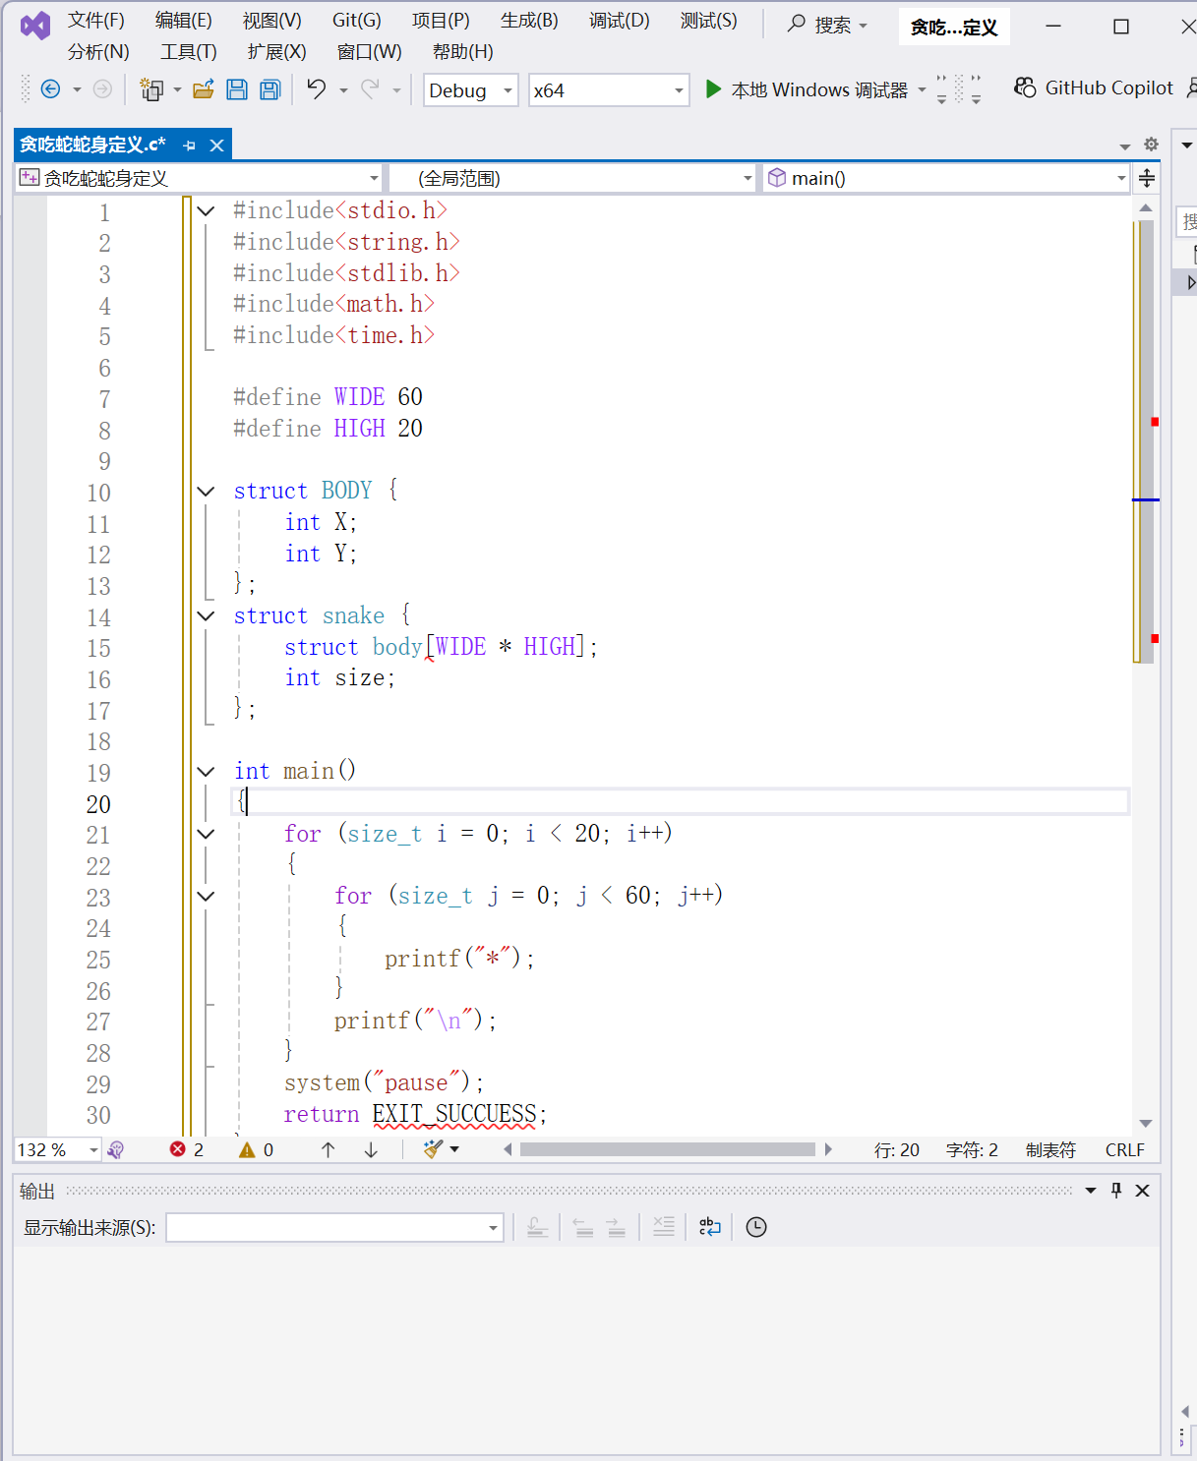
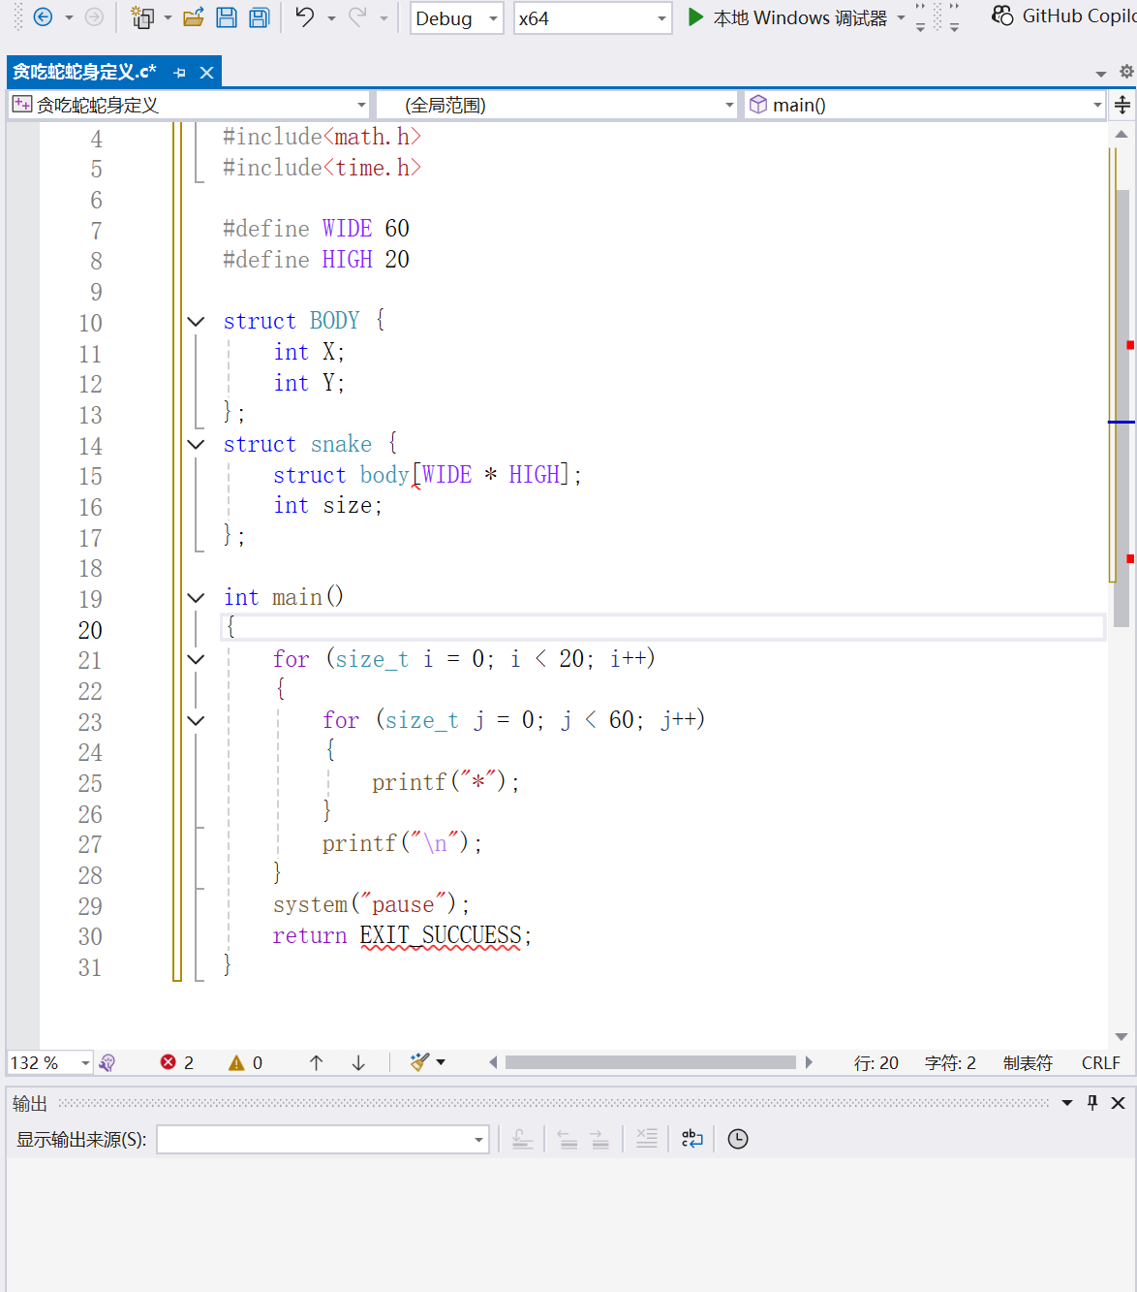
贪吃蛇的初始化
代码实现：
#include<stdio.h>
#include<string.h>
#include<stdlib.h>
#include<math.h>
#include<time.h>

#define WIDE 60
#define HIGH 20

struct BODY {
int X;
int Y;
};

struct SNAKE {
struct BODY body[WIDE * HIGH];
int size;
}snake;

struct FOOD {
int X;
int Y;
}food;

int score = 0;

void initSnake(void)
{
snake.size = 2;
snake.body[0].X = WIDE / 2;//头
snake.body[0].Y = HIGH / 2;
snake.body[1].X = WIDE / 2-1;//第一节身
snake.body[1].Y = HIGH / 2;
return;
}

void initFood(void)
{
food.X = rand() % WIDE;
food.Y = rand() % HIGH;
return;
}
int main(void)
{
srand(time(NULL));

system("pause");
return EXIT_SUCCESS;
}

运用的函数:
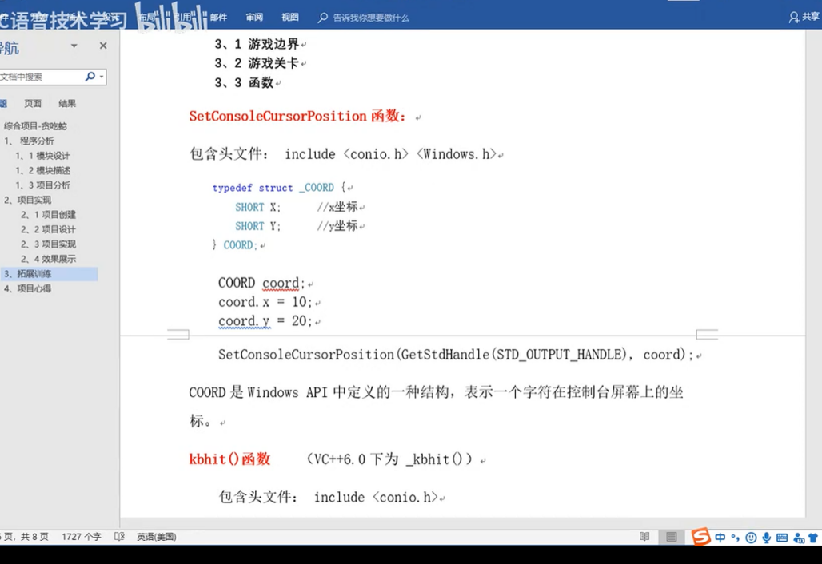
设置（set）控制台（console）光标（cursor）位置（position）
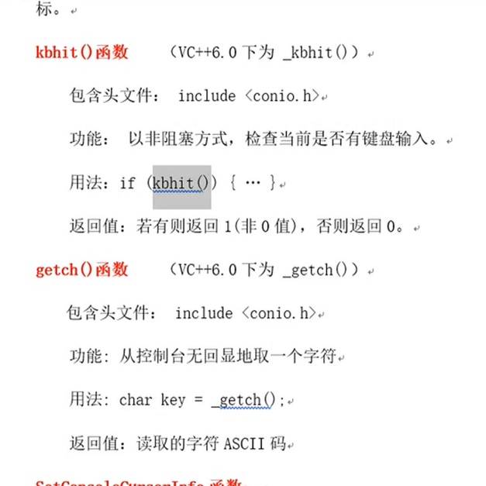

控制移动和食物的过程：
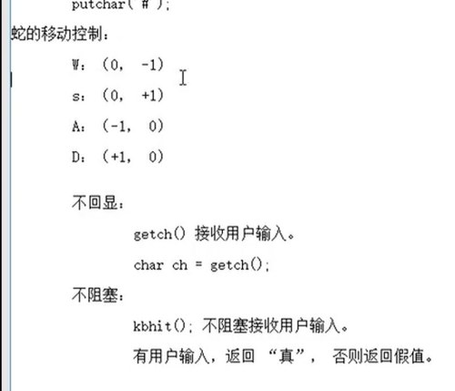
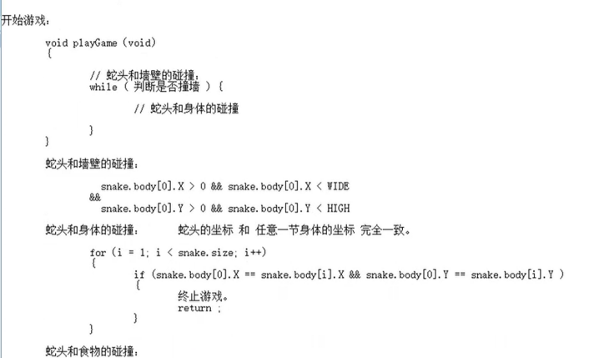
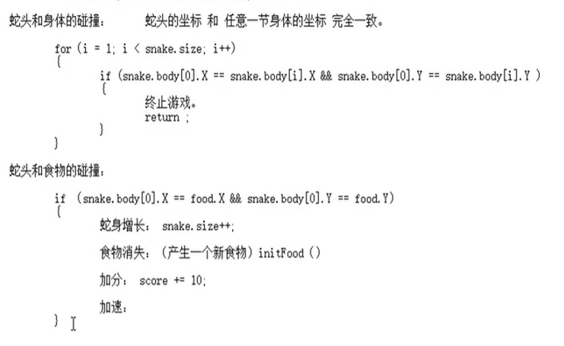
注意：
蛇移动，前一节身体给后一节赋值
for (size_t i = snake.size - 1; i > 0; i--)
{
snake.body[i].X = snake.body[i - 1].X;
snake.body[i].Y = snake.body[i - 1].Y;
}

snake.body[0].X += kx;
snake.body[0].Y += ky;
并且要构建最开始的坐标系;
int kx=0;
int ky=0;

