ПРАКТИЧЕСКАЯ РАБОТА №1

по дисциплине

«Компьютерная графика»

**Вариант 1**

|  |  |
| --- | --- |
| Выполнил  студент гр. 5130904/10101 | Абраамян А. М. |
| Преподаватель | Леонтьева Т.В. |

Оглавление

Цель работы 3

Порядок выполнения 3

Результат выполнения 4

Код программы 6

Вывод 9

# Цель работы

Целью работы является ознакомление с основами векторной графики и получение навыков работы с базовыми функциями графического API и трехмерными графическими примитивами. Требуется при помощи стандартных функций библиотеки (OpenGL/Vulkan или DirectX) изобразить указанные объекты и произвести необходимые преобразования.

# Порядок выполнения

1. Изобразить каркасный конус и каркасную сферу, расположенные на некотором расстоянии друг от друга.
2. Совместить центр основания конуса и центр сферы.
3. Изобразить тор и цилиндр. Размеры и местоположение примитивов задать самостоятельно.
4. Выполнить последовательно сначала поворот цилиндра вокруг оси Х, а затем растяжение тора в 2 раза.

# Результат выполнения

1. Изобразить каркасный конус и каркасную сферу, расположенные на некотором расстоянии друг от друга.

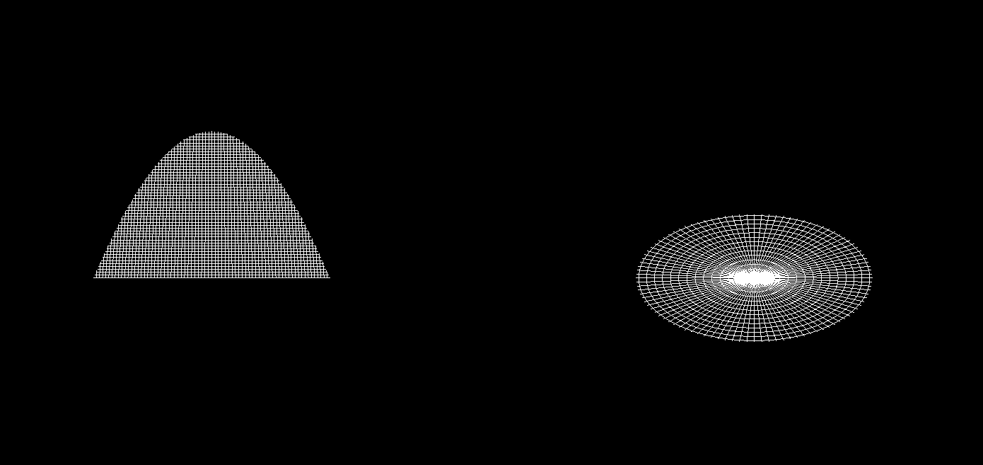

1. Совместить центр основания конуса и центр сферы.
2. Изобразить тор и цилиндр. Размеры и местоположение примитивов задать самостоятельно.

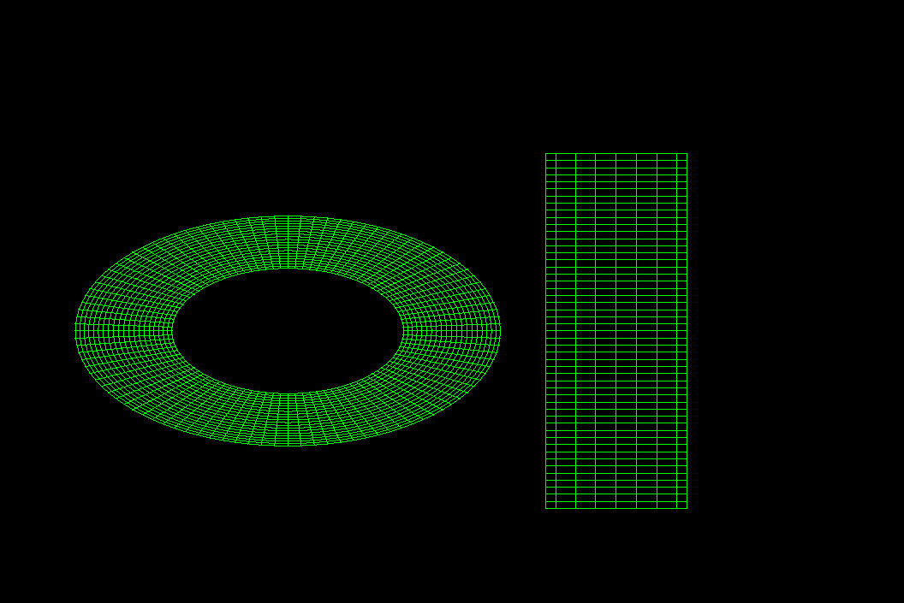

4. Выполнить последовательно сначала поворот цилиндра вокруг оси Х, а затем растяжение тора в 2 раза

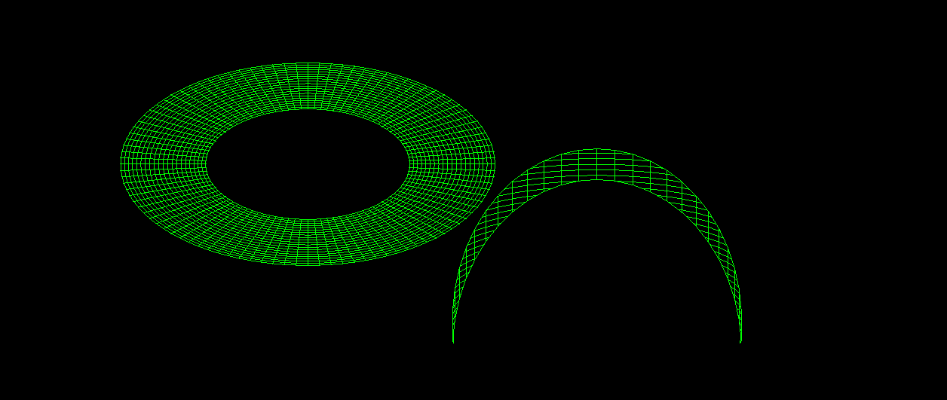

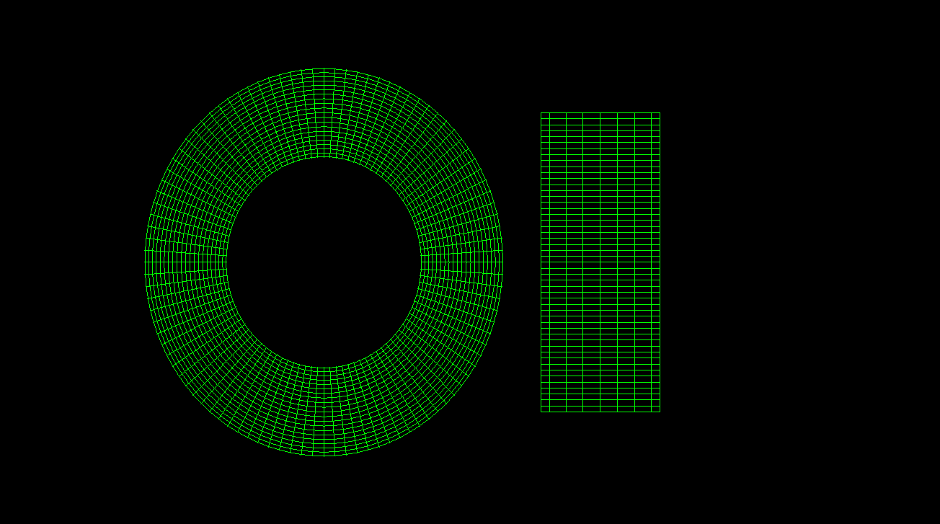

# Код программы

|  |
| --- |
| #include <states/conus_sphere_stay_state/conus_sphere_stay_state.h>  #include <iostream>  #include <GL/glut.h> // Include GLUT for cool drawing utils  #include <state_machine/state_machine.h>  #include <states/conus_sphere_moving_state/conus_sphere_moving_state.h>  #include <states/conus_sphere_stay_state/constants.h>  using namespace states::conus_sphere_stay_state::constants;  namespace states {  GLState* ConusSphereStayState::display()  {  glClear(GL_COLOR_BUFFER_BIT);  glPushMatrix();  glLoadIdentity();  glTranslated(cone_start_pos.x, cone_start_pos.y, cone_start_pos.z);  glRotated(90, -1, 0, 0);  glutWireCone(cone_base, cone_height, cone_slices, cone_stacks);  glPopMatrix();  glLoadIdentity();  glPushMatrix();  glLoadIdentity();  glTranslated(sphere_start_pos.x, sphere_start_pos.y, sphere_start_pos.z);  glutWireSphere(sphere_radius, sphere_slices, sphere_stacks);  glutSwapBuffers();  glPopMatrix();  return this;  }  void ConusSphereStayState::timeout()  {  std::cout << "ConusSphereStayState timeout " << frames_count << std::endl;  frames_count++;  glutPostRedisplay();  if (frames_count == MAX_FRAMES_COUNT) {  std::cout << "Switching the state\n";  state_machine::StateMachine::instance()->set_state(new states::ConusSphereMovingState());  }  }  } // namespace states  #pragma once  #include <constants.h>  #include <states/states.h>  namespace states {  class ConusSphereStayState : public GLState  {  public:  GLState* display() override final;  void timeout() override final;  private:  size_t frames_count = 0;  };  } // namespace states  #pragma once  #include <GL/glut.h> // Include GLUT for cool drawing utils  #include <glm/vec3.hpp>  #include <constants.h>  namespace states::conus_sphere_stay_state::constants {  static constexpr size_t STAY_SECONDS = 1;  static constexpr size_t MAX_FRAMES_COUNT = ::constants::FRAMES_PER_SECONDS * STAY_SECONDS;  static constexpr GLdouble cone_base = 20.0;  static constexpr GLdouble cone_height = 200.0;  static constexpr GLint cone_slices = 500;  static constexpr GLint cone_stacks = 500;  static constexpr GLint sphere_radius = 20;  static constexpr GLint sphere_slices = 100;  static constexpr GLint sphere_stacks = 100;  static constexpr glm::dvec3 cone_start_pos = glm::dvec3(-20, 0, -19);  static constexpr glm::dvec3 sphere_start_pos = glm::dvec3(20, 0, -19.0);  }  #pragma once  #include <constants.h>  #include <states/states.h>  namespace states {  class TorStretchCylinderState : public GLState  {  public:  GLState* display() override final;  void timeout() override final;  private:  size_t frames_count = 0;  };  } // namespace states  #include <states/tor_stretch_cylinder_state/tor_stretch_cylinder_state.h>  #include <iostream>  #include <cmath>  #include <GL/glu.h>  #include <GL/glut.h> // Include GLUT for cool drawing utils  #include <state_machine/state_machine.h>  #include <states/tor_cylinder_state/constants.h>  #include <states/tor_stretch_cylinder_state/constants.h>  using namespace states::tor_cylinder_state::constants;  using namespace states::tor_stretch_cylinder_state::constants;  namespace states {  GLState* TorStretchCylinderState::display()  {  glClear(GL_COLOR_BUFFER_BIT | GL_DEPTH_BUFFER_BIT); // Clear both color and depth buffers  // --- Draw the solid cylinder ---  glPushMatrix(); // Save the current matrix state  glLoadIdentity();  // Create a quadric object for the cylinder  GLUquadric* quadric = gluNewQuadric();  frames_count = frames_count > tor_stretch_cylinder_state::constants::MAX_FRAMES_COUNT ? tor_stretch_cylinder_state::constants::MAX_FRAMES_COUNT : frames_count;  constexpr auto max_frames = tor_stretch_cylinder_state::constants::MAX_FRAMES_COUNT;  glScaled(torus_result_scale.x, torus_result_scale.y - (1.0 * max_frames - frames_count) / max_frames, 1);  glTranslated(torus_start_pos.x, torus_start_pos.y, torus_start_pos.z);  glutWireTorus(torus_inner_radius, torus_outer_radius, torus_sides, torus_rings);  // --- Draw the wireframe cylinder on top ---  glPolygonMode(GL_FRONT_AND_BACK, GL_LINE); // Switch to wireframe mode  // Set the color for the wireframe  glColor3f(0.0, 1.0, 0.0); // Green color for the wireframe lines  glPopMatrix(); // Restore the previous matrix state  glPushMatrix(); // Save the current matrix state  glRotated(90, 1, 0, 0);  glTranslated(cylinder_start_pos.y, -cylinder_start_pos.x, cylinder_start_pos.z);  // Draw the wireframe cylinder (same dimensions for the overlay)  gluCylinder(quadric, cylinder_base, cylinder_top, cylinder_height, cylinder_slices, cylinder_stacks); // Same cylinder dimensions as the solid, increased slices  // Reset the polygon mode to solid rendering  glPolygonMode(GL_FRONT_AND_BACK, GL_FILL);  // Clean up the quadric object  gluDeleteQuadric(quadric);  glPopMatrix(); // Restore the previous matrix state  // Swap the buffers to display the rendered frame  glutSwapBuffers();  return this;  }  void TorStretchCylinderState::timeout()  {  std::cout << __PRETTY_FUNCTION__ << " timeout " << frames_count << std::endl;  frames_count++;  glutPostRedisplay();  // if (frames_count == MAX_FRAMES_COUNT)  // state_machine::StateMachine::instance()->set_state(new states::ConusSphereMoveState());  }  } // namespace states  #pragma once  #include <GL/glut.h> // Include GLUT for cool drawing utils  #include <glm/vec3.hpp>  #include <constants.h>  namespace states::tor_stretch_cylinder_state::constants {  static constexpr size_t STAY_SECONDS = 1;  static constexpr size_t MAX_FRAMES_COUNT = ::constants::FRAMES_PER_SECONDS * STAY_SECONDS;  static constexpr glm::dvec3 torus_result_scale = glm::dvec3(1, 2, 1);  }  #include <states/tor_cylinder_rotate_state/tor_cylinder_rotate_state.h>  #include <iostream>  #include <GL/glu.h>  #include <GL/glut.h> // Include GLUT for cool drawing utils  #include <state_machine/state_machine.h>  #include <states/tor_cylinder_rotate_state/constants.h>  #include <states/tor_cylinder_state/constants.h>  #include <states/tor_stretch_cylinder_state/tor_stretch_cylinder_state.h>  using namespace states::tor_cylinder_rotate_state::constants;  using namespace states::tor_cylinder_state::constants;  namespace states {  GLState* TorCylinderRotateState::display()  {  glClear(GL_COLOR_BUFFER_BIT | GL_DEPTH_BUFFER_BIT); // Clear both color and depth buffers  // --- Draw the solid cylinder ---  glPushMatrix(); // Save the current matrix state  // Create a quadric object for the cylinder  GLUquadric* quadric = gluNewQuadric();  glTranslated(torus_start_pos.x, torus_start_pos.y, torus_start_pos.z);  glutWireTorus(torus_inner_radius, torus_outer_radius, torus_sides, torus_rings);  // --- Draw the wireframe cylinder on top ---  glPolygonMode(GL_FRONT_AND_BACK, GL_LINE); // Switch to wireframe mode  // Set the color for the wireframe  glColor3f(0.0, 1.0, 0.0); // Green color for the wireframe lines  glPopMatrix(); // Restore the previous matrix state  glPushMatrix(); // Save the current matrix state  constexpr auto max_frames_count = tor_cylinder_rotate_state::constants::MAX_FRAMES_COUNT;  frames_count = frames_count > max_frames_count ? max_frames_count : frames_count;  glRotated(90 + frames_count * 360 / max_frames_count, 1, 0, 0);  glTranslated(cylinder_start_pos.y, -cylinder_start_pos.x, cylinder_start_pos.z);  // Draw the wireframe cylinder (same dimensions for the overlay)  gluCylinder(quadric, cylinder_base, cylinder_top, cylinder_height, cylinder_slices, cylinder_stacks); // Same cylinder dimensions as the solid, increased slices  // Reset the polygon mode to solid rendering  glPolygonMode(GL_FRONT_AND_BACK, GL_FILL);  // Clean up the quadric object  gluDeleteQuadric(quadric);  glPopMatrix(); // Restore the previous matrix state  // Swap the buffers to display the rendered frame  glutSwapBuffers();  return this;  }  void TorCylinderRotateState::timeout()  {  std::cout << __func__ << " timeout " << frames_count << std::endl;  frames_count++;  glutPostRedisplay();  if (frames_count == ::states::tor_cylinder_rotate_state::constants::MAX_FRAMES_COUNT)  state_machine::StateMachine::instance()->set_state(new states::TorStretchCylinderState());  }  } // namespace states  #pragma once  #include <constants.h>  #include <states/states.h>  namespace states {  class TorCylinderRotateState : public GLState  {  public:  GLState* display() override final;  void timeout() override final;  private:  size_t frames_count = 0;  };  } // namespace states  #pragma once  #include <GL/glut.h> // Include GLUT for cool drawing utils  #include <glm/vec3.hpp>  #include <constants.h>  namespace states::tor_cylinder_rotate_state::constants {  static constexpr size_t STAY_SECONDS = 4;  static constexpr size_t MAX_FRAMES_COUNT = ::constants::FRAMES_PER_SECONDS * STAY_SECONDS;  }  #include <states/conus_sphere_moving_state/conus_sphere_moving_state.h>  #include <iostream>  #include <GL/glut.h> // Include GLUT for cool drawing utils  #include <state_machine/state_machine.h>  #include <states/conus_sphere_stay_state/constants.h>  #include <states/conus_sphere_moving_state/constants.h>  #include <states/tor_cylinder_state/tor_cylinder_state.h>  using namespace states::conus_sphere_moving_state::constants;  using namespace states::conus_sphere_stay_state::constants;  namespace states {  GLState* ConusSphereMovingState::display()  {  glClear(GL_COLOR_BUFFER_BIT);  glPushMatrix();  glLoadIdentity();  frames_count = frames_count <= MAX_ANIMATION_FRAMES ? frames_count : MAX_ANIMATION_FRAMES;  glm::dvec3 new_cone_pos {  cone_start_pos.x + (cone_end_pos.x - cone_start_pos.x) / MAX_ANIMATION_FRAMES * frames_count,  cone_start_pos.y + (cone_end_pos.y - cone_start_pos.y) / MAX_ANIMATION_FRAMES * frames_count,  cone_start_pos.z + (cone_end_pos.z - cone_start_pos.z) / MAX_ANIMATION_FRAMES * frames_count,  };  glTranslated(new_cone_pos.x, new_cone_pos.y, new_cone_pos.z);  glRotated(90, -1, 0, 0);  glutWireCone(cone_base, cone_height, cone_slices, cone_stacks);  glPopMatrix();  glLoadIdentity();  glPushMatrix();  glLoadIdentity();  glm::dvec3 new_sphere_pos {  sphere_start_pos.x + (sphere_end_pos.x - sphere_start_pos.x) / MAX_ANIMATION_FRAMES * frames_count,  sphere_start_pos.y + (sphere_end_pos.y - sphere_start_pos.y) / MAX_ANIMATION_FRAMES * frames_count,  sphere_start_pos.z + (sphere_end_pos.z - sphere_start_pos.z) / MAX_ANIMATION_FRAMES * frames_count,  };  glTranslated(new_sphere_pos.x, new_sphere_pos.y, new_sphere_pos.z);  glutWireSphere(sphere_radius, sphere_slices, sphere_stacks);  glutSwapBuffers();  glPopMatrix();  return this;  }  void ConusSphereMovingState::timeout()  {  std::cout << "ConusSphereMovingState timeout " << frames_count << std::endl;  frames_count++;  glutPostRedisplay();  if (frames_count == MAX_FRAMES_COUNT)  {  state_machine::StateMachine::instance()->set_state(new states::TorCylinderState());  }  }  } // namespace states  #pragma once  #include <constants.h>  #include <states/states.h>  namespace states {  class ConusSphereMovingState : public GLState  {  public:  GLState* display() override final;  void timeout() override final;  private:  size_t frames_count = 0;  };  } // namespace states  #pragma once  #include <GL/glut.h> // Include GLUT for cool drawing utils  #include <glm/vec3.hpp>  #include <constants.h>  namespace states::conus_sphere_moving_state::constants {  static constexpr size_t ANIMATION_SECONDS = 1;  static constexpr size_t MAX_ANIMATION_FRAMES = ANIMATION_SECONDS * ::constants::FRAMES_PER_SECONDS;  static constexpr glm::dvec3 cone_end_pos = glm::dvec3(0, 0, -19);  static constexpr glm::dvec3 sphere_end_pos = glm::dvec3(0, 0, -19.0);  }  #include <states/tor_cylinder_state/tor_cylinder_state.h>  #include <iostream>  #include <GL/glu.h>  #include <GL/glut.h> // Include GLUT for cool drawing utils  #include <state_machine/state_machine.h>  #include <states/tor_cylinder_state/constants.h>  #include <states/tor_cylinder_rotate_state/tor_cylinder_rotate_state.h>  using namespace states::tor_cylinder_state::constants;  namespace states {  GLState* TorCylinderState::display()  {  glClear(GL_COLOR_BUFFER_BIT | GL_DEPTH_BUFFER_BIT); // Clear both color and depth buffers  // --- Draw the solid cylinder ---  glPushMatrix(); // Save the current matrix state  // Create a quadric object for the cylinder  GLUquadric* quadric = gluNewQuadric();  glTranslated(torus_start_pos.x, torus_start_pos.y, torus_start_pos.z);  glutWireTorus(torus_inner_radius, torus_outer_radius, torus_sides, torus_rings);  // --- Draw the wireframe cylinder on top ---  glPolygonMode(GL_FRONT_AND_BACK, GL_LINE); // Switch to wireframe mode  // Set the color for the wireframe  glColor3f(0.0, 1.0, 0.0); // Green color for the wireframe lines  glPopMatrix(); // Restore the previous matrix state  glPushMatrix(); // Save the current matrix state  glRotated(90, 1, 0, 0);  glTranslated(cylinder_start_pos.y, -cylinder_start_pos.x, cylinder_start_pos.z);  // Draw the wireframe cylinder (same dimensions for the overlay)  gluCylinder(quadric, cylinder_base, cylinder_top, cylinder_height, cylinder_slices, cylinder_stacks); // Same cylinder dimensions as the solid, increased slices  // Reset the polygon mode to solid rendering  glPolygonMode(GL_FRONT_AND_BACK, GL_FILL);  // Clean up the quadric object  gluDeleteQuadric(quadric);  glPopMatrix(); // Restore the previous matrix state  // Swap the buffers to display the rendered frame  glutSwapBuffers();  return this;  }  void TorCylinderState::timeout()  {  std::cout << __func__ << " timeout " << frames_count << std::endl;  frames_count++;  glutPostRedisplay();  if (frames_count == MAX_FRAMES_COUNT)  state_machine::StateMachine::instance()->set_state(new states::TorCylinderRotateState());  }  } // namespace states  #pragma once  #include <GL/glut.h> // Include GLUT for cool drawing utils  #include <glm/vec3.hpp>  #include <constants.h>  namespace states::tor_cylinder_state::constants {  static constexpr size_t STAY_SECONDS = 1;  static constexpr size_t MAX_FRAMES_COUNT = ::constants::FRAMES_PER_SECONDS * STAY_SECONDS;  static constexpr GLdouble torus_inner_radius = 5;  static constexpr GLdouble torus_outer_radius = 10;  static constexpr GLint torus_sides = 100;  static constexpr GLint torus_rings = 100;  static constexpr GLint cylinder_base = 10;  static constexpr GLint cylinder_top = 10;  static constexpr GLint cylinder_height = 40;  static constexpr GLint cylinder_slices = 50;  static constexpr GLint cylinder_stacks = 50;  static constexpr glm::dvec3 torus_start_pos = glm::dvec3(-10, 0, 5);  static constexpr glm::dvec3 cylinder_start_pos = glm::dvec3(-10, 10, -20);  }  #pragma once  #include <constants.h>  #include <states/states.h>  namespace states {  class TorCylinderState : public GLState  {  public:  GLState* display() override final;  void timeout() override final;  private:  size_t frames_count = 0;  };  } // namespace states  #pragma once  #include <memory>  namespace states {  enum State  {  CONUS_SPHERE_STAY,  CONUS_SPHERE_MOVE,  TOR_CYLLINDRE_STAY,  CYLLINDRE_SPIN,  TOR_STRETCH  };  class GLState  {  public:  virtual GLState* display() = 0;  virtual void timeout() = 0;  virtual void keyboard_callback(unsigned char key, int param1, int param2);  virtual void mouse(int button, int state, int x, int y);  virtual void reshape(int w, int h);  };  } // namespace states  #include <states/states.h>  #include <iostream>  #include <GL/glut.h>  #include <GL/gl.h>  #include "states.h"  void states::GLState::keyboard_callback(unsigned char key, int param1, int param2)  {  if (key == 'q') {  std::cout << "Quitting application";  glutDestroyWindow(param1);  exit(0);  }  }  void states::GLState::mouse(int button, int state, int x, int y) {}  void states::GLState::reshape(int w, int h)  {  glViewport(0, 0, (GLsizei)w, (GLsizei)h);  glMatrixMode(GL_PROJECTION);  glLoadIdentity();  glOrtho(-50.0, 50.0, -50.0, 50.0, -1.0, 1.0);  glMatrixMode(GL_MODELVIEW);  glLoadIdentity();  }  #pragma once  #include <stdio.h> // For size_t  #include <GL/gl.h>  namespace constants  {  static constexpr size_t FRAMES_PER_SECONDS = 60;  // Perspective Projection Settings  static constexpr GLdouble FOV_Y = 45.0; // Field of view in the Y direction  static constexpr GLdouble NEAR_PLANE = 0.1; // Near clipping plane  static constexpr GLdouble FAR_PLANE = 100.0; // Far clipping plane  // Camera Settings (move the camera further back and slightly up)  static constexpr GLdouble CAMERA_POS_X = 0.0; // Camera position X  static constexpr GLdouble CAMERA_POS_Y = 5.0; // Move camera slightly up along the Y-axis  static constexpr GLdouble CAMERA_POS_Z = 15.0; // Move camera further back along the Z-axis  static constexpr GLdouble LOOK_AT_X = 0.0; // Look-at point X  static constexpr GLdouble LOOK_AT_Y = 0.0; // Look-at point Y  static constexpr GLdouble LOOK_AT_Z = 0.0; // Look-at point Z  static constexpr GLdouble UP_X = 0.0; // Up vector X  static constexpr GLdouble UP_Y = 1.0; // Up vector Y  static constexpr GLdouble UP_Z = 0.0; // Up vector Z  // Window Settings  static constexpr size_t WINDOW_WIDTH = 800;  static constexpr size_t WINDOW_HEIGHT = 600;  static constexpr size_t WINDOW_POSITION_X = 0;  static constexpr size_t WINDOW_POSITION_Y = 0;  }  #include <state_machine/state_machine.h>  #include <iostream>  #include <GL/glut.h>  void state_machine::StateMachine::keyboard_callback(unsigned char key, int param1, int param2) {  if (current_state)  current_state->keyboard_callback(key, param1, param2);  else  std::cout << "No state set" << std::endl;  }  void state_machine::StateMachine::mouse(int button, int state, int x, int y) {  if (current_state)  current_state->mouse(button, state, x, y);  else  std::cout << "No state set" << std::endl;  }  void state_machine::StateMachine::reshape(int w, int h) {  if (current_state)  current_state->reshape(w, h);  else  std::cout << "No state set" << std::endl;  }  void state_machine::StateMachine::display() {  if (current_state)  current_state->display();  else  {  std::cout << "No state set" << std::endl;  glClearColor(0.0, 0.0, 0.0, 1);  glClear(GL_COLOR_BUFFER_BIT);  glutSwapBuffers();  }  }  bool state_machine::StateMachine::timeout() {  if (current_state)  {  current_state->timeout();  return true;  }  else  return false;  }  #pragma once  #include <states/states.h>  namespace state_machine {  class StateMachine  {  public:  void keyboard_callback(unsigned char key, int param1, int param2);  void mouse(int button, int state, int x, int y);  void reshape(int w, int h);  void display();  bool timeout();  void set_state(states::GLState* state) {  if (current_state != nullptr) {  delete current_state;  current_state = nullptr;  }  current_state = state;  }  static StateMachine *instance()  {  static StateMachine instance;  return &instance;  }  private:  states::GLState* current_state = nullptr;  StateMachine() = default;  };  } // namespace state_machine  #pragma once  #include <iostream>  #include <GL/glut.h> // Include GLUT for cool drawing utils  #include <states/conus_sphere_stay_state/conus_sphere_stay_state.h>  #include <state_machine/state_machine.h>  #include <constants.h>  state_machine::StateMachine *state_machine_obj = state_machine::StateMachine::instance();  void init()  {  glMatrixMode(GL_PROJECTION); // Switch to projection matrix  glLoadIdentity(); // Reset the projection matrix  // Set up a perspective projection using the constants  gluPerspective(constants::FOV_Y,  (double)constants::WINDOW_WIDTH / (double)constants::WINDOW_HEIGHT,  constants::NEAR_PLANE,  constants::FAR_PLANE);  // Set the camera position and look-at point using the constants  gluLookAt(constants::CAMERA_POS_X, constants::CAMERA_POS_Y, constants::CAMERA_POS_Z, // Camera position  constants::LOOK_AT_X, constants::LOOK_AT_Y, constants::LOOK_AT_Z, // Look-at point  constants::UP_X, constants::UP_Y, constants::UP_Z); // Up vector  glMatrixMode(GL_MODELVIEW); // Switch back to model-view matrix  glLoadIdentity(); // Reset the model-view matrix  glEnable(GL_DEPTH_TEST); // Enable depth testing  glDisable(GL_CULL_FACE); // Disable face culling  }  void display()  {  state_machine_obj->display();  }  void reshape(int w, int h)  {  state_machine_obj->reshape(w, h);  }  void keyboard_callback(unsigned char key, int param1, int param2)  {  state_machine_obj->keyboard_callback(key, param1, param2);  }  void mouse(int button, int state, int x, int y)  {  state_machine_obj->mouse(button, state, x, y);  }  void timeout(int /*unused*/)  {  if (state_machine_obj->timeout())  glutTimerFunc(1000 / constants::FRAMES_PER_SECONDS, timeout, 0);  }  //Запросить режим двойной буферизации  //Зарегистрировать функции обработки мышиного ввода  int main(int argc, char** argv)  {  glutInit(&argc, argv);  glutInitDisplayMode(GLUT_DOUBLE | GLUT_RGB | GLUT_DEPTH);  init();  glutInitWindowSize(constants::WINDOW_WIDTH, constants::WINDOW_HEIGHT);  glutInitWindowPosition(constants::WINDOW_POSITION_X, constants::WINDOW_POSITION_Y);    glutCreateWindow("Simple GLUT App with animations");  state_machine_obj->set_state(new states::ConusSphereStayState());  glutTimerFunc(1000 / constants::FRAMES_PER_SECONDS, timeout, 0);  glutDisplayFunc(display);  glutReshapeFunc(reshape);  glutMouseFunc(mouse);  glutKeyboardFunc(keyboard_callback);  glutMainLoop();  return 0;  } |

# Вывод

В процессе выполнения работы мы изучили основы векторной графики и освоили базовые функции графического API, необходимые для создания и обработки трехмерных графических примитивов. Мы также ознакомились с библиотекой OpenGL, исследуя методы создания, позиционирования, масштабирования и перемещения трехмерных объектов.