ПРАКТИЧЕСКАЯ РАБОТА №2

по дисциплине

«Компьютерная графика»

**Вариант 1**

|  |  |
| --- | --- |
| Выполнил  студент гр. 5130904/10101 | Абраамян А. М. |
| Преподаватель | Леонтьева Т.В. |

Оглавление

Цель работы 3

Порядок выполнения 3

Результат работы 4

Код программы 5

Вывод 25

# Цель работы

Целью работы является ознакомление с основными функциями API, описывающими свойства материалов объектов и позволяющими задавать параметры источника освещения.

# Порядок выполнения

Требуется разработать программу, изображающую заданный набор из трех предметов с указанными свойствами материалов и параметры источника освещения. При этом в качестве базового набора объектов выступают 3D примитивы, указанные в вашем варианте задания №1. (**Конус, сфера, циллиндр**).

Следует наделить один из объектов свойствами прозрачности (значение параметра должно быть выше 0,5). Другой выбранный объект должен имитировать отполированную поверхность (shininess, значение указывается максимальным). В качестве такого объекта следует выбирать примитивы с выпуклыми поверхностями, например - цилиндр, тор, конус, сферу, чайник. Третий объект должен быть диффузно-рассеивающим, матовым.

# Результат работы

Были построены фигуры:

1. Прозрачный конус
2. Отполированная сфера
3. Текстурированный циллиндр

Установлен источник света, который при перемещении ползунка перемещается во всех плоскостях, меняет цвет и яркость. Powered by Qt.

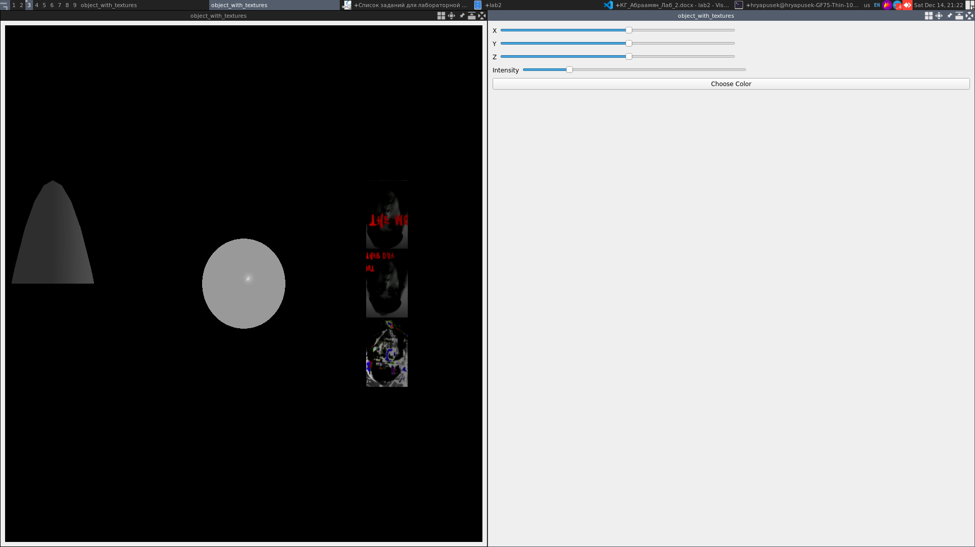**Изменение цвета источника света**

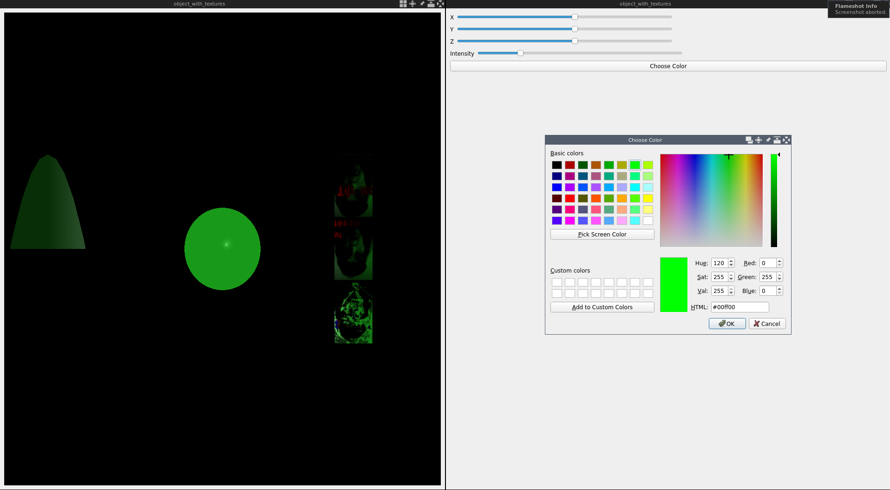

**Перемещение источника света**

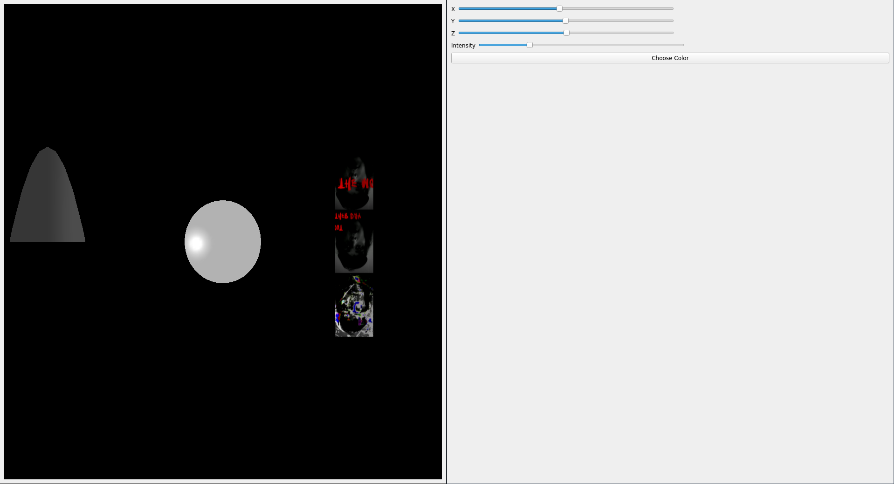**Изменение яркости источника света**

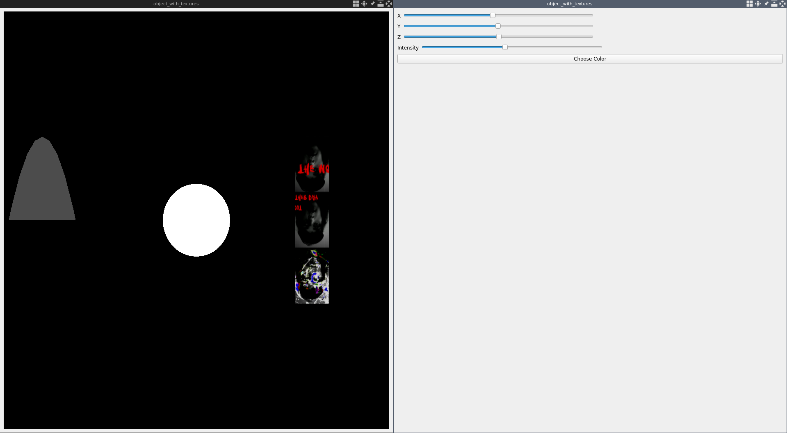

# Код программы

|  |
| --- |
| #pragma once  #include <QWidget>  #include <QMainWindow>  #include <QVBoxLayout>  #include <QHBoxLayout>  #include <QSlider>  #include <QPushButton>  #include <glwidget/glwidget.h>  #include <custom_widgets/fancy_slider.h>  namespace params_window_ns {  class ParamsWindow : public QMainWindow  {  Q_OBJECT  public:  ParamsWindow(QWidget *parent = nullptr);  signals:  void sig_light_position_updated(glm::fvec3 position);  void sig_light_position_updated_x(GLfloat new_x);  void sig_light_position_updated_y(GLfloat new_y);  void sig_light_position_updated_z(GLfloat new_z);  void sig_color_changed(QColor color);  void sig_light_intensity_updated(GLfloat new_intensity);  private:  QWidget *main_widget = nullptr;  QVBoxLayout *main_layout = nullptr;  custom_widgets::FancySlider *x_slider = nullptr;  custom_widgets::FancySlider *y_slider = nullptr;  custom_widgets::FancySlider *z_slider = nullptr;  QPushButton *choose_color_button = nullptr;  custom_widgets::FancySlider *light_intensity_slider = nullptr;  };  } // namespace main_window_ns  #include <QLabel>  #include <params_window/params_window.h>  #include <glwidget/glwidget.h>  #include <QColorDialog>  namespace params_window_ns {  ParamsWindow::ParamsWindow(QWidget* parent)  : QMainWindow(parent)  {  main_widget = new QWidget(this);  main_layout = new QVBoxLayout(main_widget);  setCentralWidget(main_widget);  x_slider = new custom_widgets::FancySlider(Qt::Horizontal);  y_slider = new custom_widgets::FancySlider(Qt::Horizontal);  z_slider = new custom_widgets::FancySlider(Qt::Horizontal);  light_intensity_slider = new custom_widgets::FancySlider(Qt::Horizontal);  for (auto& slider : {x_slider, y_slider, z_slider}) {  slider->setMinimum(-1000);  slider->setMaximum(1000);  slider->setValue(100);  slider->setTickPosition(QSlider::TickPosition::NoTicks);  }  {  QHBoxLayout* pair_layout = new QHBoxLayout;  QLabel* label = new QLabel("X");  pair_layout->addWidget(label);  pair_layout->addWidget(x_slider);  main_layout->addLayout(pair_layout);  connect(x_slider, &QSlider::valueChanged,  [this](int value) { sig_light_position_updated_x(value / 10.0f); });  pair_layout->addSpacerItem(new QSpacerItem(40, 20, QSizePolicy::Expanding, QSizePolicy::Minimum));  }  {  QHBoxLayout* pair_layout = new QHBoxLayout;  QLabel* label = new QLabel("Y");  pair_layout->addWidget(label);  pair_layout->addWidget(y_slider);  main_layout->addLayout(pair_layout);  connect(y_slider, &QSlider::valueChanged,  [this](int value) { sig_light_position_updated_y(value / 10.0f); });  pair_layout->addSpacerItem(new QSpacerItem(40, 20, QSizePolicy::Expanding, QSizePolicy::Minimum));  }  {  QHBoxLayout* pair_layout = new QHBoxLayout;  QLabel* label = new QLabel("Z");  pair_layout->addWidget(label);  pair_layout->addWidget(z_slider);  main_layout->addLayout(pair_layout);  connect(z_slider, &QSlider::valueChanged,  [this](int value) { sig_light_position_updated_z(value / 10.0f); });  pair_layout->addSpacerItem(new QSpacerItem(40, 20, QSizePolicy::Expanding, QSizePolicy::Minimum));  }  {  QHBoxLayout* pair_layout = new QHBoxLayout;  QLabel* label = new QLabel("Intensity");  pair_layout->addWidget(label);  pair_layout->addWidget(light_intensity_slider);  main_layout->addLayout(pair_layout);  connect(light_intensity_slider, &QSlider::valueChanged,  [this](int value) { sig_light_intensity_updated(value / 10.0f); });  pair_layout->addSpacerItem(new QSpacerItem(40, 20, QSizePolicy::Expanding, QSizePolicy::Minimum));  }  light_intensity_slider->setMinimum(0);  light_intensity_slider->setMaximum(50);  light_intensity_slider->setValue(10);  light_intensity_slider->setTickPosition(QSlider::TickPosition::NoTicks);  choose_color_button = new QPushButton();  choose_color_button->setText("Choose Color");  connect(choose_color_button, &QPushButton::clicked, [this]() {  auto new_color = QColorDialog::getColor(Qt::black, this, "Choose Color");  if (new_color.isValid()) {  sig_color_changed(new_color);  }  });  main_layout->addWidget(choose_color_button);  main_layout->addSpacerItem(new QSpacerItem(20, 20, QSizePolicy::Expanding, QSizePolicy::Expanding));  }  } // namespace params_window_ns  #include <states/conus_sphere_stay_state/conus_sphere_stay_state.h>  #include <iostream>  #include <GL/glut.h> // Include GLUT for cool drawing utils  #include <state_machine/state_machine.h>  #include <states/conus_sphere_stay_state/constants.h>  #include <states/tor_cylinder_state/constants.h>  #include <utils/utils.h>  using namespace states::conus_sphere_stay_state::constants;  using namespace states::tor_cylinder_state::constants;  namespace states {  GLState* ConusSphereStayState::display()  {  glClear(GL_COLOR_BUFFER_BIT | GL_DEPTH_BUFFER_BIT); // Clear both color and depth buffers  // --- Draw Opaque Objects First ---  glPushMatrix();  glLoadIdentity();  // Draw opaque sphere  glTranslated(sphere_start_pos.x, sphere_start_pos.y, sphere_start_pos.z);  glColor4f(1.0f, 1.0f, 1.0f, 1.0f); // Fully opaque  glMaterialfv(GL_FRONT, GL_SPECULAR, states::conus_sphere_stay_state::constants::mat_specular);  glMaterialfv(GL_FRONT, GL_SHININESS, states::conus_sphere_stay_state::constants::mat_shininess);  glutSolidSphere(sphere_radius, sphere_slices, sphere_stacks); // Draw filled sphere  glPopMatrix();  // --- Draw Textured Cylinder ---  glPushMatrix(); // Save the current matrix state  static GLuint textureID = utils::loadTexture(cone_texture_path);  // Create a quadric object for the cylinder  GLUquadric* quadric = gluNewQuadric();  gluQuadricTexture(quadric, GL_TRUE);  gluQuadricNormals(quadric, GLU_SMOOTH);  glRotated(90, 1, 0, 0);  glTranslated(cylinder_start_pos.y + 20, -cylinder_start_pos.x, cylinder_start_pos.z);  glMaterialfv(GL_FRONT, GL_AMBIENT, mat_ambient);  glMaterialfv(GL_FRONT, GL_DIFFUSE, mat_diffuse);  glMaterialfv(GL_FRONT, GL_SPECULAR, states::tor_cylinder_state::constants::mat_specular);  glMaterialfv(GL_FRONT, GL_SHININESS, states::tor_cylinder_state::constants::mat_shininess);  glBindTexture(GL_TEXTURE_2D, textureID);  // Draw the textured cylinder  gluCylinder(quadric, cylinder_base, cylinder_top, cylinder_height, cylinder_slices,  cylinder_stacks);  glBindTexture(GL_TEXTURE_2D, 0); // Unbind texture  // Clean up the quadric object  gluDeleteQuadric(quadric);  glPopMatrix(); // Restore the previous matrix state  // --- Draw Transparent Cone Last ---  // Enable blending for transparency  glEnable(GL_BLEND);  glBlendFunc(GL_SRC_ALPHA, GL_ONE_MINUS_SRC_ALPHA);  // Disable depth writing for the transparent object  glDepthMask(GL_FALSE);  glPushMatrix();  glLoadIdentity();  glTranslated(cone_start_pos.x, cone_start_pos.y, cone_start_pos.z);  glRotated(90, -1, 0, 0);  // Set color with transparency (for lighting)  glColor4f(1.0f, 1.0f, 1.0f, constants::LOWER_ALPHA);  // Set the material with transparency  GLfloat mat_diffuse_with_alpha[] = {1.0f, 1.0f, 1.0f, constants::LOWER_ALPHA};  glMaterialfv(GL_FRONT, GL_DIFFUSE, mat_diffuse_with_alpha);  // Draw the transparent cone  glutSolidCone(cone_base, cone_height, cone_slices, cone_stacks);  // Restore depth writing and disable blending  glDepthMask(GL_TRUE);  glDisable(GL_BLEND);  glPopMatrix();  return this;  }  void ConusSphereStayState::timeout()  {  std::cout << "ConusSphereStayState timeout " << frames_count << std::endl;  frames_count++;  // if (frames_count == MAX_FRAMES_COUNT) {  // std::cout << "Switching the state\n";  // state_machine::StateMachine::instance()->set_state(new states::ConusSphereMovingState());  // }  }  } // namespace states  #pragma once  #include <constants.h>  #include <states/states.h>  namespace states {  class ConusSphereStayState : public GLState  {  public:  GLState* display() override final;  void timeout() override final;  private:  size_t frames_count = 0;  };  } // namespace states  #pragma once  #include <GL/glut.h> // Include GLUT for cool drawing utils  #include <glm/vec3.hpp>  #include <constants.h>  namespace states::conus_sphere_stay_state::constants {  static constexpr size_t STAY_SECONDS = 1;  static constexpr size_t MAX_FRAMES_COUNT = ::constants::FRAMES_PER_SECONDS * STAY_SECONDS;  static constexpr GLdouble cone_base = 20.0;  static constexpr GLdouble cone_height = 200.0;  static constexpr GLint cone_slices = 60;  static constexpr GLint cone_stacks = 300;  static constexpr GLint sphere_radius = 20;  static constexpr GLint sphere_slices = 100;  static constexpr GLint sphere_stacks = 100;  static constexpr glm::dvec3 cone_start_pos = glm::dvec3(-40, 0, -19);  static constexpr glm::dvec3 sphere_start_pos = glm::dvec3(0, 0, -19.0);  static constexpr GLfloat mat_specular[] = { 1.0f, 1.0f, 1.0f, 1.0f };  static constexpr GLfloat mat_shininess[] = { 120.0f }; // Shininess factor (higher values mean more polished)  }  #pragma once  #include <GL/glut.h> // Include GLUT for cool drawing utils  #include <glm/vec3.hpp>  #include <constants.h>  namespace states::tor_cylinder_state::constants {  static constexpr size_t STAY_SECONDS = 1;  static constexpr size_t MAX_FRAMES_COUNT = ::constants::FRAMES_PER_SECONDS * STAY_SECONDS;  static constexpr GLdouble torus_inner_radius = 5;  static constexpr GLdouble torus_outer_radius = 10;  static constexpr GLint torus_sides = 100;  static constexpr GLint torus_rings = 100;  static constexpr GLint cylinder_base = 10;  static constexpr GLint cylinder_top = 10;  static constexpr GLint cylinder_height = 40;  static constexpr GLint cylinder_slices = 50;  static constexpr GLint cylinder_stacks = 50;  static constexpr glm::dvec3 torus_start_pos = glm::dvec3(-10, 0, 5);  static constexpr glm::dvec3 cylinder_start_pos = glm::dvec3(-10, 10, -20);  static constexpr GLfloat mat_ambient[] = { 0.5f, 0.5f, 0.5f, 1.0f }; // Low intensity ambient (grey)  static constexpr GLfloat mat_diffuse[] = { 1.0f, 1.0f, 1.0f, 0.5f }; // Bright green diffuse (matte green)  static constexpr GLfloat mat_specular[] = { 0.0f, 0.0f, 0.0f, 1.0f }; // No specular highlights for matte  static constexpr GLfloat mat_shininess[] = { 0.0f }; // Shininess (set to 0 for matte finish)  static constexpr const char *cone_texture_path = "textures/cone_texture.png";  }  #pragma once  #include <memory>  namespace states {  enum State  {  CONUS_SPHERE_STAY,  CONUS_SPHERE_MOVE,  TOR_CYLLINDRE_STAY,  CYLLINDRE_SPIN,  TOR_STRETCH  };  class GLState  {  public:  virtual GLState* display() = 0;  virtual void timeout() = 0;  virtual void keyboard_callback(unsigned char key, int param1, int param2);  virtual void reshape(int w, int h);  };  } // namespace states  #include <states/states.h>  #include <iostream>  #include <GL/glut.h>  #include <GL/gl.h>  #include "states.h"  void states::GLState::keyboard_callback(unsigned char key, int param1, int param2)  {  if (key == 'q') {  std::cout << "Quitting application";  glutDestroyWindow(param1);  exit(0);  }  }  void states::GLState::reshape(int w, int h)  {  glViewport(0, 0, (GLsizei)w, (GLsizei)h);  glMatrixMode(GL_PROJECTION);  glLoadIdentity();  glOrtho(-50.0, 50.0, -50.0, 50.0, -1.0, 1.0);  glMatrixMode(GL_MODELVIEW);  glLoadIdentity();  }  #include "glwidget.h"  #include <iostream>  #include <GL/glut.h> // Include GLUT for cool drawing utils  #include <QWindow>  #include <QOpenGLContext>  #include <states/conus_sphere_stay_state/conus_sphere_stay_state.h>  #include <constants.h>  namespace glwidget {  GLWidget::GLWidget(QWidget* parent)  : QGLWidget(parent)  {  }  void GLWidget::initializeGL()  {  glutInitDisplayMode(GLUT_DOUBLE | GLUT_RGB | GLUT_DEPTH);  glMatrixMode(GL_PROJECTION); // Switch to projection matrix  glLoadIdentity(); // Reset the projection matrix  // Set up a perspective projection using the constants  gluPerspective(constants::FOV_Y,  (double)constants::WINDOW_WIDTH / (double)constants::WINDOW_HEIGHT,  constants::NEAR_PLANE, constants::FAR_PLANE);  // Set the camera position and look-at point using the constants  gluLookAt(constants::CAMERA_POS_X, constants::CAMERA_POS_Y,  constants::CAMERA_POS_Z, // Camera position  constants::LOOK_AT_X, constants::LOOK_AT_Y, constants::LOOK_AT_Z, // Look-at point  constants::UP_X, constants::UP_Y, constants::UP_Z); // Up vector  glMatrixMode(GL_MODELVIEW); // Switch back to model-view matrix  glLoadIdentity(); // Reset the model-view matrix  glEnable(GL_DEPTH_TEST); // Enable depth testing  glDepthFunc(GL_LEQUAL); // Set the type of depth-test  glDisable(GL_CULL_FACE); // Disable face culling  glBlendFunc(GL_SRC_ALPHA, GL_ONE_MINUS_SRC_ALPHA);  glEnable(GL_BLEND);  glEnable(GL_LIGHTING);  glEnable(GL_LIGHT0);  glEnable(GL_TEXTURE_2D);  startTimer(1000 / constants::FRAMES_PER_SECONDS);  }  void GLWidget::paintGL()  {  paint_light();  state_machine_obj->display();  }  void GLWidget::resizeGL(int width, int height) { state_machine_obj->reshape(width, height); }  void GLWidget::timerEvent(QTimerEvent* event)  {  state_machine_obj->timeout();  update();  QGLWidget::timerEvent(event);  }  void GLWidget::set_light_position(glm::fvec3 position)  {  light_position[0] = position.x;  light_position[1] = position.y;  light_position[2] = position.z;  }  void GLWidget::paint_light()  {  std::array<GLfloat, 4> intensity_light_ambient = {};  std::array<GLfloat, 4> intensity_light_diffuse = {};  std::array<GLfloat, 4> intensity_light_specular = {};  std::array<GLfloat, 4> intensity_light_position = {};  std::transform(light_ambient.begin(), light_ambient.end(), intensity_light_ambient.begin(),  [this](GLfloat val) { return val * light_intensity; });  std::transform(light_diffuse.begin(), light_diffuse.end(), intensity_light_diffuse.begin(),  [this](GLfloat val) { return val * light_intensity; });  std::transform(light_specular.begin(), light_specular.end(), intensity_light_specular.begin(),  [this](GLfloat val) { return val * light_intensity; });  std::transform(light_position.begin(), light_position.end(), intensity_light_position.begin(),  [this](GLfloat val) { return val * light_intensity; });  glLightfv(GL_LIGHT0, GL_AMBIENT, intensity_light_ambient.data()); // Ambient light  glLightfv(GL_LIGHT0, GL_DIFFUSE, intensity_light_diffuse.data()); // Diffuse light  glLightfv(GL_LIGHT0, GL_SPECULAR, intensity_light_specular.data()); // Specular light  glLightfv(GL_LIGHT0, GL_POSITION, intensity_light_position.data());  }  } // namespace glwidget  #pragma once  #include <QGLWidget>  #include <QWidget>  #include <glm/glm.hpp>  #include <state_machine/state_machine.h>  namespace glwidget {  class GLWidget : public QGLWidget  {  public:  GLWidget(QWidget* parent);  virtual ~GLWidget() = default;  void initializeGL() override;  void paintGL() override;  void resizeGL(int width, int height) override;  void timerEvent(QTimerEvent* event) override;  public slots:  void set_light_position(glm::fvec3 position);  void set_light_position_x(GLfloat x) {  light_position[0] = x;  }  void set_light_position_y(GLfloat y) {  light_position[1] = y;  }  void set_light_position_z(GLfloat z) {  light_position[2] = z;  }  void set_light_color(QColor color) {  light_ambient[0] = color.redF();  light_ambient[1] = color.greenF();  light_ambient[2] = color.blueF();  }  void set_light_intensity(GLfloat new_intensity) {  light_intensity = new_intensity;  }  protected:  state_machine::StateMachine* state_machine_obj = state_machine::StateMachine::instance();  std::array<GLfloat, 4> light_position = {1.0f, 1.0f, 1.0f, 1.0f};  std::array<GLfloat, 4> light_ambient = { 1.f, 1.f, 1.f, 1.0f }; // Low intensity ambient light  std::array<GLfloat, 4> light_diffuse = { 1.0f, 1.0f, 1.0f, 1.0f }; // Full intensity white diffuse light  std::array<GLfloat, 4> light_specular = { 1.0f, 1.0f, 1.0f, 1.0f }; // Full intensity white specular light  GLfloat light_intensity = 1.0f;  void paint_light();  };  } // namespace glwidget  #include <QLabel>  #include <main_window/main_window.h>  #include <glwidget/glwidget.h>  namespace main_window_ns {  MainWindow::MainWindow()  {  gl_widget = new glwidget::GLWidget(this);  main_widget = new QWidget(this);  main_layout = new QVBoxLayout(main_widget);  setCentralWidget(main_widget);  main_layout->addWidget(gl_widget);  params_window = new params_window_ns::ParamsWindow(this);  connect(params_window, &params_window_ns::ParamsWindow::sig_light_position_updated,  [this](glm::fvec3 position) { gl_widget->set_light_position(position); });  connect(params_window, &params_window_ns::ParamsWindow::sig_light_position_updated_x,  [this](GLfloat new_x) { gl_widget->set_light_position_x(new_x); });  connect(params_window, &params_window_ns::ParamsWindow::sig_light_position_updated_y,  [this](GLfloat new_y) { gl_widget->set_light_position_y(new_y); });  connect(params_window, &params_window_ns::ParamsWindow::sig_light_position_updated_z,  [this](GLfloat new_z) { gl_widget->set_light_position_z(new_z); });  connect(params_window, &params_window_ns::ParamsWindow::sig_color_changed,  [this](QColor color) { gl_widget->set_light_color(color); });    connect(params_window, &params_window_ns::ParamsWindow::sig_light_intensity_updated,  [this](GLfloat new_intensity) { gl_widget->set_light_intensity(new_intensity); });  params_window->show();  }  } // namespace main_window_ns  #pragma once  #include <QWidget>  #include <QMainWindow>  #include <QVBoxLayout>  #include <QHBoxLayout>  #include <QSlider>  #include <glwidget/glwidget.h>  #include <params_window/params_window.h>  namespace main_window_ns {  class MainWindow : public QMainWindow  {  public:  MainWindow();  private:  QWidget *main_widget = nullptr;  QVBoxLayout *main_layout = nullptr;  glwidget::GLWidget *gl_widget = nullptr;  params_window_ns::ParamsWindow *params_window = nullptr;  };  } // namespace main_window_ns  #pragma once  #include <stdio.h> // For size_t  #include <GL/gl.h>  namespace constants  {  static constexpr size_t FRAMES_PER_SECONDS = 60;  static constexpr GLfloat LOWER_ALPHA = 0.3f;  // Perspective Projection Settings  static constexpr GLdouble FOV_Y = 45.0; // Field of view in the Y direction  static constexpr GLdouble NEAR_PLANE = 0.1; // Near clipping plane  static constexpr GLdouble FAR_PLANE = 100.0; // Far clipping plane  // Camera Settings (move the camera further back and slightly up)  static constexpr GLdouble CAMERA_POS_X = 0.0; // Camera position X  static constexpr GLdouble CAMERA_POS_Y = 5.0; // Move camera slightly up along the Y-axis  static constexpr GLdouble CAMERA_POS_Z = 15.0; // Move camera further back along the Z-axis  static constexpr GLdouble LOOK_AT_X = 0.0; // Look-at point X  static constexpr GLdouble LOOK_AT_Y = 0.0; // Look-at point Y  static constexpr GLdouble LOOK_AT_Z = 0.0; // Look-at point Z  static constexpr GLdouble UP_X = 0.0; // Up vector X  static constexpr GLdouble UP_Y = 1.0; // Up vector Y  static constexpr GLdouble UP_Z = 0.0; // Up vector Z  // Window Settings  static constexpr size_t WINDOW_WIDTH = 800;  static constexpr size_t WINDOW_HEIGHT = 600;  static constexpr size_t WINDOW_POSITION_X = 0;  static constexpr size_t WINDOW_POSITION_Y = 0;  }  #include <state_machine/state_machine.h>  #include <iostream>  #include <GL/glut.h>  void state_machine::StateMachine::keyboard_callback(unsigned char key, int param1, int param2) {  if (current_state)  current_state->keyboard_callback(key, param1, param2);  else  std::cout << "No state set" << std::endl;  }  void state_machine::StateMachine::reshape(int w, int h) {  if (current_state)  current_state->reshape(w, h);  else  std::cout << "No state set" << std::endl;  }  void state_machine::StateMachine::display() {  if (current_state)  current_state->display();  else  {  std::cout << "No state set" << std::endl;  glClearColor(0.0, 0.0, 0.0, 1);  glClear(GL_COLOR_BUFFER_BIT);  }  }  bool state_machine::StateMachine::timeout() {  if (current_state)  {  current_state->timeout();  return true;  }  else  return false;  }  #pragma once  #include <states/states.h>  namespace state_machine {  class StateMachine  {  public:  void keyboard_callback(unsigned char key, int param1, int param2);  void reshape(int w, int h);  void display();  bool timeout();  void set_state(states::GLState* state) {  if (current_state != nullptr) {  delete current_state;  current_state = nullptr;  }  current_state = state;  }  static StateMachine *instance()  {  static StateMachine instance;  return &instance;  }  private:  states::GLState* current_state = nullptr;  StateMachine() = default;  };  } // namespace state_machine  #include <utils/utils.h>  #include <iostream>  #include <map>  #include <memory>  #include <mutex>  #include <GL/glut.h>  #include <image_loader/stb_image.h>  namespace utils {  struct CachedTexture  {  GLuint id;  int width;  int height;  int nrChannels;  GLenum format;  std::unique_ptr<unsigned char[]> data;  };  GLuint loadTexture(const std::string& filepath)  {  static std::map<std::string, CachedTexture> textureMap;  static std::once_flag flag;  auto found_texture = textureMap.find(filepath);  if (found_texture == textureMap.end()) {  CachedTexture texture = {};  glGenTextures(1, &texture.id);  // Flip the image vertically during loading  stbi_set_flip_vertically_on_load(true);  unsigned char* data =  stbi_load(filepath.c_str(), &texture.width, &texture.height, &texture.nrChannels, 0);  if (!data) {  std::cerr << "Failed to load texture at path: " << filepath << std::endl;  return 0;  }  texture.data = std::unique_ptr<unsigned char[]>(data);  if (texture.nrChannels == 1)  texture.format = GL_RED;  else if (texture.nrChannels == 3)  texture.format = GL_RGB;  else if (texture.nrChannels == 4)  texture.format = GL_RGBA;  else {  throw std::runtime_error("Unsupported number of channels: " +  std::to_string(texture.nrChannels));  }  textureMap[filepath] = std::move(texture);  }  auto& texture = textureMap[filepath];  glBindTexture(GL_TEXTURE_2D, texture.id);  glTexParameteri(GL_TEXTURE_2D, GL_TEXTURE_WRAP_S, GL_REPEAT);  glTexParameteri(GL_TEXTURE_2D, GL_TEXTURE_WRAP_T, GL_REPEAT);  glTexParameteri(GL_TEXTURE_2D, GL_TEXTURE_MIN_FILTER, GL_LINEAR_MIPMAP_LINEAR);  glTexParameteri(GL_TEXTURE_2D, GL_TEXTURE_MAG_FILTER, GL_LINEAR);  // Upload the texture data  gluBuild2DMipmaps(GL_TEXTURE_2D, texture.format, texture.width, texture.height, texture.format,  GL_UNSIGNED_BYTE, texture.data.get());  return texture.id;  }  GLuint getTextureId(const std::string& filepath)  {  static std::map<std::string, GLuint> textureMap;  if (textureMap.find(filepath) == textureMap.end()) {  GLuint textureID = loadTexture(filepath);  textureMap[filepath] = textureID;  return textureID;  } else {  return textureMap[filepath];  }  }  } // namespace utils  #pragma once  #ifdef _MSC_VER  #define CURRENT_FUNCTION __FUNCTION__  #elif defined(__GNUC__)  #define CURRENT_FUNCTION __PRETTY_FUNCTION__  #else  #define CURRENT_FUNCTION __func__  #endif  #include <GL/gl.h>  #include <string>  namespace utils {  GLuint loadTexture(const std::string& filepath);  GLuint getTextureId(const std::string& filepath);  }  #include <iostream>  #include <GL/glut.h>  #include <QApplication>  #include <main_window/main_window.h>  #include <state_machine/state_machine.h>  #include <states/conus_sphere_stay_state/conus_sphere_stay_state.h>  #include <constants.h>  state_machine::StateMachine *state_machine_obj = state_machine::StateMachine::instance();  //Запросить режим двойной буферизации  //Зарегистрировать функции обработки мышиного ввода  int main(int argc, char** argv)  {  glutInit(&argc, argv);  QApplication app(argc, argv);  main_window_ns::MainWindow main_window;  main_window.resize(constants::WINDOW_WIDTH, constants::WINDOW_HEIGHT);  state_machine_obj->set_state(new states::ConusSphereStayState());  main_window.show();  return app.exec();  }  #include <custom_widgets/fancy_slider.h>  #include <QStyleOptionSlider>  #include <QToolTip>  namespace custom_widgets {  FancySlider::FancySlider(QWidget* parent)  : QSlider(parent)  {  }  FancySlider::FancySlider(Qt::Orientation orientation, QWidget* parent)  : QSlider(orientation, parent)  {  }  void FancySlider::sliderChange(QAbstractSlider::SliderChange change)  {  QSlider::sliderChange(change);  if (change == QAbstractSlider::SliderValueChange) {  QStyleOptionSlider opt;  initStyleOption(&opt);  QRect sr = style()->subControlRect(QStyle::CC_Slider, &opt, QStyle::SC_SliderHandle, this);  QPoint bottomRightCorner = sr.bottomLeft();  QToolTip::showText(mapToGlobal(QPoint(bottomRightCorner.x(), bottomRightCorner.y())),  QString::number(value()), this);  }  }  } // namespace custom_widgets  #pragma once  #include <QSlider>  namespace custom_widgets {  class FancySlider : public QSlider  {  Q_OBJECT  public:  explicit FancySlider(QWidget* parent = 0);  explicit FancySlider(Qt::Orientation orientation, QWidget* parent = 0);  protected:  virtual void sliderChange(SliderChange change);  };  } // namespace custom_widgets |

# Вывод

В процессе работы были изучены ключевые функции API, которые описывают характеристики материалов объектов и позволяют настраивать параметры источников света. Также ознакомились с библиотекой OpenGL и процессом создания установки, а также настройки материалов для 3D-объектов и освещения.