Министерство образования и науки РФ
Санкт-Петербургский Политехнический университет Петра Великого
Институт компьютерных наук и кибербезопасности
Высшая школа программной инженерии

Работа №1
по дисциплине
«Разработка программного обеспечения для моделирования физических процессов»

Вариант CP3

Выполнил
студент гр. 5130904/10101
Абраамян А. М.

Преподаватель
Воскобойников С.П.

Санкт-Петербург
2024
Оглавление
Постановка задачи 3
Аппроксимация 3
Разностная схема 5
Метод прогонки 5
Вычисление погрешности 7
Оценка работы алгоритма на различных примерах 9
Пример 1 9
Пример 2 10
Пример 3 10
Код 11

Постановка задачи
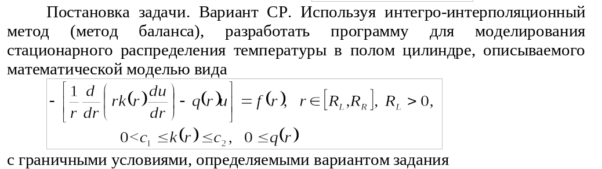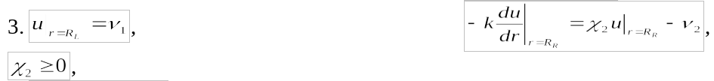

Аппроксимация
Для третьего рода подойдут следующие формулы:
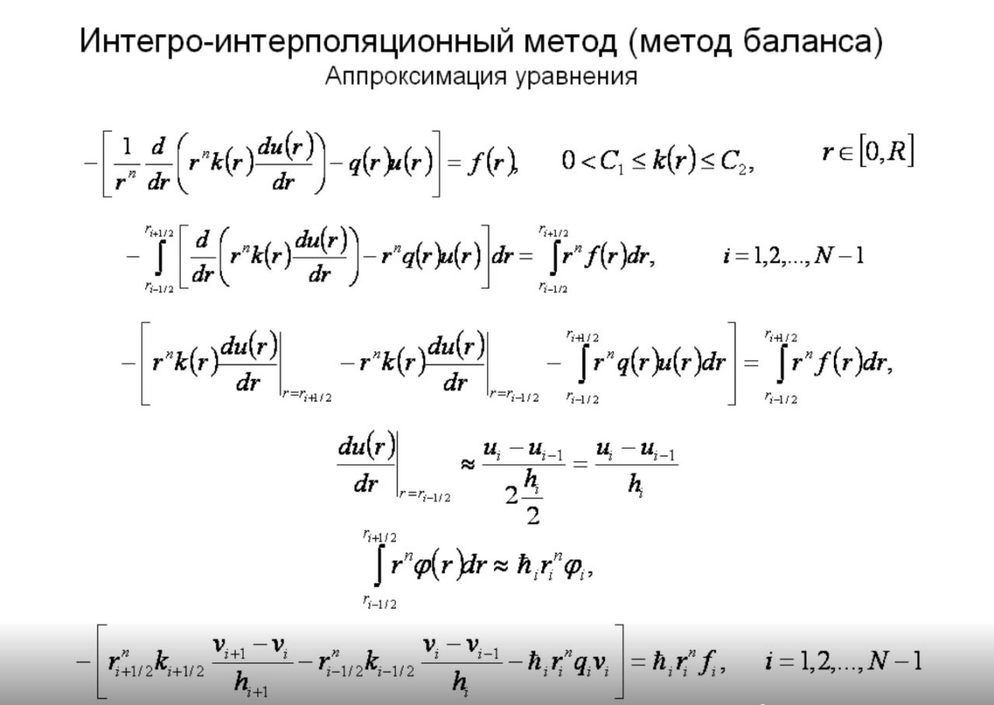
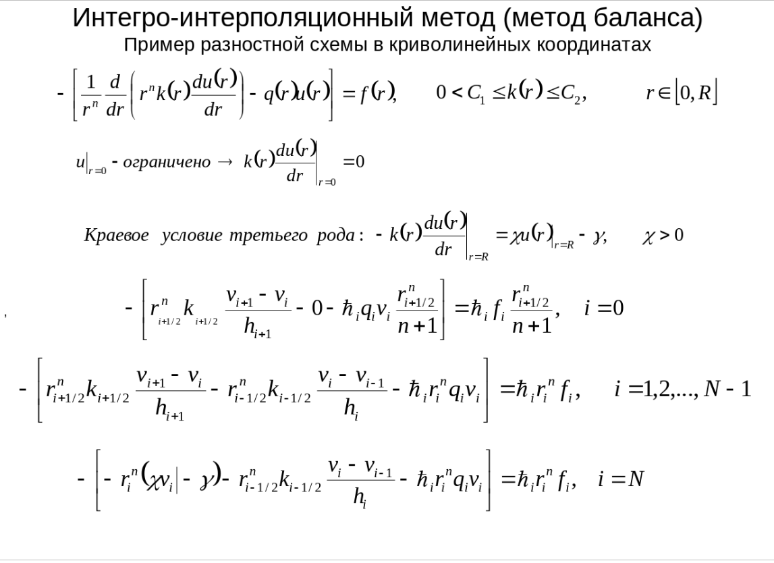

Разностная схема
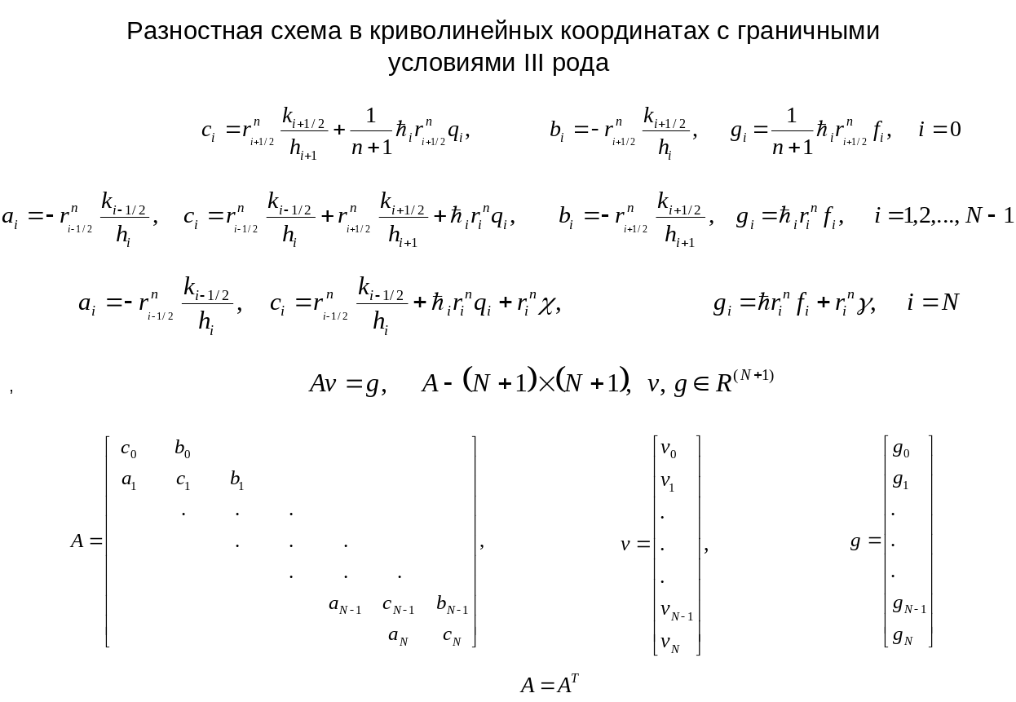
Из приведенной выше схемы для моего варианта задания подойдёт всё кроме i=0. Для i=0 подойдут следующие коэффициенты – b = 0, c = 1.

Метод прогонки
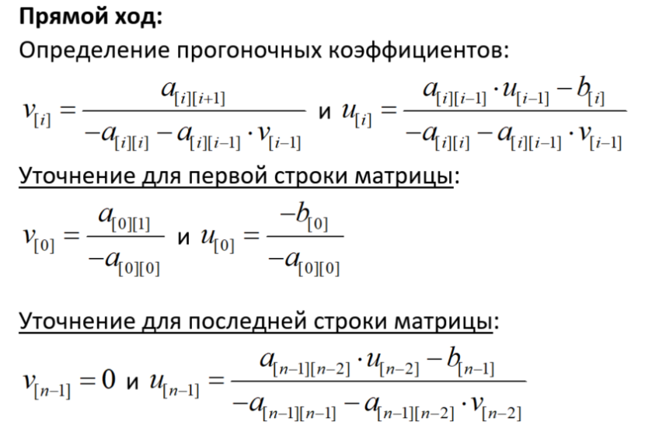
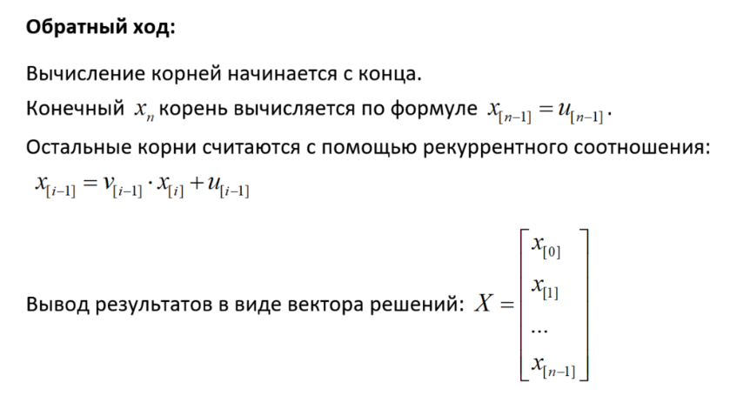
Проверить работоспособность метода помогут тесты. Ниже приведен один из многочисленных тестов доказывающих правильность работы программы и алгоритма в целом
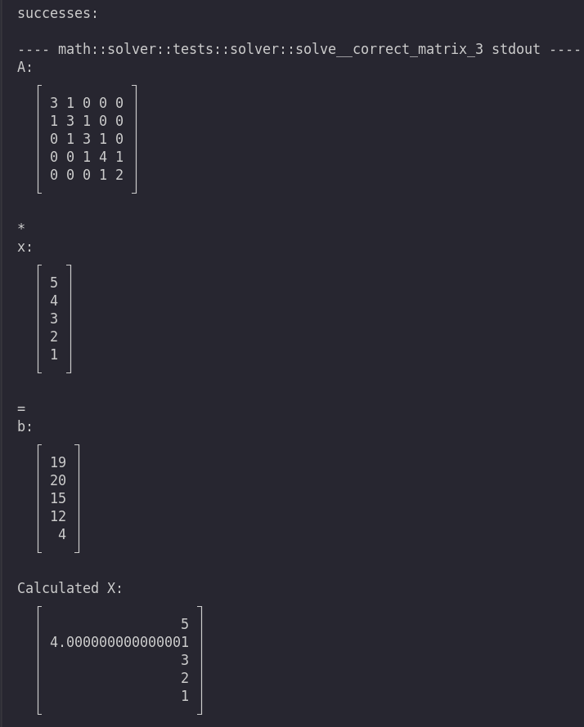
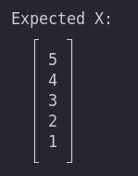

Вычисление погрешности
Погрешность можно оценить с помощью следующих формул
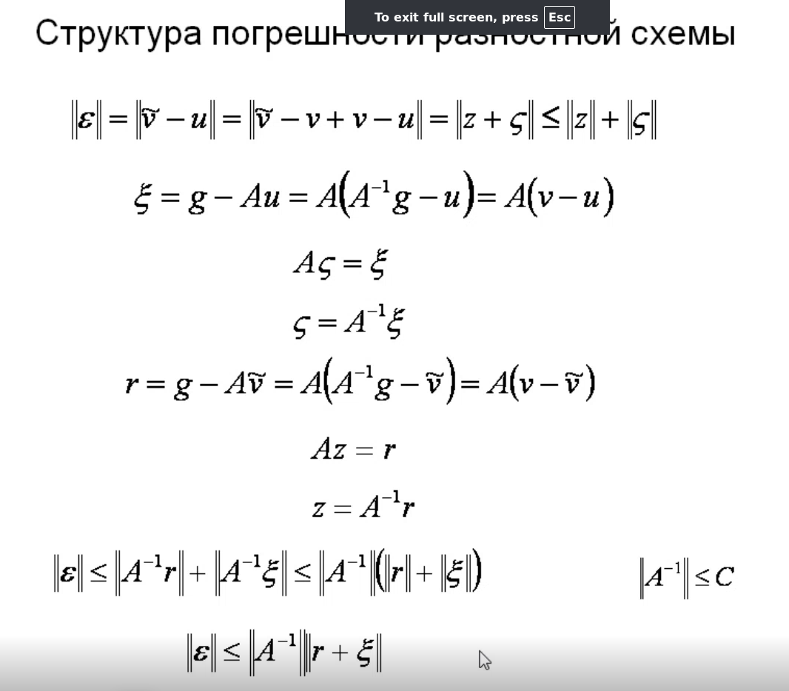
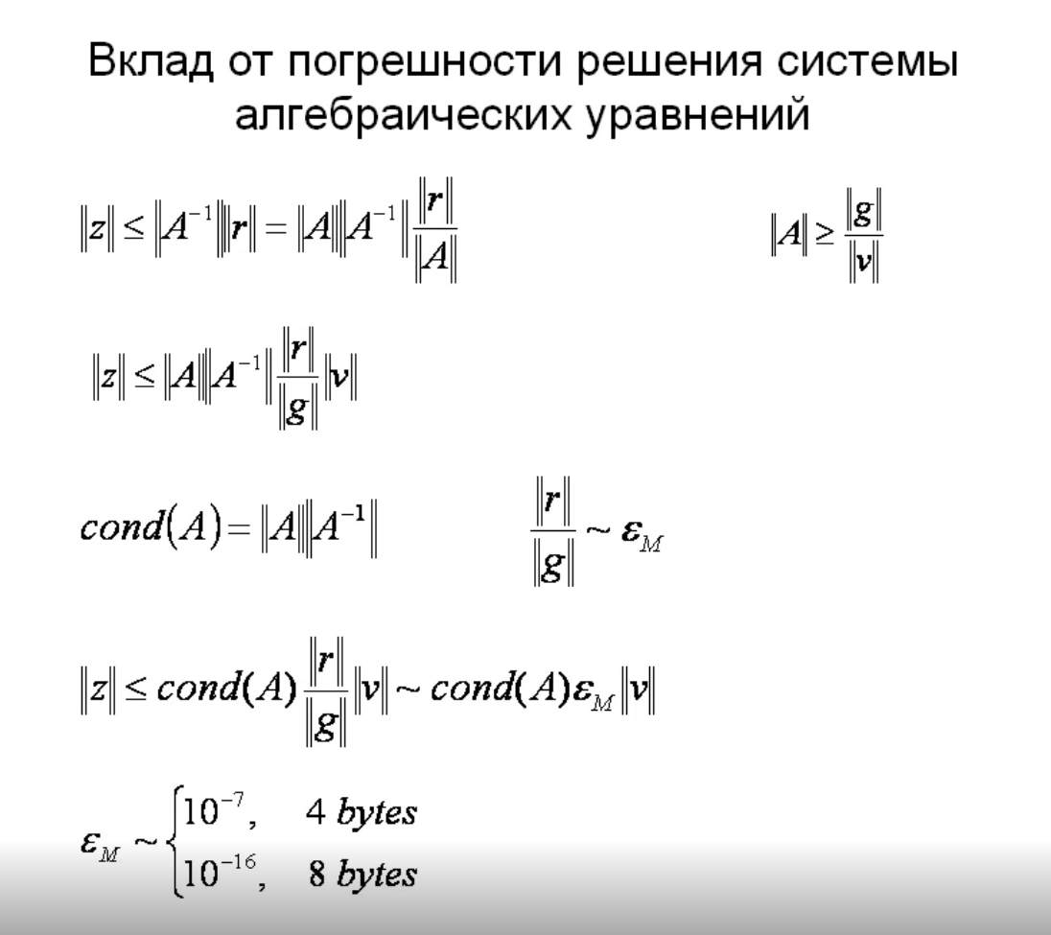
Взглянув на разложение невязки, можно понять откуда берется погршеность и почему ее нету(она близка к нулевой) для линейных уравнений.

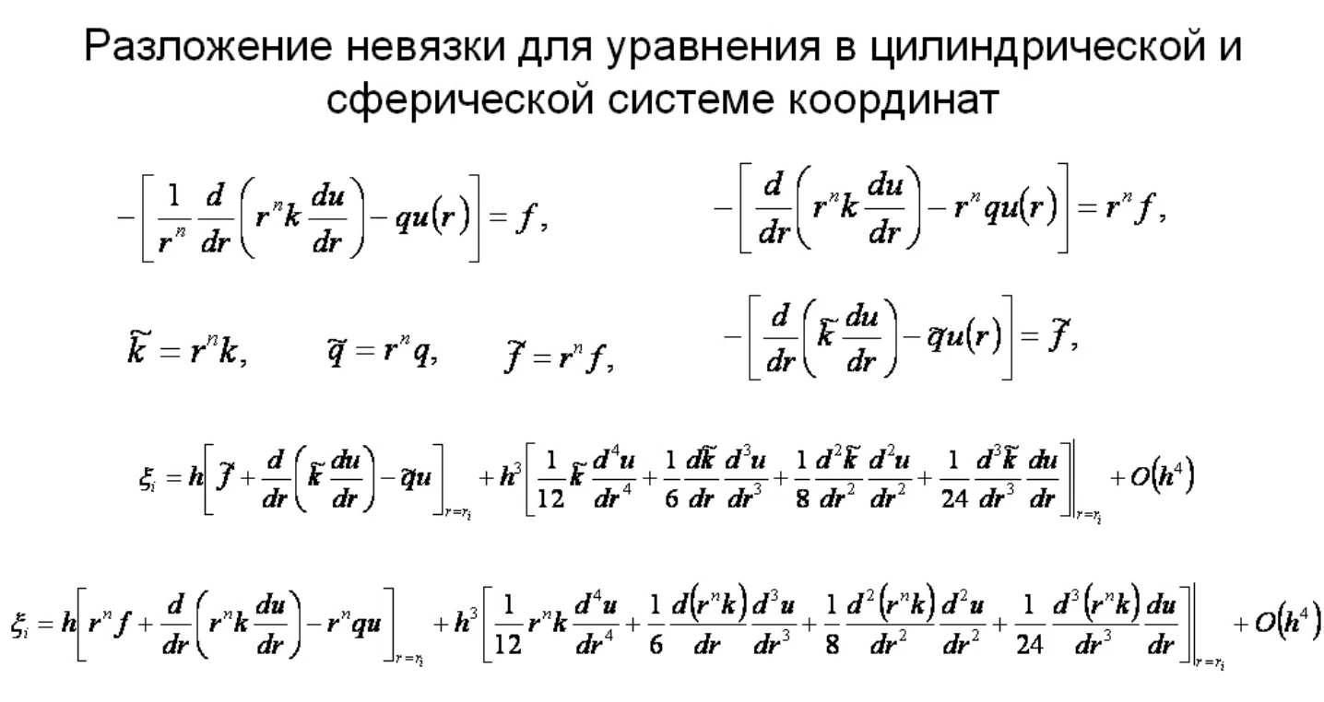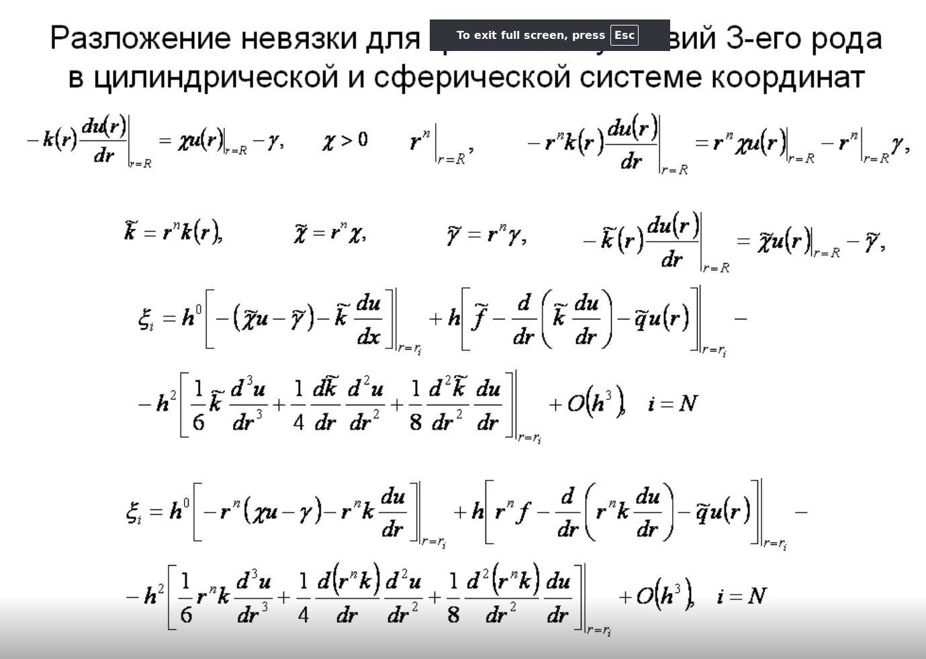

Оценка работы алгоритма на различных примерах
Для оценки работы составим различные функции и сравним теоретические и экспериментальные данные.

Пример 1
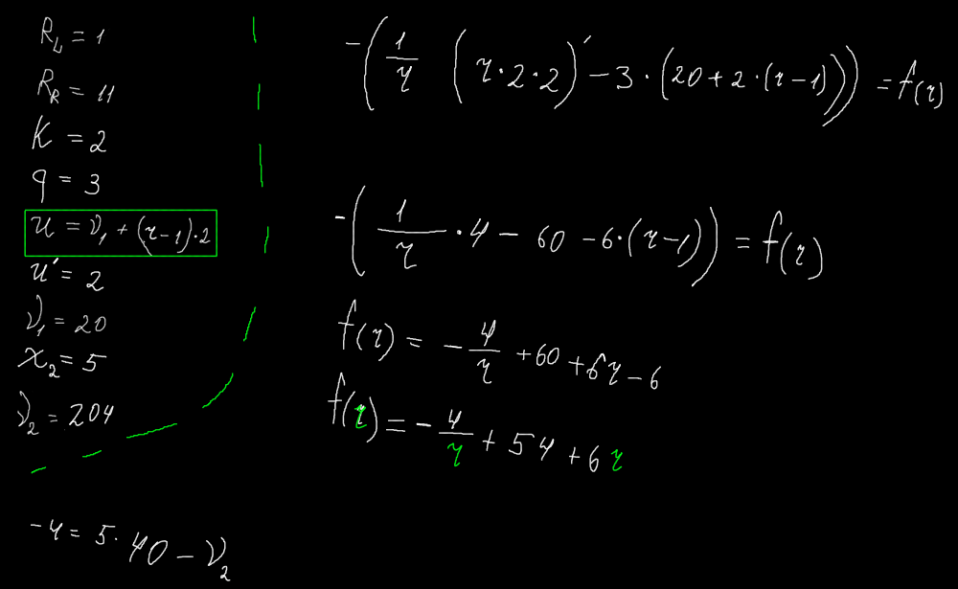
Данный пример предполагает k и q константные для простоты. Введем данные в программу и посмотрим на результат.
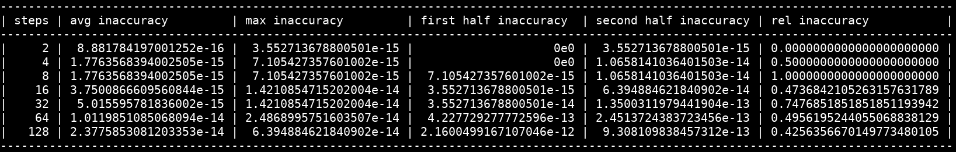
Получаем таблицу показывающую нулевые погрешности. Первый столбец это сумма погрешностей каждого x_i. Второй столбец – максимальная погрешность между i элементами. Третий столбец – сумма погрешностей первой половины найденного вектора. Четвертый столбец – сумма погрешностей второй половины найденного вектора. Пятый столбец – отношение текущей средней погрешности к предыдущей.
Погрешность оказалась близка к нулю.

Пример 2
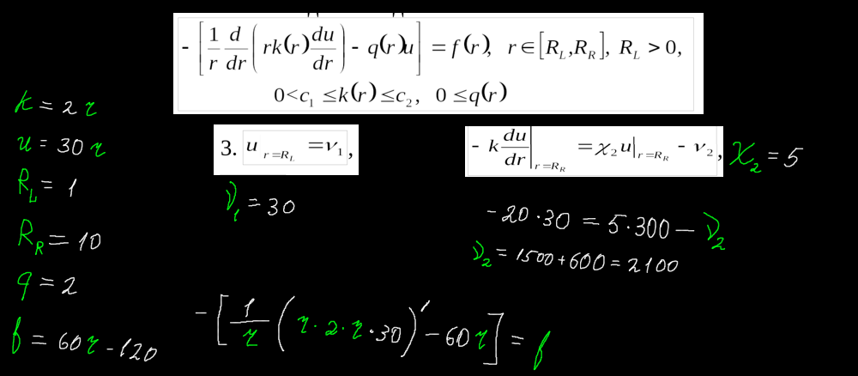 Второй пример уже немного интереснее – в качестве входных данных были взяты все константы, кроме k. k стала линейной функцией. Результаты работы программы следующие:
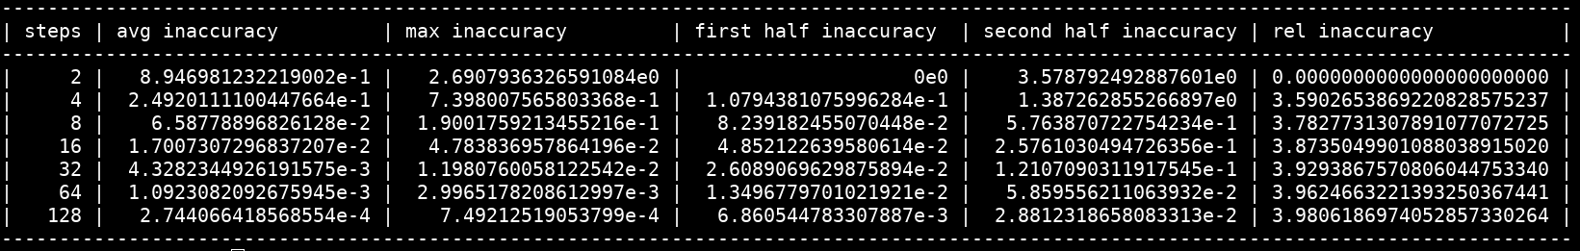
Здесь можно увидеть что погрешность не совсем близка к нулю. Дело в том что граница третьего рода дала нам эту погрешность – если взглянуть на разложение и аппроксимацию этой самой погрешности – то можно увидеть что большинство слагаемых не обратилось в ноль, даже при условии линейности k q u и тд...

Пример 3
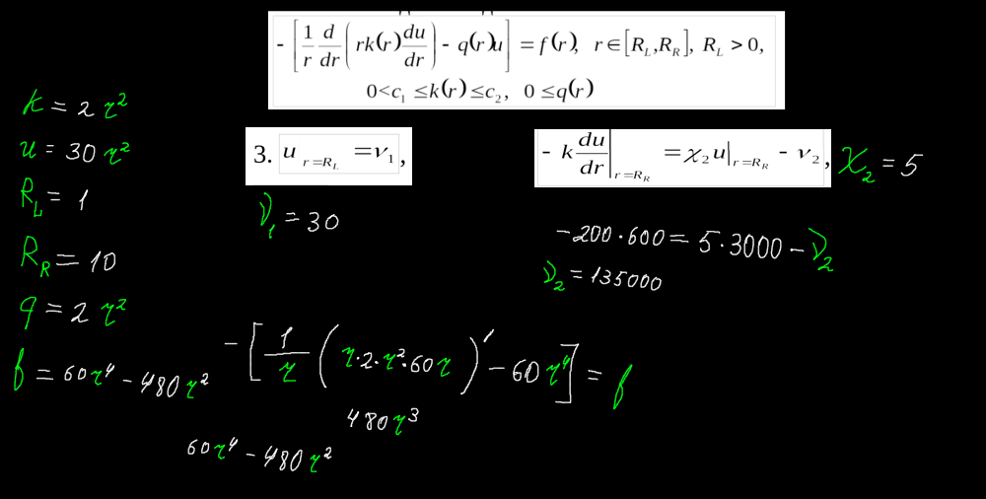
Теперь приведём уже взрослый пример и посмотрим насколько успешно наш алгоритм справится с этой задачей. Все функции взяты хотя бы второй степени, что возможно окажется непосильной задачей для нашей программы.
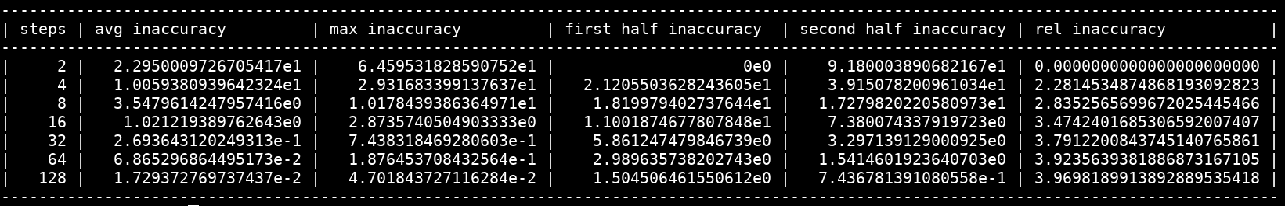
Полученная погрешность объясняется тем же что и в предыдущем примере – разложением погрешности граничного условия третьего рода

Код
Код программы находится на гитхабе по ссылке https://github.com/Hryapusek/rust-tridiagonal-matrix-vector.git в ветке СР3.

Main.rs
mod math;

use math::{coeff_calculator::*, solver};
use math::stepping::{IntervalSplitter, Stepping};
use nalgebra::DVector;

fn generate_points(left: f64, right: f64, step_count: i32) -> Vec<f64> {
let step_size = (right - left) / step_count as f64;
let mut points: Vec<f64> = Vec::<f64>::new();

for i in 0..=step_count {
points.push(left + i as f64 * step_size);
}

points
}

fn exercise_accuracy_base_example() {
const LEFT: f64 = 1.0;
const RIGHT: f64 = 11.0;

// k(r) = 1, q(r) = 0, f(r) = 0 for a simple cylindrical heat conduction case
let kfunc = LambdaFunction::from(|_r: f64| 2.0);
let qfunc = LambdaFunction::from(|_r: f64| 3.0);
let ffunc = LambdaFunction::from(|r: f64| -4.0 / r + 54.0 + 6.0 * r);

// Boundary conditions: T(0) = 0 (center), T(1) = 1 (outer radius)
let y1 = 20.0;
let hi2 = 5.0;
let y2 = 204.0;

// The 'n' value for cylindrical symmetry (n=1 for 2D axisymmetric cylindrical case)
let n = 1;
let original_function = |r: f64| y1 + (r-1.0) * 2.0;

let mut step_count_vec = Vec::<i32>::new();
let mut avg_inaccuracy_vec = Vec::<f64>::new();
let mut max_inaccuracy_vec = Vec::<f64>::new();
let mut inaccuracy_in_first_half_vec = Vec::<f64>::new();
let mut inaccuracy_in_second_half_vec = Vec::<f64>::new();

for step_count in [2, 4, 8, 16, 32, 64, 128].iter() {
let points = generate_points(LEFT, RIGHT, *step_count);
let splitter = IntervalSplitter::new(points.clone());

let coeff_calculator_v =
math::coeff_calculator::first_third_calculator::FirstThirdCalculator::new(
splitter,
&kfunc,
&qfunc,
&ffunc,
y1,
hi2,
y2,
n,
);
let (A, g) = math::coeff_calculator::matrix_building::build_tridiagonal_matrix(&coeff_calculator_v);

let calculated_v = solver::solve(&A, &g);
let expected_v: DVector<f64> = DVector::from_vec(points.iter().map(|x| original_function(*x)).collect());
let accuracy = &calculated_v - &expected_v;
let avg_inaccuracy = accuracy.fold(0.0, |acc, x| acc + x.abs()) / (accuracy.len() as f64 + 1.0);

step_count_vec.push(*step_count);

avg_inaccuracy_vec.push(avg_inaccuracy);

max_inaccuracy_vec.push(accuracy.iter().fold(0.0, |max, x| x.abs().max(max)));

let first_half_inaccuracy: f64 = accuracy
.iter()
.take(accuracy.len() / 2)
.fold(0.0, |acc, x| acc + x.abs());

let second_half_inaccuracy: f64 = accuracy
.iter()
.skip(accuracy.len() / 2)
.fold(0.0, |acc, x| acc + x.abs());
inaccuracy_in_first_half_vec.push(first_half_inaccuracy);
inaccuracy_in_second_half_vec.push(second_half_inaccuracy);
}
let mut rel_inaccuracy: Vec<f64> = vec![];
for i in 1..avg_inaccuracy_vec.len() {
rel_inaccuracy.push(avg_inaccuracy_vec[i-1] / avg_inaccuracy_vec[i]);
}
let digits_after_dot = 16;
println!("{}", "-".repeat(136));
println!(
"| {:>5} | {:width$.width$} | {:width$.width$} | {:width$.width$} | {:width$.width$} | {:width$.width$} |",
"steps",
"avg inaccuracy",
"max inaccuracy",
"first half inaccuracy",
"second half inaccuracy",
"rel inaccuracy",
width = digits_after_dot + 6
);
println!("{}", "-".repeat(136));
for i in 0..step_count_vec.len() {
println!(
"| {:>5} | {:width$e} | {:width$e} | {:width$e} | {:width$e} | {:width$.width$} |",
step_count_vec[i],
avg_inaccuracy_vec[i],
max_inaccuracy_vec[i],
inaccuracy_in_first_half_vec[i],
inaccuracy_in_second_half_vec[i],
if i > 0 { rel_inaccuracy[i - 1] } else { 0.0 },
width = digits_after_dot + 6
);
}
println!("{}", "-".repeat(136));
}

fn exercise_accuracy_kr_high_accuracy() {
const LEFT: f64 = 1.0;
const RIGHT: f64 = 10.0;
// k(r) = 1, q(r) = 0, f(r) = 0 for a simple cylindrical heat conduction case
let kfunc = LambdaFunction::from(|r: f64| 2.0 * r);
let qfunc = LambdaFunction::from(|_r: f64| 2.0);
let ffunc = LambdaFunction::from(|r: f64| 60.0 * r - 120.0);

// Boundary conditions: T(0) = 0 (center), T(1) = 1 (outer radius)
let y1 = 30.0;
let hi2 = 5.0;
let y2 = 2100.0;

// The 'n' value for cylindrical symmetry (n=1 for 2D axisymmetric cylindrical case)
let n = 1;
let original_function = |r: f64| 30.0 * r;

let mut step_count_vec = Vec::<i32>::new();
let mut avg_inaccuracy_vec = Vec::<f64>::new();
let mut max_inaccuracy_vec = Vec::<f64>::new();
let mut inaccuracy_in_first_half_vec = Vec::<f64>::new();
let mut inaccuracy_in_second_half_vec = Vec::<f64>::new();

for step_count in [2, 4, 8, 16, 32, 64, 128].iter() {
let points = generate_points(LEFT, RIGHT, *step_count);
let splitter = IntervalSplitter::new(points.clone());

let coeff_calculator_v =
math::coeff_calculator::first_third_calculator::FirstThirdCalculator::new(
splitter,
&kfunc,
&qfunc,
&ffunc,
y1,
hi2,
y2,
n,
);
let (A, g) = math::coeff_calculator::matrix_building::build_tridiagonal_matrix(&coeff_calculator_v);

let calculated_v = solver::solve(&A, &g);
let expected_v: DVector<f64> = DVector::from_vec(points.iter().map(|x| original_function(*x)).collect());
let accuracy = &calculated_v - &expected_v;
let avg_inaccuracy = accuracy.fold(0.0, |acc, x| acc + x.abs()) / (accuracy.len() as f64 + 1.0);

step_count_vec.push(*step_count);

avg_inaccuracy_vec.push(avg_inaccuracy);

max_inaccuracy_vec.push(accuracy.iter().fold(0.0, |max, x| x.abs().max(max)));

let first_half_inaccuracy: f64 = accuracy
.iter()
.take(accuracy.len() / 2)
.fold(0.0, |acc, x| acc + x.abs());

let second_half_inaccuracy: f64 = accuracy
.iter()
.skip(accuracy.len() / 2)
.fold(0.0, |acc, x| acc + x.abs());
inaccuracy_in_first_half_vec.push(first_half_inaccuracy);
inaccuracy_in_second_half_vec.push(second_half_inaccuracy);
}
let mut rel_inaccuracy: Vec<f64> = vec![];
for i in 1..avg_inaccuracy_vec.len() {
rel_inaccuracy.push(avg_inaccuracy_vec[i-1] / avg_inaccuracy_vec[i]);
}
let digits_after_dot = 16;
println!("{}", "-".repeat(136));
println!(
"| {:>5} | {:width$.width$} | {:width$.width$} | {:width$.width$} | {:width$.width$} | {:width$.width$} |",
"steps",
"avg inaccuracy",
"max inaccuracy",
"first half inaccuracy",
"second half inaccuracy",
"rel inaccuracy",
width = digits_after_dot + 6
);
println!("{}", "-".repeat(136));
for i in 0..step_count_vec.len() {
println!(
"| {:>5} | {:width$e} | {:width$e} | {:width$e} | {:width$e} | {:width$.width$} |",
step_count_vec[i],
avg_inaccuracy_vec[i],
max_inaccuracy_vec[i],
inaccuracy_in_first_half_vec[i],
inaccuracy_in_second_half_vec[i],
if i > 0 { rel_inaccuracy[i - 1] } else { 0.0 },
width = digits_after_dot + 6
);
}
println!("{}", "-".repeat(136));
}

fn exercise_accuracy_kr_no_accuracy() {
const LEFT: f64 = 1.0;
const RIGHT: f64 = 10.0;
// k(r) = 1, q(r) = 0, f(r) = 0 for a simple cylindrical heat conduction case
let kfunc = LambdaFunction::from(|r: f64| 2.0 * r * r);
let qfunc = LambdaFunction::from(|r: f64| 2.0 * r * r);
let ffunc = LambdaFunction::from(|r: f64| 60.0 * r.powf(4.0) - 480.0 * r * r);

// Boundary conditions: T(0) = 0 (center), T(1) = 1 (outer radius)
let y1 = 30.0;
let hi2 = 5.0;
let y2 = 135000.0;

// The 'n' value for cylindrical symmetry (n=1 for 2D axisymmetric cylindrical case)
let n = 1;
let original_function = |r: f64| 30.0 * r * r;

let mut step_count_vec = Vec::<i32>::new();
let mut avg_inaccuracy_vec = Vec::<f64>::new();
let mut max_inaccuracy_vec = Vec::<f64>::new();
let mut inaccuracy_in_first_half_vec = Vec::<f64>::new();
let mut inaccuracy_in_second_half_vec = Vec::<f64>::new();

for step_count in [2, 4, 8, 16, 32, 64, 128].iter() {
let points = generate_points(LEFT, RIGHT, *step_count);
let splitter = IntervalSplitter::new(points.clone());

let coeff_calculator_v =
math::coeff_calculator::first_third_calculator::FirstThirdCalculator::new(
splitter,
&kfunc,
&qfunc,
&ffunc,
y1,
hi2,
y2,
n,
);
let (A, g) = math::coeff_calculator::matrix_building::build_tridiagonal_matrix(&coeff_calculator_v);

let calculated_v = solver::solve(&A, &g);
let expected_v: DVector<f64> = DVector::from_vec(points.iter().map(|x| original_function(*x)).collect());
let accuracy = &calculated_v - &expected_v;
let avg_inaccuracy = accuracy.fold(0.0, |acc, x| acc + x.abs()) / (accuracy.len() as f64 + 1.0);

step_count_vec.push(*step_count);

avg_inaccuracy_vec.push(avg_inaccuracy);

max_inaccuracy_vec.push(accuracy.iter().fold(0.0, |max, x| x.abs().max(max)));

let first_half_inaccuracy: f64 = accuracy
.iter()
.take(accuracy.len() / 2)
.fold(0.0, |acc, x| acc + x.abs());

let second_half_inaccuracy: f64 = accuracy
.iter()
.skip(accuracy.len() / 2)
.fold(0.0, |acc, x| acc + x.abs());
inaccuracy_in_first_half_vec.push(first_half_inaccuracy);
inaccuracy_in_second_half_vec.push(second_half_inaccuracy);
}
let mut rel_inaccuracy: Vec<f64> = vec![];
for i in 1..avg_inaccuracy_vec.len() {
rel_inaccuracy.push(avg_inaccuracy_vec[i-1] / avg_inaccuracy_vec[i]);
}
let digits_after_dot = 16;
println!("{}", "-".repeat(136));
println!(
"| {:>5} | {:width$.width$} | {:width$.width$} | {:width$.width$} | {:width$.width$} | {:width$.width$} |",
"steps",
"avg inaccuracy",
"max inaccuracy",
"first half inaccuracy",
"second half inaccuracy",
"rel inaccuracy",
width = digits_after_dot + 6
);
println!("{}", "-".repeat(136));
for i in 0..step_count_vec.len() {
println!(
"| {:>5} | {:width$e} | {:width$e} | {:width$e} | {:width$e} | {:width$.width$} |",
step_count_vec[i],
avg_inaccuracy_vec[i],
max_inaccuracy_vec[i],
inaccuracy_in_first_half_vec[i],
inaccuracy_in_second_half_vec[i],
if i > 0 { rel_inaccuracy[i - 1] } else { 0.0 },
width = digits_after_dot + 6
);
}
println!("{}", "-".repeat(136));
}

fn main() {
// exercise_accuracy_base_example();
// exercise_accuracy_kr_high_accuracy();
exercise_accuracy_kr_no_accuracy();
}

Math.rs
pub mod solver;
pub mod stepping;
pub mod coeff_calculator;
pub mod sparse_matrixes;

Stepping.rs
pub trait NumberTrait:
std::ops::Div<Self, Output = Self>
+ std::ops::Sub<Output = Self>
+ std::ops::Add<Output = Self>
+ std::ops::Mul<Output = Self>
+ num_traits::Pow<u16, Output = Self>
+ Sized
+ Copy
+ std::convert::From<i32>
+ std::convert::From<u16>
{
}

impl NumberTrait for i32 {}
impl NumberTrait for f64 {}

pub trait Stepping<Number>
where
Number: NumberTrait,
{
/// **NOTE:** `i > 0` and `i <= self.steps_count()`
fn step(&self, i: usize) -> Number;

/// **NOTE:** `i >= 0` and `i <= self.steps_count()`
fn cross_step(&self, i: usize) -> Number {
assert!(i < self.points().len());
if i == 0 {
self.step(1) / Number::from(2)
} else if i == self.points().len() - 1 {
self.step(i) / Number::from(2)
} else {
(self.step(i + 1) - self.step(i)) / Number::from(2)
}
}

fn points(&self) -> &Vec<Number>;

fn point(&self, i: usize) -> Number;

/// Returns the middle point between `i` and `i+1`
fn middle_point(&self, i: usize) -> Number;
}

pub struct IntervalSplitter<Number> {
points: Vec<Number>,
/// points.size() - 1
steps: Vec<Number>,
/// points.size()
cross_steps: Vec<Number>,
}

impl<Number> IntervalSplitter<Number>
where
Number: NumberTrait,
{
pub fn new(points: Vec<Number>) -> IntervalSplitter<Number> {
let mut steps: Vec<Number> = vec![];
for i in 1..points.len() {
steps.push(points[i] - points[i - 1]);
}

let mut cross_steps: Vec<Number> = vec![];
for i in 0..points.len() {
if i == 0 {
cross_steps.push(steps[i] / Number::from(2));
} else if i == points.len() - 1 {
cross_steps.push(steps[i - 1] / Number::from(2));
} else {
cross_steps.push((steps[i - 1] + steps[i]) / Number::from(2));
}
}

IntervalSplitter {
points,
steps,
cross_steps,
}
}
}

impl<Number> Stepping<Number> for IntervalSplitter<Number>
where
Number: NumberTrait,
{
fn step(&self, i: usize) -> Number {
self.steps[i - 1]
}

fn cross_step(&self, i: usize) -> Number {
self.cross_steps[i]
}

fn points(&self) -> &Vec<Number> {
&self.points
}

fn point(&self, i: usize) -> Number {
self.points[i]
}

fn middle_point(&self, i: usize) -> Number {
assert!(i < self.points.len() - 1);
(self.points[i] + self.points[i + 1]) / Number::from(2)
}
}

sparse_matrixes.rs
use crate::math::solver::vectors_almost_equal;
use std::ops::Index;
use std::ops::IndexMut;
use std::ops::Mul;

trait TridiagonalMatrixSize {
fn size(&self) -> usize;
}
trait TridiagonalNumberType<NumberType>:
std::convert::From<i32>
+ Clone
+ std::cmp::PartialEq
+ std::cmp::PartialOrd
+ std::ops::Add<Output = NumberType>
+ std::ops::Sub<Output = NumberType>
+ std::ops::Mul<Output = NumberType>
+ std::ops::Div<Output = NumberType>
+ std::ops::AddAssign
+ std::ops::SubAssign
+ std::ops::MulAssign
+ std::ops::DivAssign
+ std::ops::Neg
+ std::ops::Add<NumberType, Output = NumberType>
+ std::ops::Sub<NumberType, Output = NumberType>
+ std::ops::Mul<NumberType, Output = NumberType>
+ std::ops::Div<NumberType, Output = NumberType>
+ std::ops::AddAssign<NumberType>
+ std::ops::SubAssign<NumberType>
+ std::ops::MulAssign<NumberType>
+ std::ops::DivAssign<NumberType>
+ std::ops::Neg<Output = NumberType>
{
}

impl TridiagonalNumberType<i32> for i32 {}
impl TridiagonalNumberType<f64> for f64 {}

pub struct TridiagonalSparseMatrix<NumberType: TridiagonalNumberType<NumberType>> {
pub subdiagonal: Vec<NumberType>,
pub maindiagonal: Vec<NumberType>,
pub updiagonal: Vec<NumberType>,
pub zero: NumberType,
}

impl<'a, NumberType> Mul<&Vec<NumberType>> for &'a TridiagonalSparseMatrix<NumberType>
where
NumberType: TridiagonalNumberType<NumberType>,
{
type Output = Vec<NumberType>;

fn mul(self, vec: &Vec<NumberType>) -> Self::Output {
let n = self.size();
let mut result = vec![self.zero.clone(); n];

for i in 0..n {
result[i] = self.maindiagonal[i].clone() * vec[i].clone();
if i > 0 {
result[i] =
result[i].clone() + self.subdiagonal[i - 1].clone() * vec[i - 1].clone();
}
if i < n - 1 {
result[i] = result[i].clone() + self.updiagonal[i].clone() * vec[i + 1].clone();
}
}

result
}
}

impl<NumberType: TridiagonalNumberType<NumberType>> TridiagonalSparseMatrix<NumberType> {
fn new(n: usize) -> TridiagonalSparseMatrix<NumberType> {
TridiagonalSparseMatrix {
subdiagonal: vec![NumberType::from(0); n - 1],
maindiagonal: vec![NumberType::from(0); n],
updiagonal: vec![NumberType::from(0); n - 1],
zero: NumberType::from(0),
}
}

#[allow(unused)]
fn check_if_three_diagonals(&self) {
let n = self.size();
if n == 0 {
panic!("The matrix has zero size");
}

// Iterate over each row
for i in 0..n {
let main_value = self.maindiagonal[i].clone();

// Check if the main diagonal element is zero (it shouldn't be)
if main_value == self.zero {
panic!("Matrix is not diagonally dominant: zero on the main diagonal");
}

// Check the condition that the sum of the subdiagonal and updiagonal elements
// is less than or equal to the main diagonal element
let mut sum_of_neighbors = self.zero.clone();

if i > 0 {
let sub_value = self.subdiagonal[i - 1].clone();
sum_of_neighbors = sum_of_neighbors + sub_value;
}

if i < n - 1 {
let up_value = self.updiagonal[i].clone();
sum_of_neighbors = sum_of_neighbors + up_value;
}

if sum_of_neighbors > main_value {
panic!(
"Matrix is not diagonally dominant: the sum of subdiagonal and updiagonal elements at row {} is greater than the main diagonal element",
i
);
}
}
}

/// This function calculates the v-coefficients for the sparse matrix
fn calculate_v_coefficients(&self) -> Vec<NumberType> {
let n = self.size();
let mut v_arr = vec![self.zero.clone(); n];
if n > 1 {
v_arr[0] = self.updiagonal[0].clone() / (-self.maindiagonal[0].clone());
for i in 1..n - 1 {
let denom = -self.maindiagonal[i].clone()
- self.subdiagonal[i - 1].clone() * v_arr[i - 1].clone();
v_arr[i] = self.updiagonal[i].clone() / denom;
}
v_arr[n - 1] = self.zero.clone();
}
v_arr
}

/// This function calculates the u-coefficients for the sparse matrix
fn calculate_u_coefficients(
&self,
b: &Vec<NumberType>,
v_arr: &Vec<NumberType>,
) -> Vec<NumberType> {
let n = self.size();
let mut u_arr = vec![self.zero.clone(); n];
if n > 0 {
u_arr[0] = -b[0].clone() / (-self.maindiagonal[0].clone());
for i in 1..n - 1 {
let denom = -self.maindiagonal[i].clone()
- self.subdiagonal[i - 1].clone() * v_arr[i - 1].clone();
u_arr[i] =
(self.subdiagonal[i - 1].clone() * u_arr[i - 1].clone() - b[i].clone()) / denom;
}
let denom_last = -self.maindiagonal[n - 1].clone()
- self.subdiagonal[n - 2].clone() * v_arr[n - 2].clone();
u_arr[n - 1] = (self.subdiagonal[n - 2].clone() * u_arr[n - 2].clone()
- b[n - 1].clone())
/ denom_last;
}
u_arr
}

/// This function solves the system of linear equations Ax = b
/// using the tridiagonal matrix algorithm (Thomas algorithm).
pub fn solve(&self, b: &Vec<NumberType>) -> Vec<NumberType> {
// Check if the matrix is diagonally dominant
self.check_if_three_diagonals();

// Calculate the v and u coefficients
let v_arr = self.calculate_v_coefficients();
let u_arr = self.calculate_u_coefficients(b, &v_arr);

// Back substitution to solve for x
let n = self.size();
let mut x_arr = vec![self.zero.clone(); n];
if n > 0 {
x_arr[n - 1] = u_arr[n - 1].clone();
for i in (0..n - 1).rev() {
x_arr[i] = u_arr[i].clone() + v_arr[i].clone() * x_arr[i + 1].clone();
}
}

x_arr
}
}

impl<'a, NumberType: TridiagonalNumberType<NumberType>> Index<(usize, usize)>
for TridiagonalSparseMatrix<NumberType>
{
type Output = NumberType;
fn index(&self, idx: (usize, usize)) -> &NumberType {
let (x, y) = idx;
match (x, y) {
(x, y) if x == y => self.maindiagonal.get(x).unwrap(),
(x, y) if x == y - 1 => self.subdiagonal.get(x).unwrap(),
(x, y) if x == y + 1 => self.updiagonal.get(x).unwrap(),
_ => &self.zero,
}
}
}

impl<'a, NumberType: TridiagonalNumberType<NumberType>> IndexMut<(usize, usize)>
for TridiagonalSparseMatrix<NumberType>
{
fn index_mut(&mut self, idx: (usize, usize)) -> &mut NumberType {
let (x, y) = idx;
match (x, y) {
(x, y) if x == y => self.maindiagonal.get_mut(x).unwrap(),
(x, y) if x == y - 1 => self.subdiagonal.get_mut(x).unwrap(),
(x, y) if x == y + 1 => self.updiagonal.get_mut(x).unwrap(),
_ => panic!("Index out of bounds"),
}
}
}

impl<'a, NumberType: TridiagonalNumberType<NumberType>> TridiagonalMatrixSize
for TridiagonalSparseMatrix<NumberType>
{
fn size(&self) -> usize {
self.maindiagonal.len()
}
}

#[cfg(test)]
mod tests {
use crate::math::solver::solve;

use super::*;
use nalgebra::{DMatrix, DVector};
use rand::Rng;
use std::ops::Mul;

// A helper function to create a simple tridiagonal matrix for testing
fn create_test_matrix(
main_diagonal: Vec<f64>,
sub_diagonal: Vec<f64>,
up_diagonal: Vec<f64>,
) -> TridiagonalSparseMatrix<f64> {
TridiagonalSparseMatrix {
maindiagonal: main_diagonal,
subdiagonal: sub_diagonal,
updiagonal: up_diagonal,
zero: 0.0,
}
}

#[test]
fn test_valid_tridiagonal_matrix() {
// A valid tridiagonal matrix where the main diagonal elements are larger
// than the sum of their neighbors
let main_diagonal = vec![4.0, 5.0, 6.0];
let sub_diagonal = vec![1.0, 1.0];
let up_diagonal = vec![1.0, 1.0];

let matrix = create_test_matrix(main_diagonal, sub_diagonal, up_diagonal);
matrix.check_if_three_diagonals(); // Should not panic
}

#[test]
#[should_panic(expected = "Matrix is not diagonally dominant")]
fn test_invalid_tridiagonal_matrix() {
// An invalid tridiagonal matrix where the main diagonal elements are smaller
// than the sum of their neighbors
let main_diagonal = vec![2.0, 2.0, 2.0];
let sub_diagonal = vec![1.5, 1.5];
let up_diagonal = vec![1.5, 1.5];

let matrix = create_test_matrix(main_diagonal, sub_diagonal, up_diagonal);
matrix.check_if_three_diagonals(); // Should panic
}

#[test]
fn test_single_element_matrix() {
// A matrix with a single element, which should be considered diagonally dominant
let main_diagonal = vec![1.0];
let sub_diagonal = vec![];
let up_diagonal = vec![];

let matrix = create_test_matrix(main_diagonal, sub_diagonal, up_diagonal);
matrix.check_if_three_diagonals(); // Should not panic
}

#[test]
#[should_panic]
fn test_zero_size_matrix() {
// A matrix with no elements, which should panic
let main_diagonal = vec![];
let sub_diagonal = vec![];
let up_diagonal = vec![];

let matrix = create_test_matrix(main_diagonal, sub_diagonal, up_diagonal);
matrix.check_if_three_diagonals(); // Should panic
}

#[test]
fn test_basic_multiplication() {
// A simple 3x3 tridiagonal matrix
let main_diagonal = vec![4.0, 5.0, 6.0];
let sub_diagonal = vec![1.0, 1.0];
let up_diagonal = vec![1.0, 1.0];
let matrix = create_test_matrix(main_diagonal, sub_diagonal, up_diagonal);

// Vector to multiply with
let vector: Vec<f64> = vec![1.0, 2.0, 3.0];

// Expected result is calculated as:
// [4*1 + 1*2, 1*1 + 5*2 + 1*3, 1*2 + 6*3] = [6, 12, 20]
let expected_result = vec![6.0, 14.0, 20.0];

// Perform the multiplication
let result = matrix.mul(&vector);

// Check if the result matches the expected values
assert_eq!(result, expected_result);
}

#[test]
fn test_single_element_multiplication() {
// A 1x1 tridiagonal matrix
let main_diagonal = vec![2.0];
let sub_diagonal = vec![];
let up_diagonal = vec![];
let matrix = create_test_matrix(main_diagonal, sub_diagonal, up_diagonal);

// Vector to multiply with
let vector = vec![3.0];

// Expected result: [2 * 3] = [6]
let expected_result = vec![6.0];

// Perform the multiplication
let result = matrix.mul(&vector);

// Check if the result matches the expected values
assert_eq!(result, expected_result);
}

#[test]
fn test_zero_size_multiplication() {
// A matrix with zero size
let main_diagonal = vec![];
let sub_diagonal = vec![];
let up_diagonal = vec![];
let matrix = create_test_matrix(main_diagonal, sub_diagonal, up_diagonal);

// Empty vector to multiply with
let vector: Vec<f64> = vec![];

// Expected result: empty vector
let expected_result: Vec<f64> = vec![];

// Perform the multiplication
let result = matrix.mul(&vector);

// Check if the result matches the expected values
assert_eq!(result, expected_result);
}

#[test]
fn test_larger_matrix_multiplication() {
// A 4x4 tridiagonal matrix
let main_diagonal = vec![4.0, 5.0, 6.0, 7.0];
let sub_diagonal = vec![1.0, 1.0, 1.0];
let up_diagonal = vec![1.0, 1.0, 1.0];
let matrix = create_test_matrix(main_diagonal, sub_diagonal, up_diagonal);

// Vector to multiply with
let vector = vec![1.0, 2.0, 3.0, 4.0];

// Expected result is calculated as:
// [4*1 + 1*2, 1*1 + 5*2 + 1*3, 1*2 + 6*3 + 1*4, 1*3 + 7*4]
let expected_result = vec![6.0, 14.0, 24.0, 31.0];

// Perform the multiplication
let result = matrix.mul(&vector);

// Check if the result matches the expected values
assert_eq!(result, expected_result);
}

/// Function to calculate b = A * x for the sparse matrix
#[allow(unused)]
fn calculate_b_sparse(a: &TridiagonalSparseMatrix<f64>, x_arr: &Vec<f64>) -> Vec<f64> {
a * x_arr
}

/// Print the equation for the sparse matrix
#[allow(unused)]
fn print_equation_sparse(a: &TridiagonalSparseMatrix<f64>, x: &Vec<f64>, b: &Vec<f64>) {
println!("Tridiagonal Matrix A:");
println!("Main Diagonal: {:?}", a.maindiagonal);
println!("Sub Diagonal: {:?}", a.subdiagonal);
println!("Up Diagonal: {:?}", a.updiagonal);
println!("x: {:?}", x);
println!("b: {:?}", b);
}

/// Base test function to solve the sparse matrix system
#[allow(unused)]
fn base_solve_test_sparse(a: &TridiagonalSparseMatrix<f64>, example_x: &Vec<f64>) {
let example_b = calculate_b_sparse(a, example_x);
print_equation_sparse(a, example_x, &example_b);
let solve_x = a.solve(&example_b);
println!("Calculated X: {:?}", solve_x);
println!("Expected X: {:?}", example_x);
println!("----------------------------");
assert!(vectors_almost_equal(
&DVector::from_vec(solve_x),
&DVector::from_vec(example_x.clone()),
0.001
));
}

#[test]
#[allow(non_snake_case)]
fn solve__correct_matrix_1_sparse() {
// A sparse tridiagonal matrix with size 5x5
let main_diagonal = vec![5.0, 5.0, 5.0, 5.0, 5.0];
let sub_diagonal = vec![1.0, 1.0, 1.0, 1.0];
let up_diagonal = vec![1.0, 1.0, 1.0, 1.0];

let matrix = TridiagonalSparseMatrix {
maindiagonal: main_diagonal,
subdiagonal: sub_diagonal,
updiagonal: up_diagonal,
zero: 0.0,
};

// Example solution vector x
let example_x = vec![1.0, 3.0, 2.0, 5.0, 4.0];

// Test the solver
base_solve_test_sparse(&matrix, &example_x);
}

/// Here we run solve tests with random tridiagonal sparse matrices
#[test]
fn solve_random_matrix_multiple_tests_sparse() {
println!("----------------------------");
println!("Running random sparse matrix tests...");
let mut rng = rand::thread_rng();

// Define the number of test runs
let test_runs = 10; // You can adjust the number of iterations for larger tests

for _ in 0..test_runs {
let n = rng.gen_range(2..10); // Matrix size, adjust for larger matrices

// Generate random main, sub, and superdiagonals for the tridiagonal matrix
let mut main_diagonal = vec![0.0; n];
let mut sub_diagonal = vec![0.0; n - 1];
let mut up_diagonal = vec![0.0; n - 1];

for i in 0..n {
// Generate the main diagonal element
main_diagonal[i] = rng.gen_range(2.1..10.0);

// Generate the subdiagonal element if applicable
if i > 0 {
sub_diagonal[i - 1] = rng.gen_range(0.1..1.0);
}

// Generate the updiagonal element if applicable
if i < n - 1 {
up_diagonal[i] = rng.gen_range(0.1..1.0);
}
}

// Create the sparse matrix
let matrix = TridiagonalSparseMatrix {
maindiagonal: main_diagonal,
subdiagonal: sub_diagonal,
updiagonal: up_diagonal,
zero: 0.0,
};

// Generate a random example x vector
let example_x: Vec<f64> = (0..n).map(|_| rng.gen_range(1.0..10.0)).collect();

// Perform the test using the base_solve_test_sparse function
base_solve_test_sparse(&matrix, &example_x);
}
}

use std::time::Instant;

/// Test with a large matrix to compare the performance between dense and sparse representations
#[test]
fn solve_large_matrix_performance_test() {
println!("----------------------------");
println!("Running large matrix performance test...");

let mut rng = rand::thread_rng();

// Define the size of the matrix (large size for performance testing)
let n = 100000; // Adjust the size for even larger tests if desired

// Generate random main, sub, and superdiagonals for the tridiagonal matrix
let mut main_diagonal = vec![0.0; n];
let mut sub_diagonal = vec![0.0; n - 1];
let mut up_diagonal = vec![0.0; n - 1];

for i in 0..n {
// Generate the main diagonal element
main_diagonal[i] = rng.gen_range(2.1..10.0);

// Generate the subdiagonal element if applicable
if i > 0 {
sub_diagonal[i - 1] = rng.gen_range(0.1..1.0);
}

// Generate the updiagonal element if applicable
if i < n - 1 {
up_diagonal[i] = rng.gen_range(0.1..1.0);
}
}

// Create the sparse matrix
let sparse_matrix = TridiagonalSparseMatrix {
maindiagonal: main_diagonal.clone(),
subdiagonal: sub_diagonal.clone(),
updiagonal: up_diagonal.clone(),
zero: 0.0,
};

// Generate a random example x vector
let example_x: Vec<f64> = (0..n).map(|_| rng.gen_range(1.0..10.0)).collect();

// Calculate b = A * x using the sparse matrix
let example_b_sparse = calculate_b_sparse(&sparse_matrix, &example_x);

// Measure the time taken to solve using the sparse matrix approach
let start_sparse = Instant::now();
let solve_x_sparse = sparse_matrix.solve(&example_b_sparse);
let duration_sparse = start_sparse.elapsed();

println!("Solution using sparse matrix(first five elements): {:?}", solve_x_sparse.iter().take(5usize).collect::<Vec<_>>());

println!(
"Sparse matrix solution time: {:.2?} for size {}",
duration_sparse, n
);
}
}

solver.rs
use core::panic;

use nalgebra::DMatrix;
use nalgebra::DVector;

/// This type allow us to specify the exact type of the number we are using in the solver
#[allow(unused)]
pub type Number = f64;

/// This function checks if the matrix is tri-diagonally dominant.
///
/// Dominant tridiagonal matrices are the ones that have only
/// non-zero elements on the main diagonal and upper and lower diagonals
#[allow(unused)]
fn check_if_three_diagonals(a: &DMatrix<Number>) -> () {
if a.nrows() != a.ncols() {
panic!("The matrix is not square");
}
for row in 0..a.nrows() {
for col in 0..a.ncols() {
if !(row.abs_diff(col) <= 1) && (a[(row, col)] != 0.0) {
panic!("Matrix is not diagonally dominant");
}
if row > 0 && row < a.nrows() - 1 && row == col && (a[(row-1, col)] + a[(row+1, col)] > a[(row, col)]) {
panic!("Matrix is not diagonally dominant");
}
if row == 0 && row < a.nrows() - 1 && row == col && (a[(row+1, col)] > a[(row, col)]) {
panic!("Matrix is not diagonally dominant");
}
}
}
}

/// This function calculates v-coefficients
#[allow(unused)]
fn calculate_v_coefficients(a: &DMatrix<Number>) -> DVector<Number> {
let mut v_arr = DVector::<Number>::from_vec(vec![0.0; a.nrows()]);
v_arr[0] = a[(0, 1)] / (-a[(0, 0)]);
for i in 1..a.nrows() - 1 {
v_arr[i] = a[(i, i + 1)] / (-a[(i, i)] - a[(i, i - 1)] * v_arr[i - 1]);
}
v_arr[a.nrows() - 1] = 0.0;
return v_arr;
}

/// This function calculates u-coefficients.
/// It depends on v-coefficients
#[allow(unused)]
fn calculate_u_coefficients(
a: &DMatrix<Number>,
b: &DVector<Number>,
v_arr: &DVector<Number>,
) -> DVector<Number> {
let mut u_arr = DVector::<Number>::from_vec(vec![0.0; a.nrows()]);
u_arr[0] = -b[0] / (-a[(0, 0)]);
for i in 1..a.nrows() - 1 {
u_arr[i] =
(a[(i, i - 1)] * u_arr[i - 1] - b[i]) / (-a[(i, i)] - a[(i, i - 1)] * v_arr[i - 1]);
}
u_arr[a.nrows() - 1] = (a[(a.nrows() - 1, a.nrows() - 2)] * u_arr[a.nrows() - 2]
- b[a.nrows() - 1])
/ (-a[(a.nrows() - 1, a.nrows() - 1)]
- a[(a.nrows() - 1, a.nrows() - 2)] * v_arr[a.nrows() - 2]);
return u_arr;
}

/// This function checks if two vectors are almost equal
///
/// We need it because nalgebra::DVector does not have almost_equal function.
/// Generally 0.99999999999 and 1.00000000001 are not equal completely, so we need to use almost_equal
#[allow(unused)]
pub fn vectors_almost_equal(
vec1: &DVector<Number>,
vec2: &DVector<Number>,
epsilon: Number,
) -> bool {
if vec1.len() != vec2.len() {
return false;
}

for i in 0..vec1.len() {
if (vec1[i] - vec2[i]).abs() > epsilon {
return false;
}
}

true
}

/// This function solves the system of linear equations
/// Ax = b
/// It uses tridiagonal matrix method
/// Make sure the matrix is tri-diagonally dominant
#[allow(unused)]
pub fn solve(a: &DMatrix<Number>, b: &DVector<Number>) -> DVector<Number> {
check_if_three_diagonals(a);
let mut v_arr = calculate_v_coefficients(a);
let mut u_arr = calculate_u_coefficients(a, b, &v_arr);

let mut x_arr = DVector::<Number>::zeros(a.ncols());
x_arr[a.nrows() - 1] = u_arr[a.nrows() - 1];
for i in (0..a.nrows() - 1).rev() {
x_arr[i] = u_arr[i] + v_arr[i] * x_arr[i + 1];
}

return x_arr;
}

/// Here are just some tests
mod tests {
use super::*;
#[allow(unused_imports)]
use nalgebra::{DMatrix, RowDVector};

/// This test checks if the matrix is tri-diagonally dominant
#[test]
#[allow(non_snake_case)]
fn check_if_three_diagonals__correct_matrix() {
let example_matrix = DMatrix::<Number>::from_rows(&[
RowDVector::from_vec(vec![5., 1., 0., 0., 0.]),
RowDVector::from_vec(vec![1., 5., 1., 0., 0.]),
RowDVector::from_vec(vec![0., 1., 5., 1., 0.]),
RowDVector::from_vec(vec![0., 0., 1., 5., 1.]),
RowDVector::from_vec(vec![0., 0., 0., 1., 5.]),
]);
check_if_three_diagonals(&example_matrix);
}

/// This test checks if the matrix is not tri-diagonally dominant and should panic because matrix is not even square
#[test]
#[should_panic]
#[allow(non_snake_case)]
fn check_if_three_diagonals__incorrect_matrix_1() {
let example_matrix = DMatrix::<Number>::from_rows(&[
RowDVector::from_vec(vec![1., 2., 3., 0., 0.]),
RowDVector::from_vec(vec![0., 1., 2., 0., 0.]),
RowDVector::from_vec(vec![0., 0., 1., 2., 0.]),
RowDVector::from_vec(vec![0., 0., 0., 1., 2.]),
]);
check_if_three_diagonals(&example_matrix);
}

/// This test checks if the matrix is not tri-diagonally dominant and should panic
#[test]
#[should_panic]
#[allow(non_snake_case)]
fn check_if_three_diagonals__incorrect_matrix_2() {
let example_matrix = DMatrix::<Number>::from_rows(&[
RowDVector::from_vec(vec![1., 2., 0., 0., 0.]),
RowDVector::from_vec(vec![3., 1., 2., 0., 0.]),
RowDVector::from_vec(vec![0., 0., 1., 2., 0.]),
RowDVector::from_vec(vec![0., 1., 3., 1., 2.]),
RowDVector::from_vec(vec![0., 0., 0., 1., 2.]),
]);
check_if_three_diagonals(&example_matrix);
}

/// This test checks if the matrix is not tri-diagonally dominant and should panic
#[test]
#[should_panic]
#[allow(non_snake_case)]
fn check_if_three_diagonals__incorrect_matrix_3() {
let example_matrix = DMatrix::<Number>::from_rows(&[
RowDVector::from_vec(vec![1., 2., 0., 0., 0.]),
RowDVector::from_vec(vec![3., 1., 2., 1., 0.]),
RowDVector::from_vec(vec![0., 1., 2., 0., 0.]),
RowDVector::from_vec(vec![0., 0., 1., 2., 1.]),
RowDVector::from_vec(vec![0., 0., 0., 1., 2.]),
]);
check_if_three_diagonals(&example_matrix);
}

#[test]
#[allow(non_snake_case)]
fn check_if_three_diagonals__correct_matrix_2() {
let example_matrix = DMatrix::<Number>::from_rows(&[
RowDVector::from_vec(vec![4., 1., 0., 0., 0.]),
RowDVector::from_vec(vec![2., 4., 1., 0., 0.]),
RowDVector::from_vec(vec![0., 2., 4., 1., 0.]),
RowDVector::from_vec(vec![0., 0., 2., 4., 1.]),
RowDVector::from_vec(vec![0., 0., 0., 2., 4.]),
]);
check_if_three_diagonals(&example_matrix);
}

#[test]
#[should_panic]
#[allow(non_snake_case)]
fn check_if_three_diagonals__incorrect_matrix_4() {
let example_matrix = DMatrix::<Number>::from_rows(&[
RowDVector::from_vec(vec![6., 2., 0., 0., -1.]),
RowDVector::from_vec(vec![3., 1., 2., 0., 0.]),
RowDVector::from_vec(vec![0., 1., 2., 0., 0.]),
RowDVector::from_vec(vec![0., 0., 1., 2., 0.]),
RowDVector::from_vec(vec![0., 0., 1., 1., 2.]),
]);
check_if_three_diagonals(&example_matrix);
}

/// Here are some tests directly for the solver
mod solver {
use super::*;
use rand::Rng;

/// This function calculates b to prepare data for text
#[allow(unused)]
fn calculate_b(a: &DMatrix<Number>, x_arr: &DVector<Number>) -> DVector<Number> {
return a * x_arr;
}

/// Here is we print the equation that about to be solved
#[allow(unused)]
fn print_equation(a: &DMatrix<Number>, x: &DVector<Number>, b: &DVector<Number>) {
print!("A:{}", a);
println!("*");
print!("x:{}", x);
println!("=");
print!("b:{}", b);
}

/// This test is used to avoid repeating of code and call the solver with different input parameters
#[allow(unused)]
fn base_solve_test(a: &DMatrix<Number>, example_x: &DVector<Number>) {
let example_b = calculate_b(&a, &example_x);
print_equation(&a, &example_x, &example_b);
let solve_x = solve(&a, &example_b);
println!("Calculated X: {}", solve_x.to_string());
println!("Expected X: {}", example_x.to_string());
println!("----------------------------");
assert!(vectors_almost_equal(&solve_x, example_x, 0.001));
}

#[test]
#[allow(non_snake_case)]
fn solve__correct_matrix_1() {
let a = DMatrix::<Number>::from_rows(&[
RowDVector::from_vec(vec![5., 1., 0., 0., 0.]),
RowDVector::from_vec(vec![1., 5., 1., 0., 0.]),
RowDVector::from_vec(vec![0., 1., 5., 1., 0.]),
RowDVector::from_vec(vec![0., 0., 1., 5., 1.]),
RowDVector::from_vec(vec![0., 0., 0., 1., 5.]),
]);
let example_x = DVector::<Number>::from_vec(vec![1., 3., 2., 5., 4.]);
base_solve_test(&a, &example_x);
}

#[test]
#[allow(non_snake_case)]
fn solve__correct_matrix_2() {
let a = DMatrix::<Number>::from_rows(&[
RowDVector::from_vec(vec![4., 2., 0., 0.]),
RowDVector::from_vec(vec![1., 3., 1., 0.]),
RowDVector::from_vec(vec![0., 1., 4., 2.]),
RowDVector::from_vec(vec![0., 0., 1., 4.]),
]);
let example_x = DVector::<Number>::from_vec(vec![1., 2., 3., 4.]);
base_solve_test(&a, &example_x);
}

#[test]
#[allow(non_snake_case)]
fn solve__correct_matrix_3() {
let a = DMatrix::<Number>::from_rows(&[
RowDVector::from_vec(vec![3., 1., 0., 0., 0.]),
RowDVector::from_vec(vec![1., 3., 1., 0., 0.]),
RowDVector::from_vec(vec![0., 1., 3., 1., 0.]),
RowDVector::from_vec(vec![0., 0., 1., 4., 1.]),
RowDVector::from_vec(vec![0., 0., 0., 1., 2.]),
]);
let example_x = DVector::<Number>::from_vec(vec![5., 4., 3., 2., 1.]);
base_solve_test(&a, &example_x);
}

#[test]
#[allow(non_snake_case)]
fn solve__correct_matrix_4() {
let a = DMatrix::<Number>::from_rows(&[
RowDVector::from_vec(vec![10., 2., 0.]),
RowDVector::from_vec(vec![3., 8., 1.]),
RowDVector::from_vec(vec![0., 4., 7.]),
]);
let example_x = DVector::<Number>::from_vec(vec![2., 1., 3.]);
base_solve_test(&a, &example_x);
}

#[test]
#[allow(non_snake_case)]
fn solve__correct_matrix_5() {
let a = DMatrix::<Number>::from_rows(&[
RowDVector::from_vec(vec![6., 1., 0.]),
RowDVector::from_vec(vec![1., 6., 2.]),
RowDVector::from_vec(vec![0., 2., 5.]),
]);
let example_x = DVector::<Number>::from_vec(vec![1., 1., 1.]);
base_solve_test(&a, &example_x);
}

/// Here we run solve tests with random matrices
#[test]
fn solve_random_matrix_multiple_tests() {
println!("----------------------------");
println!("Running random matrix tests...");
let mut rng = rand::thread_rng();

// Define the number of test runs
let test_runs = 10; // You can adjust the number of iterations for larger tests

for _ in 0..test_runs {
let n = rng.gen_range(2..10); // Matrix size, adjust for larger matrices

// Generate a random tridiagonal matrix
let mut matrix = DMatrix::<Number>::zeros(n, n);
for i in 0..n {
// Diagonal element
matrix[(i, i)] = rng.gen_range(2.1..10.0);

// Subdiagonal element (if applicable)
if i > 0 {
matrix[(i, i - 1)] = rng.gen_range(0.1..1.0);
}

// Superdiagonal element (if applicable)
if i < n - 1 {
matrix[(i, i + 1)] = rng.gen_range(0.1..1.0);
}
}

// Generate a random x vector
let example_x = DVector::<Number>::from_fn(n, |_, _| rng.gen_range(1.0..10.0));

// Call the base_solve_test function to perform the test
base_solve_test(&matrix, &example_x);
}
}
}
}

coeff_calculator.rs
pub trait CoeffCalculator<Number> {
fn calc_a(&self, i: usize) -> Number;
fn calc_b(&self, i: usize) -> Number;
fn calc_c(&self, i: usize) -> Number;
fn calc_g(&self, i: usize) -> Number;
fn size(&self) -> usize;
}

pub struct LambdaFunction<Number, Func: Fn(Number) -> Number> {
ffunc: Func,
phatnom: std::marker::PhantomData<Number>,
}

impl<Number, Func: Fn(Number) -> Number> Function<Number> for LambdaFunction<Number, Func> {
fn calc(&self, x: Number) -> Number {
(self.ffunc)(x)
}
}

impl<Number, Func: Fn(Number) -> Number> std::convert::From<Func> for LambdaFunction<Number, Func> {
fn from(ffunc: Func) -> Self {
LambdaFunction {
ffunc,
phatnom: std::marker::PhantomData,
}
}
}

pub trait Function<Number> {
fn calc(&self, x: Number) -> Number;
}

/// This module will contain calculator that works
/// when we have **1st condition** at the left and **3rd condition** at the right
pub mod first_third_calculator {
use std::marker::PhantomData;

use super::Function;
use crate::math::coeff_calculator::CoeffCalculator;
use crate::math::stepping::{NumberTrait, Stepping};

pub struct FirstThirdCalculator<'a,
SteppingObject: Stepping<Number>,
KFunctionType: Function<Number>,
QFunctionType: Function<Number>,
FunctionType: Function<Number>,
Number: NumberTrait,
> {
stepping: SteppingObject,
kfunc: &'a KFunctionType,
qfunc: &'a QFunctionType,
ffunc: &'a FunctionType,
y1: Number,
hi2: Number,
y2: Number,
n: u16,
}

impl<
'a,
SteppingObject: Stepping<Number>,
KFunctionType: Function<Number>,
QFunctionType: Function<Number>,
FunctionType: Function<Number>,
Number: NumberTrait,
> FirstThirdCalculator<'a, SteppingObject, KFunctionType, QFunctionType, FunctionType, Number>
{
pub fn new(
stepping: SteppingObject,
kfunc: &'a KFunctionType,
qfunc: &'a QFunctionType,
ffunc: &'a FunctionType,
y1: Number,
hi2: Number,
y2: Number,
n: u16,
) -> FirstThirdCalculator<'a, SteppingObject, KFunctionType, QFunctionType, FunctionType, Number>
{
FirstThirdCalculator {
stepping,
kfunc,
qfunc,
ffunc,
y1,
hi2,
y2,
n,
}
}
}

impl<
'a,
SteppingObject: Stepping<Number>,
KFunctionType: Function<Number>,
QFunctionType: Function<Number>,
FunctionType: Function<Number>,
Number: NumberTrait,
> CoeffCalculator<Number>
for FirstThirdCalculator<'a, SteppingObject, KFunctionType, QFunctionType, FunctionType, Number>
{
fn calc_a(&self, i: usize) -> Number {
if i == 0 {
panic!("i == 0")
} else if i < self.stepping.points().len() {
Number::from(-1)
* self.stepping.middle_point(i - 1).pow(self.n)
* self.kfunc.calc(self.stepping.middle_point(i - 1))
/ self.stepping.step(i)
} else {
panic!("i > self.stepping.steps_count()")
}
}

fn calc_b(&self, i: usize) -> Number {
if i == 0 {
Number::from(0)
} else if i < self.stepping.points().len() - 1 {
Number::from(-1)
* self.stepping.middle_point(i).pow(self.n)
* self.kfunc.calc(self.stepping.middle_point(i))
/ self.stepping.step(i + 1)
} else {
panic!("i >= self.stepping.points().len()")
}
}

fn calc_c(&self, i: usize) -> Number {
if i == 0 {
Number::from(1)
} else if i < self.stepping.points().len() - 1 {
self.stepping.middle_point(i - 1).pow(self.n)
* self.kfunc.calc(self.stepping.middle_point(i - 1))
/ self.stepping.step(i)
+ self.stepping.middle_point(i).pow(self.n)
* self.kfunc.calc(self.stepping.middle_point(i))
/ self.stepping.step(i + 1)
+ self.stepping.cross_step(i)
* self.stepping.point(i).pow(self.n)
* self.qfunc.calc(self.stepping.point(i))
} else if i == self.stepping.points().len() - 1 {
// Contribution from the left neighbor (i-1)
let a_term = self.stepping.middle_point(i - 1).pow(self.n)
* self.kfunc.calc(self.stepping.middle_point(i - 1))
/ self.stepping.step(i);

// Source term at the boundary (if any)
let q_term = self.stepping.cross_step(i)
* self.stepping.point(i).pow(self.n)
* self.qfunc.calc(self.stepping.point(i));

// Robin boundary condition
let boundary_term = self.stepping.point(i).pow(self.n) * self.hi2;

// Return the sum of all terms
a_term + q_term + boundary_term
} else {
panic!("i > self.stepping.points().len()")
}
}

fn calc_g(&self, i: usize) -> Number {
if i == 0 {
self.y1
} else if i < self.stepping.points().len() - 1 {
self.stepping.cross_step(i)
* self.stepping.point(i).pow(self.n)
* self.ffunc.calc(self.stepping.point(i))
} else if i == self.stepping.points().len() - 1 {
self.stepping.cross_step(i)
* self.stepping.point(i).pow(self.n)
* self.ffunc.calc(self.stepping.point(i))
+ self.stepping.point(i).pow(self.n) * self.y2
} else {
panic!("i >= self.stepping.points().len()")
}
}

fn size(&self) -> usize {
self.stepping.points().len()
}
}
}

pub mod matrix_building {
use crate::CoeffCalculator;
use nalgebra::{DMatrix, DVector};

/// Builds the tridiagonal matrix and the right-hand side vector
/// using the provided coefficient calculator.
pub fn build_tridiagonal_matrix<Number, Calculator>(
calculator: &Calculator,
) -> (DMatrix<Number>, DVector<Number>)
where
Number: nalgebra::RealField, // Ensures we can work with nalgebra numbers
Calculator: CoeffCalculator<Number>,
{
let n = calculator.size();
// Create an NxN matrix initialized to zeros
let mut matrix = DMatrix::zeros(n, n);
// Create a vector for the right-hand side of the equation
let mut rhs_vector = DVector::zeros(n);

// Fill the matrix with values from the coefficient calculator
for i in 0..n {
if i > 0 {
matrix[(i, i - 1)] = calculator.calc_a(i); // Sub-diagonal (below the main diagonal)
}
matrix[(i, i)] = calculator.calc_c(i); // Main diagonal
if i < n - 1 {
matrix[(i, i + 1)] = calculator.calc_b(i); // Super-diagonal (above the main diagonal)
}

// Fill the right-hand side vector (the g vector)
rhs_vector[i] = calculator.calc_g(i);
}

(matrix, rhs_vector)
}
}

