- ACTIVITY 1:

SELECT Last_Name, Job_Id, Hire_Date

FROM employees

WHERE Hire_Date BETWEEN 1998-02-20 AND 1998-05-01 ORDER BY Hire_Date ASC;
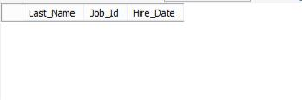

table for activity 1

- ACTIVITY 2:

SELECT Last_Name, Department_Id

FROM employees

WHERE Department_id BETWEEN 20 AND 50 ORDER BY Last_Name ASC;
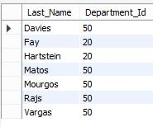

table for activity 2

- ACTIVITY 3:

SELECT Last_Name, Hire_Date

FROM employees

WHERE Hire_Date LIKE '%1994%';
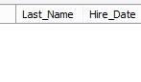

table for activity 3

- ACTIVITY 4:

Select Last_Name, Salary, Commission_pct

FROM employees

WHERE Commission_pct

NOT IN('NULL')

ORDER BY Salary, Commission_pct DESC;
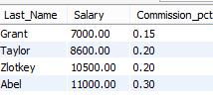

table for activity 4

- ACTIVITY 5:

Select Last_Name

FROM employees

WHERE Last_Name LIKE '%a%'

AND Last_Name LIKE '%e%';
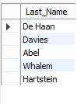

table for activity 5

