# CHAPTER 1: Project study

Introduction

In this chapter, we will first present the company in which we carried out our proposed subject of work. Second, we will interest to study existing solutions and their limits. Finally, we will explain the objectives of our proposed solution as well as all the necessary to carry it out such as the agile framework used and all the development tools.

## Company presentation

The Higher Institute of Technological Studies of Mahdia was established in September 2001 by decree No. 1456/2001 dated June 15, 2001.

The main objective of the Higher Institute of Technological Studies (ISET) is to provide a fundamental theoretical education that enables students to easily adapt to the job market by offering continuous training programs closely aligned with the needs of businesses.

The fundamental missions of the Higher Institute of Technological Studies (ISET) of Mahdia are:

* Training of higher-level technicians in fields tailored to the needs of the regional and national economy.
* Professional integration of graduates.
* Support for the establishment of businesses in innovative sectors.
* Provision of continuing education, consulting, and expertise services to local businesses.

## CONTEXT OF THE INTRENSHIP

In today's world, security is a major concern for individuals, businesses, and governments alike. Traditional security systems often have limitations in terms of coverage, flexibility, and real-time monitoring capabilities. There is a need for innovative solutions that can provide comprehensive security coverage while being adaptable to different environments and situations.

## Analysis of the existing

### 1. Existing solutions description

#### 1.1 Closed-Circuit Television (CCTV) Systems

CCTV systems are widely used for security observation in various settings such as public areas, commercial buildings, and residential properties. These systems consist of cameras strategically placed to monitor and record activities in real-time. They often include features such as motion detection, remote viewing, and archival storage

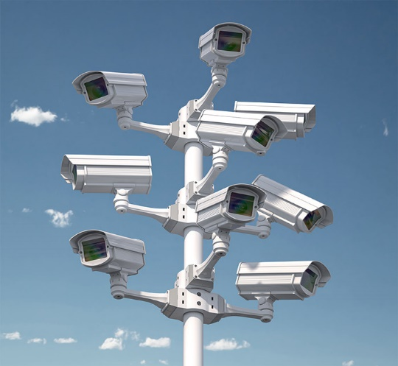

#### 1.2 Perimeter Intrusion Detection Systems (PIDS)

PIDS are designed to detect and alert security personnel to unauthorized access attempts along the perimeter of a secured area. These systems may utilize technologies such as infrared sensors, microwave detectors, or fiber optic cables to detect intrusions and trigger alarms

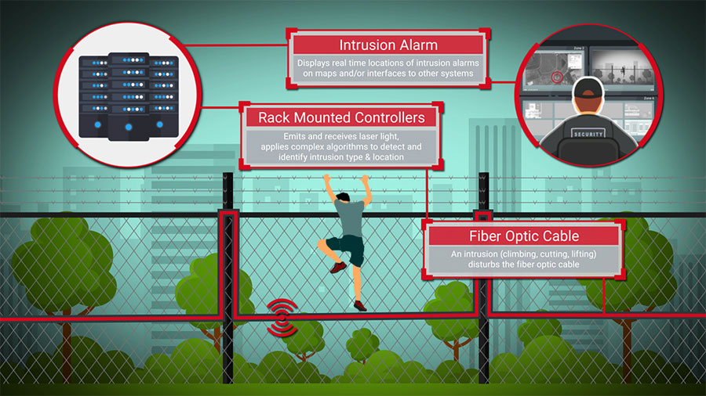

#### 1.3 Mobile Surveillance Units

Mobile surveillance units are equipped with cameras, sensors, and communication systems mounted on vehicles or trailers. These units can be deployed to temporary or remote locations for surveillance purposes, such as monitoring construction sites, events, or emergency situations

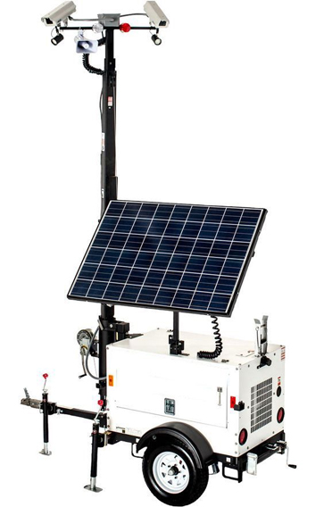

### 2. Critical of existing solutions

While existing security observation solutions offer valuable capabilities, they also face several critical challenges and limitations

#### 2.1 Privacy Concerns

Many surveillance technologies, such as CCTV systems, raise concerns about privacy infringement. The widespread deployment of surveillance systems can lead to increased surveillance of individuals' movements and activities in public spaces, raising questions about civil liberties and personal privacy

#### 2.2 Cybersecurity Vulnerabilities

Security observation systems that rely on network connectivity, such as CCTV cameras and smart city surveillance systems, are susceptible to cyber attacks. Hackers may exploit vulnerabilities in these systems to gain unauthorized access, disrupt operations, or compromise sensitive data

#### 2.3 False Alarms and False Positives

Intrusion detection systems and video analytics algorithms used in security observation can generate false alarms or false positives, leading to unnecessary alerts and wasted resources. Factors such as environmental conditions, wildlife activity, and system malfunctions can trigger erroneous alerts, reducing the effectiveness of the system

#### 2.4 Limited Coverage and Blind Spots

Traditional surveillance technologies, including fixed CCTV cameras and perimeter intrusion detection systems, may have limited coverage and blind spots that leave areas vulnerable to security breaches. Achieving comprehensive coverage of large or complex environments can be challenging and may require significant investment in infrastructure and equipment

#### 2.5 Reliance on Human Monitoring and Intervention

Many security observation systems require human operators to monitor feeds, analyze data, and respond to security incidents. This reliance on human intervention can lead to delays in detection and response, especially in high-volume environments or during periods of peak activity

### 3. Proposed solution

The solution is to develop a drone-based security surveillance system equipped with real-time streaming capabilities to enhance security monitoring and response effectiveness. This system aims to overcome the limitations of traditional security measures by :

* Utilizing a robust drone platform equipped with advanced sensors such as high-resolution cameras, and motion detectors. The drone should be capable of autonomous flight, navigation, and obstacle avoidance to ensure efficient coverage of the surveillance area
* Integrate a real-time streaming system that enables live video feed transmission from the drone to a centralized control center or mobile devices. This system should leverage reliable communication technologies
* Incorporate artificial intelligence algorithms for real-time analysis of the video feed. These algorithms can detect and classify potential security threats such as intruders, unauthorized vehicles, or suspicious activities. Additionally, AI can enable object tracking and anomaly detection to enhance situational awareness.
* Ensure compatibility and seamless integration with existing security systems such as access control, perimeter fencing, and alarm systems. This enables a holistic approach to security management, where drone-based surveillance complements and enhances the effectiveness of other security measures.

## Framework adopted

The growing complexity of computer systems has led designers to take an interest in development methods. The latter have always tried to provide continuous control over a project throughout its life process to end up with reliable and quality software and to guarantee that it remains faithful to the needs of the customer

### Choice of methodological framework

In our project, we have opted to leverage a combination of Scrum and DevOps methodologies as our method of work. By integrating Scrum's iterative development approach with DevOps' principles of collaboration, automation, and continuous delivery, we aim to achieve a streamlined and efficient software development process.

### Presentation of scrum

Ken Schwaber and Jeff Sutherland the creators of SCRUM define it in their guide as follows: « SCRUM is an iterative framework for responding to complex and changing problems, while productively and creatively delivering products of the greatest value possible ». SCRUM is a project management framework based on empiricism and Lean thinking. Which allows to deliver products of the greatest added value in an iterative and incremental approach. SCRUM is a Framework which helps teams to collaborate and encourages them to learn by experience, to self-organize while they try to solve a problem. This method places the customer's needs at the center of priorities and favors dialogue between all project stakeholders

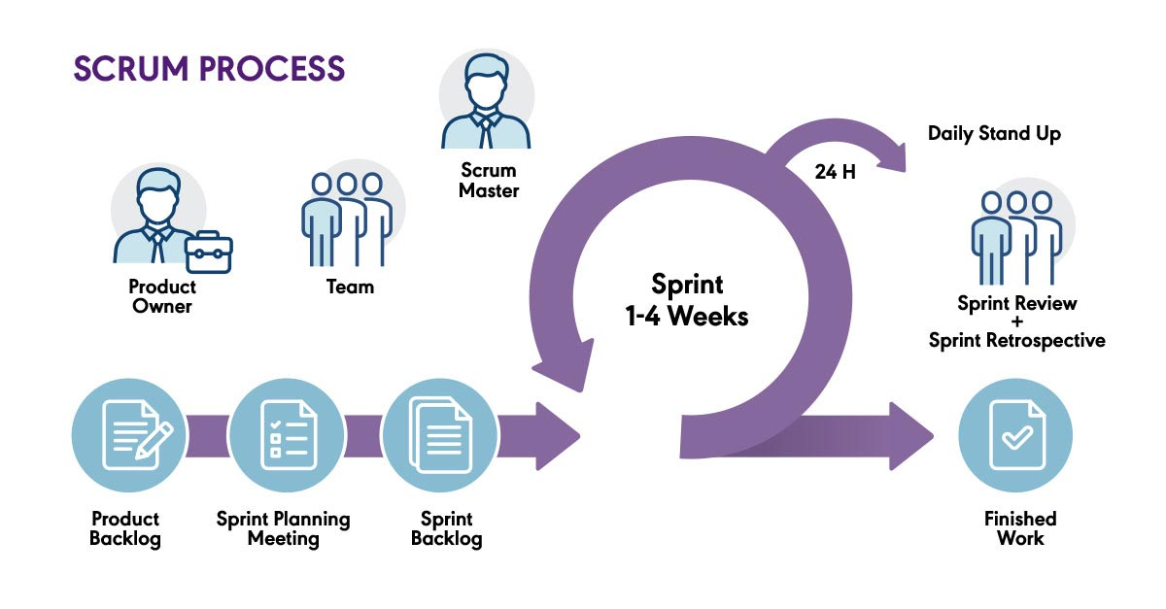

#### SCRUM sprint

SCRUM sprint is a time-boxed iteration within the SCRUM framework, which is an agile project management approach widely used in software development and other industries. It is a fundamental component of SCRUM that enables teams to deliver incremental value and adapt to changing requirements.

#### SCRUM Roles

In the SCRUM framework, there are three primary roles that contribute to the success of a project :

* Product Owner: the Product Owner represents the stakeholders, customers, and users of the product being developed. His primary responsibility is to ensure that the product delivers maximum value and meets the needs of the customers. The Product Owner collaborates with stakeholders to gather requirements, defines the product vision, and prioritizes items in the product backlog. He works closely with the Developers to clarify requirements, answer questions, and make decisions regarding the product.
* SCRUM Master: the SCRUM Master is a servant leader and facilitator for the SCRUM team. His primary role is to ensure that the SCRUM framework is understood and followed, and to remove any obstacles that hinder the team's progress. The SCRUM Master coaches the team on SCRUM practices, helps them to be self-organized and cross-functional, and facilitates SCRUM events such as sprint planning, daily stand up, sprint reviews, and retrospectives. He also foster a culture of continuous improvement and promote collaboration and communication within the team and with stakeholders.
* Developers: the developers are professionals who are responsible for delivering the product increment. They are typically cross-functional and self-organizing, with the necessary skills to complete the work. The Developers collaboratively work on the selected product backlog items during the sprint, breaking them down into tasks, estimating effort, and delivering potentially releasable increments. They are accountable for the quality of the work they deliver and continuously collaborate with the Product Owner and SCRUM Master to clarify requirements and seek feedback.

#### 2.3 SCRUM Artifacts

In the SCRUM framework, there are three main artifacts that serve as tangible representations of the work being done and the progress of the project. These artifacts are :

* Product Backlog: The Product Backlog is an ordered list of all the desired features, enhancements, bug fixes, and other items that could potentially be included in the product. It is managed and prioritized by the Product Owner in collaboration with stakeholders. The items in the Product Backlog are described as user stories or other appropriate formats, and they represent the requirements and functionality of the product. The Product Backlog is dynamic and evolves throughout the project as new insights are gained and priorities change.
* Sprint Backlog: the Sprint Backlog is a subset of the Product Backlog items that the Developers select and commit to completing during a specific sprint. It contains the user stories or tasks that the team will work on during the sprint. The Sprint Backlog is created during the sprint planning meeting, and it represents the work plan for the Developers. As the team progresses through the sprint, they may update and adjust the Sprint Backlog based on their understanding, capacity, and changing circumstances
* Increment: the Increment is the sum of all the completed and potentially releasable product backlog items at the end of a sprint. It is the tangible outcome of the Developers's work during the sprint. The Increment should meet the team's definition of "Done," which is a shared understanding of what it means for an item to be completed and in a shippable state. The Increment demonstrates visible progress and can be potentially released to stakeholders, providing value and functionality.

### Presentation of DEVOPS

DevOps is a transformative approach to software development and delivery that emphasizes collaboration, automation, and continuous improvement. By breaking down silos between development, operations, and quality assurance teams, DevOps fosters a culture of shared responsibility and rapid iteration. Through automation of manual tasks, such as code deployment and infrastructure provisioning, DevOps enables organizations to deliver software faster, more reliably, and with higher quality. Continuous integration and delivery practices ensure that code changes are tested and deployed frequently, reducing the time it takes to bring new features to market. Ultimately, DevOps empowers teams to respond quickly to customer feedback, adapt to changing requirements, and deliver value to stakeholders more efficiently

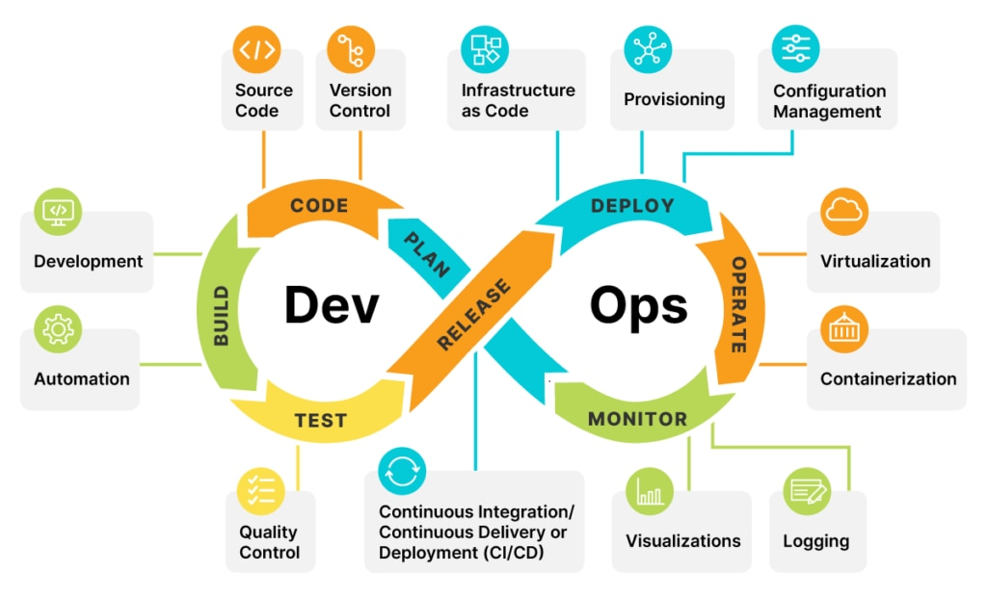

#### 3.1 Core Concepts of DevOps

* Collaboration: Breaking down silos between Dev and Ops teams, fostering communication and shared responsibility.
* Automation: Streamlining processes through automation of build, test, deployment, and monitoring tasks.
* CI/CD: Implementing continuous integration to merge code changes frequently and continuous delivery to deploy code to production rapidly and reliably.

#### 3.2 DevOps Tools and Technogies

* Overview of common DevOps tools and technologies:
  + Version control systems (e.g., Git)
  + Continuous integration servers (e.g., Jenkins)
  + Configuration management tools (e.g., Ansible, Puppet, Chef)
  + Containerization and orchestration platforms (e.g., Docker, Kubernetes)
  + Monitoring and logging solutions (e.g., Prometheus, ELK stack)

### Why SCRUM and DevOps together ?

This hybrid approach allows us to prioritize flexibility, responsiveness to change, and rapid delivery of high-quality software solutions, while also fostering a culture of collaboration and shared responsibility across development and operations teams.

By harnessing the strengths of both methodologies, we are confident in our ability to meet project goals and deliver value to our stakeholders.

## Working environment

During the different development phases of our project, we have used many tools that we describe in this section.

### Hardware specifications

Arduino raspberry pi4 model b:

Arduino is a microcontroller platform, meaning it's a small computer that can be programmed to perform specific tasks. It's great for projects where you need real-time control over hardware, such as robotics, sensor interfacing, and simple electronic projects. Arduino boards are relatively inexpensive, easy to use, and have a wide range of compatible sensors and shields

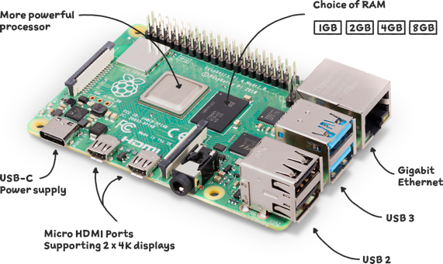

brushless dc moter:

Brushless DC motors (BLDC motors) are a type of electric motor that doesn't use brushes for commutation. Instead of brushes and a commutator, BLDC motors use electronic controllers to switch the currents in the windings of the motor to produce rotational movement.

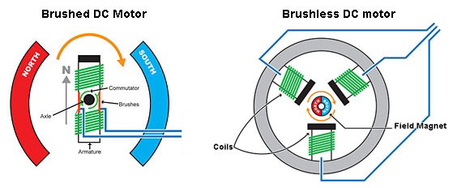

Shield motor l293d :

The L293D is a popular motor driver IC (integrated circuit) commonly used to control DC motors or stepper motors with a microcontroller like Arduino. It's often used in robotics projects and other applications where motor control is needed

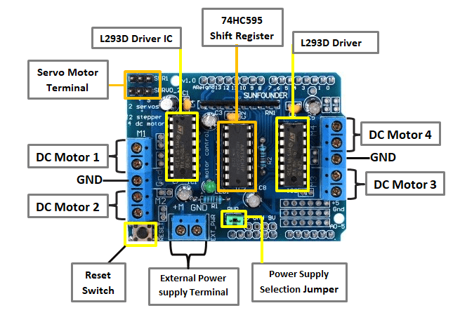

HC-05 Bluetooth module:

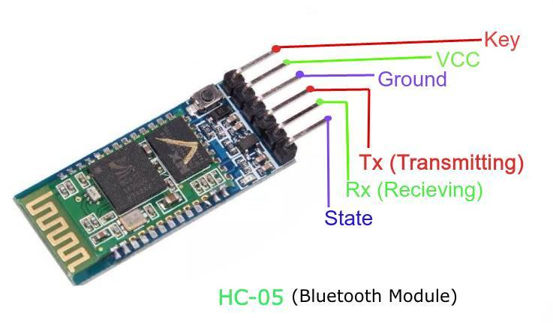The HC-05 Bluetooth module is a popular Bluetooth serial communication module used in electronics projects, particularly those involving wireless communication between microcontrollers or between a microcontroller and a smartphone or computer. It allows for wireless serial communication over Bluetooth.

Raspberry camera :

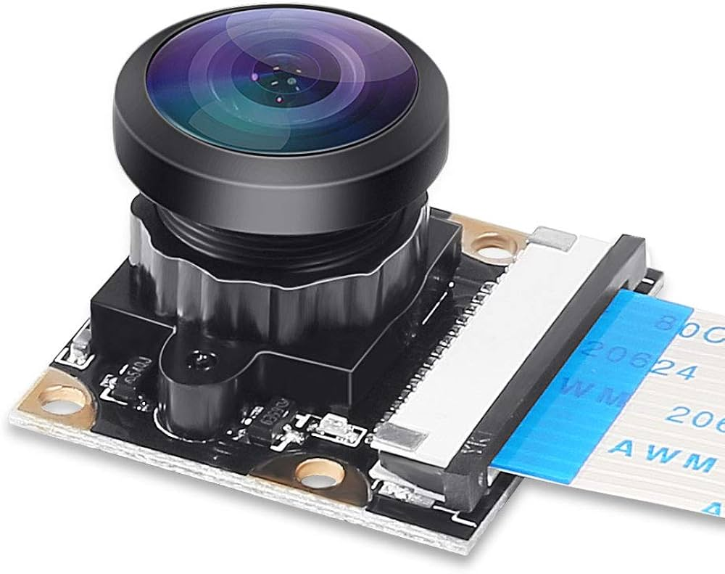The Raspberry Pi Camera Module is a small, low-cost camera board that can be connected to a Raspberry Pi single-board computer. It allows you to capture still images and video directly from your Raspberry Pi, making it ideal for a wide range of projects, including photography, video streaming, surveillance, and machine vision applications.

### Software environment

The software tools used are described below

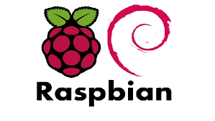

RASPBIAN:

Raspbian is an open-source Debian-based operating system specifically designed for the Raspberry Pi single-board computers. It was the official operating system for Raspberry Pi devices before it was rebranded as Raspberry Pi OS. Raspbian provided a user-friendly interface and a wide range of pre-installed software optimized for the Raspberry Pi's ARM architecture

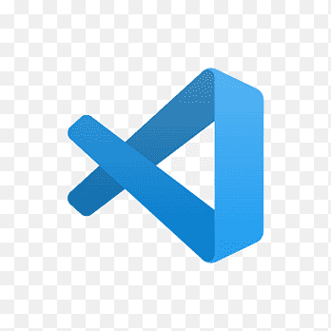

VS CODE:

Visual Studio Code (VS Code) is a free and open-source source code editor developed by Microsoft. It's known for its versatility, ease of use, and extensive customization options, making it a popular choice among developers for various programming tasks

FIREBASE :

Firebase is a comprehensive mobile and web application development platform developed by Google. It provides a wide range of tools and services to help developers build, improve, and grow their applications more efficiently



TENSORFLOW :

TensorFlow is an open-source machine learning framework developed by Google. It's widely used by researchers, engineers, and developers to build and deploy machine learning models for a variety of tasks, including image recognition, natural language processing, recommendation systems, and more. TensorFlow provides a flexible and scalable platform for building and training machine learning models, with support for both deep learning and traditional machine learning algorithms.

 DJANGO FRAMEWORK:

Django is a high-level Python web framework that encourages rapid development and clean, pragmatic design. It's open-source and follows the Model-View-Controller (MVC) architectural pattern, but with its own twist, often referred to as Model-View-Template (MVT). Django's primary goal is to make it easier to build complex, database-driven websites by providing a set of tools and conventions for common web development tasks

### Technologies and languages used

PYTHON : Python is a high-level, interpreted programming language known for its simplicity, readability, and versatility. It was created by Guido van Rossum and first released in 1991. Python emphasizes code readability and productivity, making it a popular choice for beginners and experienced developers alike.

C LANGUAGE : The C programming language, born in the early 1970s, is a cornerstone of modern computing. Its efficiency, flexibility, and low-level capabilities have influenced countless other languages and systems. With a philosophy of simplicity and control, C empowers developers to craft efficient and portable solutions. From system programming to embedded development, C remains an essential tool in the toolkit of programmers worldwide.

SCRIPT SHELL : Shell scripting involves writing scripts using a specialized language designed for interacting with the operating system shell, such as Bash. These scripts consist of sequences of commands and constructs that automate tasks, customize the shell environment, and streamline workflows. Shell scripting is a powerful tool for system administrators, developers, and power users, allowing them to efficiently manage and control Unix-like systems from the command line.

HTML : HTML, or Hypertext Markup Language, is the standard markup language used for creating web pages and web applications. It provides a set of markup tags that structure the content of a web page, including text, images, links, forms, and multimedia elements. HTML documents are interpreted by web browsers to render the visual representation of a web page for users.

CSS : or Cascading Style Sheets, is a style sheet language used to define the presentation and layout of HTML documents. CSS enables web developers to control the appearance of web pages, including elements such as text, images, backgrounds, and layout structures. By separating the content of a web page from its presentation, CSS allows for greater flexibility, consistency, and maintainability in web design.

JAVASCRIPT : javaScript is a versatile and powerful programming language primarily used for adding interactivity and dynamic behavior to web pages. Developed by Brendan Eich at Netscape in 1995, JavaScript has evolved into one of the most widely used languages for web development, enabling developers to create rich and interactive web applications.

# CONCLUSION

In this chapter, we have given an overview of the project by presenting Higher Institute of Technological Studies,the aims of our solution, as well as the justification for choosing the SCRUM Framework alongside with DevOps and all the tools and technologies to be used for developing this project. The next chapter will be devoted to modeling the specification of functional and non-functional needs, and the Product Backlog.

# CHAPTER 2: Needs Analysis and Planning

# INTRODUCTION

This chapter will be devoted to the presentation of the planning and architecture of our project. We will start by identifying the actors of our platform. Then, we will specify the functional and non-functional. Next, we will give an overview of the Product Backlog, the use cases diagram, and the architecture of our application. Finally, we present the planning of our SCRUM sprints.

## Analysis of needs

### Actors identification

An actor represents the abstraction of a role played by entities that interacts directly with the system under study. Our platform will have two actors :

|  |  |
| --- | --- |
| Actor | Description |
| Security agent | The security agent can interact with the system interface and deploy the drone in case of needs. he interacts with the real time feed and intervein to deactivate or reactivate the system if needed |
| Organism administration | have access to streaming recordings, system reports, they also have access to enabling or disabling some functionalities in case of need |

### Functional needs

Functional needs or business needs are the essential needs that the application must meet. To better understand we will detail the functional need as shown in the following table

|  |  |
| --- | --- |
| Role | Features |
| Security agent | * Sign up as a security agent * Login as security agent * Access camera’s real time streaming * Manipulate the drone and it’s movement * Enable and disables some of the functionalities as needed * Access stream recordings |

|  |  |
| --- | --- |
| Role | Features |
| Organizm administration | * Sign up as administrator * Login as an administrator * Access live streams recordings,real time streaming and have the abilities to manipulate them(e.g.,download ) * Controle all the sensors * Access the security system log reports (e.g.,detections ,deployments ..) * Have all control over the functioning of the drone and it’s deployment and give access to the security agent to manipulate it |

## Project management with SCRUM

### Team and roles

The different actors involved in the development of the different phases of our project and their associated roles are described in the below table

|  |  |  |
| --- | --- | --- |
| SCRUM Role | Full Name | Assignments |
| Product Owner | ISET MAHDIA | * Definition of business needs |
| SCRUM Master | Mrs. Hela Boughammoura | * Follow-up of the good practice of the SCRUM framework |
| Developers | Mr. Hamza Sassi  Mr. Dhia Melki | * Development of the steaming interface * Development of the drone system * Construction of the drone * Developing the communicating system between the security components * Integration of the system in the organism with the security system in use |

### Product backlog

The product backlog is a prioritized list of features, functionalities, and tasks that need to be

completed for a product. It serves as a dynamic tool for product management and is maintained

and updated regularly throughout the product development lifecycle. We present here our product backlog