Shipwrecked

# Summary

## Plot

Patrols become shipwrecked on a desert island and must complete a series of challenges to stay alive before they are rescued.

## Format

Patrols receive envelopes with their tasks in and race to complete them before the other patrols. As soon as a patrol completes a task they ask for the next envelope.

Patrols will each receive a set of items to start.

# Set up

You will need a space large enough for each patrol to make a home camp, and to set up the challenges below.

* Catching ducks
* Finding berries

# End Game

You can finish the game when the first patrol is rescued or let them all finish. Patrols that starve to death could be given a get out of collecting a lot of food especially if it happens early on.

If the game is taking too long remove some of the optional envelopes, (make sure you do this fairly across the patrols).

1 - Shipwrecked

**You have been shipwrecked on a deserted island. Fortunately, you had the presence of mind to grab a few useful things while you swam to shore. From time to time, you may hear other people on your island, but try to avoid them at all costs. They may be members of an unfriendly tribe and you don't want to accidentally start a war before you are rescued.**

**Unfortunately, you have found no source of fresh water on the island. In this heat you need to have a drink of water within 24hrs. Sea water is too salty and will make you more thirsty and ill. You will have to desalinate (take the salt out of) the sea water to survive.**

Create a desalinisation system:

1. 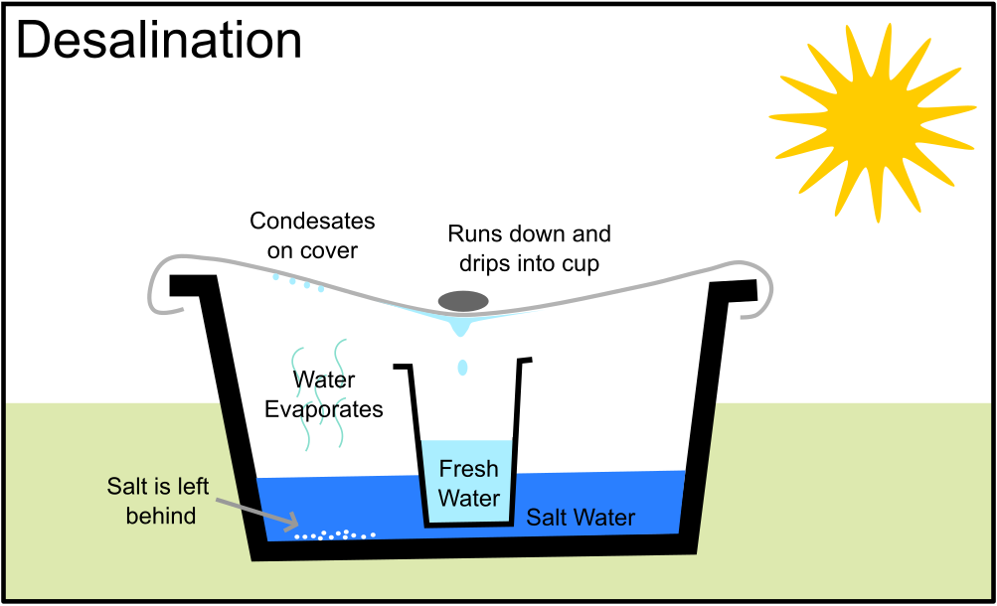Take a large bowl and fill with a few centimetres of salt water.
2. Place a cup in the centre, making sure that no salt water gets inside.
3. Cover the bowl with a waterproof sheet.
4. Place a small weight in the middle so that condensation runs down the sheet to the middle and drips into the cup.
5. Leave somewhere warm and dry where it will not be disturbed.

Once you have set up your desalination station send one member of you patrol for your next challenge.

2- Fire

**Now you are creating fresh water, but this still might contain bacteria and germs and is not safe to drink. You will need to create a fire and boil the water to make it safe. A fire will also keep wild animals away and provide a source of warmth through the cold nights.**

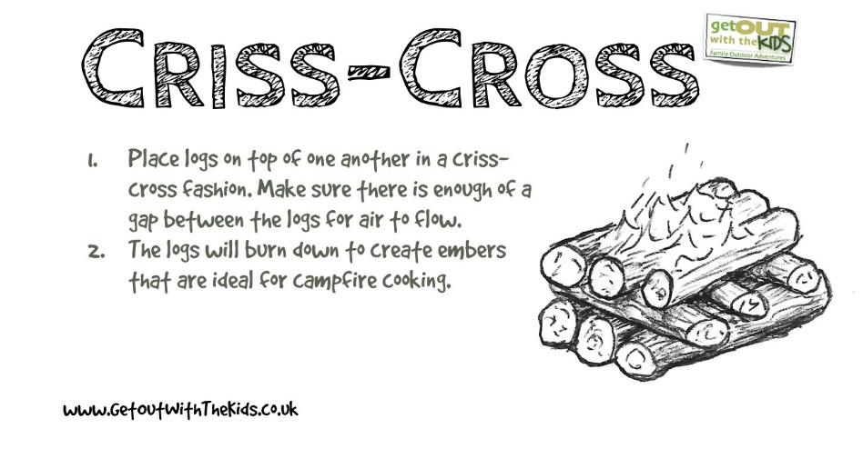Scavenge around the island for wood (make sure you don’t take any from the pile gathered by the hostile natives) and set them up like a criss-cross fire. You need the fire to be big enough to place a large saucepan on.

(Do not light the fire, this is a game!)

3- Food

**Now you have safe water to drink, but you don’t know how long you will be stranded on this island. Time to think about how you are going to survive long term.**

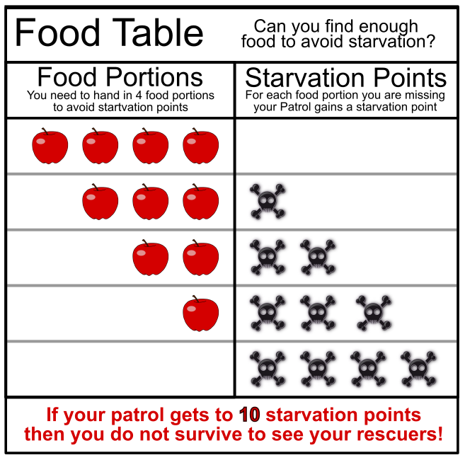

You will need to regularly collect food for the remainder of your time on the island. From now on whenever you complete a challenge you will also need to hand in 4 food tokens. If you cannot find enough food you can hand in fewer but be careful do this too many times and your patrol will starve!

There are two main food sources on the island.

Find 4 food portions to feed your party.

4 - Shelter

**It’s cold at night and you’re not sure what terrible predators you are sharing this island with. Build a shelter that your whole patrol can fit in to protect you from the cold and whatever lurks in the darkness!**

(Don’t forget you also need 4 food portions)

5- Signals

**You’re sure somebody will have noticed your missing by now and sent out a rescue party. Make two signals one to be seen from the sky and one from the sea. You to make them big and bright so they can be seen from far away.**

(Don’t forget you also need 4 food portions)

6- First Aid

**Whilst exploring the island the smallest member of your patrol has slipped and fallen, injuring their arm and banging their head. You need to support their arm in a sling and bandage the head up to stop the bleeding. They will need to rest in the shelter and won’t be able to help with food gathering this round.**

1. To make a sling, cut a piece of cloth, such as a pillowcase, about 40 inches square. Then cut or fold the square diagonally to make a triangle. Slip one end of the bandage under the arm and over the shoulder. Bring the other end of the bandage over the other shoulder, cradling the arm.

2. Tie the ends of the bandage behind the neck. Fasten the edge of the bandage, near the elbow, with a safety pin.



7- Storm

**Are those storm clouds gathering on the horizon? Quick gather your patrol together and huddle in your shelter. You will have to stay inside until the storm passes as the wind and rain make the island very dangerous.**

To pass the time make a paracord bracelet each. This will mean you always have some rope handy when you are moving around the island.

Unfortunately, you are not able to collect any food this round and will have to survive on whatever rations you have stored.

8- Sickness

**You have all been up half the night being sick. The island diet isn’t agreeing with you. You realise you need to make your diet more varied.**

While exploring the island you find some white roots, these have medicinal qualities and will hopefully settle your stomachs. However, they are poisonous before being cooked.

Break up the roots so each piece is smaller than the width of your little finger ready for cooking to gain 4 root portions.

You will need 8 food portions as you need to replace the calories you lost being ill in the night. These need to be varied to avoid becoming sick again. 4 Roots, 2 Berries and 2 Ducks.

9- Rockfall

**Overnight there was a lot of rain and you heard a low rumble followed by some large bangs. In the morning light you can see that your path to the ducks is now blocked by a large rockpile.**

Look around for a pile of plastic balls and 2 hoops. Move the “rockfall” of plastic balls from one hoop to the other. All the plastic balls must be inside the second hoop for you to have successfully moved the rockfall.

10- A ship!

**As dusk falls, you see a ship in the distance! Quick signal it a message in morse code!**

Unfortunately, you can only remember some letters in morse code:

Signal the message to a leader using only the above letters.

11- Rescue

**You see the ship alter course towards you, a few hours later you see them launch a boat to come and investigate.**

Your rescuers bring with them fresh food and water and you know it won’t be long before you are back home.