1 - Shipwrecked

**You have been shipwrecked on a deserted island. Fortunately, you had the presence of mind to grab a few useful things while you swam to shore. From time to time, you may hear other people on your island, but try to avoid them at all costs. They may be members of an unfriendly tribe and you don't want to accidentally start a war before you are rescued.**

**Unfortunately, you have found no source of fresh water on the island. In this heat you need to have a drink of water within 24hrs. Sea water is too salty and will make you more thirsty and ill. You will have to desalinate (take the salt out of) the sea water to survive.**

Create a desalinisation system:

1. 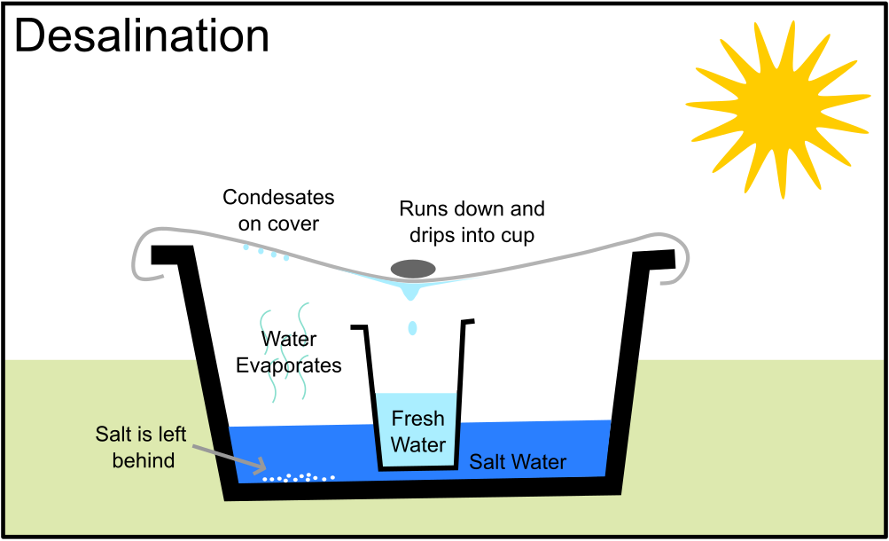Take a large bowl and fill with a few centimetres of salt water.
2. Place a cup in the centre, making sure that no salt water gets inside.
3. Cover the bowl with a waterproof sheet.
4. Place a small weight in the middle so that condensation runs down the sheet to the middle and drips into the cup.
5. Leave somewhere warm and dry where it will not be disturbed.

Once you have set up your desalination station send one member of you patrol for your next challenge.

2- Fire

**Now you are creating fresh water, but this still might contain bacteria and germs and is not safe to drink. You will need to create a fire and boil the water to make it safe. A fire will also keep wild animals away and provide a source of warmth through the cold nights.**

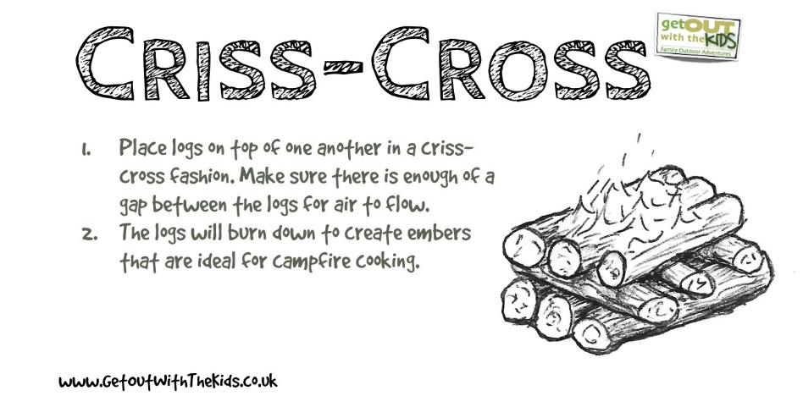Scavenge around the island for wood (make sure you don’t take any from the pile gathered by the hostile natives) and set them up like a criss-cross fire. You need the fire to be big enough to place a large saucepan on.

(Do not light the fire, this is a game!)

3- Food

**Now you have safe water to drink, but you don’t know how long you will be stranded on this island. Time to think about how you are going to survive long term.**

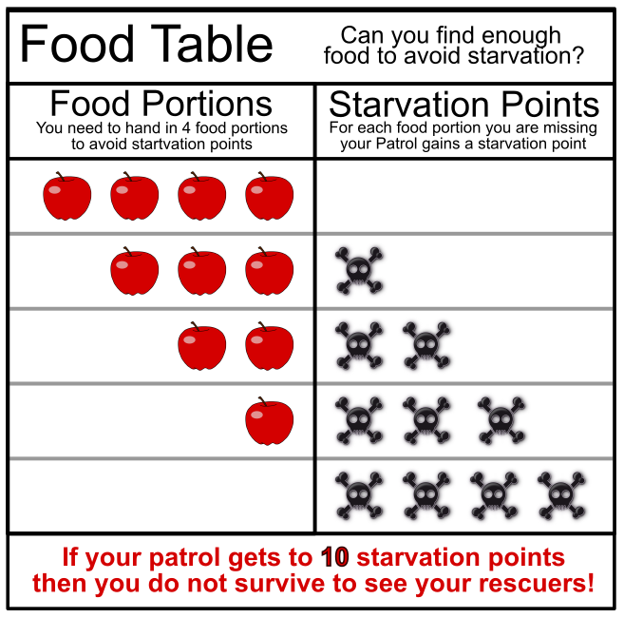

You will need to regularly collect food for the remainder of your time on the island. From now on whenever you complete a challenge you will also need to hand in 4 food tokens. If you cannot find enough food you can hand in fewer but be careful, do this too many times and your patrol will starve!

There are two main food sources on the island.

Find 4 food portions to feed your party.

4 - Shelter

**It’s cold at night and you’re not sure what terrible predators you are sharing this island with. Build a shelter that your whole patrol can fit in to protect you from the cold and whatever lurks in the darkness!**

(Don’t forget you also need 4 food portions)

5- Signals

**You’re sure somebody will have noticed your missing by now and sent out a rescue party. Make two signals one to be seen from the sky and one from the sea. You to make them big and bright so they can be seen from far away.**

(Don’t forget you also need 4 food portions)

6- First Aid

**Whilst exploring the island the smallest member of your patrol has slipped and fallen, injuring their arm and banging their head. You need to support their arm in a sling and bandage the head up to stop the bleeding. They will need to rest in the shelter and won’t be able to help with food gathering this round.**

1. To make a sling, cut a piece of cloth, such as a pillowcase, about 40 inches square. Then cut or fold the square diagonally to make a triangle. Slip one end of the bandage under the arm and over the shoulder. Bring the other end of the bandage over the other shoulder, cradling the arm.

2. Tie the ends of the bandage behind the neck. Fasten the edge of the bandage, near the elbow, with a safety pin.

7- Storm

**Are those storm clouds gathering on the horizon? Quick gather your patrol together and huddle in your shelter. You will have to stay inside until the storm passes as the wind and rain make the island very dangerous.**

To pass the time make a bracelet each. This will mean you always have some rope handy when you are moving around the island.

Unfortunately, you are not able to collect any food this round and will have to survive on whatever rations you have stored.

8- Sickness

**You have all been up half the night being sick. The island diet isn’t agreeing with you. You realise you need to make your diet more varied.**

While exploring the island you find some white roots, these have medicinal qualities and will hopefully settle your stomachs. However, they are poisonous before being cooked.

Break up the roots so each piece is smaller than the width of your little finger ready for cooking to gain 4 root portions.

You will need 8 food portions as you need to replace the calories you lost being ill in the night. These need to be varied to avoid becoming sick again. 4 Roots, 2 Berries and 2 Ducks.

9- Rockfall

**Overnight there was a lot of rain and you heard a low rumble followed by some large bangs. In the morning light you can see that your path to the ducks is now blocked by a large rockpile.**

Look around for a pile of plastic balls and 2 hoops. Move the “rockfall” of plastic balls from one hoop to the other. All the plastic balls must be inside the second hoop for you to have successfully moved the rockfall.

10- A ship!

**As dusk falls, you see a ship in the distance! Quick signal it a message in Morse code!**

Unfortunately, you can only remember some letters in Morse code:

   

    

Write your message below and signal the message to a leader.

11- Rescue

**You see the ship alter course towards you, a few hours later you see them launch a boat to come and investigate.**

**Tidy up everything you have made and take it with you when you are rescued. Leave no trace that you were once here, don’t leave anything to litter this beautiful island.**

Your rescuers bring with them fresh food and water and you know it won’t be long before you are back home.

**Congratulations on being rescued!**

Ducks

You have spotted some ducks flying overhead that seemed to land somewhere on the island. You track them until you come to a large swamp between you and they are swimming on a pond. You must make your way across the swamp to the little island that looks safe to stand on and try and catch the ducks from there. You might need to make something to help you!

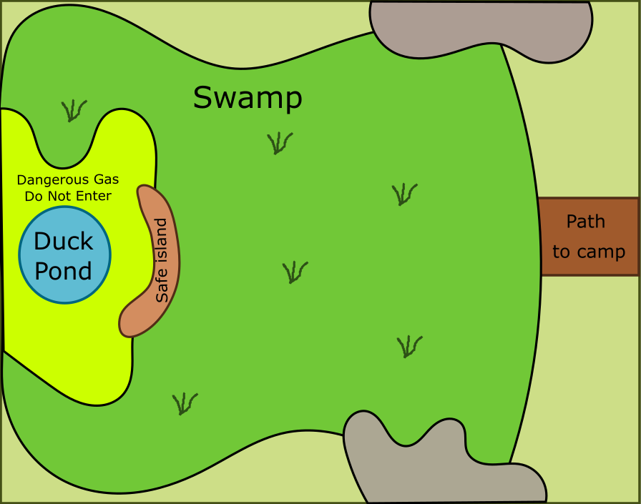This raft (plastic bag) will keep you safe from the swamp and any alligators hiding in its depth. Your whole patrol must make their way across the swamp to the island. From there the toxic gas prevents you from getting any closer. You can only catch 1 duck per trip, depending on how fat and juicy the duck is it could be worth up to 6 food portions!

Bring the duck safely back across the swamp and swap it for duck food tokens. If at any point any member of your patrol steps of the raft (plastic bag) into the swamp. You must begin that leg of your trip again. (If you are on your way out return to the start, if you are coming back in return to the little island)

Berries

You have seen some berries growing on bushes around the island but know they aren’t all safe to eat.

After some discussion you can remember the following facts.

1. There are 3 types of berries that live in this climate, Dinberries, Bisberries and Josberries
2. Josberries are not purple.
3. No plant has the same colour berries as leaves
4. One of you got some nasty scratches while picking orange fruit last year.
5. Dinberries are poisonous
6. Bisberries have spiky leaves.

You may only collect berries with borders of your patrols colour. Leave the others where they are for the other patrols. If you hand in a poisonous berry as food your patrol will gain 2 starvation points.

