

SIMULATION-BASED REINFORCEMENT LEARNING FOR SOCIAL DISTANCING

by

F. Ege Hoşgüngör

213150

A Dissertation

Submitted to the Department of Engineering & Informatics

University of Sussex

In Partial Fulfilment of the Requirements

For the Degree of Master of Science

June 2020

CONTENTS

1 INTRODUCTION 5

2 RELATED WORK 7

2.1 AGENT-BASED MODELLING 7

2.2 EPIDEMIC SIMULATIONS 8

2.3 REINFORCEMENT LEARNING 8

2.4 EPIDEMIC SIMULATION WITH RL 9

2.5 MULTI-AGENT REINFORCEMENT LEARNING 9

2.6 COOPERATIVE MULTI-AGENT 10

2.6.1 Team Learning 10

2.6.2 Concurrent Learning 10

2.6.3 Communication in Cooperative MAS 11

2.7 LEARNING ALGORITHMS 11

2.8 REWARD SIGNALS 12

2.9 RL SIMULATION FRAMEWORKS 12

3 METHODOLOGY 13

3.1 EPIDEMIC SIMULATION 13

3.2 RESEARCH DESIGN 14

3.3 POLICY OPTIMIZATION 14

3.3.1 Notation 15

3.3.2 Proximal Policy Optimization (PPO) 15

3.3.3 Optimization Parameters 15

3.4 CURRICULUM LEARNING 15

3.5 OPTIMIZATION SETUP 15

4 EVALUATION 15

4.1 ENVIRONMENT ADAPTATION 15

5 DISCUSSION AND CONCLUSION 16

6 REFERENCES 17

7 Appendix 19

ACKNOWLEDGEMENT / DEDICATORY

The report may be freely copied and distributed provided the source is acknowledged.

Throughout the writing of this dissertation, I have received a great deal of support and assistance. I would first like to thank my supervisor, Prof. T. Nowotny, whose expertise was invaluable in the formulating of the research topic and methodology in particular. In addition, I would like to thank my parents for their wise counsel and hospitality during these rough times. Specially thanks to my close-friend Utku Demir for helping me out with Cloud Computing when my laptop broke down. Finally, there are my other friends, who were of great support in deliberating over our problems and findings, as well as providing happy distraction to rest my mind outside of my research.

ABSTRACT

Through agent-based modelling, and standard reinforcement learning algorithms at scale, we found AI agents can give insights about ongoing epidemics by simulating the disease. An epidemic simulation has been created with a physics engine and analyzed its results with SIR graphs. We found clear evidence of the relation between social distancing and getting infected rates. We further provide evidence that multi agent cooperation may scale better with increasing environment complexity and lead to a behavior that closer to far more human behavior. Ya da maskenin takılma yüzdesi ne kadar etkiliyor bunu yazıcaz. <https://www.scribbr.co.uk/thesis-dissertation/abstract/>

KEYWORDS

Epidemic simulation, reinforcement learning, cooperative multi-agent environment, agent-based-modelling, social distancing, covid-19

# INTRODUCTION

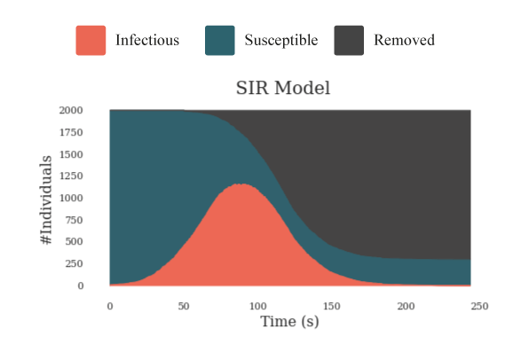Ever since the outbreak of Severe Acute Respiratory Syndrome as known as Covid-19 came out, life has changed drastically. Many researchers dedicated themselves to fight against the spread of this fatal virus and minimize the loss. Artificial Intelligence researchers are focusing their expertise knowledge to develop mathematical models for analyzing this epidemic disease.[1] An epidemic disease requires quick decisions to be made about interventions that could reduce or contain the disease spread. Decision-makers need to be agile about their strategy since they race with the time. Every second that is wasted doubles the damage to humanity. In contrast, in order to decide confidently which strategy will work, decision makers need to analyze many scenarios and variables since if they give a wrong decision, that can also cause harm. This is an optimization problem which researchers cope by creating their own data and utilizing Reinforcement Learning to develop optimal strategies.[2]

Figure 1: An SIR curve as one of our epidemic simulation’s output. Vertical axis represents the number of individuals. Horizontal axis represents the time pass in the simulation. The red area shows the number of infected people. Green area shows susceptible and dark gray area shows recovered/removed individuals. The disease starts to spread from the first second of the simulation and peaks around 75 second in simulation time.

Reinforcement Learning is an area of Machine Learning where an agent learns the best behavior by interacting with the environment. Creating these complex environments and artificial intelligent agents that solve complex human relevant tasks has been life-long challenge for RL researchers.[3] Environment which is a crucial component of RL, describes the task that the agent attempts to solve. Agent and environments cannot be considered separately, and it is only a design choice for the researcher to determine where the environment starts and the agent ends. Most of the time environment is defined as anything that agent cannot have a direct control on it. In this article we introduce an environment which can simulate the epidemic spread with physics engine of Unity. With the help of Reinforcement Learning, agents are trained to learn social distancing by their own.

Social distancing is one of the most effective precaution that individuals can apply to their daily life. It is a successful strategy to prevent the infectious disease from spreading. It has many forms but at its core, the aim is to keep people apart enough from each other by putting physical distance and/or confining them to their homes. In this article, we took the idea of social distancing and simplified it to physical interaction. In other words, we assume social distancing is just having a physical distance between individuals. An infection mechanism starts when individuals are closer to each other than the threshold value. Being closer means individual has higher chance to get infected. In following chapter, this mechanism will be explained in detail.

To analyze possible outcomes, we used SIR graphs which is a widely common mathematical model that provides insights about the infectious disease outbreak. The model divides individuals to three categories. Susceptible, Infectious and Recovered. Recovered ones can be also called as Removed since they don’t have any affect to simulation. We also used the same number of categories in our simulation. Although it has been proven that the individual has short-term immunity after recovering from the covid-19, the character of the virus is still ambiguous. To avoid ambiguity, we assume when individuals recovered from the disease, they will immune to it forever and after recovery, they don’t have any effect to the curve.

For our deep reinforcement learning task, we used Proximal Policy Optimization Algorithm (PPO). This algorithm is designed by OpenAI. [3] and it is used in numerous different tasks from robotics to Atari games. On a collection of benchmark tasks, PPO outperformed other online policy gradient methods and had a better balance between sample complexity and simplicity. OpenAI defines their algorithm with three features. Easy code, sample efficiency and ease of tune.

We introduce a new cooperative multi-agent physics-based reinforcement learning environment for control of epidemic spread. Through only a health status-based sparse reward function, agents learn many human-relevant skills to protect themselves from epidemic outbreak including social distancing and self-isolation when they get sick. For example, agents learned how to maintain a balance between collecting reward boxes and not risking getting infected. We find that for several tests, curriculum learning can visibly change the results of the training. Setting the task step by step harder helped agents to learn better and to converge the loss function closer to the global minimum. In addition to that we showed pretrained agents learned the task faster than agents which is trained from scratch. Moreover, we observe signs of collaboration and simple communication between agents even though they don’t get direct reward from their actions. For instance, in one of the sessions, infected agents learned to gather up in a location where they avoid infecting others without knowing each other’s health status. This behavior demonstrates that they found a way to tell that they are infected or not to other agents.

The main contributions of this work are: 1) clear evidence that social distancing is mathematically a correct way to flatten the SIR curve. 2) A demonstration of how agent-based strategies and advances in computing can be leveraged to determine the optimal policy in an epidemic outbreak for a particular environment without expert human guidance.[4] 3) Evidence that self-isolation buralara bir şeyler gelmeli ve acil gelmeli

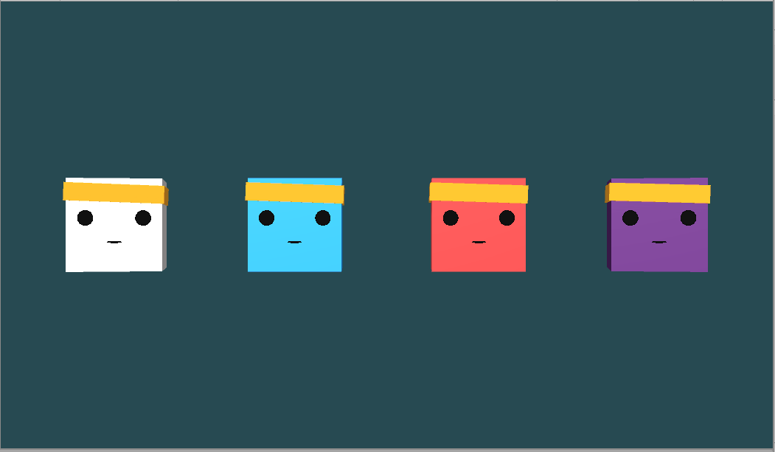

*Figure 2: Different states of the agents. Through the simulation, agent’s status of health changes. To represent the change, we used 4 different colors. a) White Bots indicates that the agent is not controlled by a brain. It only has simple hard-coded actions such as directly going targeted locations or bouncing from the walls. This represent individuals in a community who are not acting logically. b) Blue Bots are agents with a brain which controls them. c)Red Bots indicates* *whether with brain or not the bot is infected. d)Purple indicates that agent is not infectious anymore. In SIR models’ purple agents call as Recovered-Removed. Please see* [[*https://github.com/Hsgngr/Pandemic_Simulation*](https://github.com/Hsgngr/Pandemic_Simulation)](https://openai.com/blog/emergent-tool-use) *for example videos.*

# RELATED WORK

In this section, we review some background on agent-based modelling, computational analysis of epidemic outbreaks, related work in the cooperative multi-agent reinforcement learning domain, Proximal Policy Optimization and reward signals.

* 1. AGENT-BASED MODELLING

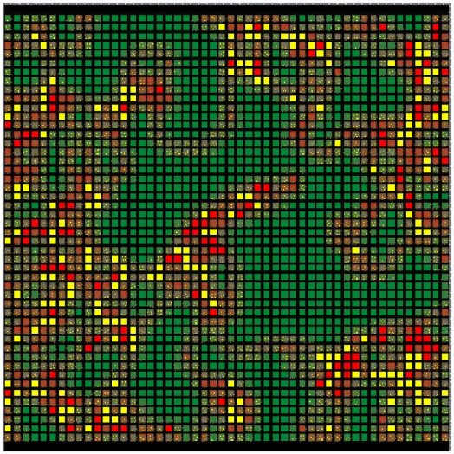The history of agent-based modelling (ABM) can be traced back to the Simula programming language, which is developed in the mid-1960s and widely used as the first framework for automating step-by-step agent simulations.[5] ABM use simple rules which can result in different sort of complex behavior. These models consist of interacting rule-based agents to create real-world-like complexity. Back in the days, the rules were strictly defined by researchers as hard-coded and therefore it was hard to generalize and get interesting results. [6] Over time, an extensive literature has developed on creating simulations and a series of studies has indicated that there are two major approach in developing them.[7] At the one end is what we call the “ brute force” method which is basically includes designing every piece of the simulation. This method works much faster and it doesn’t need any AI training since every action is pre-decided. However, finding an optimal behavior of how the simulation works requires redoing large chunks of the model or even starting over, depending on the significance of the change. In addition to that, in some cases the wanted behavior is impossible to code. For example, in a real-world autonomous driving task, researchers create their own synthetic data with a single virtual camera which gets RGB images from the environment.[8]. They used augmented data in training since coding images by hand was simply impractical.

*Figure 3:Two-dimensional agent-based epidemic simulation visualization. Each square represents an individually programmable agent. Color-coding allows easy visual tracking of agents with different health status. (Microbial Threats to Health: Emergence, Detection, and Response 2003)*

The other end of this spectrum is an extremely flexible simulation in a way that researchers define rules as minimal as possible. This creates a suitable environment for AI.[7] In this kind of simulations, at first agents don’t have any assumptions about their environment. By trial and error, they develop an internal model which represents how they understand the system by observing the surrounding and collecting data. Letting the agent to create its own strategy rather than coding one, creates an opportunity to generate more comprehensive and complex behavior. Additionally, agent-based simulations generally have many parameters which requires to be tuned. By using brute force, it would take much longer to explore every possible scenario that can happen. On the other hand, utilizing sub-sampling and creating scenarios most likely to occur, AI can deliver dramatic speed increases for large-scale ABM simulations.

* 1. EPIDEMIC SIMULATIONS

Mathematics and statistics have been crucial for analyzing infectious disease and control them since 1766 when Bernoulli published his evaluation about life expectancies and death rates.[9] Early work is formulated deterministic differential equations models for the transmission called SIR by Kermack and McKendrick[10]. Epidemiology is a science which interested investigating all the factors that determine the presence or absence of diseases and disorders. Earlier, the biggest obstacle in front of the epidemiology was not being an experimental science. Since the experiments were not practical nor ethical study populations were having limitations even though the discipline concerns itself with large populations of ill humans. Embracement of new powerful computational technologies to analyze, model, and simulate the dynamics of infectious disease has accelerated research in the field of epidemiology in 90’s.[11] Such simulations served as dry lab where new interventions could be designed, evaluated, and optimized on outbreaks, with many advantages for real-world epidemic prevention and control efforts.[6] The development of this new science lead a new interdisciplinary, collaborative area which consist of epidemiologists and other computationally oriented academic disciplines. In his paper, Hofmeyr gets inspiration from biological immune system to design a better computer security in the form of a network intrusion detection system called “ARTIS”. [12] He asserts immune system is a highly complex system and precisely tuned to detect and eliminate any infection disease. To create such a system, he uses a computer simulation in order to imitate immune system and apply for computer security. More recent work of modelling and simulating an epidemic spread classified in two categories: host and spread.[13] While host models investigate the effect of disease on individuals, spread models focuses on predicting how disease spread among group of people. In this paper we created a spread class simulation where we investigate how an infectious disease passes from one to another instead of how it effects the host individual which will be discussed in following chapter.

* 1. REINFORCEMENT LEARNING

Sutton explains reinforcement learning (RL) with following example: An Infant explores itself and its environment without any explicit teacher, but it does have a direct sensorimotor connection to its surroundings. By practicing same actions, it produces a wealth of information about cause and effect, about the consequences of actions, and about what to do in order to achieve goals. [8] Humans learn by interacting with their environment and try to make inference from their experiences. Whether this is learning how to ride a bike or hold a conversation, the process works the same. We have an awareness about our environment via our observations and we constantly try optimizing ourselves by predicting our action’s consequences. That’s how any human learn from interaction and it is a foundational idea underlying nearly all theories of learning and intelligence.[14] The problems which is solved by interacting them, can be defined as Reinforcement Learning tasks. These tasks are essentially closed-loop problems in a way that taken actions shape future inputs. At each step, agent comes to a state with a reward of . With its current policy, agent gives a decision and takes an action which gets the agent one step further in a state called . Agent doesn’t get any external support about what to do to solve the problem, but instead it learns from its own actions and consequences which may result with getting a reward. By taking the difference between actual and expected rewards it tries to optimize its policy and takes another action. Thus, the process consists of trial-and-error search.

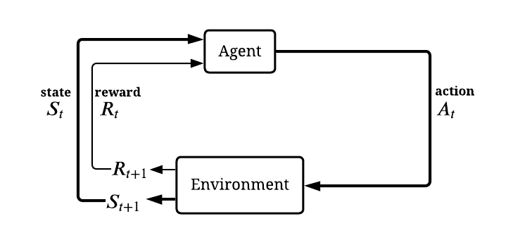*Figure 4: Simplified diagram of RL closed-loop process representation (inspired from Sutton, Introduction to Reinforcement Learning)*

* 1. EPIDEMIC SIMULATION WITH RL

Although Reinforcement Learning have been widely studied in the literature there has not been many studies about epidemic spread control with RL. In epidemic outbreaks, particularly this method of machine learning is beneficial since researchers are not limited with real data. In addition, a brute force approach to this problem is computationally intractable and inefficient, since calculating every states -even not at all useful ones- require large amount of computation power[15] In lieu of identifying optimal policies , other computational AI-related methods have been used. For instance, Big data is used for estimating the severity of seasonal influenza.[16]. Shrimp disease occurrence prediction has been made with neural networks and logistic regression[17] In parallel, a network-based contact-tracing model has been developed to learn about outbreak propagation in STD’s.[18] Even genetics algorithms is used for finding optimal vaccination strategies in influenza.[19] In [2], Yanez has created a baseline for how to design a reinforcement learning environment to represent the problem of epidemics and finding optimal interventions. In her study, agents represent the decision-makers such as governments, health institutions and the task is finding the optimal intervention strategy in 3 categories: preventive inverventions, treatment of disease and reduce-transmission interventions. The state includes infection rates, reproducibility etc. besides whether they are susceptible, infected or recovered. The action set includes mask-wearing, social distancing, contact tracing, closing schools, lockdown etc. The reward is given related to the death or infection spread rates depending on selection. We abstracted the idea of having epidemic simulation to physical form and changed the representation of the agents to people. Instead of intervention strategies which governments can take, we have investigated precautions which can be applied by individuals. The action set was also inspired from Yanez,[2] but rather than abstractly representing mask-wearing or social distancing, our task was physically show that agents can create these actions by their own. A recent study in 2018, [20] approach the problem of selecting optimal strategies for influenza as k-bandit problem, which is a common problem in reinforcement learning.[14][21]

* 1. MULTI-AGENT REINFORCEMENT LEARNING

In the context of Multi-agent, there have been many researches in the literature. Many reinforcement learning tasks involve the participation of more than one single agent which fall into the area of multi-agent reinforcement learning (MARL),.[22]. Recent years have witnessed astonishing advances in MARL such as OpenAI’s Hide and Seek game and Dota 2 AI OpenAI Five[3][23] These developments became possible due to the development of deep neural networks (DNNs). In multi-agent RL tasks, agents operate in a common environment each of which aims to optimize its own cumulative reward by interacting with the environment and other agents.[24] Due to the interaction between agents, the tasks complexity and according to that needed computation power can be increased exponentially. On the other hand, under the favor of the complexity it provides, multi-agents systems reserve a place in many areas from social science to finance.[25][26] Multi-agent algorithms can be divided into 3 categories; cooperative, competitive, and the combination of this two depending on the task which agents solve. In the cooperative settings, agents collaborate with each other while try to optimize the common long-term cumulative return. On the contrary, in competitive multiagent tasks, the cumulative reward of agents sums up to zero. The combination of these two also called as “Ecosystem” which is multiple interacting agents with independent reward signals. This kind of environments can be thought of as an environment with full of animals where some of them will collaborate and some of them will compete. Apart from interaction between agents in MARL, the basic framework of multi-agents differs from single agent settings in terms of stationarity. Agents improve their policies concurrently which creates self autocurricula [3] and the environment faced by agents become non-stationary in MARL.[27] Eliminating the stationary environment settings is also a choice of design. Although RL methods optimized themselves in stationary environments better than non-stationary ones they are restrictive and usually overfit the task. As researchers our goal was to get as close as possible to a real-world scenarios since almost every one of the real-life applications are non-stationary.[27] Furthermore in [28], authors discuss that MARL systems suffer from the curse of dimensionality also known as combinatorial nature of MARL. One way to overcome this difficulty in multiagent scenarios is the use of search parallelization which is possible with neural networks. In upcoming paragraphs, we will discuss the advantage of using deep neural networks with approximation algorithms such as Proximal Policy Algorithm (PPO) in deep reinforcement learning (DRL).

* 1. COOPERATIVE MULTI-AGENT

Cooperation between agents fits the definition of surviving in an epidemic outbreak therefore we focused on developing a cooperative environment. Agents creates strategies even though they don’t share the same observations. The collaboration comes from having the common goal. Cooperative also called utilitarian agents can be seen as competitive too if they accidentally learn an aggressive policy work and stuck with it. Therefore, researcher needs to design carefully the dynamics of the environment. There are two types of learning strategy in cooperative multi agent RL. *Team learning* and *concurrent learning*. Team learning is a common and easy way to design agents where they learn same set of behavior.[29] The advantage of team learning approach is that it can use single agent machine-learning techniques which sidesteps the complexity of co-adaptation of several learners as it is the case in concurrent learning.

### Team Learning

Team learning may be divided into two categories. *Homogeneous* and *heterogeneous* team learning.[29] In homogeneous team learning all agents have the same goals and actions. The only differences among them are their sensory observations and their current states which differentiate their decisions. They learn single agent behavior which is known by every agent in the environment. On the other hand, heterogenous team agents can develop more complex behaviors with different roles in team. Heterogeneous teams have larger actions space but generally converge to a better solution through agent specialization.[29] Choosing among these approaches depends on the reinforcement task and some problems do not require agent specialization. In our task we believed individuals do not need specialization and therefore we implemented a homogeneous team learning multi agents to represent the individuals in equal conditions. As an advantage of utilizing same brain, the search space is remarkably reduced during the training. Surprisingly in our case, as author mentions in [29], homogeneous agents learned to act heterogeneously due to the development of sub-behavior that differs based on agent’s health status. This behavior is discussed in results chapter.

### Concurrent Learning

A common alternative learning strategy to team learning in cooperative MAS is concurrent learning. The fundamental difference is that each agent has its own brain and they attempt to improve different parts of the team easier since the tasks can be learned independently in a degree. However, the problem with concurrent learning is learners co-adapting. In team learning where agents can use standard single-agent RL algorithms, they explore the environment while improving their policy. On the contrary, in concurrent learning agents can make obsolete assumptions about others’ behaviors while others modify their current behavior.[30] One way to tackle this problem is assuming that other agents are also the part of the dynamic environment although agents are more than dynamic units, they also improve their own behavior during training which makes convergence harder.

### Communication in Cooperative MAS

Communication between agents in MARL is a subject of different opinions. In [31], Stone and Veloso argue that communicating agents are not really multi-agents. Instead having unrestricted communication between agents decrease the task to a single agent RL problem. Real-world applications mostly have restrictions in terms of latency and throughput in the communication. Therefore, we believe that a correct multi-agent problem should need some restrictions. In addition, as knowing other agents’ states via communicating can exceptionally increase the search space which can sabotage more than it helps to find the optimal policy. Edmund recommends in his paper hardcoded communication system in order to simplify the learning process. [32] Direct and indirect are two type of communication style in MARL. Direct communication can be defined which agents inform each other by sharing their own sensor information. Indirect communication methods involve not explicit sharing but modification of surroundings. For instance, leaving footsteps in snow or white smoke behind while flying with an airplane, standing in a special location where it means something to other agents. Most of the indirect communication literature comes from social insects’ behaviors. We observed a simplistic indirect communication in our simulation which is described in detail in further chapters.

* 1. LEARNING ALGORITHMS

In this paper, two algorithms from different families are compared. Soft Actor-Critic and Proximal Policy Optimization.

Off policy algorithms aim to reuse past experience therefore they don’t require new samples for each gradient step. This quickly becomes crucial as the number of gradient steps increase, the process becomes extravagantly expensive for on-policy algorithms. Furthermore, samples per step needed to learn an effective policy increases with task complexity. A commonly used algorithm, deep deterministic policy gradient (DDPG) can be given as an example of off policy.[33] Even though it provides sample-efficiency it lacks being robust against hyperparameter tuning and brittleness. Soft actor-critic is an algorithm which provides both sample efficient learning and stability. Therefore, it is the only competitor against the popular PPO algorithm. SAC gains this advantage by exploiting Bellman’s equations for optimality, which a Q-function can be trained to satisfy using any observations. [34][35] However, satisfying the Bellman's equation is not guarantees great policy performance always. Empirically one can get great performance—and when it happens, the sample efficiency is wonderful. These algorithms will eventually explore every reachable state and action infinitely often but can take exponentially long to learn the optimal policy and most of the times, there is not enough training time to find the optimal policy.

On the other hand, PPO is an on-policy algorithm that it doesn't use old data, which makes it weaker on sample efficiency. But in return, it can optimize the objective that we care about -policy performance-and it works out mathematically that you need on-policy data to calculate the updates.[36] So, this family of algorithms trades off sample efficiency in favor of stability. These algorithms are better on not-yet understood states and actions since they always try to optimize what they have currently. Consequently, as the agent learns more about the environment, the agent’s performance should approach optimality. We compared the results of SAC and PPO and we decided to use PPO which is described in detailed in further chapters.

* 1. REWARD SIGNALS

In RL tasks, the aim is to maximize the expected cumulative reward. The reward signal is a channel for communicating between agent and the designer of the task. At each time step, agent gets a reward signal and try to find an optimal policy π*. Therefore, researcher needs to define the reward function carefully. A common mistake is to design based on how the agent will solve the task. Instead a correct design should be based on “What will agent achieve”. [14] The suggested reward function for designing an epidemic outbreak is giving a penalty for getting infected and at the end of the episode giving a reward if agent is not infected.[2] By this strategy agent has to discover a long sequence of “correct” actions in order to find an optimal policy π*.[33] These kind of rewards are called as sparse since agent doesn’t get feedback very often. Moreover, these rewards are extrinsic since they are hand-designed by researchers and given externally into RL algorithms which can cause sub-optimal policy convergence.

One common way is to endow the agent with a sense of curiosity and to reward it based on how surprised it is by the world around it.[34] The idea comes from baby individuals who doesn’t have any task except their intrinsic motivation to explore around. This sense of curiosity provides needed entertainment for the baby. When agent gets an unexpected reward, it surprises and try to develop new strategies to explore unknown states and gets more surprised. Hopefully, along the way agent will learn better policy with better extrinsic rewards.

* 1. RL SIMULATION FRAMEWORKS

Even though MARL is a recent area, there are plenty of simulators with different characteristics for RL agent training. Furthermore, these simulators are generally open-sourced and have built-in RL algorithms for ease of researchers. However, a small percentage of them have support for designing new environments. We described simulators which fits our design research below.

- A platform for designing artificial intelligence experiments in Minecraft called Malmo. [37] As RL community expands, researchers looking for simulators to train their own agents and design their own tasks. Minecraft is an ideal base for such platform since it provides a sandbox with many varieties. Malmo provides an abstraction layer on top of the game and supports multiagent scenarios.

-Arcade Learning Environment (ALE) is an open source platform which is built on top of the Atari 2600 Emulator.[38] The platform presents hundreds of Atari games and many research challenges including imitation-learning, transfer learning and intrinsic motivation. Rather than creating new environments ALE is more suitable for testing domain independent agents.

-OpenAI Gym is a toolkit for reinforcement learning research published in 2016.[39] The aim of the platform is to combine best features of previous platforms such as variety of environments, continuous control, creating benchmark collection and versioning the platform which guarantees that older results remain meaningful an reproducible. Although it is possible to create custom environments, the platform mostly focuses on developing and comparing RL algorithms. For physics-based training it uses MujoCo physics simulation which is not free.

- Arena is a MARL platform based on world-leading game engine in Unity.[40] It has 35 example environments of diverse logics and representations in it. The advantage of this platform is creating environments in Unity which is highly used engine for creating games. With the help of user-friendly GUI and community support, Arena provides a highly flexible platform for researchers who want to design their own environments.

-The Unity Machine Learning Agents Toolkit (ML-Agents) is an open-source general platform for training intelligent agents.[41] Throughout an easy-to-use Python API, agents can be trained with reinforcement learning, imitation learning, neuroevolution or other state-of-art machine learning methods. The platform has expanding collection of benchmarks and +15 example environment from single-agent tasks to ecosystems. In addition, it contains some of the examples of Arena. The toolkit is one-step ahead of Arena by being a native product of Unity. In other words, researchers do not need to use any 3rd party product to use mlagents for training. The only thing that researcher needs to do is importing the mlagents package into the project and train the agents easily. Unity has its own physics engine called *PhysX* as it is a game engine therefore it doesn’t need any other rendering or physics simulation engine like MujoCo.

One drawback of Unity mlagents is that there are not many RL algorithms which can be used by researchers as in OpenAI Gym. However, Unity solves this problem by creating environments which are convertible to Gym environments. Therefore, they can also be used with Gym instead of Unity if desired. Though gym convertibility is only supported for single-agents, Unity mlagents package is actively developing. After comparing these many simulator options, we choose to continue with Unity mlagents package as a platform

To the best of our knowledge, there has been no research recently done on physics-based epidemic simulation with reinforcement learning. Authors in [2] offer approaches about how to design RL environments for epidemic spread however it is neither agent-based nor physics-based simulation. Authors in [6],[11] use ABM simulations without utilizing the artificial intelligence whereas in our epidemic simulation, agents implicitly develop this instinct through RL training and multi-agent cooperation.

# METHODOLOGY

Agents are tasked with cooperating as a team in a physics-based epidemic outbreak. The aim is staying uninfected as much as possible and not to spread the disease once infected. The healthy agents are tasked to actively avoid each other, and infected ones are tasked to not infect other agents. Before designing a reinforcement learning environment, we started from creating an epidemic simulation which can use as a base for our RL task.

* 1. EPIDEMIC SIMULATION IMPLEMENTATION

We have created the environment where the training will take place in Unity Engine with C#. The fundamental assumptions of our simulation are: Cubes represent agents as a group and indicates a community who live together. Spreading infection and getting sick are only depends on physical proximity between agents. In other words, we simplify the social distancing only to physical form. In addition, agents do not show any symptoms of the disease such as color changes to each other therefore they don’t know each other’s health status.

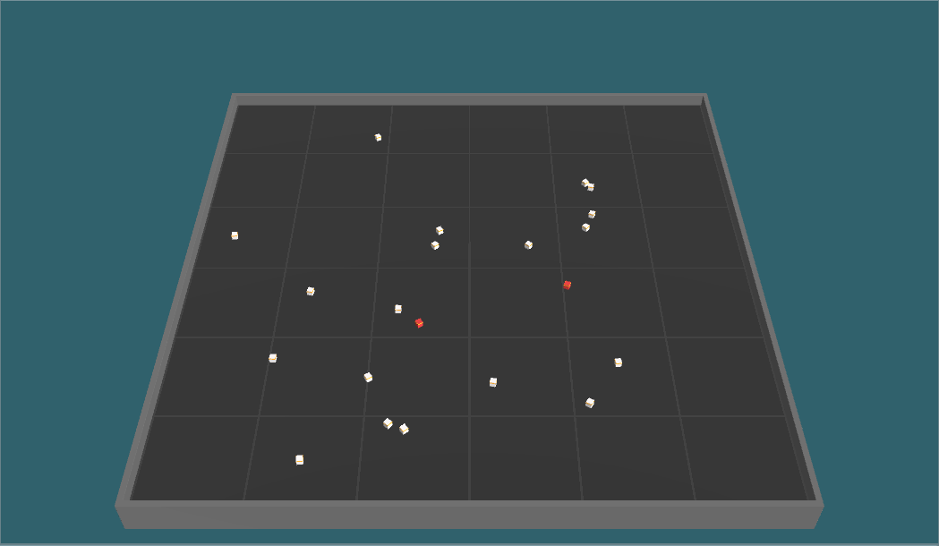The environment is a square shaped area with a wall around so agents cannot go through. Unity mlagents package comes with +15 environments and this area was used in one of the experiments.

Figure 5:The Environment and agents. The square shape court limits the area and the cubes are the agents. White ones represent healthy and red ones represent infectious agents. The simulation shows how one infected agent starts to spread the disease in each time

We used the same 3D model for the area from *Food Collector*[41]which is a competitive multi-agent environment example where agents can shoot each other to get the *goodFood* and avoid *badFood*. The purpose of using very basic shapes like cubes was to avoid any error during the training due to the 3D objects and decrease the complexity of the computation which is also recommended by Unity.

First, we have created hard coded dummy bots which do not have an artificial neural network. The aim of having dummy bots are to create danger and problem to solve for our agents. They should be seen as a part of the environment and they represent individuals who do not take any precautions during an epidemic outbreak and cause the spread of the disease in real-life. We define two movement style for the dummy bots: target-choosers and bouncers. The simulation based on physics engine of Unity *PhysX* has some built in components such as rigidbody which allows designer to control of an object’s position through the physics simulation. There were couple of options for position manipulation such as adding force, adding velocity and directly changing the position. For both movement style of our dummy bots, we choose directly changing position to eliminate the complexity of physics engine. For the bouncer dummy bots, when they collide with an object e.g. wall or another cube, they bounce in the opposite direction such as screen saver logos. However, this was not our first choice due to its simplicity and obvious behavior. The target-choosers choose a random position inside of the area and until they reach there, they try to go in that direction without interruption. When they reach their target, they instantly choose another one. From designer perspective this style was more unpredictable and convincing than bouncing cubes until our agents find out a weakness of target-choosers. Turns out the target-choosers don’t go edges of the arena as much as bouncers since bouncers have to bounce from the walls. Therefore, after our first results came out, we found out our agents learned to hide in corners since it was a blind-spot for target-choosers and converge to suboptimal policy. Thus, we used the combination of two different movement style in our dummy bots.

The infection mechanism works as follows: every cube has its own sphere-shaped colliders called *infectionColliders*. At each time step, Unity physics engine checks if any of these colliders touch to each other. If there are infectionColliders which start to intersect and one of the cubes is sick, the other one is exposed to infection every time step. Expose function gets the distance between agents and calculates the probability of getting infected inversely proportional to the distance. At each step there is a random chance that agent can get infected and the probability increases if they stay longer. There is also an *infection coefficient constant* which can be used to adjust the infectious rate of the disease thus the risk of getting sick.

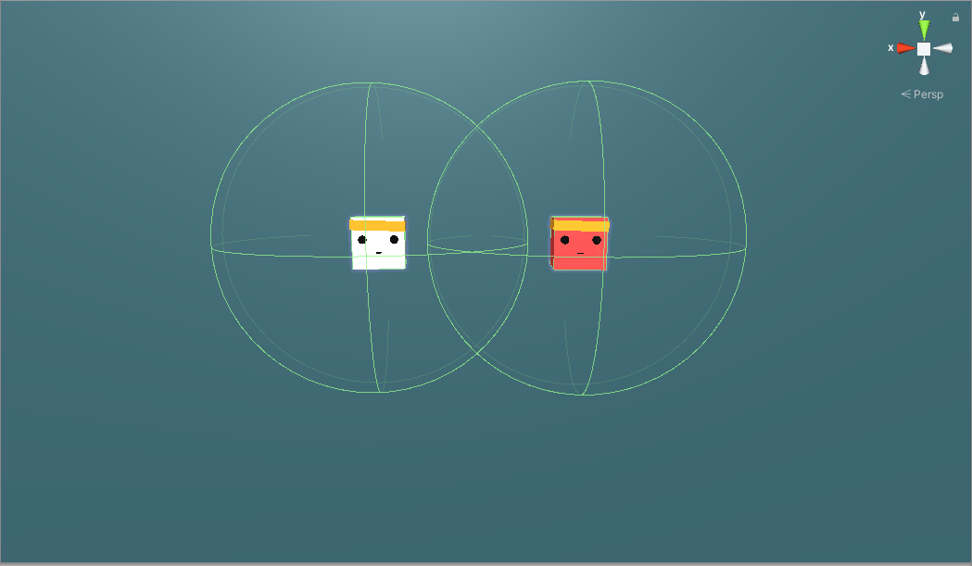

Figure 6: Two cubes with their visible sphere colliders. One is infected and the other one is at risk to get infected every time step. The risk is getting higher if the distance between two is closer.

Agents are simulated as cubic object with blue color. We choose a different color from the bots for distinguishing whether it is controlled by a model or behaving randomly. The observation set of the agent was local velocity at x and z axis and their infection status. Observation vectors is stacked with 5 previous observations before being fed to neural network. The "Number of stacked vectors" parameter changes how many sets of observations into the past you'd like to stack. Increasing this allows the agent to "see" further into the past. In our case 5 step back was enough. Stacking observations can be seen as a memory enhancement however it shouldn’t be confused with Long Short Term Memory (LSTM), which is not implemented in our task yet, but it is mentioned in the future work. Agents also have 360 degree raycast observations as seen in below figures. Each agent has 16 rays with a sphere on their end. The agents’ *infection Spheres* are masked out therefore rays cannot hit these colliders. Instead they can only hit cubes and walls. During observations, these rays are cast into the physics world, and the objects that hit determine the observation vector that is produced as list of floats. The sphere radius increases the chance of the raycast to collide with an object. When raycast hit an object, ray’s color turns to red and fed neural network with what type of object did it hit as an input. We gave different tags to objects and we split it into 3 different object types: walls, agents-bots and reward cube. The reward cube tag only used in single-agent scenarios and removed in multi-agent environment. In our case, there were 165 raycast sensor observation for single-agent scenarios and 132 in multi-agent scenarios.

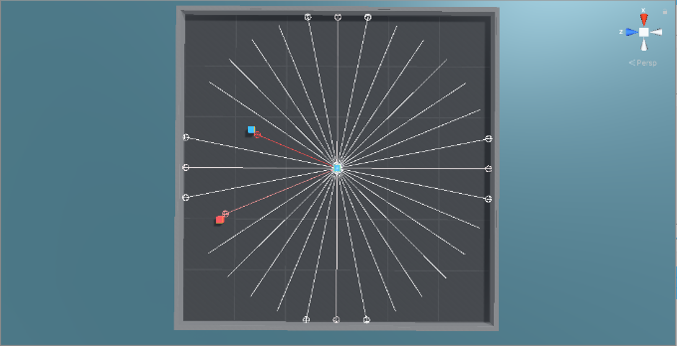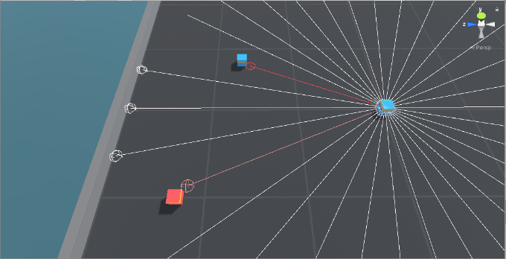

Figure 7:Raycasts of an Agent. 16 Raycast provides 360 degree theoretical vision. However this is not the optimal way of seeing since there could be a small object close to agent which does not hit the spheres on the end of rays thus agents cannot see them. For optimizing the training 16 rays were enough for our task.

Calculation of the raycast observations is as follows:

As output of the neural network, agents have 2 types of discrete actions set that can be chosen simultaneously at each time step. First action set consist of 3 actions which is for moving in x and z axis. The agent may choose to move forward, backward or not move. The second action set consist of 2 actions which is for rotating clockwise or counterclockwise. We did not implement “do not rotate” action due to decrease complexity of action space. Moreover, agent was able to compensate rotation with constant shifting. A heuristic mode is also implemented for testing the movements.

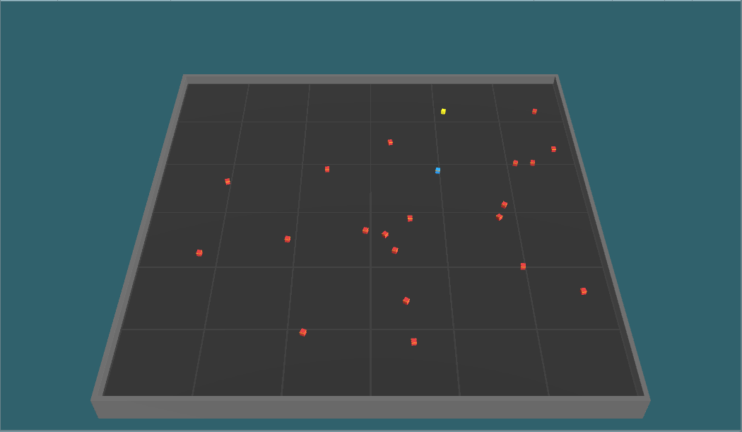

Reward cube

Agent

Figure 8. A single-agent scenario where agent tries to avoid infected bots and collect the reward. The reward spawns randomly when agents collide with it. Each collection of reward cube counts as +1 reward.

We first started with a single-agent scenario where agent is alone with other 1-20 infected dummy bots. The maximum time step of an episode is defined as 10000 steps. For each time step that agent is alive we gave 0.01f survival bonus. For getting infected we gave -1 and finished the episode. If agent survive till the end, its cumulative reward would be 10. To avoid suboptimal behaviors such as hiding corners we took some precautions. A shiny yellow colored cube has been spawned on environment representing the work. This encouraged our agent to dive in group of infected bots and collect the reward instead of waiting its death in the corner. As an extra help for the agent, we gave the distance and direction vector in space as an observation. Also, number of detectable tags were increased by 1 with reward cube tag. Also, we ended episodes when our single agent got infected since there is no point to continue learning. Through simulation the episode lengths increased.

The spawning mechanism of the infected bots was creating some problem since they were spawning randomly on the beginning of episodes and if they spawn too close to agents, they directly infect agents, without giving any time to them. Therefore, we updated the mechanism. Firstly, bots will freeze for 1 second just after episode starts which saves some time for agents to run. Secondly, we separated spawning areas of agents and infected bots. Bots spawning in the inner square with half of the arena’s range and agents spawning between inner square and arena’s walls. We aim to give a wake-up time for agents in the environment which visibly decreased our noise.

Single-agent scenario was successful in a way that agent learned how to maximize its cumulative rewards by collecting reward cubes and avoiding infected bots. As shown in below graphs at the end of the 20 million steps, agent increased its reward from -1 to 10 in average. The policy loss correlates to how much the policy (process for deciding actions) is changing. The magnitude of this should decrease during a successful training session as it did. It was a design choice to start with a single agent and eliminating multi-agent complexity at first for improving the experiment easier. We made bunch of change on the way. We optimized the training by changing the decision interval between steps. Agents decide a new action set at each 5 steps. This optimization worked since steps are minuscule and there was no difference in the cumulative reward, but training time is reduced after this update. Another addition into our training was adding intrinsic motivation. We combined curiosity and extrinsic rewards. The implementation that we used is coming from [42] by Deepak Pathak and his colleagues at Berkeley. Let intrinsic curiosity reward at time t denoted as and extrinsic reward denoted as . The policy is trained to maximize sum of these rewards as

Figure 9: Left: Cumulative Reward / Step Graph. In 20 million steps agent learned how to avoid infected bots and collect rewards. Right: Policy Loss / Step. As episodes pass, the loss function decreases as it is supposed to be in successful trainings.

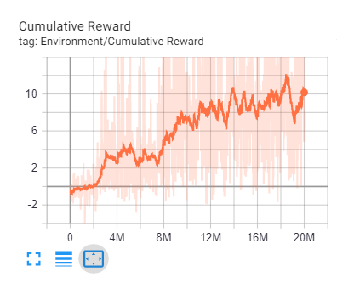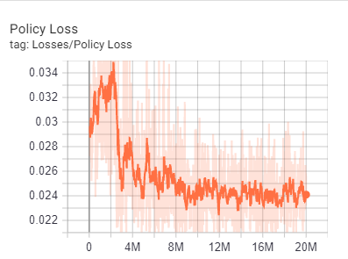

The intrinsic reward is composed of two subsystems, a forward and an inverse neural network. The mechanism utilizes prediction error for creating curiosity reward. The inverse model takes the input state and encodes into a feature vector ), forward model takes as inputs the feature encoding ),) and predicts the action which is taken by the agent to move to the next state.[42] The inverse dynamic model, learning function g can be defined as:

where is the predicted estimate of the action and the neural network parameters are trained to optimize,

Where is the loss function that measures the discrepancy between predicted and actual actions. In the logits layer of our neural network, function g outputs probability which sums to 1 by utilizing a soft-max distribution across all possible actions. At the same time the forward dynamic model is trained for predicting the ) and then taking the difference between actual and prediction as intrinsic reward. The curiosity especially works when there are not relatively dense rewards in the environment. In our case the rewards are sparse except survival bonus, however it doesn’t say much about environment. Adding curiosity increased the cumulative reward and helped agent to converge earlier. However, the computation time is increased which is a disadvantage of using curiosity.

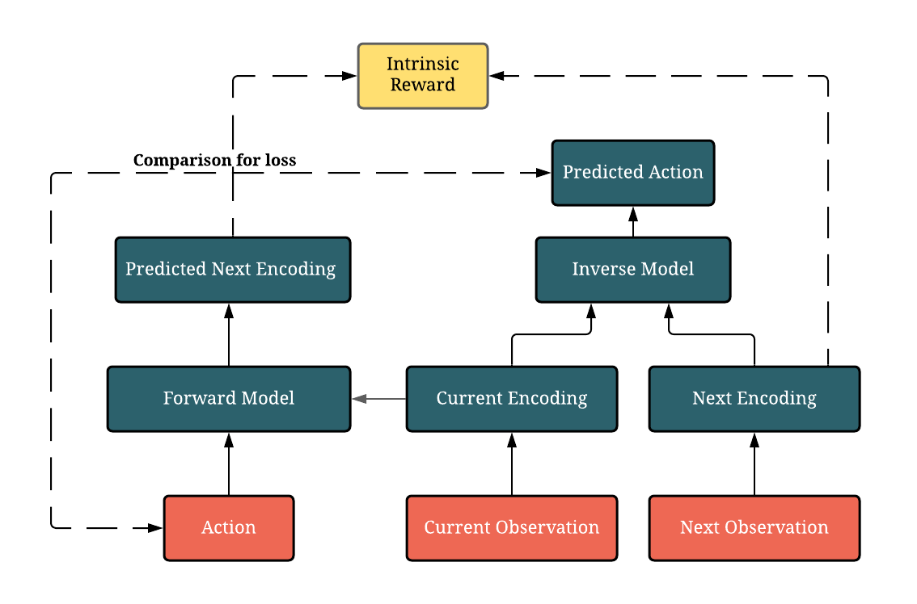After getting successful results from single-agent trainings we migrate to the multi-agent scenarios. Unity Engine made migration extremely easy for researchers. There were only few changings in the setting. We gather agents into one single area instead of separate areas next to each other. We changed the mechanism of ending episodes. The episodes were finishing once agent got infected, since now there are multiple agents on environment the episode continue until there is no agent left uninfected. We also removed the reward cube, it’s distance and direction observations and the detectable tag on raycasts from the environment as it is not required in multi-agent scenario. The total observations except raycasts decreased to 4 from 7. The raycast observation vector count decreased from 195 to 152. After a few optimizations and test runs the multi-agent training were ready and working successfully. In fact, some stunning results came out of it. In addition to default graphs we define our own parameters to observe the simulation better. One of them were collision counts of healthy agents. Since we aim for social distancing, we would like to see a decrease in count of collisions between healthy agents while the training continues.

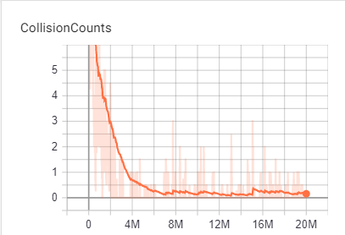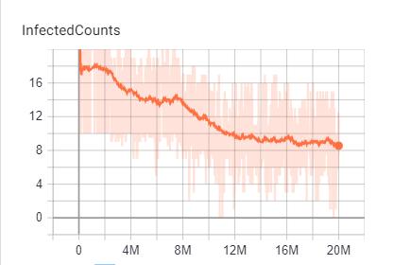

Figure 10: The diagram showing how curiosity reward is calculated. Red boxes show inputs. Dark Green boxes correspond to neural network with two subsystem and the yellow box is . Dotted lines between action- predicted action and encoding -predicted encoding correspond to comparisons used for loss function.

Figure 11: Left: Number of Collisions/Step graph shows agents understand physical proximity cause them lose rewards therefore they decreased that to almost 0. Right: Infected Counts/ Step graphs. In every run there were 20 agents and at the start almost everyone got infected. As the training continues the number of the infected agents also decrease. This means the standard deviation of the rewards decreased and agent got more stable.

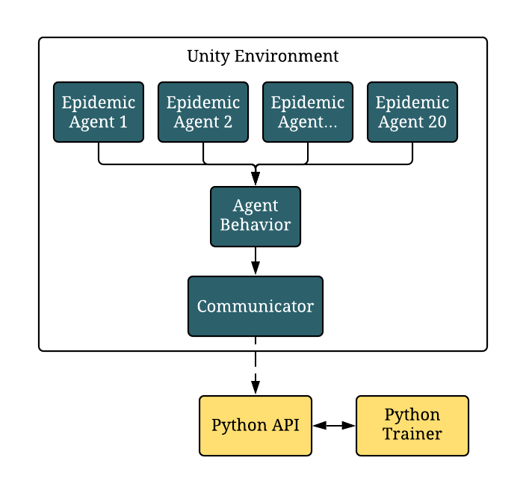In both single and multi-agent scenarios the training architecture was the same as shown in figure 12 below. We used multiple agents to feed one single-brain model whether it is used in single or many agents. The optimal environment number was 20 in parallel in our local machine and we used CPU for computation power. The mlagents package was built in python it serves with an API. The Unity game engine communicates with Python Trainer via a communicator in Unity side and an API in python side.

Figure 12: Diagram of mlagents training architecture. The dark green boxes correspond to processes which occur in Unity Game Engine and yellow boxes corresponds to the Python-side of the project.

* 1. POLICY OPTIMIZATION

Agent policies are trained using Proximal Policy Optimization (PPO) and Soft-Actor Critic (SAC). Both algorithms are compared, and PPO is selected for this task. Even though SAC’s results was close to PPO it was taking much more time in training. At execution time, each agent act by using only their own observations and at optimization time, we use all agents’ observations to update our policy. So even though 20 different environments are used during training there was only one neural network as an output. In other words, agents share the same policy parameters but act and observe independently as each of them were in different states.

### Notation

We consider the standard multi-agent reinforcement learning formalism of N agents interacting with each other in an environment and inspired form OpenAI’ s Emergent Tool Use From Multi-Agent Autocurricula paper.[3]

### Proximal Policy Optimization (PPO)

### Optimization Parameters

Normalization’ın nasıl değiştirdiğini koy.

Initialization’ın nasıl değiştirdiğini koy.

Configuration tablosunu koy.

Runların karşılaştırmasını koy. After designing the environment and creating the simulation time has come to hyperparameter tuning.

* 1. 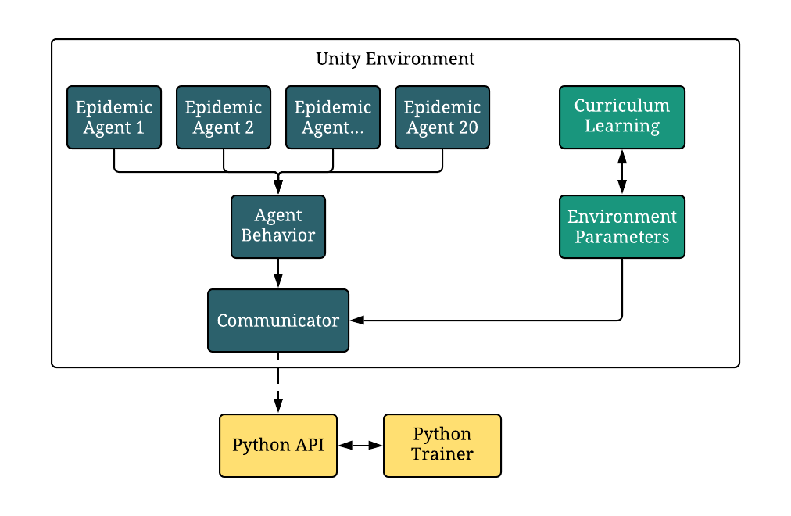CURRICULUM LEARNING

Curriculumsuz ve curriculumlu karşılaştırması. Curriculumsuz olanın nasıl overfit ettiğine bak.

* 1. OPTIMIZATION SETUP

Converting to executable

AWS cloud computing

# EVALUATION

SIR Graph’ın AI’sız nasıl çalıştığını sonuç verdiğini koy.

SIR GRAPHLERINE ETKISI

* 1. ENVIRONMENT ADAPTATION

Train edilenle test edilen environmentlar farklı. O environment’a fit ettikleri stratejiler çalışmayabilir. Bunu yenebilmek için random parametrization kullandık. Farklı farklı environment boyları, radiusları, coefficientları denedik.

FARKLI FARKLI SIMULASYONLAR

# DISCUSSION AND CONCLUSION

We have demonstrated that an epidemic simulation with a simple infection mechanism, multi-agent cooperative environment and standard reinforcement learning algorithms at scale can induce agents to learn complex strategies and human-like behaviors. We observed many strategies from social distancing to self-quarantine that agents developed suggesting that it is possible to flatten the SIR curve by taking individual precautions in an epidemic outbreak.

Our results with epidemic simulation should be viewed as a proof of concept showing a agent-based simulation with reinforcement learning can be used to assist decision makers during the epidemic.

Future work koy. House

# REFERENCES

[1] N. S. Punn, S. K. Sonbhadra, and S. Agarwal, “COVID-19 Epidemic Analysis using Machine Learning and Deep Learning Algorithms,” *medRxiv*, p. 2020.04.08.20057679, 2020.

[2] A. Yañez, C. Hayes, and F. Glavin, “Towards the control of epidemic spread: Designing reinforcement learning environments,” *CEUR Workshop Proc.*, vol. 2563, pp. 188–199, 2019.

[3] B. Baker *et al.*, “Emergent Tool Use From Multi-Agent Autocurricula,” 2019.

[4] O. Bent, S. L. Remy, S. Roberts, and A. Walcott-Bryant, “Novel Exploration Techniques (NETs) for Malaria Policy Interventions,” *32nd AAAI Conf. Artif. Intell. AAAI 2018*, pp. 7735–7740, Dec. 2017.

[5] B. C. Perley, “Programming Language Maintenance,” in *Defying Maliseet Language Death*, UNP - Nebraska, 2017, pp. 63–84.

[6] E. C. Mark S. Smolinski, Margaret A. Hamburg, and Joshua Lederberg, on E. M. T. to H. in the 21st C. B. on Global, and H. I. of Medicine, *Microbial Threats to Health*. Washington, D.C.: National Academies Press, 2003.

[7] B. Zeigler, A. Muzy, and L. Yilmaz, “Artificial Intelligence in Modeling and Simulation,” in *Encyclopedia of Complexity and Systems Science*, New York, NY: Springer New York, 2009, pp. 344–368.

[8] B. Osiński *et al.*, “Simulation-based reinforcement learning for real-world autonomous driving,” 2019.

[9] Dietz and H. JAP, “Bernoulli was ahead of modern epidemiology,” *Nature*, 2000.

[10] Robert E. Serfling, “Summary for Policymakers,” in *Climate Change 2013 - The Physical Science Basis*, vol. 53, no. 9, Intergovernmental Panel on Climate Change, Ed. Cambridge: Cambridge University Press, 2019, pp. 1–30.

[11] J. S. Koopman, “Emerging objectives and methods in epidemiology.,” *Am. J. Public Health*, vol. 86, no. 5, pp. 630–632, May 1996.

[12] S. A. Hofmeyr and S. Forrest, “Architecture for an artificial immune system.,” *Evol. Comput.*, vol. 8, no. 4, pp. 443–473, 2000.

[13] M. Shatnawi, S. Lazarova-Molnar, and N. Zaki, “Modeling and simulation of epidemic spread: Recent advances,” *2013 9th Int. Conf. Innov. Inf. Technol. IIT 2013*, no. March, pp. 118–123, 2013.

[14] S. Richard and A. G. Barto, “An introduction to reinforcement learning,” in *Reinforcement Learning: An introduction*, 1998, pp. 1–352.

[15] W. J. M. Probert *et al.*, “Context matters: using reinforcement learning to develop human-readable, state-dependent outbreak response policies,” *Philos. Trans. R. Soc. B Biol. Sci.*, vol. 374, no. 1776, p. 20180277, Jul. 2019.

[16] L. Simonsen, J. R. Gog, D. Olson, and C. Viboud, “Infectious disease surveillance in the big data era: Towards faster and locally relevant systems,” *J. Infect. Dis.*, vol. 214, no. Suppl 4, pp. S380–S385, 2016.

[17] P. Leung and L. T. Tran, “Predicting shrimp disease occurrence: artificial neural networks vs. logistic regression,” *Aquaculture*, vol. 187, no. 1–2, pp. 35–49, Jul. 2000.

[18] K. T. D. Eames and M. J. Keeling, “Contact tracing and disease control,” *Proc. R. Soc. B Biol. Sci.*, vol. 270, no. 1533, pp. 2565–2571, 2003.

[19] R. Patel, I. M. Longini, and M. E. Halloran, “Finding optimal vaccination strategies for pandemic influenza using genetic algorithms,” *J. Theor. Biol.*, vol. 234, no. 2, pp. 201–212, 2005.

[20] P. Libin *et al.*, *Machine Learning and Knowledge Discovery in Databases*, vol. 11053, no. June. Cham: Springer International Publishing, 2019.

[21] T. Alamo, D. G. Reina, and P. Millán, “Data-Driven Methods to Monitor, Model, Forecast and Control Covid-19 Pandemic: Leveraging Data Science, Epidemiology and Control Theory,” pp. 1–65, Jun. 2020.

[22] K. Zhang, Z. Yang, and T. Başar, “Multi-Agent Reinforcement Learning: A Selective Overview of Theories and Algorithms,” pp. 1–72, Nov. 2019.

[23] OpenAI *et al.*, “Dota 2 with Large Scale Deep Reinforcement Learning,” Dec. 2019.

[24] L. Busoniu, R. Babuska, and B. De Schutter, “A Comprehensive Survey of Multiagent Reinforcement Learning,” *IEEE Trans. Syst. Man, Cybern. Part C (Applications Rev.*, vol. 38, no. 2, pp. 156–172, Mar. 2008.

[25] J. Z. Leibo, V. Zambaldi, M. Lanctot, J. Marecki, and T. Graepel, “Multi-agent reinforcement learning in sequential social dilemmas,” *Proc. Int. Jt. Conf. Auton. Agents Multiagent Syst. AAMAS*, vol. 1, pp. 464–473, 2017.

[26] J. W. Lee, J. Park, J. O, J. Lee, and E. Hong, “A multiagent approach to Q-learning for daily stock trading,” *IEEE Trans. Syst. Man, Cybern. Part ASystems Humans*, vol. 37, no. 6, pp. 864–877, 2007.

[27] S. Padakandla, P. K. J, and S. Bhatnagar, “Reinforcement Learning in Non-Stationary Environments,” *Appl. Intell.*, May 2019.

[28] P. Hernandez-Leal, B. Kartal, and M. E. Taylor, “A Survey and Critique of Multiagent Deep Reinforcement Learning,” *Auton. Agent. Multi. Agent. Syst.*, vol. 33, no. 6, pp. 750–797, Oct. 2018.

[29] L. Panait and S. Luke, “Cooperative Multi-Agent Learning: The State of the Art,” *Auton. Agent. Multi. Agent. Syst.*, vol. 11, no. 3, pp. 387–434, Nov. 2005.

[30] R. F. Denison and K. Muller, “The evolution of cooperation,” *Scientist*, vol. 30, no. 1, 2016.

[31] P. Stone and M. Veloso, “Multiagent Systems : A Survey from a Machine Learning Perspective 1 Introduction 2 Multiagent Systems,” *Auton. Robots*, vol. 8, no. 3, pp. 345–383, 1997.

[32] E. H. Durfee, V. R. Lesser, and D. D. Corkill, “Coherent Cooperation Among Communicating Problem Solvers,” *IEEE Trans. Comput.*, vol. C–36, no. 11, pp. 1275–1291, Nov. 1987.

[33] D. Silver, G. Lever, N. Heess, T. Degris, D. Wierstra, and M. Riedmiller, “Deterministic policy gradient algorithms,” *31st Int. Conf. Mach. Learn. ICML 2014*, vol. 1, pp. 605–619, 2014.

[34] T. Haarnoja, A. Zhou, P. Abbeel, and S. Levine, “Soft Actor-Critic: Off-Policy Maximum Entropy Deep Reinforcement Learning with a Stochastic Actor,” *35th Int. Conf. Mach. Learn. ICML 2018*, vol. 5, pp. 2976–2989, Jan. 2018.

[35] T. Haarnoja *et al.*, “Soft Actor-Critic Algorithms and Applications,” 2018.

[36] J. Schulman, F. Wolski, P. Dhariwal, A. Radford, and O. Klimov, “Proximal Policy Optimization Algorithms,” pp. 1–12, Jul. 2017.

[37] M. Johnson, K. Hofmann, T. Hutton, and D. Bignell, “The malmo platform for artificial intelligence experimentation,” *IJCAI Int. Jt. Conf. Artif. Intell.*, vol. 2016-January, pp. 4246–4247, 2016.

[38] M. G. Bellemare, Y. Naddaf, J. Veness, and M. Bowling, “The Arcade Learning Environment: An Evaluation Platform for General Agents,” *J. Artif. Intell. Res.*, vol. 47, pp. 253–279, Jul. 2012.

[39] G. Brockman *et al.*, “OpenAI Gym,” pp. 1–4, Jun. 2016.

[40] Y. Song *et al.*, “Arena: A General Evaluation Platform and Building Toolkit for Multi-Agent Intelligence,” no. 1, May 2019.

[41] A. Juliani *et al.*, “Unity: A General Platform for Intelligent Agents,” pp. 1–28, Sep. 2018.

[42] D. Pathak, P. Agrawal, A. A. Efros, and T. Darrell, “Curiosity-Driven Exploration by Self-Supervised Prediction,” in *2017 IEEE Conference on Computer Vision and Pattern Recognition Workshops (CVPRW)*, 2017, vol. 2017-July, pp. 488–489.

# Appendix

Social Distancing – Hayvanlarda da var, psikolojide mantıklı

Niye flocking gibi algoritmalar kullanmıyorum. – Aslında burada yine agent-based modellingde AI’ın önemini vurgulamış olucam.

Social Distancting hakkında bir şeyler -hayvanlarda da görülüyor. Ödül ceza sistemine göre RL.

Flocking- gibi başka distance ayarlama algoritmaları

Flocking

Early work explored

Was further explored

More recent work attempted

Epidemic Simulation -SIR Model RL in Covid

The second form of memory is the inclusion of an optional recurrent layer for th neural network being trained. These Recurrent Neural Networks (RNNs) have the ability to learn to keep track of important information over time in a hidden state.

Tensorboard kullanımından bahset. Version Control

Multi-agentları işin içine katarak nasıl non-stationary hale getirdiğini anlat. [27]

Bundan sonra agentların daha global optimal bir solution’a converge olduğundan bahset.