Hiren Shah

3/14/21

1. 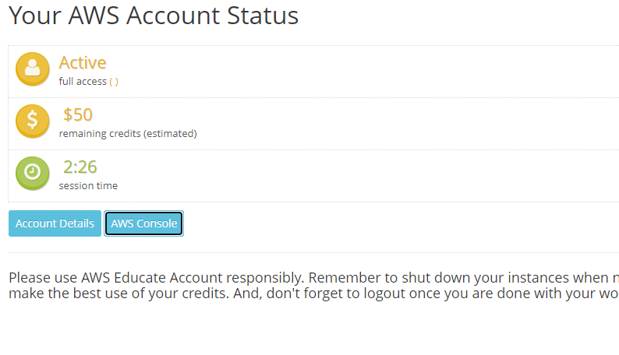**This is a screenshot of logging into the AWS educate and navigating to the myclassroom and the dashboard displays. Display shows account details and AWS console.**

**Figure 1. Successfully navigating to the AWS Account Status dashboard. Shah, Hiren ©**

1. **Once logging into AWS for first time and getting the token. This message indicates that I have 3 hours before the next token is required.**

**AWS Access**  
   Session started at: 2021-03-13T16:01:40-0800  
   Session to end  at: 2021-03-13T19:01:40-0800  
   Remaining session time: 2h59m12s  
  
   Term: 162 days 11:35:09

Figure 2. Successfully showing AWS Token details. Shah, Hiren **©**

1. Once we spun up an instance of a database. After it completed the creation of the database, I was able to take a picture of the hostname and port.

Figure 3. Successfully showing Connectivity and Security details. Shah, Hiren **©**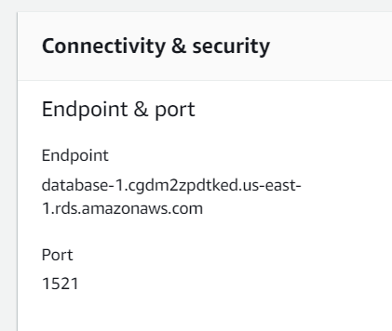

d.) After installing SQL Developer, I had to set the connection to my new RDS in Amazon AWS. I used the same username and password created before and connected the SQL developer to the database.

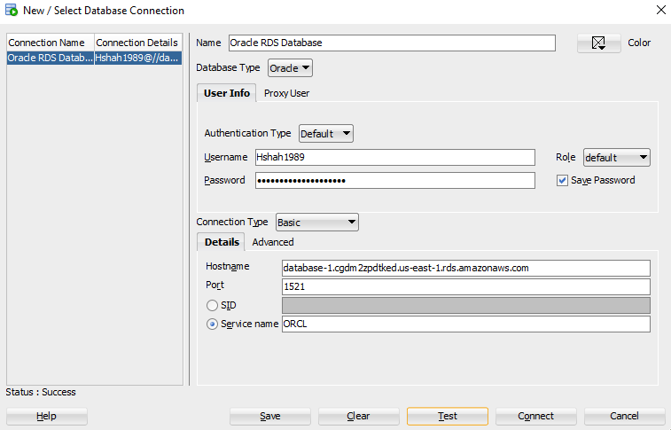Figure 4. Successfully connecting the Oracle Database. Shah, Hiren **©**

1. I created a table on my RDS database from SQL developer. I was able to confirm this by looking at the connection on the left navigation.

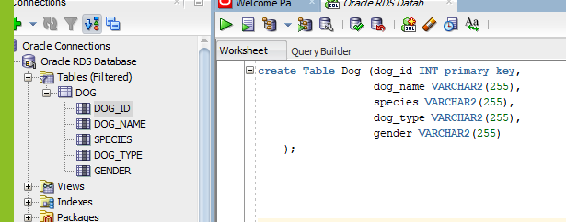Figure 5. Successfully created a table with 4 columns and primary key. Shah, Hiren **©**