/* Write and test a set of SQL statements that will drop tables */

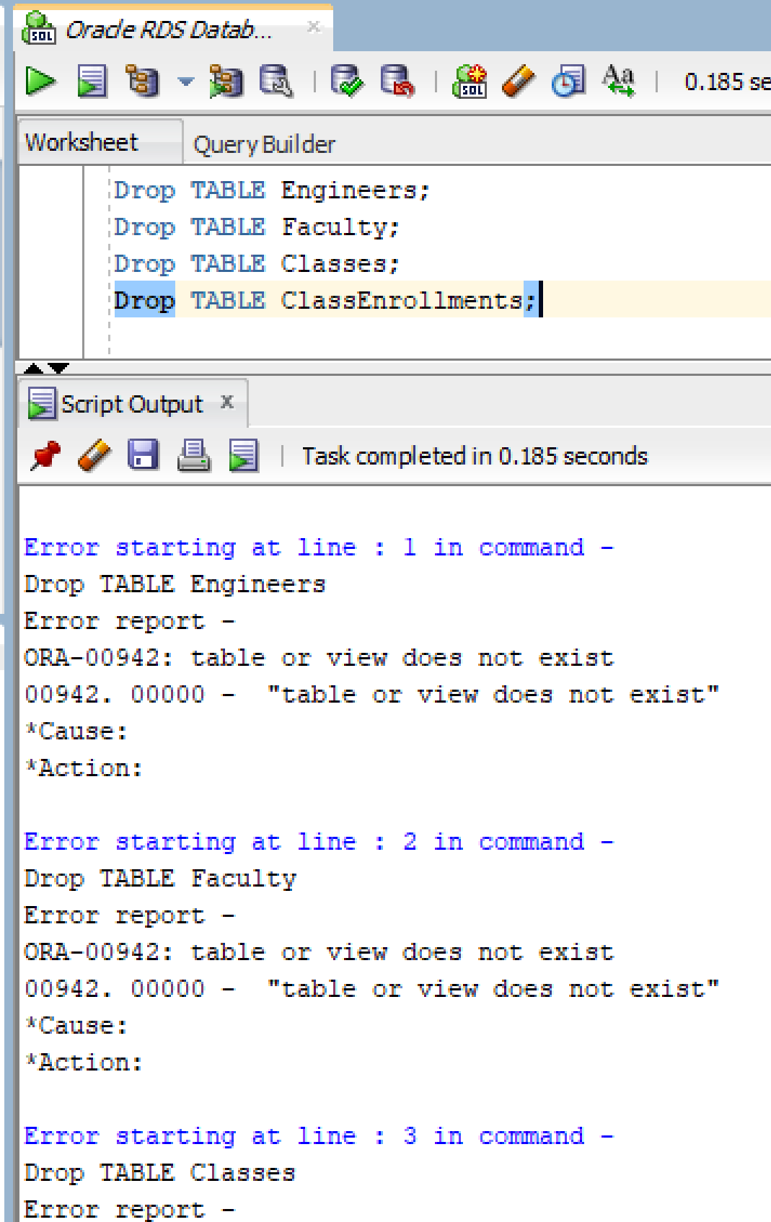Fig. 1. Showing output of above statement.

/* Write and test a set of SQL statements that will create the following tables */

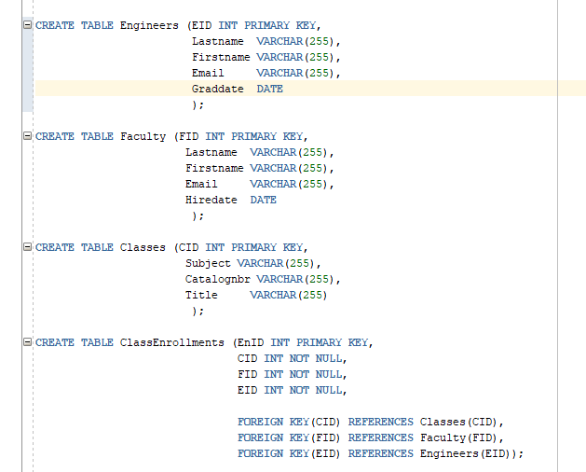

Fig 2. Showing screenshot of sql statement of table creation

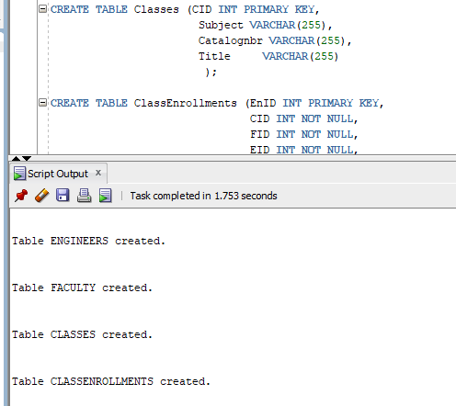

Fig3. Showing success of table creations.

Write and test a set of SQL statements that will insert the following quantity of records into each table

a. 15 Engineers

b. 3 Faculty

c. 3 Classes

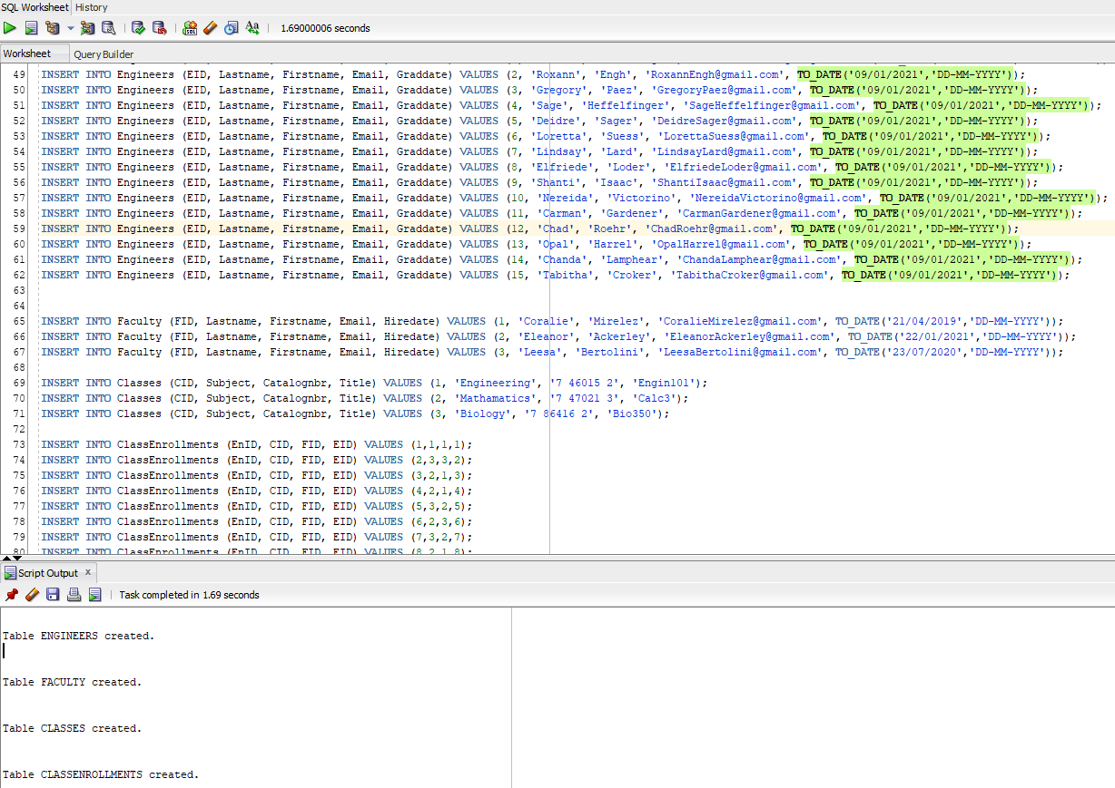d. 15 ClassEnrollments

Fig 4. Showing insert statements in created tables

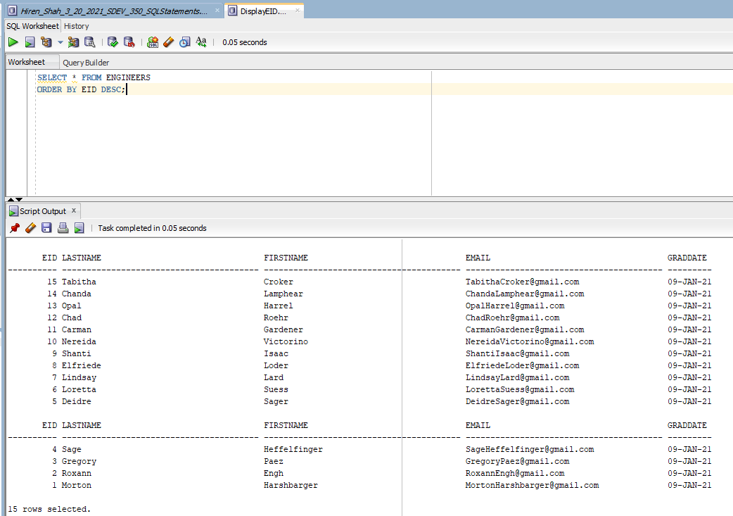Write and test a set of SQL statements that will select **all** records from **each** table. The output should display the records in **descending** order by Primary key.

Fig. 5. Showing everything from Engineers table descending by primary key.

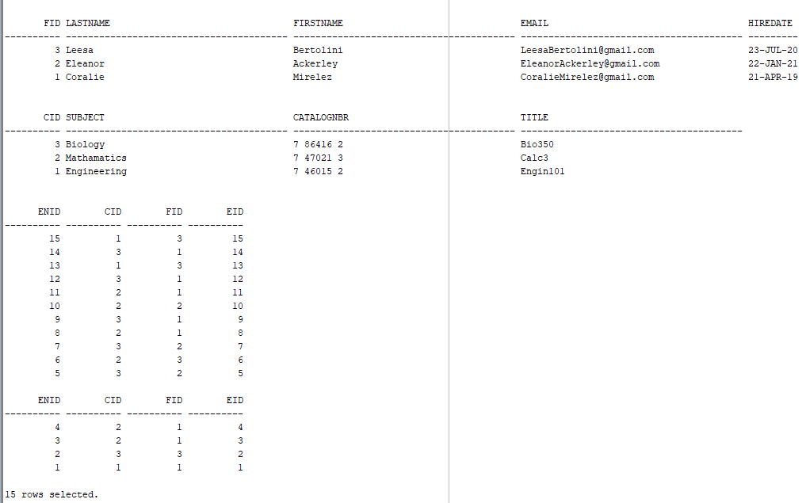

Fig 6. Showing everything from Faculty, Classes, and ClassEnrollments table by descending primary key

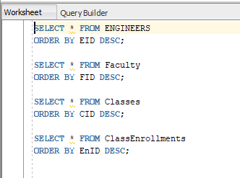Fig 7. Query for table outputs for assignment2.

Write and test a set of SQL statements that will Update records with the following specifications

a. Update the Lastname of one faculty in the Faculty table to be “Friendship”.

b. Update the Firstname of one engineer in the Engineers table to be “Amadeus”.

c. Update the Subject of one class in the Classes table to be “IOT Cyber”.

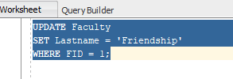

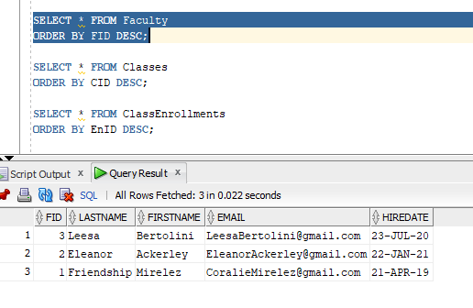Fig. 8. Showing the update of Faculty table of column 1, row 1 of Lastname update to “Friendship”.

5b)

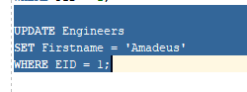

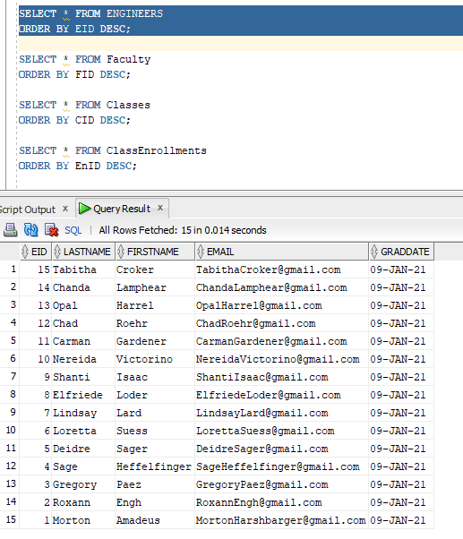Fig 9. Showing the Engineers table, column Firstname where primary key is 1 updated to “Amadeus”

5c)

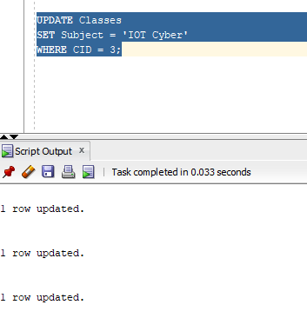

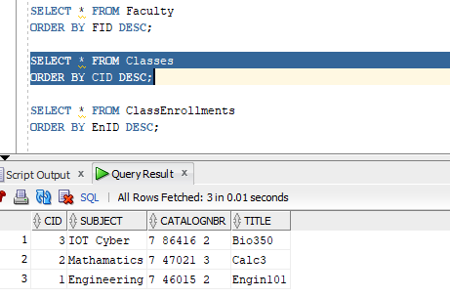Fig 10. Showing the Subject column where CID = 3, the Subject updated to “IOT Cyber”

Write and test a SQL statement that will Delete the ClassEnrollments record with the lowest EnID

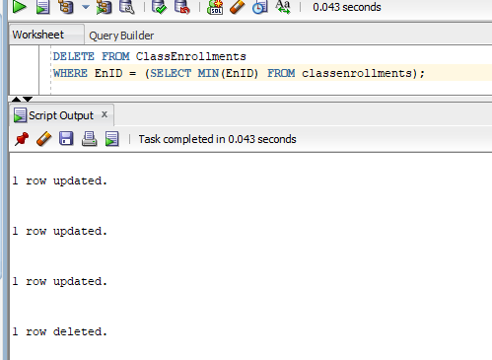

Fig 11. Showing SQL statement that deletes the ClassEnrollments record with lowest EnID

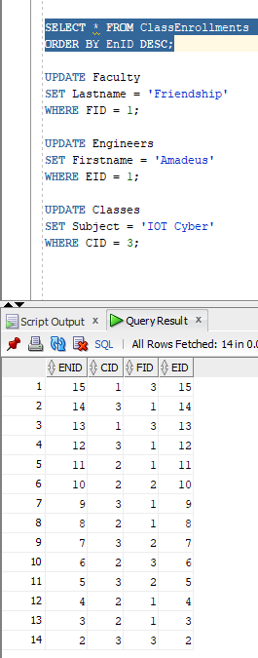Fig 12. Showing the table in ClassEnrollments and row 1 is deleted.

Write and test a SQL statement that creates a **view** joining the required tables such that a user can retrieve the Engineer’s Lastname and Firstname, the Faculty Lastname and Email and the Classes’s Subject and Title for each Course enrollment.

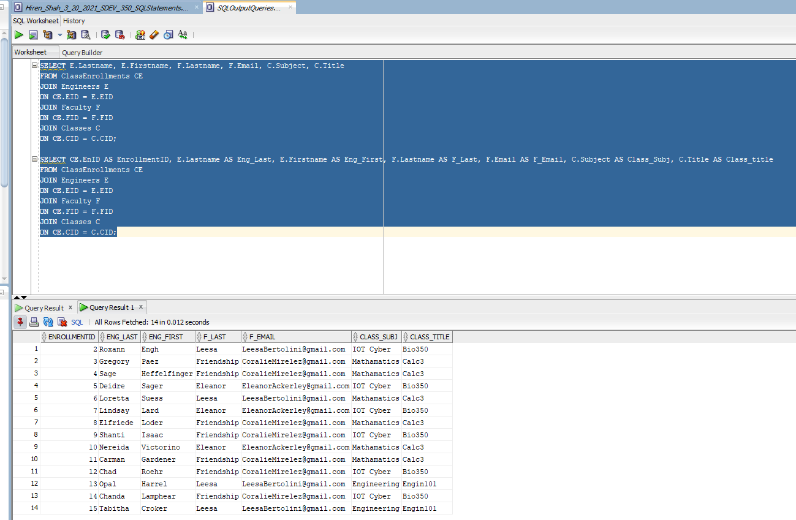Fig 13. Connecting tables column to ClassEnrollments column, then Showing columns and referring to that tables primary key values.