1. Setup the repository
2. Run command to install the packages
   1. npm install
3. Run command to start the application
   1. npm start
4. Output
   1. List employee information

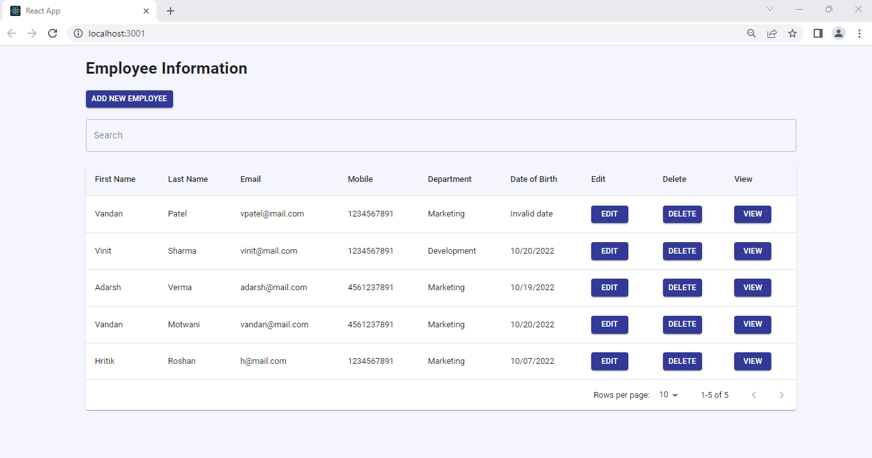

* 1. Add new employee

* 1. Edit employee

* 1. View detailed employee information.

* 1. Delete employee

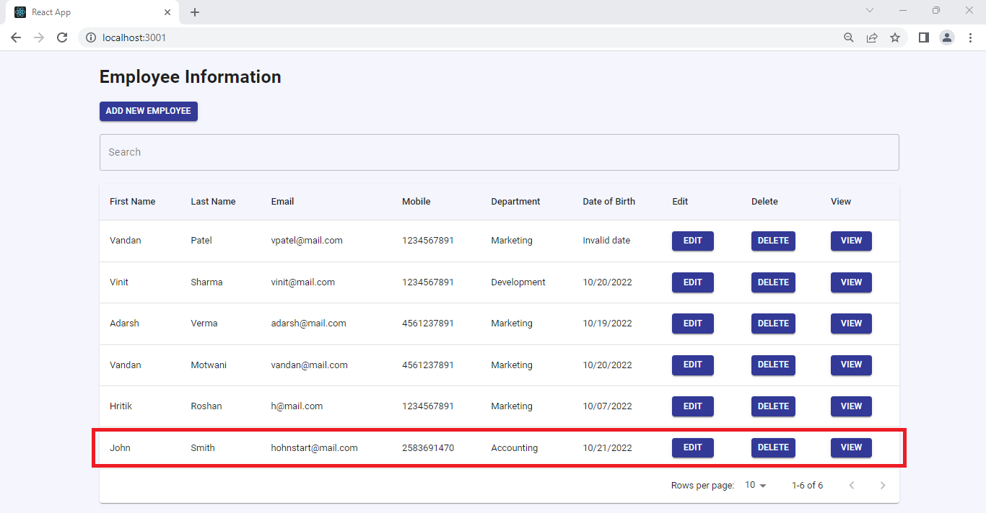

* 1. Search employee

