Part IV Research Project Report
Department of Electrical & Computer Engineering
University of Auckland, Auckland, New Zealand

Project Title: Object Imaging Using High definition 3D Scanner
Project Number: 114
Name: Hsiao-Tien Fan
UID: 4872922
Supervisor Name: Dr. Waleed Abdulla
Second Examiner Name: Dr. Catherine Watson
Partner Name: Samuel Prasetya Loho
Partner UID: 1104880
Submission date: 12/09/2011
Declaration of Originality

This report is my own unaided work and was not copied from nor written in collaboration with any other person.

Hsiao-Tien Fan
11.09.2011

OBJECTS IMAGING USING HIGH DEFINITION 3D SCANNERS
Hsiao-Tien Fan
Department of Electrical and Computer Engineering
University of Auckland, Auckland, New Zealand

Abstract
This report provides background information regarding the fields currently employing the techniques of 3D scanning and briefly describes its different types. The theories of the structured light scanner, which is the type used for the project, is discussed. The system setup is presented in the report, illustrating individual system components in terms of both hardware and software. The importance of a proper calibration was demonstrated to yield images of much higher quality than those which were poorly calibrated. A detailed description of the aims and objectives is included and the system limitations are discussed. Details of the theories behind a proof on concept algorithm were discussed and its successful results were shown from its implementations. It was concluded that a full understanding of the project has been gained, which has resulted in the accurate setup of the system to yield high quality 3D models, and that the proposed algorithm is capable of reconstructing a recognisable 3D representation of the object scanned

Introduction to 3D Scanning
A 3D scanner is a device which collects information about an object or the environment in a digital form, which is then reconstructed digitally into a three dimensional model.[1] Depending on the quality of the scanning system and the scanning techniques employed, different levels of detail may be captured by the scanner and displayed in the 3D model obtained. With manipulation through software, scanned results can be applied to many fields.
One of the applications for 3D scanning currently being explored is in the field of reverse engineering. The outlines and shapes of components of machines can be easily realized in a digital form.[2] These models can then be further analyzed and modified using computer programs, such as CAD software. This allows industry to easily scan and replicate the shape and contour of existing objects, and thus easily design and manufacture items such as replacement parts or accessories for existing products.
3D scanning techniques have also become highly useful in the area of cultural heritage applications and archaeology. The method is now being employed as a means of obtaining digital data for 3D analysis of items of interest as well as a means of providing a digital archival record.[3] In using such techniques, artefacts and rare items can easily be replicated and distributed for study without risking damage to the original. A comprehensive analysis on the size and dimensions of the objects can also be conducted from the model using specialised software without the handling of the actual object.
In general, 3D scanning techniques provide a solution for implementations where a digital realization of a physical object is required. If a 3D model of a physical object is required, it is likely that taking a scan of it would be more timely compared to constructing it using a CAD program.
With these applications in mind, the aim of this project is to improve on current scanning methods and develop a reliable approach to obtaining images of a greater quality and detail. This report will discuss the basic types of 3D scanners available and the theories behind the scanner used for this project. The progress of the project will also be illustrated, and future developments will be discussed.

Types of 3D Scanners
There are two main types of 3D scanners: the contact and non-contact. The properties, advantages and disadvantages of such scanners will be described in this section.

Contact scanner
A system using this method, such as the CMM (coordinate measuring machine) has a probe mounted on a mechanical arm. The probe is placed against and moved across the object surface throughout the scanning process. The probe obtains coordinate data which is interpreted and constructed into a 3D model. The advantage of such a method is its high precision, which is a reason for its use in reverse engineering and manufacturing. [2]
The disadvantage of this system is that by utilizing a probe, the item being scanned may sustain lasting damage which makes such a technique unsuitable for the scanning of soft or easily damaged objects. Also, this scanning technique can be very time consuming.

Non-contact scanner
This type of scanner requires emitters, which emit some form of radiation, normally in the form of light or laser, which bounces off the object and back to a receiver, thus providing information about the object. [1] Depending on the type of radiation used, non-contact scanners may have one or multiple cameras which act as the receivers.
In many cases, a system of two cameras is used, and by applying the theories of triangulation or stereo image analysis, relative positions of the object surface can be obtained, converted into coordinate data and plotted into a 3D model.[4, 5]
The main advantages of this technique are that the scans are preformed at a much higher speed compared to the contact methods, and at the same time fragile objects can be scanned without the risk of damage. However, the disadvantages include not being able to scan anything with a highly reflective surface, or anything which is self-occlusive. [4, 5]

Details on the scanning techniques used
For this project, the non-contact structured light scanner is used. In this section, details on the theories behind the structured light technique such as the structured light patterns, gray code and triangulation are discussed.

Structured light technique.
The structured light scanner projects light patterns onto an object, which are recorded by a camera system. The deformation of the light pattern reflected from the object gives information about the shape of the surface and its depth. Vertical and horizontal stripes are the patterns most commonly used though other alternative, more effective patterns are the subject of ongoing research
In a 3D scanning system using the stripped pattern, the term “stripe” does not refer strictly to the light stripes produced by the projector, but imaginary stripes visualised across the entire projection field. An example of this is shown in Figure 1. [5], [6]

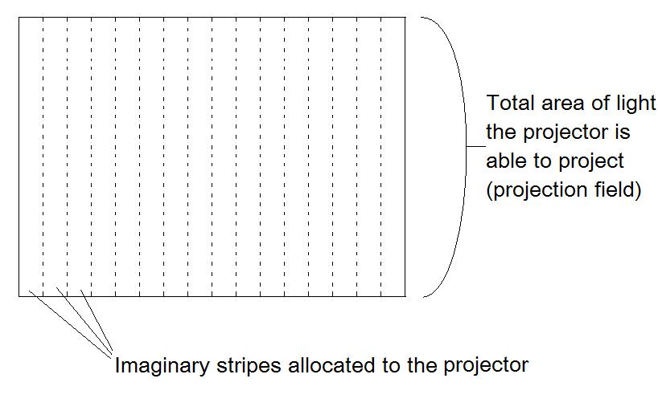
Figure 1: Allocation of stripes on the projection field
For such a system, it is important to acquire information such as the relative positions and how far each stripe lies from the outer edge of the projection field. To do this, a method of identifying individual stripes must be used. There are a number of ways of assigning an identifying characteristic to a light stripe, such as by producing the stripes in different colours or assigning a numeric value to the stripe. In the case of this project, the latter method is employed. To achieve this, the numeric values are assigned to the stripes in the binary form. The projected white stripes are interpreted as 1s while the dark stripes are interpreted as 0s. [5], [6]
The process of assigning the binary coded pattern to the stripes requires multiple sets of projections to be made. As demonstrated in Figure 2, to give all four stripes a different identifying value, three light patterns has to be projected in succession. The values of the individual patterns are analysed and stacked to give a unique binary sequence for each stripe. Any pattern sequence can be used to assign the stripes, as long as each stripe receives a unique value at the end.
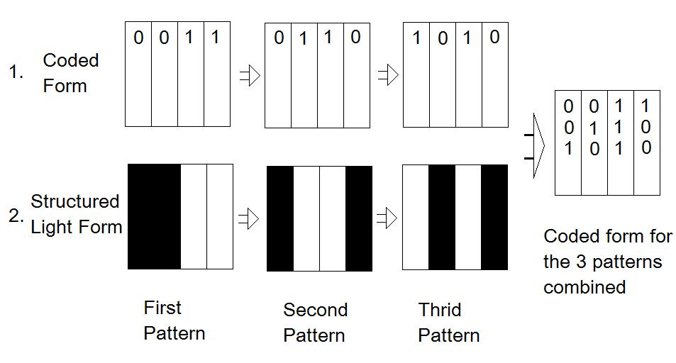 Figure 2: Sequence of light patterns projected in succession to assign a code to each stripe.

Gray Code
For our scanner, the stripe coding used is the Gray code, as it is native to the system. The Gray code differs to the natural binary code in that for the Gray code, when an increment or decrement is made from any number on the system, only one bit changes. For example when the Gray code 011 is incremented, the code becomes 010. When this is done for the natural binary system, 011 is incremented to 100, in which all three bits change.
Due to this property, the Gray code reduces the chances of misinterpreting the sequence as the light images are being projected, as only one bit is changing at a time. Figure 3 shows an example of the Gray code, with each row representing light patterns to be projected. [6]

Figure 3: Gray code structured light sequence[7]

Triangulation
Triangulation is one of the methods used to determine the 3D coordinates of points on a scanned object. Given a system with an emitter and sensor which are separated by a known distance apart, the projected light hitting the object being scanned allows individual points to be analyzed. As shown in Figure 4, by knowing the base distance b and the angle α, it is possible to obtain the distances "h" and "x", thus giving the coordinate data of P, the point of interest. [6]
Figure 4: 2D diagram illustration of obtaining position information h and d by triangulation[6]

The relationsip of the the angles and distances are describe in equations (1), (2) and (3)

$\frac{f}{\sin{α}} =\frac{b}{\sin{γ}}$ (1)

$f = \frac{b*sin{α}}{\sin{γ}} = \frac{b*\sin{α}}{\sin\left(π-α-β\right)} = \frac{b*\sin{α}}{\sin{(π-α-β)}}$ (2)

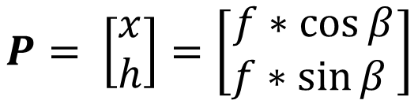
(3)

For the system, the same theory is applied, but in the third dimension. In Figure 4, the angles and lengths are obtained in one plane. This is extended by adding a vertical angle to the analysis, so that the vertical distance between P and the plane horizontal to the camera can be obtained, thus giving all the required data for the system to assign a 3D coordinate to point P, which can then be used to plot the object in the form of a 3D model. [6]

System components and setup
In this following section, the 3D scanning system used for this project and its individual components are described. The scanning system used for this project is the “HDI 3D Scanner” purchased from 3D3Solutions. A setup of the system is shown in Figure 5.
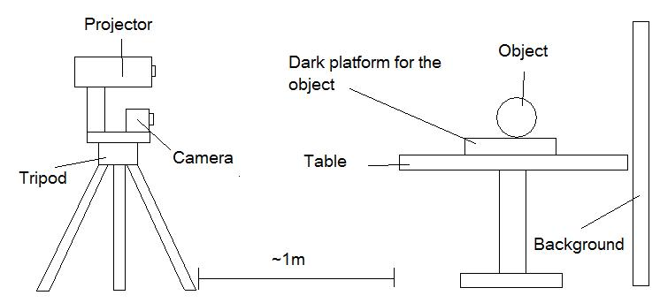
Figure 5: A diagram indicating the relative position for the set up of the scanner system

Cameras
There are two HD cameras on the scanning system used for this project, both of which are attached to a platform on a tripod. Each camera is connected to the computer through a USB cable and all aspects of the cameras’ operations are controlled through a software package. Settings such as the exposure rate can be adjusted using the software.

Projector
The projector used in this system is a white light projector, which is also mounted on the same platform as the cameras. The projection focus has to be manually adjusted by rotating the lens when the system is being calibrated. It is connected to the computer via a VGA cable.

Flexscan3D
Flexscan3D is the software package provided, and serves as the most vital part of the whole scanner system. The Flexscan3D program deals with the calibration of the system as well as the main scanning process. The light patterns used in the scanning are an integrated part of the software. The program also takes care of the scan analysis and interpretation, displaying the 3D models after each scan. It also has the function of meshing separate scan results into one complete model. It should be noted that this software package cannot be modified in any way in the way of coding, thus no functionalities may be added. However, it has been found that the light patterns can be changed manually, though the software’s ability to obtain accurate data from the modified patterns is currently unknown.

Hardware connections
Upon commencing, it should be ensured that all hardware components have been connected appropriately. The USB cables from the camera should be connected to the computer and the green LED on the back of the camera should be lit to indicate correct functionality. The projector should be connected as the second display to the computer, which can be verified in the display settings.

Object platform
Through the scanning process, the object being scanned is placed on a table 1 meter in front of the scanner. A board is placed behind the object to serve as a dark background, providing contrast when the object is being scanned.

Aims, objectives and progress
In this section, the objectives of the project are illustrated and the scanning parameters, which are the environmental variables used for the scanning, are discussed. The system limitations and the process of calibration are also described. The scan results are then shown, and several future developments are discussed.

Aim of the project
The main objective of this project was to set up, calibrate and capture high detail and quality scan results using the 3D scanning system described in section 4. A reliable method of consistently obtaining high quality images is to be devised.
Another primary issue to be addressed is reducing the number of scans required for each 3D model. For certain applications, such as scanning in biometrics, it is difficult for a person to maintain the same posture for an extended period of time. Thus, to apply this scanning method in such applications, the number of scans and the time required for each scan must be reduced.
The process of 3D data acquisition is also to be explored and an algorithm is to be developed to provide proof of the accuracy of our concept and understanding of the process.

Scanning parameters
Through experimentation, it was observed that many parameters contribute to the quality of the scan. For example, it was observed that by moving the object closer to the projector and camera, the quality and detail of the model increased.
Another factor which affects the quality of the scan was the amount of ambient light in the room. An improvement on the performance was observed when all the lights in the room were switched off during the scanning process.
The importance of using a black background was also realized when certain scan results were returned with large errors. Upon the implementation of a black background, the errors were no longer presented, while the models obtained finer and more defined edges.
One parameter which was not immediately obvious to adjust to achieve a boosted performance was the exposure rate of the cameras. Depending on the material and surface of the object being scanned, the optimum exposure rate may differ, and require a manual method of repeated trial until a value is decided upon.

System limitations
One of the main limitations of this system is its inability to scan objects which do not have a surface with suitable reflectivity. Any object that doesn’t reflect light well will not be captured clearly, making it impossible for any transparent or dark object to be scanned. A similar issue is encountered with objects with high reflectivity. A mirror, for instance, cannot be scanned as light reflects too brightly off it, and cannot be captured by the camera to be analysed. This puts a large restriction on the objects which can be scanned by the system.

Calibration
The calibration process is a series of steps designed to adjust the system to accommodate for various environmental settings. When system parameters such as the position and the angle of the cameras are changed, the calibration process ensures that the system is interpreting the data the way it is intended to, and adjusts the system to perform at its optimum. Through the calibration process, intrinsic parameters such as the focal length, principal point, and scale factors are found, which relates the points on the images taken to a real work coordinate system. The chequered board in Figure 6 is used for the calibration. Reference coloured lines are drawn and the circles are used to mark the corners of the squares to indicate that the system recognises the points accurately.
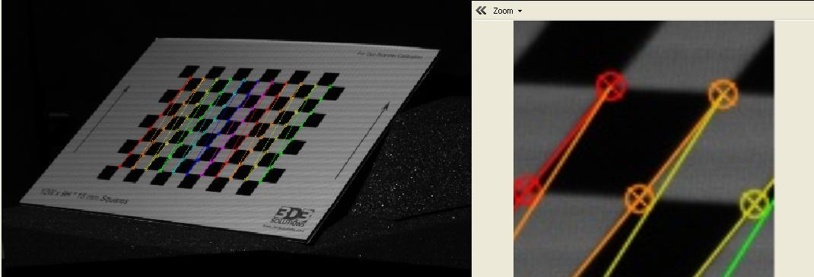
Figure 6: Calibration board showing the coloured lines marking the points recognised by the system
Following the calibration process, it accuracy must be verified. For the verification process, the calibration board, which has a known shape and dimension, is scanned by the 3D system. In Figure 7, cross section views of the calibration boards are shown for two different calibration settings. As it is known that the calibration board is flat, the corresponding 3D model displayed should also be. As seen in model 1 in Figure 7, the system was accurately calibrated as there is no warping effect. However, if the calibration is inaccurate, the resulting model will be skewed, as shown in the left.
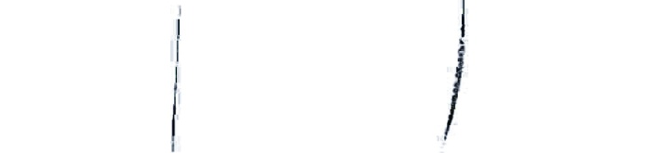
1

Type a quote from the document or the summary of an interesting point. You can position the text box anywhere in the document. Use the Text Box Tools tab to change the formatting of the pull quote text box.]
2

Type a quote from the document or the summary of an interesting point. You can position the text box anywhere in the document. Use the Text Box Tools tab to change the formatting of the pull quote text box.]
Figure 7: Cross section comparison of the calibration board scanned with the accurately calibrated setting (left) and the inaccurately calibrated setting (right)

Scanning process
For the Flexscan3D system, there are 3 main steps in the 3D scanning process: stripe pattern acquisition, 3D data acquisition, and 3D data display. In this section, the theories behind these steps will be described.

Stripe Pattern Acquisition
For the process of stripe interpretation, a photo of each stripe pattern is captured by the system. As seen in Figures 8 and 9, the system has obtained two sets of images, one from each of the left and right cameras. The gray code stripe patterns that are projected onto the object are interpreted by the software system. This allows a unique identifying code to be assigned to each point on the object.
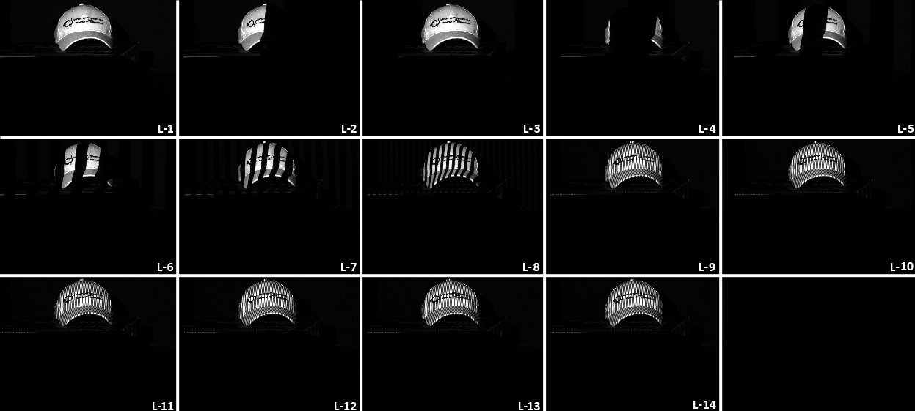
Figure 8: Sequence of Gray Code patterns projected onto the object being scanned and capture by the left camera
Figure 9: Sequence of Gray Code patterns projected onto the object being scanned and capture by the right camera

3D data acquisition
The data acquisition process for this phase of the project was completed by the Flexscan3D program. It was an automated process which was executed by the software once the stripe patterns have been successfully captured. The results were displayed in a 3D plot in the software platform.
Once the computation is complete, the Flexscan3D software is able to display the 3D data in a solid surface representation which can be rotated. The data can subsequently be exported in the .stl, .ply, .obj and .asc formats

Scan results
For the first part of the project, the system was calibrated and several scans were made. It was found that the fine details on the objects were not completely captured by the system. As seen in the Figure 8, model 1 has many holes. Details such as the buttons on the phone are not detected, and are shown as holes on the model.
It was later found that the calibration process was not preformed properly for the initial scans. The system yielded much sharper results with the proper calibration. As seen from the model 2 on Figure 10 the buttons on the phone now have much clearer detail. From this we can see the importance of calibration on the quality of the outcome of the scans.
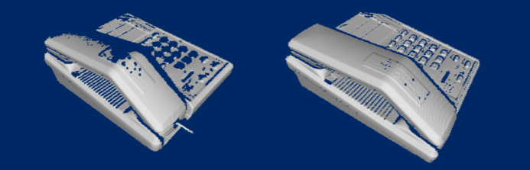
1

Type a quote from the document or the summary of an interesting point. You can position the text box anywhere in the document. Use the Text Box Tools tab to change the formatting of the pull quote text box.]
2

Type a quote from the document or the summary of an interesting point. You can position the text box anywhere in the document. Use the Text Box Tools tab to change the formatting of the pull quote text box.]
Figure 10: Comparison of the phone model scanned with the accurately calibrated setting (right) and the inaccurately calibrated setting (left)
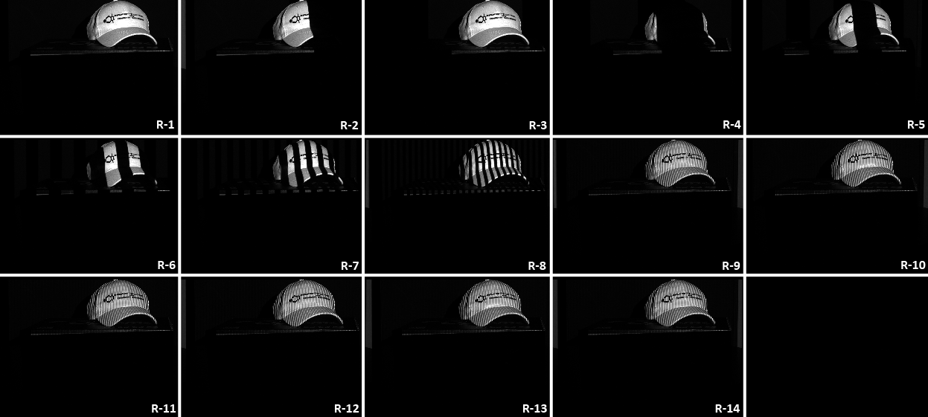
There were other factors which were also found to have an impact on the quality and accuracy of the model obtained, such as moving the object during the scanning process.
Small movements which are not avoidable when scanning body parts such as the face, the hand or the arm results in a poor quality 3D model to be reconstructed where much of the information in missing. This is due to that fact that when the objects being scanned moves during the imaging process, the projected lines on the object become distorted somewhat, causing the system to misinterpret the information. This could lead to noise or information being lost in the final reconstruction of the 3D model.

Proof of Concept Algorithm
Throughout the first phase of the project, the commercial program "Flexscan3D" was used in conjunction with the scanning system to produce the 3D results. This software operated as a "black box", as it provided no indication of how the data acquisition took place.
This followed on to the secondary objective for our project, which was to devise a method of verifying our understand of how the 3D data is extracted from the 2D images. In this section, the methodologies behind the implemented algorithm will be discussed, along with the limitations and the results. In the flow diagrom on the next page, an outline of the steps implemented in the algorithm in computing the 3D data has been shown.

Load images into MATLAB

Image binarisation

Noise reduction

Striped Images decoded for individual points on the object of interest

Decoded points analysed in correspondence matching

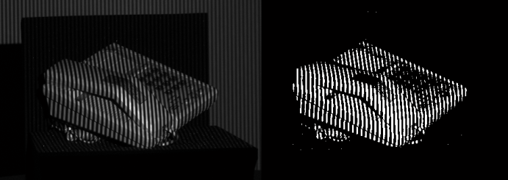

Triangulation

Display 3D data

Algorithm characteristics and features
The proposed algorithm was implemented in MATLAB. The same scanner setup was used as it was felt that the 2D images obtained from the previous system was of a good quality to build the new algorithm upon. As the objectives of this task was not to replicate the commercial software in its entirety, but rather an exercise to prove our concept of the data acquisition, a simplified method was implemented. For the simplified algorithm, the calibration process was removed, and a more generalised form of triangulation was preformed.

Loading Images into MATLAB
The first function to be implemented in the algorithm is the ability to load the 2D photos acquired by the scanner. A script was written to load the bitmap images into MATLAB in the form of a matrix. Each cell of the matrix represented a pixel of the image, which allowed for the direct manipulation of pixel data to take place. This was important, as for the system to recognise the stripes which were captured, a process called binarisation was required.

Image Binarisation
For the purposes of interpreting the stripe patterns acquired from the images, binary values are required. The gray code, which was implemented for this project, consists of only black and white patterns, thus is represented by zeros and ones. However, upon inspecting the numerical values of each pixel for a bitmap image taken by the system, one would discover a numbers ranging from 0 to 255. Therefore, to decode the stripped patterns and compare them to the gray code, the pixel values must be mapped to a binary value of either zero or one.
To achieve this, each pixel value, now loaded into a matrix in MATLAB, is compared to a threshold value. If the pixel number is less than the threshold, the pixel is binarised to the value of zero while if it's higher than the threshold, the value is mapped to one.
An example of the image before and after binarisation is shown in Figure 11.
Figure 11: Comparison of the phone image before (left) and after binarisation (right)
The binarisation process removes much of the background information which is not required from the images. As shown in Figure 11, the unbinarised image on the left has a part of the white background visible behind the phone. Upon binarisation, however, it can be seen that the background is no longer visible.

Noise reduction
As the range of the camera is quite large, unavoidable unwanted data is captured on occasion. In this case, as seen in Figure 12, parts of the white background has been captured on the left and right sections of the image. To minimise the amount of unnecessary information present in the reconstructed 3D model, as much as of the unnecessary data should be removed.
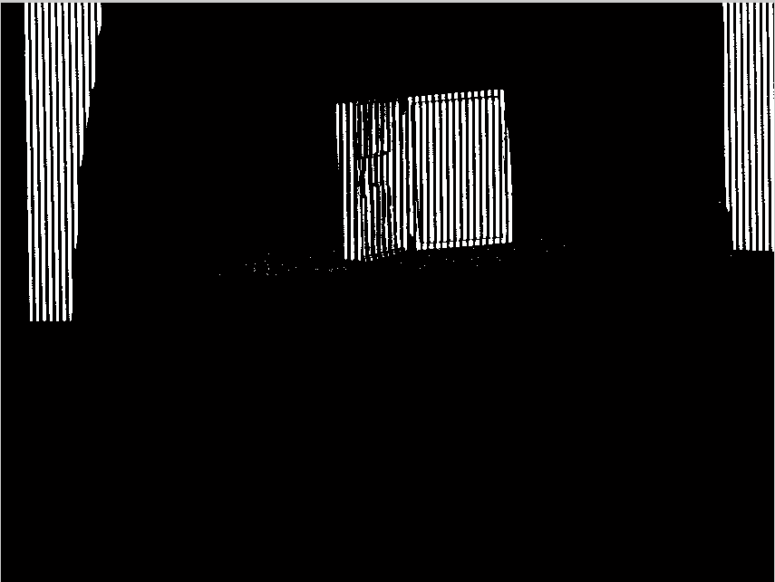

Figure 12: Binarised striped image of a toolbox prior to noise reduction
This is achieved through a cropping process. A script was written to identify the area of space in which the object is located. Once this has been achieved, all the pixels outside the designated area of space is written to zero, thus eliminating the background data. The resulting image is shown Figure 13

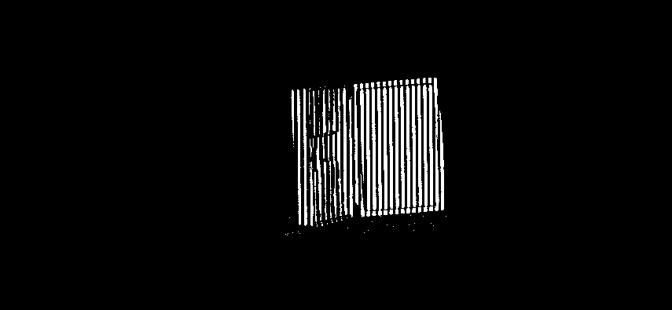
Figure 13: Binarised striped image of a toolbox prior to noise reduction

Stripe Pattern Decoding
Once binary values have been assigned to each pixel, it is possible to decode the patterns and assign a unique code to different location on the object. As illustrated in section 3 with regards to the gray code and structured light techniques, the code obtained on each horizontal location of the of the object will differ.
This allows a specific code to be associated to a specific physical location on the object. Using this property, it is possible to match the points on photos taken by the left and right images in a process called correspondence matching.

Correspondence matching
The process of the correspondence matching allows the system to identifying similar points on the left and right photos taken by the system. For a given point of interest, it's code is identified, and points at its equivalent height on its corresponding image is scanned for the same code. Points found to have the same code is said to be "similar" In this case, "similar points" identified on the photos indicate the two points to be at the same physical location on the object. When such points are found, the points are said to be "matched". This can be observed on Figure 14.

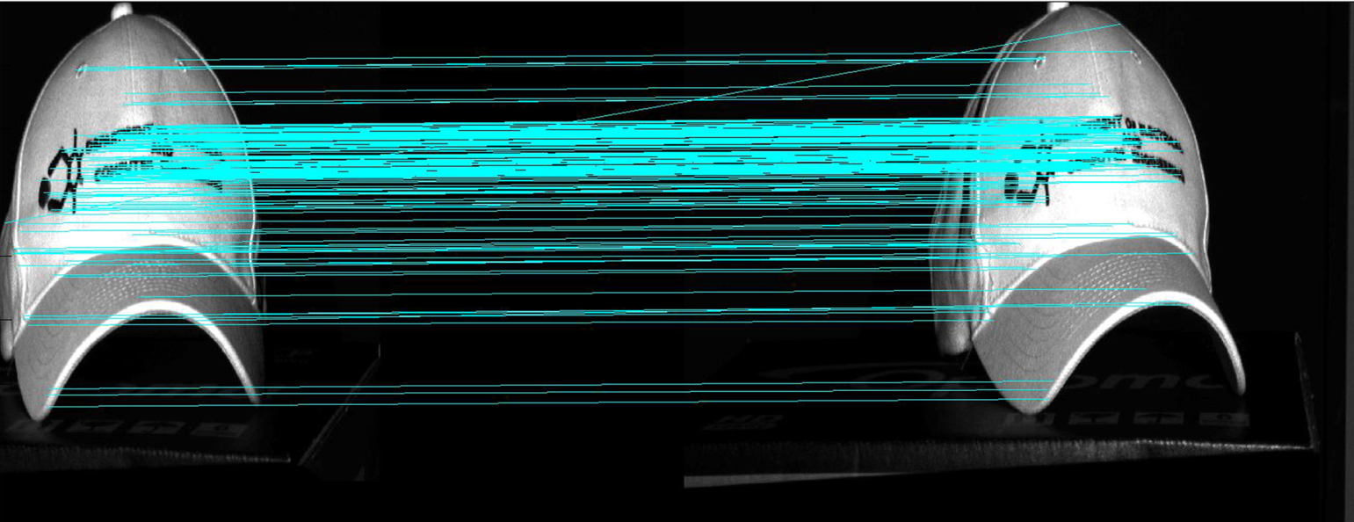

Figure 14: Lines link points that have been matched from the right image to the left image

The lines shown in the figure link points from the right image to their corresponding points on the left, indicating the points to be "matched". This provides valuable information for the process of triangulation, as the pixel location of a particular "point of interest" is required from both pictures for the triangulation to take place.
For this process to be implemented in the algorithm, the top leftmost point of the object is selected to be the point of interest. The identifying code for the point of interest is compared to a list of the Gray code values projected onto the object. In the event where there is no match, a new point of interest is selected and the process is repeated.
Hoverer, in the event of a match being found, the algorithm moves on to scanning all the points that is at the equivalent height on the corresponding image for the same code. If a point with the same gray code is found on both images, the algorithm records the vertical and horizontal pixel number of the matching points from both images. This information is used later in the triangulation process. Similarly, if no match is found, the process start again on a new point. The process is repeated until all points have been accounted for.

Triangulation
Once the points have been matched, stereo triangulation is performed on each of the points, thus obtaining 3D dat. Figure 15 shows the important system parameters required for the triangulation. As described previously in the theory section, the angles α , β and the distance "d" are described by the equation:
(3)

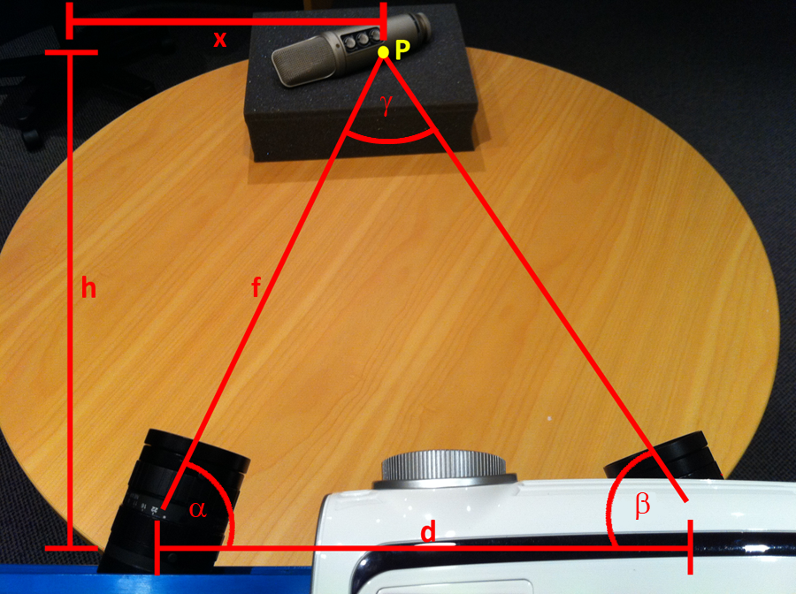

Figure 15: System setup showing the angles α and β, and the distance between the cameras "d"

Whilst the distance between the cameras can easily be measured, the values for α and β are not as easily obtained. This is due to the fact that these angles are not the physical angles at which the cameras are set at. Instead, the angle α is the angle between the camera separation distance d and the focal distance f. As it can be observed from the figure, as the point of interest "P" varies in position over the object, so does the distance f, and the angles α and β accordingly.
To obtain a quantitative value for the angles of interest, the viewing angle "a" of the camera must be first considered. This is illustrated in Figure 16.
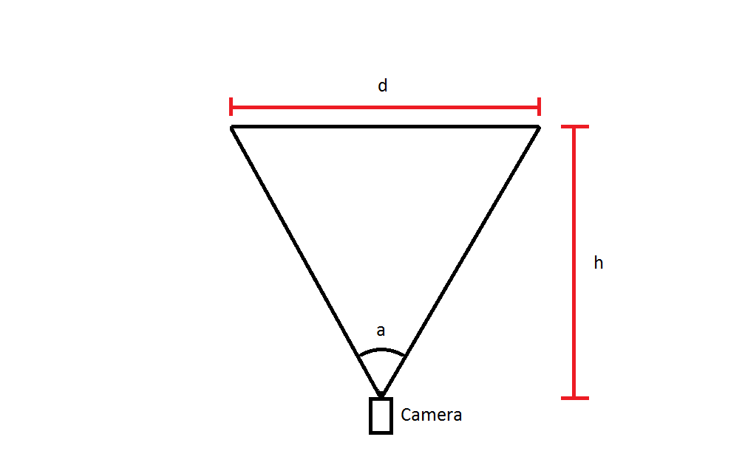
Figure 16: Diagram illustrating the viewing angle of the camera

The angle "a" can be determined by taking empirical measurements of d and h, and applying equation 4. It can also be obtained from the datasheet of the camera.

$a{=2tan}^{-1}{(\frac{d}{2h})}$ (4)

Considering the total number of horizontal pixels present in any image taken by the camera, which spans across the distance d, it is possible to assign an equivalent angle θ represented by each pixel with equation 5

$θ =\frac{a}{P_{N}}$ (5)

Where P_{N} is the number of horizontal pixels present in the image.

By knowing the angle each pixel represents, it is then possible to find the pixel location on a specific image for a point of interest, determine its pixel location and multiply this to the pixel angle. From this, an equivalent angle is obtained, which when added or subtracted from the physical angle of the camera, would yield the angles α and β. Written in equation form:

$α = (θ*P_{L})+∅$ (6)

$β = (θ*P_{L})-∅$ (7)

$α = (θ*P_{L})-∅$ (8)

$β = (θ*P_{L})+∅$ (9)

Where ϕ is the physical angle at which the camera is set and P_{L} is pixel location.

For P_{L}<0.5 P_{N}, α and β are calculated using equations 6 and 7 while for P_{L}>0.5 P_{N}, α and β are calculated using equations 8 and 9. Once the angles have been obtained they can be applied to the equations mentioned in section 3.3 to obtain coordinate data.

3D Data Display
Due to the nature of the proposed algorithm, the resulting 3D data has been presented in the form of 3D coordinates. This data is plotted in MATLAB, using an inbuilt function, as a point cloud. As it can be seen from Figure 17, a recognisable reconstruction of the hat has been achieved
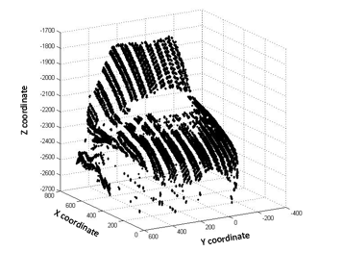
Figure 17: Lines link points that have been matched from the right image to the left image

Comparison of Flexscan3D and simplified model
An immediate effect is observed upon comparing the results obtained from the Flexscan3D system to that from the simplified algorithm. The quality disparity is large, and the information in the simplified model is not as complete. Apart from this, a phenomenon of warping has also been observed. A number of possible causes to the difference in quality has been proposed.

Lack of calibration in the simplified system
For the proposed algorithm, calibration was not completed, as the purposes of the algorithm was to provide the proof on concept for how the 3D data acquisition was preformed rather than to reproduce the commercial software. Due to this simplification, certain errors inherent to the system, such as the warping effects from the camera lenses, have not been accounted from. This would likely cause distortions of the results

Simplification of the triangulation process
In the described method, the theory of triangulation used was in two dimensions rather than three. Due to this, certain assumptions had to be made. First of all, as the vertical distances are not taken into account by the triangulation process, the vertical distance represented by each pixel was assumed. This may have caused inaccuracies to the separation of points placed along the axis in question.

Assumption of several system parameters.
For the implementation of this algorithm, several assumptions were made for the system parameters. For instance, the distance "d" between the two cameras and the physical angle of the cameras were assumed rather than measured. Due to this, the parameters inserted into the triangulation equations would be inaccurate to a certain extent, and thus produce errors in the final 3D model

Flexscan3D VS Simplified Algorithm
As it can be seen in Figure 18. there is a large warping effect present in the reconstructed model using the simplified algorithm. This is likely to have been caused by the reasons mentioned above. It is also clear that there is missing information in the simplified version, where as the Flexscan3D system has a reasonably evenly distributed data points. It is also noted that the simplified model has a significantly fewer number of points, with a count

Figure 18: Comparison of data obtained from the Flexscan3D system and the algorithms devised by the author

Future work

Further refining and developing the proposed algorithm
Due to the time constraints, limited number of featured were implemented in the algorithm, with little or no optimisation. A goal for the future is to improve on the image quality obtained by the system by introducing compensating procedures such as the calibration process

Standardizing the review of the image quality
At this point in time, the quality of the images is judged solely by comparing the object and the 3D model visually. A more quantitative approach should be explored and possibly implemented as a function through MATLAB

Displaying 3D model obtained in different formats
Currently, using the devised algorithm, 3D data can only be obtained in the form of coordinates. This resulted in the plotting of the data in the form of a point cloud, However, there are many methods of displaying such data, such as in the form of solid surface or mesh. Thus for future work, further development of the data display technique should be explored to allow for the data to be plotted in different forms.

Automating the process of exposure setting
The exposure rate for the camera determines the amount of light captured by it. For this application, the Flexscan3D software can only analyze an object if it has the correct amount of exposure. Anything too high or low would result in misinformation. Currently the exposure rate is still set manually and may take repeated attempts before the optimum is achieved. A method should be considered to adjust for the exposure rate automatically regardless of the object being imaged.

Automating the process of image meshing
One of the tasks that still needs to be addressed in order
to improve the efficiency and reliability of the scanning
process is the automation and optimization of the
meshing process. Meshing separate scans together is a
very time consuming task as to a very large extent the
meshing has to be completed manually. For future work, a system could be designed and implemented to carry out an automated meshing process.

Conclusions
In this report, the various aspects of the scanner system, such as the setup, operation environment, limitations and the quality of the results have been discussed. An overview of the theory and implementation of a simplified algorithm was also provided.
For the first section of our project, we have completed the setup of the Flexscan3D system and optimised the system to yield high quality results. The 3D model obtained was of a substantially higher quality than that obtained before optimisation.
A thorough understand of the 3D data acquisition process has been acquired, and a proof of concept algorithm has been implemented. The algorithm is able to adequately reconstruct a scanned object to a recognisable standard, though it has been recognised that the quality is not entirely replicated.
Through completing this research project, the author has gained an insight to the technology behind the field of 3D imaging, understood it's limitations, and see the endless opportunities and development this field has to offer.

Acknowledgements
I would like to thank the following people for their assistance in the project: Dr. Waleed Abdulla, who has given us invaluable advice on the project and guided us towards its completion, Dr. Catherine Watson, for her advice on constructing the report and her suggestions and insights on possible applications of our algorithm, and PhD student Maja Krivokuca who has assisted us with all the technical aspects of the 3D scanner as well as providing us with essential feedback about our work. Finally I thank my partner Samuel Prasetya Loho who has worked most diligently throughout the duration of this project.

References
[1] Retrieved: (10.March.11). Title: 3D scanners. Available: http://en.wikipedia.org/wiki/3D_sca nner
[2] Retrieved: (01.May.2011). Title: 3D scanning. Available: http://coep.vlab.co.in/?sub=34&brch =106&sim=661&cnt=1
[3] Retrieved: (29.04.2011).Title: 3D SCANNING: CULTURAL HERITAGE AND THE ARTS Available: http://www.accurexmeasure.com/cul turalheritageandarts.htm
[4] C. Rocchini, P. Cignoni, C. Montani, P. Pingi, and R. Scopigno, "A low cost 3D scanner based on structured light," Computer Graphics Forum, vol. 20, pp. 299-308, 2001.
[5] O. H.-H. Szymon Rusinkiewicz, Marc Levoy, "Real-Time 3D Model Acquisition," ACM Transactions on Graphics (TOG) - Proceedings of ACM SIGGRAPH 2002 vol. 21, July 2002 2002.
[6] A. U. lecture. (2006, 27.04.2011). Structured light Available: www.cs.auckland.ac.nz/~rkle tte/TeachAuckland.html/mm/MI17slides.pdf
[7] D. Lanman and G. Taubin, "Build your own 3D scanner: 3D photography for beginners," presented at the ACM SIGGRAPH 2009 Courses, New Orleans, Louisiana, 2009.

