電通二乙微處理器實驗 實驗結報

實驗名稱 | Lab06音樂教室
組別 |  | 組員 | 陳信夫

- 實驗目的
如何使Arduino發出特定旋律
Arduino接喇叭如何接線
如何使用tone library
如何演奏一段音樂
如何使用4*4鍵盤演奏
如何發報摩斯電碼
- 實驗步驟
用ARDUINO演奏一段音樂

- 程式碼
1.
#define c 131
#define cs 139
#define d 147
#define ds 156
#define e 165
#define f 175
#define fs 185
#define g 196
#define gs 208
#define a 220
#define as 233
#define b 247
#define c2 262
#define cs2 277
#define d2 294
#define ds2 311
#define e2 330
#define f2 349
#define fs2 370
#define g2 392
#define gs2 415
#define a2 440
#define as2 466
#define b2 494
#define WHOLE 1 //全分符
#define HALF 0.5 //半分符
#define QUARTER 0.25
#define EIGHTH 0.125
#define SIXTEENTH 0.0625
int tune[] = { g, c, d, e, e, e, e, f, e, f, a, g, e, d, e, f, f, f, a, c, c, d, e};
float duration[] = { EIGHTH, QUARTER , QUARTER , QUARTER, QUARTER, QUARTER, QUARTER, QUARTER, QUARTER, QUARTER, QUARTER, EIGHTH + EIGHTH, QUARTER, QUARTER, QUARTER + EIGHTH, QUARTER, QUARTER, QUARTER, QUARTER, QUARTER, QUARTER, QUARTER, QUARTER };

int length;
void setup() {
pinMode(5, OUTPUT);
length = sizeof(tune) / sizeof(tune[0]);
}

void loop() {
for (int x=0; x<length; x++) {
tone(5, tune[x]);
delay(2500 *duration[x]);
noTone(5);
}
delay(5000);

delay(5000);

}

2.
#define c 131
#define cs 139
#define d 147
#define ds 156
#define e 165
#define f 175
#define fs 185
#define g 196
#define gs 208
#define a 220
#define as 233
#define b 247
#define c2 262
#define cs2 277
#define d2 294
#define ds2 311
#define e2 330
#define f2 349
#define fs2 370
#define g2 392
#define gs2 415
#define a2 440
#define as2 466
#define b2 494
#define WHOLE 1 //全分符
#define HALF 0.5 //半分符
#define QUARTER 0.25
#define EIGHTH 0.125
#define SIXTEENTH 0.0625

int tune[] = {c, cs, d, ds, e, f, fs, g, gs, a, as, b, c2, cs2, d2, ds2 };
float duration = 500;

int length;

#include<Keypad.h>
#include<SevSeg.h>
SevSeg sevseg;

const byte ROWS = 4;
const byte COLS = 4;
char keys[ROWS][COLS] = {{'F', 'B', '7', '3'}, {'E', 'A', '6', '2'}, {'D', '9', '5', '1'}, {'C', '8', '4', '0'}};
byte rowPins[ROWS] = {8, 9, 10, 11};
byte colPins[COLS] = {12, 13, 14, 15};
Keypad keypad = Keypad(makeKeymap(keys), rowPins, colPins, ROWS, COLS);
char key;

void setup() {
pinMode(5, OUTPUT);
Serial.begin(9600);
}

void loop()
{

key = keypad.getKey();
if (key != NO_KEY)
{
switch (key)
{
case '0':
tone(5, c, duration);
break;
case '1':
tone(5, cs, duration);
break;
case '2':
tone(5, d, duration);
break;
case '3':
tone(5, ds, duration);
break;
case '4':
tone(5, e, duration);
break;
case '5':
tone(5, f, duration);
break;
case '6':
tone(5, fs, duration);
break;
case '7':
tone(5, g, duration);
break;
case '8':
tone(5, gs, duration);
break;
case '9':
tone(5, a, duration);
break;
case 'A':
tone(5, as, duration);
break;
case 'B':
tone(5, b, duration);
break;
case 'C':
tone(5, c2, duration);
break;
case 'D':
tone(5, cs2, duration);
break;
default :
tone(5, d2, duration);
break;

}
}

}

3.
char *morse[]={"01","1000","1010","100",
"0","0010","110","0000",
"00","0111","101","0100",
"11","10","111","0110",
"1101","010","000","1"
"001","0001","11","1001",
"1011","1100"};
const byte Buzzer =10;
char chr,index;
char*ptr;

void setup()
pinMode(Buzzer,OUTPUT);
Serial.begin(9600);
}

void loop() {
if(Serial.available())
{
chr = Serial.read();
Serial.println(chr);
if((chr-'A')>=0 && (chr-'Z')<=0)
index=chr-'A';
ptr=morse[index];
while(*ptr!='\0')
{
if(*ptr=='0')
{
tone(Buzzer,440,100);
delay(100);
}
else
{
tone(Buzzer,440,300);
delay(300);
}
ptr++;
delay(100);
}
delay(300);
}
}
- 實驗結果及分析
成功演奏音樂
成功發出摩斯電碼
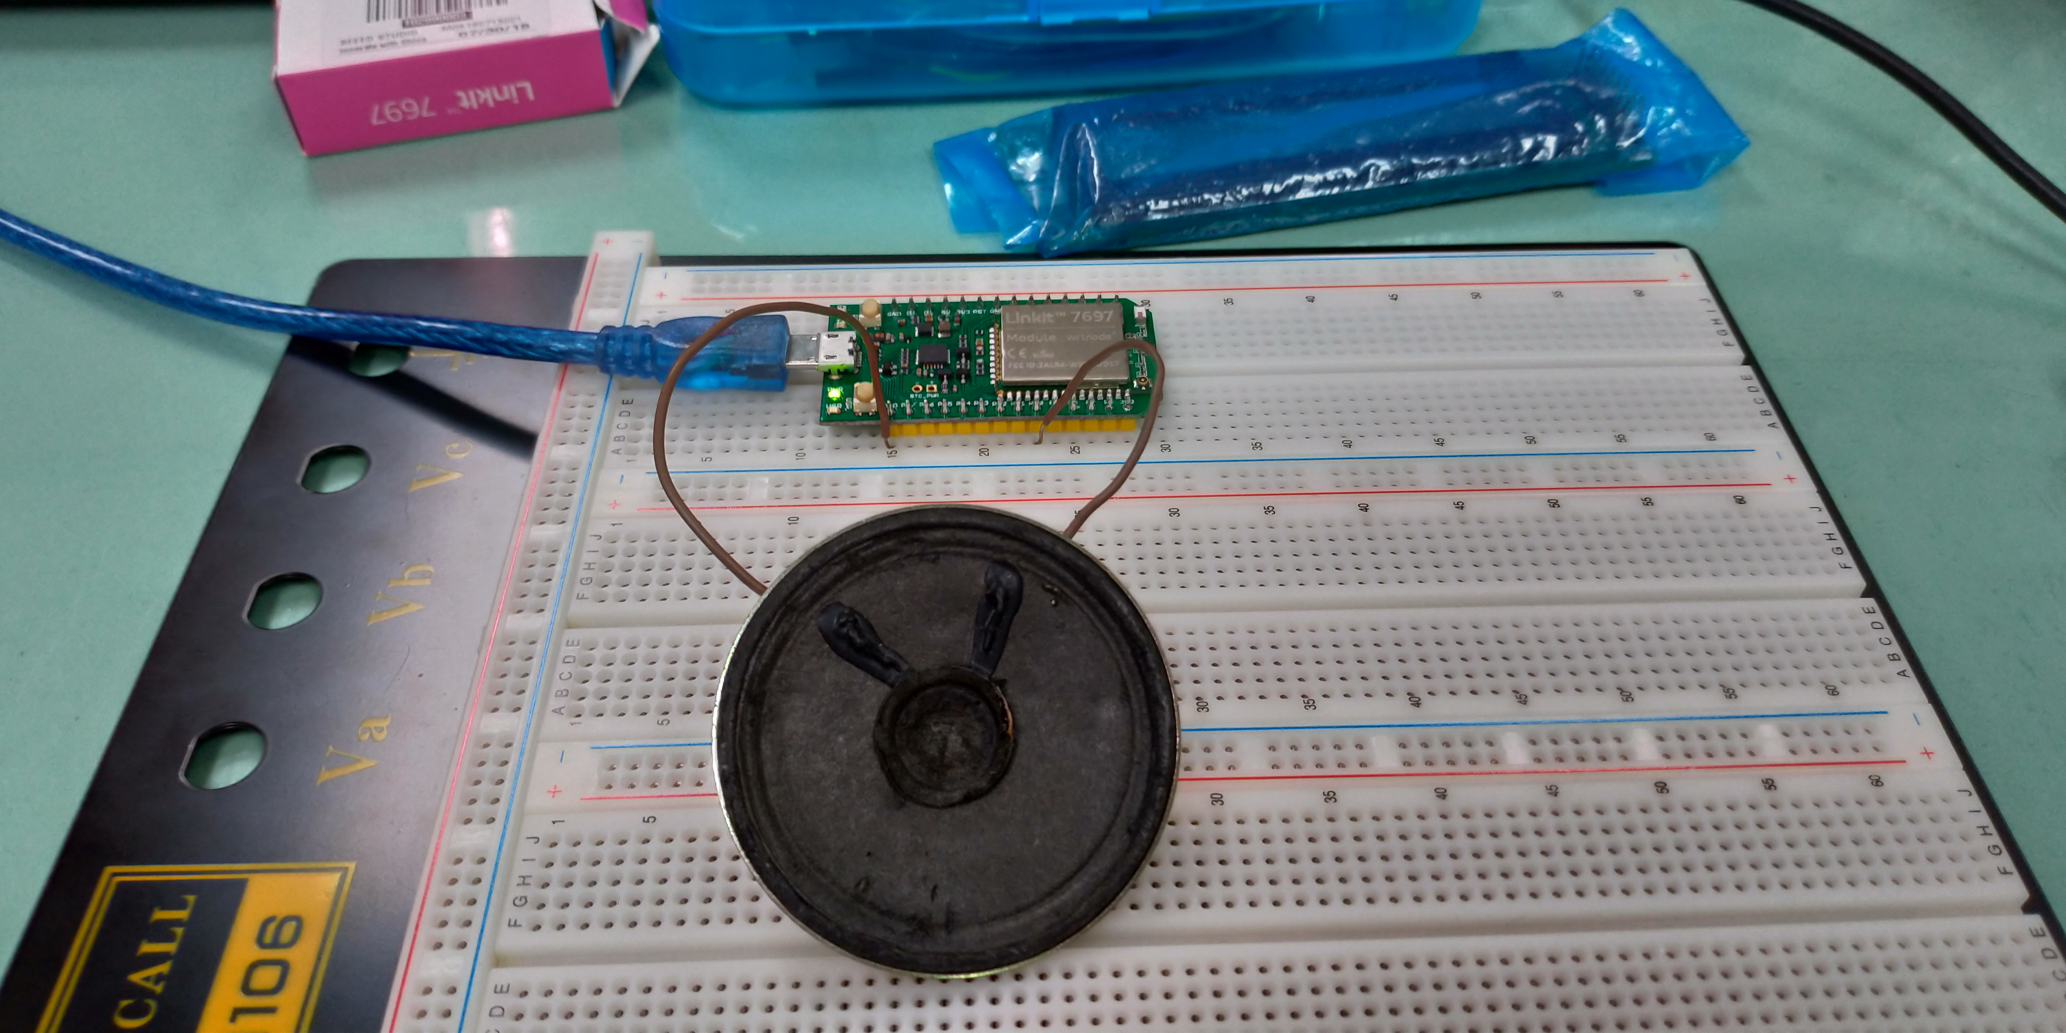
- 心得討論
這次的實驗內容很有趣

