"Wine" plays a particularly important role in French society, whether it is a meal with friends or a drink alone; a glass of red wine can also be drunk when you go to a restaurant for lunch on a weekday, and it is even sold in the school cafeteria, which shows that red wine is a French An important partner in life. However, there has been a structural change in the French who drink wine now.

Wine has a long history in France, dating back to around 600 BC, when the Greeks arrived in what is now Marseille, France, and brought vines and viticulture with them. In 51 BC, Caesar conquered the Gaul region, and formal vine cultivation began here. As the viticulture continued to expand northwards, in the 3rd century AD, Bordeaux and Burgundy began to produce wine for the undersupplied wine market. In the 6th century AD, with the rise of the church, the demand for wine increased sharply, coupled with the rich's demand for high-quality wine, which accelerated the pace of development of the French wine industry. During the Middle Ages, wine developed into a major French export. In the 19th century, French grape acreage hit a record high. In 1855, the Paris International Exposition carried out the famous chateau classification of French wine, which promoted French fine wine to the world.

“Le vin est le sang du Christ, c'est bon pour la santé” it means “Wine is the blood of Christ, it is good for health”

Now let's introduce some wine-related festivals in France

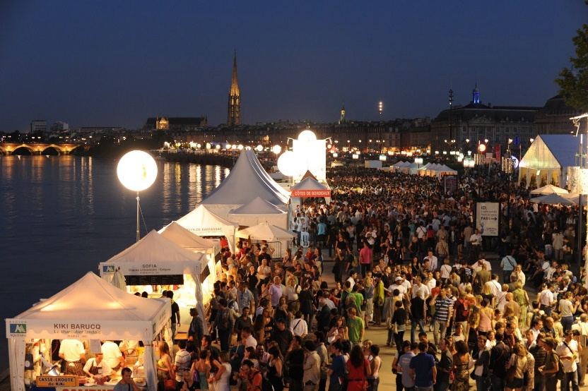Bordeaux wine Festival

The Bordeaux Wine Festival, or Fête le Vin as it is called by French people, is an international event open to the public held every two years. The festival is organized mainly on the river Garonne’s waterfront. On the Bordeaux quays, in the heart of this magnificent city, wine AND, food and culture lovers are invited to join the festival and discover the architectural beauty of the city, its exceptional regional products and the surrounding vineyards you can enjoy on Bordeaux wine tours.

There is a superb culinary offer on terraces, stands and stalls of local product. The main attraction of these festivals is the wine of Bordeaux, of course. In the wonderful Place des Quinconces, one of the largest city square in Europe, you can find 8 tasting pavilions where you can discover the 57 appellations of Bordeaux and the 23 ones belonging to the Aquitaine’s region.

Bordeaux wine tours are renowned all over the world. During the Bordeaux Wine Festival, you can experience almost a kind of a self-guided one, buying in pre-sales or directly there a tasting pass for approximately 20 USD. It includes a wine glass in its case with more than a dozens of tickets to taste some of red and white Bordeaux wines, which are among the greatest wines in the world, such as Pomerol, Saint Emilion and Medoc. With these tickets you can also experience some of the culinary gems of the area like the foie gras from Périgord, the Ossau-Iraty cheese and oysters from Arcachon in a cheerful atmosphere,Visiting the Wine Festival is a great excuse to explore Bordeaux. <=[source](https://www.risingvacations.com/bordeaux-wine-festival/)

=====================================================================

As far back as the 1800s, Beaujolais growers would gather to celebrate the end of the harvest by toasting the vintage with some of the young wine produced that year. (This is part of the French tradition of vin de primeur, or “early wines” , released in the same year as harvest, which 55 appellations in France are allowed to produce.) During this time, Lyonnais barkeepers and restauranturs had been in the habit of buying barrels of this new Beaujolais wine, that had been pressed in September and ready to serve in November. The new wine was served via pitchers dipped into barrels. The barrels were sometimes transported simply by floating them down the Saône river. Once the Beaujolais AOC was established in 1937, AOC rules meant that Beaujolais only wine could on be officially sold after 15 December in the year of harvest.These rules were relaxed in November 1951,and the Union Interprofessionnelle des Vins du Beaujolais (UIVB) formally set 15 November as the release date for what would henceforth be known as Beaujolais nouveau. In 1985 the Institut National des Appellations d'Origine (INAO) established the third Thursday of November to allow for a uniform release date for the wine.

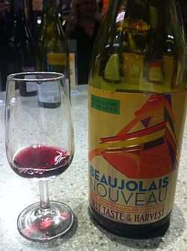The wine used to be released from France at 12:01 on the third Thursday of November. During the 2000s the release rules started to relax, with the wines shipped ahead of time, and released to local markets at 12:01 a.m. local time. Starting in the 2010s, it started to be sent to retailers ahead of the third Thursday, with instruction not to sell it until the third Thursday.

Some members of the UIVB saw the potential for marketing Beaujolais nouveau by capitalizing on fast distribution of the vintage, starting with a race to get the first bottles to Paris. In the 1960s, races from English clubs rewarded the drivers who returned the quickest with the most wine (sometimes resulting in spare tires being left in Beaujolais).There continued to be more media coverage, and by the 1970s it had become a national event. The races spread to neighboring countries in Europe in the 1980s, followed by North America, and in the 1990s to Asia.

Until 1972, New York was the only US city to import Beaujolais nouveau. That year, Minneapolis became the second US city to import it; now, it is available in most US metropolis areas, and in many large cities across the globe.

This "Beaujolais Day" is accompanied by publicity events and heavy advertising. The traditional slogan, even in English-speaking countries, was "Le Beaujolais nouveau est arrivé!" (literally, "The new Beaujolais has arrived!"), but in 2005 this was changed to "It's Beaujolais Nouveau Time!". In the United States, it is promoted as a drink for Thanksgiving, which always falls exactly one week after the wine is released (on the fourth Thursday of November).

In the United Kingdom, Beaujolais Day is particularly popular in Swansea, Wales, where people book tables in restaurants and bars for the day up to a year in advance.Historian Peter Stead argues that its rise in popularity there can be traced to the city's No Sign Bar in the 1960s, which was then owned by former Wales rugby union captain Clem Thomas, who owned a house in Burgundy and could transport Beaujolais quickly and cheaply to south Wales, and suggests that it reflected Swansea's efforts to "gentrify and intellectualise itself" at the time. In 2015 it was estimated that Beaujolais Day contributed £5 million to the local economy.

As of 2014, there were over 100 Beaujolais Nouveau-related festivals held in the Beaujolais region. One such festival, Les Sarmentelles, was held in Beaujeu, the capital of the region, and lasted for days. The winner of the annual tasting contest won their weight in wine.

Many producers release the nouveau with colourful or abstract design that changes every year, usually as an evolution from the previous year's design. Starting in 2017, one producer has a contest for their Beaujolais Nouveau label, and in 2020 there were over 1,000 entries.[14] Duboeuf has silk ties made each year with their label's abstract design, and releases them through select wholesalers and distributors.<=[source](https://en.wikipedia.org/wiki/Beaujolais_nouveau)