1. 向記帳本一樣，了很多的交易紀錄
2. 加密
3. 1:

> generate 100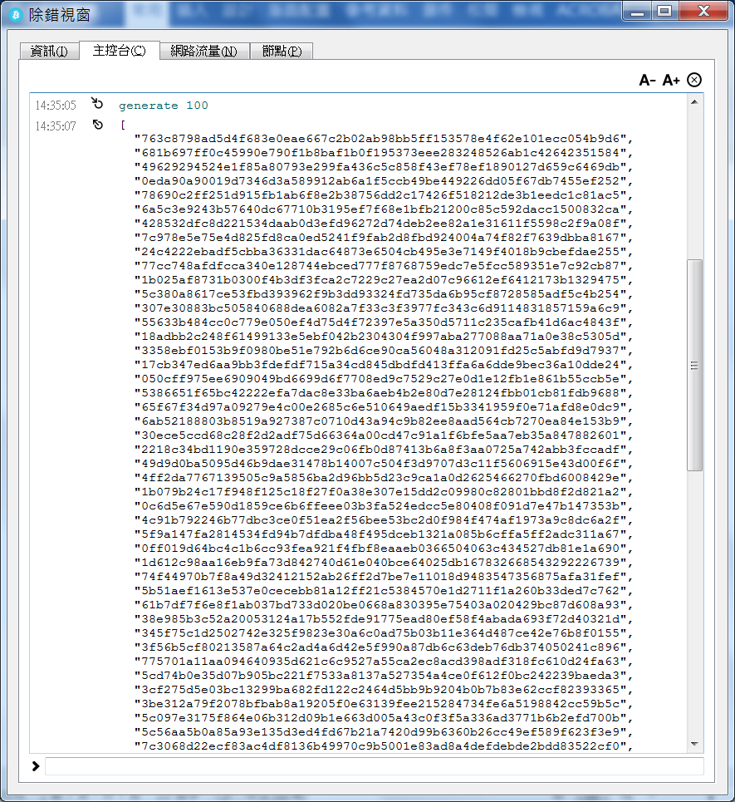

> getnewaddress

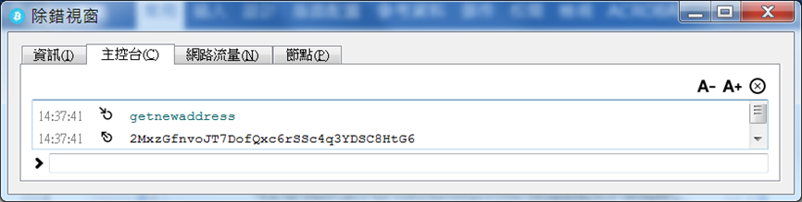

> sendtoaddress 2MxzGfnvoJT7DofQxc6rSSc4q3YDSC8HtG6 10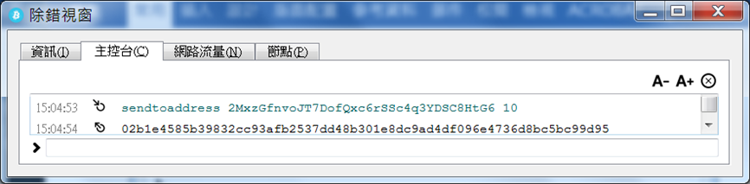

> createrawtransaction '''

[

{

"txid": "'02b1e4585b39832cc93afb2537dd48b301e8dc9ad4df096e4736d8bc5bc99d95'",

"vout": '0'

}

]

''' '''

{

"'2MxzGfnvoJT7DofQxc6rSSc4q3YDSC8HtG6'": 49.9999

}'''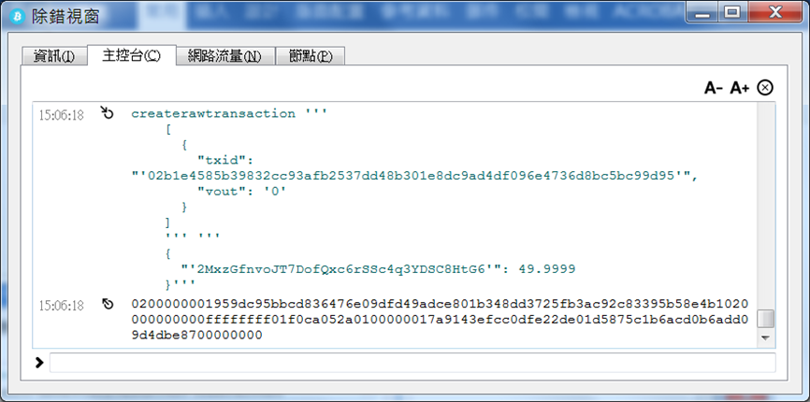

> signrawtransaction 0200000001923c53b5d3b5ce7e76ee78b0c737fa9dfdb6f8f6007ec1995e76a53fd64d19c70000000000ffffffff0100ca9a3b0000000017a9143efcc0dfe22de01d5875c1b6acd0b6add09d4dbe8700000000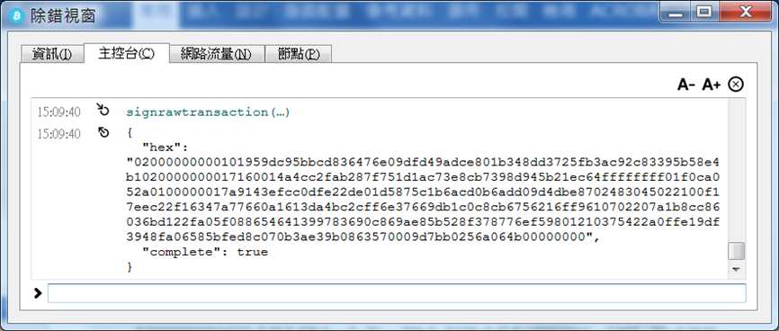

> signrawtransaction