**Statistical Computing**

61061110 Pan,Hsing-Cheng

HW6-2

首先畫圖觀察一下函數 $f\left(x\right)={-x}^{4}+{3x}^{2}+2$ 的樣子。

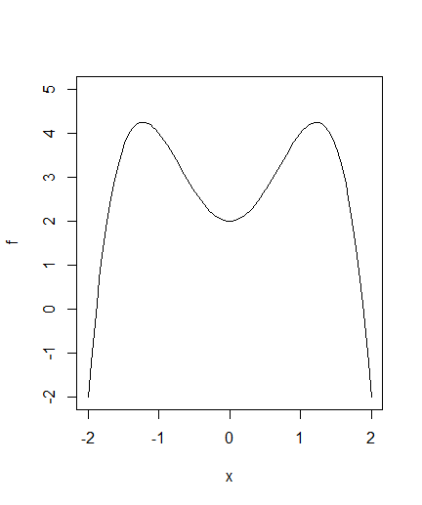

發現他有2個根，一個介於1到2另一個介於-1到-2。

首先使用二分法，對於1到2的跟進行估計。

|  |  |  |  |  |
| --- | --- | --- | --- | --- |
| 迭代次數 | 起始左端點 | 起始右端點 | 最後收斂的點 | 誤差設定 |
| 20 | 1 | 2 | 1.887208 | $${10}^{-6}$$ |
| 21 | 0 | 2 | 1.887208 | $${10}^{-6}$$ |
| 35 | 0 | 2 | 1.887208 | $${10}^{-10}$$ |
| 34 | 1 | 2 | 1.887208 | ${10}^{-10}$ |
| 37 | -1 | 10 | 1.887208 | $${10}^{-10}$$ |

再來使用二分法對於-1到-2的根進行估計。

|  |  |  |  |  |
| --- | --- | --- | --- | --- |
| 迭代次數 | 起始左端點 | 起始右端點 | 最後收斂點 | 誤差設定 |
| 36 | -3 | 1 | -1.887208 | $${10}^{-10}$$ |
| 22 | -3 | 1 | -1.887208 | $${10}^{-6}$$ |
| 26 | -50 | 1 | -1.887208 | $${10}^{-6}$$ |
| 39 | -50 | 1 | -1.887208 | ${10}^{-10}$ |

再來根據二分法結果選取牛頓法的起始點。首先是估計1到2的根。

|  |  |  |  |
| --- | --- | --- | --- |
| 迭代次數 | 起始點 | 最後收斂點 | 誤差設定 |
| 12 | 3 | 1.887208 | $${10}^{-10}$$ |
| 16 | 10 | 1.887208 | $${10}^{-10}$$ |
| 24 | 100 | 1.887208 | $${10}^{-10}$$ |

再來是估計-1到-2的根。

|  |  |  |  |
| --- | --- | --- | --- |
| 迭代次數 | 起始點 | 最後收斂點 | 誤差設定 |
| 11 | -3 | -1.887208 | $${10}^{-10}$$ |
| 17 | 0 | -1.887208 | $${10}^{-10}$$ |
| 150 | -1 | 0.7053442 | $${10}^{-10}$$ |

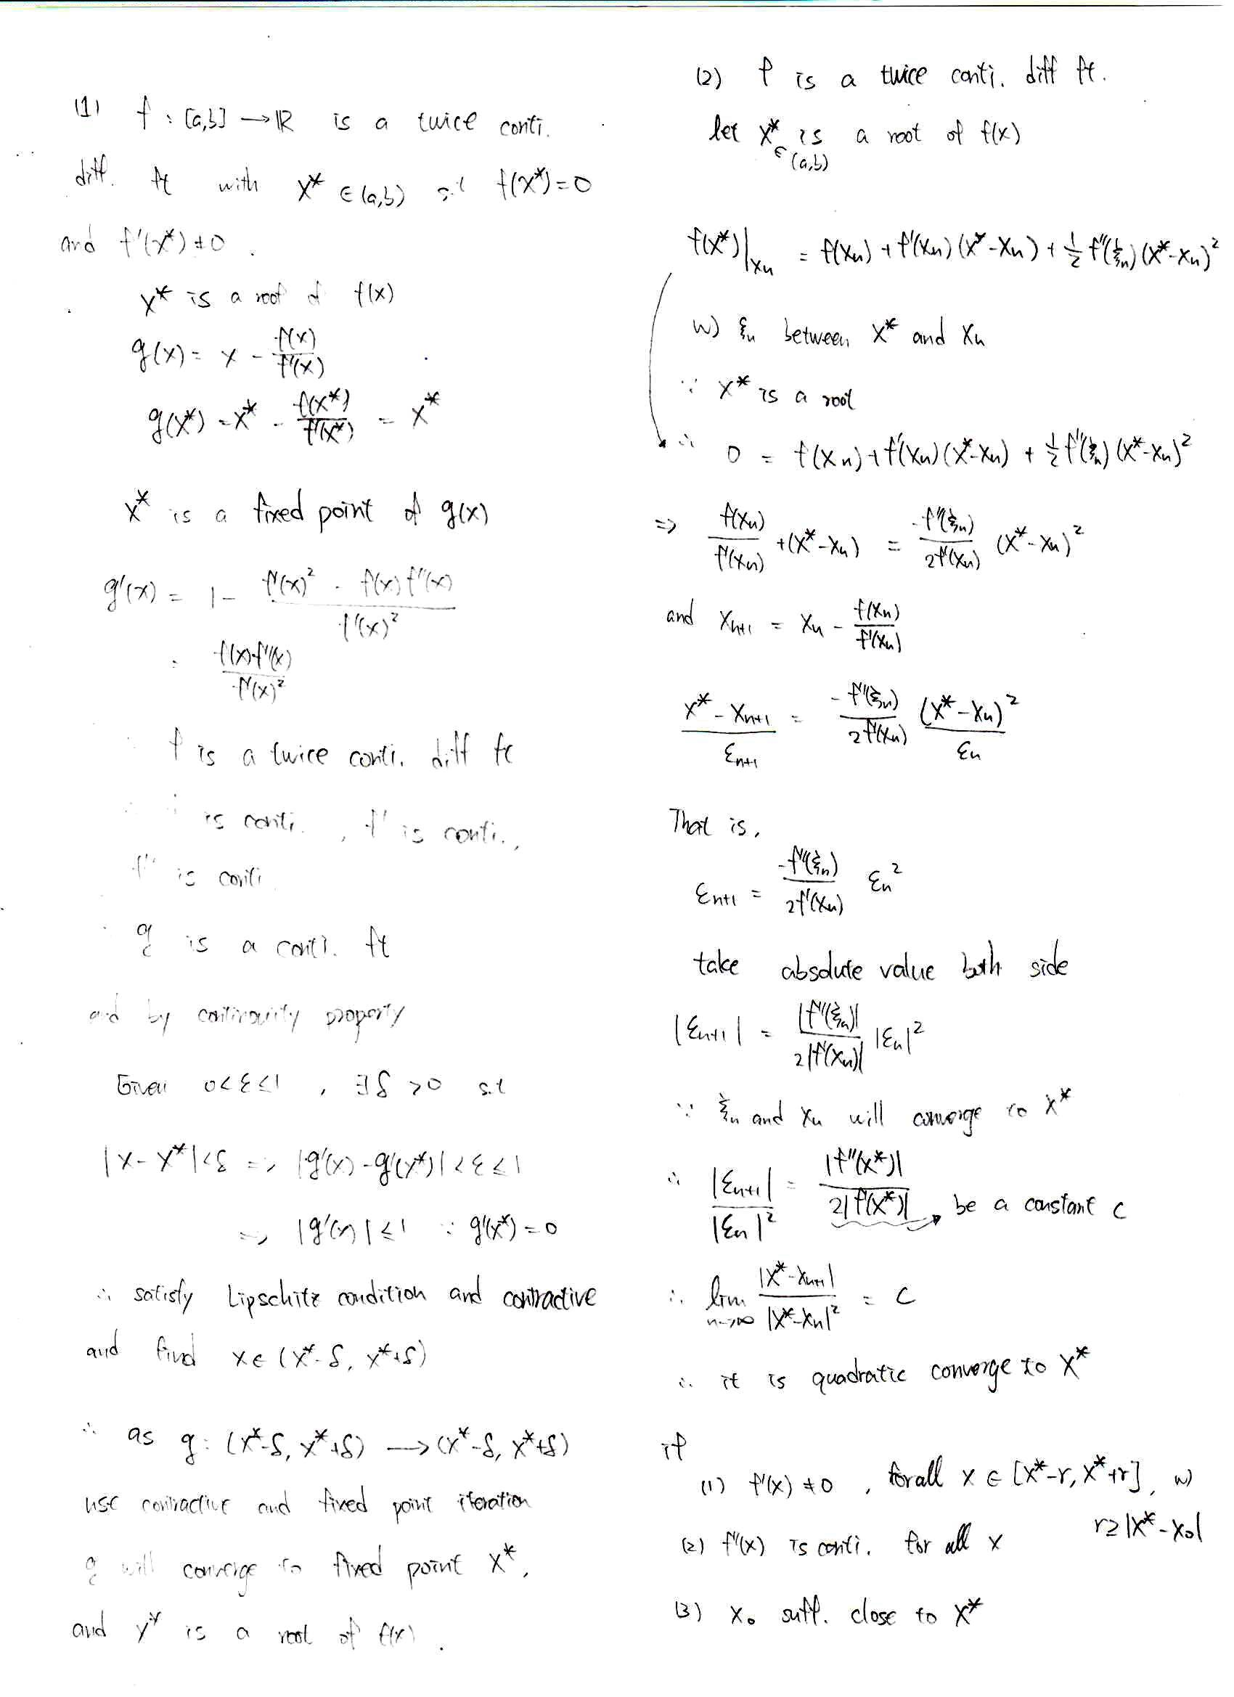

6-2 code:

|  |
| --- |
| f<-function(x){  -x^4+3*x^2+2  }  plot(f,xlim = c(-2,2),ylim =c(-2,5))  a<- -50  b<- 1  n<-1  conv<-FALSE  while(!conv){  xa<-a  xb<-b  xn<-(xa+xb)/2    if(f(xa)*f(xn)<0){  b<-xn  } else if(f(xn)*f(xb)<0){  a<-xn} else{cat("it had wrong interval!","\n")}    if(f(xn)==0){  cat("now n is:",n,"and find root is :",xn,"f(xn) is:",f(xn),"\n")  } else if(abs(a-b)<10^-10 | n>150){conv<-TRUE}  cat("now is",n,"iteration and xa value is:",a,"and xb is:",b,"\n")  cat("f(xa)*f(xb) is:",f(a)*f(b),"\n")  cat("middle value is:",(a+b)/2,"middle function value is:",f((a+b)/2),"\n\n")  n<-n+1  }  ####  f<-function(x){  -x^4+3*x^2+2  }  conv<-FALSE  x0<- -0.5  n<-1  h<-10^-5  xa<-x0  while(!conv){  xb<-xa  xn<-xb-f(xb)/((f(xb+h)-f(xb))/h)  xa<-xn  if(abs(f(xa))<10^-10 | n>150){conv<-TRUE}  cat("now is",n,"iteration and x value is:",xa,"and f(x) is:",f(xa),"\n")  n<-n+1  } |