Joanne Lee

Nov. 20, 2022

DB Foundation

Assignment 06

<https://github.com/Hsinjou99/DBFoundations>

Views

# Introduction

This week I learned about views in SQL, how to make them, and when to use them. Although tables and views both store data, views take their data from existing tables, and are automatically updated when the table it took data from is updated. Views, functions, and stored procedures all are similar to each other and can be used to simplify complex code.

# Views

By creating a view, you can save data from one or more tables by saving a select statement of a table. Views act like tables themselves because they are saved in databases and you can select them as well to see what’s stored in a view. To create a view, you need the CREATE VIEW statement. You will need add the name of the view, and the select statement to take data from one or more table. Example shown in Figure 1.

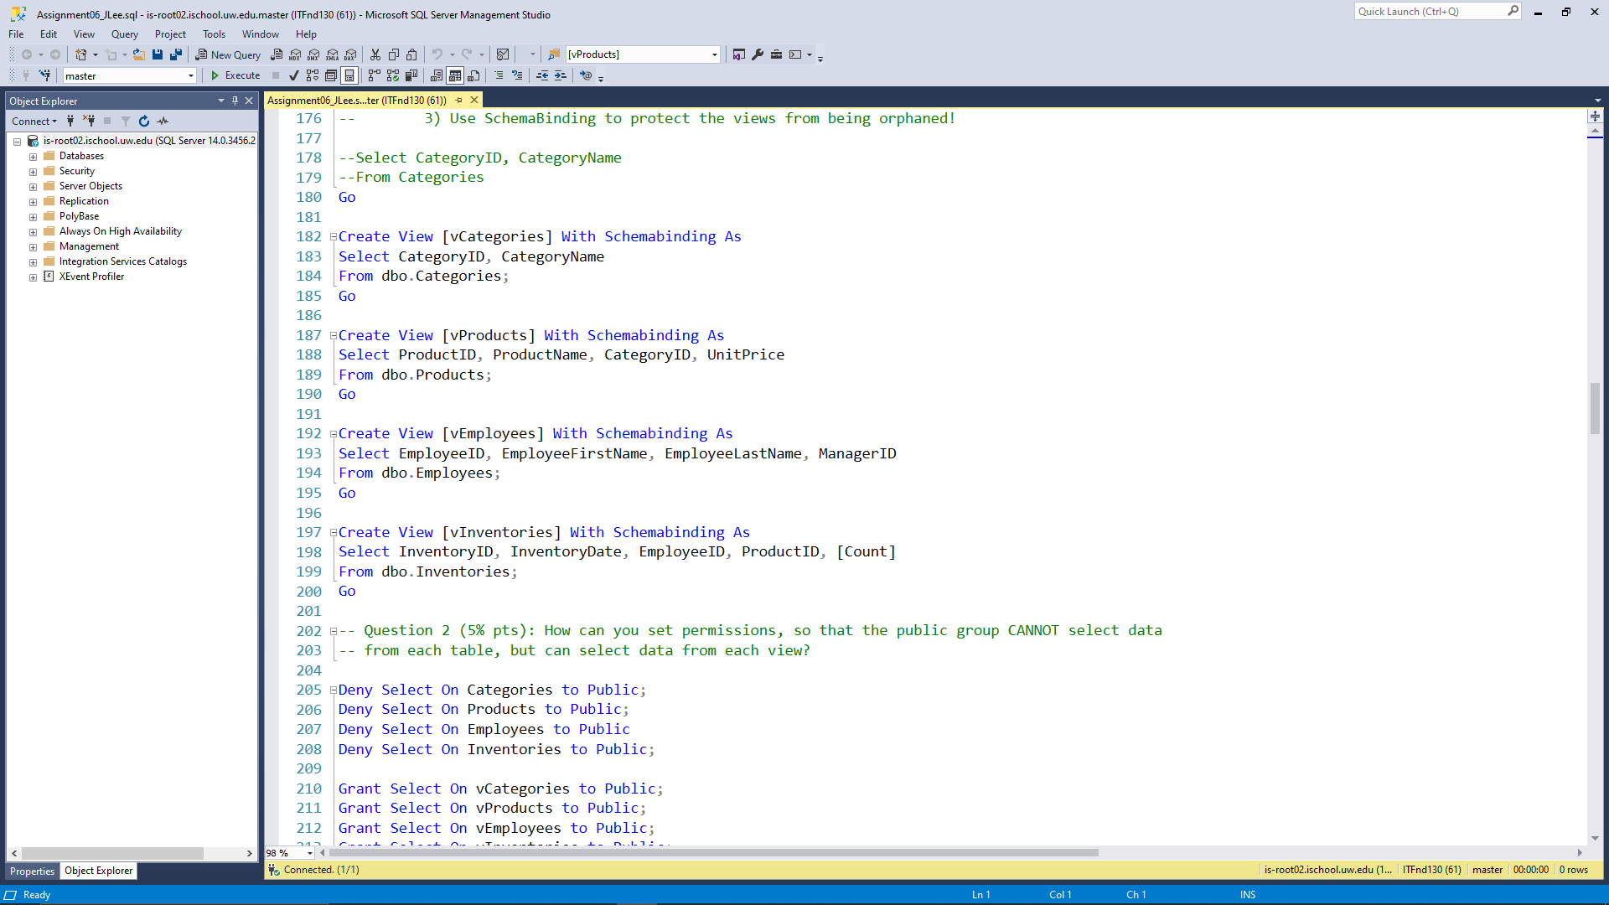

**Figure 1: Creating a view based off of the Categories table.**

# Functions

You can create a custom function to behave similarly to a. You can set up a function to return a table, and when executing a select statement with the function would give you a table just like a view would. What makes functions and views different is that you can set a parameter with functions so that it would give you a specific number of rows depending on what you are asking it to return. With views this would be the equivalent of using the WHERE clause. The difference in creating views and functions is that the CREATE FUNCTION statement requires RETURNS TABLE before the AS keyword, has the SELECT statement inside of RETURN(), and has () after the name of the function.

# Stored Procedures

Stored procedures can also do what views or functions can do. The setup of a stored procedure is just like that of a view, except that the name of the stored procedure has () just like functions, and uses the EXECUTE keyword instead of SELECT.

# Summary

Views, functions, and stored procedures can all be used to store SELECT statements within a database without having to use a text file. They can also be used to simplify a table for easier understanding. The three statements have different uses and specific keywords for creation, but all three can be used to do the same things.