Database Schema & API Contract
AI-Powered Social-Commerce Shop Automation Platform
Companion to the SRS and System Architecture documents | Prepared: 21 October 2026
Stack: PostgreSQL + pgvector, Python/FastAPI, React/TypeScript

1. Purpose
This document gives engineers a concrete starting point for implementation: the core entity-relationship model (tables, fields, relationships) and a first-pass REST API contract covering every module in the SRS. Field names and endpoint paths are a baseline for the first sprint and may be refined during detailed design, but the entities, relationships, and resource boundaries should remain stable, since other documents (SRS requirement IDs, architecture service boundaries) are written against them.

2. Entity-Relationship Diagram
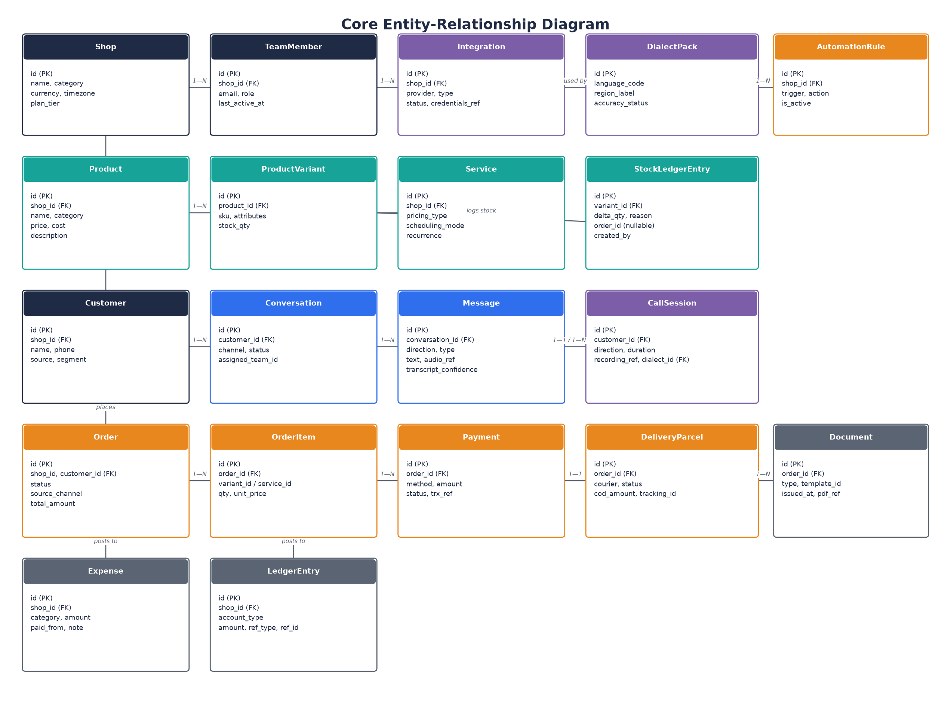
Figure 1 — Core entities and relationships across tenancy, catalogue, conversations/calls, commerce, and finance.

2.1 Entity Notes
Entity | Notes
Shop | The tenant root. Every other table (directly or transitively) scopes to shop_id for isolation.
TeamMember | A user account scoped to a Shop with a role (Super Admin, Admin, Sales, Support, Warehouse).
Integration | One row per connected external provider (messaging, payment, courier, productivity, telephony); stores status and a reference to encrypted credentials, never the raw secret.
DialectPack | Reference/config table of supported language/dialect models and their current accuracy/Beta status; referenced by CallSession and by Message transcription metadata.
AutomationRule | A configured rule/workflow/recipe instance: trigger condition plus action, togglable per Shop.
Product / ProductVariant | Product is the sellable item; ProductVariant holds per-variant SKU, attributes (size/color/etc.), and the authoritative stock_qty.
Service | A bookable/quotable offering, parallel to Product, with its own pricing/scheduling model (see SRS 3.3.2).
StockLedgerEntry | Append-only audit log of every stock change (order confirmation, cancellation, manual stock count, receive stock), each attributable to a user, automation, or order.
Customer | A buyer profile scoped to a Shop, with acquisition source and segment.
Conversation | A chat thread (any channel) tied to a customer; carries current handover/assignment state.
Message | An individual inbound/outbound message within a Conversation; for voice notes, stores an audio reference and transcript confidence score.
CallSession | A single phone call (inbound or outbound), separate from Message/Conversation because it has call-specific fields (duration, recording, detected dialect) but still links to the same Customer.
Order / OrderItem | Order is the header record (status, totals); OrderItem lines reference either a ProductVariant or a Service.
Payment | One row per recorded or gateway-reported payment against an Order, including manual-entry fields (method, sender, trx_ref) and confirmation status.
DeliveryParcel | One row per courier booking against an Order, tracking status and COD amount.
Document | A generated invoice/receipt/quotation/etc. tied to an Order, referencing the template used and the rendered PDF.
Expense / LedgerEntry | Expense is a manually or automatically recorded cost; LedgerEntry is the derived bookkeeping posting used to compute P&L and net worth.

3. REST API Contract (First-Pass)
All endpoints are prefixed with /api/v1 and require an Authorization bearer token unless marked Public. Every endpoint is implicitly scoped to the authenticated user's Shop; cross-tenant access is rejected at the service layer regardless of what a client requests.

3.1 Identity, Tenant & Team
Method & Path | Description | Auth
POST /auth/login | Authenticate and receive an access/refresh token pair. | Public
POST /auth/refresh | Exchange a refresh token for a new access token. | Public
POST /auth/logout | Invalidate the current session/token. | Team member
GET /shops/me | Get the current Shop profile, plan, and setup-checklist status. | Team member
PATCH /shops/me | Update shop profile, address, opening hours, delivery charges. | Admin+
GET /team-members | List team members with role and last-active status. | Admin+
POST /team-members/invite | Invite a teammate by email with a pre-assigned role. | Admin+
PATCH /team-members/{id} | Change a team member's role or deactivate them. | Super Admin

3.2 Integrations & Channels
Method & Path | Description | Auth
GET /integrations | List all integrations with status, grouped by category. | Admin+
POST /integrations/{provider}/connect | Start the guided connect flow for a provider (returns an OAuth URL or form). | Admin+
POST /integrations/{provider}/callback | OAuth/consent callback completing a connection. | Public (signed)
DELETE /integrations/{provider} | Disconnect a provider. | Admin+
POST /webhooks/{provider} | Inbound webhook receiver for a connected provider (messages, payment events, courier status). | Public (signature-verified)
GET /dialect-packs | List supported regional dialect packs and their status (GA/Beta). | Admin+
PATCH /dialect-packs/{id} | Enable/disable a dialect pack for this Shop. | Admin+

3.3 Catalogue & Inventory
Method & Path | Description | Auth
GET /products | List/search/filter products. | Team member
POST /products | Create a product (photo, name, price minimum). | Sales+
PATCH /products/{id} | Update a product or its variants. | Sales+
DELETE /products/{id} | Remove a product. | Admin+
POST /products/import | Bulk import products from an uploaded spreadsheet. | Admin+
GET /services | List/search services. | Team member
POST /services | Create a service with pricing/scheduling configuration. | Sales+
GET /inventory | List stock levels, low-stock and sold-out variants. | Team member
POST /inventory/receive-stock | Record incoming stock quantities. | Warehouse+
POST /inventory/stock-count | Submit a manual stock-count reconciliation. | Warehouse+
GET /inventory/{variant_id}/ledger | Get the full audit log of stock changes for a variant. | Admin+

3.4 Conversations, Messages & Calls
Method & Path | Description | Auth
GET /conversations | List/filter the unified inbox (messages + comments). | Team member
GET /conversations/{id}/messages | Get the full message thread for a conversation. | Team member
POST /conversations/{id}/messages | Send a reply (manual or AI-drafted-then-approved). | Sales+
POST /conversations/{id}/handover | Hand a conversation to another team/queue with an AI summary. | Support+
GET /saved-replies | List saved reply templates. | Team member
POST /saved-replies | Create a saved reply template with shortcut and merge variables. | Admin+
POST /messages/{id}/transcribe | Request/retrieve transcription for a voice-note message. | Team member
POST /calls/outbound | Place an outbound AI or human-initiated call. | Sales+
GET /calls/{id} | Get call details: status, duration, recording, transcript. | Team member
POST /calls/{id}/handover | Transfer a live call to a human team member. | Support+
POST /calls/{id}/monitor | Join a live call to silently listen in. | Admin+

3.5 Orders, Payments & Delivery
Method & Path | Description | Auth
GET /orders | List/filter orders by status, channel, customer. | Team member
POST /orders | Create an order (manual, from chat, or from a call). | Sales+
PATCH /orders/{id}/status | Transition an order's status (Confirmed, Packed, Shipped, Delivered, Returned, On Hold). | Sales+
GET /payments | List payments, filterable by status (Needs You, Auto-Confirmed, COD, All). | Team member
POST /payments | Record a manual payment against an order. | Sales+
POST /payments/{id}/confirm | Confirm a pending/queued payment. | Sales+
GET /delivery/parcels | List parcels with courier, status, and COD amount. | Team member
POST /delivery/parcels/book | Book one or more confirmed orders with a courier (supports bulk). | Warehouse+
GET /delivery/cod-summary | Get COD amounts outstanding with each courier. | Admin+

3.6 Customers & Marketing
Method & Path | Description | Auth
GET /customers | List/search customers with segment and order history. | Team member
PATCH /customers/{id}/block | Block or unblock a customer. | Support+
GET /customers/segments | List auto-computed customer segments. | Admin+
POST /social-posts | Create/schedule a social content post. | Sales+
POST /campaigns/bulk-message | Send a bulk email, SMS, WhatsApp, or voice-call campaign to a segment. | Admin+
GET /campaigns/{id}/report | Get delivery/read/outcome report for a bulk campaign. | Admin+

3.7 AI Assistant & Training
Method & Path | Description | Auth
POST /ai/ask | Ask the conversational assistant a question about the Shop's own data. | Team member
GET /ai/knowledge | List everything the AI has learned (facts, FAQs, instructions, files). | Admin+
POST /ai/knowledge | Teach the AI a new fact/policy/instruction. | Admin+
GET /ai/knowledge/pending | List AI-inferred facts awaiting merchant approval. | Admin+
POST /ai/knowledge/pending/{id}/approve | Approve (or reject) an AI-inferred fact. | Admin+
POST /ai/simulate-chat | Start a simulated chat session to test AI behavior. | Admin+
POST /ai/simulate-call | Start a simulated test call (optionally in a selected dialect). | Admin+

3.8 Finance & Documents
Method & Path | Description | Auth
GET /finance/overview | Get P&L, cash forecast, and what-you-own-and-owe summary. | Admin+
POST /finance/expenses | Record an expense. | Admin+
GET /finance/statements/{period} | Get a monthly/quarterly/annual statement. | Admin+
GET /finance/exports/{type} | Download an export (accountant pack, sales book, expenses, stock value). | Admin+
GET /documents/templates | List invoice/receipt/etc. templates and the current default per type. | Admin+
PATCH /documents/templates/default | Set the default template for a document type. | Admin+
GET /documents | List issued documents for an order or period. | Team member
POST /documents/issue | Manually issue a document (catch-up run). | Admin+

3.9 Automation & Plans
Method & Path | Description | Auth
GET /automations/rules | List configured automation rules/workflows. | Admin+
POST /automations/rules | Create a rule/workflow. | Admin+
GET /automations/recipes | List pre-built recipes available to enable. | Admin+
POST /automations/recipes/{id}/enable | Enable a pre-built recipe. | Admin+
GET /plan | Get current plan, AI-credit balance, and usage. | Admin+
POST /plan/change | Upgrade, downgrade, or request a custom plan. | Super Admin

4. Conventions
- All list endpoints support pagination (?page, ?page_size), filtering via query parameters, and a consistent envelope: {"data": [...], "meta": {"total": N, "page": N}}.
- All timestamps are ISO 8601 UTC; monetary amounts are integers in the smallest currency unit to avoid floating-point rounding errors.
- Role column values (Sales+, Admin+, etc.) mean "this role or any role with equal/greater scope," matching the role table in the SRS.
- Every mutating endpoint publishes a corresponding domain event to the event bus (e.g., order.confirmed, payment.matched, call.ended) for the Automation Engine, Analytics, and Notification subscribers described in the architecture document.

