System Architecture & Development Flow
AI-Powered Social-Commerce Shop Automation Platform
Companion to the Software Requirements Specification | Prepared: 21 October 2026
Covers: Architecture, Data Flow, Technology Stack, and Total Development Workflow

1. Purpose & How to Use This Document
This document translates the Software Requirements Specification into a concrete system architecture and a complete development workflow. It is intended for engineering leads, architects, and the delivery team to align on: how the system is structured in layers and services, how a single customer interaction flows end-to-end through those layers, and the step-by-step process the team follows from requirement to production release. It should be read alongside the SRS, which remains the source of truth for functional scope.

2. System Architecture

2.1 Architecture Style
The system is built as a multi-tenant, service-oriented (microservice-leaning) cloud application, organized into five layers: Client, Edge/Gateway, Application & AI Service, Data, and External Integration. Each tenant ("Shop") is isolated at the data layer while sharing the same application and AI services, allowing new Shops to be onboarded without additional infrastructure. Services communicate synchronously via internal APIs for request/response needs and asynchronously via an event bus for background processing (stock updates, document generation, automation triggers, analytics).

2.2 Layered Architecture Diagram
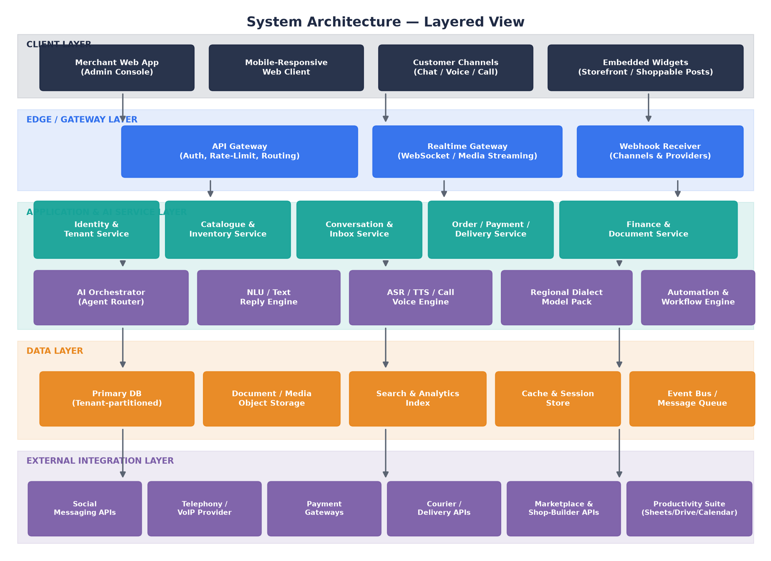
Figure 1 — Layered system architecture: client surfaces, edge/gateway, application & AI services, data layer, and external integrations.

2.3 Layer-by-Layer Description

2.3.1 Client Layer
- Merchant Web App (Admin Console) — the primary operator interface: dashboard, orders, catalogue, inbox, finance, settings.
- Mobile-Responsive Web Client — the same application rendering correctly on phone-width viewports; no separate native codebase required for launch.
- Customer Channels — the surfaces a shopper actually uses: chat threads, voice notes, and live phone calls, routed in through the gateway layer.
- Embedded Widgets — shoppable elements embedded in a storefront or social post that let a customer tap to view price/order without leaving the content.

2.3.2 Edge / Gateway Layer
- API Gateway — single entry point for all client-originated REST/GraphQL calls; handles authentication, per-tenant rate-limiting, and request routing to the correct internal service.
- Realtime Gateway — manages WebSocket connections for live inbox updates and streams audio for live voice calls to/from the Voice Engine with minimal latency.
- Webhook Receiver — the inbound endpoint that accepts events pushed by external providers (message-channel events, payment callbacks, courier status updates) and converts them into internal events.

2.3.3 Application & AI Service Layer
- Identity & Tenant Service — authentication, team/role management, and tenant (Shop) isolation boundaries.
- Catalogue & Inventory Service — product/service CRUD, variants, stock ledger, and catalogue sync from connected channels.
- Conversation & Inbox Service — unified message/comment/call-session storage, saved replies, and handover routing logic.
- Order / Payment / Delivery Service — order state machine, payment matching/reconciliation, and courier booking/tracking.
- Finance & Document Service — bookkeeping ledgers, statements, and invoice/receipt template rendering and issuance rules.
- AI Orchestrator (Agent Router) — the central decision-maker that inspects an incoming event and routes it to the right AI capability (text reply, voice reply, automation, or human escalation), applying the merchant's configured guardrails and Autopilot settings.
- NLU / Text Reply Engine — intent/entity extraction and reply drafting for chat-based conversations.
- ASR / TTS / Call Voice Engine — real-time speech recognition, speech synthesis, and call-session management for live calls and voice-note transcription.
- Regional Dialect Model Pack — the pluggable set of language/acoustic models covering Standard Bangla, English, and supported regional varieties, loaded by the Voice Engine based on detected language.
- Automation & Workflow Engine — executes merchant-defined rules, scheduled jobs, and pre-built recipes, and reacts to events published on the event bus.

2.3.4 Data Layer
- Primary Database — the tenant-partitioned relational store holding shops, products, orders, payments, customers, and configuration.
- Document / Media Object Storage — stores product photos, call recordings, voice-note audio, and generated PDF documents.
- Search & Analytics Index — a denormalized, query-optimized index powering dashboard KPIs, reporting, and full-text/semantic search across products and conversations.
- Cache & Session Store — low-latency storage for active sessions, rate-limit counters, and frequently accessed reference data.
- Event Bus / Message Queue — decouples services; publishes domain events (order confirmed, payment matched, call ended) consumed by Finance, Automation, Analytics, and Notification subscribers.

2.3.5 External Integration Layer
- Social Messaging APIs — Facebook Page/Messenger, Instagram Direct, WhatsApp Business, Telegram, and a generic webhook channel.
- Telephony / VoIP Provider — provides phone numbers, call routing, recording, and real-time audio streaming for the Voice Engine.
- Payment Gateways — mobile wallets, card processors, and payment-link providers.
- Courier / Delivery APIs — parcel booking, tracking, and COD settlement providers.
- Marketplace & Shop-Builder APIs — external storefronts and marketplaces for catalogue syndication and order pull-in.
- Productivity Suite — spreadsheet, cloud-storage, and calendar integrations used for bulk import/export and service scheduling.

2.4 Technology Stack (Selected: Single-Language Python Backend)
To avoid cross-language network hops between business logic and the AI/Voice layer, and to keep the team and hiring pool to one backend language, the platform standardizes on Python across every backend service, paired with a React/TypeScript frontend.
Layer | Selected Technology
Client (Web Admin Console) | React with TypeScript; a component library (e.g., MUI/Ant Design) for dashboards, tables, and forms; responsive layout for mobile-width screens.
Client (Future Native Mobile) | React Native, reusing business logic, API clients, and a large share of UI components from the web app.
Edge / Gateway | FastAPI-based API gateway (Python) with JWT/OAuth2 authentication, per-tenant rate-limiting; native WebSocket support (FastAPI/Starlette) for the Realtime Gateway; FastAPI endpoints for webhook ingestion with signature verification.
Application Services | A Python modular monolith (FastAPI) organized into clear internal modules — Identity/Tenant, Catalogue/Inventory, Conversation/Inbox, Orders/Payments/Delivery, Finance/Documents — deployed as one or a small number of services, not a large microservice fleet.
AI Orchestrator & NLU | Python, using an LLM provider (managed API or self-hosted) for intent extraction, reply drafting, and the Agent Router; a vector store (e.g., pgvector or a dedicated vector DB) for AI-training facts/FAQ retrieval.
ASR / TTS / Call Voice Engine | Python service wrapping a streaming speech-to-text engine and a text-to-speech engine, with pluggable acoustic/language models per Regional Dialect Pack; same language as the rest of the backend, so no serialization/network boundary between NLU and Voice logic.
Background Jobs / Automation Engine | Celery (or RQ) with Python task workers for scheduled jobs, automation recipes, and asynchronous processing (document generation, bulk campaigns, stock reconciliation).
Data | PostgreSQL (tenant-partitioned schemas or row-level isolation) as the primary database — pgvector extension covers the vector-store need in the same database; object storage (e.g., S3-compatible) for media, recordings, and documents; a managed search/analytics engine for dashboard KPIs and reporting if PostgreSQL alone is insufficient at scale.
Cache & Sessions | Redis for session storage, rate-limit counters, and frequently accessed reference data; also used as the Celery broker/result backend.
Messaging / Events | Redis Streams or a managed pub/sub service as the event bus, published to and consumed by Python services/workers for domain events (order confirmed, payment matched, call ended).
Infrastructure | Docker containers for every Python service and the React app; container orchestration (e.g., Kubernetes) across multiple availability zones; infrastructure-as-code for repeatable environments; centralized logging, metrics, and tracing (e.g., OpenTelemetry) across all Python services.

Net effect on the layered architecture in Figure 1: every box in the "Application & AI Service Layer" is implemented in Python and can share code (data models, validation, authentication) directly, rather than through a network API — the only genuinely external network boundaries remain the Edge/Gateway-to-client boundary and the External Integration Layer (third-party providers).

3. End-to-End Data & Message Flow

3.1 Flow Diagram
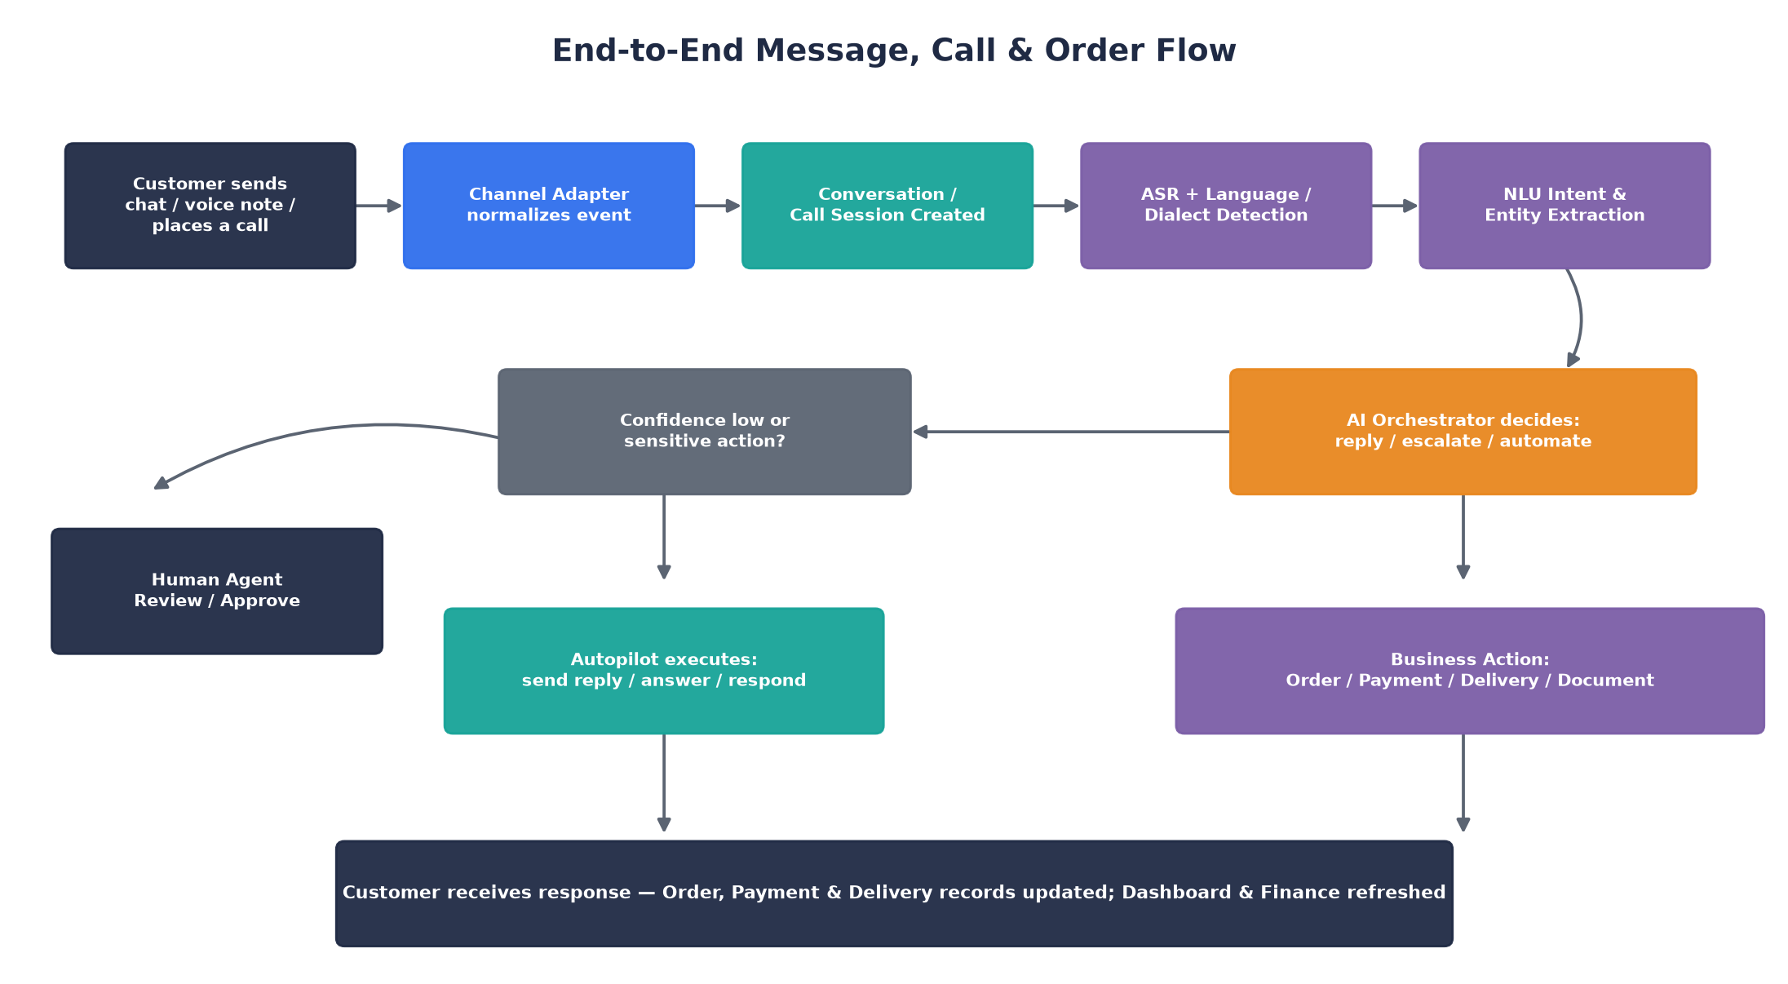
Figure 2 — A single customer interaction traced from channel entry through AI processing to business action and response.

3.2 Step-by-Step Narrative
- A customer sends a chat message, a voice note, or places a phone call through any connected channel.
- The relevant Channel Adapter normalizes the event (regardless of source channel) into a common internal message/call format.
- The Conversation & Inbox Service creates or appends to a conversation/call session tied to the customer and Shop.
- For voice input, the ASR engine transcribes the audio while simultaneously running language/dialect detection, selecting the correct Regional Dialect Model where applicable.
- The NLU stage extracts intent and entities (e.g., "wants to order," "asking about delivery charge," "reporting a problem") from the transcribed or typed text.
- The AI Orchestrator evaluates the extracted intent against the merchant's configured guardrails and decides one of three paths: reply directly, escalate to a human, or trigger an automation/business action.
- If the interaction involves a sensitive action (e.g., large order value, refund request) or the AI's confidence is low, the system routes it to a Human Agent for review and approval before anything is sent to the customer.
- Otherwise, Autopilot executes the response directly — sending a text reply, speaking on the call, or both.
- In parallel, any resulting business action (creating an order, matching a payment, booking a delivery, issuing a document) is executed by the relevant Application Service and recorded.
- The customer receives their response, and the merchant's dashboard, order list, and finance figures update in real time via the event bus.

3.3 Key Design Principles Reflected in the Flow
- Human-in-the-loop by default for financially sensitive or low-confidence cases, with Autopilot available only where the merchant has explicitly enabled it.
- Every AI decision is logged with its confidence and the data it used, supporting later audit and dialect-accuracy measurement.
- Voice and text share the same downstream NLU/Orchestrator/Business-Action pipeline — only the input (ASR) and output (TTS/call audio vs. text message) legs differ — minimizing duplicated logic.

4. Total Development Flow

4.1 Development Workflow Diagram
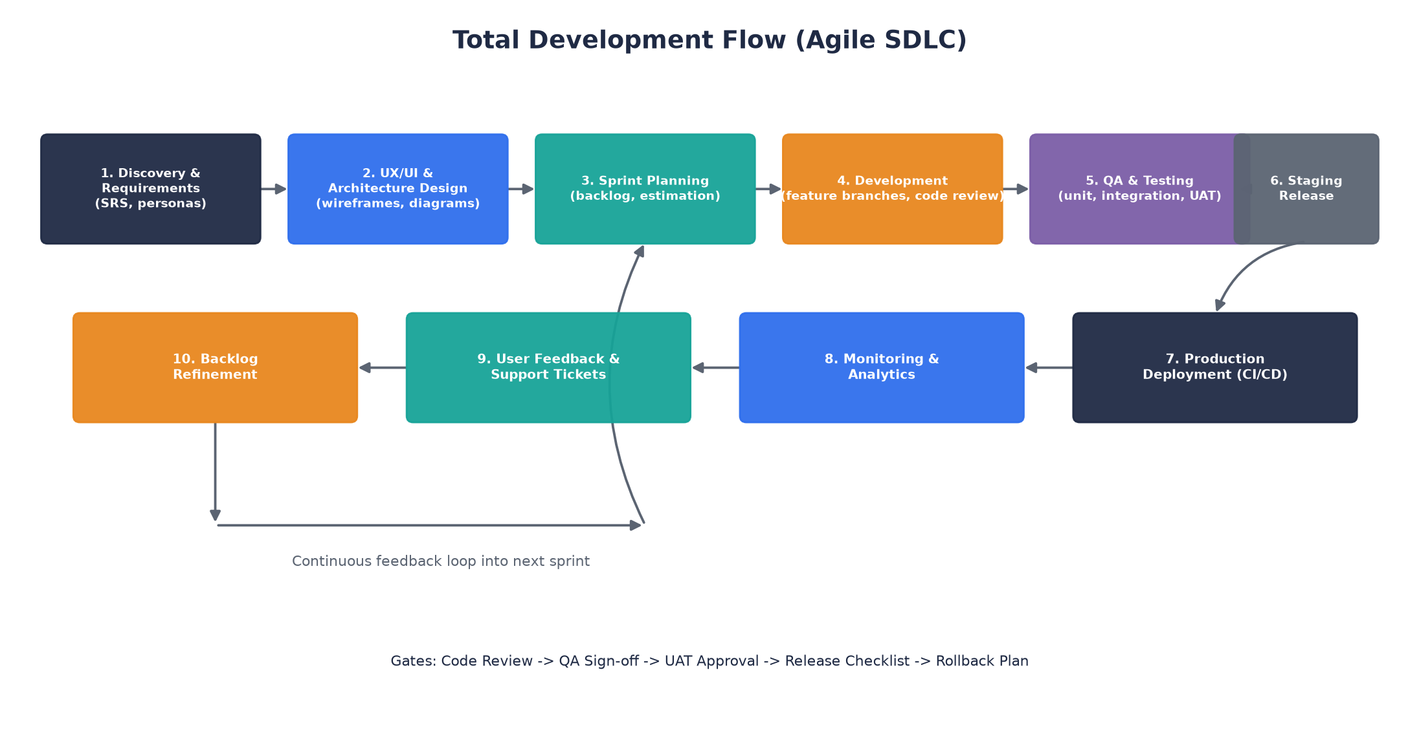
Figure 3 — The full Agile development lifecycle, from requirements through release, with a continuous feedback loop back into planning.

4.2 Phase-by-Phase Description

4.2.1 Discovery & Requirements
Business goals, user personas, and functional/non-functional requirements are captured and maintained in the Software Requirements Specification. Open questions are resolved with stakeholders before design begins; requirement IDs established here are referenced through design, development, and test.

4.2.2 UX/UI & Architecture Design
Wireframes and clickable prototypes are produced for each module; the architecture and data-flow diagrams in Sections 2–3 of this document are finalized and reviewed by engineering leads before implementation starts. API contracts between services are drafted at this stage.

4.2.3 Sprint Planning
Requirements are broken into a prioritized backlog of user stories, estimated, and pulled into time-boxed sprints. Each story references its source requirement ID for traceability.

4.2.4 Development
Engineers implement stories on isolated feature branches, with mandatory peer code review before merging. Automated unit tests accompany new code; services are built and run in containers matching the production environment.

4.2.5 QA & Testing
Dedicated QA performs functional testing against acceptance criteria, integration testing across services (including third-party sandbox integrations for channels, payments, and couriers), and coordinates User Acceptance Testing (UAT) with the business stakeholder before sign-off.

4.2.6 Staging Release
Approved changes are deployed to a staging environment that mirrors production configuration, where a final smoke test and stakeholder walkthrough occur prior to promotion.

4.2.7 Production Deployment (CI/CD)
A continuous-integration/continuous-deployment pipeline builds, tests, and deploys approved changes automatically, following a documented release checklist and a tested rollback plan.

4.2.8 Monitoring & Analytics
Post-release, system health (uptime, latency, error rates), AI/voice quality metrics (confidence, dialect accuracy, handling time), and business KPIs are continuously monitored on operational dashboards, with alerting on anomalies.

4.2.9 User Feedback & Support Tickets
Issues and feature requests raised through the in-app support center, merchant interviews, or monitoring alerts are triaged and logged.

4.2.10 Backlog Refinement
Triaged feedback and new requirements feed back into backlog refinement, closing the loop into the next sprint-planning cycle — making this a continuous, iterative process rather than a single linear pass.

4.3 Release Gates
Every release must pass the following gates in order: Code Review approval, QA sign-off, UAT approval from the business stakeholder, completion of the release checklist, and confirmation that a rollback plan is in place and tested.

4.4 Environments
Environment | Purpose
Local / Development | Individual engineer workstations; feature branches; mocked or sandbox third-party integrations.
Integration / QA | Shared environment for automated test suites and manual QA; sandbox credentials for all external providers.
Staging | Production-equivalent configuration for final verification and stakeholder UAT before go-live.
Production | Live multi-tenant environment serving real Shops and customers; full monitoring, alerting, and backup in place.

5. Suggested Delivery Roadmap (Phased)
Phase | Focus
Phase 1 — Foundation | Identity/Tenant service, Catalogue & Inventory, basic Orders, one messaging channel (text only), core dashboard.
Phase 2 — Commerce Operations | Payments reconciliation, Delivery/courier booking, Finance/bookkeeping basics, Document templates & auto-issuance.
Phase 3 — Conversational AI | NLU/Text Reply Engine, AI training interface, saved replies, Autopilot guardrails for chat.
Phase 4 — Voice & Calling | Telephony integration, ASR/TTS Voice Engine, voice-note transcription, initial Standard Bangla + English dialect support, call handover.
Phase 5 — Regional Dialect Expansion | Incremental rollout of additional regional dialect packs in Beta, accuracy monitoring, continuous model improvement feedback loop.
Phase 6 — Growth & Automation | Social content studio, bulk email/SMS/WhatsApp/voice campaigns, automation engine and recipes, advanced team/role features, marketplace integrations.

