Introduction to Machine Learning Course

Short HW2: Classification: Introduction
Submitted individually by Sunday, 07.07, at 23:59.
You may answer in Hebrew or English and write on a computer or by hand (but be clear).
Please submit a PDF file named as your ID number, e.g., 123456789.pdf.
Bonus (maximal grade is 100): Writing on a computer (using LyX/LaTeX, Word + Equation tool, etc.) = 2 pts.

Decision trees
- This question demonstrates that ID3 does not always yield an optimal tree. Consider the following dataset:

ID | Feature A | Feature B | Feature C | Target
1 | 1 | 1 | 1 | +1
2 | 1 | 0 | 0 | +1
3 | 1 | 1 | 0 | -1
4 | 0 | 0 | 1 | -1

  - Run ID3 manually up to depth 2. In the case of a leaf with non-zero entropy predict the majority label in that leaf. In case of a tie, predict “-1”. The nodes and edges in the decision tree should be labeled appropriately. You can use your preferred graphics software to draw the tree, or you can hand draw it (neatly). Calculate the training error on the given dataset and state which tuples were misclassified.
Answer:
Notes:
- Target is denoted as T, meaning Target = +1 is equivalent to T = +1.
First decision:
- Computing Information gain for all feature splits per feature:
- Feature A:
- Splitting by A yields the following ID’s split: {4} given A =0 , {1,2,3} Given A=1
- Computing probabilities:
T\A | A = 0 | A =1
T = +1 | 0 | 2/3
T = -1 | 1 | 1/3

- Computing Entropies:
- H(v = root) = 1 (i.e. initial Entropy)
- H(A =1) = 0.91829
- H(A = 0) = 0
- Computing Information gain: (From V = root node)
- IG(V,A) = 0.312

- Feature B:
- Splitting by B yields the following ID’s split: {2,4} given B =0 , {1,3} Given B=1
- Computing probabilities:
T\B | B = 0 | B=1
T = +1 | 1/2 | 1/2
T = -1 | 1/2 | 1/2

- Computing Entropies:
- H(v = root) = 1 (i.e. initial Entropy)
- H(B =1) = 1
- H(B = 0) = 1
- Computing Information gain: (From V = root node)
- IG(V,B) = 0
- Feature C:
- Splitting by C yields the following ID’s split: {2,3} given C =0 , {1,4} Given C=1
- Computing probabilities:
T\C | C = 0 | C=1
T = +1 | 1/2 | 1/2
T = -1 | 1/2 | 1/2

- Computing Entropies:
- H(v = root) = 1 (i.e. initial Entropy)
- H(C =1) = 1
- H(C = 0) = 1
- Computing Information gain: (From V = root node)
- IG(V,C) = 0

- Feature A yields the most information gain, therefore the first split is by the values of A.
- For A =0 we get a pure node consisting of ID = 4 by itself
- For A = 1, we get the following table:
ID’S | A | B | C | Target
1 | 1 | 1 | 1 | +1
2 | 1 | 0 | 0 | +1
3 | 1 | 1 | 0 | -1

Second decision:
- Computing Information gain for all feature (except feature A, since it yields a trivial split resulting in an information gain of zero) splits per feature:
- Feature B:
- Splitting by B yields the following ID’s split: {2} given B =0 , {1,3} Given B=1
- Computing probabilities: Given A =1
T\B | B = 0 | B=1
T = +1 | 1 | 1/2
T = -1 | 0 | 1/2

- Computing Entropies:
- H(v = root of {A =1}) = H({A =1}) = 0.91829 (i.e. initial Entropy, from the A = 1 sub tree)
- H(A =1,B =1) = 1
- H(A =1,B = 0) = 0
- Computing Information gain: (From V = root node)
- IG(V = root of {A =1},B) = 0.251
- Feature C:
- Splitting by C yields the following ID’s split: {2,3} given C =0 , {1} Given C=1
- Computing probabilities: Given A =1
T\C | C = 0 | C=1
T = +1 | 1/2 | 1
T = -1 | 1/2 | 0

- Computing Entropies:
- H(v = root of {A =1}) = H({A =1}) = 0.91829 (i.e. initial Entropy, from the A = 1 sub tree)
- H(A =1,C =1) = 0
- H(A =1,C = 0) = 1
- Computing Information gain: (From V = root node)
- IG(V = root of {A =1},C) = 0.251
- Since B and C are tied in terms of information gain, arbitrarily we can choose to split by B.
The final result for the tree:
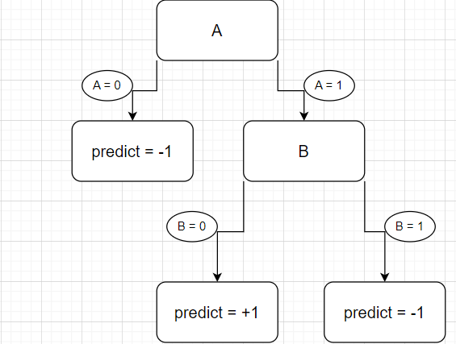
Note: for A = B =1, the prediction is -1 due to the majority rules given
Predictions on training data summary:
- ID’s predicted right: 2,3,4
- ID’s predicted wrong: 1
- 25% error rate
  - Find (manually) a decision tree of depth 2 that fits the training data perfectly.

Answer: Consider the following tree, where each path to a leaf describes a unique ID in the training data set.
Therefore achieving perfect accuracy.
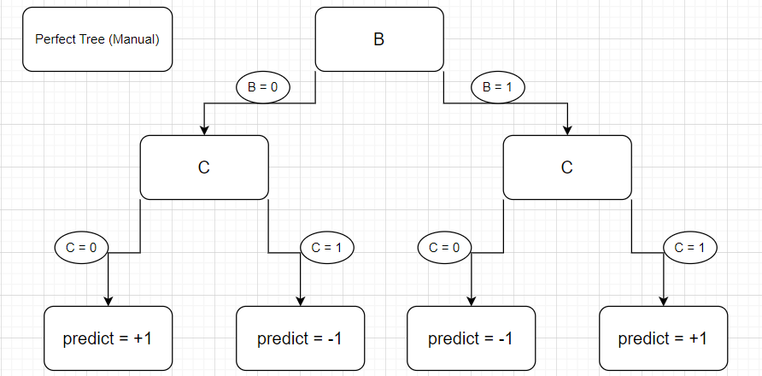

Decision trees strike again
- Given before you a dataset that consists of samples with two features $x_{1},x_{2}∈R$ and a label $y∈\{-1,1\}$

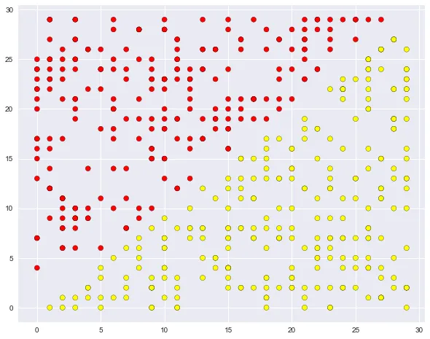
$$x_{1}$$
$$x_{2}$$

Note: For the following questions I assumed red = -1 and yellow = +1.
- The drawing referred to in all sections is the following:
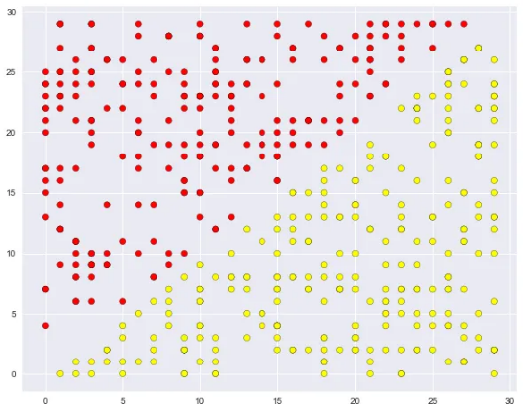
  - Can you identify a linear classifier $h\left(x_{1},x_{2}\right)=sign(w^{T}x+b)$ that achieves a perfect accuracy on the dataset? You may provide a drawing to emphasize your point.
Answer:
Yes, the classifier defined by w = (1,-1), b = (0,0).
  - Can you identify a decision tree of depth 1 that achieves a perfect accuracy on the dataset? You may provide a drawing of the decision boundary to emphasize your point.
Answer:
No, a decision tree can not achieve perfect accuracy, since there is no single tree decision boundary that can fit like the decision boundary line that is drawn. That is because a trees decision boundary has to be perpendicular to one of the features axis.
  - Can you identify a decision tree of depth 2 that achieves a perfect accuracy on the dataset? You may provide a drawing of the decision boundary to emphasize your point.
Answer:
No, a decision tree can not achieve perfect accuracy, since any four region split made of lines perpendicular to the features axi won’t separate the training data according to the given labels.

  - Will your answers change if we rotate the dataset by 45 degrees clockwise? Specifically, if each $(x_{1},x_{2})$ in the dataset is multiplied by a 45 degrees rotation matrix $R∈R^{2×2}$, while the labels remain unchanged?
Answer:
Yes, for decision trees of depth 1 or 2, using one split according to the feature x2 will suffice in terms of splitting the data. This kind of decision boundary would result in pure nodes immediately, therefore achieving perfect training accuracy.
- We now wish to prove that the information gain, i.e., $IG\left(v,a\right)=H\left(v\right)-\frac{\left|v_{a=T}\right|}{\left|v\right|}H\left(v_{a=T}\right)-\frac{\left|v_{a=F}\right|}{\left|v\right|}H\left(v_{a=F}\right)$, is non-negative for any set of examples $v$ and a binary attribute $a$.
Recall our definition of $v_{a=T}≜\left\{\left(x_{i},y_{i}\right)∈v | x_{i}\left[a\right]=T\right\}$ and $v_{a=F}≜\left\{\left(x_{i},y_{i}\right)∈v | x_{i}\left[a\right]=F\right\}$.
See the following dialogue, where we (really) asked ChatGPT to prove this (we shortened it a little):
Question: could you prove that the information gain in id3 cannot be negative?
Answer: Yes, I can prove this using mathematical reasoning.
In the ID3 algorithm, the information gain (IG) of an attribute A with respect to a dataset D is defined as: IG(A) = Entropy(D) - Sum([|Dv| / |D| * Entropy(Dv)])
where Entropy(D) is the entropy of the original dataset D, |Dv| is the number of instances in the subset of D that have a specific value v for the attribute A, and Entropy(Dv) is the entropy of that subset.
Entropy is a measure of the randomness or unpredictability of the target variable, and it is calculated as: Entropy(D) = - Sum([p(c) * log2(p(c))])
where p(c) is the proportion of instances in D that belong to class c.
Now, let's assume that the IG for a given attribute A is negative, i.e., IG(A) < 0.
Then we have: Entropy(D) - Sum([|Dv| / |D| * Entropy(Dv)]) < 0
Rearranging the terms, we get: Entropy(D) < Sum([|Dv| / |D| * Entropy(Dv)])
Since both Entropy(D) and Entropy(Dv) are non-negative, the right-hand side of the inequality is also non-negative.
Therefore, we have: Entropy(D) >= 0.
This contradicts the assumption that IG(A) < 0, because
Entropy(D) - Sum([|Dv| / |D| * Entropy(Dv)]) is the value of IG(A).
Thus, we can conclude that the information gain in the ID3 algorithm is always non-negative and cannot be negative.
  - Attached is a quote from “ארץ נהדרת” that best describes the answer above.
Briefly explain what the problem with the above “proof” is.
Answer: this following part, specifically deducing that the previous statements about Entropy(D) implies the following :
“This contradicts the assumption that IG(A) < 0, because
Entropy(D) - Sum([|Dv| / |D| * Entropy(Dv)]) is the value of IG(A).”



  - Let us really prove this.
Let $v$ be an arbitrary set of examples and $a$ be a binary attribute (feature).
Assume the classes are also binary.
The entropy is thus: $H\left(v\right)=H\left(\frac{1}{\left|v\right|}\left\{\left(x,y\right)∈v | y=1\right\}\right)≜H\left(p_{v}\right)=-p_{v}\log_{2}{p_{v}}-\left(1-p_{v}\right)\log_{2}\left(1-p_{v}\right)$.
(Notice that like in the tutorial, we use $H$ with a set $v$ or with a probability $p_{v}$ interchangeably.)

Prove: $IG\left(v,a\right)≥0$.
You can use the following property without proving it.
Property: It holds $∀β_{1},β_{2},α∈\left[0,1\right]$ that: $-αH\left(β_{1}\right)-\left(1-α\right)H\left(β_{2}\right)≥-H\left(αβ_{1}+\left(1-α\right)β_{2}\right)$.
Answer:
For $α=\left(\left|\left\{x∈D s.t. A=true\right\}\right|÷\left|D\right|\right), and β_{1},β_{2} fitting for D_{A=true}, D_{A=false}$ , we get the following:
$$αH\left(β_{1}\right)-\left(1-α\right)H\left(β_{2}\right)≤H\left(αβ_{1}+\left(1-α\right)β_{2}\right)$$
Which is equivalent to:
$$H\left(v\right)≥\frac{\left|v_{a=T}\right|}{\left|v\right|}H\left(v_{a=T}\right)+\frac{\left|v_{a=F}\right|}{\left|v\right|}H\left(v_{a=F}\right)$$
By rearranging, we get that $IG\left(v,a\right)≥0$ as needed. ◙

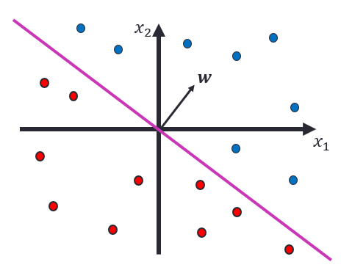
Linear classification
In tutorial 02, we illustrated algebraic and geometric properties of linear classifiers. Specifically, we explained that a homogeneous linear classifier $h:R^{d}→R$ is parameterized by a normal vector $w∈R^{d}$, such that:
$h\left(x\right)=+1⟺w^{⊤}x=\underset{>0}{\underbrace{\left\|w\right\|\left\|x\right\|}}\cos{∠\left(w,x\right)}>0⟺\cos{∠\left(w,x\right)}>0$.
Notice how the decision rule is invariant to the scale of $w$, and only considers its direction.
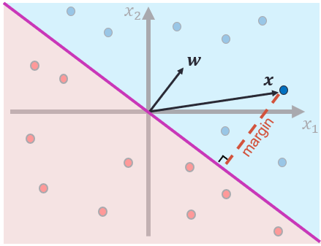
Furthermore, we showed that the geometric (signed) margin of $x∈R^{d}$ is:
$$\frac{w^{⊤}x}{\left\|w\right\|}$$

- A nonhomogeneous linear classifier $h:R^{d}→R$ is parameterized by a vector $w∈R^{d}$ and a bias $b∈R$, such that:
$h\left(x\right)=+1⟺w^{⊤}x>-b$.
Notice how $b$ can almost be interpreted as the minimal margin required for a positive prediction (we say “almost” since $w^{⊤}x$ is not the margin, but rather $\frac{w^{⊤}x}{\left\|w\right\|}$is).

  - In the homogeneous case, we had a degree of freedom while choosing $w$ (due to the scale invariance).
What similar degree of freedom do we have while choosing $w,b$ in the non-homogeneous case?
That is, how can $w,b$ be changed without changing the classifier itself? Briefly explain your answer.
Answer:
This time, with one degree of freedom for scaling both w and b at the same time we get:
${∀c>0, w}^{T}x÷c>-b÷c ⇔ w^{T}x > -b$
  - Following are 4 figures of decision boundaries induced by the same $w$ with different biases $b∈R$.
The biases are ordered as: $b_{1}>b_{2}>0>b_{3}>b_{4}$.
Which bias corresponds to which figure?
Write your answer in the following format (answers are made up): A is $b_{1}$, B is $b_{2}$, C is $b_{3}$, D is $b_{4}$.
No explanations are required.

(A) (B) (C) (D)
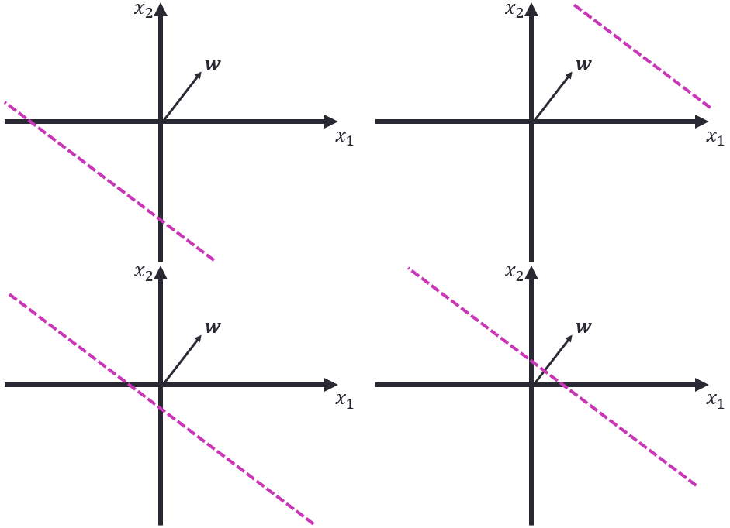
Answer: A is $b_{1}$, B is $b_{4}$, C is $b_{2}$, D is $b_{3}$.

$k$ Nearest Neighbors
- Following are 2 training sets in the $R^{2}$ feature space with 2 classes (blue/red).
Assume no dataset has two points in the exact same coordinates.
(A) | (B)
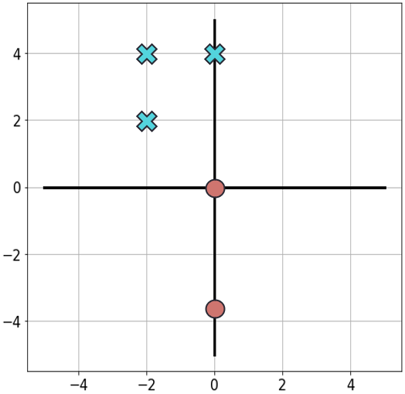 | 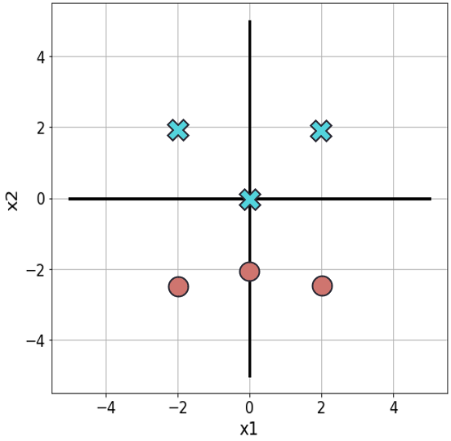
Following are 3 models.
- kNN with $k=1$ (a training point is not considered a neighbor of itself) w.r.t. $d\left(u,v\right)={\left\|u-v\right\|}_{2}$
- kNN with $k=3$ (a training point is not considered a neighbor of itself) w.r.t. $d\left(u,v\right)={\left\|u-v\right\|}_{2}$
- kNN with $k=1$ (a training point is not considered a neighbor of itself) w.r.t. $d\left(u,v\right)={\left\|u-v\right\|}_{1}$

  - For each model above, write which datasets this model can perfectly fit (i.e., with 0 training error) and which datasets it cannot. Write your answers in a table, like in the example below. When you say a model cannot perfectly fit a certain dataset, explain why in 1-2 sentences (without drawings).
Example for a table (answers are random):
Note: when I use the term “closest”, I mean it relative to the specific distance defined for each model.
Model / dataset | (A) | (B)
i. | Yes. | No.  Because of the center point being blue but closest to a red point.
ii. | No.  center point has 2 out of 3 closest neighbors being blue. Therefore it will be miss labeled. | Yes.
iii. | Yes | No.  since the center point is blue but closest to a red point.

  - Now assume that the data points from all datasets above are rotated by the same unknown angle $θ$ (around the origin). That is, each 2-dimensional data point $\left[\begin{matrix}x_{1} \\ x_{2}\end{matrix}\right]$ is mapped into $\left[\begin{matrix}\cos{θ} & -\sin{θ} \\ \sin{θ} & \cos{θ}\end{matrix}\right]\left[\begin{matrix}x_{1} \\ x_{2}\end{matrix}\right]$.
Without knowing the exact angle $θ$, answer for each of the models above:
- Might your answers for that model change?
- If not, briefly explain why.
- Otherwise, the answers for which datasets might change? Briefly explain why.

Answer for example:
    - Answers unchanged because this is the best model ever.
    - Answers unchanged since this was once revealed to me in a dream.
    - Answers on dataset (A) might change because of this and that.

Answers:
      - No change for A and B, for Both data sets we are measuring actual physical distance between points (Unlike the norm used in model 3)
      - No change for A and B, for Both data sets we are measuring actual physical distance between points (Unlike the norm used in model 3)
      - A change may occur. For example ,incase of dataset A, if we rotate the points such that the blue point in (-,2,2) would be on the y axis, meaning on (0,2*sqrt(2)), we will get a miss classification for the center red point.

