{HW4}

Part A:
Question 1
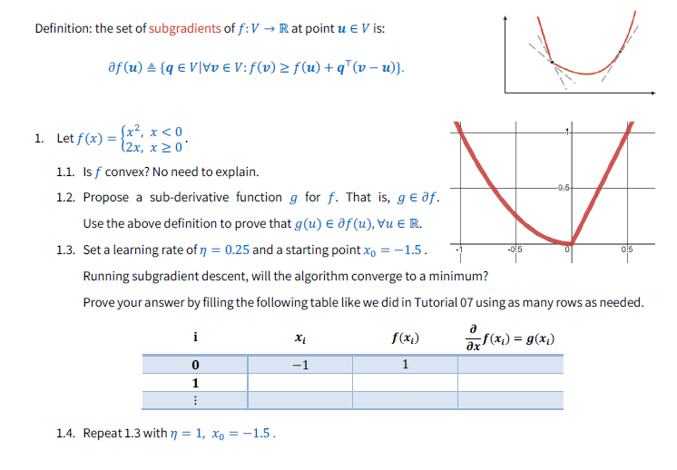
  - Yes f(x) is convex.
  - Define $g\left(x\right)= \left\{\begin{aligned}2x, if x<0 \\ 0, if x=0 \\ 2, if x≥0\end{aligned}\right.$
Said g(x) is a sub-derivative function since it agrees with f’(x) where it is differentiable. And where it is not we have g(0) = 0 which satisfies what is needed.
All we essentially needed here is some: $α∈\left[0,2\right]$
$$to plug in for g\left(0\right)=α, since f^{'}\left(0^{-}\right)=0 and f^{'}\left(0^{+}\right)=2$$

1.3 $x_{0}= -1.5 , η=0.25$
$i$ | $$x_{i}$$ | $$f\left(x_{i}\right)$$ | $$g(x_{i})$$
0 | -1.5 | 2.25 | -3
1 | -0.75 | $$\frac{9}{16}$$ | -1.5
2 | -0.375 | $$\frac{9}{64}$$ | -0.75
3 | $$-\frac{3}{16}$$ | $$\frac{9}{256}$$ | -0.375

1.4 $x_{0}= -1.5 , η=1$
$i$ | $$x_{i}$$ | $$f\left(x_{i}\right)$$ | $$g(x_{i})$$
0 | -1.5 | 2.25 | -3
1 | 1.5 | 2.25 | 2
2 | -0.5 | 0.25 | -1
3 | 0.5 | 0.25 | 2
4 | -1.5 | 2.25 | -3

We don’t get convergence since $x_{0}=x_{4}$, meaning we are stuck in a loop.
Part B:
Question 2
Data: $\left(x,y\right)∈\{\left(0,0\right),\left(1,3\right), (2,12)\}$
Hypothesis class: $H=\left\{w_{0}+w_{1}x+w_{2}x^{2}+w_{3}x^{3} \right| w_{i}∈R\}$
2.1:
Fsor $w_{0}=0, w_{1}=2 , w_{2}=0,w_{3}=1$ we get the polynomial given by: ${p\left(x\right)= x}^{3}+2x$
We get:
$$p\left(0\right)=0^{3}+2*0 =0$$
$$p\left(1\right)=1^{3}+2*1=3$$
$$p\left(2\right)=2^{3}+2*2=8+4=12$$

2.2:
The polynomial $f\left(x\right)=3x^{2}$ fits the data perfectly and is quadratic.
2.3:
For quadratic model, $w_{2.2}=(0,0,3,0)$
For the cubic model, $w_{2.1}=(0,2,0,1)$
Therefore: since m = 3
- $l\left(w_{2.2}\right)=\frac{1}{3}\left(\sum_{i=1}^{3}{{\left(3x_{i}^{2}-y_{i}\right)}^{2}}\right)=0$
- $l\left(w_{2.1}\right)=\frac{1}{3}\left(\sum_{i=1}^{3}{{\left(x_{i}^{3}+2x_{i}-y_{i}\right)}^{2}}\right)=0$
2.4:
For $w_{line}=(-1,6,0,0)$ we have:
- $l\left(w_{line}\right)=\frac{1}{3}\left(\sum_{i=1}^{3}{{\left(6x_{i}-1+y_{i}\right)}^{2}}\right)=$
$$\frac{1}{3}\left({\left(0-1-0\right)}^{2}+{\left(6-1-3\right)}^{2}+{\left(6*2-1-12\right)}^{2}\right)=$$
$$\frac{1}{3}\left(1+4+1\right)=2$$
2.5:
For $l_{λ}\left(w\right), w∈\{w_{2.1},w_{2.2},w_{line}\}$we have:
- $l_{λ}\left(w_{2.1}\right)=0+λ(1^{2}+2^{2})=5λ$
- $l_{λ}\left(w_{2.2}\right)=0+λ(3^{2})=9λ$
- $l_{λ}\left(w_{line}\right)=0+λ(6^{2}+{\left(-1\right)}^{2})=37λ$
2.6:
Since the regularized loss of the discussed cubic polynomial is strictly less than the regularized loss of the cubic polynomial for all $λ>0$, Therefore while minimizing the term $l_{λ}(w)$, we would prefer $w_{cubic}$ over $w_{quadratic}$. Leading to the choice of the cubic polynomial over the quadratic one.
2.7:
For L1 regularization, both polynomials have regularized loss of $3λ$, meaning this method prefers both polynomials equally. Since l1 regularization tends to zero out more coefficients, the quadratic polynomial is favored.

Part C:
Question 3
Initial figure:
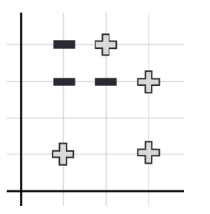
All figures:
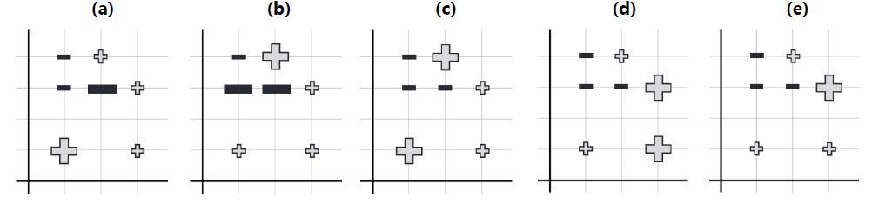

Possible figures:
(a) For this split:
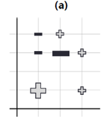
(b) For this split:
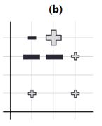
(c) For this split:
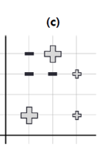

(d) + (e) No split can produce these distributions.

Question 4
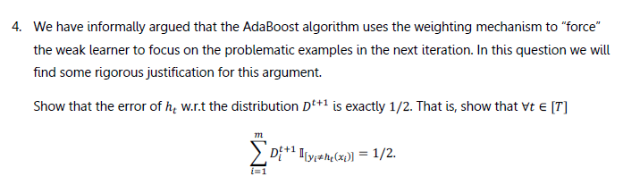
Proof:
Denote R = $\left\{x_{i}\right| h_{t}\left(x_{i}\right)≠y_{i}\}$, consider: $\sum_{i=1}^{m}{D_{i}^{t+1}}I_{\left[h_{t}\left(x_{i}\right)≠y_{i}\right]}$ = ***.
*** = $\sum_{i∈R}^{.}{D_{i}^{t+1}}=\sum_{i∈R}^{.}{\frac{D_{i}^{t}e^{-α_{t}y_{i}h_{t }(x_{i})}}{\sum_{j=1}^{m}{D_{i}^{t}e^{-α_{t}y_{j}h_{t }(x_{j})}}}}$.
Note: For all $x_{i}∈R$, we have that $y_{i}h_{t }\left(x_{i}\right)=-1$, therefore:
*** = $\sum_{i∈R}^{.}{\frac{D_{i}^{t}e^{α_{t}}}{\sum_{j=1}^{m}{D_{i}^{t}e^{-α_{t}y_{j}h_{t }(x_{j})}}}}$.
Consider: $e^{α_{t}}=e^{\frac{1}{2}\ln\left(\frac{1}{ϵ_{t}}-1\right)}=\sqrt{\frac{1}{ϵ_{t}}-1 }$ = **
Consider: $\sum_{j=1}^{m}{D_{i}^{t}e^{-α_{t}y_{j}h_{t }(x_{j})}}= \sum_{i∈R}{D_{i}^{t}e^{α_{t}}}+ \sum_{i∉R}{D_{i}^{t}e^{{-α}_{t}}}$
= $\sum_{i∈R}{D_{i}^{t}\sqrt{\frac{1}{ϵ_{t}}-1}}+ \sum_{i∉R}{D_{i}^{t}\sqrt{\frac{ϵ_{t}}{ϵ_{t}-1}}}$ = *

Observe now: *** = $\sum_{i∈R}^{.}{\frac{D_{i}^{t}\sqrt{\frac{1}{ϵ_{t}}-1 }}{\sum_{i∈R}{D_{i}^{t}\sqrt{\frac{1}{ϵ_{t}}-1}}+ \sum_{i∉R}{D_{i}^{t}\sqrt{\frac{ϵ_{t}}{ϵ_{t}-1}}}}}$ .
Multiplying both the enumerator the denominator by $\sqrt{ϵ_{t}}$ we get:
*** = $\sum_{i∈R}^{.}{\frac{D_{i}^{t}\sqrt{1-ϵ_{t}}}{\sum_{i∈R}{D_{i}^{t}\sqrt{1-ϵ_{t}}}+ \sum_{i∉R}{D_{i}^{t}\sqrt{\frac{ϵ_{t}^{2}}{ϵ_{t}-1}}}}}$
Notice that $ϵ_{t}=\frac{\sum_{i∈R}{D_{i}^{t}}}{\sum_{i∈R}{D_{i}^{t}}+\sum_{i∉R}{D_{i}^{t}}}→ \sum_{i∉R}{D_{i}^{t}}=\frac{\sum_{i∈R}{D_{i}^{t}}}{ϵ_{t}}- \sum_{i∈R}{D_{i}^{t}}$
Combining this with what we showed above we have:
*** = $\sum_{i∈R}^{.}{\frac{D_{i}^{t}\sqrt{1-ϵ_{t}}}{\sum_{i∈R}{D_{i}^{t}\sqrt{1-ϵ_{t}}}+(\frac{\sum_{i∈R}{D_{i}^{t}}}{ϵ_{t}}- \sum_{i∈R}{D_{i}^{t})\sqrt{\frac{ϵ_{t}^{2}}{ϵ_{t}-1}} }}}$
Now dividing by $\sum_{i∈R}{D_{i}^{t}}$ we get:
*** = $\frac{\sqrt{1-ϵ_{t}}}{\sqrt{1-ϵ_{t}}+\left(\frac{1}{ϵ_{t}}- 1\right)\sqrt{\frac{ϵ_{t}^{2}}{ϵ_{t}-1}}}$
Multiplying both enumerator and denominator by $\sqrt{1-ϵ_{t}}$ we finally have:
*** = $\frac{1-ϵ_{t}}{1-ϵ_{t}+\left(\frac{1}{ϵ_{t}}- 1\right)ϵ_{t} }=\frac{1-ϵ_{t}}{1-ϵ_{t}+ 1-ϵ_{t}}=\frac{1}{2}$
Therefore proving what is needed.

Part D:
Question 5:
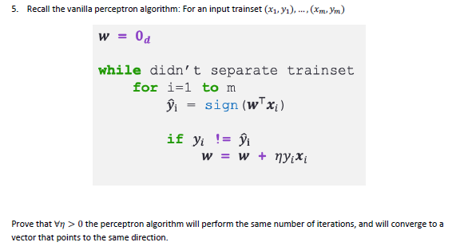
Proof:
Let learning rates $η_{1},η_{2}$ greater than zero, given an input training set
${\left\{\left(x_{i},y_{i}\right)\right\}}_{i}^{m}$, we have for any iteration $i∈N$ :
$$w_{i}= \sum_{j=1}^{i}{η_{r}y_{j}x_{j}} for r∈\{1,2\}$$
Therefore, since the ratio between $η_{1} and η_{2}$ is positive, $w_{i}$ produced by either one will be in the same direction.
Regarding the number of iterations, consider for any iteration $n∈N$:
$${y_{i}}_{pred}= sign\left(w_{n}^{T}x_{i}\right)=sign\left(\sum_{j=1}^{n}{η_{r}y_{j}x_{j}^{T}x_{i}}\right)= sign(\sum_{j=1}^{n}{y_{j}x_{j}^{T}x_{i}})$$
For any $r∈\{1,2\}$, since $η_{r}>0$.
Therefore predictions are invariant to any $η>0$, at any iteration.
Meaning convergence is reached with the same number of iterations regardless of $η$.

