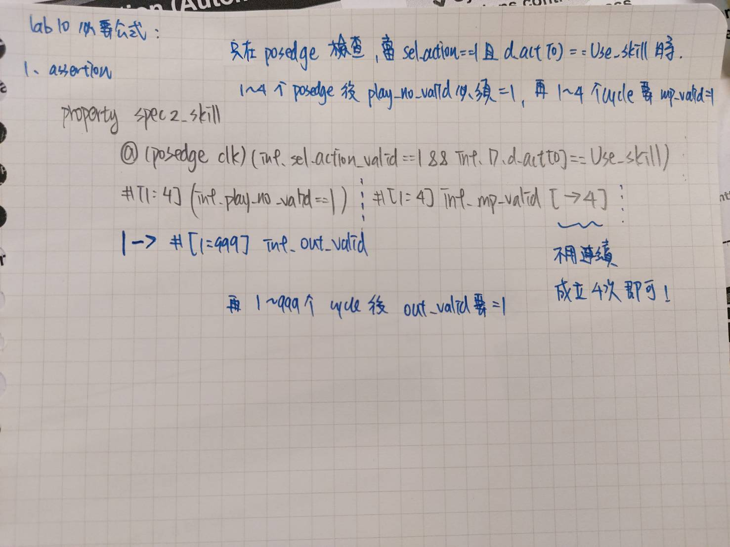
Link: https://chatgpt.com/share/69205662-2c28-8004-8410-9ad9b4c681ad

