1在05/LEF中
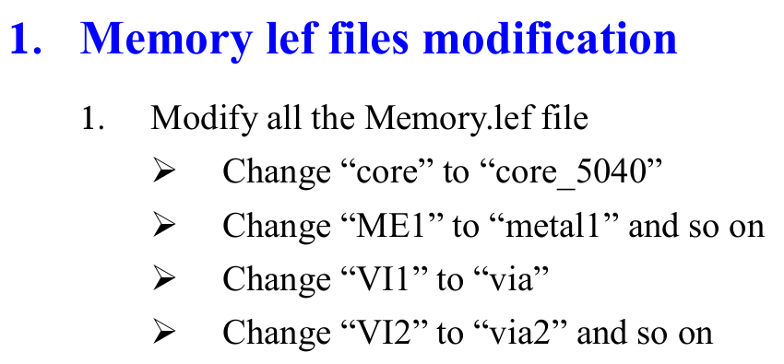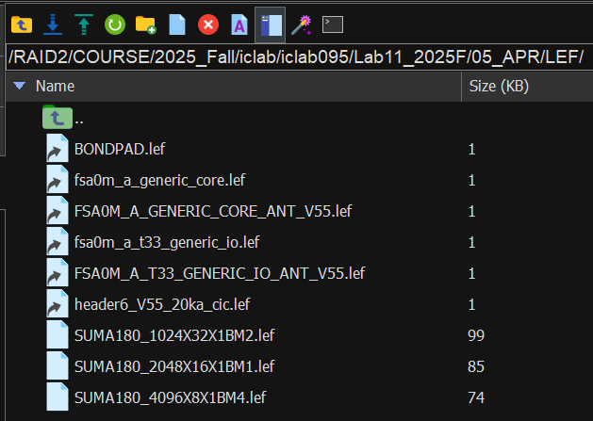
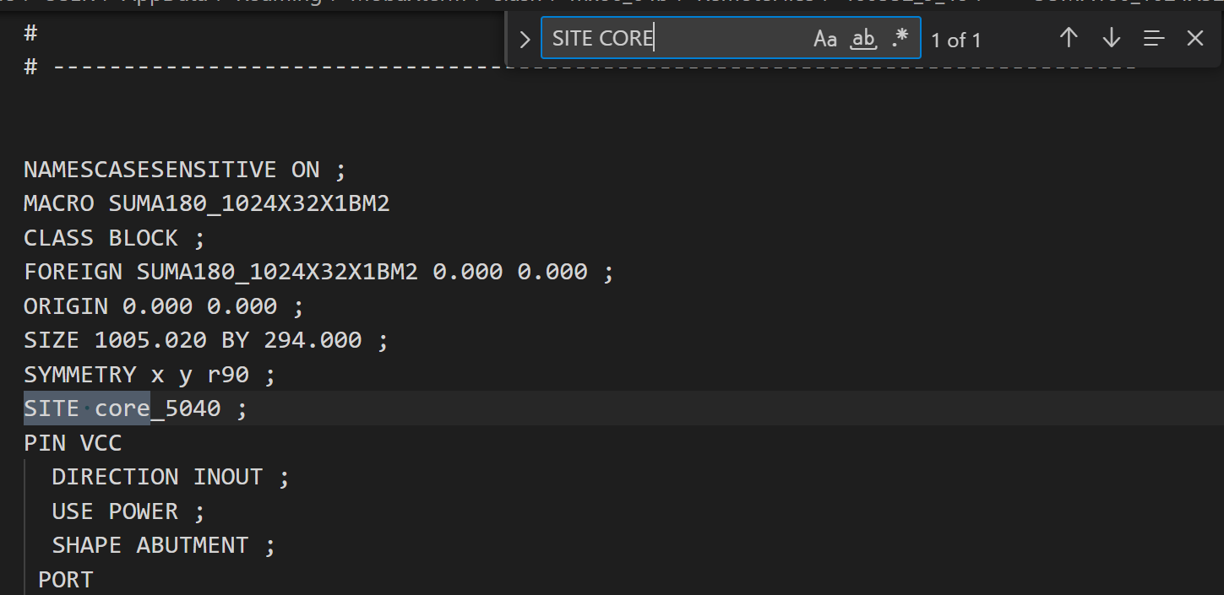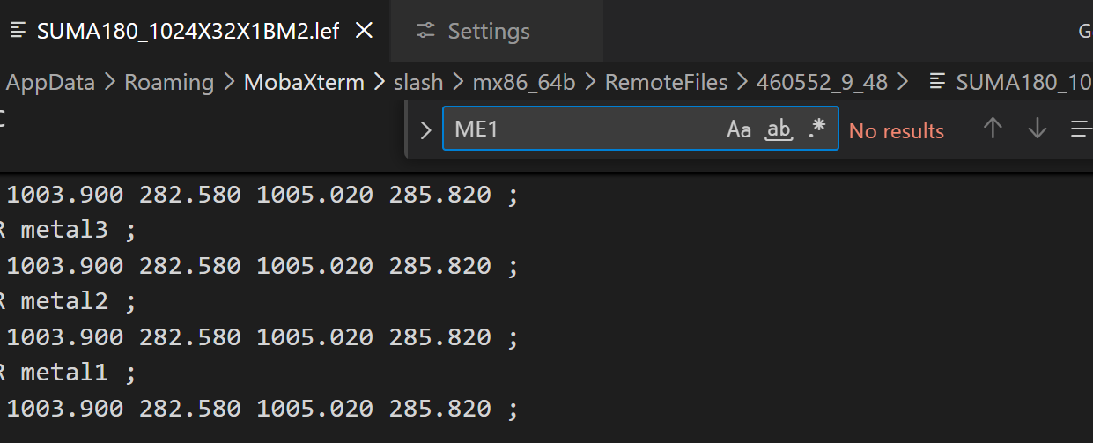
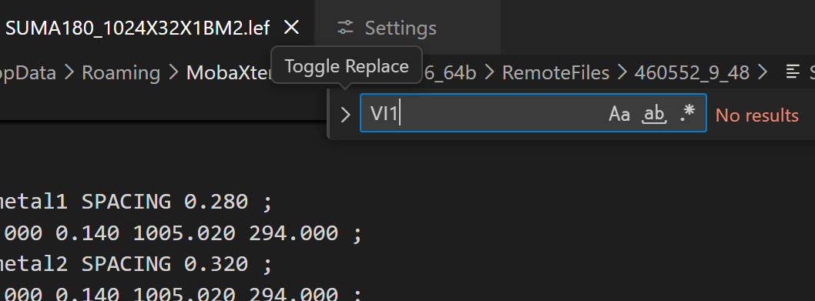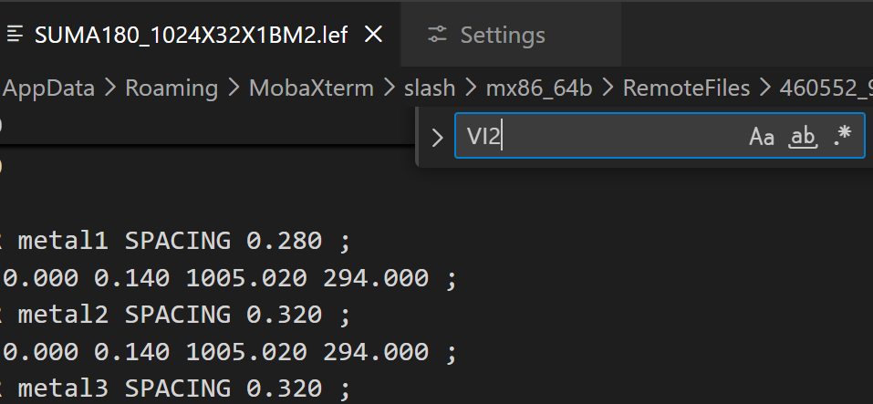
2, 3, 4 ./00_combine
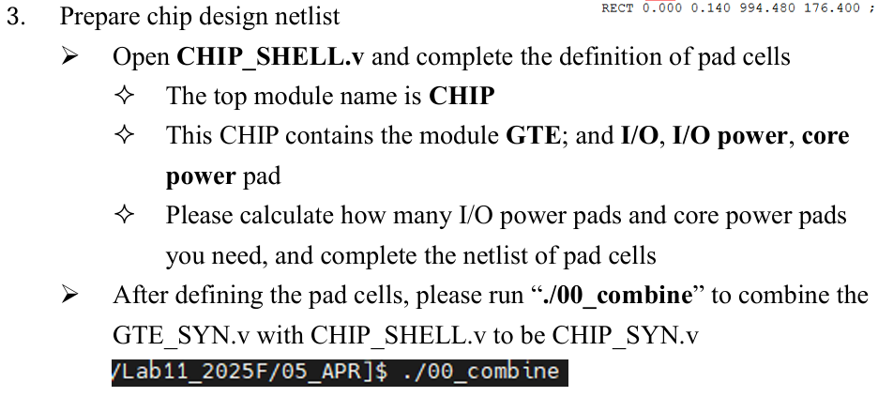
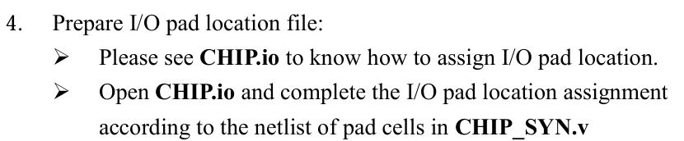

5 cp ../02_SYN/Netlist/GTE_SYN.sdc CHIP.sdc
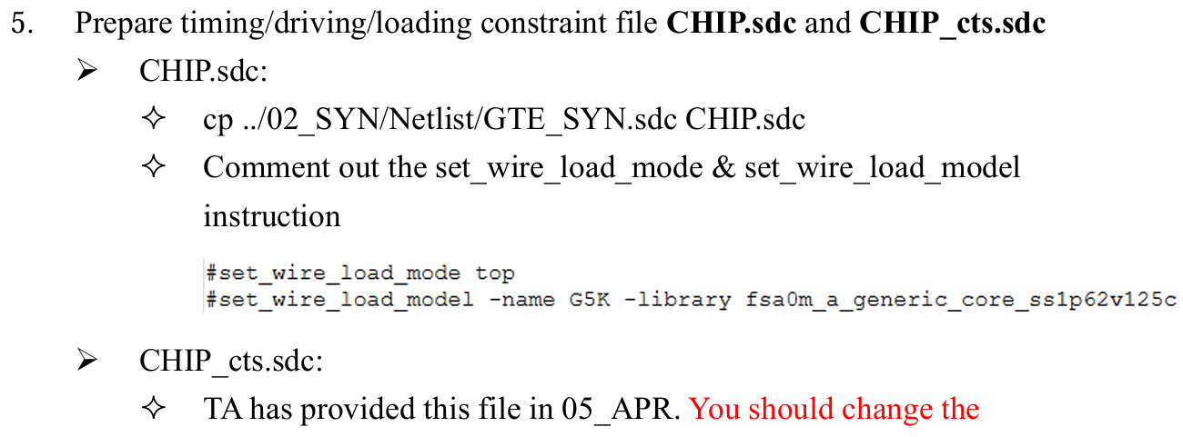
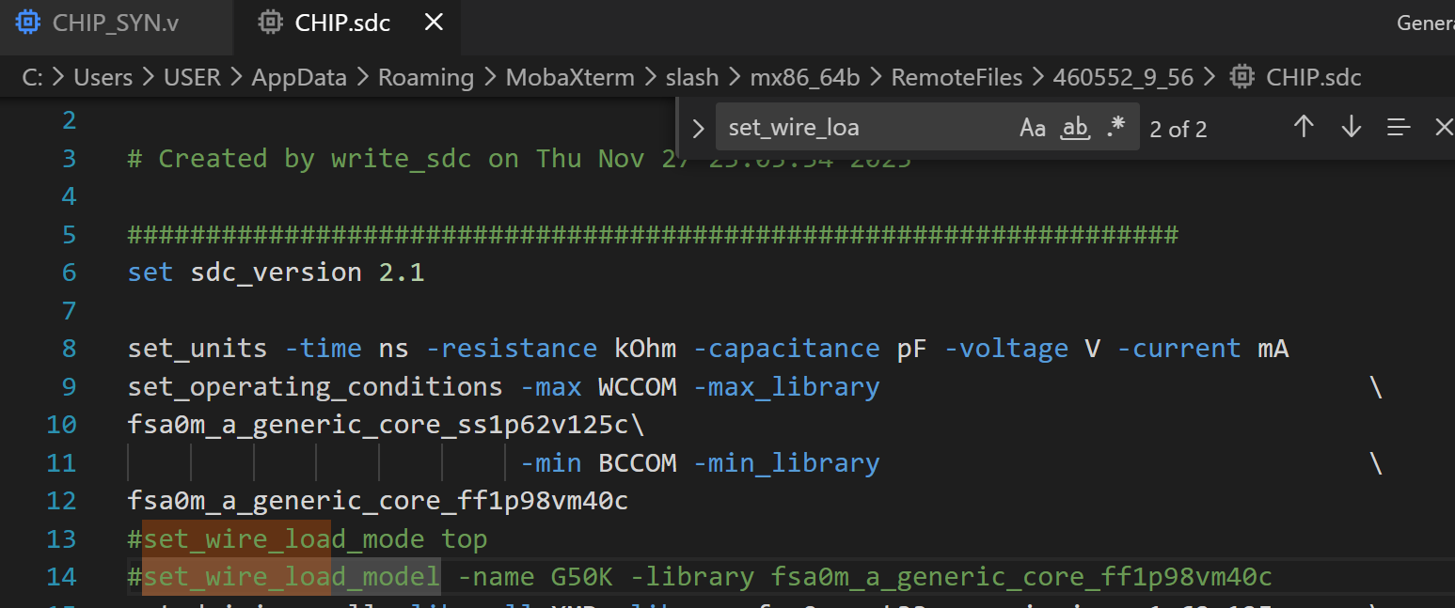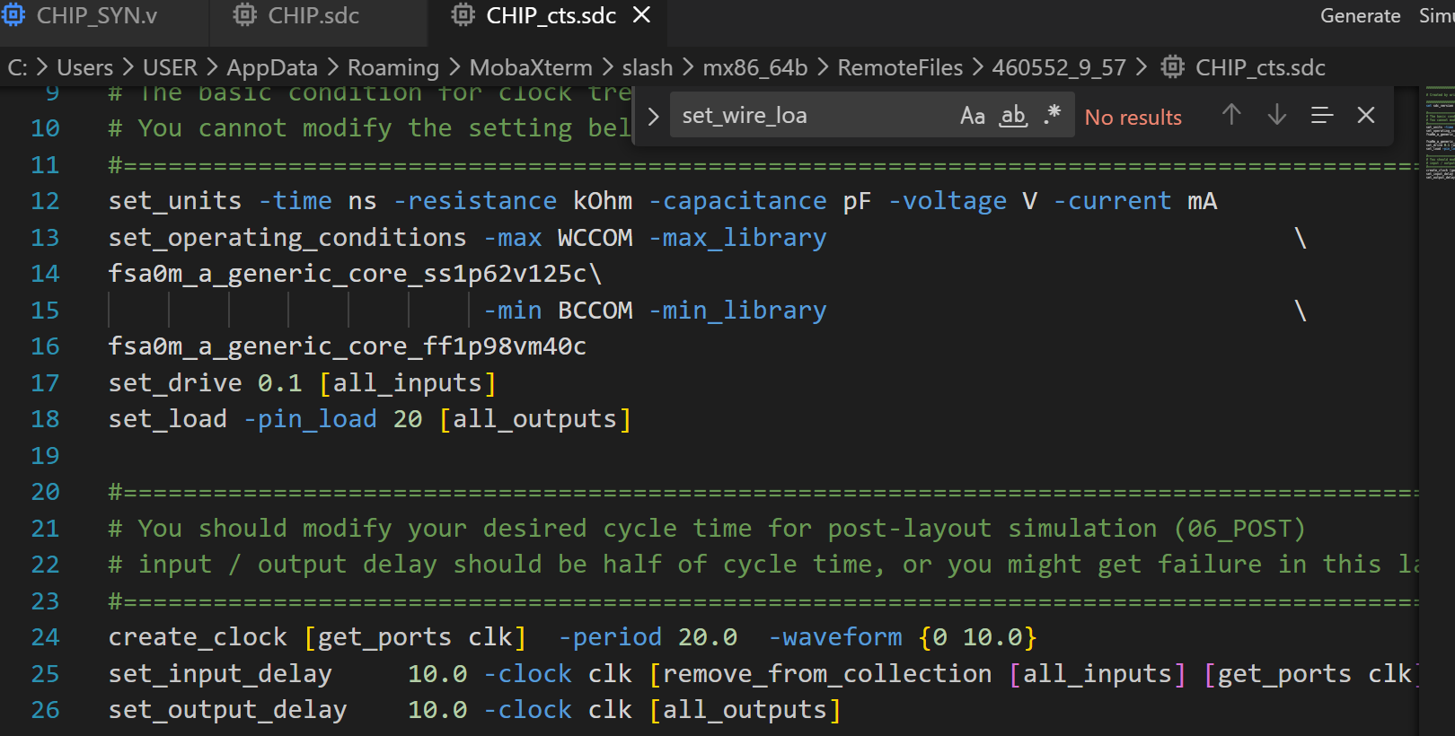

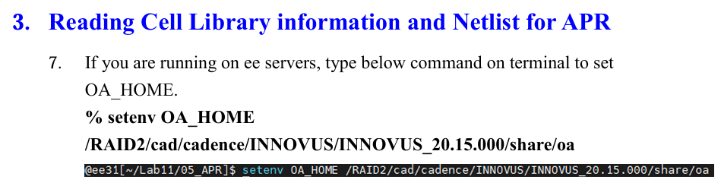
- 在05_APR: setenv OA_HOME /RAID2/cad/cadence/INNOVUS/INNOVUS_20.15.000/share/oa
- Innovus
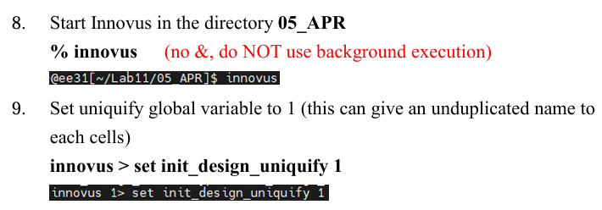
- set init_design_uniquify 1
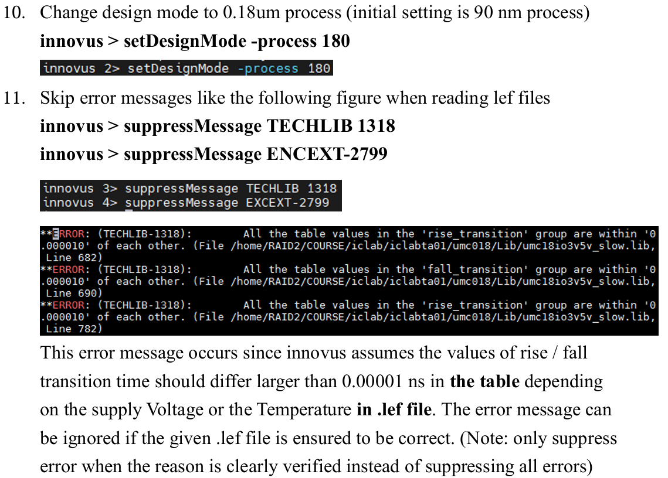

- setDesignMode -process 180
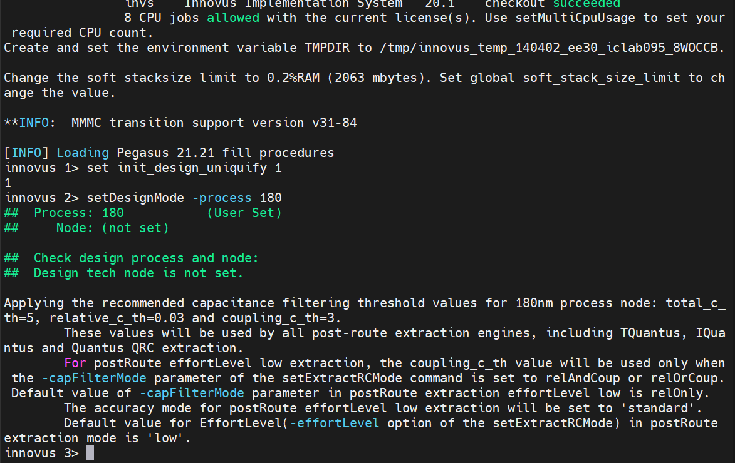
- suppressMessage TECHLIB 1318
- suppressMessage ENCEXT-2799
- step 12
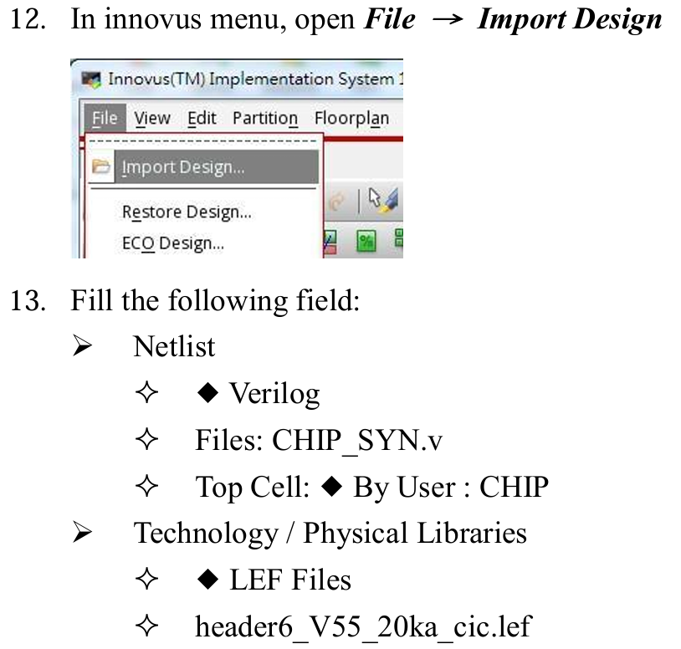
- step 13
CHIP_SYN.v, CHIP

header6_V55_20ka_cic.lef fsa0m_a_generic_core.lef FSA0M_A_GENERIC_CORE_ANT_V55s.lef fsa0m_a_t33_generic_io.lef FSA0M_A_T33_GENERIC_IO_ANT_V55.lef BONDPAD.lef SUMA180_1024X32X1BM2.lef SUMA180_2048X16X1BM1.lef SUMA180_4096X8X1BM4.lef
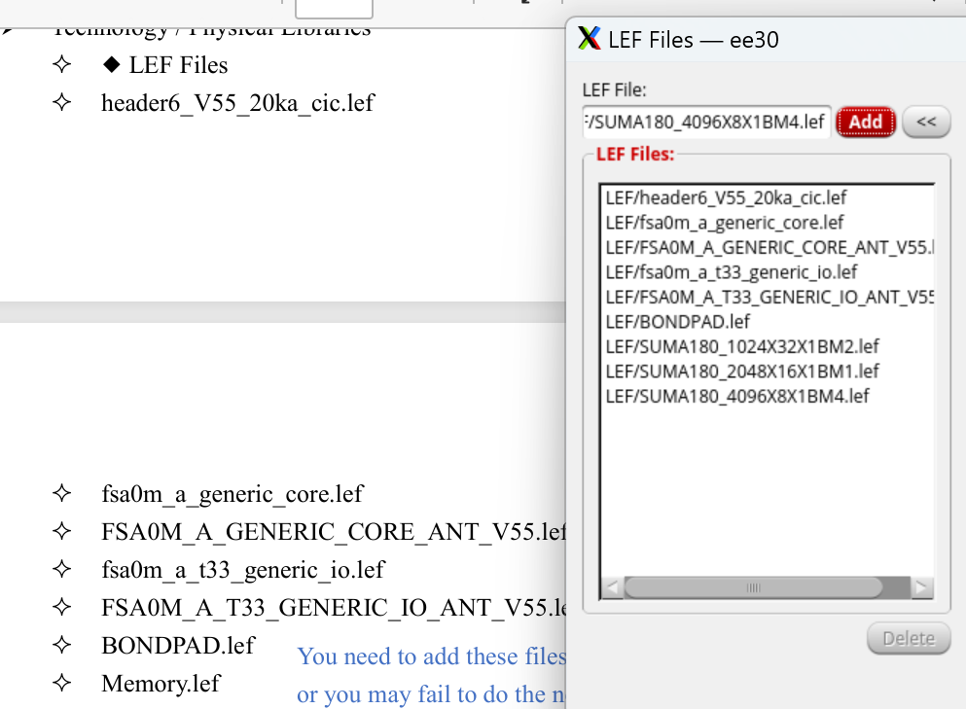
CHIP.io

VCC GND
- step 14
lib_max
fsa0m_a_generic_core_ss1p62v125c.lib
fsa0m_a_t33_generic_io_ss1p62v125c.lib
SUMA180_1024X32X1BM2_WC.lib
SUMA180_2048X16X1BM1_WC.lib
SUMA180_4096X8X1BM4_WC.lib

u18_ss.cdb
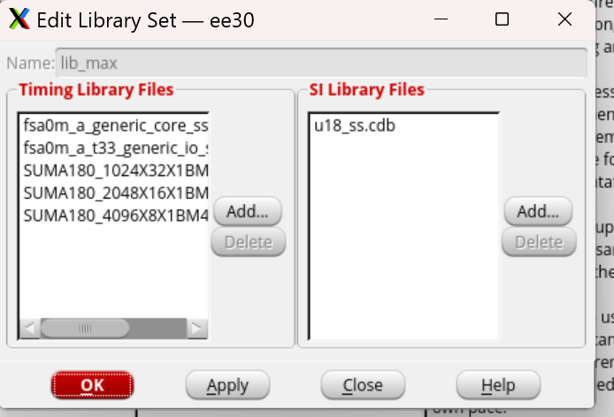
lib_min
fsa0m_a_generic_core_ff1p98vm40c.lib
fsa0m_a_t33_generic_io_ff1p98vm40c.lib
SUMA180_1024X32X1BM2_BC.lib
SUMA180_2048X16X1BM1_BC.lib
SUMA180_4096X8X1BM4_BC.lib

u18_ff.cdb
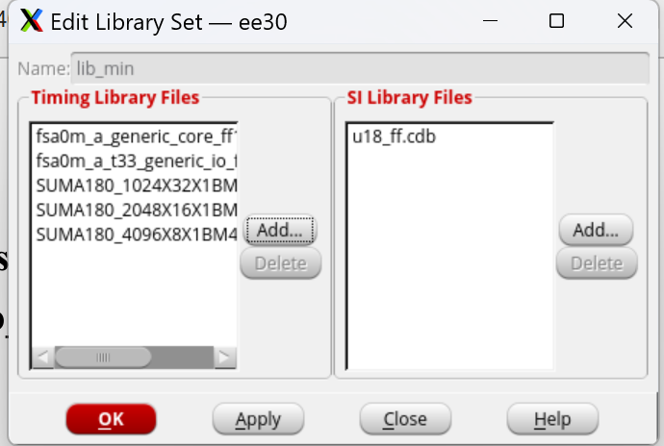
RC_Corner
u18_Faraday.CapTbl
icecaps.tch
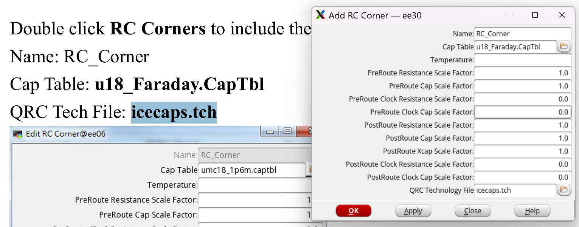
Delay_corner_max
RC_Corner
lib_max
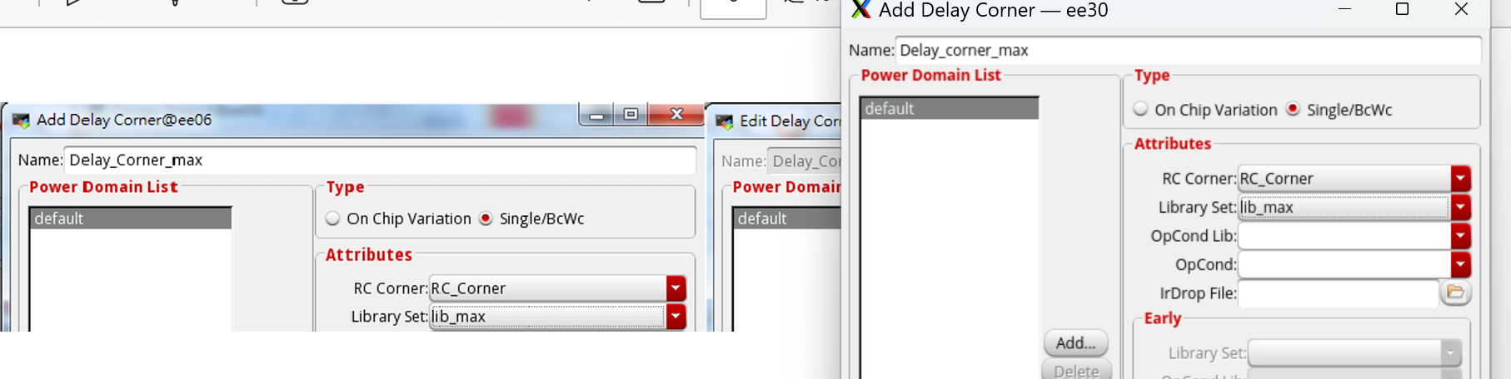
Delay_corner_min
RC_Corner
lib_min
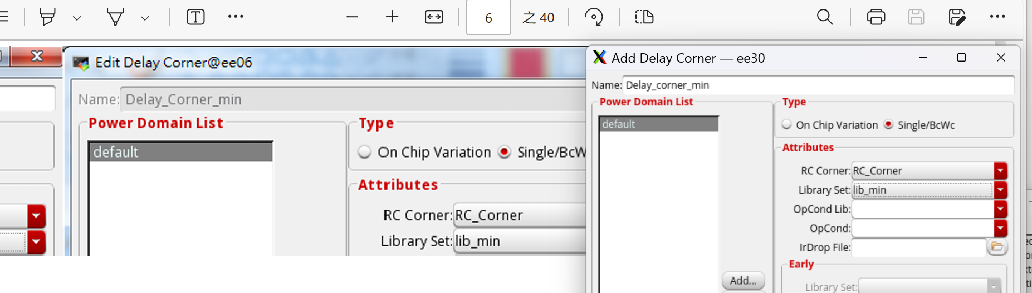
func_mode
CHIP.sdc
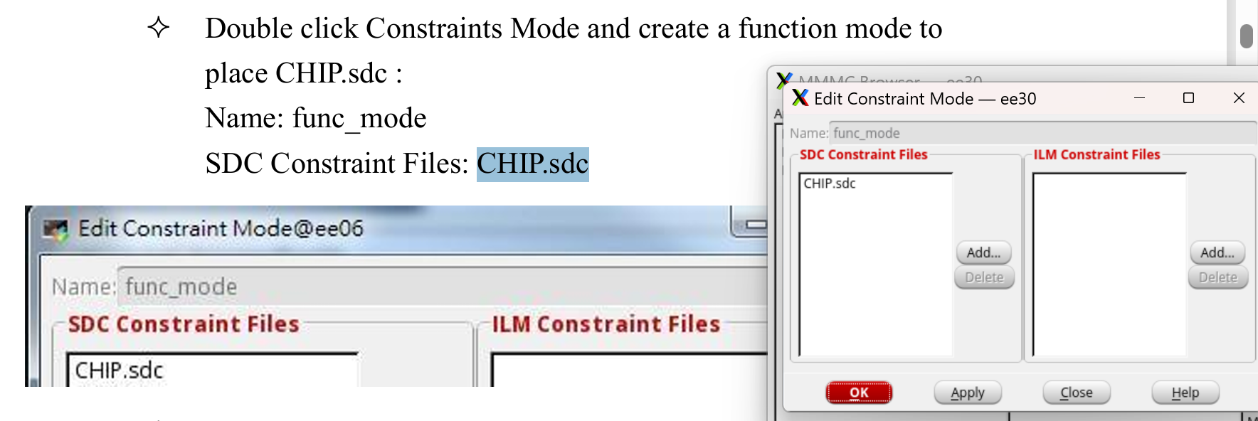

av_func_mode_max
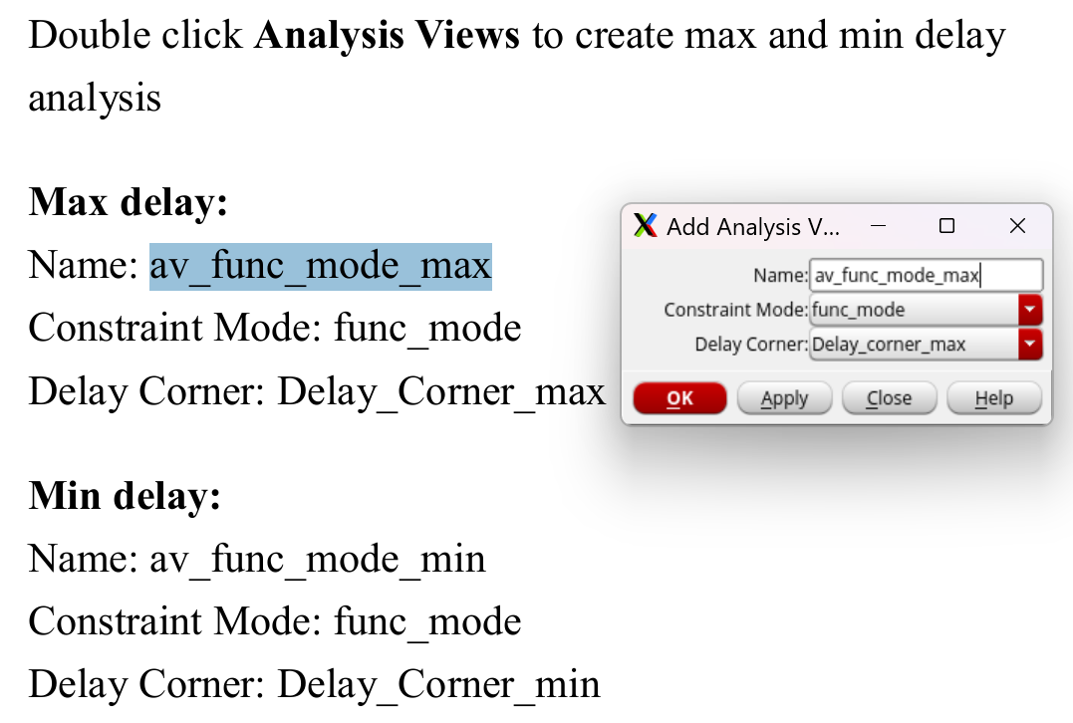
av_func_mode_min
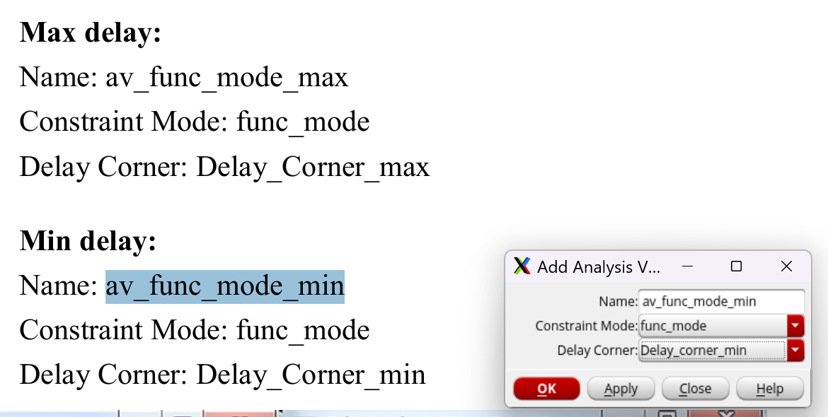
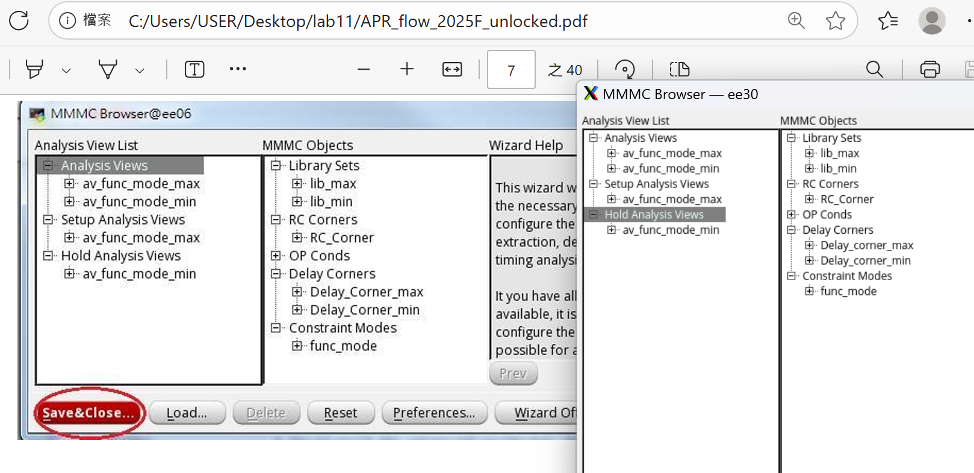
重點!! 一定會用到
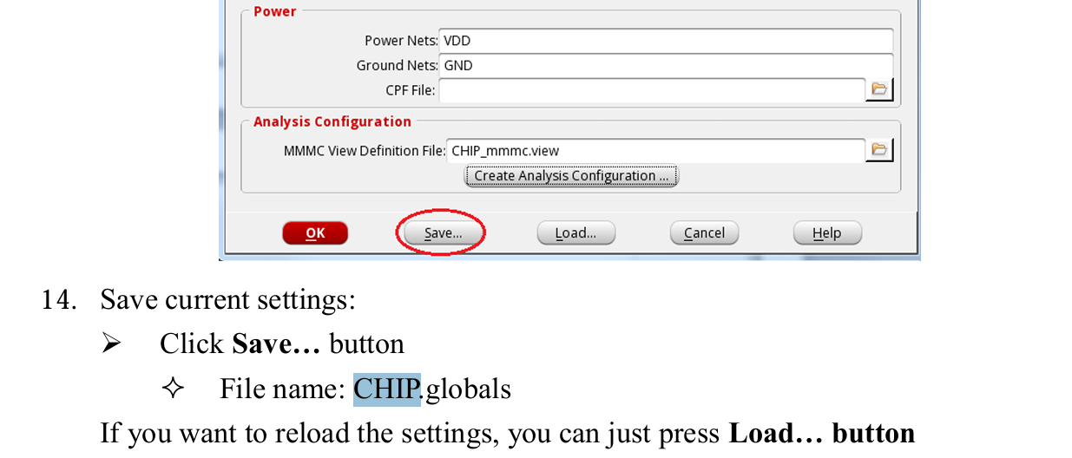
- 目前(4組 pad)
